Supplementary Material

Geographical-structured model
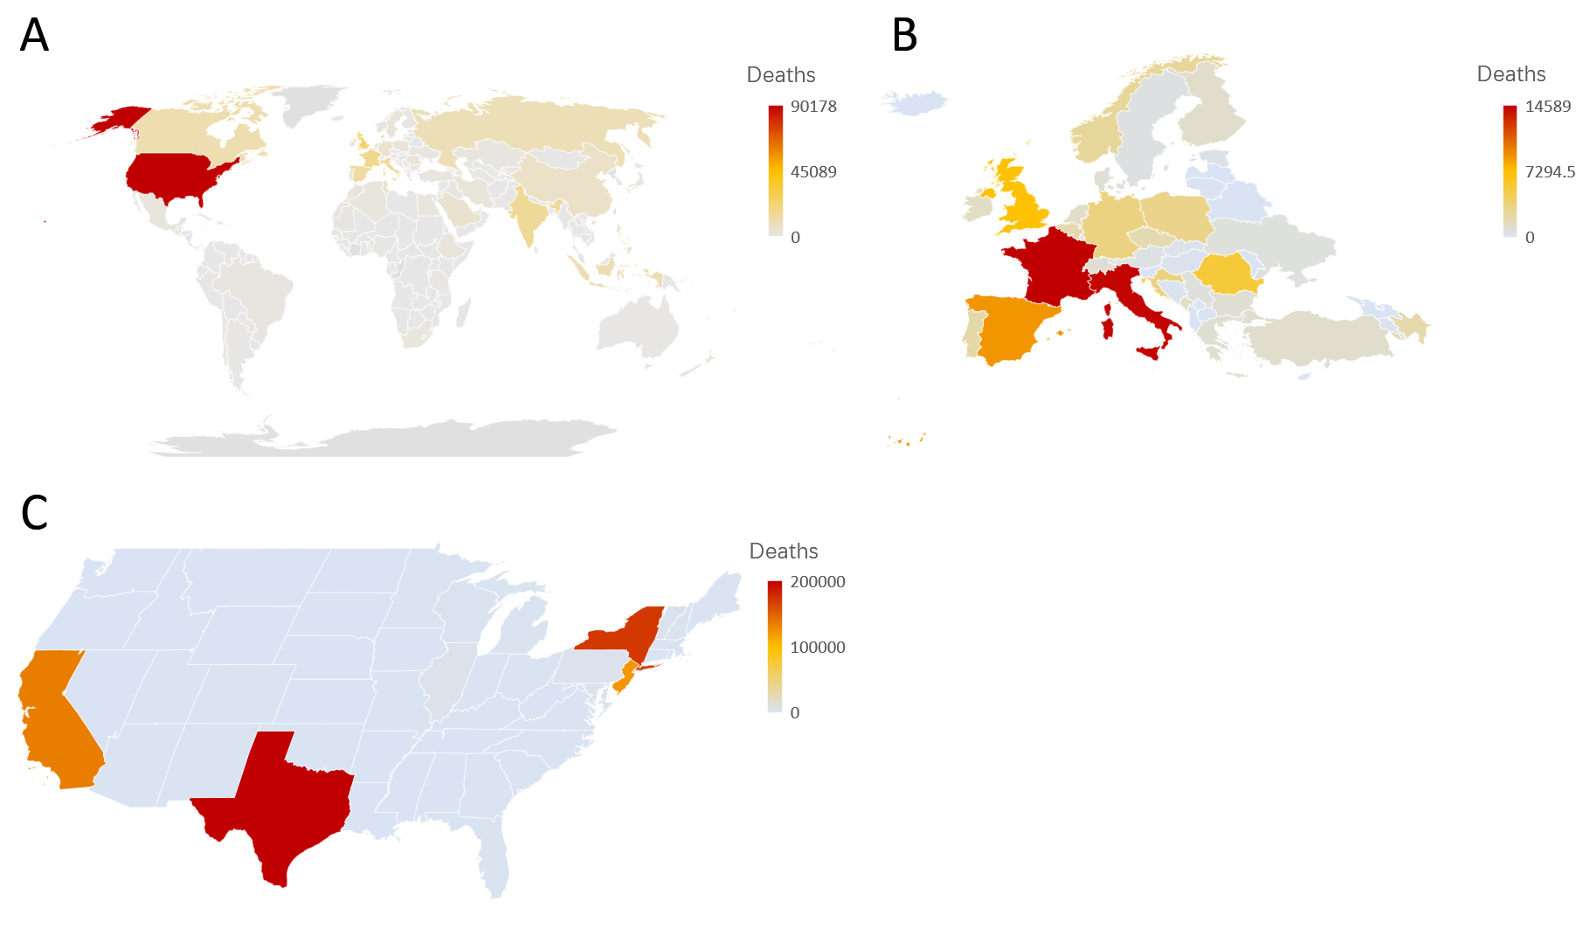
Figure 1: Sample geographical division
We included all county/province level that has airports. Overall, there are 250 countries/regions and 2154 province level districts in our model.,

Transmission model
We constructed a conventional SEIR model for each county-level unit. The overall model from a macro scale can be written as:
$$\left\{\begin{aligned}\frac{dS\left(t\right)}{dt}=-\frac{βSI}{N} \\ \frac{dE\left(t\right)}{dt}=\frac{βSI}{N}-σE \\ \frac{dI(t)}{dt}=σE-\left(δ+D\right)I \\ \frac{dR(t)}{dt}=\left(δ+D\right)I \\ \frac{dD(t)}{dt}=DI \\ \frac{dr(t)}{dt}=δI\end{aligned}\right.$$
The flowchart for an individual patient is:
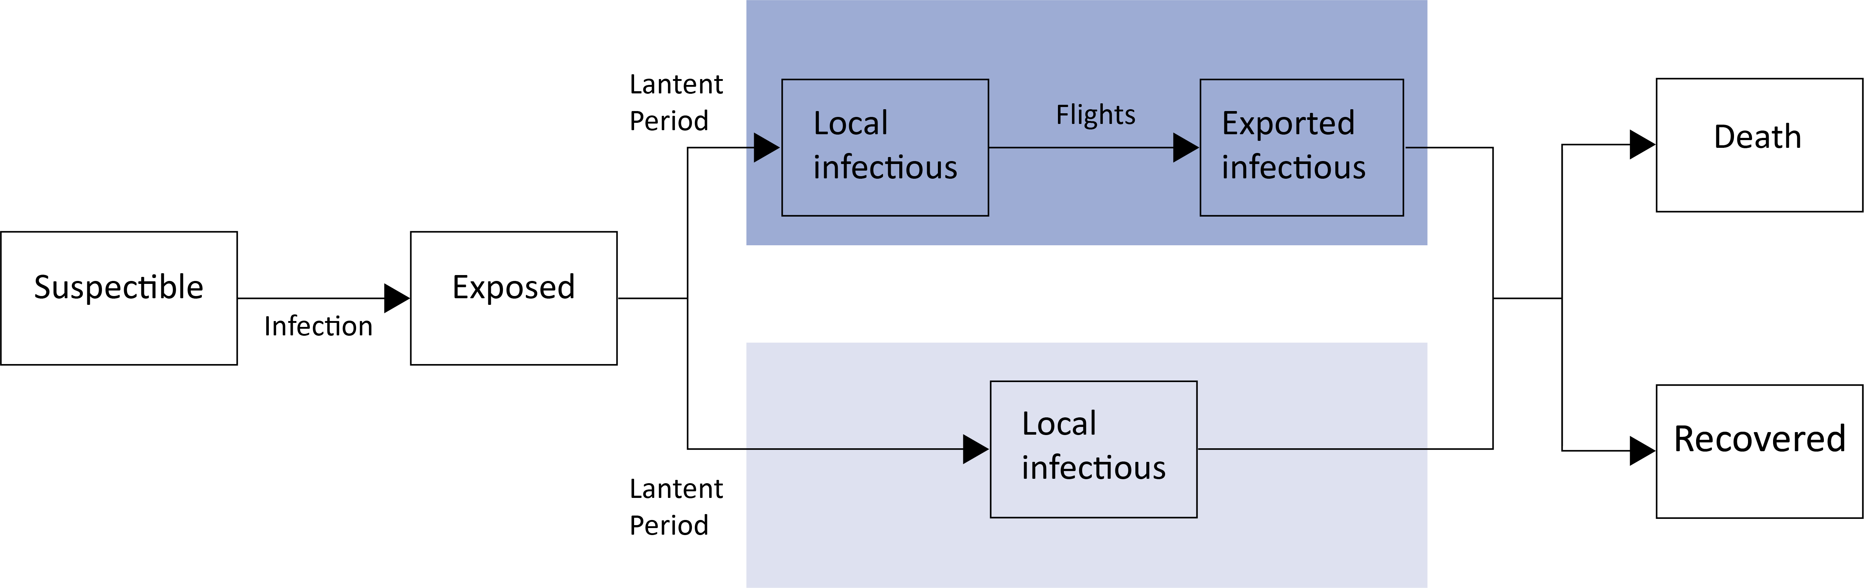
Figure 2: Description of the transmission model
Individuals in the stochastic compartmental model are classified into susceptible, exposed, infectious, and removed states. The cases will be determined to be an exported case or a local case by the stochastic algorithm.

Stochastic algorithm for flight assign
We integrated 21,081,805 flights from September 1, 2019 to June 1, 2020 to describe the mobility of the population. To utilize this day, we used a stochastic algorithm to determine the number of patients on board.
For a county with the population of $N$, the number of fights taken off of on a certain day $n$, passenger of each flight of $α_{n}$, passenger load factor of $μ$, the possibility of an individual onboard is:
$$P\left(onboard\right)=\frac{1}{N}\sum_{0}^{n}{α_{n}}$$
The expectancy of the number of exposed/infectious individuals onboard ($E_{O}$ and $I_{O}$)is:
$$I_{O}+E_{O}=\sum_{0}^{n}{α_{n}}\frac{(E+I)}{N}$$
However, to reduce the amount of computational power required for the model, we simplified this algorithm to a Gaussian distribution function. Therefore, the number of exposed/infectious passenger is:
$$I_{O}+E_{O}=(1+0·3e^{-η^{2}})(\sum_{0}^{n}{α_{n}}\frac{\left(E+I\right)}{N})$$
After determining the number of patients that will be onboard, t he model will randomly pick certain patients to be exported from the province. The algorithm will then assign them a flight and a destination.

We picked 10 flights on January 11, 2020 from Shanghai, China (ISO-3166: CN-SH) to demonstrate our algorithm (Table 1).
Table 1: Sample flight record on January 11, 2020
Flight number | Departure | Arrival | Departure time | Arrival time | Aircraft | Seats | Passenger code
MU735 | PVG | SYD | 2020-01-10 00:36:00 | 2020-01-10 11:12:00 | B787 | 285 | $μ$ (0-285)
K6861 | PVG | REP | 2020-01-10 01:05:00 | 2020-01-10 05:09:00 | A320 | 180 | $μ$ (286-465)
SQ825 | PVG | SIN | 2020-01-10 00:41:00 | 2020-01-10 05:47:00 | B777 | 264 | $μ$ (466-729)
LH727 | PVG | MUC | 2020-01-10 00:58:00 | 2020-01-10 12:04:00 | A380 | 509 | $μ$ (730-1238)
MU219 | PVG | FRA | 2020-01-10 00:50:00 | 2020-01-10 12:11:00 | A350 | 288 | $μ$(1239-1526)
MU771 | PVG | AMS | 2020-01-10 01:17:00 | 2020-01-10 12:30:00 | A350 | 288 | $μ$ (1527-1814)
MU553 | PVG | CDG | 2020-01-10 01:03:00 | 2020-01-10 12:59:00 | B777 | 316 | $μ$(1815-2130)
MU779 | PVG | AKL | 2020-01-10 00:47:00 | 2020-01-10 12:41:00 | B787 | 285 | $μ$(2133-2415)
MU739 | PVG | MEL | 2020-01-10 00:38:00 | 2020-01-10 11:03:00 | A330 | 234 | $μ$(2416-2649)
UL867 | PVG | CMB | 2020-01-10 01:09:00 | 2020-01-10 07:58:00 | A330 | 297 | $μ$(2650-2946)
Overall, there are 2946 seats available ($S_{a}$) to choose from. However, there may be some seats that do not have passengers; therefore, we will multiply $S_{a}$ by the passenger load factor ($μ$ = 82·6%) to find the number of passengers on board ($S_{o}$), which $S_{o}$ equals:
$$S_{o}= {μ S}_{a }=0·826{ S}_{a }$$
In this case, $S_{o}$ is 2,433. The algorithm will then generate a random integer from 0 to $S_{o}$ (2433) for each passenger, this number is the passenger code for them (Table 1). The passenger code is corresponding to one flight, and this is the flight which the passenger is going to take.

Key parameters in the model
The key epidemiology parameters in our model are acquired from published studies.,, We used a serial interval of 7 days based on published studies. We also used the mean of the latent period 4·5 days.⁴ The patient will be determined whether to demise or recover after a median of 18·8 days (95% credible interval [CrI] 15·7–49·7). ⁴
The mortality rate of the model for each individual was determined based on their age according to the table (Table 2).
Table 2: Mortality rate of COVID-19 patient by age in China
Age | Mortality rate
≤20 | 0.2%
20~ | 0.2%
30~ | 1.2%
40~ | 0.4%
50~ | 1.3%
60~ | 3.6%
70~ | 8.0%
≥80 | 14.8%

References

ISO. ISO 3166 - Country Codes. 2020. https://www.iso.org/iso-3166-country-codes.html (accessed September 15, 2020).
IATA. World Air Transport Statistics. https://www.iata.org/en/publications/store/world-air-transport-statistics/ (accessed September 15, 2020).
IATA. Slower but Steady Growth in 2019. https://www.iata.org/en/pressroom/pr/2020-02-06-01/ (accessed September 15, 2020).
Verity R, Okell LC, Dorigatti I, Winskill P, Whittaker C, Imai N, et al. Estimates of the severity of coronavirus disease 2019: a model-based analysis. The Lancet Infectious Diseases. 2020;20(6):669–77.
Bi Q, Wu Y, Mei S, Ye C, Zou X, Zhang Z, et al. Epidemiology and Transmission of COVID-19 in Shenzhen China: Analysis of 391 cases and 1,286 of their close contacts. 2020;
Liu Y, Gayle AA, Wilder-Smith A, Rocklöv J. The reproductive number of COVID-19 is higher compared to SARS coronavirus. Journal of Travel Medicine. 2020;27(2).

