Table 1. Comparison of patient characteristics between the 2L(+) and 2L(−) groups.
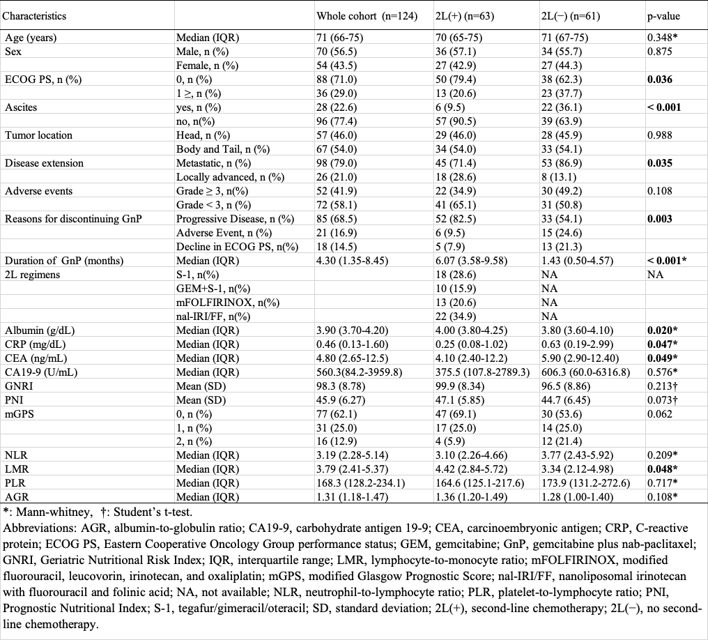
Table 2. Efficacy results and best therapeutic response (RECIST version 1.1) to GnP.
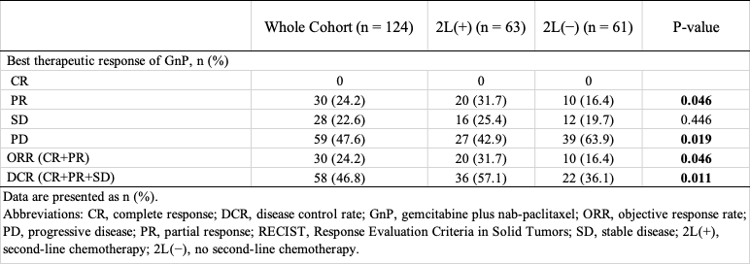
Table 3. Univariate and multivariate analyses of prognostic factors for OS in patients with UR-PC.
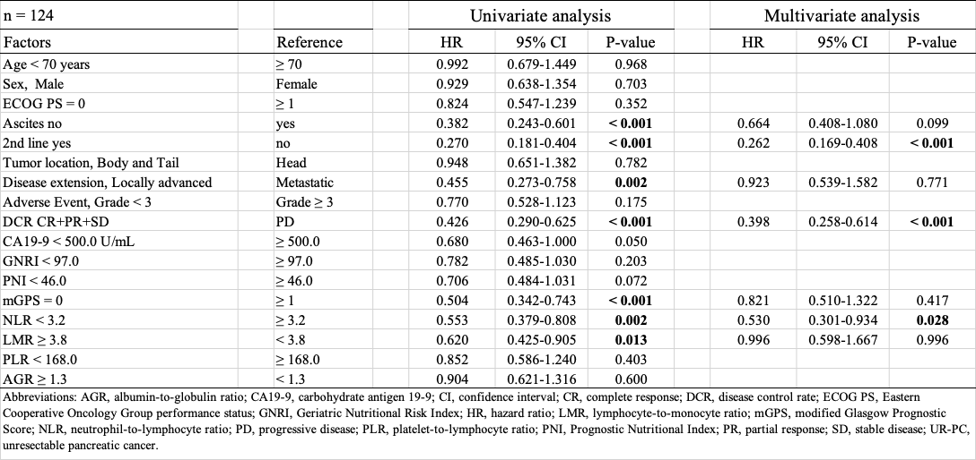
Table 4. Univariate and multivariate binomial logistic regression analyses to identify factors associated with 2L administration.
