Supplementary Material for
“Analyses of Small Seismic Events Around the Underground Nuclear Test Site in the Democratic People’s Republic of Korea”

Journal: Pure and Applied Geophysics

Won-Young Kim^{1, 2}, Jun Yong Park², Yonggyu Ryoo³, and YoungHee Kim²

¹ Lamont-Doherty Earth Observatory, Columbia University, Palisades, NY 10964, U.S.A.
² School of Earth and Environmental Sciences, Seoul National University, Seoul, Republic of Korea,
³ Earthquake Business H.Q, KITValley Co., Ltd.

Contents
This supplemental material contains nine figures and four tables that supplement the results presented in the paper.

Figure S1. Black circles are 100 small seismic events around Punggye-ri Test Site in DPRK from September 2016 to December 2025 reported by KMA, and red circles are 78 precisely relocated events using the Lg wave cross-correlation and double-difference earthquake relocation method in this paper. Blue stars are locations of six UNEs during 2006 – 2017. Majority of those events are located within a 10 km radius of the Mantap-san site. Before the UNTs in the area since 2006, only a handful of seismic events were reported by ISC; the largest event was on 2002-04-16 (mb 4.1) located about 200 km south-southwest from the study area. A square represents the 23 September 2017 event (#4) reported by Tian et al. (2018). Relocated events indicate that these 78 events are confined to a very small area with two distinct northeast-southwest lineaments. Events’ magnitude (M_{L}) range from 2.0 to 3.4. About 12 events occurred annually, but the most events were reported in 2023 (33; 35%), followed by 20 in 2024 (22%); hence, the annual seismicity rate is uneven over time.
Figure S2. Source-station paths for about 20 selected stations are plotted. Red lines connecting the epicentral area with stations are good Lg wave paths, blue lines indicate paths that are weakly affected by offshore crustal structure, and black lines indicate Lg paths that are partially affected by the oceanic crust.
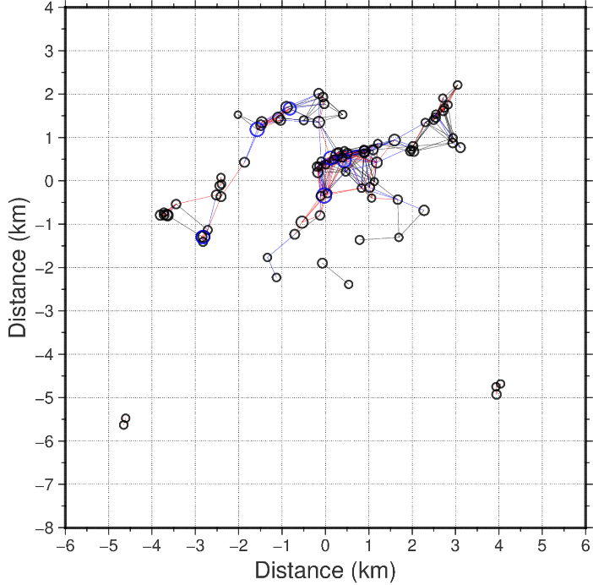
Figure S3. Connectedness of epicentral relocation. An interevent distance threshold of 1 km is applied. Red, blue, and black lines indicate event pairs with ≥10 dt measurements, 5–9 dt measurements, and <5 dt measurements, respectively.

Figure S4a. Changes of fitting errors and source mechanism as a function of focal depth for the event 4, 2017-09-23, 08:29. The fitting error reaches a global maximum at various depths. The inversion results for focal depths between 3 and 5 km produce similar overall waveform fits and source mechanisms for the event, indicating a range of acceptable depths, and are indicated as the horizontal dashed line representing 5% smaller fitting error, i.e., 0.95 × Emin.
Figure S4b. Comparison between observed (black lines) and synthetic (red lines) waveforms of the Event 4, 2017-09-23, 08:29. Synthetics are calculated for a focal depth of 4.5 km. Station code with components (Z = vertical, R = radial, and T = transverse), the peak amplitude of observed records in micrometers (μ), trace seismic moment in 10¹⁴ N m from the amplitude ratio between the observed and synthetics, variance reduction in percentage, and time shift in seconds are indicated at the end of each trace.

Figure S5a. Changes of variance reduction (VR) and source mechanism as a function of focal depth for the event 27, 2022-02-11, 01:35. The fitting error reaches a global maximum (VR_{max}) at various depths. The inversion results for focal depths between 1 and 2 km produce similar overall waveform fits and source mechanisms for the event, indicating a range of acceptable depths, and are indicated as the horizontal dashed line representing 5% smaller variance reduction, i.e., 0.95 × VR_{max}.

Figure S5b. Comparison of waveform fits of the aftershock of event 27, 2022-02-11, 01:35. Synthetics are calculated for a focal depth of 1 km. The mean seismic moment is 4.88 × 10¹⁴ N m from 13 traces. Other notations are the same as in Fig. S4(b).

Figure S6a. Changes of variance reduction (VR) and source mechanism as a function of focal depth for the event 45, 2023-07-03, 01:04. The fitting error reaches a global maximum (VR_{max}) at various depths. The inversion results for focal depths between 1 and 5 km produce similar overall waveform fits are indicated as the horizontal dashed line representing 5% smaller variance reduction, i.e., 0.95 × VR_{max}. However, source mechanisms change between the shallow depth (< 3 km) for normal faulting, and strike-slip faulting for deeper depth > 3 km.Usually, the focal mechanism does not change rapidly with depth. We observe this for all three events we analyzed for the sequence, perhaps, a lack of stations coverage in the east and west directions may have caused such varation. Hence, for the three events we modeled, we used depth phase and short-period Rg waves to constrain the depth.

Figure S6b. Comparison of waveform fits of the aftershock of event 45, 2023-07-03, 01:04; the largest event with Mw 3.8. Synthetics are calculated for a focal depth of 1 km. The mean seismic moment is 5.19 × 10¹⁴ N m from 12 traces. Other notations are the same as in Fig. S4(b).

Figure S7. Additional vertical component records at the MDJ station to illustrate excitation of the short-period Rg waves. The top three traces are from cluster 4, which appears to be deeper than the other events.

Figure S8. Bars are for 20 small seismic events around NKTS and 6 UNEs at a half dozen stations in China and the southern Korean peninsula. Each populatoin shows very small scatter, but P/S ratios of UNEs at frquencies above 9 Hz converge to the ratios of the earthquake population. This was caused by the large UNEs, and it may suggest to make adjustment or corrections for the event size in P/S ratio.

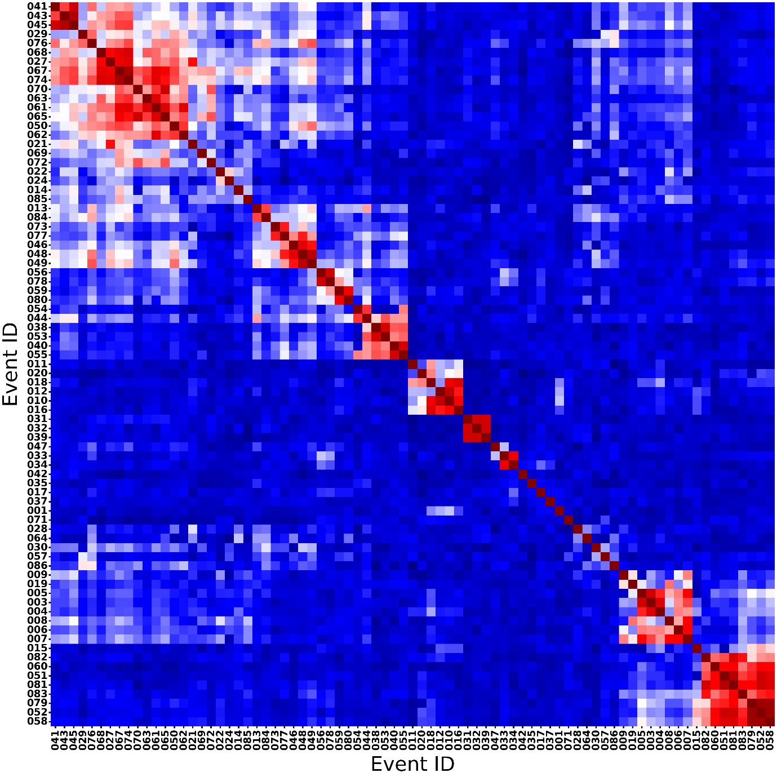
Figure S9. Waveform cross-correlation coefficient matrix for the analyzed seismic events. The matrix was calculated using the Lg-wave window from the vertical component recorded at the YKB station. The events are ordered to highlight discrete clusters with high waveform similarity (indicated by red-colored cells). Bright red colored events indicates doubletts and multipletts.

Table S1. List of seismic events around the Punggye-ri test site by KMA

 | Date | Time (UTC) | Lat (ºN) | Long (ºE) | H (km) | M_{L}
01 | 2016-09-11 | 01:50:50.00 | 41.30 | 129.05 | 0 | 1.8
02 | 2017-09-03 | 03:38:31.00 | 41.34 | 129.04 | - | 4.1
03 | 2017-09-23 | 04:43:00.00 | 41.35 | 129.06 | - | 2.6
04 | 2017-09-23 | 08:29:16.00 | 41.35 | 129.06 | - | 3.2
05 | 2017-10-12 | 16:41:08.00 | 41.39 | 129.03 | - | 2.7
06 | 2017-12-01 | 22:45:56.00 | 41.32 | 129.20 | - | 2.5
07 | 2017-12-05 | 14:40:53.00 | 41.32 | 129.13 | - | 2.7
08 | 2017-12-09 | 06:13:35.00 | 41.32 | 129.10 | 16 | 3.0
09 | 2017-12-09 | 06:40:02.00 | 41.31 | 129.11 | - | 2.8
10 | 2018-02-06 | 10:53:53.00 | 41.33 | 129.10 | - | 2.6
11 | 2018-02-07 | 21:46:01.00 | 41.32 | 129.09 | - | 2.7
12 | 2018-04-22 | 19:31:17.00 | 41.35 | 129.12 | - | 2.3
13 | 2019-01-01 | 22:20:29.00 | 41.30 | 129.21 | 12 | 2.8
14 | 2019-03-20 | 19:41:05.00 | 41.32 | 129.09 | 11 | 2.8
15 | 2020-01-29 | 00:33:47.00 | 41.29 | 129.11 | - | 2.5
16 | 2020-08-07 | 12:27:43.00 | 41.30 | 129.09 | - | 2.4
17 | 2020-11-16 | 18:10:29.00 | 41.28 | 129.18 | - | 2.6
18 | 2021-04-19 | 06:48:52.00 | 41.28 | 129.13 | 20 | 2.7
19 | 2021-06-13 | 14:57:32.00 | 41.29 | 129.13 | 15 | 2.5
20 | 2021-09-01 | 09:39:52.00 | 41.30 | 129.13 | 15 | 2.4
21 | 2021-09-10 | 18:47:27.00 | 41.29 | 129.15 | 8 | 2.1
22 | 2021-10-11 | 12:58:59.00 | 41.30 | 129.18 | 25 | 2.4
23 | 2021-10-11 | 13:00:53.00 | 41.29 | 129.20 | 20 | 2.5
24 | 2021-10-17 | 14:13:56.00 | 41.26 | 129.45 | - | 2.4
25 | 2021-12-30 | 05:21:35.00 | 41.31 | 129.21 | 19 | 2.3
26 | 2021-12-30 | 08:54:56.00 | 41.30 | 129.17 | 14 | 2.2
27 | 2022-02-11 | 01:35:26.00 | 41.30 | 129.21 | 17 | 3.1
28 | 2022-02-14 | 05:33:22.00 | 41.27 | 129.24 | 22 | 2.3
29 | 2022-02-14 | 10:47:27.00 | 41.28 | 129.26 | 18 | 2.3
30 | 2022-02-14 | 21:52:28.00 | 41.29 | 129.23 | 29 | 2.5
31 | 2022-02-28 | 12:31:28.00 | 41.25 | 129.28 | 24 | 2.1
32 | 2022-03-03 | 17:15:37.00 | 41.24 | 129.22 | 29 | 2.1
33 | 2022-10-07 | 17:54:49.00 | 41.30 | 129.13 | 23 | 2.5
34 | 2022-10-08 | 05:33:34.00 | 41.29 | 129.21 | 14 | 2.4
35 | 2022-11-20 | 06:21:41.00 | 41.29 | 129.22 | 11 | 2.0
36 | 2022-12-16 | 03:07:11.00 | 41.30 | 129.22 | 26 | 2.1
37 | 2023-02-08 | 16:10:04.00 | 41.29 | 129.27 | 10 | 2.1
38 | 2023-03-09 | 15:13:23.00 | 41.27 | 129.06 | 9 | 2.1
39 | 2023-03-13 | 17:18:42.00 | 41.27 | 129.14 | 20 | 2.4
40 | 2023-05-19 | 05:03:33.00 | 41.29 | 129.19 | 14 | 2.4
41 | 2023-05-25 | 13:27:39.00 | 41.25 | 129.24 | 18 | 2.4
42 | 2023-06-07 | 06:30:05.00 | 41.31 | 129.16 | 22 | 2.1
43 | 2023-06-18 | 14:39:16.00 | 41.28 | 129.19 | 17 | 2.3
44 | 2023-06-25 | 02:55:14.00 | 41.32 | 129.21 | 17 | 2.4
45 | 2023-07-03 | 01:04:38.00 | 41.30 | 129.12 | 14 | 3.3
46 | 2023-07-04 | 16:02:38.00 | 41.27 | 129.21 | 15 | 2.1
47 | 2023-07-28 | 04:16:43.00 | 41.31 | 129.23 | 17 | 2.0
48 | 2023-08-12 | 18:11:39.00 | 41.29 | 129.19 | 19 | 2.3
49 | 2023-08-12 | 18:13:37.00 | 41.30 | 129.19 | 15 | 2.7
50 | 2023-08-12 | 22:55:00.00 | 41.31 | 129.16 | 5 | 2.3
51 | 2023-09-02 | 11:50:37.00 | 41.26 | 129.10 | 28 | 2.1
52 | 2023-09-02 | 11:54:33.00 | 41.28 | 129.15 | 15 | 2.5
53 | 2023-09-07 | 18:29:48.00 | 41.29 | 129.24 | 17 | 2.2
54 | 2023-09-07 | 19:01:16.00 | 41.30 | 129.23 | 24 | 2.1
55 | 2023-09-07 | 20:12:01.00 | 41.32 | 129.17 | 19 | 2.3
56 | 2023-09-26 | 15:48:43.00 | 41.33 | 129.16 | 6 | 3.2
57 | 2023-09-30 | 22:35:56.00 | 41.26 | 129.29 | 23 | 2.1
58 | 2023-10-06 | 09:29:03.00 | 41.29 | 129.13 | 12 | 2.5
59 | 2023-10-09 | 14:16:36.00 | 41.30 | 129.23 | 13 | 2.2
60 | 2023-10-27 | 23:37:14.00 | 41.25 | 129.12 | - | 2.2
61 | 2023-11-22 | 07:29:32.00 | 41.31 | 129.18 | 23 | 2.9
62 | 2023-11-22 | 08:40:59.00 | 41.30 | 129.20 | 24 | 2.3
63 | 2023-11-22 | 22:54:55.00 | 41.29 | 129.16 | 20 | 2.5
64 | 2023-11-23 | 03:42:02.00 | 41.23 | 129.05 | 6 | 2.2
65 | 2023-11-23 | 12:21:44.00 | 41.30 | 129.20 | 15 | 2.6
66 | 2023-11-23 | 12:31:58.00 | 41.31 | 129.14 | 18 | 2.2
67 | 2023-12-03 | 17:28:02.00 | 41.30 | 129.15 | 22 | 3.1
68 | 2023-12-04 | 20:53:41.00 | 41.29 | 129.22 | 19 | 2.2
69 | 2023-12-06 | 10:11:06.00 | 41.26 | 129.22 | 28 | 2.0
70 | 2024-01-11 | 10:00:53.00 | 41.30 | 129.16 | 20 | 2.4
71 | 2024-02-07 | 18:15:44.00 | 41.46 | 129.25 | 21 | 2.3
72 | 2024-02-14 | 14:33:00.00 | 41.28 | 129.15 | 20 | 2.2
73 | 2024-03-15 | 13:35:42.00 | 41.30 | 129.20 | 20 | 2.2
74 | 2024-03-27 | 00:43:10.00 | 41.29 | 129.19 | 24 | 2.9
75 | 2024-03-27 | 00:45:06.00 | 41.30 | 129.15 | 20 | 2.5
76 | 2024-03-27 | 02:14:27.00 | 41.31 | 129.12 | 16 | 2.7
77 | 2024-04-29 | 16:54:46.00 | 41.30 | 129.14 | 16 | 2.5
78 | 2024-05-08 | 20:41:25.00 | 41.32 | 129.18 | 11 | 2.2
79 | 2024-05-22 | 03:29:19.00 | 41.27 | 129.06 | 16 | 2.3
80 | 2024-06-01 | 02:55:28.00 | 41.33 | 129.17 | 6 | 2.1
81 | 2024-07-27 | 03:50:57.00 | 41.30 | 129.13 | 17 | 2.9
82 | 2024-08-26 | 15:15:21.00 | 41.28 | 129.09 | 12 | 2.7
83 | 2024-10-04 | 04:23:30.00 | 41.27 | 129.11 | 10 | 2.3
84 | 2024-10-21 | 06:33:07.00 | 41.29 | 129.20 | 7 | 2.2
85 | 2024-10-21 | 16:47:05.00 | 41.27 | 129.20 | 18 | 2.1
86 | 2024-10-28 | 05:11:44.00 | 41.29 | 129.20 | 17 | 2.3
87 | 2024-11-02 | 12:24:57.00 | 41.28 | 129.21 | 17 | 2.5
88 | 2024-11-09 | 04:23:12.00 | 41.27 | 129.19 | 11 | 3.1
89 | 2024-12-02 | 14:04:22.00 | 41.31 | 129.18 | 12 | 2.4
90 | 2025-03-31 | 12:19:43.00 | 41.36 | 129.43 | 12 | 2.0
91 | 2025-05-01 | 07:26:07.00 | 41.29 | 129.23 | 20 | 2.3
92 | 2025-06-15 | 22:04:18.00 | 41.32 | 129.16 | 5 | 2.4
93 | 2025-06-22 | 03:00:39.00 | 41.22 | 129.05 | 16 | 2.1
94 | 2025-06-22 | 09:10:48.00 | 41.29 | 129.17 | 27 | 2.2
95 | 2025-09-21 | 01:59:59.00 | 41.33 | 129.18 | 19 | 2.5
96 | 2025-10-12 | 05:32:59.00 | 41.29 | 129.18 | 23 | 2.2
97 | 2025-10-17 | 00:11:36.00 | 41.30 | 129.20 | 10 | 2.4
98 | 2025-10-17 | 02:22:46.00 | 41.28 | 129.24 | 17 | 2.4
99 | 2025-10-23 | 18:21:13.00 | 41.28 | 129.25 | 21 | 2.3
100 | 2025-11-20 | 21:20:32.00 | 41.30 | 129.24 | 14 | 2.2

Table S2. List of stations used.

Code | Lat (ºN) | Long (ºE) | Elev (m) | Sensor type
BAR2 | 37.9771 | 124.7142 | 39 | BB­(STS-2.5)
CHC2 | 37.7776 | 127.8145 | 238
CHJ2 | 36.8730 | 127.9748 | 217
CWO2 | 38.0835 | 127.5205 | 368
CWS1 | 38.2881 | 127.5870 | 0
DACB | 37.8317 | 124.7068 | 81
GAHB | 37.7076 | 126.4465 | 63
HWCB | 38.2214 | 127.6707 | 302
IJA2 | 37.9865 | 128.1111 | 217 | ACC(ES-T)
JMJ | 37.8816 | 128.7561 | 73
KS31 | 37.4421 | 127.8844 | 0
MDJ | 44.6170 | 129.5908 | 220
MUS2 | 37.8862 | 126.7656 | 24 | ACC(ES-T)
SEHB | 38.2686 | 128.2525 | 401
SEO2 | 37.4939 | 126.9171 | 85
SHHB | 37.3488 | 126.7039 | 39
SKC2 | 38.2899 | 128.5219 | 56
USA0B | 44.1999 | 131.9887 | 170
YNCB | 38.0398 | 126.9258 | 55
YPDB | 37.6080 | 125.7102 | 0

Table S3. Explosions analyzed.

id | Date (year-mo-dy) | Time (hh:mm:s) | Lat (°N) | Long (°E) | Mag (M_{L}) | Explosion type/ Information source
1 | 2006-10-09 | 01:35:28.00 | 41.287 | 129.108 | 3.93 | UNE*/Z&W2015§
2 | 2009-05-25 | 00:54:43.18 | 41.294 | 129.082 | 4.53 | UNE/Z&W2015
3 | 2013-02-12 | 02:57:51.33 | 41.291 | 129.076 | 4.89 | UNE/Z&W2015
4 | 1998-08-12 | 15:00:08.10 | 42.865 | 128.223 | 1.0 | SHCE†/Wu
5 | 1998-08-18 | 14:00:06.69 | 42.914 | 129.324 | 2.0 | SHCE/Wu
6 | 1998-08-19 | 15:00:07.79 | 42.091 | 128.739 | 1.9 | SHCE/Wu
7 | 1998-08-25 | 15:00:07.46 | 42.427 | 126.748 | 1.0 | SHCE/Wu
8 | 2010-01-15 | 06:18:01.44 | 41.7488 | 126.9143 | 2.9 | CE‡/ISC
9 | 2011-01-05 | 05:46:05.66 | 41.7317 | 126.9674 | 2.8 | CE/ISC, KIGAM
10 | 2011-02-18 | 15:25:58.15 | 41.7345 | 126.8917 | 3.5 | CE/ISC
11 | 2011-05-19 | 09:38:21.58 | 42.2512 | 129.3803 | 2.6 | CE/ISC
12 | 2012-01-21 | 07:54:45.59 | 42.2306 | 129.3680 | 2.6 | CE/ISC
*UNE = underground nuclear explosion; § Z&W2015, Zhang and Wen (2015a);
†SHCE = single hole chemical explosion; ‡CE = chemical explosion.
*UNE = underground nuclear explosion; § Z&W2015, Zhang and Wen (2015a);

Table S4. Selected earthquakes analyzed.
id | Date (yr-mo-dy) | Time (hh:mm:s) | Lat (°N) | Long (°E) | Depth (km) | Mag (M_{L}) | Agency
1 | 1994-01-25 | 08:51:38.2 | 42.23 | 127.12 | 04 | 4.0 | NK
2 | 2004-12-16 | 18:59:14.5 | 41.79 | 127.94 | 10 | 4.0 | PDE
3 | 2007-12-31 | 21:33:38.0 | 40.41 | 127.25 | 0 | 3.2 | KMA
4 | 2009-08-05 | 12:08:12.6 | 42.349 | 127.223 | 10 | 3.8 | ISC
5 | 2010-05-18 | 04:08:10.3 | 42.83 | 125.96 | 10 | 3.7 | Z&W2015
6 | 2010-10-09 | 05:45:14.7 | 42.352 | 128.388 | 10 | 3.4 | ISC
7 | 2010-10-09 | 06:07:09.2 | 42.370 | 128.420 | 5 | 3.6 | ISC
8 | 2010-11-07 | 11:11:39.74 | 40.062 | 128.199 | 18 | 3.5 | KIGAM
9 | 2010-11-12 | 02:10:44.8 | 43.00 | 125.89 | 7 | 2.8 | Z&W2015
10 | 2011-06-09 | 01:10:35.1 | 42.44 | 127.19 | 6 | 3.3 | Z&W2015
11 | 2011-12-26 | 13:34:08.6 | 42.381 | 127.246 | 0 | 3.6 | ISC
12 | 2014-08-04 | 21:16:36.0 | 40.110 | 127.200 | 0 | 2.5 | KMA

# Earthquakes 5, 9, and 10 were used by Zhang and Wen (2015a)

