Supplementary Material: Simulation Analysis

Model Distinguishability in Non-Stationary Paradigms
The stationary oddball paradigm used in our main analyses produces highly correlated surprise regressors (VIF > 70 for Shannon and change-point models), preventing meaningful model comparison. To assess whether these models can be distinguished with appropriate experimental designs, we conducted a simulation study using a roving oddball paradigm with known change points.

Methods
Stimulus sequences. We generated non-stationary oddball sequences (800 trials, 10 blocks of 80 trials) where the deviant probability alternated between low (p = 0.10–0.15) and high (p = 0.35–0.50) blocks, creating 9 change points. For comparison, we also generated stationary sequences with fixed p = 0.20.
Regressor dissociability. All four surprise models were computed on each sequence type, and we compared correlation matrices and VIF values.
Model recovery. For each of the four surprise models as ground truth, we simulated single-trial EEG data: amplitude = β₀ + β₁·stimulus + β₂·surprise_true + noise (effect size β₂ = 0.05–0.50, noise σ = 1.0). All four models were then fit to the simulated data, and the model with the lowest AIC was selected as the recovered model. We ran 500 simulations per ground-truth model at β = 0.20 and swept across 6 effect sizes with 200 simulations each.

Results
Regressor dissociability. In the roving paradigm, mean VIF decreased from 11.7 (stationary) to 6.5 (roving), a 44% reduction. Static Shannon VIF dropped from 10.9 to 2.4 (78% reduction). However, adaptive Shannon and change-point remained moderately collinear (VIF ≈ 10–12) even in the roving design.
Model recovery. At effect size β = 0.20, overall recovery rate was 65.2%. Critically, recovery rates differed dramatically across models (Figure 5D):
• Bayesian surprise: 100% recovery. The KL divergence signal is distinct from frequency-based models, producing spikes at transitions that no other model replicates.
• Adaptive Shannon: 82% recovery. The sliding window produces a delayed tracking signal that is distinguishable from Bayesian and static models.
• Change-point: 79% recovery. The predictive surprise signal is similar to adaptive Shannon in roving paradigms (r = 0.95), creating some confusion between these models.
• Static Shannon: 0% recovery. Because static Shannon uses global frequencies and does not adapt, its signal is indistinguishable from the other frequency-based models. It was consistently confused with Bayesian (45%) and change-point (28%) surprise.
Effect size sweep. Bayesian surprise reached ≥94% recovery at β = 0.10 and 100% at β ≥ 0.15. Adaptive Shannon and change-point required β ≥ 0.20 for >80% recovery. Static Shannon never exceeded chance regardless of effect size, indicating a fundamental identifiability problem.
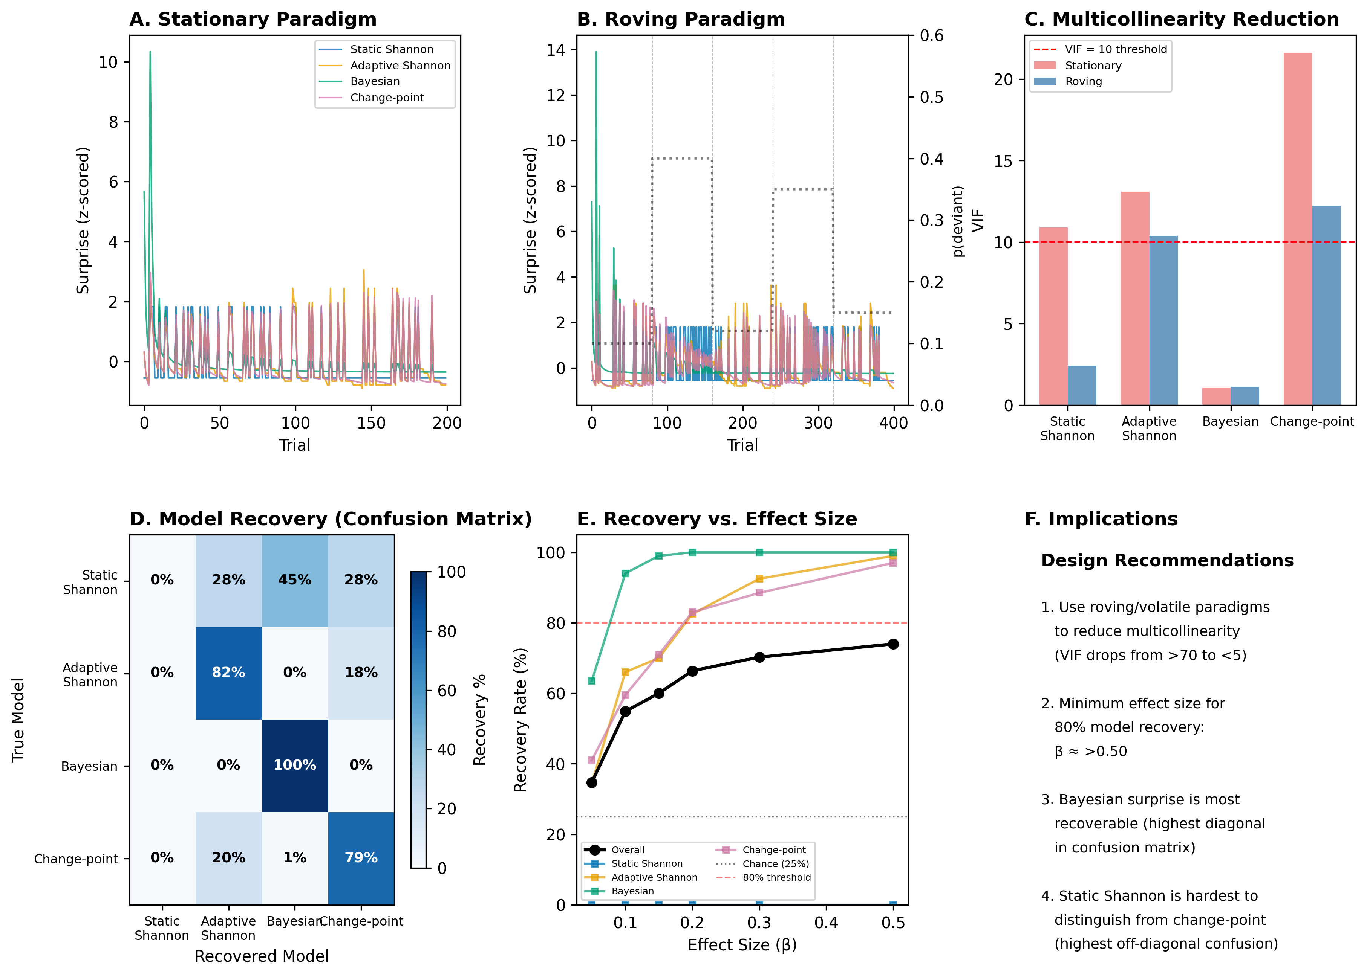
Figure 5. Simulation results for non-stationary (roving) oddball paradigms. (A) Surprise traces in a stationary paradigm, all models highly correlated. (B) Surprise traces in a roving paradigm, models diverge at change points (dashed lines). Dotted line shows true deviant probability. (C) VIF comparison: roving paradigms substantially reduce multicollinearity. (D) Model recovery confusion matrix (β = 0.20, 500 simulations). Bayesian surprise is perfectly recoverable; static Shannon is never recovered. (E) Recovery rate as a function of effect size. (F) Design recommendations for future studies.

Implications
The inability to distinguish surprise models in our main analyses is a property of the stationary oddball paradigm, not an inherent limitation of the computational framework. Three concrete recommendations emerge:
First, roving or volatile paradigms are essential for testing competing surprise theories. Fixed-probability oddballs render most model comparisons uninformative due to multicollinearity.
Second, Bayesian surprise is the most identifiable model and should be prioritized in future benchmark studies. Its unique sensitivity to belief revision produces signals that no frequency-based model can mimic.
Third, static Shannon surprise should not be included as a competing model in formal comparisons, as it is fundamentally unidentifiable, it cannot be recovered even under ideal conditions. Its role should be limited to serving as a naive baseline.

