Supplemental Digital Content

Figure S1 3
Table S1a-c 4
Table S2 5

Figure S1
Flowchart of included patients

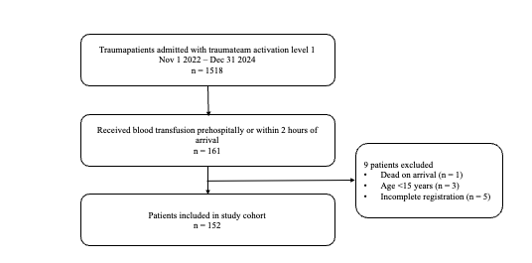

Table S1a-c
Unadjusted and adjusted associations between prehospital blood transfusion and mortality presented as HR (95% CI).

Table S1a. Association between prehospital blood transfusion and 24-hour mortality.
 | HR (95% CI) | p-value
Unadjusted | 1.9 (0.9-4.4) | 0.12
Adjusted* | 0.8 (0.3-2.4) | 0.71
HR, Hazard Ratio; CI, Confidence Interval

Table S1b. Association between prehospital blood transfusion and 30-day mortality.
 | HR (95% CI) | p-value
Unadjusted | 1.3 (0.7-2.6) | 0.43
Adjusted* | 0.9 (0.4-0.2.2) | 0.84
HR, Hazard Ratio; CI, Confidence Interval

Table S1c. Association between prehospital blood transfusion and 90-day mortality.
 | HR (95% CI) | p-value
Unadjusted | 1.2 (0.6-2.4) | 0.54
Adjusted* | 1.0 (0.4-2.3) | 0.995
HR, Hazard Ratio; CI, Confidence Interval

*Adjusted for age, sex, Injury Severity Score (ISS), prehospital transport time (scene departure to trauma unit arrival), first systolic blood pressure at trauma unit arrival.

Table S2
Prehospital transfusion and massive transfusion risk: crude and adjusted estimates, presented as OR (95% CI).

 | OR (95% CI) | p-value
Unadjusted | 0.6 (0.3-1.1) | 0.015
Adjusted* | 0.4 (0.2-0.8) | 0.015
OR, Odds Ratio; CI, Confidence Interval
*Adjusted for age, sex, Injury Severity Score (ISS), prehospital transport time (scene departure to trauma unit arrival), first systolic blood pressure at trauma unit arrival.

