Extended Data

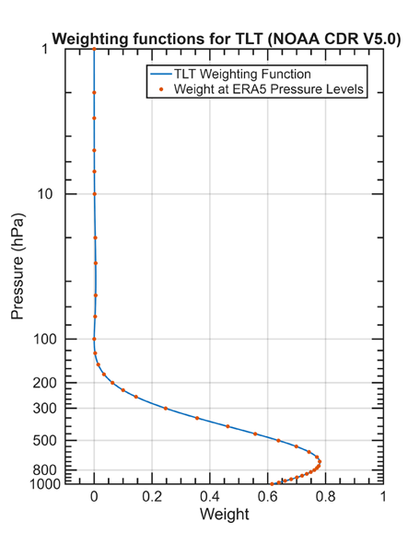
Extended Data Fig. 1 | TLT weighting function. The blue line is the TLT weighting function used to derive the equivalent ERA5 TLT from ERA temperatures at discrete pressure levels (red dots).

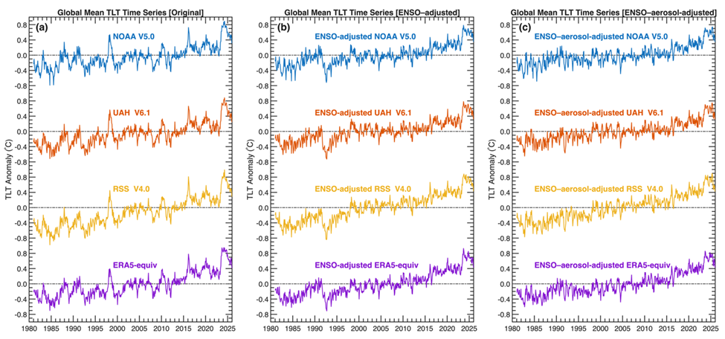

Extended Data Fig. 2 | Comparison of original, ENSO-adjusted, and ENSO–aerosol-adjusted TLT. The plot shows global monthly mean anomaly time series from 1981 to 2025 for the (a) original, (b) ENSO-adjusted, and (c) ENSO–aerosol-adjusted TLT. Different datasets are represented by different colors. The 5-month-lagged Niño 3.4 index and the 8-month-lagged MERRA-2 reanalysis AOD dataset are used to remove the ENSO and aerosol effects, respectively.

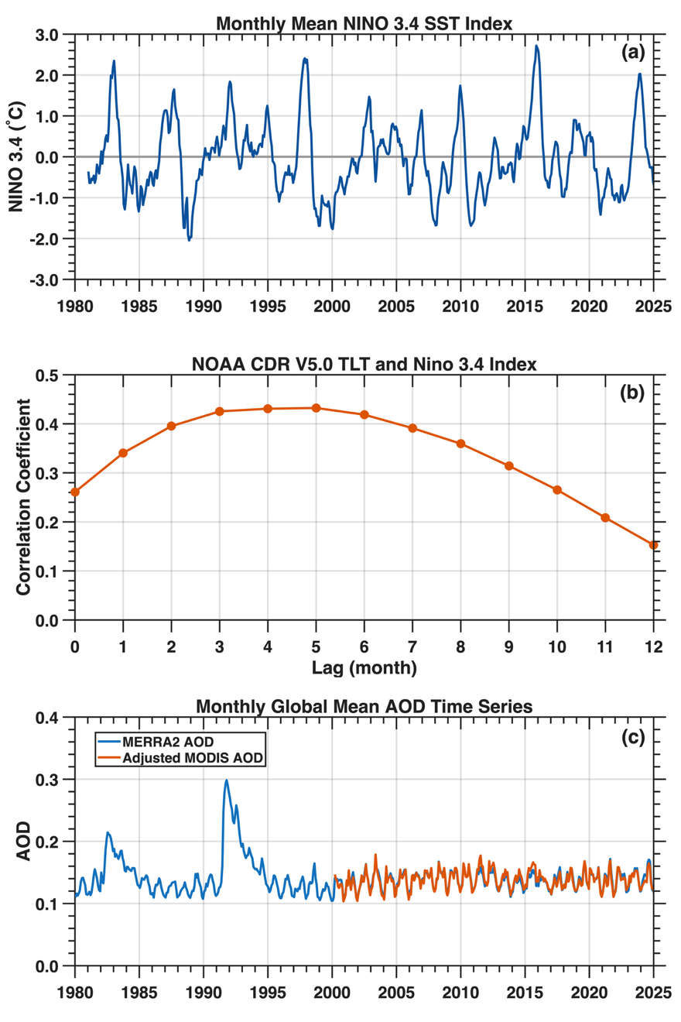
Extended Data Fig. 3 | ENSO and aerosol indices used to remove the ENSO and aerosol effects in TLT. (a) Time series of the NINO3.4 index representing the average sea surface temperature (SST) over the central Pacific region (5°N–5°S, 170°W–120°W) (dataset available at https://psl.noaa.gov/data/timeseries/month/Nino34_CPC/). (b) Lagged correlations of TLT with the NINO3.4 index. (c) MERRA-2 (blue lines) and bias-corrected MODIS (red lines) monthly global mean AOD time series from 1981-2025.

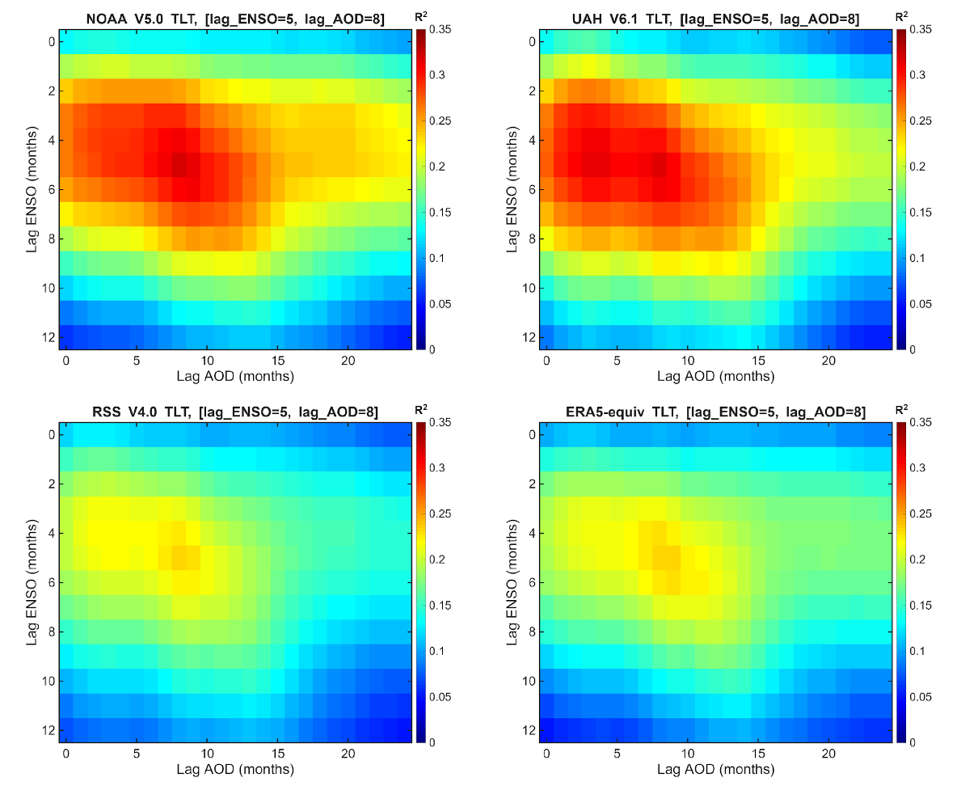
Extended Data Fig. 4 | Two-dimensional lagged correlations between ENSO and TLT, and between MERRA-2 AOD and TLT.

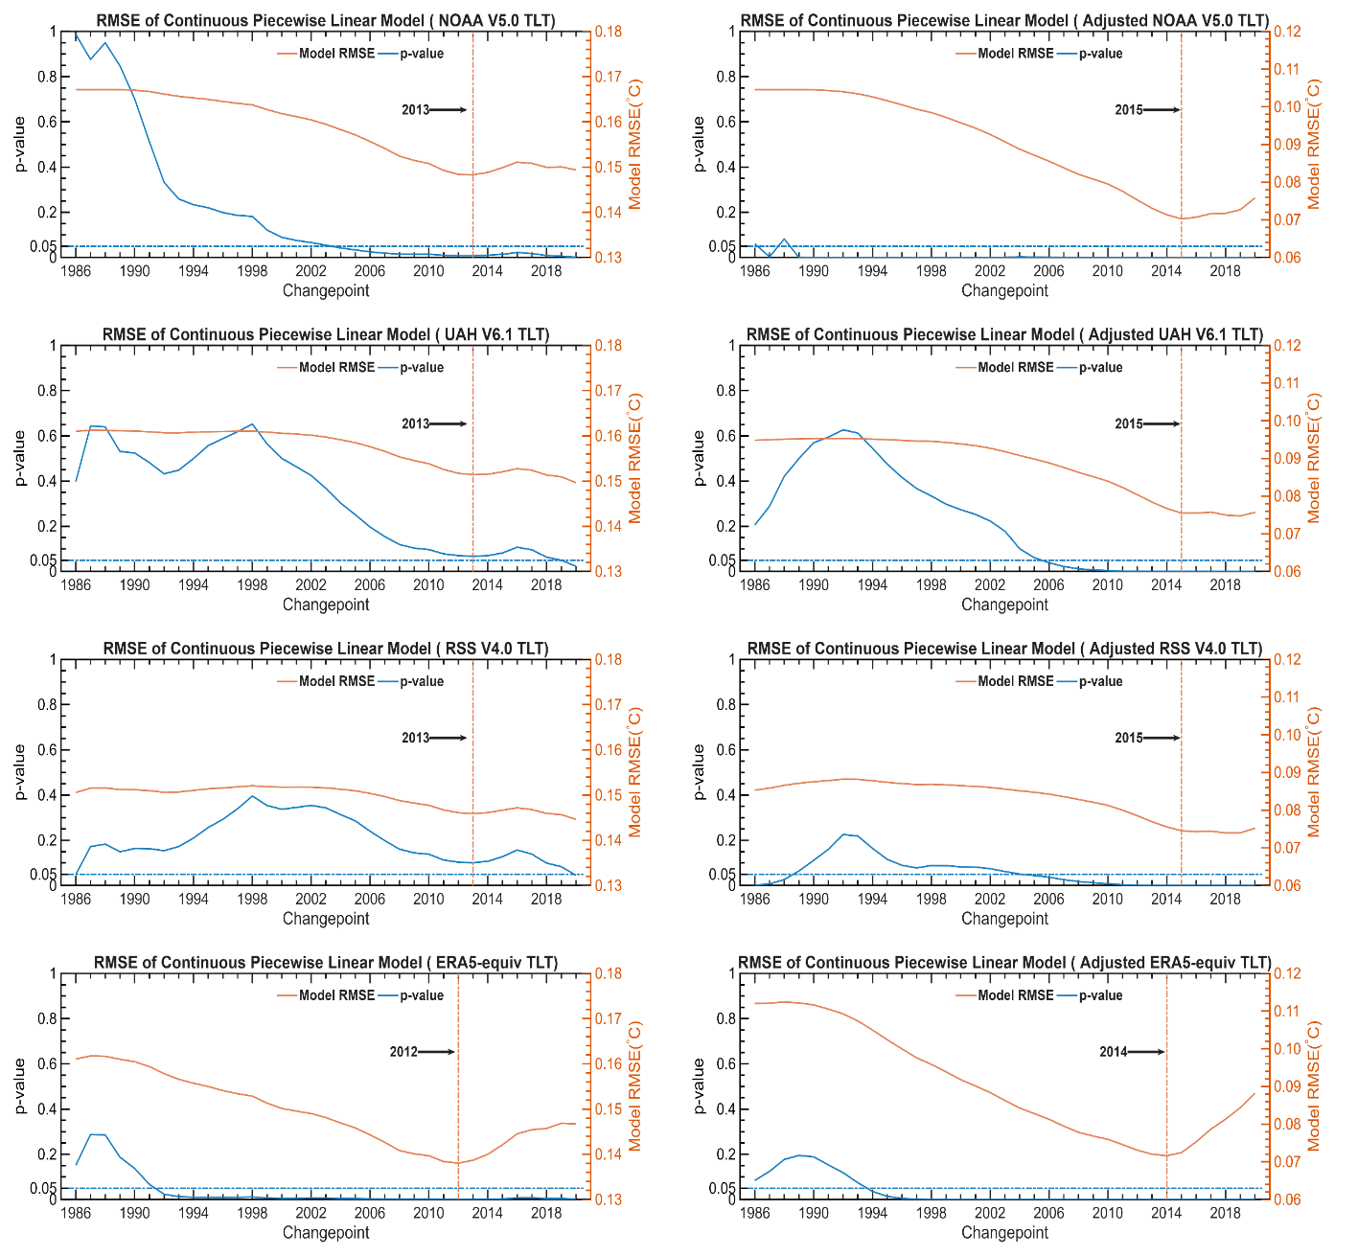
Extended Fig. 5 | Search for changepoints and test their statistical significance for the piecewise fitting model. Variations in RMSE (red lines) and p‑values (blue lines) as functions of the changepoint. Left panels: original TLT time series for the NOAA, UAH, RSS, and ERA5 datasets. Right panels: same as the left panels, but for the ENSO‑aerosol‑adjusted TLT time series.

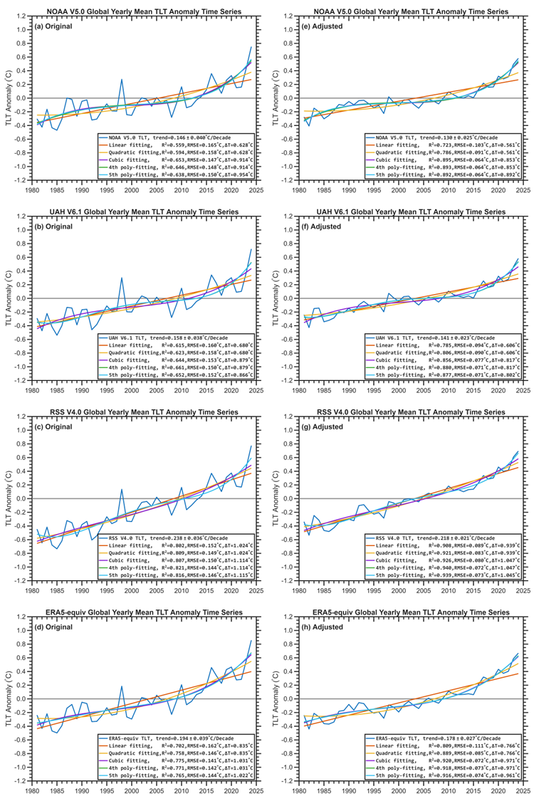

Extended Data Fig. 6 | Search for the optimal polynomial fit to the TLT time series. Global annual mean TLT time series (left panels) and ENSO–aerosol-adjusted TLT series (right panels) during 1981-2024 with polynomial fits up to fifth order for the NOAA, UAH, RSS, and ERA5 datasets.

Extended Data Fig. 7 | Statistical significance test for the polynomial fitting models. P-values for the leading coefficients in polynomial fits to all datasets for both the original (left panels) and ENSO-aerosol-adjusted (right panels) time series. Polynomial degrees range from 1 (linear) to 5. The Root Mean Square Error (RMSE) for the model fit is also shown.

Extended Data Fig. 8 | Comparison of cubic fitting and LOESS-smoothed TLT during 1981-2024 for all datasets, for both the original (left panels) and ENSO–aerosol-adjusted (right panels) time series.

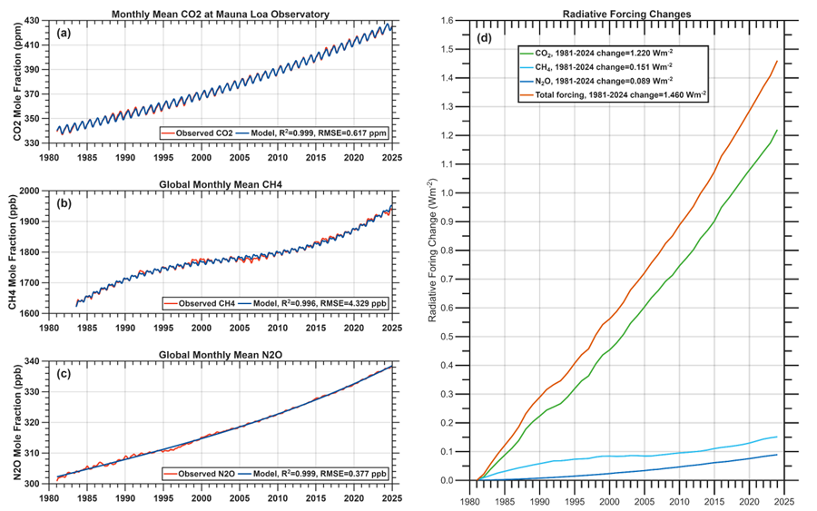
Extended Data Fig. 9 | Examination of potential drivers for the TLT acceleration. (a) Monthly CO₂ concentration (ppm) time series at Mauna Loa Station (ref. 64-65), with a fit using a quadratic trend plus seasonal cycle; (b) Global monthly mean CH₄ time series from NOAA Global Monitoring Laboratory measurements (ref. 66-67), with a fit using a cubic trend plus seasonal cycle; (c) Global monthly mean N₂O time series from NOAA Global Monitoring Laboratory measurements (ref. 67-68), with a quadratic fit. (d) Radiative forcing changes since 1981 based on the formula in ref. 63.

