Supplementary Information

Biomimetic Magneto-Responsive Bioinks Enabling Field-Assisted Cartilage Regeneration
Lili Hao¹, Mengmeng Liu¹, Xincheng Feng², Zhen Chen¹, Haoyang Ding¹, Maiqi Xin¹, Chao Sun²*, Jiquan Yang³, Zhongwei Gu¹, Hongli Mao¹*

1. Research Institute for Biomaterials, Tech Institute for Advanced Materials, Bio-inspired Biomedical Materials & Devices Center, College of Materials Science and Engineering, Jiangsu Collaborative Innovation Center for Advanced Inorganic Function Composites, Nanjing Tech University, Nanjing 211816, China
2. Department of Spine Surgery, The Affiliated Jiangning Hospital of Nanjing Medical University, Nanjing 211100, China
3. Jiangsu Key Lab of 3D Printing Equipment and Manufacturing, Nanjing Normal University, Nanjing 210046, China
* Corresponding authors: drsunchao@163.com (C. Sun), h.mao@njtech.edu.cn (H. Mao)

§ Experimental Section
§ Materials
Hyaluronic acid (Mw~200-400 kDa) was purchased from Bloomage Biotechnology Corp. Ltd. Gelatin type B was obtained from Shanghai yuanye Bio-Technology Co., Ltd. Methacrylic anhydride, dimethyl phenylphosphine (DMPP), 2,4,6-trimethylbenzoyl chloride (TMBC), FeCl₂·4H₂O, and PBS were obtained from Shanghai Macklin Biochemical Co., Ltd. LiBr, FeCl₃·6H₂O, tannic acid, NaOH, anhydrous ethanol, and carbonate were purchased from Shanghai Aladdin Biochemical Technology Co., Ltd. Dulbecco’s modified Eagle medium/nutrient mixture F-12 (DMEM/F12) was acquired from Thermo Fisher Scientific. Penicillin-streptomycin and cell freezing medium were obtained from NCM Biotech. Fetal bovine serum (FBS) was provided by Servicebio. Cell Counting Kit-8 (CCK-8), AM/PI, DAPI, phalloidin, and paraformaldehyde were purchased from Beyotime Biotechnology. Unless otherwise specified, all reagents used in this study were analytical grade.
§ Preparation and Characterization of Bioink Precursor Materials
Hyaluronic acid (HA, 2.00 g) was dissolved in 300 mL of ultrapure water and stirred at room temperature for 2 h until complete dissolution. Subsequently, under light-protected conditions, 15 mL of methacrylic anhydride solution was slowly added to the above solution using a constant-pressure dropping funnel. The reaction mixture was then transferred to a low-temperature stirring system and allowed to react at 4°C for 24 h. During the reaction, the pH of the system was continuously maintained at 8.5-9.0 by the addition of 0.5 mol/L NaOH. After completion of the reaction, the solution pH was adjusted to neutral. The resulting product is purified by dialysis (Mw~3500 Da) against ultrapure water, followed by freeze-drying to obtain methacrylic anhydride–modified hyaluronic acid (HAMA).
Gelatin type B (Gel, 10.00 g) was added to 100 mL of carbonate buffer and heated to 50°C with stirring until complete dissolution. Subsequently, 350 µL of methacrylic anhydride was added to the solution, while the pH of the reaction system was maintained at 8.5-9.0 by the addition of 1 M NaOH. After completion of the reaction, the solution pH was adjusted to neutral using 0.1 M hydrochloric acid. The product was purified by dialysis (Mw~8000-12000 Da) against ultrapure water and then freeze-dried to obtain methacrylic anhydride–modified gelatin (GelMA).
At room temperature under a nitrogen atmosphere, 3.00 g of dimethyl phenylphosphonite was added to a reaction flask, followed by the slow addition of 3.20 g of 2,4,6-trimethylbenzoyl chloride, and the mixture was allowed to react for 16 h. Subsequently, 12.20 g of LiBr dissolved in 300 mL of 2-butanone was added to the reaction system and stirred for an additional 30 min. After completion of the reaction, the resulting white precipitate was collected by filtration, repeatedly washed with 2-butanone, and vacuum-dried to yield the photoinitiator lithium phenyl-2,4,6-trimethylbenzoylphosphinate (LAP).
Approximately 10.00 mg of each sample (HAMA, GelMA, and LAP) was weighed and dissolved in 0.5 mL of deuterium oxide (D₂O). The ¹H NMR spectra were acquired using a nuclear magnetic resonance spectrometer, and the substitution degree (DS) of HAMA and GelMA was calculated according to Equations (1–1) and (1-2), respectively. Fourier transform infrared (FT-IR) spectroscopy was performed using the KBr pellet method. Briefly, the samples were thoroughly ground with potassium bromide, compressed into pellets, and scanned over the wavenumber range of 400-4000 cm⁻¹.
$$\begin{aligned}DS \left(\%\right)=\left[\frac{I^{δH5.70}+I^{δH6.14}}{2}÷\left(\frac{I^{δH1.98+δH1.90}}{3}-\frac{I^{δH5.70}+I^{δH6.14}}{2}\right)\right]×100.\#\left(1-1\right)\end{aligned}$$
Here, $I^{δH5.70}$, $I^{δH6.14}$ and $I^{δH1.98}$ denote the integral areas of the corresponding peaks in the ¹H NMR spectra of HAMA.
$$\begin{aligned}DS \left(\%\right)=\frac{I^{GelδH2.99}-I^{GelMAδH2.99}}{I^{GelδH2.99}}×100.\#\left(1-2\right)\end{aligned}$$
Here, $I^{GelMAδH2.99}$ and $I^{GelδH2.99}$ denote the integral areas of the peaks at 2.99 ppm in the ¹H NMR spectra of Gel and GelMA, respectively.
§ Preparation and Characterization of Magnetic Nanoparticles
Ultrapure water (200 mL) was added to a three-necked round-bottom flask, purged with nitrogen, and heated to 80°C in an oil bath. FeCl₃·6H₂O (0.41 g) and FeCl₂·4H₂O (0.15 g) were then added to the flask, followed by the rapid addition of 15 mL of ammonia solution. The reaction was mechanically stirred for 1 h. After completion of the reaction, the products were magnetically separated, washed with ultrapure water 5-6 times, and freeze-dried to obtain iron oxide nanoparticles (IO NPs). In addition, tannic acid (0.08 g) was dissolved in 50 mL of ultrapure water and rapidly added to the three-necked flask containing the IO NPs. The reaction was allowed to proceed for 24 h under a nitrogen atmosphere. After completion, the product was purified by dialysis (Mw~3500 Da) under vacuum conditions, followed by freeze-drying to obtain tannic acid-modified iron oxide nanoparticles (TIO NPs).
The chemical composition and crystalline structure of the obtained magnetic nanoparticles were characterized by FT-IR spectroscopy, X-ray photoelectron spectroscopy (XPS), and X-ray diffraction (XRD). The particle size distribution and zeta potential were measured using dynamic light scattering (DLS). The magnetic properties of the nanoparticles were evaluated using a vibrating sample magnetometer (VSM). The thermal stability of IO and TIO was analyzed by thermogravimetric analysis (TGA). The absorbance of tannic acid at 275 nm was measured using a UV–vis spectrophotometer. A standard calibration curve for tannic acid was constructed based on the absorbance values and corresponding concentrations (R² ≥ 0.999). The grafting ratio of tannic acid on TIO was subsequently calculated from the absorbance of IO@TA at 275 nm.
§ Preparation of Biomimetic Magnetic Bioinks
Appropriate amounts of HAMA and GelMA were dissolved in PBS containing the photoinitiator LAP, and magnetic NPs were uniformly dispersed in the solution by ultrasonication to obtain biomimetic magnetic bioinks. In the as-prepared bioinks, the concentrations of GelMA, HAMA, LAP, and magnetic NPs were 10%, 1%, 0.06% (w/v), and 0.5 mg mL⁻¹, respectively. Bioinks containing IO and TIO were denoted as HG/IO and HG/TIO, respectively, whereas the bioink without magnetic NPs was denoted as HG. The bioinks were then transferred into molds and irradiated with 405 nm ultraviolet light (5 mW/cm2) to achieve complete crosslinking, resulting in the formation of magnetic hydrogels.
§ Morphological Characterization
Aliquots (0.5 mL) of the hydrogel precursor solutions were transferred into molds and photocrosslinked to form hydrogels. The samples were then freeze-dried, fractured in liquid nitrogen, sputter-coated with gold, and the cross-sectional internal morphologies of the hydrogels were examined using scanning electron microscopy (SEM).
§ Swelling Behavior Evaluation
The hydrogels prepared as described above were freeze-dried, and their initial dry weights (W_{d}) were recorded using an analytical balance. The dried hydrogels were then immersed in 2 mL of PBS buffer and incubated in a shaking incubator at 37°C. At predetermined time points, the samples were removed, gently blotted to remove excess surface water, and weighed to obtain the swollen weight (W_{w}). The swelling ratio of the hydrogels was calculated according to the following equation,
$$\begin{aligned}Swelling Ratio \left(\%\right)=\frac{W_{w}-W_{d}}{W_{d}}×100.\#\left(1-3\right)\end{aligned}$$
§ Rheological and Mechanical Property Measurements
Appropriate amounts of the hydrogel precursor solutions were cast into circular molds with a diameter of 10 mm and photocrosslinked to form hydrogels. The rheological and mechanical properties were subsequently measured using an oscillatory rheometer. Time-sweep measurements were performed at 26°C with a frequency of 1 Hz and a strain of 1% to record the evolution of the hydrogel modulus over 0-300 s. Frequency-sweep tests were conducted at 26°C and a strain of 1% over a frequency range of 0.1–10 Hz. Strain-sweep measurements were carried out at 26°C and a frequency of 1 Hz over a strain range of 0.1–500%. In addition, stress–strain curves of the hydrogels were obtained at room temperature. The maximum compressive stress and the corresponding strain at fracture were recorded, and the fracture energy of each group was calculated according to the following equation,
$$\begin{aligned}Fracture Energy=\int{δdδ}.\#\left(1-4\right)\end{aligned}$$
§ Antioxidant Activity Evaluation
The DPPH free radical scavenging assay was performed as follows. DPPH reagent (1.00 mg) was dissolved in 15 mL of anhydrous ethanol, and an 80% methanol solution was prepared simultaneously. The assay system was divided into three groups according to predetermined volume ratios: a control group consisting of 400 µL of the tested sample and 600 µL of 80% methanol solution; an experimental group consisting of 400 µL of the tested sample and 600 µL of the DPPH solution; and a blank group consisting of 400 µL of 80% methanol solution and 600 µL of the DPPH solution. All mixtures were thoroughly mixed and incubated at room temperature in the dark for 30 min, followed by centrifugation at 4000 rpm for 5 min. Subsequently, 200 µL of the supernatant was transferred to a 96-well plate, and the absorbance was measured at 517 nm using a microplate reader. The DPPH free radical scavenging efficiency of each sample was calculated according to the following equation,
$$\begin{aligned}DPPH scavenging efficiency \left(\%\right)=\left(1-\frac{A_{e}-A_{c}}{A_{b}}\right)×100,\#\left(1-5\right)\end{aligned}$$
where $A_{e}$, $A_{c}$ and $A_{b}$ represent the average absorbance values of the experimental group, control group, and black group, respectively.
The ABTS free radical scavenging assay was conducted as follows. First, the ABTS working solution was prepared by mixing 200 µL of ABTS solution with 200 µL of oxidant solution and incubating the mixture at room temperature in the dark for 12 h. The resulting solution was then diluted 40-fold with PBS buffer prior to use. For the assay, 200 µL of the ABTS working solution was added to each well of a 96-well plate. For the blank group, 20 µL of PBS solution was added to each well, whereas 20 µL of the tested sample was added to each well of the experimental group. After incubation for 10 min, the absorbance of each group was measured at 405 nm. The ABTS free radical scavenging efficiency of each sample was calculated according to the following equation,
$$\begin{aligned}ABTS scavenging efficiency \left(\%\right)=\left(\frac{A_{b}-A_{e}}{A_{b}}\right)×100,\#\left(1-6\right)\end{aligned}$$
where $A_{b}$ and $A_{e}$ represent the average absorbance values of the black group and experimental group, respectively.
§ Blood Compatibility Evaluation
Fresh blood (2 mL) was collected and centrifuged at 1500 rpm for 15 min at 4°C. The supernatant was discarded, and the red blood cells were washed several times with PBS and then diluted to 5% (v/v) for subsequent use. The samples were added to PBS containing the red blood cell suspension and incubated at 37°C in a shaking incubator for 1 h. The mixtures were then centrifuged at 1500 rpm for 15 min, and the supernatants were transferred to a 96-well plate. The absorbance was measured at 540 nm using a microplate reader. The hemolysis rate of the samples was calculated using the following equation,
$$\begin{aligned}Hemolysis rate \left(\%\right)=\frac{OD_{s}-OD_{p}}{OD_{w}-OD_{p}}×100,\#\left(1-7\right)\end{aligned}$$
where $OD_{s}$, $OD_{p}$ and $OD_{w}$ represent the average absorbance values of the sample supernatant, the positive control group (PBS), and the negative control group (water), respectively.
§ Cell Compatibility Evaluation
Stem cells were seeded into 48-well plates at a density of $2×{10}^{4}$ cells per well and cultured for 12 h. Sterilized hydrogels were then added, and the cells were co-cultured with the hydrogels for 24 h. Subsequently, the culture medium and hydrogels were removed, and fresh culture medium containing 10% (v/v) CCK-8 was added. The plates were incubated in the dark for 2 h. After incubation, 200 µL of the supernatant was transferred to a 96-well plate, and the absorbance was measured at 450 nm using a microplate reader. Cell viability for each group was calculated according to the following equation,
$$\begin{aligned}Cell viability \left(\%\right)=\frac{OD_{e}-OD_{b}}{OD_{c}-OD_{b}}×100,\#\left(1-8\right)\end{aligned}$$
where $OD_{e}$, $OD_{b}$ and $OD_{c}$ represent the average absorbance values of the experiment group, the black group, and the control group, respectively.
In addition, to evaluate the protective effect of the hydrogels on cells under oxidative stress conditions, stem cells were pretreated with H₂O₂ and their viability was assessed. Specifically, stem cells were seeded into culture plates and allowed to fully adhere. Fresh culture medium containing an appropriate concentration of H₂O₂ and the treated hydrogels was then added, followed by incubation for 6 h. The medium was subsequently removed, and the cells were washed three times with PBS. Fresh culture medium containing 10% (v/v) CCK-8 was added, and the plates were incubated in the dark for 2 h. After incubation, 200 µL of the supernatant was transferred to a 96-well plate, and the absorbance of each group was measured at 450 nm using a microplate reader. Cell viability under oxidative stress conditions was calculated according to Equation (1–8).
§ Cell Adhesion Evaluation
Sterilized hydrogel precursor solutions (500 µL) were added to 12-well plates and photocrosslinked by ultraviolet irradiation to form hydrogels. Stem cells were then seeded onto the hydrogels at a density of $3×{10}^{4}$ cells per well. After the cells had spread on the hydrogel surfaces, the culture medium was removed and the samples were washed three times with PBS. The cells were fixed with 500 µL of paraformaldehyde for 30 min, washed with PBS, and permeabilized with 500 µL of 1% Triton X-100 solution for 1 h. After washing with PBS, the samples were stained with 300 µL of 0.2% phalloidin solution at room temperature in the dark for 30 min, followed by incubation with 200 µL of 10% DAPI solution for 5 min. The samples were then washed and observed under a microscope to evaluate cell morphology. In addition, to assess the effect of magnetic stimulation on cell adhesion behavior, the samples were cultured under static magnetic field (SMF+) conditions. Specifically, the cell culture plates were incubated either in a standard incubator or in an incubator equipped with magnetic stimulation.
§ Printability Evaluation of Biomimetic Magnetic Bioinks
Hydrogel precursor solutions (200 µL) were subjected to rheological measurements to evaluate their viscosity as a function of temperature over a range of 0-45°C, as well as their viscosity as a function of shear rate over a range of 0-1000 s⁻¹. These measurements were used for a preliminary assessment of printability and for screening suitable printing temperatures. Subsequently, the biomimetic magnetic bioinks were loaded into a printing barrel, and their filament extrusion behavior was systematically investigated under different printing parameters, including barrel temperature, extrusion pressure, and printing speed. The printing parameters preliminarily optimized according to the filament continuity, surface smoothness, and diameter uniformity. Grid structures were then printed and imaged using an inverted fluorescence microscope. The perimeter (L) and area (A) of the grids were quantified, and the printing roundness (Pr) under each set of printing parameters was calculated according to the following equation. Based on the optimized printing parameters, complex structures with various shapes were fabricated through model slicing and printing.
$$\begin{aligned}Pr=\frac{L^{2}}{16A}.\#\left(1-9\right)\end{aligned}$$
§ Mechanical Properties and Stability Evaluation of Printed Hydrogels
Grid scaffolds with dimensions of 10 mm × 10 mm × 2 mm were fabricated using the optimized printing parameters. The time-dependent evolution of the scaffold modulus was measured using a rheometer at 25°C with a frequency of 1 Hz and a strain of 1% over a duration of 0-300 s. In addition, the printed scaffolds were immersed in PBS buffer and incubated in a shaking incubator at 37°C. The structural integrity and morphological stability of the scaffolds were examined on days 1, 3, 5, 7, and 14.
§ In Vitro Biological Evaluation of Printed Magnetic Hydrogels
Sterilized hydrogel precursor solutions were homogeneously mixed with stem cells at a density of $5×{10}^{6}$ cells mL⁻¹ and subsequently printed to fabricate cell-laden scaffolds. The printed constructs were placed in 24-well plates and supplemented with fresh culture medium, followed by incubation for predetermined periods either in a standard incubator or in an incubator with a magnetic field applied. Cell viability was then evaluated. For live/dead staining, after culturing for the designated time, the culture medium was removed and 500 µL of AM/PI working solution (0.05%, v/v) was added to each well. The samples were incubated in the incubator for 20 min, washed three times with PBS, and observed using an inverted fluorescence microscope. In addition, the cell-laden printed scaffolds were cultured in an incubator for 12 h, after which the medium was removed and replaced with culture medium containing hydrogen peroxide, followed by further incubation for 6 h. The samples were then washed three times with PBS, and cell viability was assessed and live/dead staining was performed.
§ Establishment of a Rabbit Articular Cartilage Defect Model
Male New Zealand white rabbits weighing 3.0-3.5 kg were selected as experimental animals and randomly divided into five groups: a blank control group, non-printed hydrogel group (HG/TIO); printed hydrogel group (3D-HG/TIO), printed cell-laden hydrogel group (3DC-HG/TIO), and printed cell-laden hydrogel group under magnetic field (3DC-HG/TIO, SMF+). All animal experimental procedures were conducted under strictly aseptic conditions. After anesthesia, the fur around the hind limb joint was shaved, and the surgical area was disinfected. The skin and subcutaneous tissue were incised, the joint capsule was opened, and the joint cavity was exposed. A full-thickness cartilage defect with a diameter of 3 mm and a depth of 2 mm was created at the distal trochlea of the femur using a sterile trephine. Subsequently, printed scaffolds matching the defect size were implanted, and joint flexion and extension were performed to confirm proper positioning of the implants within the defect site. Finally, the knee joint was closed with surgical sutures and disinfected. Postoperatively, the animals were provided with standard food and water and maintained for 8 weeks.
§ In Vivo Evaluation of Articular Cartilage Repair
To evaluate the repair of articular cartilage, macroscopic observation and magnetic resonance imaging (MRI) were performed at 4 and 8 weeks postoperatively. In addition, at predetermined time points, the rabbits were euthanized, and the regenerated cartilage tissues were harvested and fixed in 4% paraformaldehyde for 24 h. The samples were subsequently decalcified for one month, embedded in paraffin, and sectioned for histological and immunohistochemical analyses. The sections were stained with hematoxylin and eosin (H&E), toluidine blue (TB), Alcian blue (AB), Safranin O/Fast Green, and immunostained for collagen type II (COL II) and collagen type I (COL I) to assess the quality of articular cartilage repair.
§ Statistical Analysis
Unless otherwise stated, all statistical analyses were performed using data obtained from at least three independent experiments. The results were expressed as the mean ± standard deviation (SD). Differences among experimental groups were analyzed using one-way analysis of variance (ANOVA). A value of p < 0.05 was considered statistically significant (*p < 0.05, **p < 0.01, ***p < 0.001).

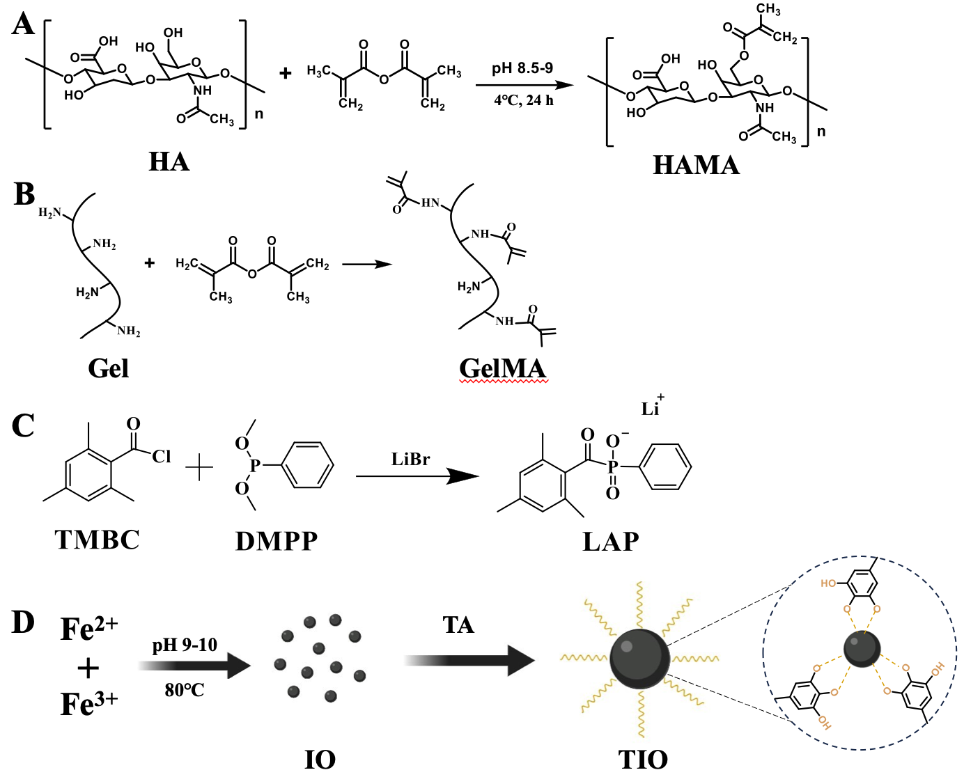
Figure S1. Synthesis routes of (A) HAMA, (B) GelMA, (C) LAP, and (D) TIO NPs.

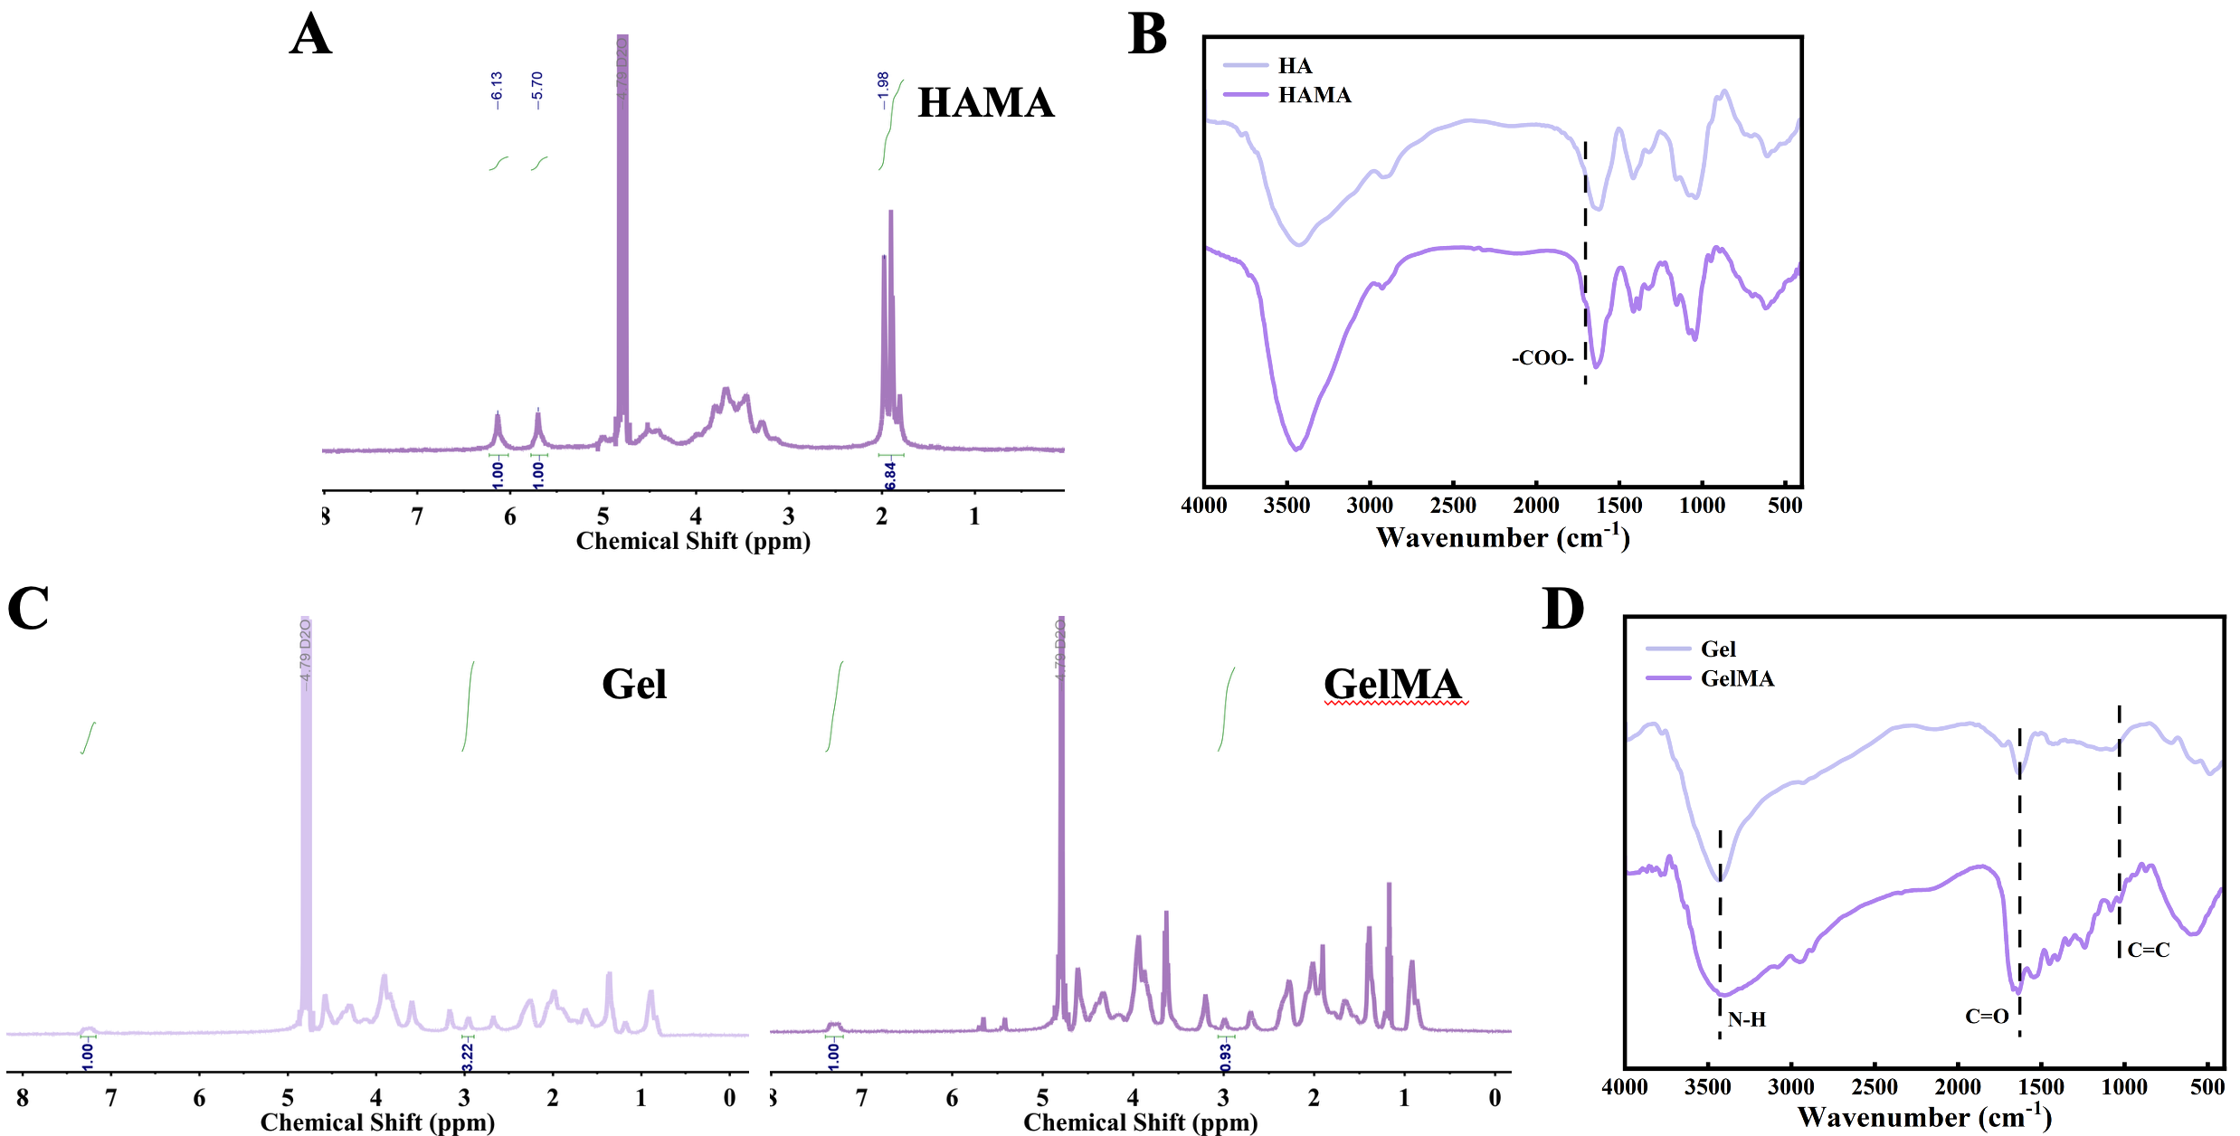

Figure S2. (A) ¹H NMR spectra and (B) FT-IR spectra of HA and HAMA. (C) ¹H NMR spectra and (D) FT-IR spectra of Gel and GelMA.

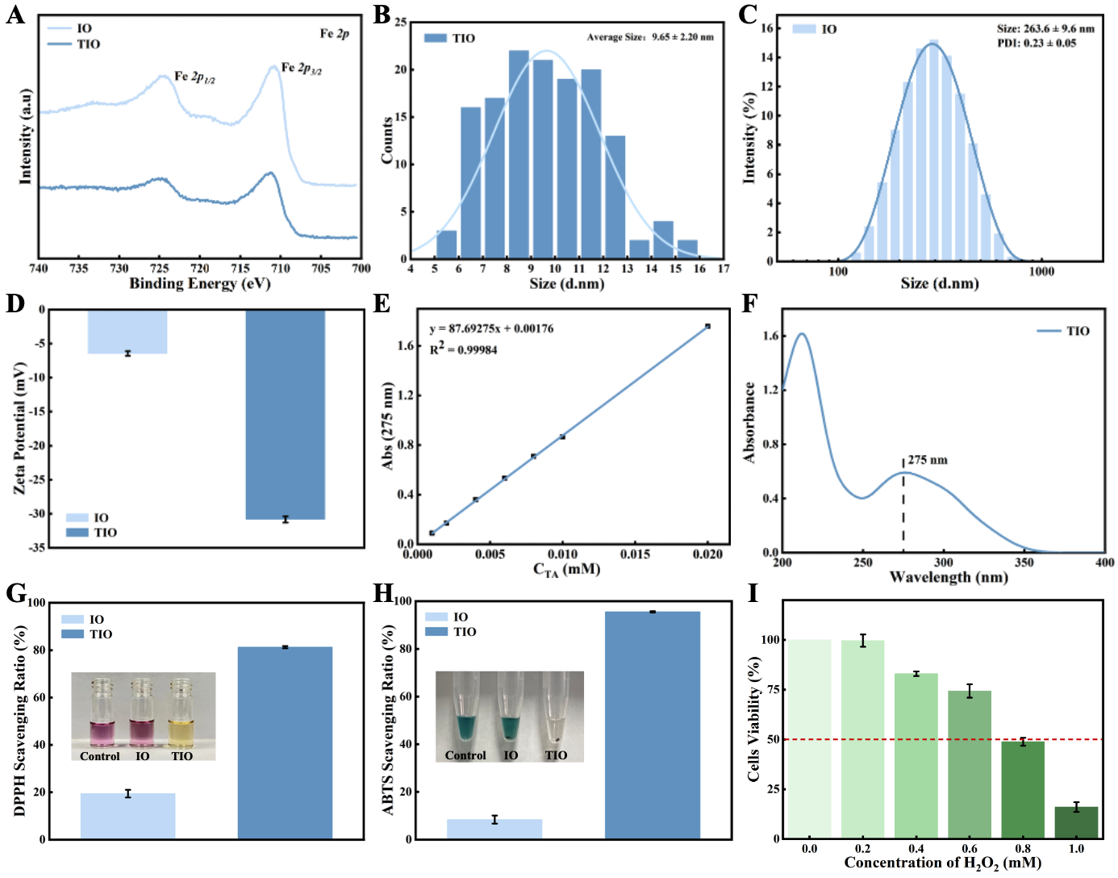
Figure S3. (A) High-resolution Fe 2p XPS spectra of IO and TIO NPs. (B) Quantitative analysis of average size of IOT NPs based on TEM images. (C) Hydrodynamic size distribution of IO NPs. (D) Zeta potential of IO and TIO NPs. (E) UV calibration curve of TA. (F) UV curve of TIO NPs. (G) DPPH and (H) ABTS assays assessing the antioxidant capacity of magnetic NPs. (I) Assessment of cell viability under different H₂O₂ concentrations.

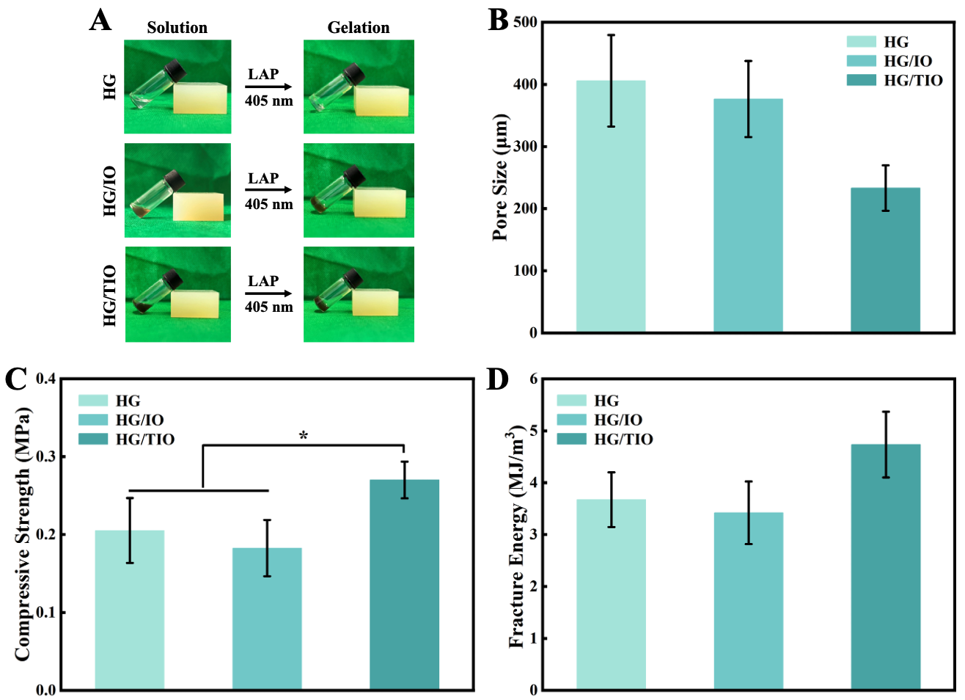
Figure S4. (A) Assessment of hydrogel gelation. (B) Pore size of the magnetic hydrogel. (C) Compressive strength and (D) Fracture energy of magnetic hydrogels.

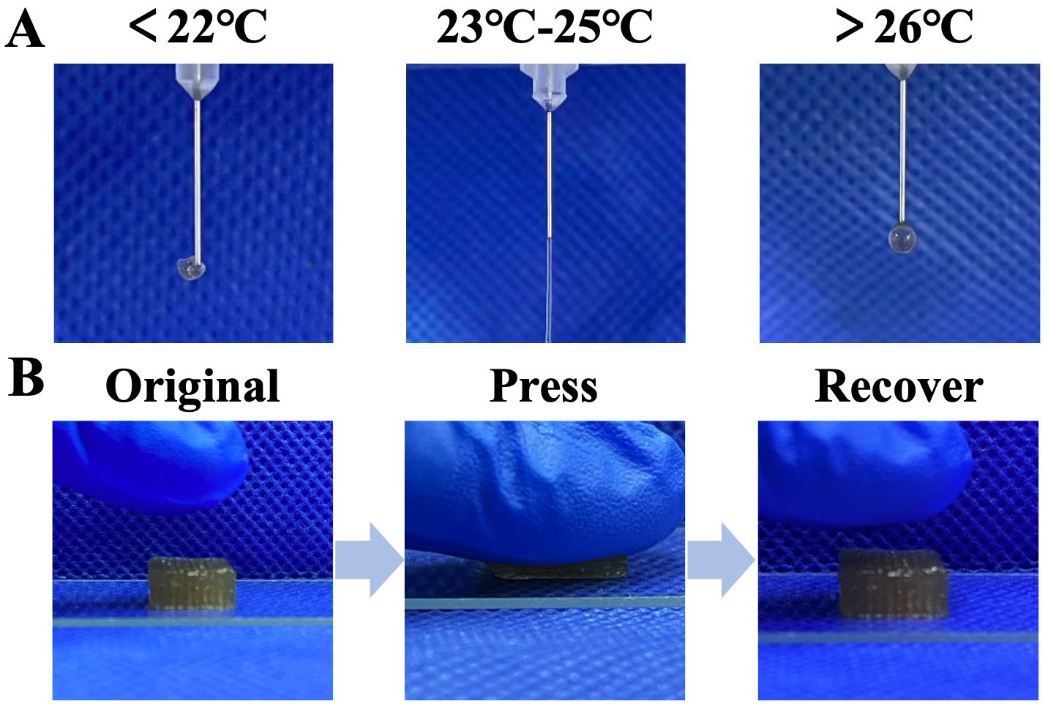
Figure S5. (A) Extrusion behavior of the magnetic bioink at different temperatures. (B) Assessment of the mechanics behavior of printed magnetic hydrogels.

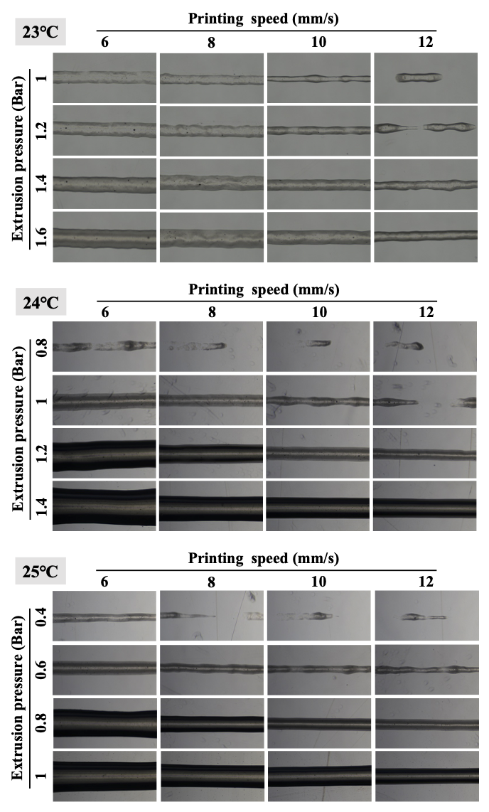
Figure S6. Line extrusion behavior of magnetic bioink under varying printing parameters.

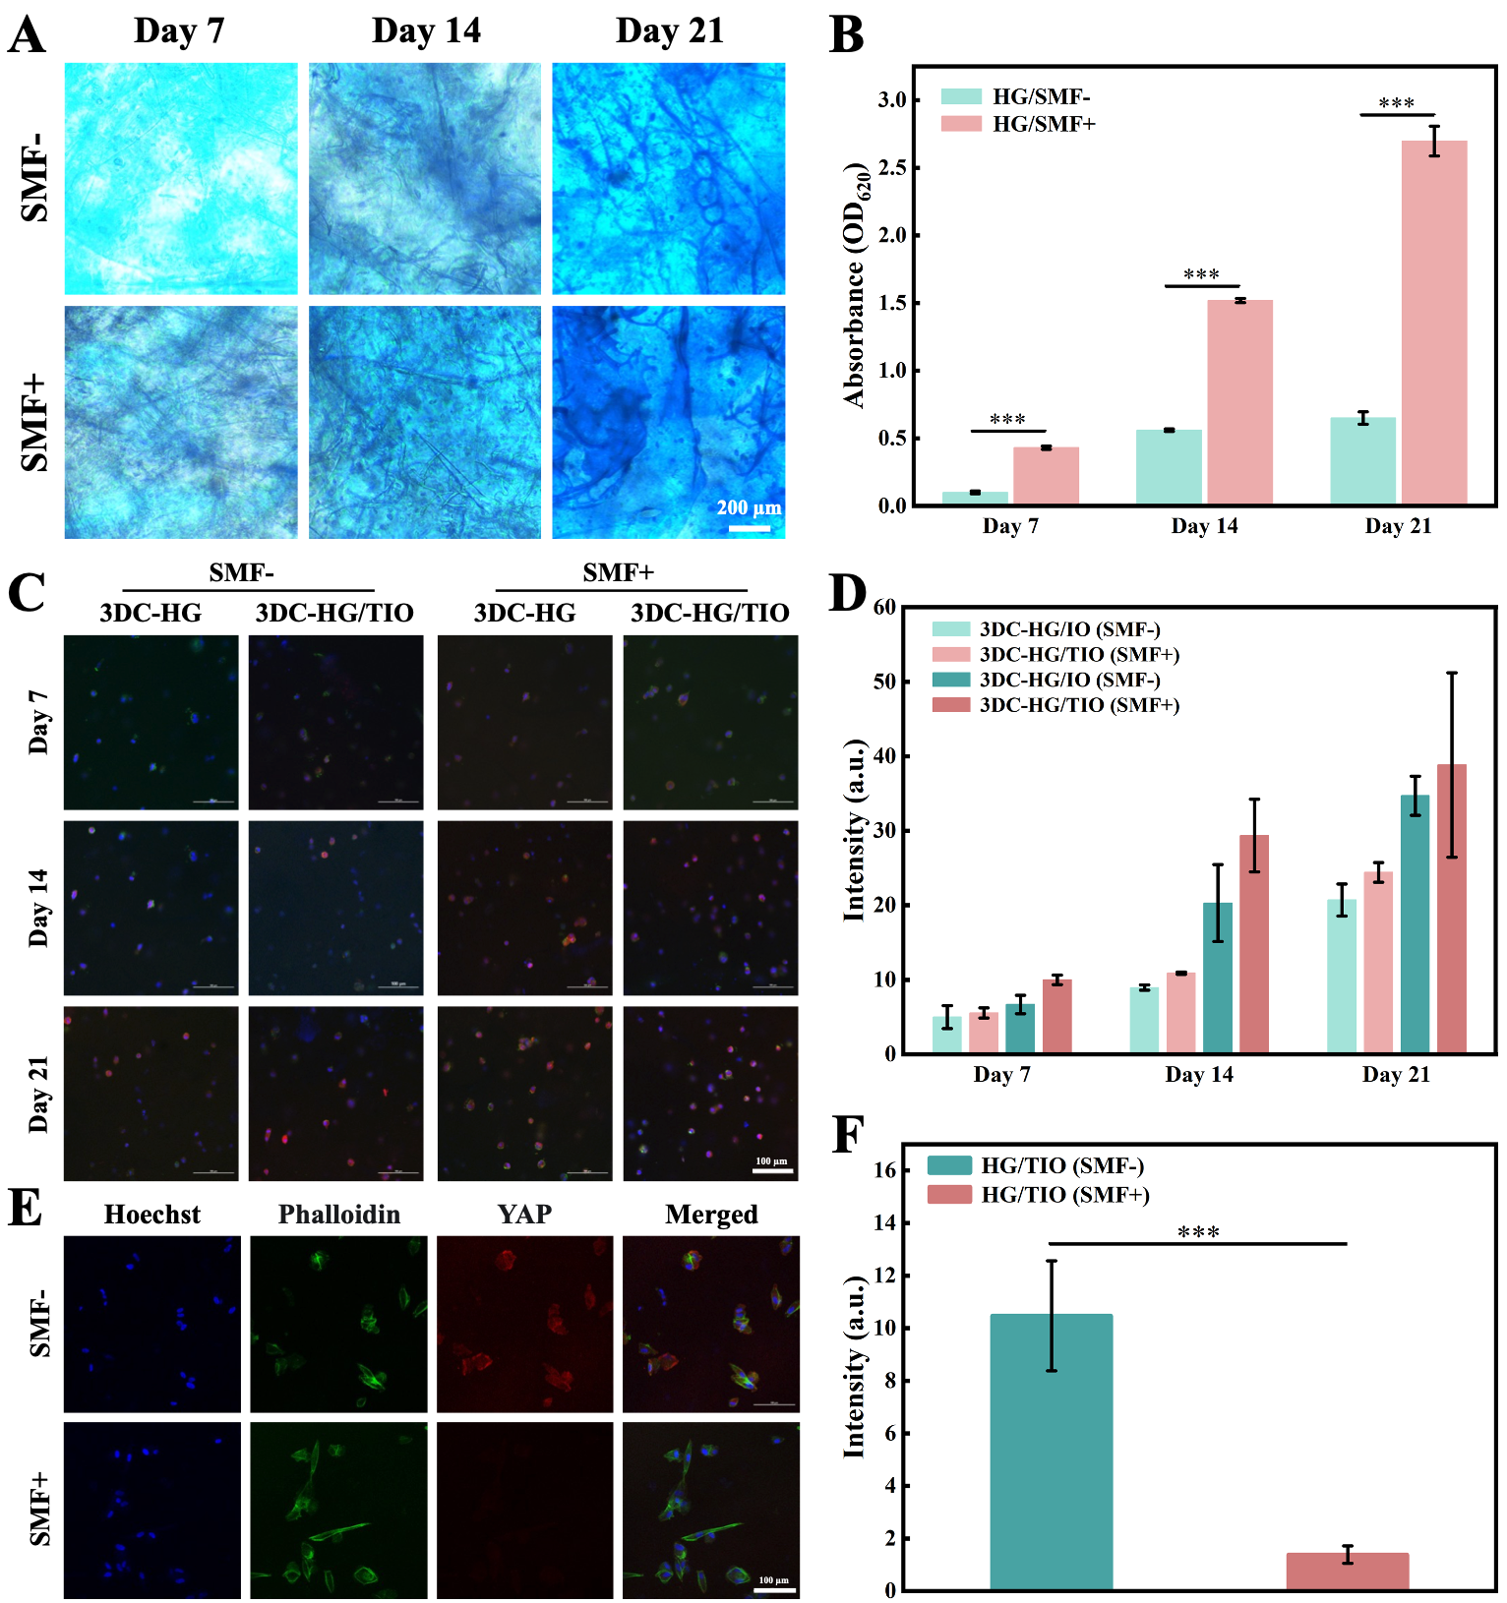
Figure S7. (A) Alcian blue staining of chondrogenic-induced differentiation in the 3DC-HG group. (B) Semi-quantitative analysis of glycosaminoglycans by measuring absorbance at 620 nm. (C) CLSM images and (D) Semi-quantitative analysis of Sox9 for hUC-MSCs in different printed hydrogels. (E) YAP staining after 7 days and Semi-quantitative analysis of YAP.

Figure S8. Representative images of H&E, AB, SO/FG, TB, and ACAN staining of the regenerated tissues in different groups at 4 weeks.

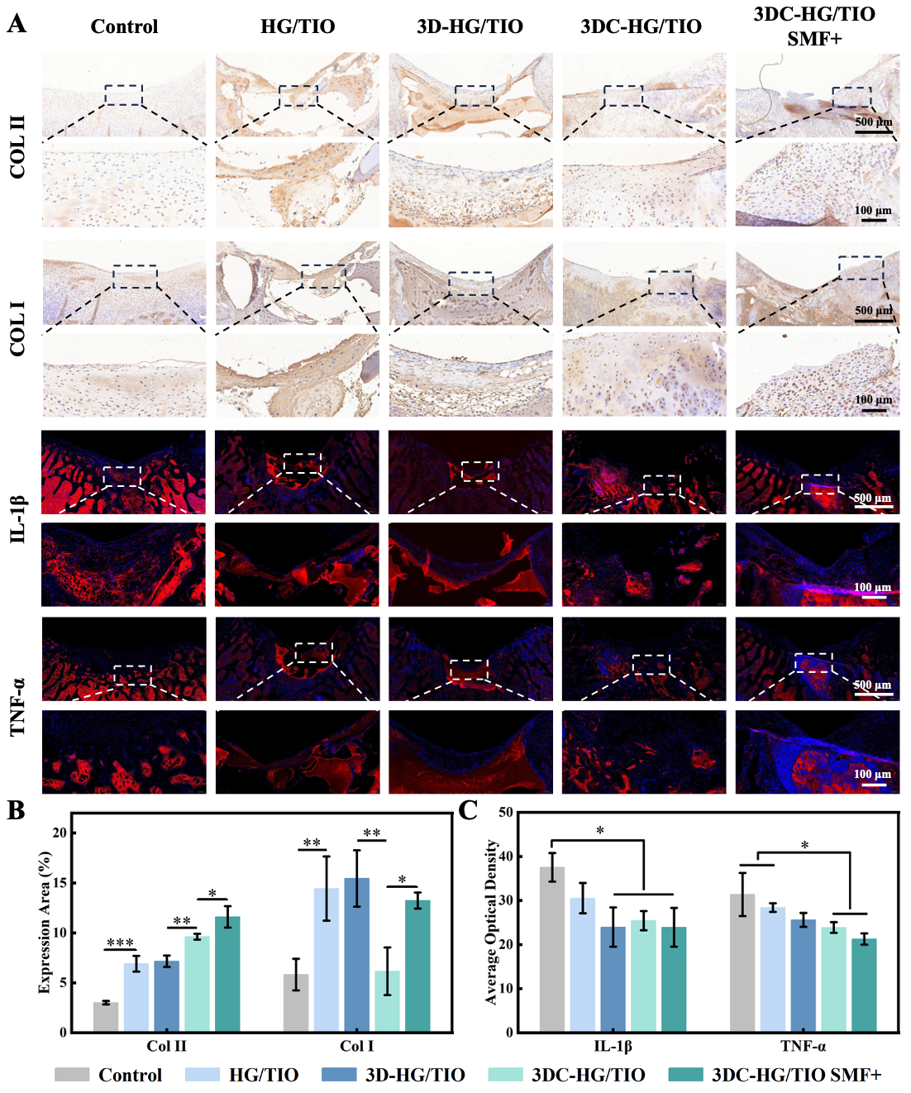
Figure S9. (A) Representative images of COL II, COL I, IL-1β, and TNF-α staining of the regenerated tissues in different groups at 4 weeks. Semiquantitative analysis of (B) collagen and (C) inflammatory factors in different groups at 4 weeks.

Figure S10. Representative images of AB, SO/FG, TB, and ACAN staining of the regenerated tissues in different groups at 8 weeks.

