ONLINE APPENDIX A

Figure A1 Incidence of cooperatives and workers in cooperatives (Total and for Big Enterprises), 2012-2022

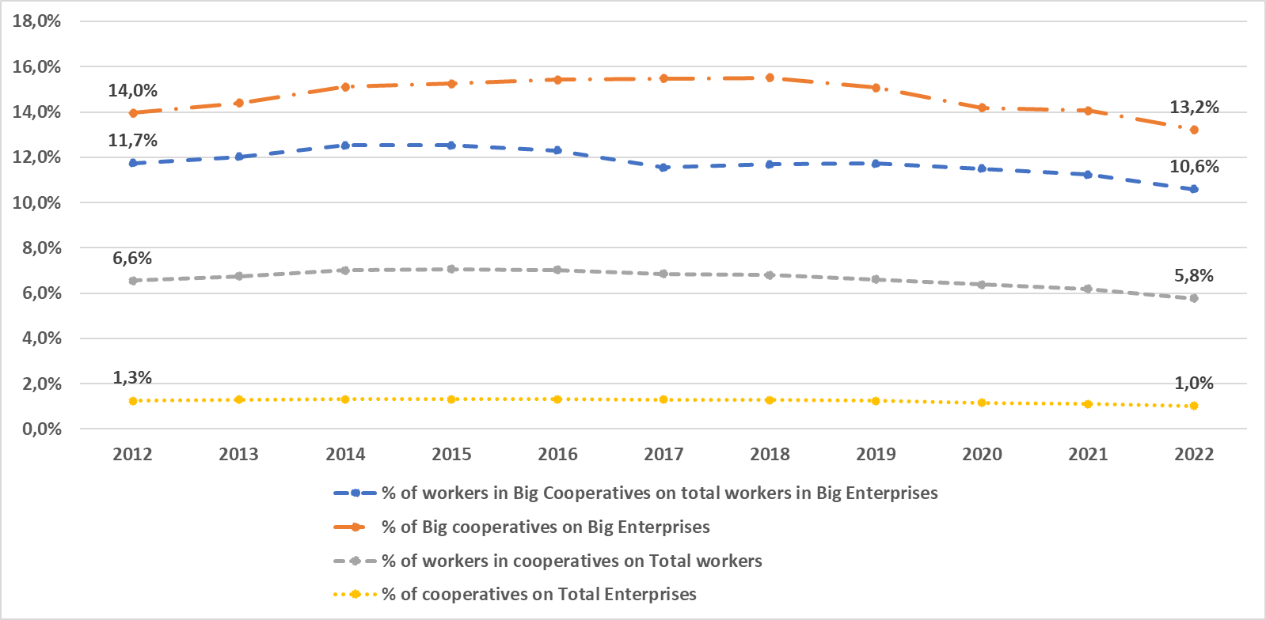
Source 1 Authors’ calculations on ASIA ISTAT Data

Figure A 2 Turnover, Operating income, value-added and Labor Costs (2013-2022, cooperatives)
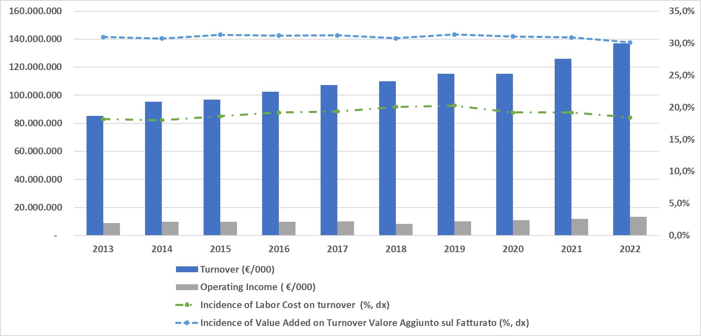
Source 2 Authors’ calculations on AIDA BVD data

Figure A 3 Total and Net Assets, Immobilizations (2013-2022, cooperatives)

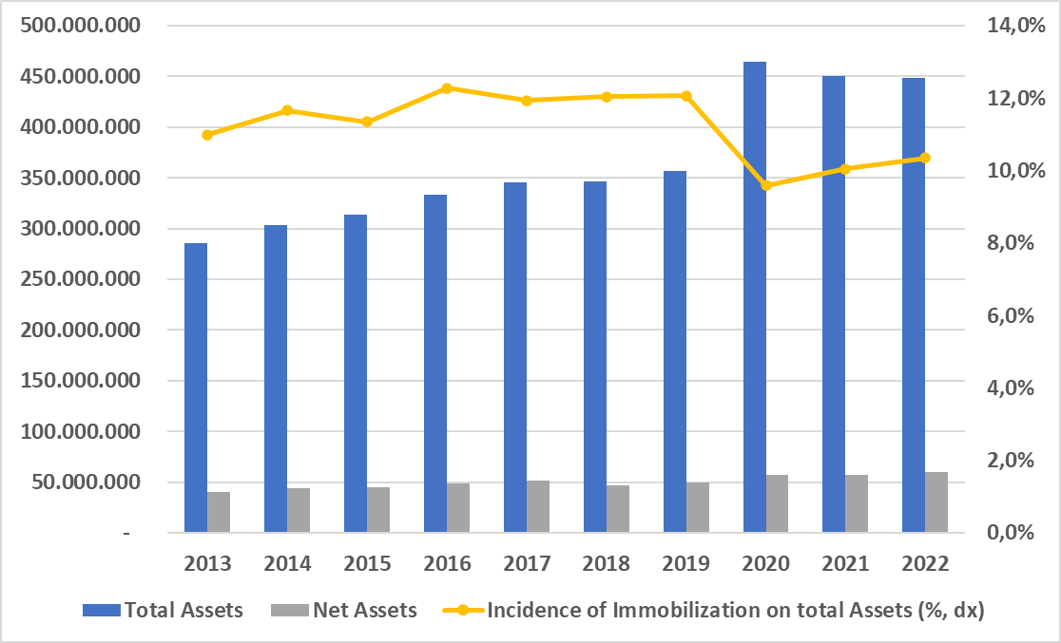
Source 3 Idem

Figure A 4 Cooperative Employment and Revenues between Southern and Central-Northern Regions (2013-2022)

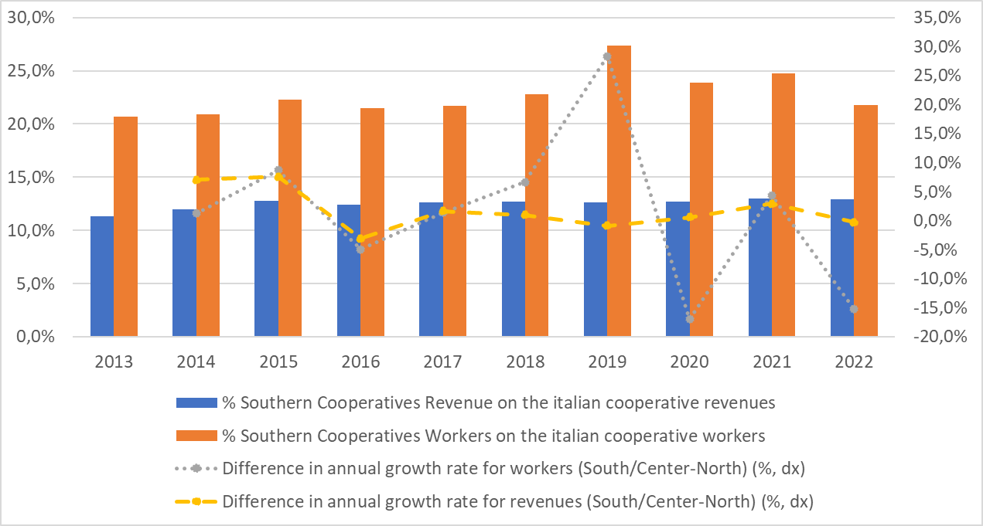
Source 4 idem

Figure A 5 Cooperative Workers by economic sectors, 2013-2022

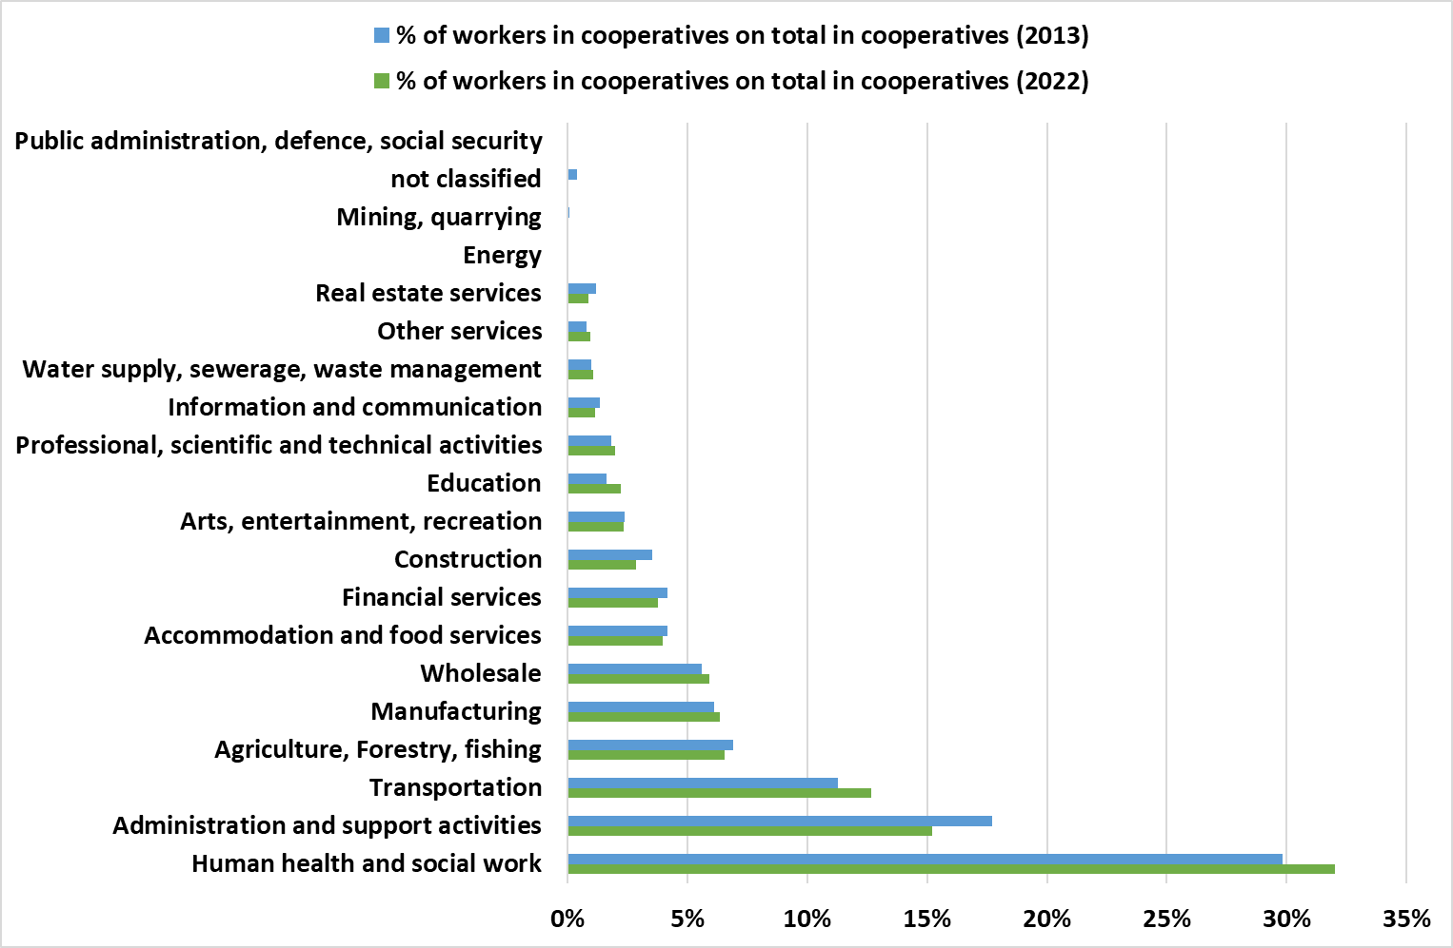
Source 5 idem

Figure A 6 Incidence of cooperative employees by regions (2022)

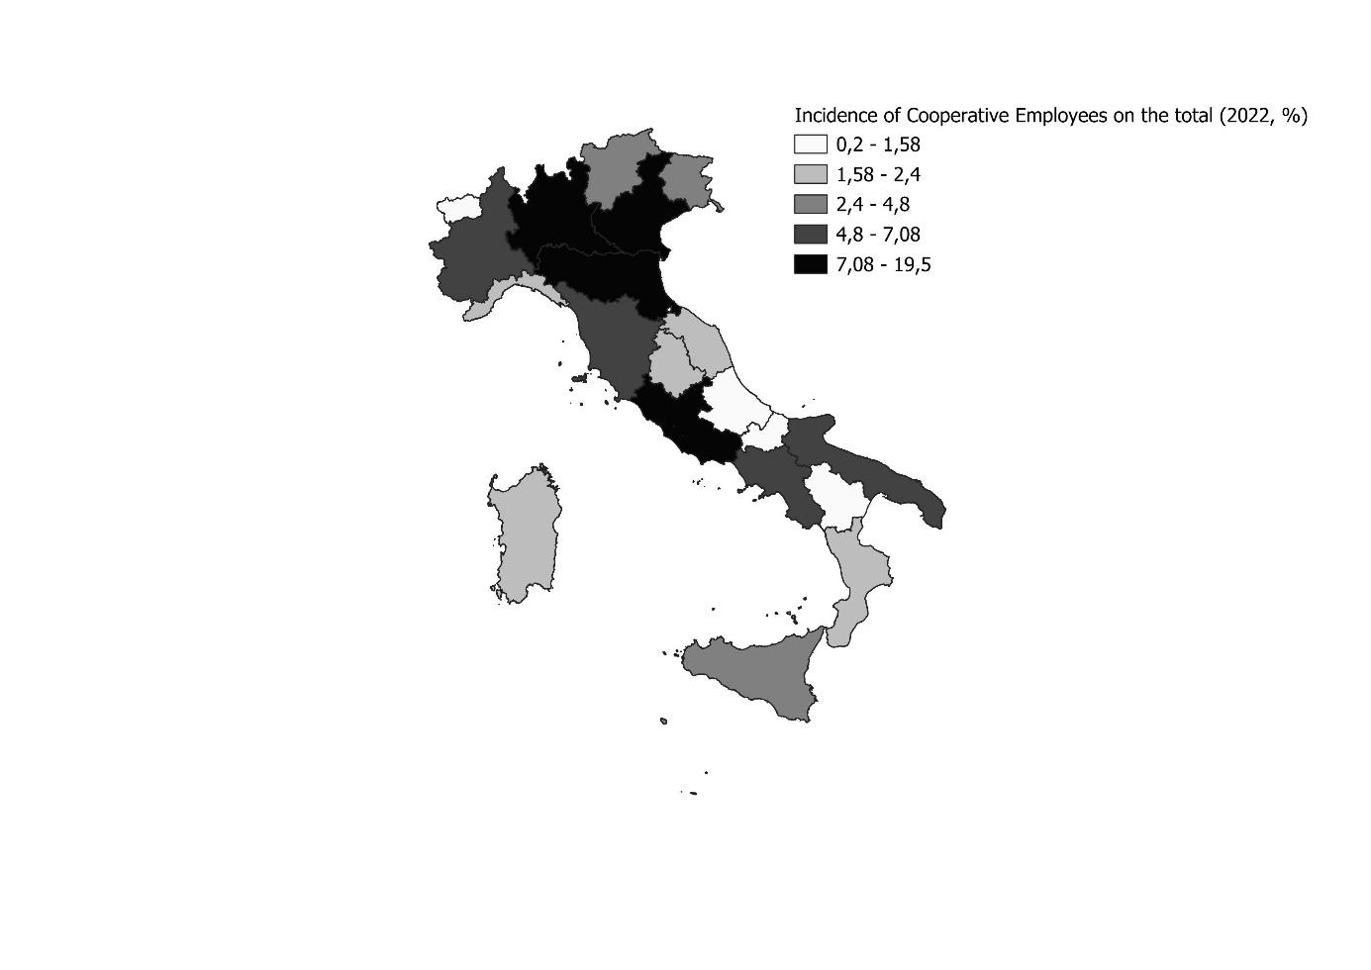
Source 6 idem

Figure A 7 European resources for SMEs (categories of expenditures), 2014-2020 budget

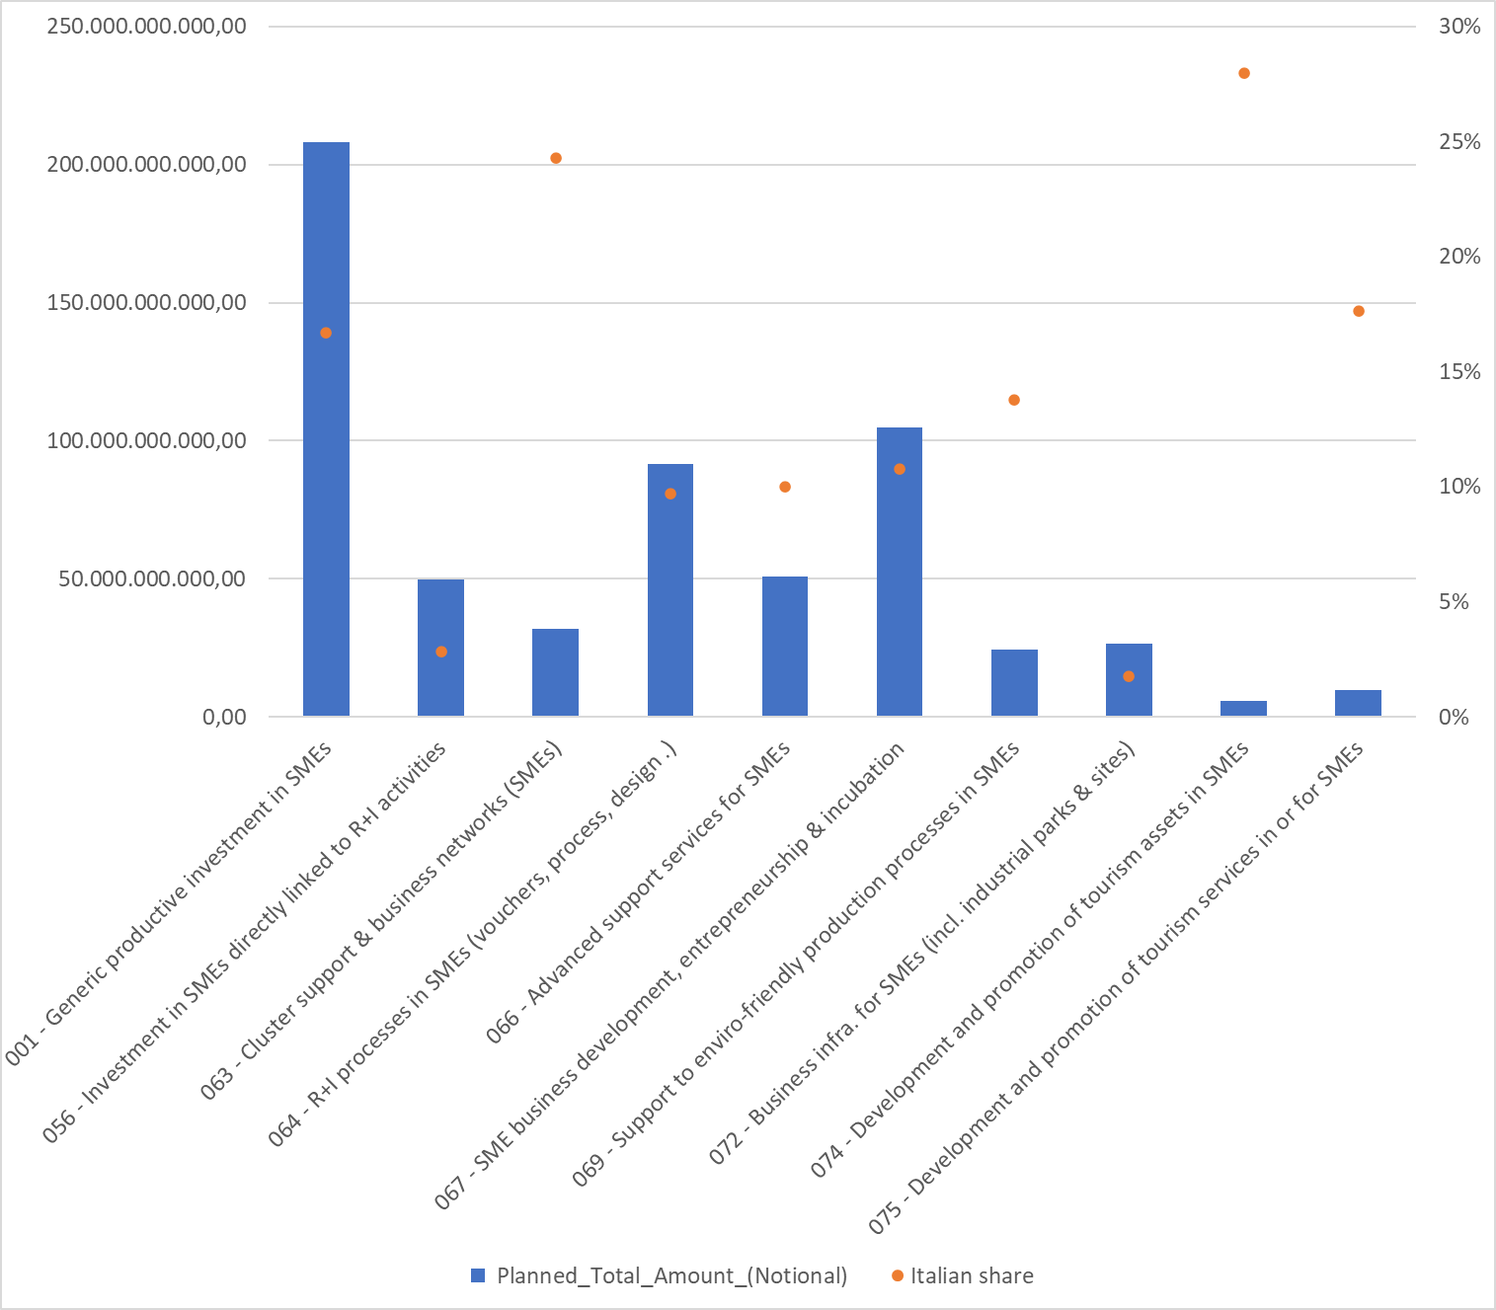
Source 7 Authors’ calculation on Open cohesion data

Table A 1 Total Implementation SIE European Fund 2014-2020

Source 8 Opencoesione, Febraury 2024

Table A 2 Multiple period treatment
 | Multiple period Treatment
Years | 0 | 2014 | 2015 | 2016 | 2017 | 2018 | 2019 | 2020 | 2021 | Total
2013 | 57.482 | 218 | 405 | 323 | 474 | 559 | 355 | 1.226 | 826 | 61.868
2014 | 57.482 | 218 | 405 | 323 | 474 | 559 | 355 | 1.226 | 826 | 61.868
2015 | 57.482 | 218 | 405 | 323 | 474 | 559 | 355 | 1.226 | 826 | 61.868
2016 | 57.482 | 218 | 405 | 323 | 474 | 559 | 355 | 1.226 | 826 | 61.868
2017 | 57.482 | 218 | 405 | 323 | 474 | 559 | 355 | 1.226 | 826 | 61.868
2018 | 57.482 | 218 | 405 | 323 | 474 | 559 | 355 | 1.226 | 826 | 61.868
2019 | 57.482 | 218 | 405 | 323 | 474 | 559 | 355 | 1.226 | 826 | 61.868
2020 | 57.482 | 218 | 405 | 323 | 474 | 559 | 355 | 1.226 | 826 | 61.868
2021 | 57.482 | 218 | 405 | 323 | 474 | 559 | 355 | 1.226 | 826 | 61.868
2022 | 57.482 | 218 | 405 | 323 | 474 | 559 | 355 | 1.226 | 826 | 61.868
Total | 574.820 | 2.180 | 4.050 | 3.230 | 4.740 | 5.590 | 3.550 | 12.260 | 8.260 | 618.680

Source 9 Authors’ calculations

Table A 3 Descriptive Statistics for all the Variables, 2013
 | Untreated |  |  |  |  | Treated
2013 | N | Mean | SD | Max | Min | N | Mean | SD | Max | Min
Turnover ( €/000) | 33.928 | 2.172 | 34.345 | 3.248.239 | - 1 | 3.339 | 3.492 | 25.593 | 790.234 | - 0
Labour Cost (€/000) | 33.537 | 358 | 3.597 | 268.746 | - 3 | 3.324 | 1.045 | 5.187 | 187.611 | - 0
Operating Income ( €/000) | 33.931 | 252 | 11.662 | 1.994.822 | - 27.739 | 3.339 | 111 | 1.515 | 71.878 | - 4.036
Value Added ( €/000) | 33.931 | 655 | 12.472 | 1.994.822 | - 10.284 | 3.339 | 1.255 | 6.535 | 225.494 | - 187
Total Assets ( €/000) | 33.931 | 7.918 | 143.982 | 14.992.021 | - | 3.339 | 5.148 | 60.707 | 2.478.529 | 0
Immobilization ( €/000) | 33.538 | 781 | 17.755 | 2.241.838 | - 10 | 3.324 | 1.570 | 17.491 | 543.517 | - 1
Current Assets ( €/000)) | 33.538 | 1.337 | 19.135 | 1.884.126 | - | 3.324 | 2.338 | 25.887 | 978.342 | -
Net Worth ( €/000) | 33.753 | 1.072 | 18.802 | 1.691.046 | - 907.138 | 3.329 | 1.339 | 15.497 | 646.327 | - 560
Debt ( €/000) | 33.538 | 1.148 | 22.184 | 2.563.593 | - 254 | 3.322 | 1.949 | 24.526 | 954.087 | - 32
Labor Cost on Operating Income | 32.732 | - 8 | 5.086 | 244.384 | - 874.405 | 3.310 | 81 | 2.446 | 129.671 | - 4.159
Valued Added per Employee | 23.398 | 30 | 73 | 4.479 | - 746 | 3.034 | 30 | 79 | 3.281 | - 47
Immobilization per Employee |  | 199.535 | 1.538 |  | - 10 |  | 9.849 | 378 |  | - 1
2022 | N | Mean | SD | Max | Min | N | Mean | SD | Max | Min
Turnover ( €/000) | 38.463 | 3.058 | 47.902 | 3.829.089 | - | 4.255 | 4.546 | 28.593 | 1.044.910 | -
Labour Cost (€/000) | 38.079 | 502 | 5.145 | 572.841 | - | 4.241 | 1.437 | 5.992 | 201.379 | -
Operating Income ( €/000) | 38.463 | 328 | 14.285 | 2.554.992 | - 147.727 | 4.255 | 144 | 2.114 | 84.927 | - 8.157
Value Added ( €/000) | 38.463 | 885 | 15.389 | 2.554.992 | - 7.157 | 4.255 | 1.697 | 7.402 | 212.759 | - 5.492
Total Assets ( €/000) | 38.463 | 10.930 | 179.917 | 14.895.381 | 0 | 4.255 | 6.527 | 80.795 | 4.364.408 | 2
Immobilization ( €/000) | 38.079 | 1.013 | 28.249 | 3.923.330 | - | 4.241 | 1.838 | 16.532 | 539.876 | -
Current Assets ( €/000)) | 38.079 | 1.575 | 22.132 | 2.645.162 | - | 4.241 | 2.785 | 25.176 | 1.387.810 | 0
Net Worth ( €/000) | 38.307 | 1.398 | 24.829 | 2.413.521 | - 1.340.947 | 4.247 | 1.615 | 17.064 | 801.919 | - 3.198
Debt ( €/000) | 38.079 | 1.366 | 26.992 | 3.817.323 | - | 4.241 | 2.142 | 19.111 | 926.958 | -
Labor Cost on Operating Income | 37.558 | 41 | 1.913 | 169.867 | - 116.226 | 4.238 | 58 | 1.340 | 63.412 | - 7.526
Valued Added per Employee | 29.080 | 34 | 60 | 2.975 | - 1.868 | 4.076 | 31 | 32 | 887 | - 323
Immobilization per Employee |  | 97.473 | 1.042 |  | - |  | 9.780 | 325 |  | -

Source 10 Authors’ calculations

Table A 4 Descriptive Statistics for all the Variables, 2022
 | Untreated |  |  |  |  | Treated
2013 | N | Mean | SD | Max | Min | N | Mean | SD | Max | Min
Log_Turnover ( €/000) | 28.716 | 5,1 | 2,1 | 15,0 | - 6,9 | 3.216 | 6,0 | 2,0 | 13,6 | - 5,8
Log_Labour Cost (€/000) | 23.890 | 4,3 | 1,9 | 12,5 | - 6,9 | 3.086 | 5,2 | 2,0 | 12,1 | - 6,2
Log_Operating Income ( €/000) | 19.845 | 2,2 | 2,2 | 14,5 | - 6,9 | 2.331 | 2,8 | 2,0 | 11,2 | - 5,3
Log_Value Added ( €/000) | 27.805 | 4,2 | 2,2 | 14,5 | - 6,9 | 3.156 | 5,3 | 2,0 | 12,3 | - 5,3
Log_Total Assets ( €/000) | 33.930 | 5,1 | 2,2 | 16,5 | - 5,8 | 3.339 | 5,9 | 2,1 | 14,7 | - 1,9
Log_ Fixed Assets ( €/000) | 30.745 | 3,1 | 2,6 | 14,6 | - 6,9 | 3.240 | 4,0 | 2,6 | 13,2 | - 6,9
Log_Current Assets ( €/000)) | 33.495 | 4,5 | 2,2 | 14,4 | - 5,8 | 3.322 | 5,4 | 2,1 | 13,8 | - 2,6
Log_ Net Worth ( €/000) | 28.807 | 3,2 | 2,4 | 14,3 | - 6,9 | 3.042 | 4,2 | 2,4 | 13,4 | - 4,7
Log_ Debt ( €/000) | 32.787 | 4,2 | 2,2 | 14,8 | - 6,9 | 3.304 | 5,0 | 2,1 | 13,8 | - 4,0
Log_ Labor Cost on Operating Income | 15.614 | 2,2 | 1,8 | 12,4 | - 10,1 | 2.202 | 2,5 | 1,6 | 11,8 | - 5,3
Log_Valued Added per Employee | 22.550 | 2,9 | 1,1 | 8,4 | - 5,5 | 2.979 | 3,0 | 0,9 | 8,1 | - 4,9
Log_Fixed Assets per Employee |  | 12,2 | 2,3 |  | - 9,5 |  | 9,2 | 2,0 |  | - 9,5
2022 | N | Mean | SD | Max | Min | N | Mean | SD | Max | Min
Log_Turnover ( €/000) | 34.795 | 5,6 | 2,1 | 15,2 | - 6,9 | 4.185 | 6,4 | 1,9 | 13,9 | - 3,0
Log_Labour Cost (€/000) | 29.999 | 4,7 | 1,9 | 13,3 | - 6,9 | 4.113 | 5,6 | 1,9 | 12,2 | - 5,3
Log_Operating Income ( €/000) | 26.011 | 2,4 | 2,1 | 14,8 | - 6,9 | 3.216 | 3,1 | 1,9 | 11,3 | - 6,2
Log_Value Added ( €/000) | 33.829 | 4,6 | 2,1 | 14,8 | - 6,9 | 4.161 | 5,8 | 1,9 | 12,3 | - 1,9
Log_Total Assets ( €/000) | 38.463 | 5,5 | 2,0 | 16,5 | - 6,9 | 4.255 | 6,4 | 1,8 | 15,3 | 0,7
Log_ Immobilization ( €/000) | 34.973 | 3,3 | 2,5 | 15,2 | - 6,9 | 4.167 | 4,5 | 2,4 | 13,2 | - 6,9
Log_Current Assets ( €/000)) | 38.063 | 5,0 | 2,0 | 14,8 | - 6,9 | 4.241 | 6,0 | 1,8 | 14,1 | - 1,7
Log_ Net Worth ( €/000) | 33.193 | 3,8 | 2,3 | 14,7 | - 6,9 | 3.880 | 4,8 | 2,2 | 13,6 | - 4,7
Log_ Debt ( €/000) | 37.564 | 4,6 | 2,1 | 15,2 | - 6,9 | 4.232 | 5,4 | 1,9 | 13,7 | - 2,7
Log_ Labor Cost on Operating Income | 21.810 | 2,3 | 1,9 | 12,0 | - 10,9 | 3.125 | 2,6 | 1,6 | 11,1 | - 7,1
Log_Valued Added per Employee | 28.422 | 3,2 | 0,9 | 8,0 | - 7,6 | 4.040 | 3,2 | 0,7 | 6,8 | - 2,3
Log_Immobilization per Employee |  | 11,5 | 2,3 |  | - 9,9 |  | 9,2 | 1,9 |  | - 6,9

Source 11 Authors’ calculations on Aida BVD dataset

Figure A 8 Kernel Density Curve_Before Matching

Source 12

Figure A 9 Kernel Density Curve_After Matching
Source 13

Table A 5 Results Italy
 | log of Turnover | P-Value | log of Operating Income | P-Value | log of Fixed Assets per employee | P-Value | Employees | P-Value | Log of Employees | P-Value
Weighted Average of Group-Time ATT | .0153686 | 0.268 | .057436* | 0.094 | .0800807*** | 0.005 | -0,4120957 | 0,953 | .0390374*** | 0.006
Weighted Average of Group-Specific Effects | .0200838 | 0.127 | .0590823* | 0.094 | .0856241*** | 0.001 | 0,391 | 0,965 | .0334471** | 0.011
Group-Specific Effect 2015 | .0232638 | 0.477 | .1746827* | 0.045 | .0417576 | 0.552 | 3,499 | 0,657 | .0501851 | 0.203
Group-Specific Effects2016 | .0261602 | 0.536 | .0576797 | 0.532 | .1566958* | 0.061 | 8,282 | 0,257 | .0735101* | 0.071
Group-Specific Effect 2017 | .0194744 | 0.574 | .0409971 | 0.551 | .1733618*** | 0.006 | 1,073 | 0,072 | .0211616 | 0.536
Group-Specific Effect 2018 | .0278243 | 0.347 | .1067752 | 0.114 | .0401354 | 0.488 | 2,058 | 0,758 | .0675643*** | 0.016
Group-Specific Effect 2019 | .0206803 | 0.511 | .003627 | 0.963 | .06339 | 0.315 | 4,206 | 0,128 | .032288 | 0.303
Group-Specific Effect 2020 | .0080289 | 0.707 | .1122851* | 0.063 | .1147207*** | 0.008 | 8,354 | 0,671 | .0045887 | 0.830
Group-Specific Effect 2021 | .0753777 | 0.011 | .0819514 | 0.339 | .0696491 | 0.171 | 1,757 | 0,28 | .0380037 | 0.177
Weighted Average of Time-Specific Effects | .0114244 | 0.357 | .0709599** | 0.043 | .059548** | 0.028 | 0,146 | 0,978 | .0346005** | 0.015
Time -Specific Effect 2015 | .0038958 | 0.847 | .2373329*** | 0.009 | .0081681 | 0.871 | 2,642 | 0,674 | .0157472 | 0.594
Time -Specifi cEffects2016 | .0069283 | 0.757 | .0683424 | 0.335 | .0261094 | 0.624 | 2,854 | 0,383 | .0582205 | 0.035
Time -Specific Effect 2017 | .0114536 | 0.581 | .0444737 | 0.396 | .0371438 | 0.361 | 1,516 | 0,542 | .0422537* | 0.059
Time -Specific Effect 2018 | .0311538 | 0.084 | .0097591 | 0.839 | .0435119 | 0.233 | 4,536 | 0,062 | .0354854* | 0.056
Time -Specific Effect 2019 | .0120321 | 0.544 | .0285887 | 0.552 | .0607143 | 0.109 | 1,470 | 0,452 | .0396238** | 0.044
Time -Specific Effect 2020 | .0253104 | 0.225 | .0319137 | 0.544 | .0718383* | 0.067 | 5,032 | 0,235 | .0195073 | 0.331
Time -Specific Effect 2021 | .0261022 | 0.217 | .0620777 | 0.284 | .0877336** | 0.028 | 2,325 | 0,446 | .0388826** | 0.049
Time -Specific Effect 2022 | .0389966 | 0.114 | .1490187** | 0.013 | .1411649*** | 0.003 | 4,696 | 0,85 | .0585782** | 0.014
Chi2 (21) -Pretrend Test | 255 | 0.2276 | 200.297 | 0.5194 | 105.820 | 0.9703 | 322.066 | 0,0558 | 308.761 | 0,0757
Pretrend Test (p-Value)
Observations | 29870
P-values:***<0,01; **<0,05; ***<0,1

Table A 6 Results_ Southern Regions
 | log of Turnover | P-Value | log of Operating Income | P-Value | log of Fixed Assets per employee | P-Value | Employees | P-Value | Log of Employees | P-Value
Weighted Average of Group-Time ATT | .0212761 | 0.372 | .0816253 | 0.125 | .1736257*** | 0.000 | -12 | 0.461 | .0311005 | 0.180
Weighted Average of Group-Specific Effects | .0265569 | 0.254 | .1312841 | 0.021 | .1463223*** | 0.001 | 1.256.753 | 0.504 | .0314728 | 0.167
Group-Specific Effect 2015 | .012255 | 0.897 | .026925 | 0.898 | .1965181 | 0.449 | 9.487.089 | 0.508 | .040393 | 0.729
Group-Specific Effects2016 | .068776 | 0.318 | .0578957 | 0.634 | .349067*** | 0.003 | 1.488.379 | 0.054 | .0206798 | 0.725
Group-Specific Effect 2017 | .0452434 | 0.421 | .059918 | 0.609 | .370832*** | 0.001 | 2.105.722 | 0.165 | .0117604 | 0.827
Group-Specific Effect 2018 | .0306634 | 0.512 | .1393729 | 0.189 | .049248 | 0.580 | 1.356.403 | 0.433 | .0964609** | 0.032
Group-Specific Effect 2019 | .0131163 | 0.817 | .1699062 | 0.171 | .0236996 | 0.808 | 3.206.357 | 0.415 | .0199172 | 0.703
Group-Specific Effect 2020 | .0177383 | 0.708 | .2842916** | 0.015 | .1775189** | 0.046 | 4.886.905 | 0.306 | .0094806 | 0.815
Group-Specific Effect 2021 | .0904571 | 0.091 | .3017008** | 0.043 | .0501349 | 0.623 | 2.653.179 | 0.306 | .0748715 | 0.195
Weighted Average of Time-Specific Effects | .0209282 | 0.350 | .0192054 | 0.723 | .2000923*** | 0.000 | 8.300.395 | 0.491 | .0193744 | 0.475
Time -Specific Effect 2015 | .0793664 | 0.245 | .1749961 | 0.435 | .2361947 | 0.263 | 1.460.961 | 0.709 | .0682055 | 0.555
Time -Specific Effect 2016 | .0020255 | 0.967 | .0198787 | 0.875 | .3461177*** | 0.004 | 7.517.196 | 0.026 | .0530867 | 0.286
Time -Specific Effect 2017 | .0057298 | 0.897 | .0353556 | 0.703 | .2034443*** | 0.006 | 1.318.051 | 0.601 | .0096723 | 0.797
Time -Specific Effect 2018 | .01833 | 0.576 | .0355191 | 0.659 | .1266009** | 0.036 | 3.265.611 | 0.136 | .0468628* | 0.093
Time -Specific Effect 2019 | .004824 | 0.893 | .0825303 | 0.305 | .1776224*** | 0.006 | 4.689.231 | 0.368 | .0207875 | 0.502
Time -Specific Effect 2020 | .0366653 | 0.367 | .0124285 | 0.898 | .1629554** | 0.040 | 3.166.194 | 0.494 | .0070952 | 0.853
Time -Specific Effect 2021 | .0628876 | 0.161 | .2360512** | 0.010 | .1297472* | 0.065 | 2.671.644 | 0.598 | .0398161 | 0.293
Time -Specific Effect 2022 | .0520355 | 0.227 | .11324 | 0.306 | .2180559** | 0.013 | 296.562 | 0.502 | .0600703 | 0.216
Chi2 (21) - Pretrend Test | 202 | 0,5091 | 181 | 0,642 | 167 | 0,7285 | 211 | 0,4544 | 166 | 0.7340
Observations | 11306
P-values:***<0,01; **<0,05; ***<0,1

Figure A 10 Event Studies - Total Fixed Assets per Employee (Italy)

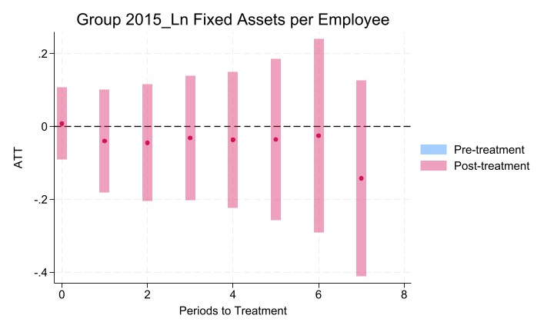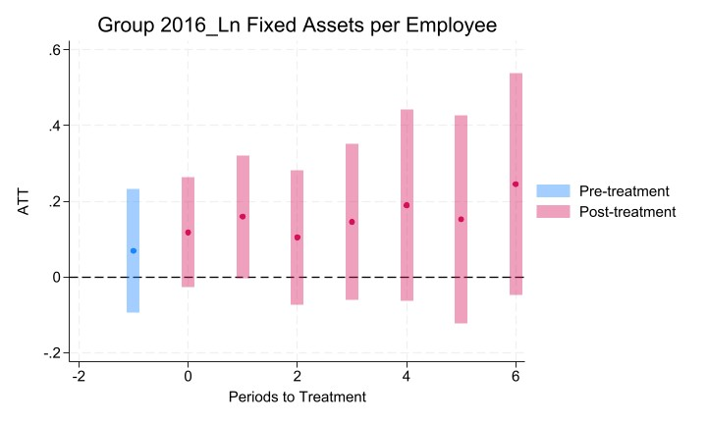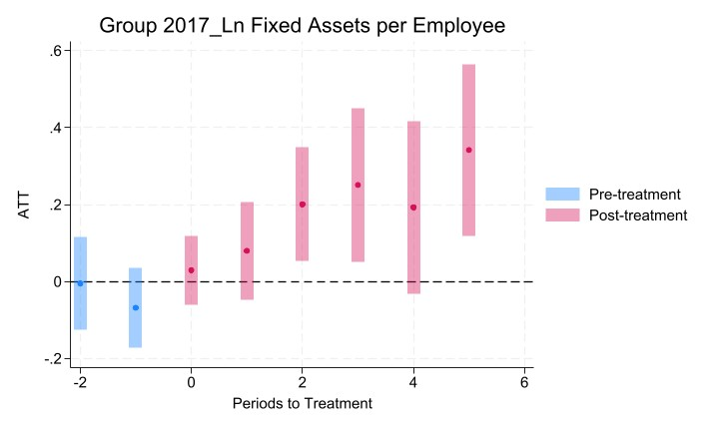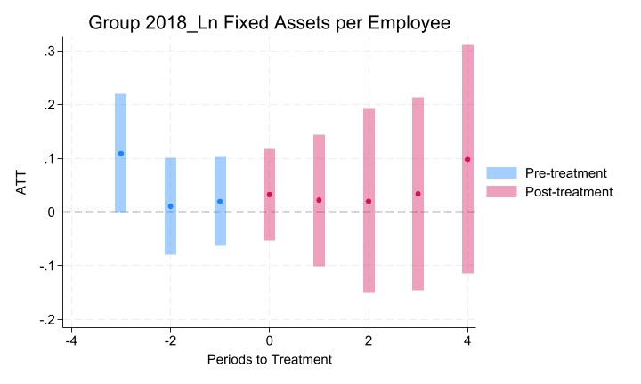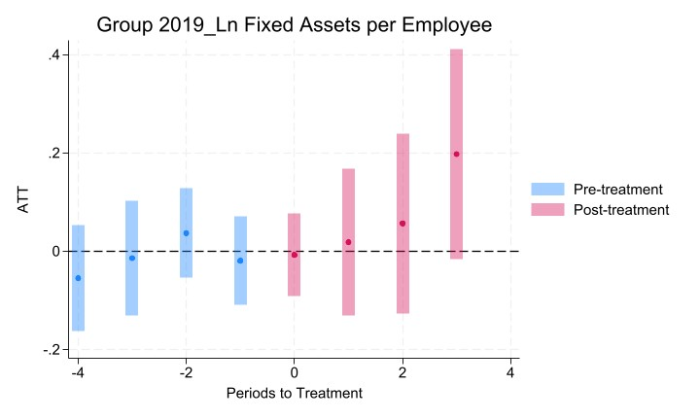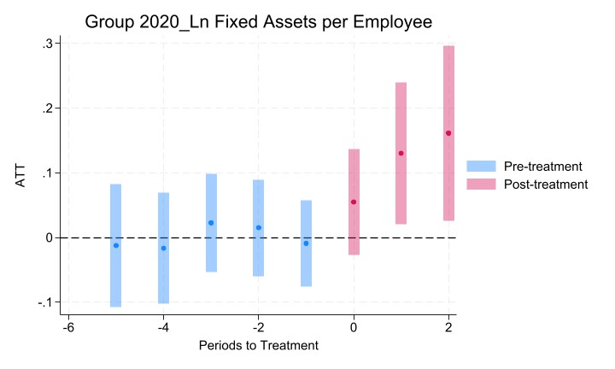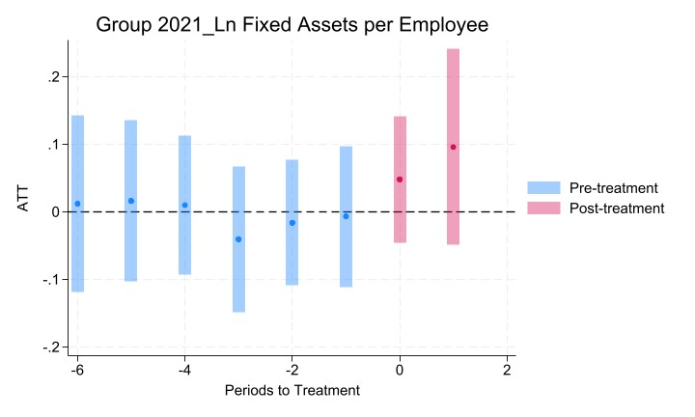

Figure A 11 Event Studies - Total Fixed Assets per Employee (Southern Regions)

