FIGURES
Manuscript: Evaluation of Road Traffic Noise Pollution Using the IDW Interpolation Method
Municipality of Ain Benian, Algiers, Algeria
Submitted to: Environmental Monitoring and Assessment (Springer)
ISSN: 0167-6369 (print) | 1573-2959 (online)
Total figures: 11 (Figs. 1–11)

Figure 1
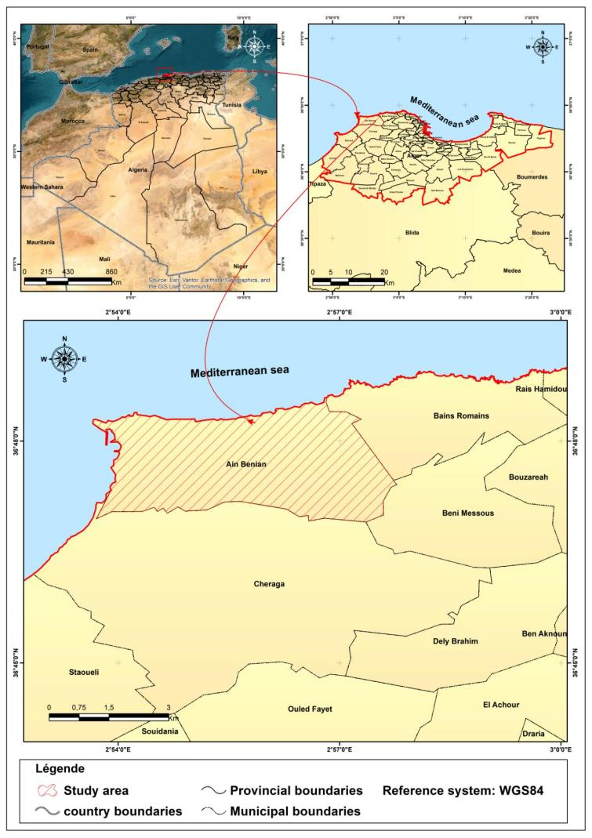
Fig. 1 Location map of the study area — Municipality of Ain Benian, Algiers, Algeria.
Note: Map lines delineate study areas and do not necessarily depict accepted national boundaries.

Figure 2
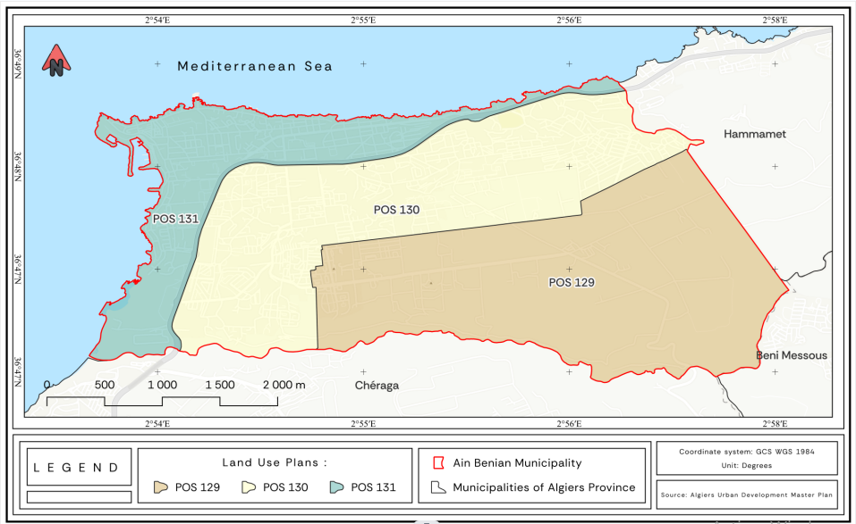
Fig. 2 Zoning of Ain Benian municipality into POS 129, 130, and 131.
Note: Map lines delineate study areas and do not necessarily depict accepted national boundaries.

Figure 3
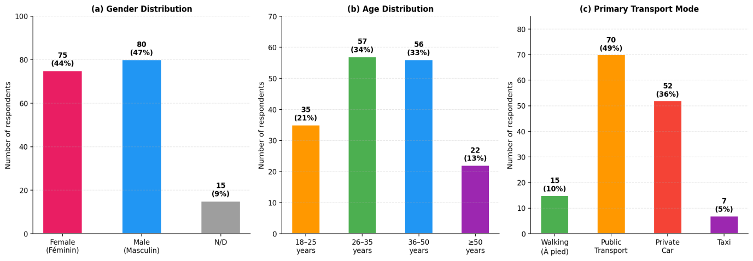
Fig. 3 Survey results: (a) gender distribution, (b) age distribution, and (c) primary transport mode among 170 respondents (Ain Benian, 2024).

Figure 4
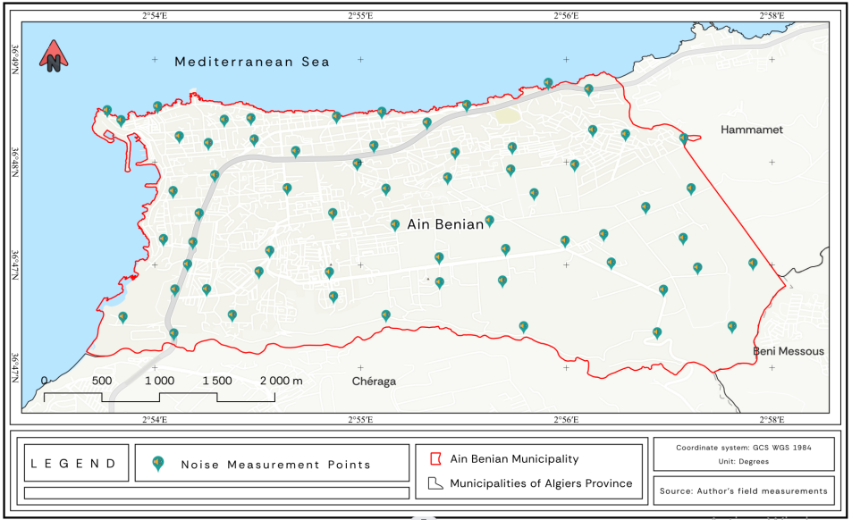
Fig. 4 Location map of the 63 measurement stations across Ain Benian municipality.

Figure 5a
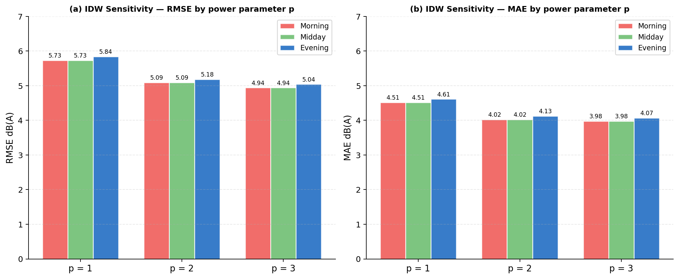
Fig. 5a Sensitivity analysis of the IDW power parameter (p = 1, 2, 3): RMSE and MAE values for the three measurement periods. p = 2 was selected as the optimal value.

Figure 5b
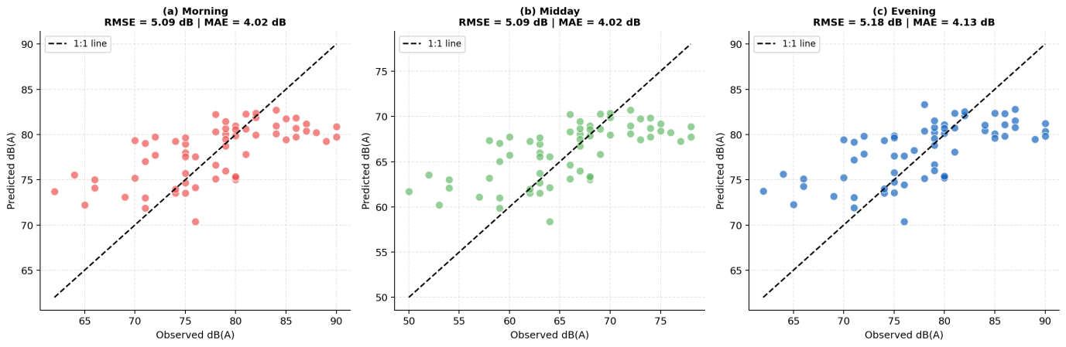
Fig. 5b Leave-one-out cross-validation (LOOCV) results: predicted vs. observed noise levels for morning, midday, and evening periods. RMSE = 5.09 dB(A) (morning and midday), 5.18 dB(A) (evening).

Figure 6
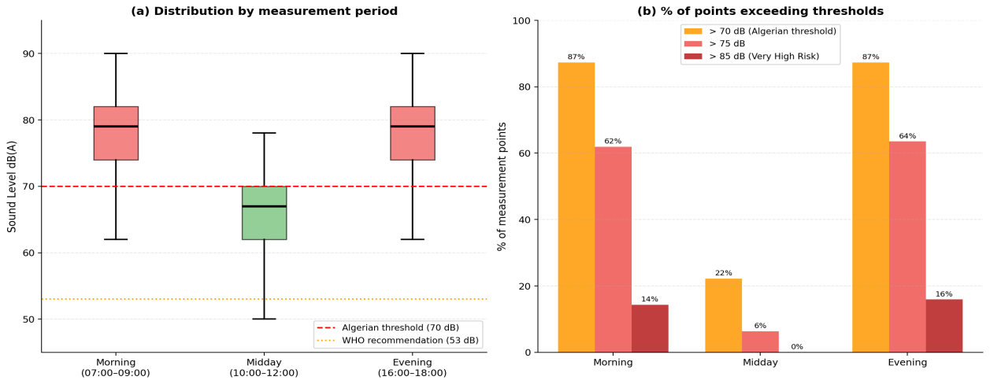
Fig. 6 (a) Boxplot distribution of noise levels by measurement period with WHO (53 dB) and Algerian (70 dB) regulatory thresholds; (b) percentage of measurement points exceeding noise thresholds by period.

Figure 7
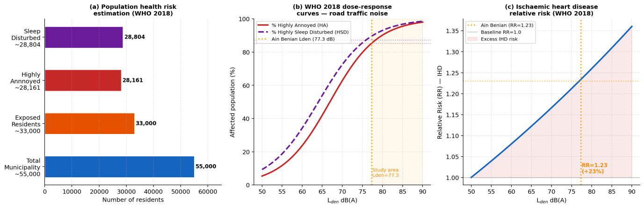
Fig. 7 Indicative health risk assessment based on WHO (2018) dose–response functions applied to estimated Lden: (a) estimated number of residents potentially affected; (b) proportion highly annoyed and at sleep disturbance risk as a function of Lden; (c) relative risk for ischaemic heart disease as a function of Lden.
Note: Values are indicative estimates subject to the limitations described in the text.

Figure 8
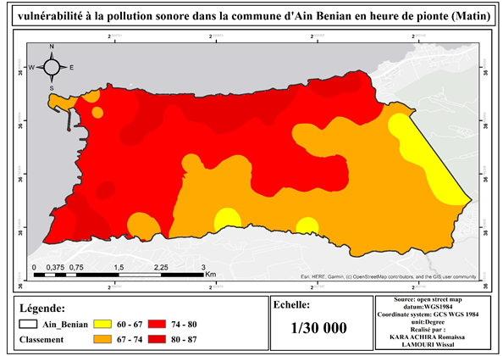
Fig. 8 Noise vulnerability map — Morning period (07:00–09:00).
Note: Map lines delineate study areas and do not necessarily depict accepted national boundaries.

Figure 9
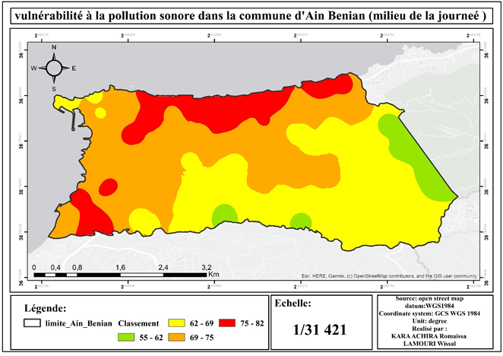
Fig. 9 Noise vulnerability map — Midday period (10:00–12:00).
Note: Map lines delineate study areas and do not necessarily depict accepted national boundaries.

Figure 10
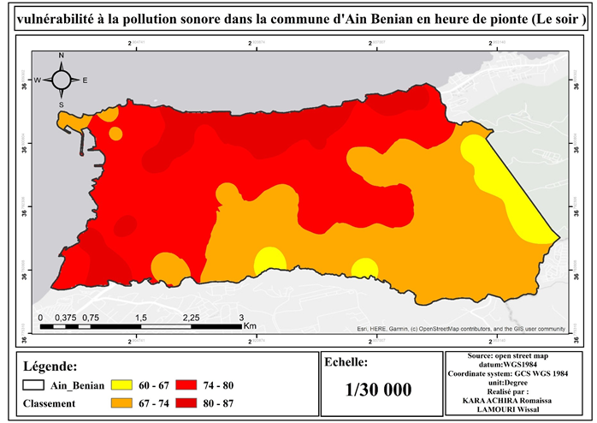
Fig. 10 Noise vulnerability map — Evening period (16:00–18:00).
Note: Map lines delineate study areas and do not necessarily depict accepted national boundaries.

Figure 11
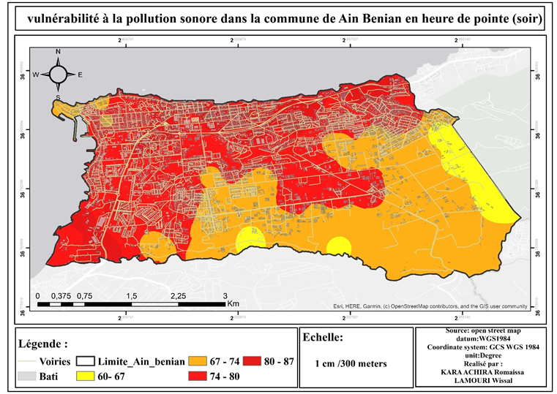
Fig. 11 Summary noise map and spatial distribution of exposure zones in Ain Benian municipality.
Note: Map lines delineate study areas and do not necessarily depict accepted national boundaries.

