Supplementary Appendix
Impact of second-trimester intrauterine fetal death on short-term morbidities and long-term growth and neurodevelopmental outcomes among extremely preterm infants from multiple pregnancies

Sumin Kim ^{1,2*}, So Yoon Ahn ^{2,3*}, Ji Eun Hwang ², Danbee Kang ^{1,4}, Misun Yang ^{2,3}, Se In Sung ^{2,3}, Juhee Cho^{1,4}, Yun Sil Chang ^{2,3,5†}

Supplementary Table 1. Summary of measures of KNN registry
Supplementary Table 2. Univariable analysis for In-hospital mortality
Supplementary Table 3. Comparison of perinatal characteristics and short-term outcomes (ND F/U vs. ND F/U loss at CA of 18-24 months)

Supplementary Table 1. Summary of measures of KNN registry
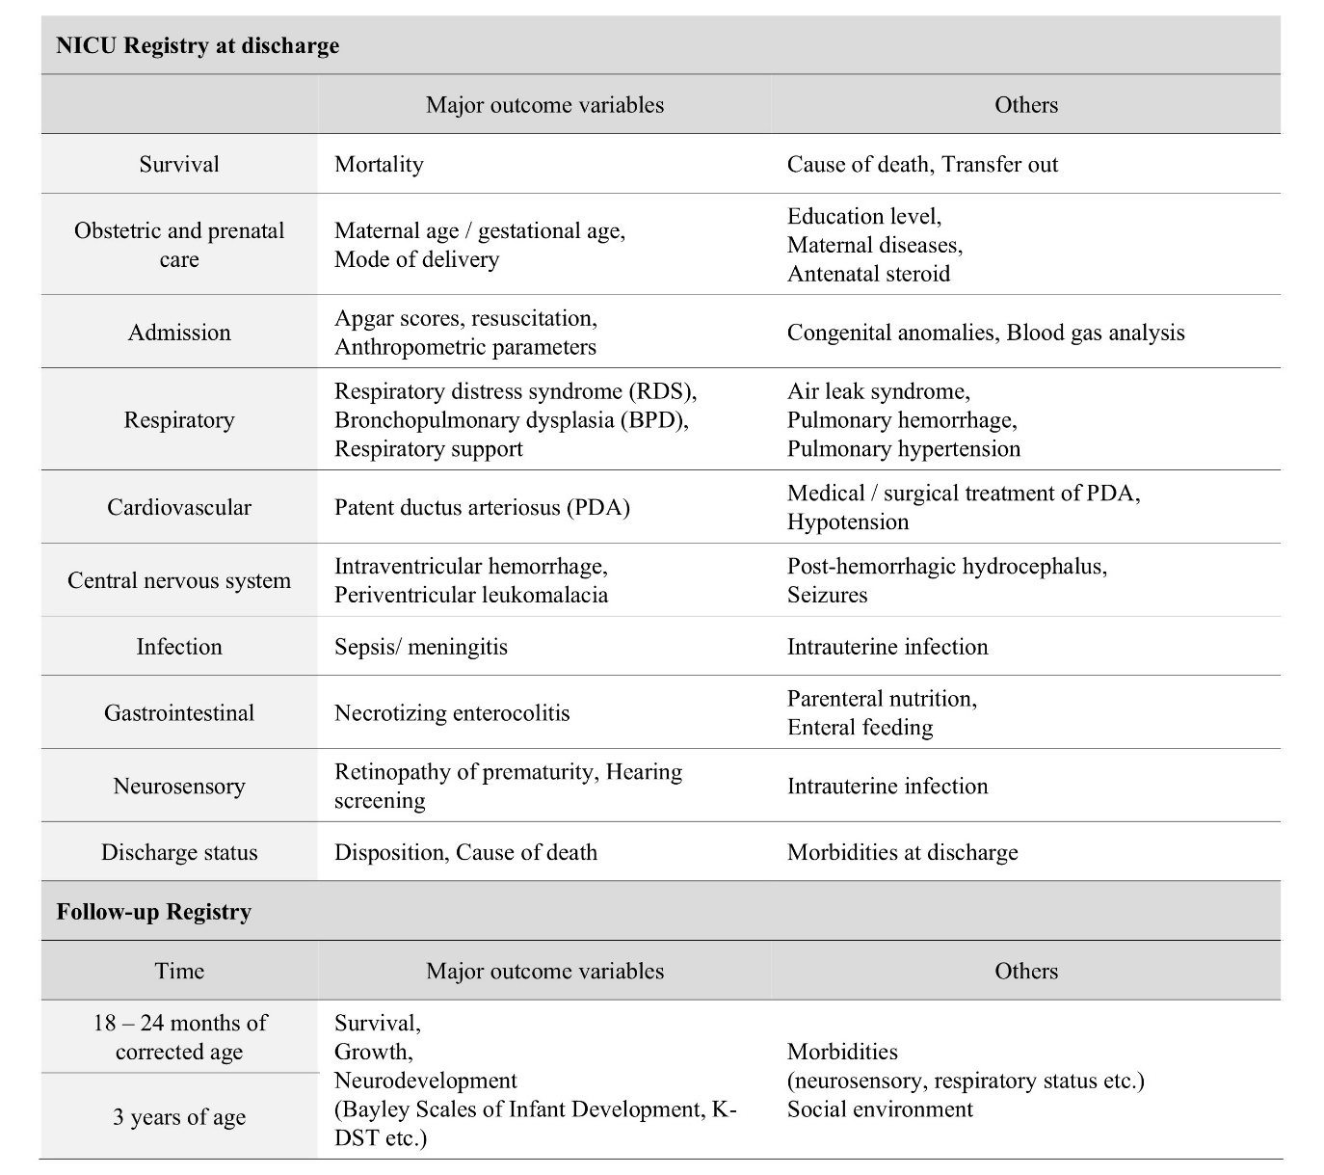
Source: modified from KNN website

Supplementary Table 2. Univariable analysis for In-hospital mortality
characteristic | In-hospital no Mortality  (n=1,391) | In-hospital Mortality# (n=627) | p-value | p’-value
Neonatal characteristic
Gestational age | 25.6±1.3 | 24.4±1.5 | <0.001
Birth weight (g) | 844.8±187.0 | 701.1±184.8 | <0.001
Male (%) | 740/1,391 (53.2) | 334/627 (53.2) | 0.977
SGA (%) | 74/1,391 (5.3) | 75/627 (11.9) | <0.001*
Apgar scores
1 minute | 3.9±1.8 | 3.1±1.7 | <0.001
5 minutes | 6.2±1.8 | 5.4±2.1 | <0.001
Maternal characteristic
Maternal age | 33.1±3.8 | 33.2±4.2 | 0.295
Oligohydramnios (%) | 136/1,261 (10.7) | 79/558 (14.1) | 0.040
Polyhydramnios (%) | 29/1,261 (2.3) | 25/558 (4.4) | 0.012
Antenatal steroid (%) | 1 210/1,373 (88.1) | 490/611 (80.2) | <0.001
Cesarean section (%) | 1 147/1,391 (82.4) | 465/627 (74.1) | <0.001
Chorioamnionitis (%) | 496/1,209 (41.0) | 217/512 (42.3) | 0.601
Maternal diabetes (%) | 146/1,391 (10.5) | 35/627 (5.5) | <0.001
Maternal hypertension (%) | 97/1,391 (6.9) | 36/627 (5.7) | 0.302
PROM, cut off 24h (%) | 245/427 (57.3) | 122/195 (62.5) | 0.222
IVF (%) | 838/1,391 (60.2) | 365/627 (58.2) | 0.390
IUFD (%) | 156/1,391 (11.2) | 118/627 (18.8) | <0.001
Neonatal short-term outcome
BPD ≥ moderate (%) | 687/1,218 (56.4) | 129/184 (70.1) | <0.001 | 0.102
IVH ≥ grade III (%) | 240/1,353 (17.7) | 186/483 (38.5) | <0.001 | <0.001
Sepsis (%) | 455/1,388 (32.7) | 203/618 (32.8) | 0.976 | 0.364
PVL (%) | 152/1,349 (11.2) | 65/477 (13.6) | 0.171 | 0.949
NEC ≥ stage Ⅱ (%) | 150/1,387 (10.8) | 90/592 (15.2) | 0.006 | 0.312
ROP ≥ stage III (%) | 412 (29.6) | 70 (11.1) | <0.001 | <0.001
ROP OP. (%) | 324/984 (32.9) | 53/258 (20.5) | <0.001 | <0.001
Postnatal growth failure at NICU discharge (Z-score< -2.0)
Weight | 0/1,391 (0) | 0/627 (0) | - | -
Height | 11/1,391 (0.7) | 54/627 (8.6) | <0.001 | <0.001
Head circumference | 22/1,391 (1.5) | 86/627 (13.7) | <0.001 | <0.001
Continuous variables are presented as means (standard deviation). Categorical variables are presented as N (%). IUFD: intrauterine fetal death; SGA: small for gestational age; PROM: premature rupture of membrane; IVF: in vitro fertilization; IUFD: intrauterine death; BPD: bronchopulmonary dysplasia; IVH: intraventricular hemorrhage; PVL: periventricular leukomalacia; NEC: necrotizing enterocolitis; ROP: retinopathy of prematurity; OP: operation; NICU: neonatal intensive care units; Adjusted for gestational age, chorioamnionitis, antenatal steroid, and maternal diabetes. #Mortality at NICU discharge. *p-value <0.05. We evaluated the impact of one triplet’s death on the surviving siblings, using maternal ID as a clustering variable, accounting for interdependent outcomes within the same mother.
Supplementary Table 3. Comparison of perinatal characteristics and short-term outcomes (F/U vs. F/U loss at CA of 18-24 months)
 | IUFD multiple (n=155) |  |  | Normal multiple (n=1,220)
characteristic | F/U  (n=59) | F/U loss  (n=96) | p-value | F/U  (n=503) | F/U loss  (n=717) | p-value
Neonatal characteristic
Gestational age | 25.3±1.2 | 25.1±1.5 | 0.718 | 25.7±1.1 | 25.5±1.3 | 0.011*
Birth weight (g) | 810.7±177.6 | 794.5±211.1 | 0.442 | 862.3±177.1 | 842.1±189.7 | 0.023*
Male (%) | 24/59 (40.6) | 54/96 (56.2) | 0.069 | 259/503 (51.4) | 395/717 (55.1) | 0.215
SGA (%) | 2/59 (3.3) | 7/96 (7.2) | 0.484 | 28/503 (5.5) | 36/717 (5.0) | 0.674
Apgar scores
1 minute | 3.8±1.7 | 3.8±1.7 | 0.898 | 3.9±1.7 | 3.8±1.8 | 0.120
5 minutes | 6.2±1.7 | 5.9±2.1 | 0.902 | 6.2±1.6 | 6.1±1.8 | 0.378
Maternal characteristic
Maternal age | 33.7±3.1 | 33.1±3.6 | 0.393 | 33.2±3.9 | 33.2± 3.7 | 0.521
Oligohydramnios (%) | 8/56 (14.2) | 17/79 (21.5) | 0.231 | 45/460 (9.7) | 64/652 (9.8) | 0.985
Polyhydramnios (%) | 3/56 (5.3) | 2/79 (2.5) | 0.384 | 11/460 (2.3) | 12/652 (1.8) | 0.638
Antenatal steroid (%) | 53/59 (89.8) | 74/92 (80.4) | 0.096 | 457/497 (91.9) | 616/710 (86.7) | 0.002*
Cesarean section (%) | 40/59 (67.8) | 68/96 (70.8) | 0.660 | 427/503 (84.8) | 600/717 (83.6) | 0.569
Chorioamnionitis (%) | 32/57 (56.1) | 41/76 (53.9) | 0.739 | 167/444 (37.6) | 248/618 (40.1) | 0.407
Maternal diabetes (%) | 1/59 (1.6) | 10/96 (10.4) | 0.053 | 60/503 (11.9) | 73/717 (10.1) | 0.335
Maternal hypertension (%) | 5/59 (8.4) | 4/96 (4.1) | 0.412 | 30/503 (5.9) | 57/717 (7.9) | 0.185
PROM, cut off 24h (%) | 24/28 (85.7) | 20/35 (57.1) | 0.026* | 78/152 (51.3) | 120/206 (58.2) | 0.192
IVF (%) | 27/59 (45.7) | 54/96 (55.2) | 0.230 | 303/503 (60.2) | 445/717 (62.1) | 0.519
Neonatal short-term outcome
BPD ≥ moderate (%) | 34/58 (58.6) | 54/80 (67.5) | 0.261 | 257/475 (54.1) | 332/593 (55.9) | 0.539
IVH ≥ grade III (%) | 11/59 (18.6) | 16/90 (17.7) | 0.995 | 71/499 (14.2) | 136/690 (19.7) | 0.014*
Sepsis (%) | 18/59 (30.5) | 40/95 (42.1) | 0.163 | 156/503 (31.0) | 233/715 (32.5) | 0.562
PVL (%) | 11/59 (18.6) | 9/89 (10.1) | 0.196 | 56/498 (11.2) | 72/688 (10.4) | 0.669
NEC ≥ stage Ⅱ (%) | 8/59 (13.5) | 17/96 (17.7) | 0.513 | 50/502 (9.9) | 72/714 (10.1) | 0.944
ROP ≥ stage III (%) | 19 (32.2) | 27 (28.1) | 0.589 | 160 (31.8) | 199 (27.7) | 0.126
ROP OP. (%) | 16/48 (33.3) | 26/68 (38.2) | 0.522 | 119/375 (31.7) | 156/480 (32.5) | 0.812
Postnatal growth failure at NICU discharge (Z-score< -2.0)
Weight | 0/59 (0) | 0/96 (0) | 1 | 0/503 (0) | 0/717 (0) | 1
Height | 0/59 (0) | 1/96 (1.0) | 1 | 1/503 (0.2) | 8/717 (1.1) | 0.090
Head circumference | 0/59 (0) | 3/96 (3.1) | 0.288 | 1/503 (0.2) | 16/717 (2.2) | 0.002
Continuous variables are presented as means (standard deviation). Categorical variables are presented as N (%). IUFD: intrauterine fetal death; SGA: small for gestational age; PROM: premature rupture of membrane; IVF: in vitro fertilization; IUFD: intrauterine death; BPD: bronchopulmonary dysplasia; IVH: intraventricular hemorrhage; PVL: periventricular leukomalacia; NEC: necrotizing enterocolitis; ROP: retinopathy of prematurity; OP: operation; NICU: neonatal intensive care units; Adjusted for gestational age, chorioamnionitis, antenatal steroid, and maternal diabetes. F/U: follow-up; CA: corrected age. *p-value <0.05. We evaluated the impact of one triplet’s death on the surviving siblings, using maternal ID as a clustering variable, accounting for interdependent outcomes within the same mother.

