Online Supplement

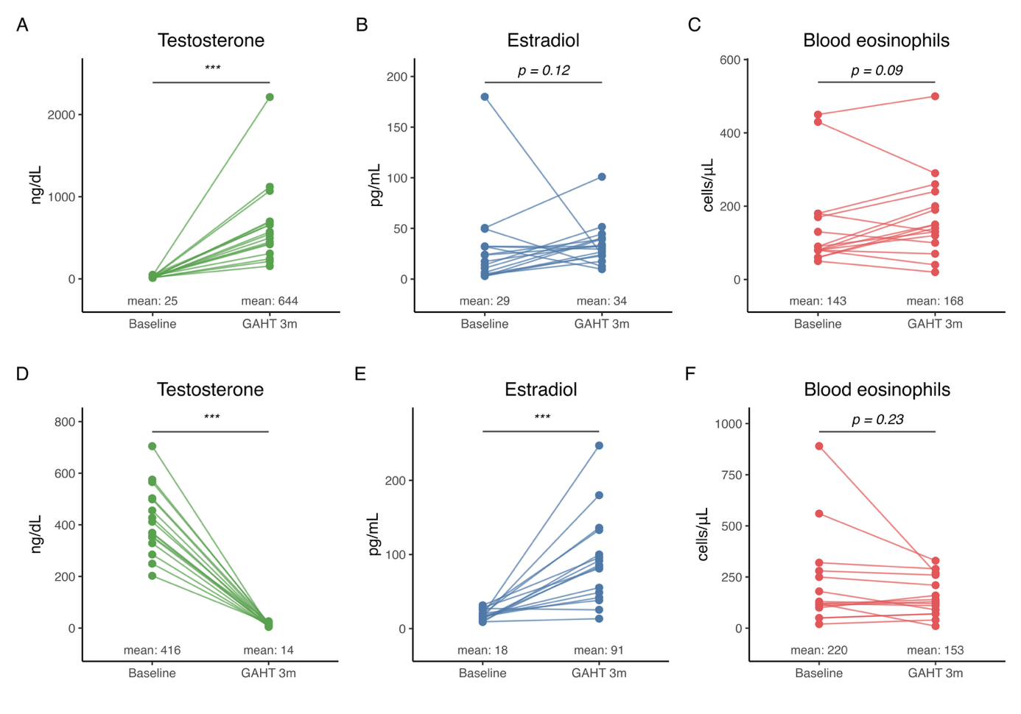
Figure S1: Changes in sex hormone levels and blood eosinophil counts following three months of gender-affirming hormone therapy (GAHT). Paired samples at baseline and after 3 months of GAHT are shown for serum testosterone (A, D), serum estradiol (B, E), and blood eosinophil counts (C, F) in trans men (A-C) and trans women (D-F), respectively. Each dot represents one individual; lines connect paired measurements from the same participant. Group means are displayed below the dots. Statistical comparisons between baseline and 3-month timepoints were performed using the Wilcoxon signed-rank test for paired samples; Significance is indicated as follows: ***p < 0.001; exact p-values are shown for non-significant comparisons.

Table S1: Immunophenotypic profiles used for the identification of the different populations of blood T-cells
FACS-sorted T-cell populations | CD3 | CD4 | CD25 | CD127 | CD183 | CD185 | CD194 | CD196 | CCR10
CD4+ naïve T cells | + | + | - | + | - | - | - | - | -
CD4+ Th1 cells | + | + | -/+ | -/+ | + | - | - | - | -
CD4+ Th2 cells | + | + | lo/+ | -/+ | - | - | + | - | -
CD4+ Th17 cells | + | + | lo/+ | -/+ | - | - | + | + | -
CD4+ Th1/Th17 cells | + | + | lo/+ | -/+ | + | - | - | + | -
CD4+ Th22 cells | + | + | lo/+ | -/+ | - | - | + | + | +
CD4+ CD183+ CD194+ CD196+ CCR10+ | + | + | lo/+ | -/+ | + | - | + | + | +
CD4+ CD183+ CD194+ CD196+ CCR10- | + | + | lo/+ | -/+ | + | - | + | + | -
CD4+ CD183+ CD194+ CD196- CCR10+ | + | + | lo/+ | -/+ | + | - | + | - | +
CD4+ CD183+ CD194+ CD196- CCR10- | + | + | lo/+ | -/+ | + | - | + | - | -
CD4+ CD183- CD194+ CD196- CCR10+ | + | + | lo/+ | -/+ | - | - | + | - | +
CD4+ Tregs | + | + | +hi | +lo | -/+ | -/+ | -/+ | -/+ | -/+
Treg TFH | + | + | -/lo | +lo | -/+ | + | -/+ | -/+ | -
Th1-like TFH | + | + | -/lo | + | + | + | - | - | -
Th2-like TFH | + | + | -/lo | + | - | + | + | - | -
Th17-like TFH | + | + | -/lo | + | - | + | + | + | -
Th1/Th17-like TFH | + | + | -/lo | + | + | + | - | + | -
CD183- CD194- CD196- CCR10- TFH | + | + | -/lo | + | - | + | - | - | -
CD183+ CD194+ CD196+ CCR10- TFH | + | + | -/lo | + | + | + | + | + | -
CD183- CD194- CD196+ CCR10- TFH | + | + | -/lo | + | - | + | + | - | +
CD183+ CD194+ CD196- CCR10- TFH | + | + | -/lo | + | + | + | + | - | +
CD185+ CD4- T cells | + | - | -/lo | + | -/+ | + | -/+ | - | -

Phenotypic profile

Abbreviations (alphabetical order): lo: low expression; TFH: follicular helper T cell; Th: T helper; Tregs: regulatory T cells

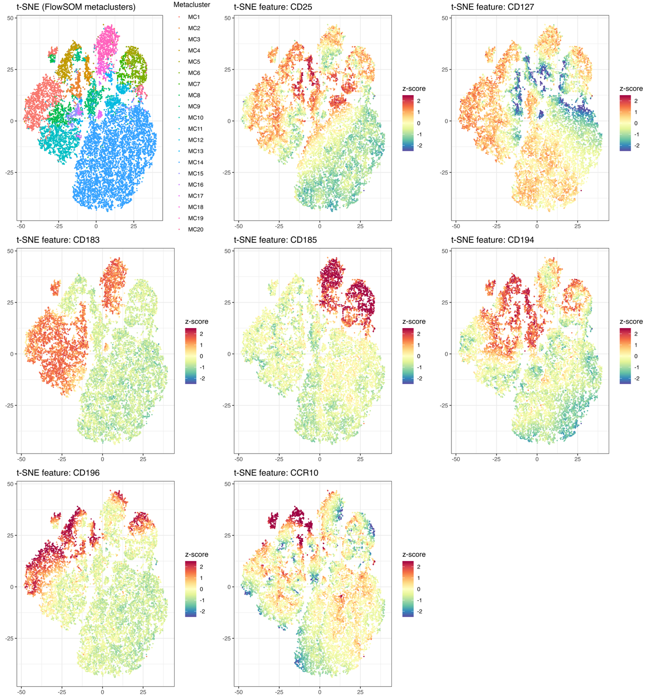

Figure S2: t-SNE plots of the relative marker expression of individual cells in the FlowSOM model, shown for each marker in the FlowSOM model. A representative subset of 20,000 cells was used for this visualization.

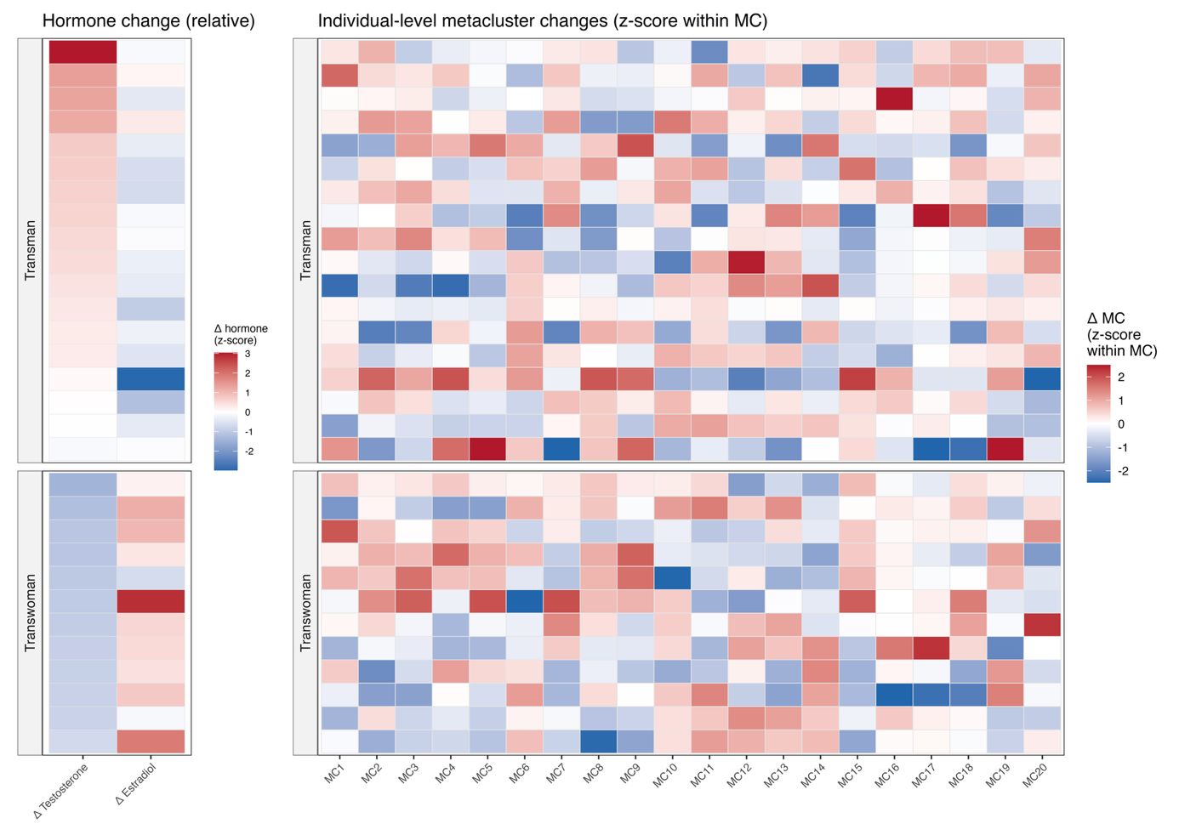
Figure S3: Heatmap of per-individual changes in immune metacluster abundances (z-scores) following 3 months of gender-affirming hormone therapy in trans men and trans women. Trans men and trans women are ordered by largest increase and largest decrease in testosterone levels respectively.

