Supplementary Information
Molecular Modeling of bIm-Substituted Mixed-Linker ZIFs for H₂ Separation: A GCMC and MD Study
Krsna Anand¹, Mohamad Rezi Abdul Hamid^{1,2}, Mohd F. Ismail³, Wan Azlina W.A.K.G^{1,2}, Musab Abdul Razak^{1,2 *}.
¹ Department of Chemical and Environmental Engineering, Universiti Putra Malaysia, Serdang, Selangor 43400, Malaysia
² Sustainable Process Engineering Research Center (SPERC), Faculty of Engineering, Universiti Putra Malaysia, Serdang, Selangor, Malaysia
³ Department of Chemistry, Universiti Putra Malaysia, Serdang, Selangor 43400, Malaysia
* musab@upm.edu.my

Mixed-linker ZIF-7-8 compositions
To maintain this stability criterion, mixed-linker configurations were generated by randomly substituting mIm linkers with bIm linkers while enforcing the constraint that no more than two bIm linkers occupy a single six-membered ring. Therefore, this threshold represents the maximum stable composition at which enhanced polarity and steric confinement can be introduced without compromising the structural integrity. Within each unit cell (uc), this corresponds to the replacement of 4, 8, and 12 mIm linkers with bIm linkers for 11%, 22%, and 33% compositions, respectively (Table S1). The inclusion of intermediate compositions enables a systematic evaluation of structure-property relationships as a function of the bIm content.

Table S1 Mixed-linker ZIF-7-8 compositions investigated in this study

ZIF Variant | bIm incorporation (%) | Number of mIm replaced by bIm per uc
ZIF-8 | 0 | 0
ZIF-7-8 (11% bIm) | 11 | 4
ZIF-7-8 (22% bIm) | 22 | 8
ZIF-7-8 (33% bIm) | 33 | 12
ZIF-7 | 100 | 36
Note: Each SOD unit cell contained 36 linkers; the values indicate the number of mIm linkers replaced by bIm.

Framework models and atom typing

Simulations were conducted on ZIF-8, ZIF-7-8, and ZIF-7 to evaluate the transferability of the selected force fields across chemically similar but structurally distinct frameworks. GCMC simulations were performed using a rigid framework, whereas MD simulations employed a flexible framework to account for dynamic guest-host interactions. The atom types were assigned based on the coordination and chemical environment of each site, ensuring consistent application of the Lennard-Jones (LJ) parameters and electrostatic charges. ZIF-8 served as the reference for atom typing, and extended atom types were introduced for ZIF-7-8 to accommodate benzimidazolate (bIm) linkers. These additions preserved compatibility with the framework topology while enabling an accurate representation of the substituted linkers. Figures S1-S3 present the atom typing schemes used for ZIF-8, ZIF-7-8, and ZIF-7, respectively, illustrating the distinctions among the metal centers, linker atoms, and substituents that are essential for reliable force field assignment in the adsorption and diffusion simulations.
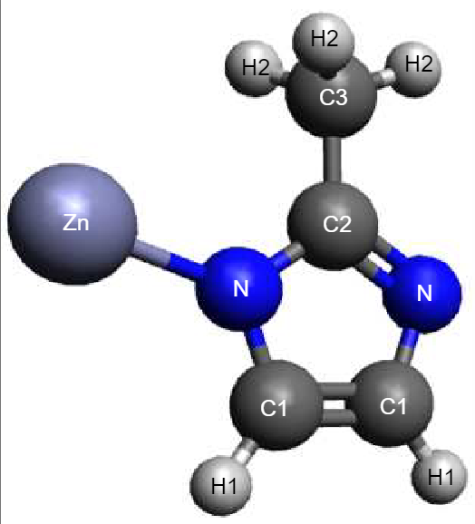
Figure S1 Atom types for ZIF-8

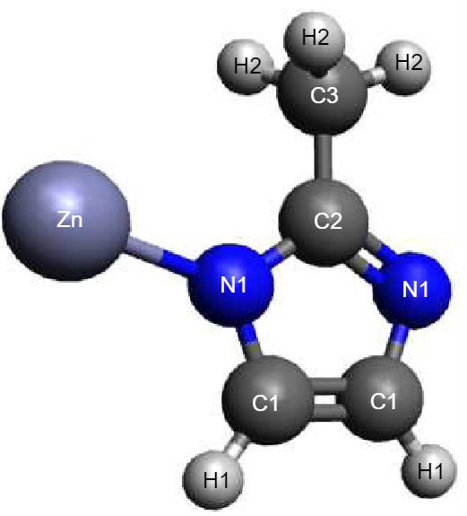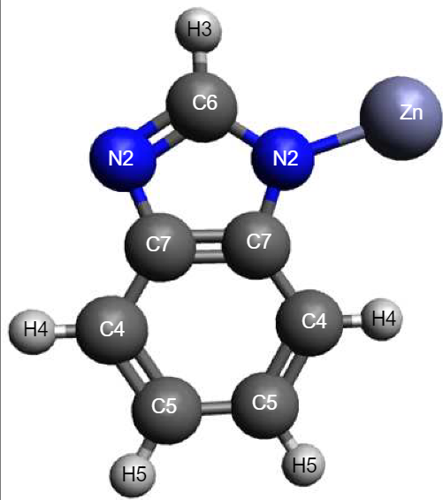
Figure S2 Atom types for ZIF-7-8

Figure S3 Atom types for ZIF-7

Grand canonical Monte Carlo (GCMC)

Force field selection

The selection of an appropriate force field for GCMC simulations was guided by a comparative validation study based on CO₂ adsorption in ZIF-8. Simulations were performed using four force fields: UFF, DREIDING, GenericMOFs, and AMBER [1–4]. The simulated isotherms were benchmarked against literature data for ZIF-8. The LJ parameters corresponding to each tested force field are listed in Table S2. The UFF exhibited the closest agreement with reference uptake data and was therefore adopted for all subsequent GCMC simulations. This choice ensured consistency across systems and preserved compatibility with established modeling protocols.

Table S2 LJ parameters assigned for each framework atom across four force fields (UFF, DREIDING, GenericMOFs, AMBER) used in ZIF-8 adsorption validation

Atom | UFF |  | DREIDING |  | GenericMOFs |  | AMBER
Atom | ε (K) | σ (Å) | ε (K) | σ (Å) | ε (K) | σ (Å) | ε (K) | σ (Å)
C1 | 52.83 | 3.43 | 47.86 | 3.47 | 47.86 | 3.47 | 55.05 | 3.4
C2 | 52.83 | 3.43 | 47.86 | 3.47 | 47.86 | 3.47 | 43.28 | 3.4
C3 | 52.83 | 3.43 | 47.86 | 3.47 | 47.86 | 3.47 | 43.28 | 3.4
H1 | 22.14 | 2.57 | 7.65 | 2.85 | 7.65 | 2.85 | 7.9 | 2.65
H2 | 22.14 | 2.57 | 7.65 | 2.85 | 7.65 | 2.85 | 7.55 | 2.511
N1 | 34.72 | 3.26 | 38.95 | 3.26 | 38.95 | 3.26 | 85.55 | 3.25
Zn | 62.40 | 2.46 | 27.68 | 4.54 | 62.40 | 2.46 | 6.29 | 1.96

Force field parameters for mixed-linker series

The LJ parameters (ε and σ) from UFF [4] assigned to each framework atom type used in the rigid GCMC models for ZIF-8, ZIF-7-8, and ZIF-7 are summarized in Table S3.

Table S3 LJ parameters for ZIF-8, ZIF-7-8, and ZIF-7

Atom type | ε (K) | σ (Å)
C1 | 52.83 | 3.43
C2 | 52.83 | 3.43
C3 | 52.83 | 3.43
C4 | 52.83 | 3.43
C5 | 52.83 | 3.43
C6 | 52.83 | 3.43
C7 | 52.83 | 3.43
H1 | 22.14 | 2.57
H2 | 22.14 | 2.57
H3 | 22.14 | 2.57
H4 | 22.14 | 2.57
H5 | 22.14 | 2.57
N1 | 34.72 | 3.26
N2 | 34.72 | 3.26
Zn | 62.40 | 2.46

Molecular dynamics (MD)

For the MD simulations, the frameworks were treated as fully flexible, using the force field parameters reported by Krokidas et al. [5], with the complete parameter set summarized in Tables S4-S12.

ZIF-8

Table S4 Bond stretching and angle bending parameters for ZIF-8

Bond | l₀ (Å) | k_{l} (kJ/mol/nm²) | Angle | θ₀ (degrees) | k_{θ} (kJ/mol/rad²)
Zn-N1 | 2.048 | 52802.1 | N1-Zn-N1 | 109.5 | 296.23
N1-C2 | 1.360 | 257818.1 | Zn-N1-C2 | 130.3 | 462.75
N1-C1 | 1.376 | 253048.3 | Zn-N1-C1 | 125.1 | 475.30
C1-C1 | 1.375 | 339991.8 | C1-N1-C2 | 104.5 | 1077.80
C1-H1 | 1.077 | 327690.9 | C1-C1-N1 | 107.9 | 909.61
C2-C3 | 1.498 | 203760.8 | C1-C1-H1 | 130.6 | 552.29
C3-H2 | 1.091 | 286855.0 | C2-C3-H2 | 110.8 | 565.68
 |  |  | H2-C3-H2 | 108.1 | 317.98
 |  |  | N1-C2-N1 | 113.8 | 955.63
 |  |  | N1-C2-C3 | 123.1 | 958.97
 |  |  | N1-C1-H1 | 121.5 | 549.78

Table S5 Torsional potential parameters for ZIF-8

Dihedral | φ₀ (degrees) | m | k_{φ} (kJ/mol) | Source
N1-C1-C1-N1 | 180 | 2 | 90.0 | AMBER
N1-C1-C1-H1 | 180 | 2 | 90.0 | AMBER
C1-C1-N1-Zn | 180 | 2 | 25.1 | AMBER
C1-C1-N1-C2 | 180 | 2 | 25.1 | AMBER
C3-C2-N1-Zn | 180 | 2 | 41.8 | AMBER
C3-C2-N1-C1 | 180 | 2 | 41.8 | AMBER

Table S6 LJ parameters for ZIF-8

Atom type | ε (kJ/mol) | σ (nm)
Zn | 0.0523 | 0.196
N1 | 0.71128 | 0.325
C1 | 0.35982 | 0.340
C2 | 0.35982 | 0.340
C3 | 0.45773 | 0.340
H1 | 0.06276 | 0.251
H2 | 0.06569 | 0.265

ZIF-7-8

Table S7 Bond stretching and angle bending parameters for ZIF-7-8 series

Bond | l₀ (Å) | k_{l} (kJ/mol/nm²) | Angle | θ₀ (degrees) | k_{θ} (kJ/mol/rad²)
Zn-N1 | 2.041 | 55479.8 | N1-Zn-N1 | 109.9 | 292.0432
N1-C2 | 1.361 | 258152.8 | Zn-N1-C2 | 130 | 454.3824
N1-C1 | 1.376 | 262169.4 | Zn-N1-C1 | 125.4 | 465.2608
C1-C1 | 1.375 | 340912.3 | C1-N1-C2 | 104.5 | 1072.7776
C1-H1 | 1.091 | 327690.9 | C1-C1-N1 | 107.8 | 912.9488
C2-C3 | 1.498 | 204095.5 | C1-C1-H1 | 128.6 | 533.8784
C3-H2 | 1.091 | 286436.6 | C2-C3-H2 | 110.8 | 561.4928
Zn-N2 | 2.067 | 45354.8 | H2-C3-H2 | 108.1 | 321.3312
C4-C5 | 1.390 | 320896.1 | N1-C2-N1 | 113.8 | 973.1984
C4-C7 | 1.398 | 316335.5 | N1-C2-C3 | 123.1 | 970.688
C5-C5 | 1.408 | 282671.0 | N1-C1-H1 | 121.6 | 550.6144
C5-H5 | 1.083 | 307088.9 | N2-Zn-N2 | 109.9 | 292.88
C6-N2 | 1.357 | 274554.1 | N1-Zn-N2 | 109.9 | 292.88
C6-H3 | 1.08 | 315967.3 | C6-N2-C7 | 103.4 | 1253.5264
C7-N2 | 1.379 | 264094.1 | N2-C6-N2 | 117 | 1030.1008
C7-C7 | 1.425 | 229517.5 | Zn-N2-C6 | 124 | 454.3824
 |  |  | Zn-N2-C7 | 132.6 | 497.0592
 |  |  | N2-C7-C4 | 131.7 | 1287.8352
 |  |  | C7-C4-H4 | 120.9 | 543.0832
 |  |  | C7-C4-C5 | 117.9 | 1338.88
 |  |  | H4-C4-C5 | 121.2 | 563.1664
 |  |  | C4-C5-C5 | 121.4 | 1571.5104
 |  |  | N2-C6-H3 | 120.6 | 500.4064
 |  |  | C7-C7-C4 | 120.6 | 1453.5216
 |  |  | C4-C5-H5 | 119.2 | 542.2464
 |  |  | C5-C5-H5 | 119.3 | 541.4096
 |  |  | C7-C7-N2 | 107.8 | 912.948

Table S8 Torsional potential parameters for ZIF-7-8 series

Dihedral | φ₀ (degrees) | m | k_{φ} (kJ/mol) | Source
N1-C1-C1-N1 | 180 | 2 | 90.0 | AMBER
N1-C1-C1-H1 | 180 | 2 | 90.0 | AMBER
C1-C1-N1-Zn | 180 | 2 | 25.1 | AMBER
C1-C1-N1-C2 | 180 | 2 | 25.1 | AMBER
C3-C2-N1-Zn | 180 | 2 | 41.8 | AMBER
C3-C2-N1-C1 | 180 | 2 | 41.8 | AMBER
C7-C4-C5-C5 | 180 | 2 | 60.7 | AMBER
C7-C7-C4-C5 | 180 | 2 | 58.6 | AMBER
N2-C7-C7-N2 | 180 | 2 | 91.2 | AMBER
C7-C4-C5-C5 | 180 | 2 | 58.6 | AMBER
C4-C5-C5-C4 | 180 | 2 | 60.7 | AMBER
C7-C7-N2-C6 | 180 | 2 | 21.3 | AMBER
C7-C7-N2-Zn | 180 | 2 | 21.3 | AMBER
C4-C7-N2-C6 | 180 | 2 | 21.3 | AMBER
C7-C7-C4-H1 | 180 | 2 | 58.6 | AMBER
C4-C7-C7-N2 | 180 | 2 | 91.2 | AMBER
C7-N2-C6-H3 | 180 | 2 | 83.7 | AMBER

Table S9 LJ parameters for ZIF-7-8 series

Atom type | ε (kJ/mol) | σ (nm)
Zn | 0.0523 | 0.196
N1 | 0.71128 | 0.325
N2 | 0.71128 | 0.325
C1 | 0.35982 | 0.340
C2 | 0.35982 | 0.340
C3 | 0.45773 | 0.340
C4 | 0.35982 | 0.340
C5 | 0.35982 | 0.340
C6 | 0.35982 | 0.340
C7 | 0.35982 | 0.340
H1 | 0.06276 | 0.251
H2 | 0.06569 | 0.265
H3 | 0.06276 | 0.251
H4 | 0.06276 | 0.251
H5 | 0.06276 | 0.251

ZIF-7

Table S10 Bond stretching and angle bending parameters for ZIF-7

Bond | l₀ (Å) | k_{l} (kJ/mol/nm²) | Angle | θ₀ (degrees) | k_{θ} (kJ/mol/rad²)
Zn-N2 | 2.067 | 45354.8 | N2-Zn-N2 | 109.9 | 292.88
C4-C5 | 1.39 | 320896.1 | C6-N2-C7 | 103.4 | 1253.5264
C4-C7 | 1.398 | 316335.5 | N2-C6-N2 | 117 | 1030.1008
C5-C5 | 1.408 | 282671 | Zn-N2-C6 | 124 | 454.3824
C5-H5 | 1.083 | 307088.9 | Zn-N2-C7 | 132.6 | 497.0592
C6-N2 | 1.357 | 274554.1 | N2-C7-C4 | 131.7 | 1287.8352
C6-H3 | 1.08 | 315967.3 | C7-C4-H4 | 120.9 | 543.0832
C7-N2 | 1.379 | 264094.1 | C7-C4-C5 | 117.9 | 1338.88
C7-C7 | 1.425 | 229517.5 | H4-C4-C5 | 121.2 | 563.1664
 |  |  | C4-C5-C5 | 121.4 | 1571.5104
 |  |  | N2-C6-H3 | 120.6 | 500.4064
 |  |  | C7-C7-C4 | 120.6 | 1453.5216
 |  |  | C4-C5-H5 | 119.2 | 542.2464
 |  |  | C5-C5-H5 | 119.3 | 541.4096
 |  |  | C7-C7-N2 | 107.8 | 912.948

Table S11 Torsional potential parameters for ZIF-7

Dihedral | φ₀ (degrees) | m | k_{φ} (kJ/mol) | Source
C7-C4-C5-C5 | 180 | 2 | 60.7 | AMBER
C7-C7-C4-C5 | 180 | 2 | 58.6 | AMBER
N2-C7-C7-N2 | 180 | 2 | 91.2 | AMBER
C7-C4-C5-C5 | 180 | 2 | 58.6 | AMBER
C4-C5-C5-C4 | 180 | 2 | 60.7 | AMBER
C7-C7-N2-C6 | 180 | 2 | 21.3 | AMBER
C7-C7-N2-Zn | 180 | 2 | 21.3 | AMBER
C4-C7-N2-C6 | 180 | 2 | 21.3 | AMBER
C7-C7-C4-H4 | 180 | 2 | 58.6 | AMBER
C4-C7-C7-N2 | 180 | 2 | 91.2 | AMBER
C7-N2-C6-H3 | 180 | 2 | 83.7 | AMBER

Table S12 LJ parameters for ZIF-7

Atom type | ε (kJ/mol) | σ (nm)
Zn | 0.0523 | 0.196
N2 | 0.71128 | 0.325
C4 | 0.35982 | 0.34
C5 | 0.35982 | 0.34
C6 | 0.35982 | 0.34
C7 | 0.35982 | 0.34
H3 | 0.06276 | 0.251
H4 | 0.06276 | 0.251
H5 | 0.06276 | 0.251

Partial atomic charges

The partial atomic charges for all atoms in the models were adopted from the charge assignment scheme reported by Krokidas et al. [5] and are summarized in Table S13.

Table S13 Partial atomic charges

ZIF-8 |  | ZIF-7-8 |  | ZIF-7
Atom type | Partial charge (e) | Atom type | Partial charge (e) | Atom type | Partial charge (e)
Zn | 1.3429 | Zn | 1.32166 | Zn | 1.32166
N1 | -0.6822 | N1 | -0.70866 | N2 | -0.84838
C1 | -0.0622 | N2 | -0.84838 | C4 | -0.32831
C2 | 0.7551 | C1 | -0.06837 | C5 | -0.21293
C3 | -0.2697 | C2 | 0.891271 | C6 | 0.542901
H1 | 0.0912 | C3 | -0.6423 | C7 | 0.467788
H2 | 0.0499 | C4 | -0.32831 | H3 | 0.04479
 |  | C5 | -0.21293 | H4 | 0.164378
 |  | C6 | 0.542901 | H5 | 0.130283
 |  | C7 | 0.467788
 |  | H1 | 0.098158
 |  | H2 | 0.149989
 |  | H3 | 0.04479
 |  | H4 | 0.164378
 |  | H5 | 0.130283

Determination of the bIm substitution limit from pore geometry and diffusion selectivity

This section analyzes the evolution of pore geometry (largest cavity diameter (LCD) and pore-limiting diameter (PLD)) and diffusion selectivity (H₂/CH₄ and H₂/CO₂) across the ZIF-7-8 compositional series to determine the upper substitution limit of bIm. By correlating structural descriptors with transport properties, the substitution level at which pore constriction begins to significantly affect diffusion performance can be identified.

Pore geometry descriptors and structural analysis

In the SOD topology, each six-membered aperture is formed by six imidazolate-type linkers surrounding a Zn-centered tetrahedral cage. Mixed-linker ZIF-7-8 structures were generated by substituting the mIm linkers with bIm linkers at different compositions. Previous studies have shown that when more than two bIm linkers occupy a six-membered ring (more than 35%), steric strain and pore contraction become significant [5]. The pore characteristics of ZIF-8, ZIF-7, and intermediate ZIF-7-8 frameworks were quantified using geometric descriptors (LCD and PLD) computed with Zeo++[6], which are summarized in Table S14. ZIF-8 and mixed-linker frameworks with 11% and 22% bIm maintain large pore dimensions (LCD = 11.39 Å, PLD = 3.41 Å), indicating an open pore structure. At 33% bIm substitution, both LCD and PLD decreased significantly (LCD = 9.12 Å and PLD = 2.54 Å), indicating the onset of pore contraction. At higher bIm contents (44-61%), the pore dimensions approached those of ZIF-7 (LCD = 5.59 Å, PLD = 2.54 Å), reflecting progressive framework densification and reduced pore accessibility. The results indicate that 33% bIm represents the transition composition at which the framework begins to contract while retaining its SOD topology. Beyond this composition, the pore descriptors converged toward those of ZIF-7, with minimal further change in the PLD, indicating that higher bIm substitutions produce structures that are geometrically and transport-wise similar to ZIF-7. Thus, the upper substitution limit for the GCMC and MD simulations was set to 33% bIm, corresponding to the onset of framework contraction.

Table S14 Pore structure descriptors of ZIF-8, mixed-linker ZIF-7-8, and ZIF-7

Structure | LCD (Å) | PLD (Å)
ZIF-8 | 11.3874 | 3.4075
ZIF-7-8 (11% bIm) | 11.3874 | 3.4075
ZIF-7-8 (22% bIm) | 9.1167 | 2.5441
ZIF-7-8 (33% bIm) | 8.5078 | 2.5441
ZIF-7-8 (44% bIm) | 8.5078 | 2.5441
ZIF-7-8 (55% bIm) | 8.5078 | 2.5441
ZIF-7-8 (61% bIm) | 5.5880 | 2.5417
ZIF-7 | 11.3874 | 3.4075

Diffusivity and selectivity data

The self-diffusivities of CO₂, CH₄, and H₂ were calculated for the ZIF-7-8 compositional series obtained by progressively substituting mIm with bIm (11-61% bIm). The diffusion selectivities (H₂/CH₄ and H₂/CO₂) were determined from the corresponding diffusivity ratios. Table S15 summarizes the calculated diffusivities and selectivities for ZIF-8, mixed-linker ZIF-7-8, and ZIF-7. Increasing the bIm substitution reduces the gas diffusivity owing to progressive pore narrowing, and the selectivity increases up to 33% bIm and decreases or fluctuates at higher substitution levels. This behavior indicates a loss of structural coherence and the onset of partially blocked or distorted diffusion pathways. ZIF-7 exhibited moderate selectivity, which is consistent with its rigid framework and constricted window environment. The diffusion selectivity increased with bIm substitution, reached an optimum at 33% bIm, and decreased beyond this composition, indicating that 33% bIm represents the optimal substitution level.

Table S15 Self-diffusivities and diffusion selectivities (H₂/CH₄ and H₂/CO₂) for ZIF-8, mixed-linker ZIF-7-8, and ZIF-7

Structure | D_{CO2} (m²/s) | D_{CH4} (m²/s) | D_{H2} (m²/s) | S_{H2/CH4} | S_{H2/CO2}
ZIF-8 | 7.93×10⁻¹¹ | 2.72×10⁻⁹ | 2.27×10⁻⁸ | 8.33 | 285.92
ZIF-7-8 (11%bIm) | 7.75×10⁻¹¹ | 1.81×10⁻⁹ | 2.38×10⁻⁸ | 13.15 | 307.32
ZIF-7-8 (22%bIm) | 6.96×10⁻¹¹ | 1.47×10⁻⁹ | 2.18×10⁻⁸ | 14.84 | 313.15
ZIF-7-8 (33%bIm) | 5.34×10⁻¹¹ | 1.04×10⁻⁹ | 2.13×10⁻⁸ | 20.48 | 399.60
ZIF-7-8 (44%bIm) | 1.03×10⁻¹⁰ | 7.08×10⁻¹⁰ | 5.04×10⁻⁹ | 7.13 | 49.00
ZIF-7-8 (55%bIm) | 6.29×10⁻¹¹ | 4.24×10⁻¹⁰ | 6.88×10⁻⁹ | 16.21 | 109.30
ZIF-7-8 (61%bIm) | 4.88×10⁻¹¹ | 1.48×10⁻¹⁰ | 2.86×10⁻⁹ | 19.38 | 58.72
ZIF-7 | 2.23×10⁻¹¹ | 7.85×10⁻¹¹ | 1.42×10⁻⁹ | 18.04 | 63.49

References

1. Mayo SL, Olafson BD, Goddard WA (1990) DREIDING: a generic force field for molecular simulations. J Phys Chem 94:8897–8909. https://doi.org/10.1021/j100389a010
2. Hertäg L, Bux H, Caro J, Chmelik C, Remsungnen T, Knauth M, Fritzsche S (2011) Diffusion of CH4 and H2 in ZIF-8. J Memb Sci 377:36–41. https://doi.org/10.1016/j.memsci.2011.01.019
3. Wu X, Huang J, Cai W, Jaroniec M (2014) Force field for ZIF-8 flexible frameworks: atomistic simulation of adsorption, diffusion of pure gases as CH₄, H₂, CO₂ and N₂. RSC Adv 4:16503–16511. https://doi.org/10.1039/C4RA00664J
4. Rappe AK, Casewit CJ, Colwell KS, Goddard WA, Skiff WM (1992) UFF, a full periodic table force field for molecular mechanics and molecular dynamics simulations. J Am Chem Soc 114:10024–10035. https://doi.org/10.1021/ja00051a040
5. Krokidas P, Moncho S, Brothers EN, Castier M, Jeong H-K, Economou IG (2018) On the Efficient Separation of Gas Mixtures with the Mixed-Linker Zeolitic-Imidazolate Framework-7-8. ACS Appl Mater Interfaces 10:39631–39644. https://doi.org/10.1021/acsami.8b12605
6. Willems TF, Rycroft CH, Kazi M, Meza JC, Haranczyk M (2012) Algorithms and tools for high-throughput geometry-based analysis of crystalline porous materials. Microporous and Mesoporous Materials 149:134–141. https://doi.org/10.1016/j.micromeso.2011.08.020

