Supporting Information

On the development of sustainable covalent adaptable networks based on epoxidized soybean oil acrylate and cystamine

Leonardo Giribaldi¹, Giacomo Damonte¹, Alberto Fina², Camilla Noè³, Alessandro Pellis^{1*}, Orietta Monticelli^{1*}
¹Dipartimento di Chimica e Chimica Industriale, Università degli Studi di Genova, Via Dodecaneso 31, 16146 Genoa, Italy
²Dipartimento di Scienza Applicata e Tecnologia, Politecnico di Torino, Viale Teresa Michel 5, Alessandria, Italy
³Dipartimento di Scienza Applicata e Tecnologia, Politecnico di Torino, C.so Duca Degli Abruzzi 24, 10129 Torino, Italy

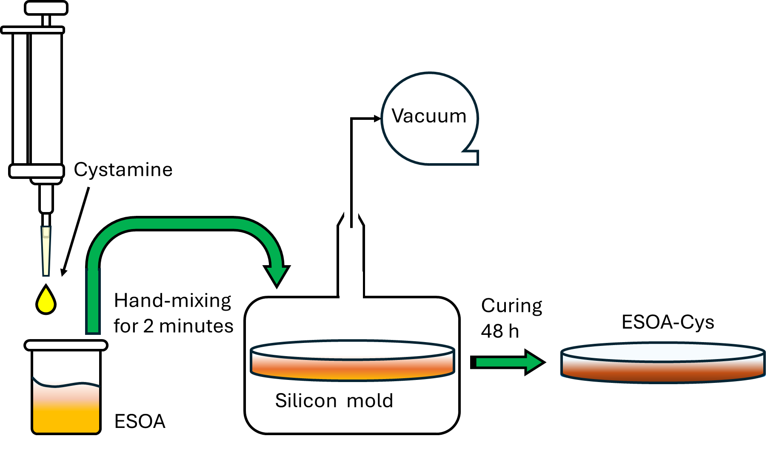
Fig. S1 Scheme of preparation of ESOA-Cys formulations

Fig. S2 FT-IR spectrum of Cys

Fig. S3 FT-IR spectrum of ESOA
30 °C |  | 50 °C |  | 100 °C
Time (h) | Normalized peak area (a.u.) | Time (h) | Normalized peak area (a.u.) | Time (h) | Normalized peak area (a.u.)
0 | 1 | 0 | 1 | 0 | 1
0.5 | 0.827 | 0.25 | 0.851 | 0.028 | 0.156
1 | 0.437 | 0.5 | 0.645 | 0.054 | 0.079
1.5 | 0.309 | 0.75 | 0.458 | 0.117 | 0.034
2 | 0.278 | 1 | 0.246 | 0.167 | 0.003
3 | 0.161 | 1.25 | 0.171 | 0.233 | 0
4 | 0.143 | 1.5 | 0.0898 | - | -
5 | 0.072 | 1.75 | 0.038 | - | -
6 | 0.052 | 2 | 0.064 | - | -
24 | 0 | 2.5 | 0.023 | - | -
- | - | 3 | 0.019 | - | -
- | - | 4 | 0 | - | -
Table S1 FT-IR peak areas for the curing process of ESOA-Cys_1:1. Red data values were used for kinetic fitting.

30 °C |  | 50 °C |  | 100 °C
Time (h) | Normalized peak area (a.u.) | Time (h) | Normalized peak area (a.u.) | Time (h) | Normalized peak area (a.u.)
0 | 1 | 0 | 1 | 0 | 1
1 | 0.785 | 0.25 | 0.735 | 0.017 | 0.673
1.5 | 0.878 | 0.5 | 0.534 | 0.083 | 0.523
2 | 0.750 | 0.75 | 0.418 | 0.133 | 0.513
4 | 0.647 | 1 | 0.374 | 0.171 | 0.506
5 | 0.598 | 1.25 | 0.321 | 0.275 | 0.466
6 | 0.509 | 1.5 | 0.421 | - | -
24 | 0.359 | 1.75 | 0.258 | - | -
48 | 0.335 | 2 | 0.283 | - | -
- | - | 2.5 | 0.281 | - | -
- | - | 3 | 0.279 | - | -
- | - | 4 | 0.253 | - | -
- | - | 5 | 0.272 | - | -
- | - | 6 | 0.167 | - | -
Table S2. FT-IR peak areas for the curing process of ESOA-Cys_2:1. Red data values were used for kinetic fitting.

Fig. S4 FT-IR spectrum of ESOA-Cys_1:1_100_48 (red) and ESOA-Cys_2:1_100_48 (blue)

Fig. S5 FT-IR calculated conversions relative to curing processes of ESOA-Cys_1:1 (a) and ESOA-Cys_2:1 (b) mixtures at 30 °C (blue), 50 °C (green), and 100 °C (red)

$\text{ln}\left(\frac{{\text{C}}_{\text{a}}^{\text{0}}}{{\text{C}}_{\text{a}}\left(\text{t}\right)}\right)\text{=}\text{ln}\left(\text{X}\left(\text{t}\right)\text{-1}\right)\text{=}\text{kt}$ (S1)

$\frac{\text{1}}{{\text{C}}_{\text{a}}\text{(t)}}\text{=}\frac{\text{1}}{{\text{C}}_{\text{a}}^{\text{0}}}\text{+ kt}$ (S2)

Table S3. Fitting line equations and determination coefficients for ESOA-Cys formulation at different temperatures
Sample | T [°C] | Fitting line equation Pseudo-first-order | R^{2*} | Fitting line equation Pseudo-second-order | R^{2**}
ESOA-Cys_1:1 | 30 | y = 0.4782x + 0.2036 | 0.9651 | y = 1.425x - 0.4391 | 0.906
ESOA-Cys_1:1 | 50 | y = 1.4952x - 0.0883 | 0.9517 | y = 17.55x - 8.1794 | 0.841
ESOA-Cys_1:1 | 100 | y = 11.851x + 0.5183 | 0.9358 | y = 143.14x - 10.093 | 0.676
ESOA-Cys_2:1 | 30 | y = 0.1161x + 0.114 | 0.9124 | y = 0.0551x + 0.3309 | 0.9444
ESOA-Cys_2:1 | 50 | y = 1.0135x + 0.0517 | 0.9733 | y = 0.4076x + 0.2285 | 0.9914
ESOA-Cys_2:1 | 100 | y = 1.3534x + 0.2042 | 0.7194 | y = 0.6025x + 0.3723 | 0.7738
*: Valid for the pseudo-first-order equation. **: Valid for the pseudo-second-order equation

Fig. S6 Second-order kinetic integral function for ESOA-Cys_2:1 at 50 °C, showing the change in linearity above 60% conversion

$k \text{= }\text{A }\text{∙ }{\text{e}}^{\text{(}\frac{\text{-}{\text{E}}_{\text{a}}}{\text{RT}}\text{)}}$ (S3)

$\text{ln}\left(\text{k}\right)\text{ = }\text{ln}\left(\text{A}\right) \text{- (}\frac{{\text{E}}_{\text{a}}}{\text{R}}\text{) ∙ (}\frac{\text{1}}{\text{T}}\text{)}$ (S4)

Fig. S7 First heating DSC thermogram of ESOA

Fig. S8 First heating DSC thermogram of Cys

Fig. S9 First heating DSC thermograms of ESOA-Cys_1:1 (a), and ESOA-Cys_2:1 (b) at different curing times at 100 °C: 0 minutes (green), 5 minutes (light green), 10 minutes (yellow), 20 minutes (orange), 40 minutes (red), 48 hours (brown)

Fig. S10 DSC First heating curves of ESOA-Cys_1:1_100_48 (red) and ESOA-Cys_2:1_100_48 (blue)

Fig. S11 TGA (a) and DTG (b) curves of: ESOA (green), Cys (grey), ESOA-Cys_1:1_100_48 (red), and ESOA-Cys_2:1_100_48 (blue)

Fig. S12 Isothermal TGA curves at 180 °C for ESOA-Cys_1:1_100_48 (red) and ESOA-Cys_2:1_100_48 (blue)

Fig. S13 Frequency sweep plate-plate rheometer plots for ESOA-Cys_1:1_100_48 and ESOA-Cys_2:1_100_48. Tests were carried out at 180°C and 0.5% deformation between 0.01 and 100 rad/s

Table S4: Stress-relaxation characteristic times
Sample | τ _{@T=170°C} [min] | τ _{@T=165°C} [min] | τ _{@T=160°C} [min] | τ _{@T=155°C} [min] | τ _{@T=150°C} [min]
ESOA-Cys_1:1_100_48 | 2.5 | 3 | 6 | 13.5 | 33
ESOA-Cys_2:1_100_48 | 17 | 48 | 146 | 377* | 919*
*:Values predicted with the stretched exponential fitting.

Fig. S14 Representative photos of the ESOA-Cys_1:1_100_48 specimens recovered after hot pressing during the recycling tests at: 160 °C (a), 170 °C (b), 180 °C (c)

Fig. S15 FTIR spectra of ESOA-Cys_2:1_100_48 before and after several hot pressing cycles

Fig. S16 Representative photos of the ESOA-Cys_2:1_100_48 before (a and b) and after (c) the self-healing test

