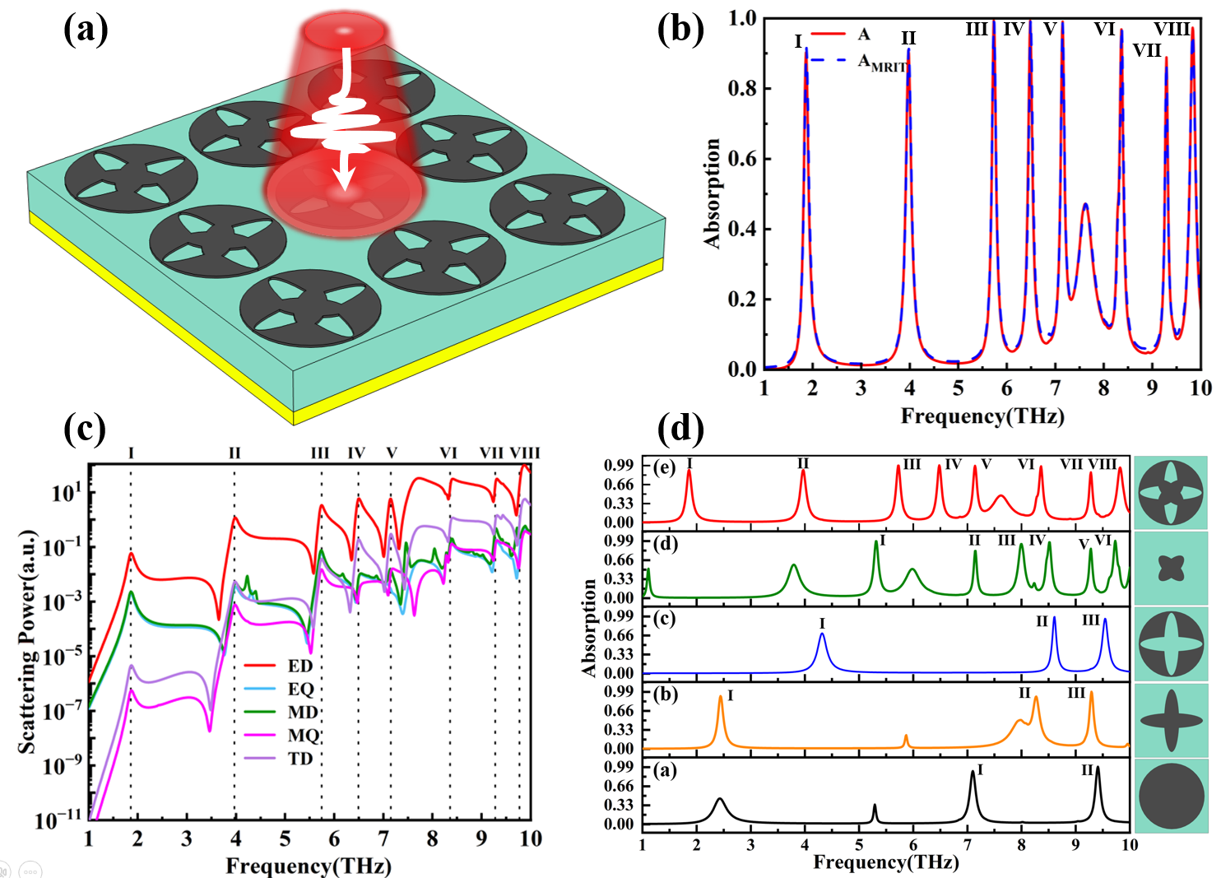
Fig. (a) depicts the schematic of the terahertz perfect absorber structural array; (b) Comparative absorption spectra: simulated versus analytical MIRT results for the device; (c) Multipole analysis within the range of 1-10 THz; (d) Absorption Spectra Corresponding to Each Structure During the Absorption Rate Optimization Process
Graphical abstract: This study designs a patterned graphene terahertz absorber integrated with cross slots and a central petal unit. Via electric dipole-dominated multimode resonant absorption modes, it excites 8 narrowband absorption peaks within 1-10 THz, featuring polarization insensitivity, wide-angle stability, and high sensitivity, thus being suitable for multi-channel sensing applications.

