Supplemental data

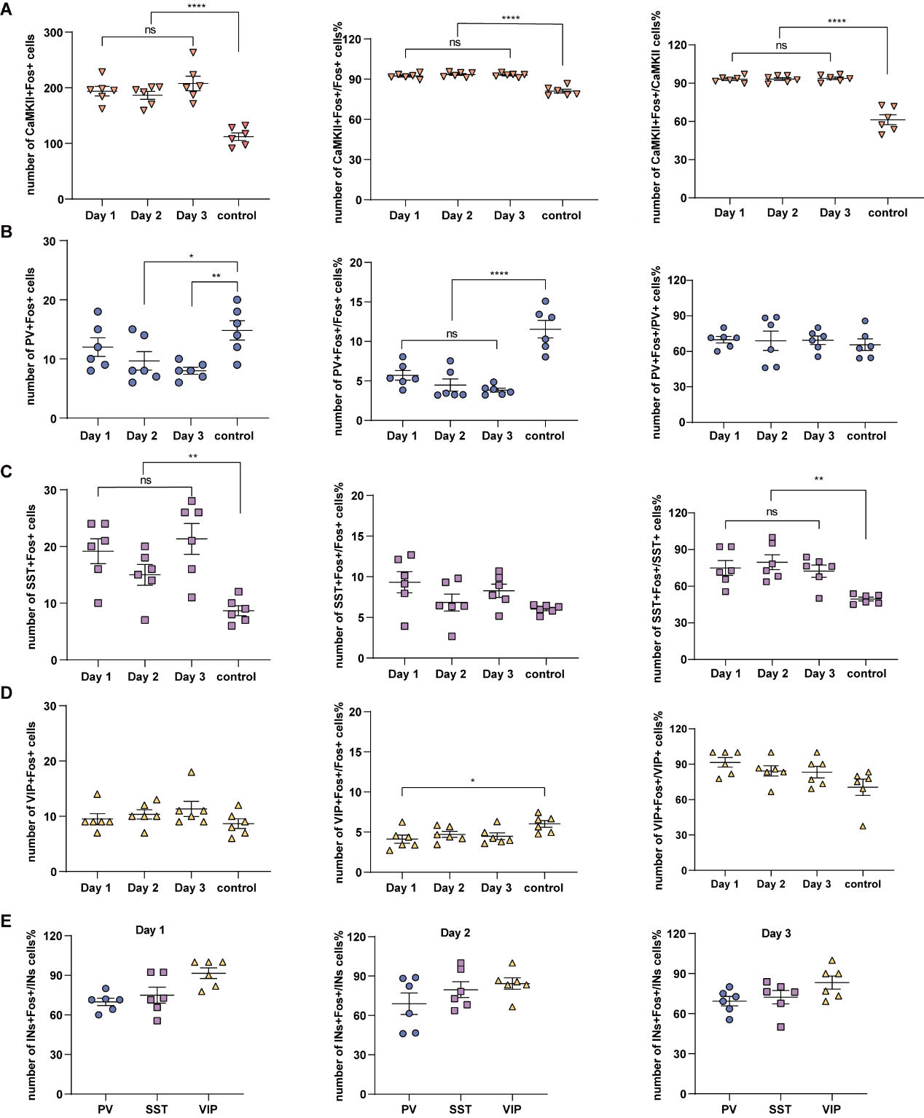
Fig. S1: Statistical analysis of CaMKIIα, PV, SST, and VIP neurons during the three stages of fear-conditioned behavior.
(A) Comparison of counting results for CaMKIIα neurons. Right: percentage of CaMKII+Fos+ cells relative to total CaMKII cells. (B) Comparison of counting results for PV neurons. (C) Comparison of counting results for SST neurons. (D) Comparison of counting results for VIP neurons. (E) Statistical chart showing the proportion of IN+Fos+ neurons at various stages of conditioned fear behavior in INs. All statistical variances in the data presented in the charts that conform to normal distribution and homogeneity of variance were analyzed using one-way ANOVA followed by simple effects analysis. Data that did not conform to normal distribution or exhibited heterogeneity of variance were analyzed using the Kruskal-Wallis H test and Nemenyi multiple comparisons test. Significant differences were identified as follows: *P < 0.05, **P < 0.01, ***P < 0.001, ****P < 0.0001. Data are presented as mean ± SEM.

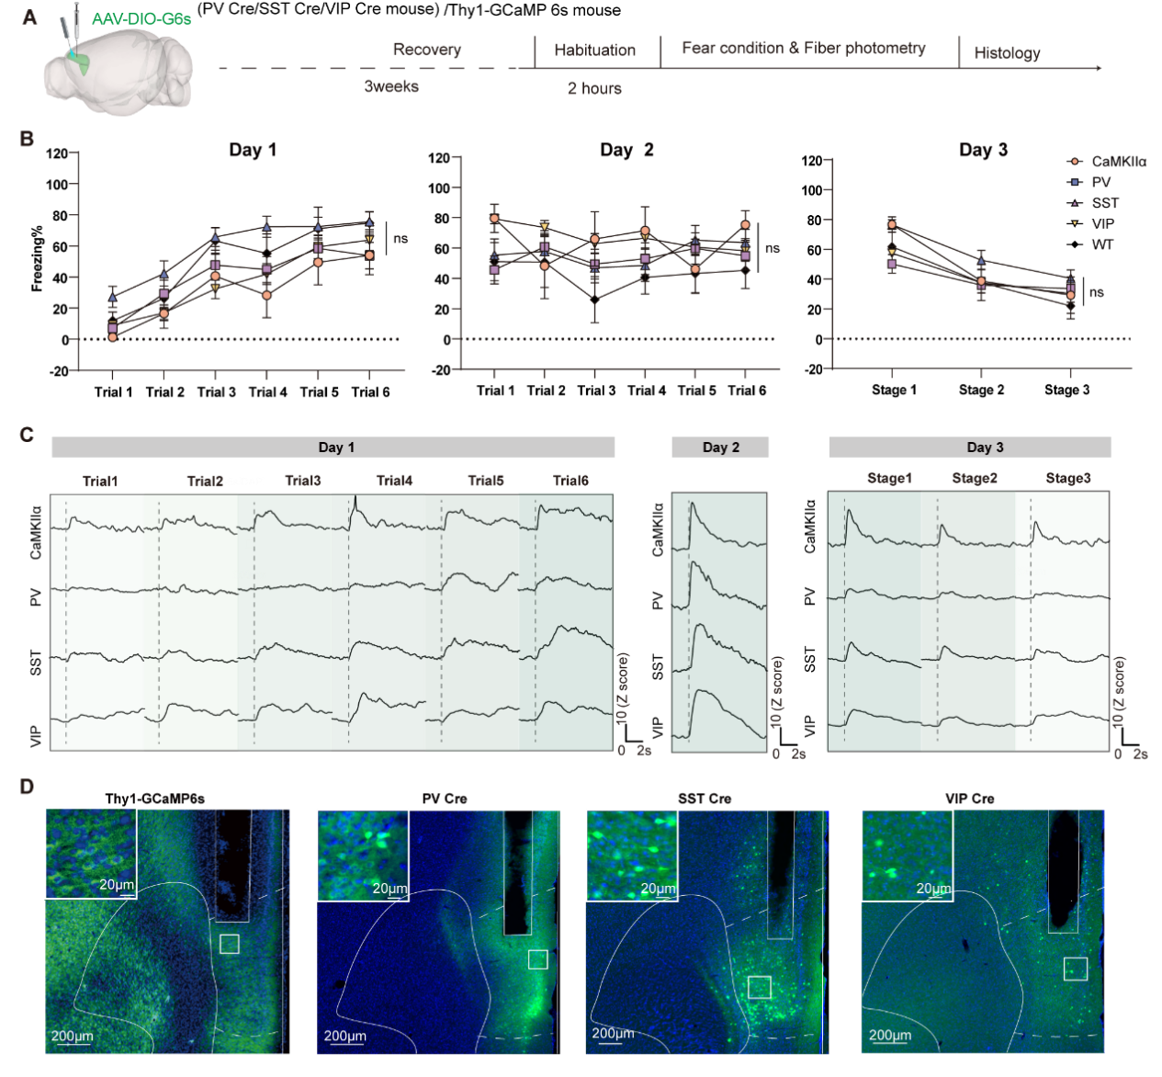
Fig. S2: Single-color, multi-channel photometry recording reveals the activation status of four neuron types during conditioned fear behavior.
(A) Flowchart of virus injection and behavioral testing. For Ca2+-based imaging of CaMKII, PV, SST, and VIP interneuron activity, GCaMP6s was injected into PV-Cre, SST-Cre, and VIP-Cre mice using a conditional vector encoding GCaMP6s. A single optic fiber was implanted targeting the prefrontal cortex. Scale bar = 200 μm. (B) The line chart illustrates the trend of freezing behavior during the 3-day behavioral test across the GCaMP6s, PV-Cre, SST-Cre, VIP-Cre, and WT groups. Days 1 and 2 represent the trend over 6 trials each, while Day 3 represents the trend across the first, middle, and last 3 stages (a total of 15 trials, with every 5 trials recorded as one stage). The rate of change in freezing behavior and the behavioral process were tracked and recorded using the built-in Behavior Tracking Master 4.0 system of the conditional fear box. Results were analyzed after daily behavioral testing. Data conforming to normal distribution and homogeneity of variance were analyzed using one-way ANOVA (Day 1: P = 0.2327; Day 2: P = 0.1726; Day 3: P = 0.7799). Data are presented as mean ± SEM. (C) Waveforms of calcium signals in CaMKIIα, PV, SST, and VIP neurons during different stages of conditioned fear. Sample sizes were n = 6 mice for the GCaMP6s and VIP-Cre groups, n = 7 mice for the PV-Cre group, and n = 10 mice for the SST-Cre group. Data are presented as mean values. (D) Map of virus injection and fiber optic implantation sites in GCaMP6s, PV-Cre, SST-Cre, and VIP-Cre mouse groups. The mapping was captured under a 10× objective lens on the FV3000 microscope. Green fluorescence indicates neurons, and blue fluorescence indicates nuclei. Scale bars = 200 μm. DAPI or Hoechst stains were used.

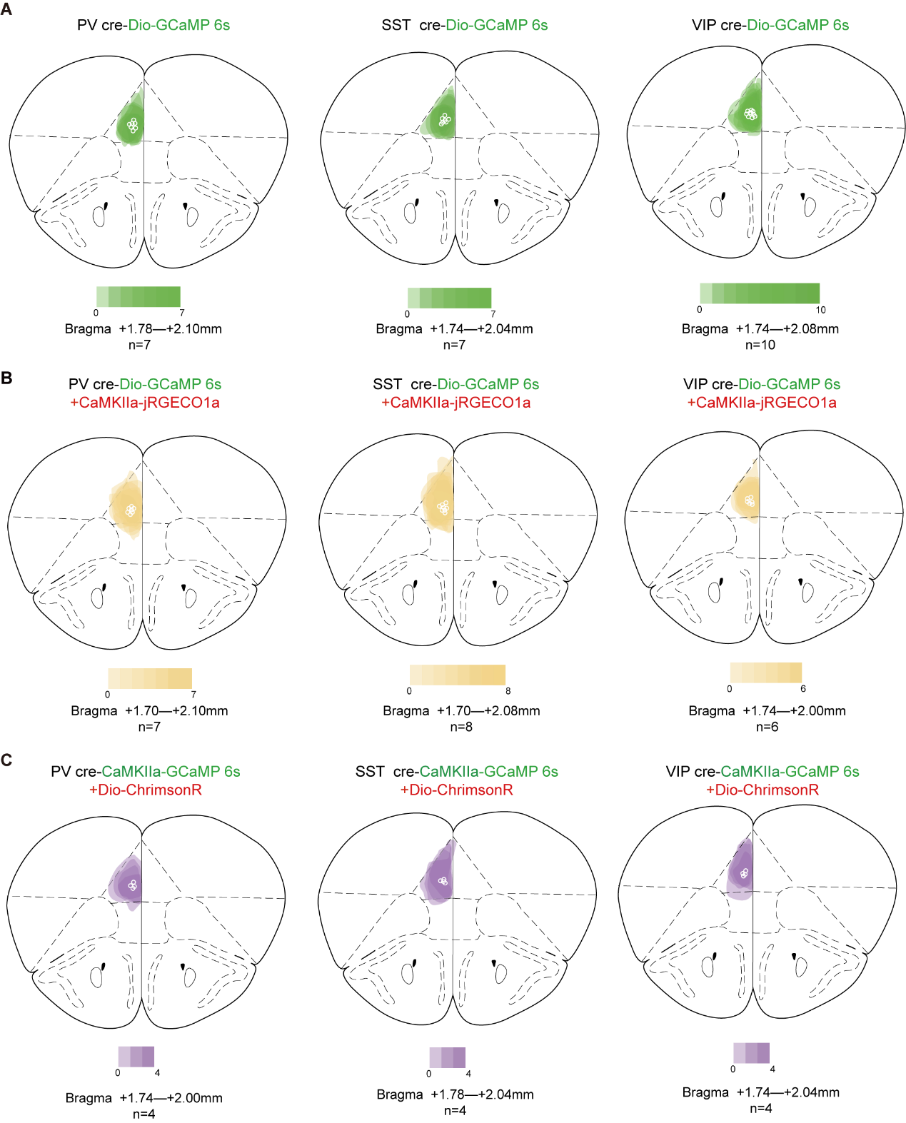
Fig. S3: The verification of the region showing viral infection patterns and precise documentation of fiber optic implantation locations.
(A) Map of virus injection and fiber optic implantation sites in PV-Cre, SST-Cre, and VIP-Cre mouse groups for single-color photometry recording. Schematic illustrating areas expressing DIO-GCaMP6s in the mPFC. (B) Map of virus injection and fiber optic implantation sites in PV-Cre, SST-Cre, and VIP-Cre mouse groups for tri-color photometry recording. Schematic illustrating areas expressing DIO-GCaMP6s and CaMKIIα-jRGECO1a in the mPFC. (C) Map of virus injection and fiber optic implantation sites in PV-Cre, SST-Cre, and VIP-Cre mouse groups for optogenetics and photometry recording. Schematic illustrating areas expressing CaMKIIα-GCaMP6s and DIO-ChrimsonR in the mPFC.

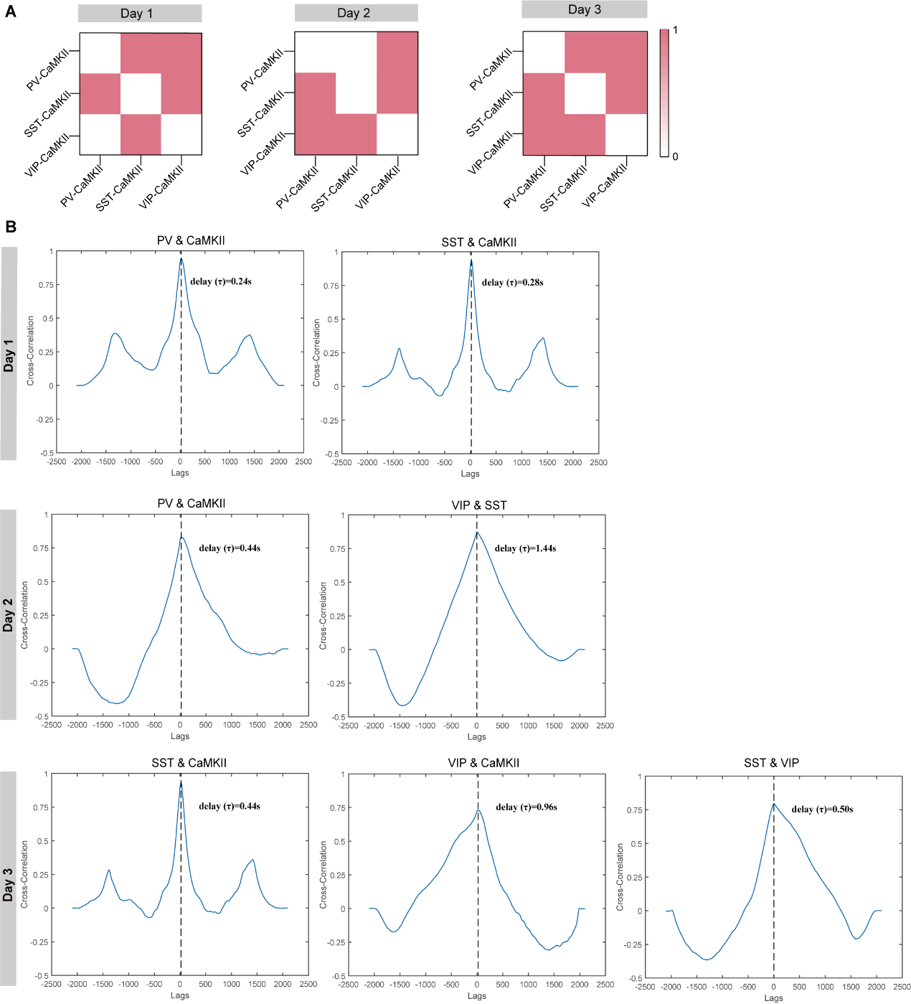
Fig. S4: Heatmap results of the Granger Causality Test between several CaMKIIα neurons, alongside the corresponding cross-correlograms illustrating neuronal interactions.
(A) Heatmap results of the Granger Causality Test between several CaMKIIα neurons during the fear learning, recall, and extinction stages. Significance is determined at α = 0.05, where “0” indicates nonsignificant and “1” indicates significant results. (B) The actual cross-correlograms depicting the mapping and time delays (τ) between neuronal interactions.
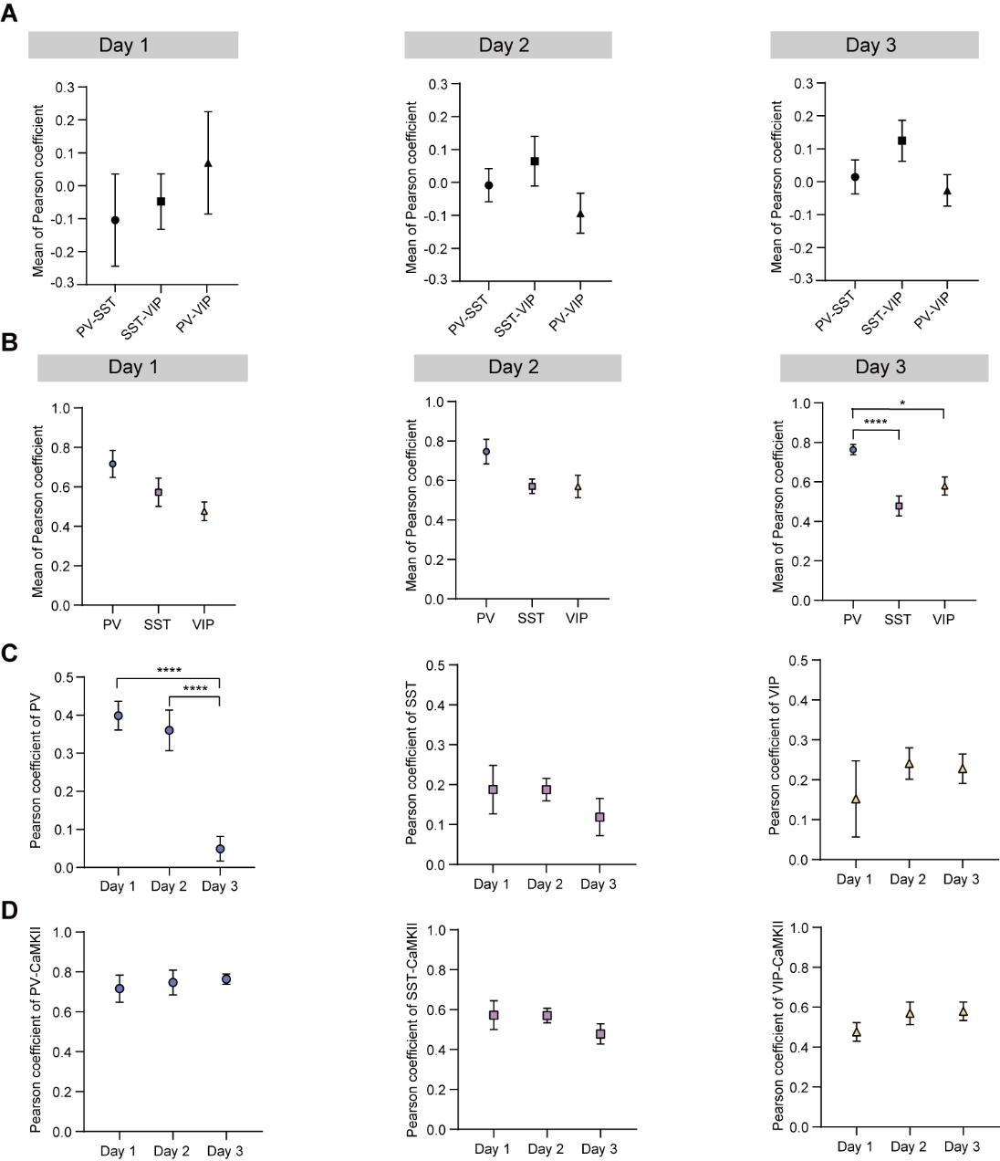
Fig. S5: Comparative statistical chart of Pearson correlation coefficients for three types of neurons at different stages of fear behavior (statistical analysis performed using an unpaired one-way ANOVA test.
(A) Comparative statistical chart of Pearson correlation coefficients among PV, SST, and VIP neurons at different stages of fear behavior. (B) Statistical comparison of Pearson correlation coefficients among PV, SST, VIP neurons, and CaMKIIα across various stages of fear behavior. (C) Comparison of Pearson correlation coefficients among PV, SST, and VIP neurons at different stages of fear behavior. (D) Comparison statistics of Pearson correlation coefficients between PV, SST, VIP neurons and CaMKIIα in different stages of fear behavior. All statistical variances in the data presented in the charts that conform to normal distribution and homogeneity of variance were analyzed using one-way ANOVA followed by simple effects analysis. Data that did not conform to normal distribution or exhibited heterogeneity of variance were analyzed using the Kruskal-Wallis H test and Nemenyi multiple comparisons test. Significant differences were found: **P < 0.01, ****P < 0.0001.

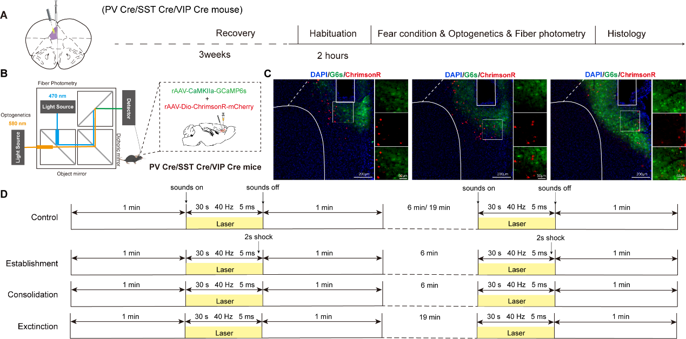
Fig. S6: Effects of optogenetic manipulation of mPFC IN-expressing neurons on the activity of glutamatergic neurons during the fear recall stage.
(A) Timeline of the experimental design. (B) Schematic illustration of virus injection and fiber photometry setup to achieve simultaneous in vivo optogenetic manipulation and synchronous photometry recording. (C) Schematic representation of virus injection and fiber optic implantation sites showing CaMKII-GCaMP6s labeled glutamatergic neurons (green) and Dio-ChrimsonR-mCherry-labeled interneurons (PV, SST, and VIP-expressing) neurons in PV-Cre, SST-Cre and VIP-Cre mice. Scale bars: 200 μm (left) and 50 μm (right). (D) Schematic diagram of the experimental flow during the light-on and light-off (control) periods.

