Supplementary Information

Enhancing the Efficiency of Flexible Triboelectric Nanogenerators via Material Ratios and Surface Optimization for Wearable Electronics
Muskan Zaheer Mughal^{a,c}, Gul Hassan^{b,c*}, Arfa Asif^{b,c}, Maryam Bibi^{d}
ªCentre for Interdisciplinary Research in Basic Sciences(CIRBS), International Islamic University, Islamabad 4400 Pakistan
^{b}Department Of Electrical and Computer Engineering, International Islamic University, Islamabad 44000 Pakistan
^{c}Centre for Advanced Electronics & Photovoltaic Engineering (CAEPE), International Islamic University, Islamabad 44000 Pakistan
^{d}Department Of Physics, International Islamic University, Islamabad 44000 Pakistan
*Gmail: gulhassan.rahi5@gmail.com

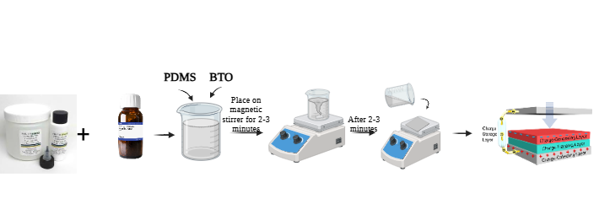
Figure S1: Preparation of TENG by varying concentrations of BTO in PDMS solution.

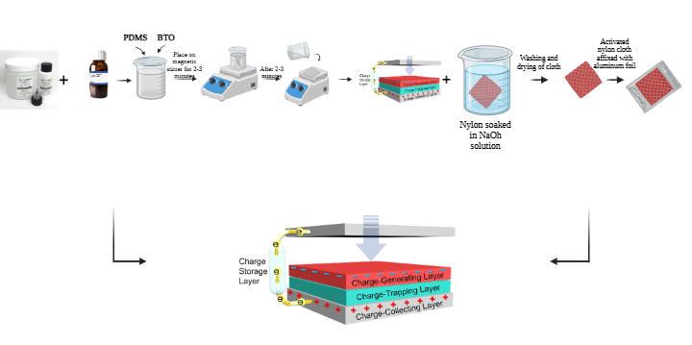
Figure S2: Preparation of TENG by using Nylon as electronegative material.
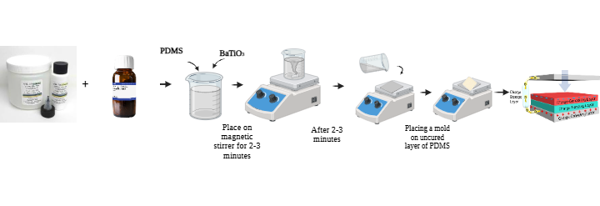
Figure S3: Preparation of TENG by using different molds for surface roughness.

