Supplementary Material: « Cross-Scale Energy Coordination in Brain–Body Systems Supports Cognitive Function Across the Lifespan »

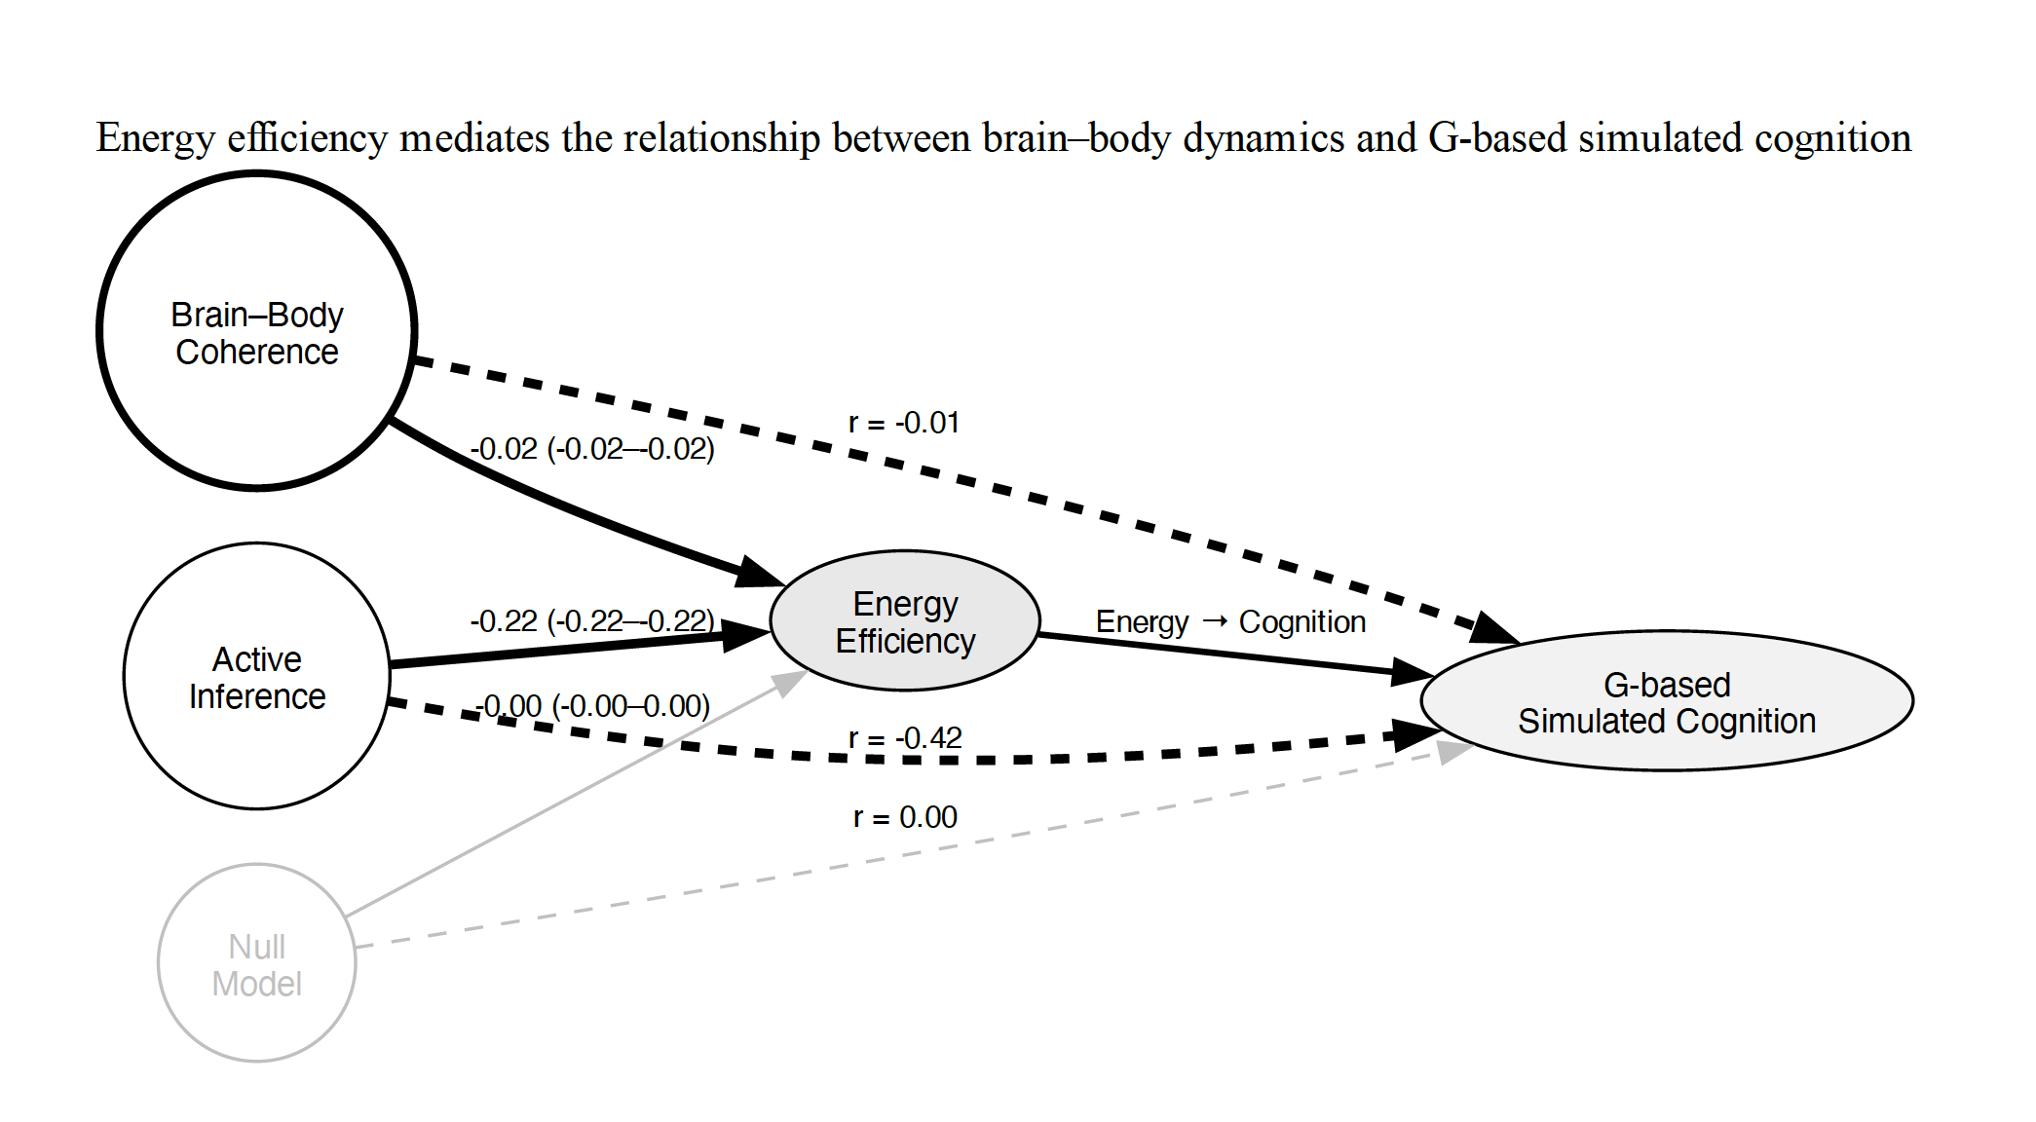
Fig S1 Energy efficiency mediates the relationship between brain–body dynamics and G-based simulated cognition. Dashed edges represent direct associations (Pearson correlation, r) between each model metric and G-based simulated cognition, while solid edges indicate bootstrapped indirect effects via energy efficiency (95% confidence interval). Brain–Body coherence shows a negligible direct association (r = –0.01) but a significant indirect effect (–0.021, 95% CI [–0.0225, –0.0188]), highlighting the mediating role of energy efficiency. Active Inference exhibits both a substantial direct negative association (r = –0.42) and a strong indirect effect (–0.219, 95% CI [–0.2204, –0.2178]). The Null model shows no significant direct or indirect effects, validating the specificity of the observed mediation. Edge thickness emphasizes significance, with bolded edges indicating significant mediation. Not directly linked to energy efficiency.

Table S1. Robustness and mediation analysis across baseline, perturbation, and ablation conditions. This table reports Pearson correlations (r) between model-derived predictors (Brain–Body coupling, Forward Modeling, and Null model) and synthetic cognition, alongside corresponding mediation effects via energy. Results are shown across three conditions: baseline, perturbed dynamics (noise added to physiological inputs and coupling parameters), and ablation (removal of energy feedback). Mediation values represent the indirect effect of each predictor on cognition through energy, while NullMean and NullStd correspond to the mean and standard deviation of permutation-based null distributions. Across conditions, effect sizes remain small but structured, with Brain–Body coupling showing consistent positive associations and Forward Modeling exhibiting negative associations, indicating that the observed relationships are stable under perturbation and partial model disruption and are not explained by null distributions.
Robustness and Mediation Results
Condition | Model | r | Mediation | NullMean | NullStd
Baseline | BrainBody | 0.0131 | 0.0033 | 2.62e-03 | 3.09e-18
Baseline | ForwardModeling | -0.0283 | -0.0140 | -1.20e-02 | 1.33e-17
Baseline | Null | 0.0038 | 0.0007 | 1.10e-04 | 3.47e-19
Perturbation | BrainBody | 0.0242 | 0.0046 | 3.28e-03 | 3.78e-18
Perturbation | ForwardModeling | -0.0783 | -0.0042 | -4.39e-03 | 5.12e-18
Perturbation | Null | 0.0131 | -0.0012 | -5.81e-04 | 6.60e-19
Ablation | BrainBody | 0.0588 | 0.0028 | 2.62e-03 | 3.24e-18
Ablation | ForwardModeling | -0.0256 | -0.0059 | -8.22e-03 | 9.42e-18
Ablation | Null | -0.0040 | 0.0001 | -1.47e-05 | 3.24e-19

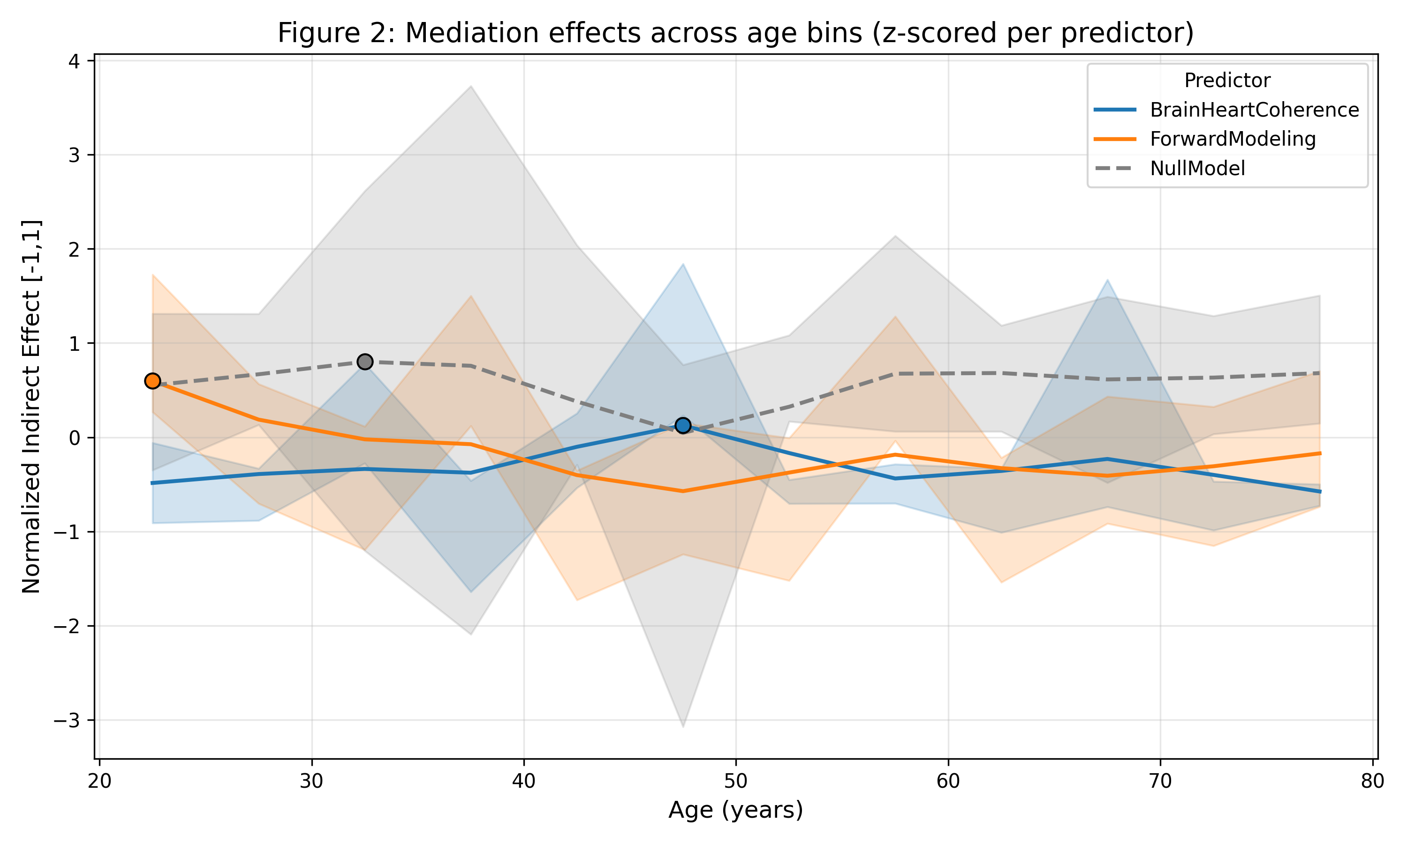
Figure S2. Bootstrap estimates of the normalized indirect effect of each predictor on the G-based behavioural proxy of cognition via Energy Efficiency across age bins. The mediation effect of Active Inference is most prominent before 25 years of age, while Brain Body Coupling exhibits two distinct peaks at 57 years. The Null Model is included as a reference (dashed line). Shaded areas represent 95% bootstrap confidence intervals, and all effects are normalized for visualization. Importantly, these patterns of mediation are consistent with the results of the generative model when the outcome variable was the physiologically constructed proxy of cognition. Still the maximum of the active inference model is about 22 – 25 years.

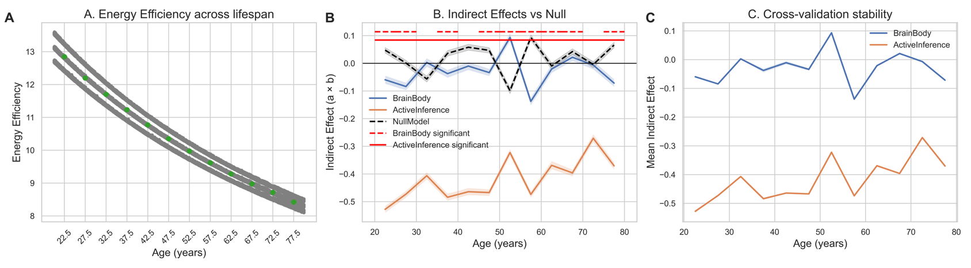

Figure S3. Lifespan trajectories of energy efficiency and mediation effects from longitudinal simulations. (A) Energy efficiency as a function of age (5-year bins from 20–85 years) showing a monotonic decline across the lifespan. Gray lines indicate subject-level trajectories with jitter, and green points denote bin-wise means with 95% confidence intervals. (B) Indirect (mediation) effects of energy efficiency on the relationship between predictors (brain–body coupling, blue; active inference metric, orange) and cognitive outcomes, estimated within each age bin using 1,000-sample nonparametric bootstrapping. Shaded regions indicate 95% confidence intervals. The null model (black dashed line) reflects indirect effects computed from Gaussian random variables. Horizontal red dashed/solid lines mark age bins surviving Benjamini–Hochberg FDR correction (q < 0.05) for brain–body and active inference models, respectively. (C) Cross-validation stability of indirect effects across five folds (80% subsampling per fold), showing mean mediation effects across age bins for each predictor. Consistent trajectories across folds indicate robustness of the lifespan patterns, with brain–body coupling effects remaining near zero and active inference effects showing stable negative mediation.

