Supplementary Material: « Cross-Scale Energy Coordination in Brain–Body Systems Supports Cognitive Function Across the Lifespan »

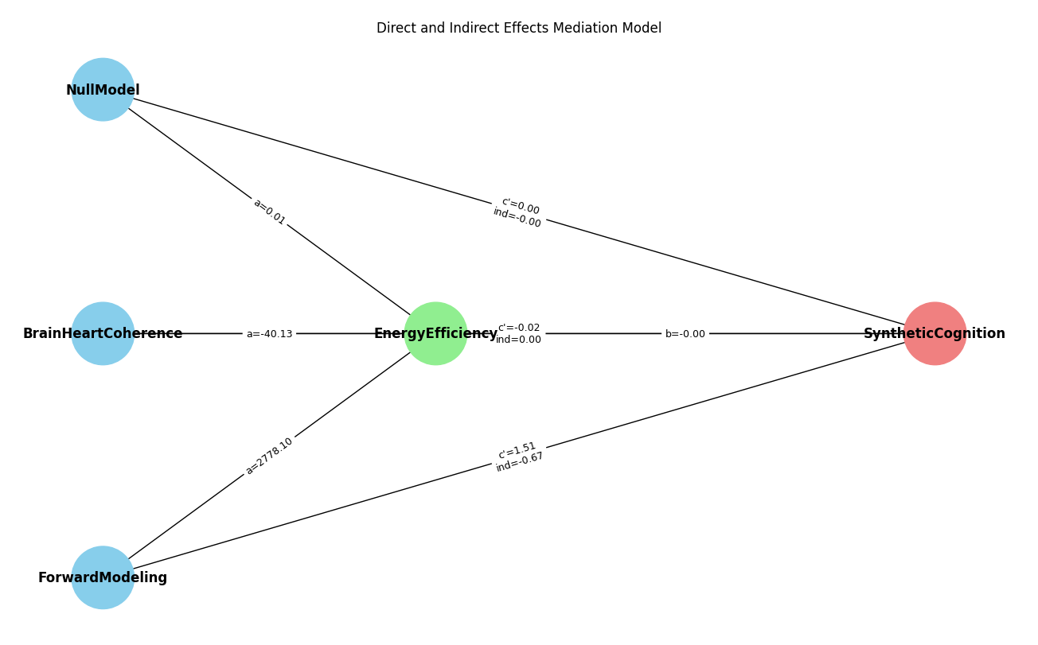
Fig S1.. Mediation model linking predictors, energy efficiency, and synthetic cognition. Graphical representation of the mediation analysis examining the relationships between Null Model, BrainHeartCoherence, and Active Inference (predictors), Energy Efficiency (mediator), and SyntheticCognition (outcome), with cognition measured as a general cognitive factor (g factor). Path coefficients are shown for each regression path: arrows from predictors to the mediator represent the a paths (effect of each predictor on EnergyEfficiency), b represents the effect of the mediator on SyntheticCognition, and c′ paths represent the direct effects of each predictor on SyntheticCognition after accounting for the mediator. Indirect effects are calculated as a × b and displayed alongside the direct effects. SyntheticCognition was derived from behavioral measures by constructing a g factor summarizing performance across cognitive tasks. This diagram illustrates both the direct contributions of the predictors to cognition and the indirect pathway through energy efficiency, demonstrating that mediation effects are present even when using a cognition measure not directly linked to energy efficiency.

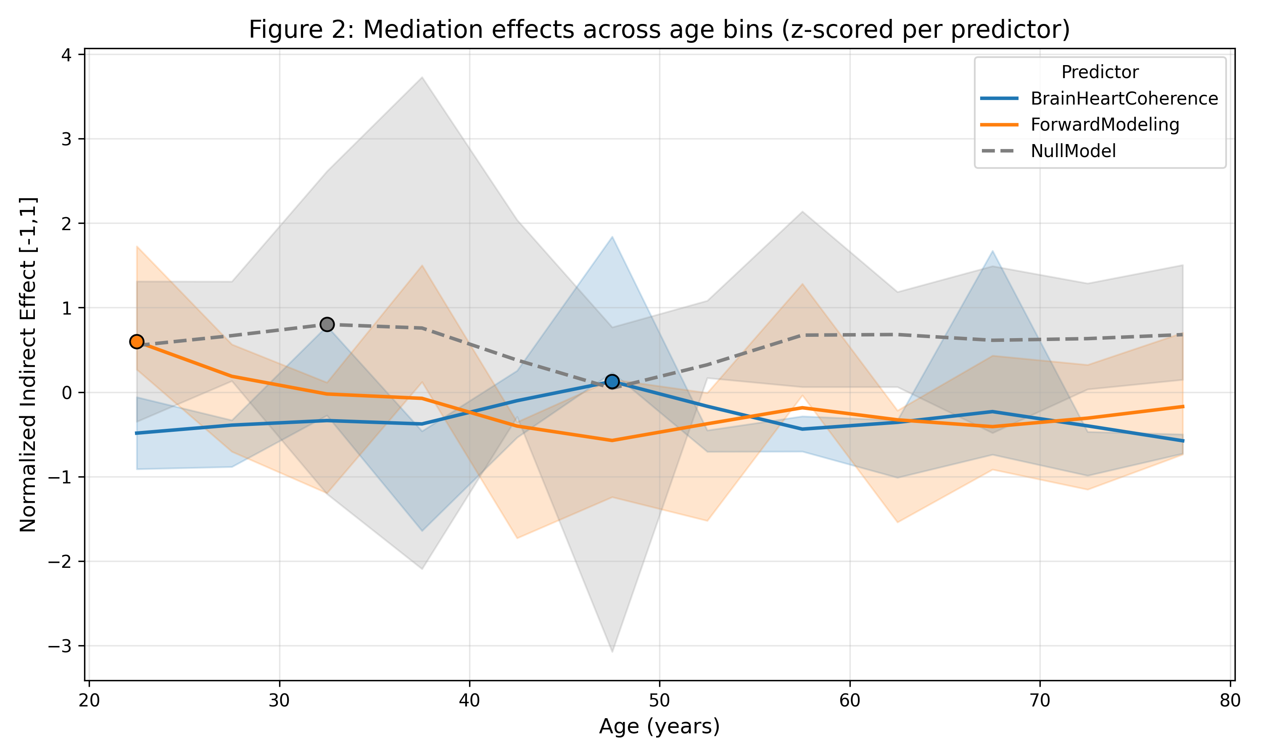
Figure S2. Bootstrap estimates of the normalized indirect effect of each predictor on the G-based behavioural proxy of cognition via Energy Efficiency across age bins. The mediation effect of Active Inference is most prominent before 25 years of age, while Brain Body Coupling exhibits two distinct peaks at 57 years. The Null Model is included as a reference (dashed line). Shaded areas represent 95% bootstrap confidence intervals, and all effects are normalized for visualization. Importantly, these patterns of mediation are consistent with the results of the generative model when the outcome variable was the physiologically constructed proxy of cognition. Still the maximum of the active inference model is about 22 – 25 years.

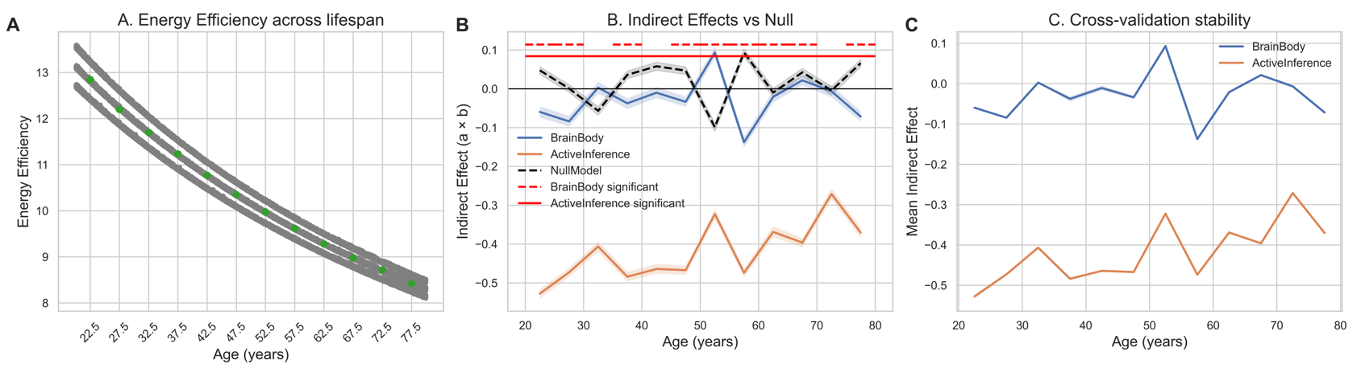

Figure S3. Lifespan trajectories of energy efficiency and mediation effects from longitudinal simulations. (A) Energy efficiency as a function of age (5-year bins from 20–85 years) showing a monotonic decline across the lifespan. Gray lines indicate subject-level trajectories with jitter, and green points denote bin-wise means with 95% confidence intervals. (B) Indirect (mediation) effects of energy efficiency on the relationship between predictors (brain–body coupling, blue; active inference metric, orange) and cognitive outcomes, estimated within each age bin using 1,000-sample nonparametric bootstrapping. Shaded regions indicate 95% confidence intervals. The null model (black dashed line) reflects indirect effects computed from Gaussian random variables. Horizontal red dashed/solid lines mark age bins surviving Benjamini–Hochberg FDR correction (q < 0.05) for brain–body and active inference models, respectively. (C) Cross-validation stability of indirect effects across five folds (80% subsampling per fold), showing mean mediation effects across age bins for each predictor. Consistent trajectories across folds indicate robustness of the lifespan patterns, with brain–body coupling effects remaining near zero and active inference effects showing stable negative mediation.

