Supplementary Material:

A ZIF-8 Derived Nano-Porous Carbon as Solid Transducing Layer in High-Performance All-Solid-State Sodium Ion Selective Electrodes
Peike Wang^{1,2,†} · Shuheng Fan^{1,2,†} · Haipeng Liu^{1,2} · Shiqiang Zhou^{1,2} · Jingjing Luo^{1,2} · Yuan Meng^{1,2} · Jin Ning^{1,2} · Suzhu Yu^{1,2} · Jun Wei^{1,2,3}
E-mail:
Suzhu Yu
szyu@hit.edu.cn
Jun Wei
junwei@hit.edu.cn
¹ Shenzhen Key Laboratory of Flexible Printed Electronics Technology, Harbin Institute of Technology (Shenzhen), Shenzhen 518055, China
² School of Materials Science and Engineering, Harbin Institute of Technology (Shenzhen), Shenzhen 518055, China
³ State Key Laboratory of Advanced Welding and Joining, Harbin Institute of Technology (Shenzhen), Shenzhen 518055, China
†These authors contributed equally to this work.

Fig. S1. XRD spectrum of ZIF-8 ZIF-8 template.

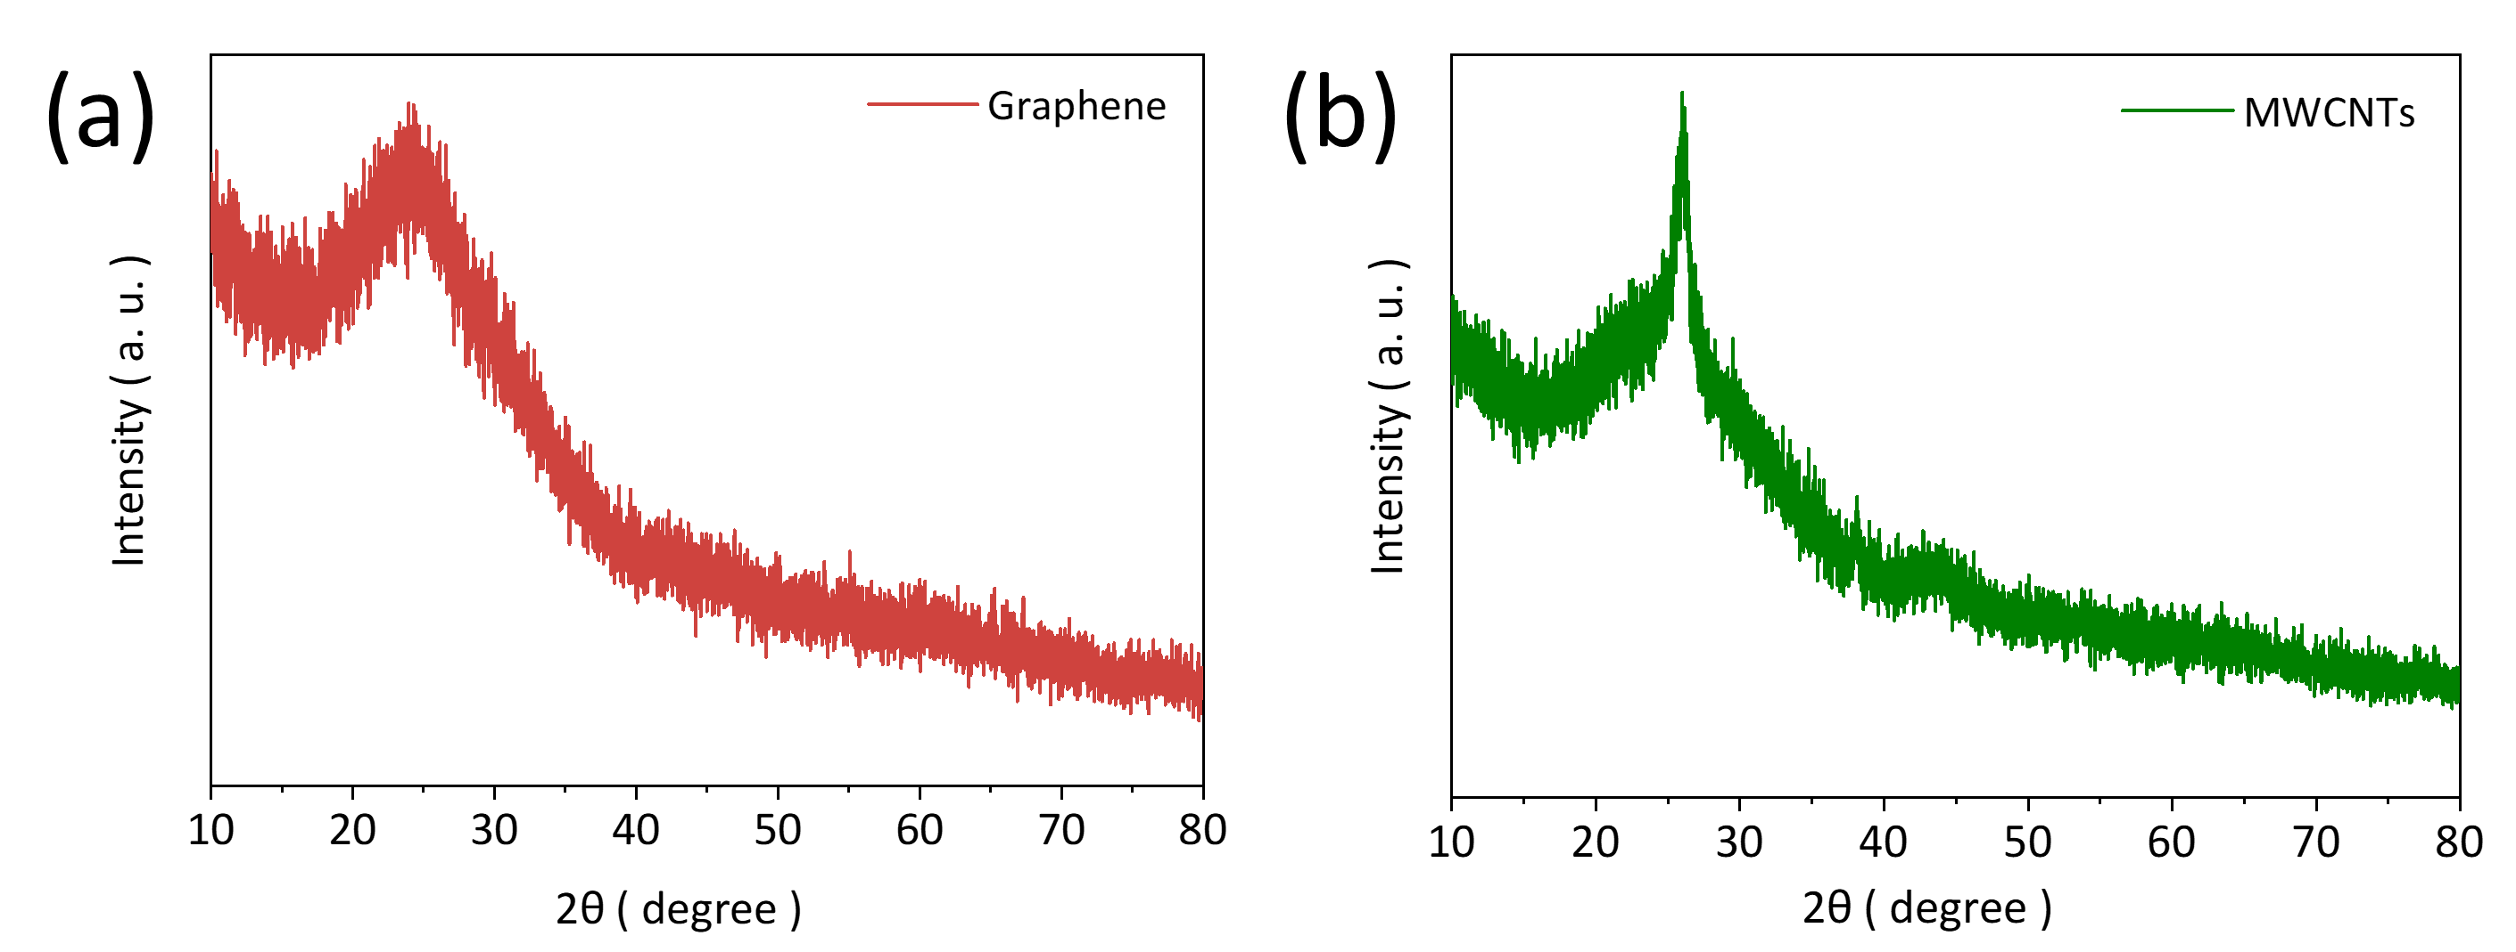
Fig. S2. XRD spectrum of (a) graphene and (b)MWCNTs.

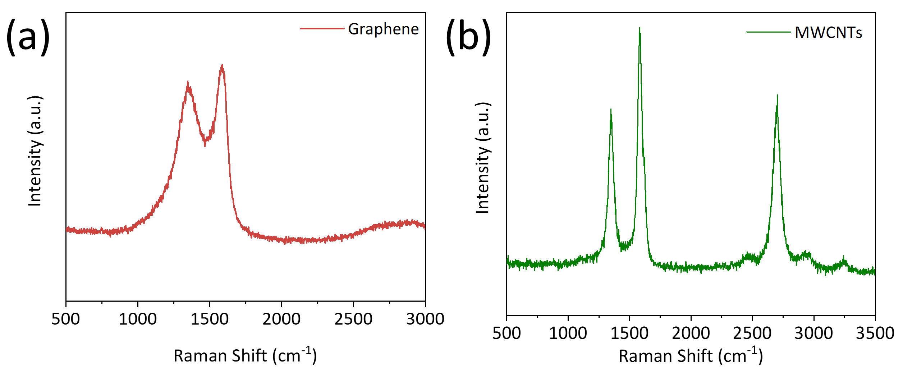
Fig. S3. Raman spectrum of (a) graphene and (b) MWCNTs.
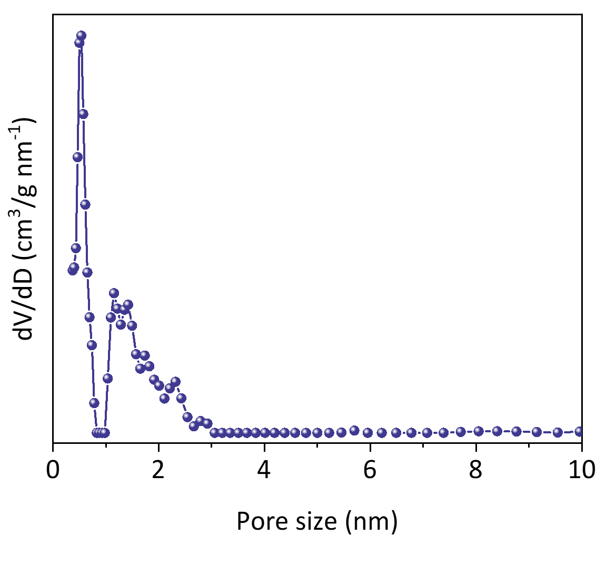
Fig. S4. Pore size distribution curve of the NPC.

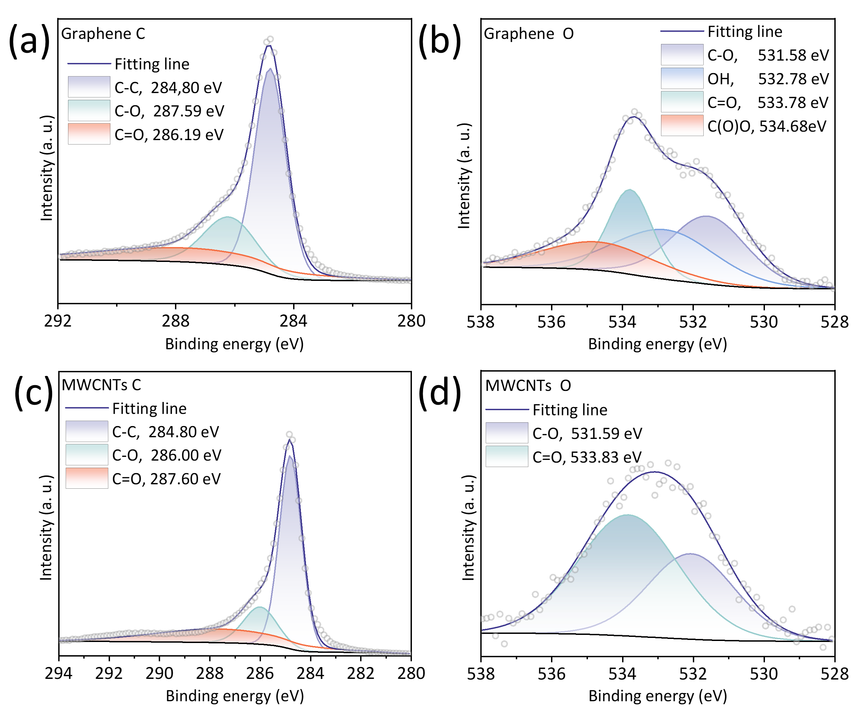
Fig. S5. C 1s and O 1s XPS spectra of (a, b) graphene and (c, d) MWCNTs, respectively

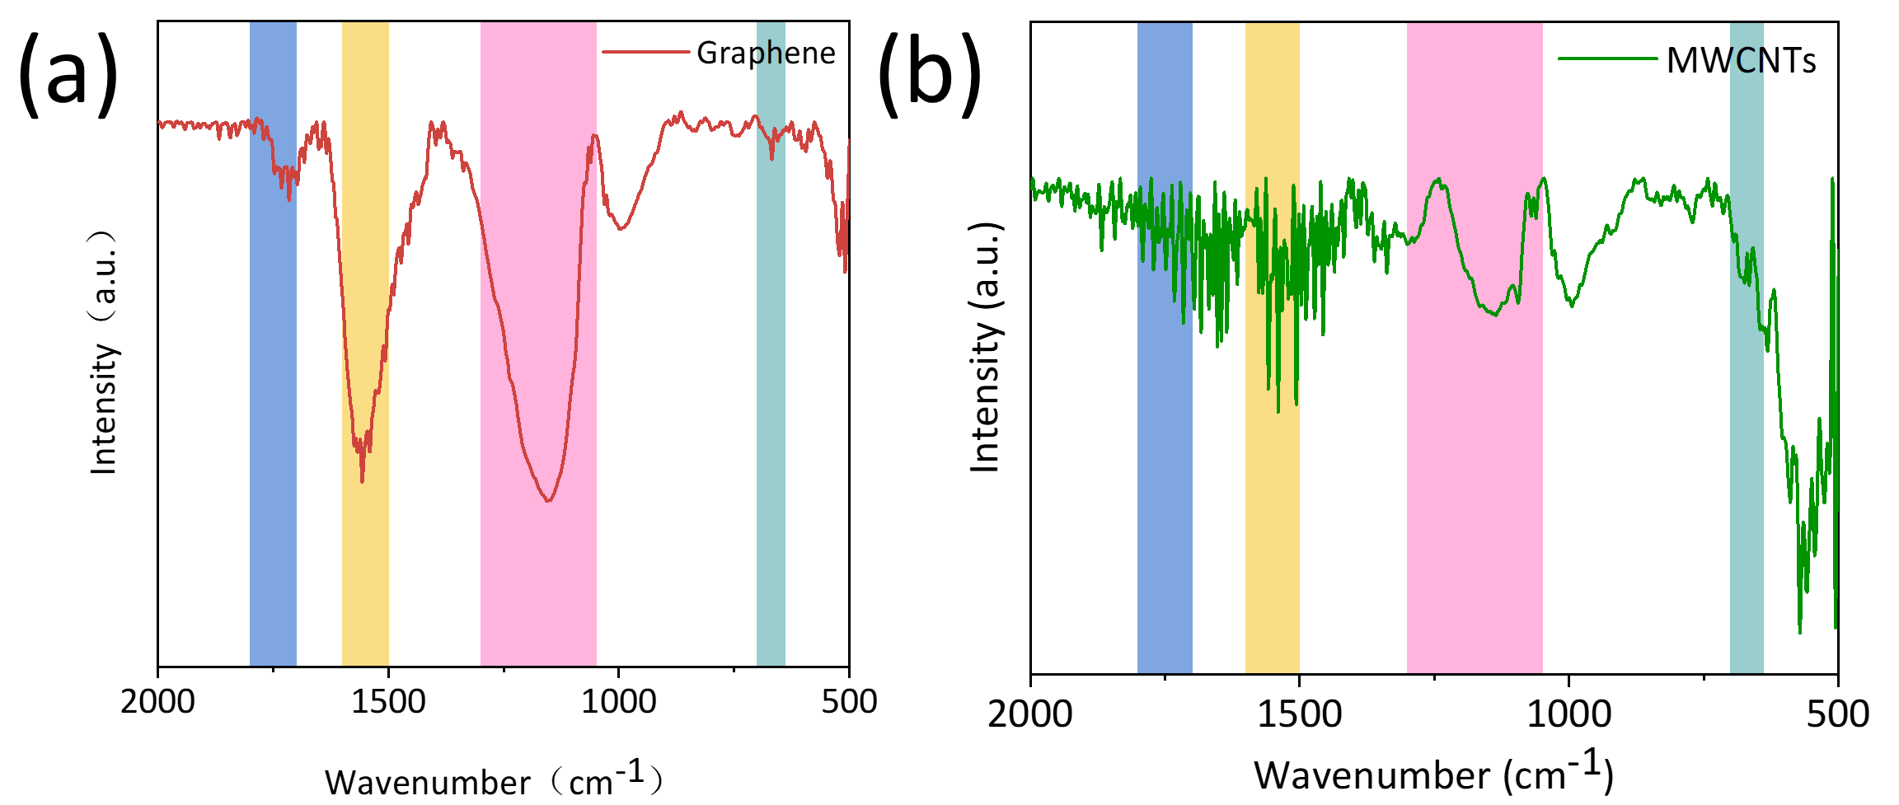
Fig. S6. FTIR spectra of (a) graphene and (b) MWCNTs.

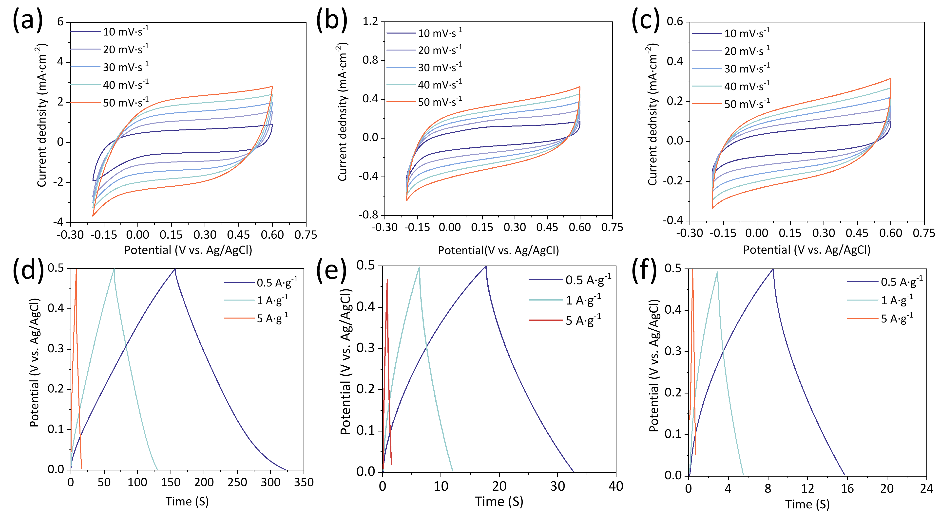
Fig. S7. CV curves of (a) NPC, (b) graphene and (c) MWCNT at different scan rates. GCD curves of (d) NPC, (e) graphene and (f) MWCNT at different current densities.

Table S1. XPS results
Samples | C (at.%) | N (at.%) | O (at.%)
MWCNT | 97.6 | 0 | 2.4
Graphene | 90.1 | 0 | 9.9
NPC | 89.1 | 7.6 | 3.0

Table S2. Comparison of the Calculated Sensitivity Results of manufactured Sensors
Sensors | Sensitivity (mV·dec⁻¹) | Range (M) | R²
Bare GCE | 32.9 | 10^{−2.3}~10⁻¹ | 0.79959
MWCNT | 59.85 | 10^{−4.5}~10⁻¹ | 0.9865
Graphene | 61.21 | 10^{−4.8}~10⁻¹ | 0.98688
NPC | 64.11 | 10^{−4.7}~10⁻¹ | 0.96462

Table S3. Comparison of the solid transducing layers reported in previous publications
SC | Support | Target ion | Sensitivity (mV·dec⁻¹) | Range (M) | Ref.
CNT | CNT | Na⁺ | 56 ± 3 | 7×10^{–7}~1 | [1]
Graphene | Carbon | Na⁺ | 60.2 ± 0.9 | 1×10⁻⁶~1 | [2]
CB | SPE | Na⁺ | 58 ± 3 | 1×10⁻⁷~1 | [3]
3DOMC | Ni mesh | K⁺ | 56.4 | 1.6×10⁻⁷~1 | [4]
PC-SMSs | GCE | K⁺ | 57.8 | 1×10⁻⁶~1 | [5]
Fullerenes | GCE | K⁺ | 55 | - | [6]
NPC | GCE | Na⁺ | 64.11 | 10^{-4.7}~10⁻¹ | This work
CNT: carbon nanotube; CB: carbon black; SPE: screen-printed electrode; 3DOMC: three-dimensionally ordered microporous carbon; GCE: glassy carbon electrode; PC-SMSs: porous carbon sub-microns.

