Supplementary for:
Meta-transcriptomic profiling of Ixodes ricinus and Ixodes persulcatus ticks reveals diverse RNA viromes, community structuring, and emerging viral lineages
Theophilus Yaw Alale¹, Jesse Mänttäri¹, Heidi Viitaniemi¹, Mikhail Ozerov^{1,2}, Miguel Baltazar-Soares¹, Jani J. Sormunen^{1,3}, Eero J. Vesterinen^{1,2}
- Department of Biology, University of Turku, Turku, Finland.
- Bioname Ltd, Itäinen Pitkäkatu 2, 20520, Turku, Finland
- School of Medical, Molecular and Forensic Sciences, Murdoch University, Perth, Western Australia, Australia

This supplement contains the following figures and tables:
Contents
Figure S1. Tick read removal efficiency. 2
Figure S2. Tick read removal efficiency. 2
Figure S3. Non-tick read QC. 3
Figure. S4. Mean relative abundance 4
Figure S5. Heatmap of viral taxa across individual tick samples. 4
Table S1. Viruses and their family names. 5
Table S2: Assembly and contig length distribution. 7
Table S3. PERMANOVA (adonis) to test if communities differ by species/sex. 7
Table S4. Differential abundance analysis of tick-associated RNA viruses between Ixodes ricinus and Ixodes persulcatus. 8

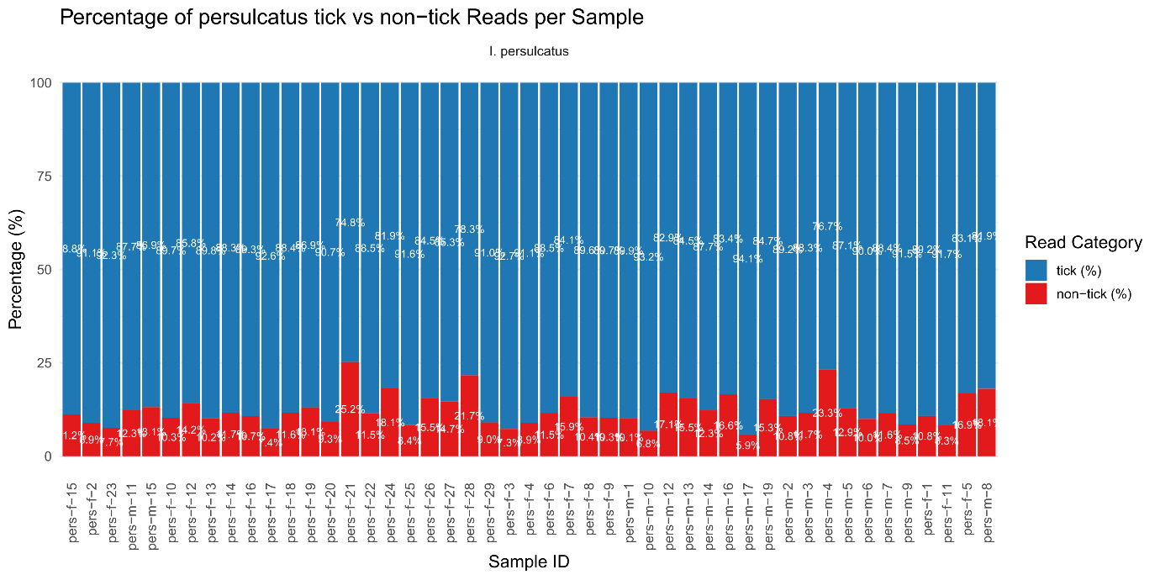

Fig S1. Tick read removal efficiency.
Proportion of mapped and unmapped reads in Ixodes persulcatus samples. Bar plots illustrating the percentage of reads mapped to the I. persulcatus reference genome and unmapped reads across individual tick samples. Unmapped reads were retained for subsequent viral discovery and taxonomic classification.

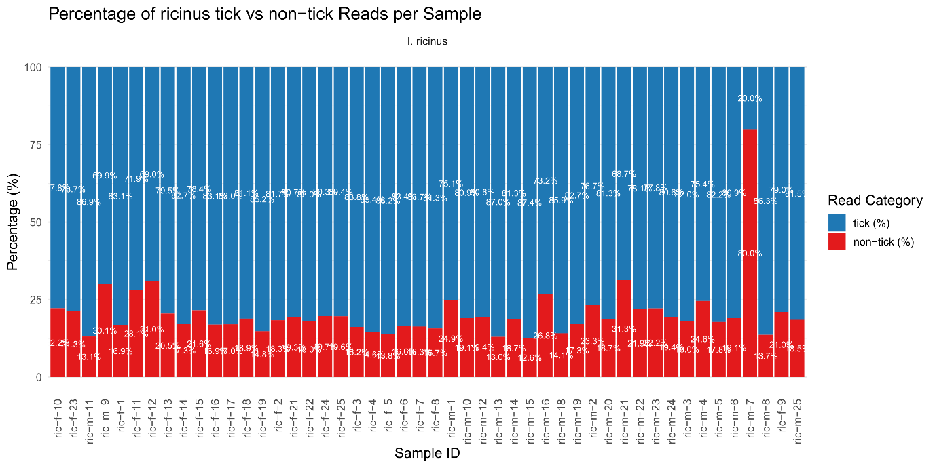

Fig S2. Tick read removal efficiency.
Proportion of mapped and unmapped reads in Ixodes ricinus samples. Bar plots showing the percentage of sequencing reads mapped to the I. ricinus reference genome (host reads) and unmapped reads retained for downstream metatranscriptomic analysis across individual tick samples. Unmapped reads represent non-host sequences, including viral, microbial, and residual environmental RNA.

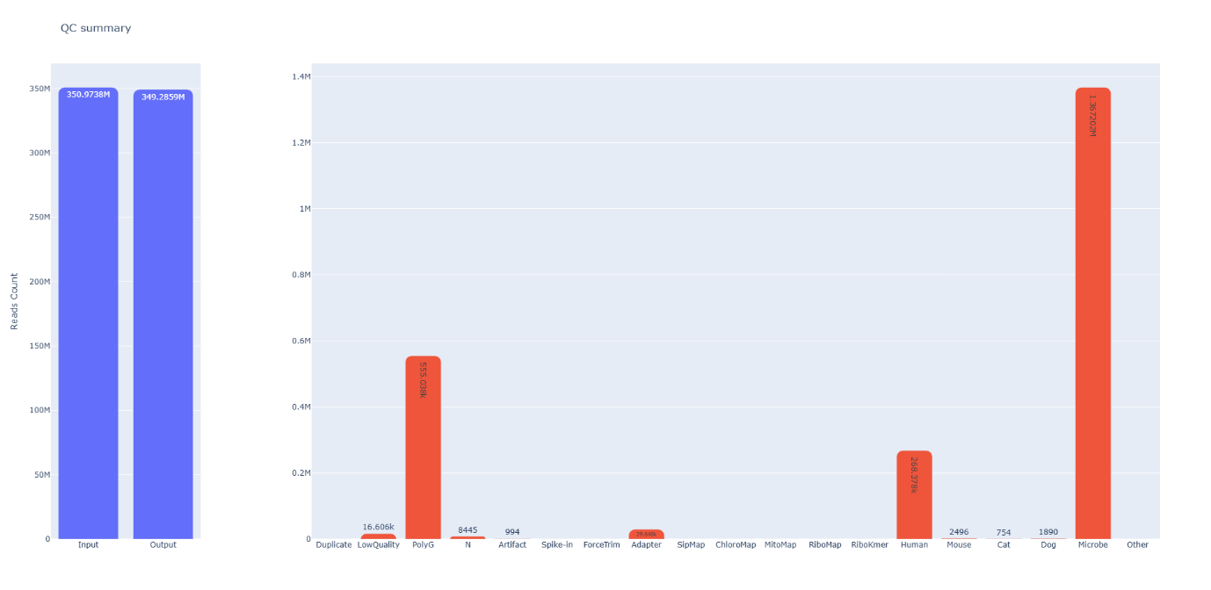

Fig S3. Non-tick read QC.
Summary composition of non-tick reads after fastqc. Blue bars indicate input and output reads, while red bars indicate composition of reads after tick read filtering.

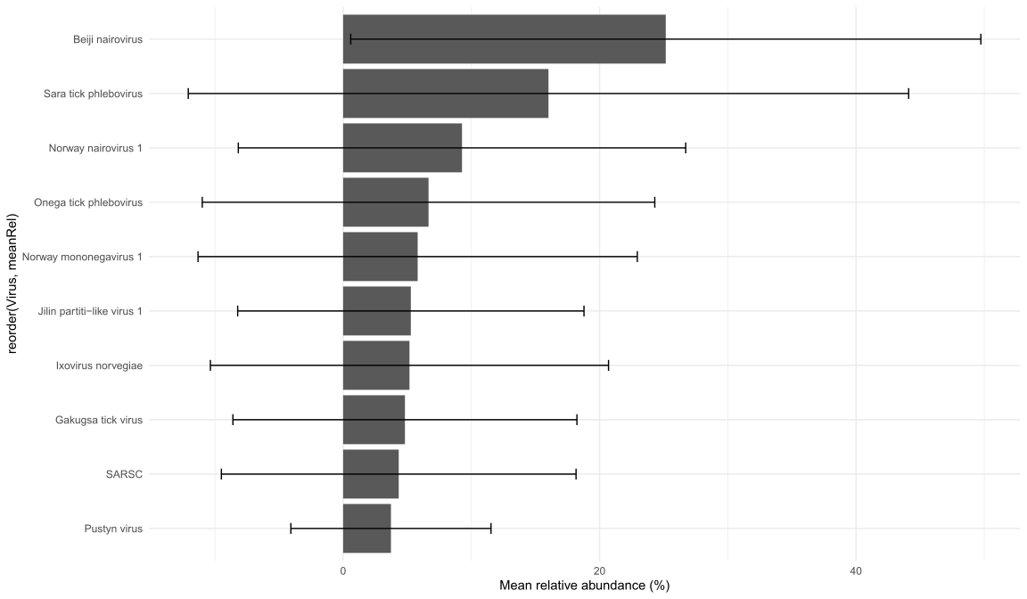

Fig S4. Mean relative abundance
Mean relative abundance (±SD) of the top 10 viruses across all samples.

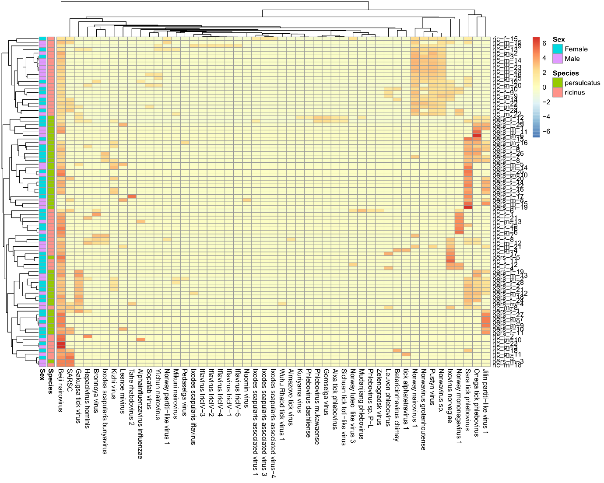

Fig S5. Heatmap of viral taxa across individual tick samples.
Hierarchical clustering heatmap showing normalized relative abundances of detected viral taxa across all individual ticks. Rows represent viruses and columns represent samples. Clustering is based on Bray-Curtis distance. Warmer colours represent higher abundance, and cooler colours indicate lower or undetected levels. Viral families such as Nairoviridae, Phenuiviridae, Iflaviridae, and Rhabdoviridae, along with several unclassified RNA viruses, are displayed on the y-axis. Hierarchical clustering reveals distinct species-specific virome profiles, with I. persulcatus showing enrichment of nairoviruses and phleboviruses, while I. ricinus harbours more iflaviruses and partiti-like viruses.

Table S1. Viruses and their family names.
Unclassified groups were assigned to hypothetical families
Scientific_Name | Virus_Family
Severe acute respiratory syndrome-related coronavirus | Coronaviridae
Beiji nairovirus | Nairoviridae
Gakugsa tick virus | Nairoviridae
Jilin partiti-like virus 1 | Partitiviridae (unclassified)
Hepacivirus hominis | Flaviviridae
Lesnoe mivirus | Mivirus (Chuviridae-related)
Kuriyama virus | Phenuiviridae (Phlebovirus-related)
Onega tick phlebovirus | Phenuiviridae (Phlebovirus)
Gomselga virus | Nairoviridae
Sichuan tick toti-like virus | Totiviridae (unclassified)
Alxa tick phlebovirus | Phenuiviridae (Phlebovirus)
Mudanjiang phlebovirus | Phenuiviridae (Phlebovirus)
Phlebovirus dashliense | Phenuiviridae (Phlebovirus)
Phlebovirus mukawaense | Phenuiviridae (Phlebovirus)
Ixodes scapularis associated virus 1 | Chuviridae (unclassified)
Sara tick phlebovirus | Phenuiviridae (Phlebovirus)
Kizhi virus | Nairoviridae
Tahe rhabdovirus 2 | Rhabdoviridae
Ixodes scapularis bunyavirus | Phenuiviridae (Bunyavirales unclassified)
Mikuni nairovirus | Nairoviridae
Ixovirus norvegiae | Ixovirus (proposed novel family within Bunyavirales)
Norway nairovirus 1 | Nairoviridae
Ixodes scapularis iflavirus | Iflaviridae
Pedaselga virus | Chuviridae (unclassified)
Wuhu Rhabd tick virus 1 | Rhabdoviridae
Nuomin virus | Chuviridae (Mivirus-related)
Norway mononegavirus 1 | Mononegavirales (unclassified)
Bronnoya virus | Nairoviridae
Pustyn virus | Phenuiviridae (Phlebovirus)
Leuven phlebovirus | Phenuiviridae (Phlebovirus)
Betaricinrhavirus chimay | Rhabdoviridae
Norwavirus sp. | Norwavirus (proposed genus in Bunyavirales)
Norwavirus grotenhoutense | Norwavirus (proposed genus in Bunyavirales)
Norway luteo-like virus 3 | Luteoviridae (unclassified)
Norway partiti-like virus 1 | Partitiviridae (unclassified)
Yichun nairovirus | Nairoviridae

Table S2: Assembly and contig length distribution.
Length distribution of viral contigs retained after assembly and filtering thresholds.
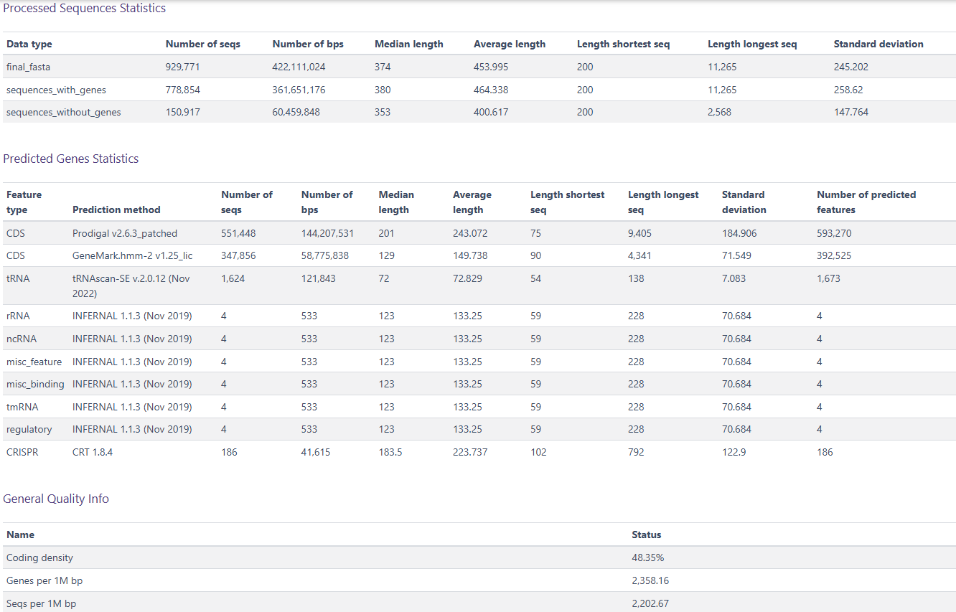

Table S3. PERMANOVA (adonis) to test if communities differ by species/sex.
This uses Bray-Curtis dissimilarity. PERMANOVA: Permutation test for adonis under reduced model.
(A)
 | Df | SumOfSqs | R2 | F | Pr(>F)
Model | 3 | 5.476327 | 0.158677 | 5.532369 | 0.001
Residual | 88 | 29.03619 | 0.841323
Total | 91 | 34.51252 | 1
adonis2(formula = mat_numeric ~ Species*Sex, data = meta, permutations = 999, method = "bray”
(B)
 | Df | SumOfSqs | R2 | F | Pr(>F)
Model | 1 | 0.333 | 0.00964 | 0.8761 | 0.564
Residual | 90 | 34.180 | 0.99036
Total | 91 | 34.513 | 1.00000
adonis2(formula = mat_numeric ~ Sex, data = meta, permutations = 999, method = "bray")
(C)
 | Df | SumOfSqs | R2 | F | Pr(>F)
Model | 1 | 4.909 | 0.14225 | 14.926 | 0.001 ***
Residual | 90 | 29.603 | 0.85775
Total | 91 | 34.513 | 1.00000
adonis2(formula = mat_numeric ~ Species, data = meta, permutations = 999, method = "bray"). Signif. codes: 0 ‘***’ 0.001 ‘**’ 0.01 ‘*’ 0.05 ‘.’ 0.1 ‘ ’ 1

Table S4. Differential abundance analysis of tick-associated RNA viruses between Ixodes ricinus and Ixodes persulcatus.
Results were generated using DESeq2 based on normalized virus read counts. The table includes log2 fold change (log2FC), standard error (lfcSE), Wald test statistic (stat), raw p-values, and Benjamini-Hochberg false discovery rate adjusted p-values (padj). Positive log2FC values indicate higher abundance in I. ricinus, whereas negative values indicate higher abundance in I. persulcatus. Viruses with adjusted p< 0.05 were considered significantly differentially abundant.
 | baseMean | log2FoldChange | lfcSE | stat | pvalue | padj
Norwavirus grotenhoutense | 803.1006 | -30 | 1.707863 | -17.5658 | 4.50E-69 | 9.90E-68
Kizhi virus | 130.3814 | 28.92488 | 2.035808 | 14.20806 | 8.17E-46 | 8.98E-45
Hepacivirus hominis | 28.97615 | -26.9786 | 2.902324 | -9.29552 | 1.46E-20 | 1.04E-19
Betaricinrhavirus chimay | 27.35998 | -26.9012 | 2.902341 | -9.26879 | 1.88E-20 | 1.04E-19
Leuven phlebovirus | 25.40602 | -26.7936 | 2.902364 | -9.23166 | 2.66E-20 | 1.17E-19
Norway partiti-like virus 1 | 11.51606 | -25.7294 | 2.902752 | -8.86379 | 7.73E-19 | 2.84E-18
Bronnoya virus | 11.78618 | -25.4975 | 2.902736 | -8.78396 | 1.58E-18 | 4.96E-18
Alphainfluenzavirus influenzae | 9.420977 | -25.3523 | 2.902909 | -8.73341 | 2.47E-18 | 6.80E-18
Norway luteo-like virus 3 | 7.91256 | -25.2178 | 2.903072 | -8.68658 | 3.74E-18 | 9.13E-18
Sopafab virus | 2.588035 | -23.717 | 2.904711 | -8.16499 | 3.21E-16 | 7.07E-16
Yichun nairovirus | 2.481369 | -23.6532 | 2.90478 | -8.14285 | 3.86E-16 | 7.72E-16
Jilin partiti-like virus 1 | 5787.666 | 10.91117 | 1.367905 | 7.976552 | 1.50E-15 | 2.76E-15
Pustyn virus | 1350.358 | -10.0407 | 1.592599 | -6.30458 | 2.89E-10 | 4.89E-10
Onega tick phlebovirus | 2551.521 | 7.222458 | 1.622422 | 4.451651 | 8.52E-06 | 1.34E-05
Sara tick phlebovirus | 14192.34 | 5.165817 | 1.25905 | 4.102949 | 4.08E-05 | 5.98E-05
Gakugsa tick virus | 8410.301 | 7.800873 | 2.08697 | 3.737894 | 0.000186 | 0.000255
Norwavirus sp. | 607.1385 | -5.28658 | 1.713529 | -3.0852 | 0.002034 | 0.002632
Norway nairovirus 1 | 3545.221 | -4.76501 | 1.688826 | -2.8215 | 0.00478 | 0.005842
Norway mononegavirus 1 | 2253.883 | -7.26552 | 2.754858 | -2.63735 | 0.008356 | 0.009675
Ixovirus norvegiae | 933.6262 | -5.26846 | 2.212906 | -2.38079 | 0.017276 | 0.019003
SARSC | 1535.877 | -3.58827 | 2.175584 | -1.64934 | 0.099078 | 0.103797
Beiji nairovirus | 31208.43 | 0.512373 | 0.544193 | 0.941527 | 0.346435 | 0.346435

