Supplementary Information

TAS2R38 Polymorphism and Bitter Taste Perception: Implications for Satmaya and Upashaya-Anupshaya Beyond Prakriti

This file includes -
- Supplementary Verses
- Supplementary Figures
- Supplementary Tables

INDEX

Supplementary Verses
Supplementary Verse 1……..………………………………………………………………2
Supplementary Verse 2….…….……………………………………………………………2
Supplementary Verse 3……..………………………………………………………………3
Supplementary Verse 4……..………………………………………………………………3
Supplementary Verse 5….……….…………………………………………………………4
Supplementary Verse 6….……….…………………………………………………………4
Supplementary Verse 7….……….…………………………………………………………5

Supplementary Figures
Supplementary Figure 1………….………………………………………………………6

Supplementary Tables
Supplementary Table 1a Distribution of TAS2R38 bitter taste phenotypes…………...7
Supplementary Table 1b HWE Analysis of TAS2R38 Bitter Taste Phenotypes………7
Supplementary Table 2 Genotype vs Phenotype (IITJ and Ayurveda cohort)...…..….. 7
Supplementary Table 3 Distribution of TAS2R38 (rs713598G>C) (Ala → Pro).……..8
Supplementary Table 4 Distribution of TAS2R38 (rs1726866G>A) (Ala → Val) ……9
Supplementary Table 5 Distribution of TAS2R38 (rs10246939C>T) (Iso → Val) ...…9

Supplementary Verse 1:
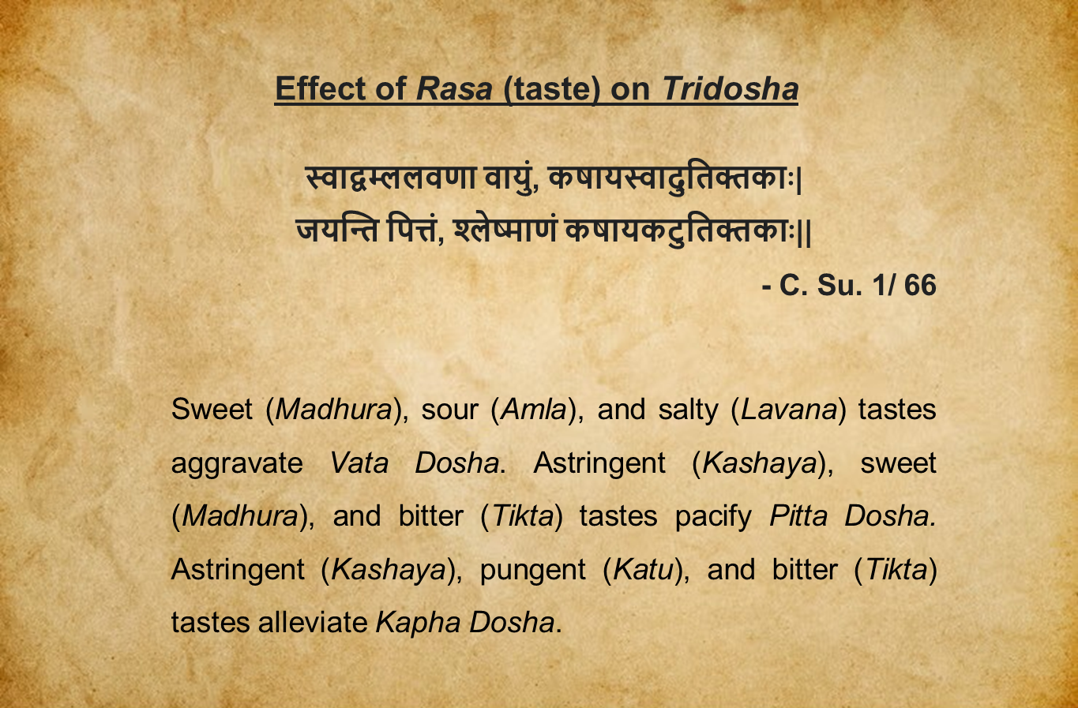
Supplementary Verse 1: This verse explains the effects of the six Rasa on the Dosha.

Supplementary Verse 2:
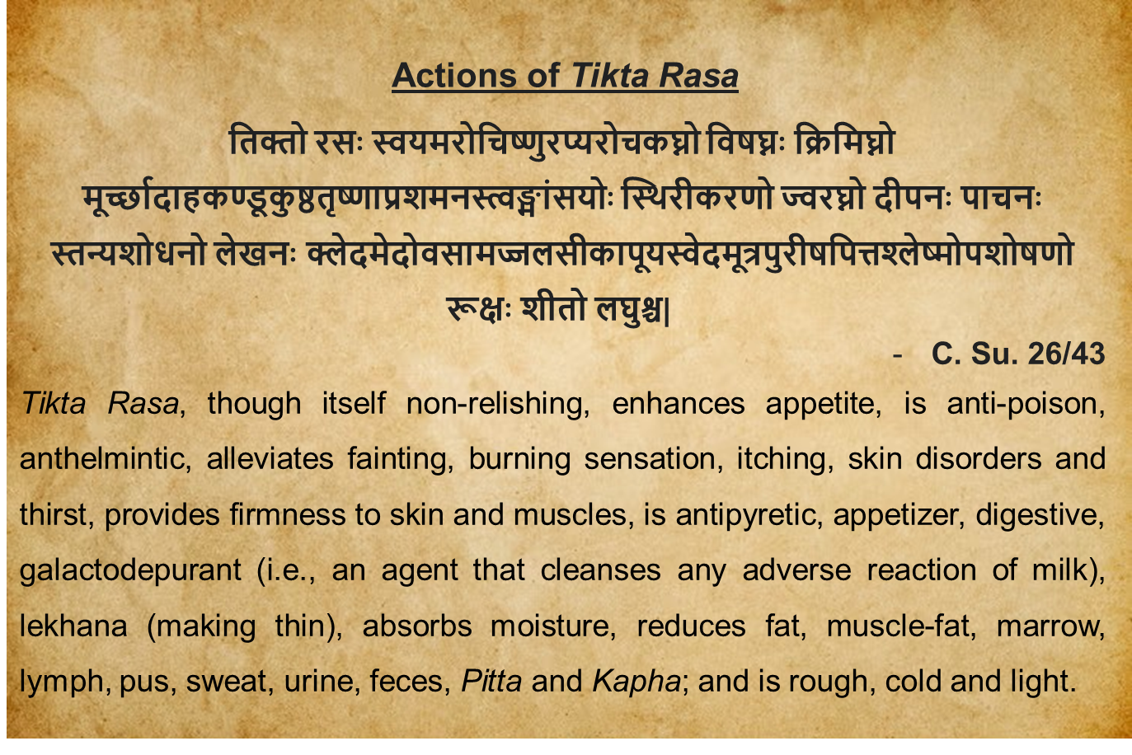
Supplementary Verse 2: This verse explains the action of Tikta Rasa (bitter taste).

Supplementary Verse 3:
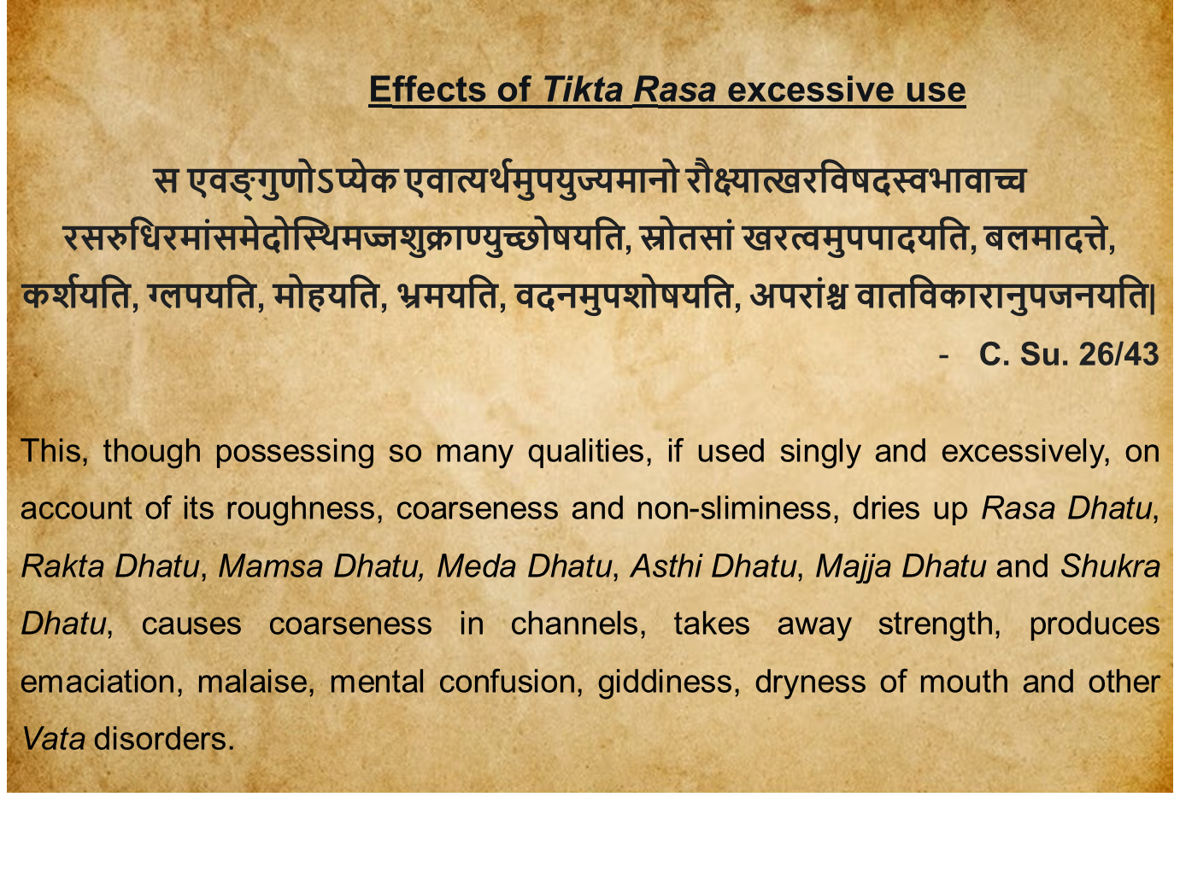
Supplementary Verse 3: This verse explains the side effects of Tikta Rasa excessive use.

Supplementary Verse 4:
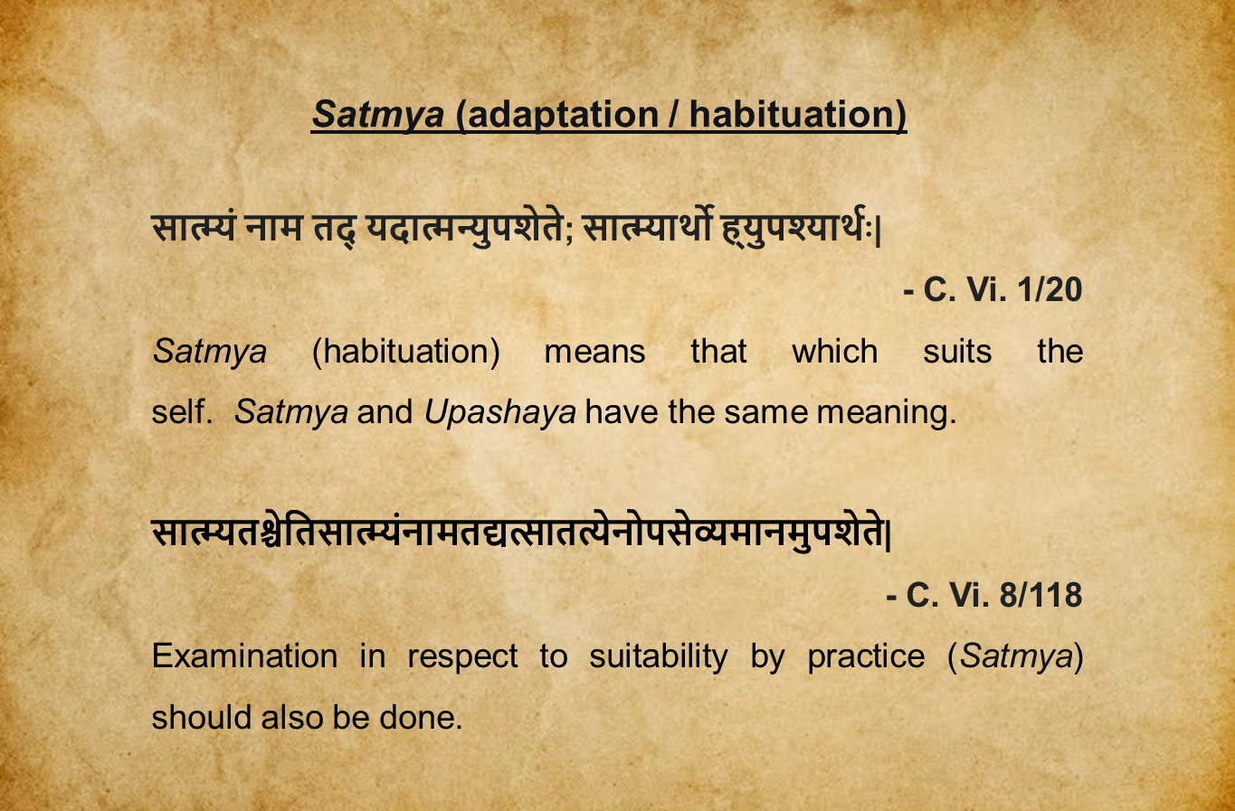

Supplementary Verse 4: This verse explains the Satmya (adaptation).

Supplementary Verse 5:
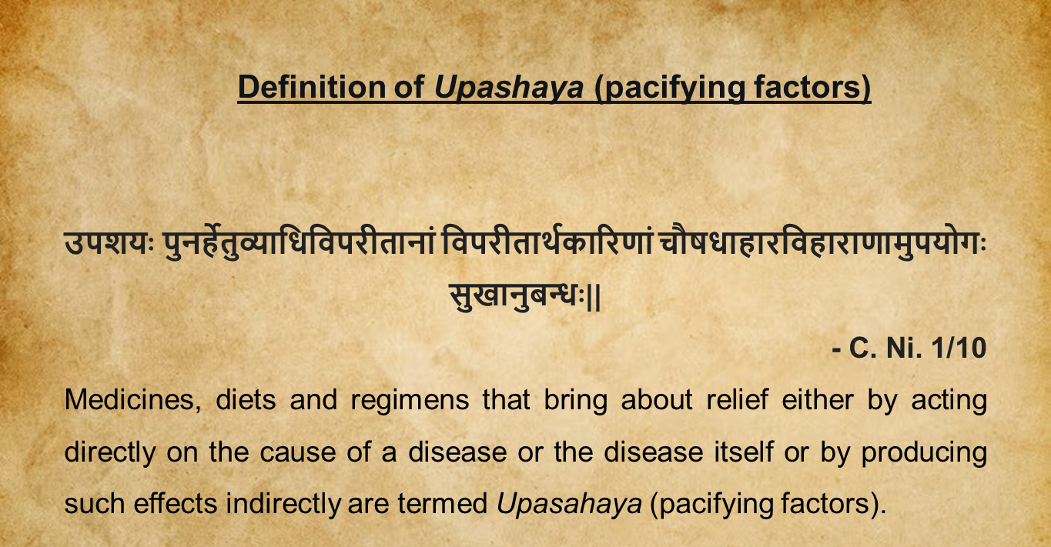
Supplementary Verse 5: This verse explains the Upashaya- Anupshaya (pacifying factors).

Supplementary Verse 6:
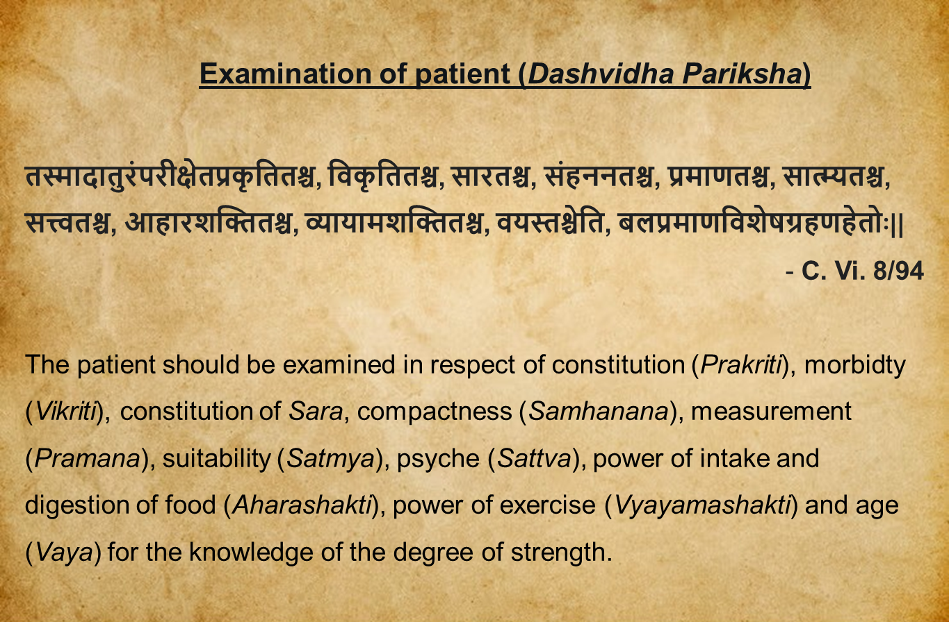
Supplementary Verse 6: This verse explains the ten fold examination of patients (Dashavidha Pariksha).

Supplementary Verse 7:
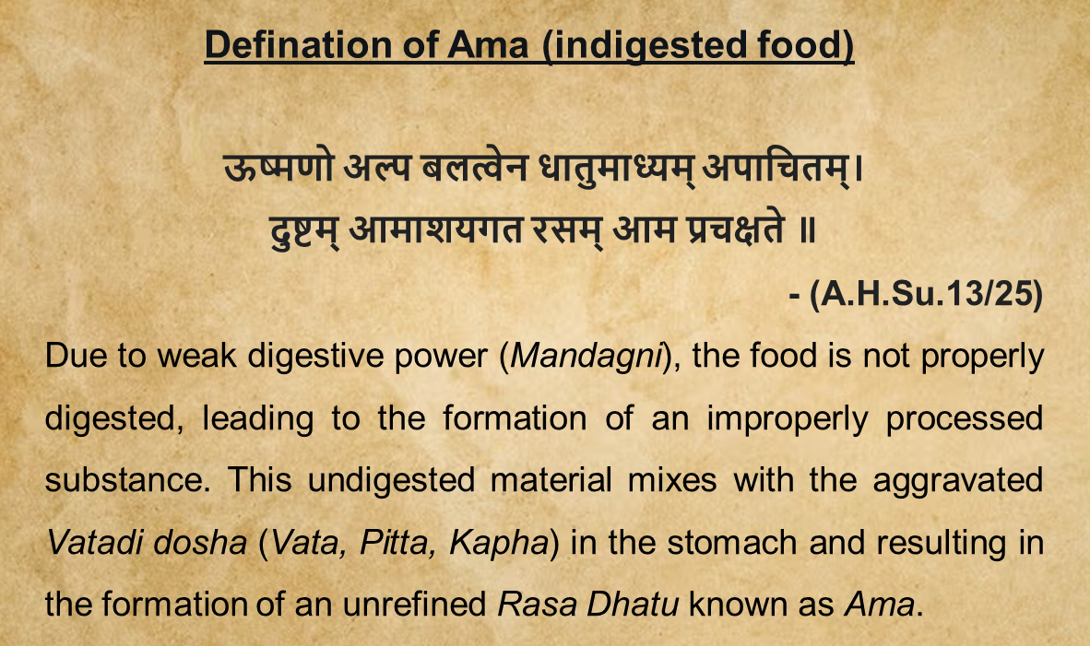
Supplementary Verse 7: This verse explains the Ama (indigested food).

Supplementary Figures

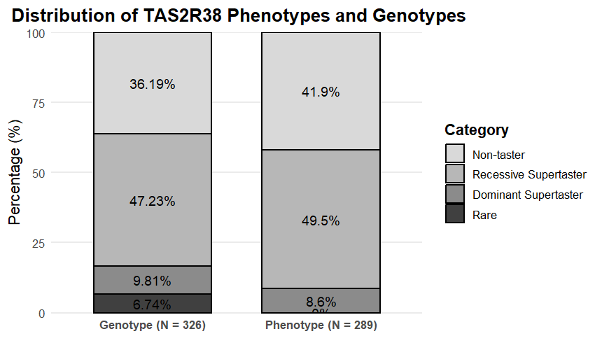
Supplementary Figure 1. Distribution of TAS2R38 bitter taste phenotypes and genotypes in the study population (n = 289). Phenotypically, 41.9% were non-tasters, 49.5% were recessive tasters, and 8.6% were dominant supertasters. Genotypic distribution showed 36.19% non-tasters (AVI/AVI), 47.23% recessive tasters (PAV/AVI), 9.81% dominant supertasters (PAV/PAV), and 6.74% rare variants. Rare variants include uncommon haplotypes such as AAV/AVI, AAI/AVI, PAV/AAV, PVI, PVI/AVI, and PVI/PVV.

Supplementary Tables

Supplementary Table 1a: Distribution of TAS2R38 bitter taste phenotypes
Population | Non-taster, n (%) | Recessive taster, n (%) | Dominant Supertaster, n (%) | Total
Ayurveda cohort | 44 (40.0) | 55 (50.0) | 11 (10.0) | 110
IITJ cohort | 77 (43.0) | 88 (49.2) | 14 (7.8) | 179

Supplementary Table 1b. HWE Analysis of TAS2R38 Bitter Taste Phenotypes
Population | p (PAV) | q (AVI) | HWE χ² | HWE p-value | HWE Status
Ayurveda cohort | 0.35 | 0.65 | 1.08 | 0.29 | In equilibrium
IITJ cohort | 0.32 | 0.68 | 2.67 | 0.10 | In equilibrium
Note: Both the Ayurveda cohort (χ² = 1.08, p = 0.29) and the IITJ cohort (χ² = 2.67, p = 0.10) conform to HWE, indicating no significant deviation from expected genotype frequencies.

Concordance Calculations:
Concordance was calculated as the proportion of individuals in whom the observed bitter taste phenotype matched the phenotype predicted by the TAS2R38 genotype.
Number of individuals with matching genotype-phenotype pairs
Concordance = -------------------------------------------------------------------------------
Total number of individuals in that genotype category

Supplementary Table 2: Genotype vs Phenotype (IITJ and Ayurveda cohort)
Phenotype/Genotype | Non-Taster (Genotype)  AVI/AVI | Recessive Taster (Genotype)  PAV/AVI | Dominant Supertaster (genotype)  PAV/PAV | Total
IITJ cohort
Non-Taster (Phenotype) | 50 | 12 | 2 | 64
Recessive Taster (Phenotype) | 13 | 54 | 15 | 82
Dominant Supertaster (Phenotype) | 0 | 7 | 1 | 8
Total | 63 | 73 | 18 | 154
Ayurveda cohort
Non-Taster (Phenotype) | 32 | 8 | 1 | 41
Recessive Taster (Phenotype) | 7 | 37 | 5 | 49
Dominant Supertaster (Phenotype) | 0 | 7 | 4 | 11
Total | 39 | 52 | 10 | 101
Grand Total | 102 | 125 | 28 | 255
Note: A difference in the total numbers may be observed as rare genotypes (AAV/AVI, AAI/AVI, PAV/AAV, PVI, PVI/AVI, and PVI/PVV) were not considered in the study.

Supplementary Table 3: Distribution of TAS2R38 (rs713598G>C) (Ala → Pro)
Phenotype/Genotype | CC (Ala) | GC (Pro/Ala) | GG(Pro) | Total
IITJ cohort
Non-Taster | 57 | 12 | 5 | 74
Recessive Taster | 13 | 58 | 15 | 86
Dominant Supertaster | 0 | 13 | 1 | 14
Total | 70 | 83 | 21 | 174
Concordance: Genotype w.r.t. Phenotype | 0.77 | 0.67 | 0.07 | -
Ayurveda cohort
Non-Taster | 33 | 10 | 1 | 44
Recessive Taster | 11 | 39 | 5 | 55
Dominant Supertaster | 0 | 7 | 4 | 11
Total | 44 | 56 | 10 | 110
Concordance: Genotype w.r.t. Phenotype | 0.75 | 0.71 | 0.36 | -
Note: The highlighted portion represents the concordance of genotype w.r.t. phenotype.
Supplementary Table 4: Distribution of TAS2R38 (rs1726866G>A) (Ala → Val)
Phenotype/Genotype | AA(Val) | GA(Ala/Val) | GG(Ala) | Total
IITJ cohort
Non-Taster | 54 | 18 | 2 | 74
Recessive Taster | 13 | 56 | 17 | 86
Dominant Supertaster | 0 | 12 | 2 | 14
Total | 67 | 86 | 21 | 174
Concordance: Genotype w.r.t. Phenotype | 0.73 | 0.65 | 0.14 | -
Ayurveda cohort
Non-Taster | 32 | 10 | 2 | 44
Recessive Taster | 8 | 41 | 5 | 54
Dominant Supertaster | 0 | 7 | 4 | 11
Total | 40 | 58 | 11 | 109
Concordance: Genotype w.r.t. Phenotype | 0.73 | 0.76 | 0.36 | -
Note: The highlighted portion represents the concordance of genotype w.r.t. phenotype.
Supplementary Table 5: Distribution of TAS2R38 (rs10246939C>T) (Iso → Val)
Phenotype/Genotype | TT(Iso) | CT(Val/Iso) | CC(Val) | Total
IITJ cohort
Non-Taster | 52 | 20 | 2 | 74
Recessive Taster | 13 | 56 | 17 | 86
Dominant Supertaster | 0 | 12 | 2 | 14
Total | 65 | 88 | 21 | 174
Concordance: Genotype w.r.t. Phenotype | 0.70 | 0.65 | 0.14 | -
Ayurveda cohort
Non-Taster | 32 | 10 | 2 | 44
Recessive Taster | 10 | 39 | 6 | 55
Dominant Supertaster | 0 | 7 | 4 | 11
Total | 42 | 56 | 12 | 110
Concordance: Genotype w.r.t. Phenotype | 0.73 | 0.71 | 0.36 | -
Note: The highlighted portion represents the concordance of genotype w.r.t. phenotype.

