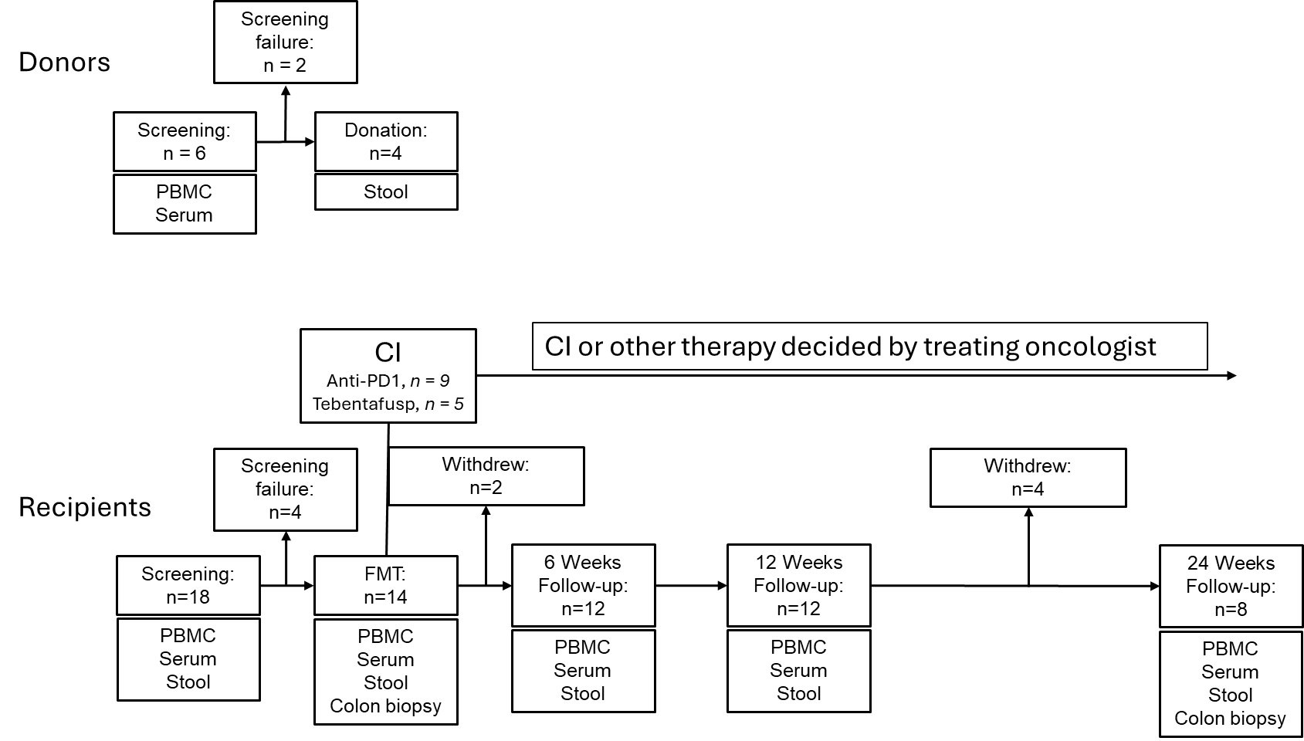
Supplementary Figure 1 | Clinical trial design. Graphical representation of the design of a clinical trial where a total of 18 patients were included (4 Donors and 14 Recipients). After a screening visit where Inclusion and exclusion criteria were carefully assessed in both Donors and Responders, Donors were tasked to come back two weeks later to provide fresh stool samples for FMT infusate preparation. Recipients were invited two weeks after screening procedure to receive a single FMT administered via colonoscopy. Baseline bio-samples were collected during the screening visit or on the day of FMT before the procedure. In addition, Recipients were assessed clinically 6-weeks, 12-weeks and 24-weeks after the FMT. At each of those follow-up visits bio-samples were also collected when possible. At 24 weeks, patients who were still enrolled in the trial underwent a Rectosigmoidoscopy to collect colon biopsies. FMT-R_016 developed severe immune-related Nephritis shortly before the 24 Weeks Follow-up visit and due to his hospitalization, could not undergo End of Study (EoS) endoscopy. CI, Cancer Immunotherapy, FMT, Fecal Microbiota Transfer, PBMC, Peripheral blood mononuclear cells
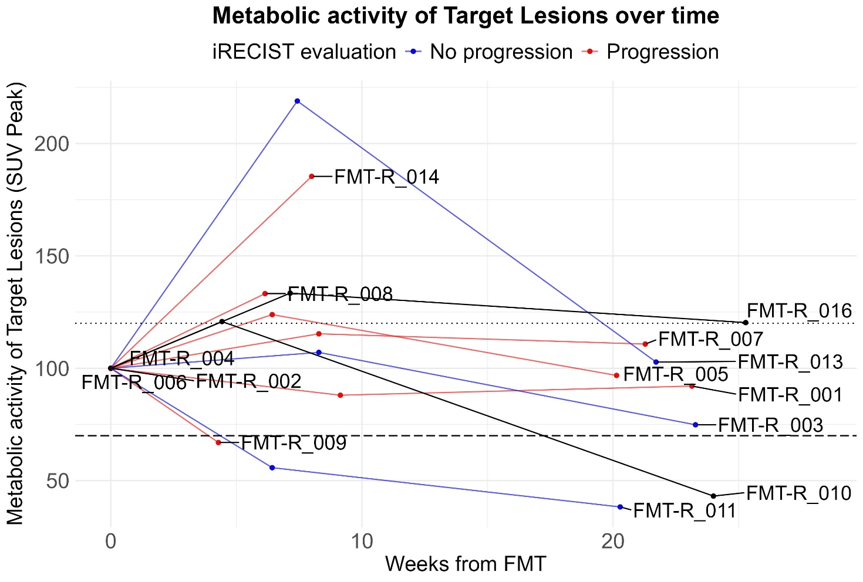
Supplementary Figure 2 | Metabolic activity of Target lesions. Radiographic change in tumor metabolic activity from baseline until 24 weeks post-FMT measured according to iRECIST (assessed by a trained radiologist) from all patients registered in the study. Response status is color coded, (Non progressors in blue, Progressors in red). The # and $ sign represents respectively Surgical and Radio ablation of tumor lesions, making the respective patients formally not evaluable by iRECIST.(noted in black).

$
#
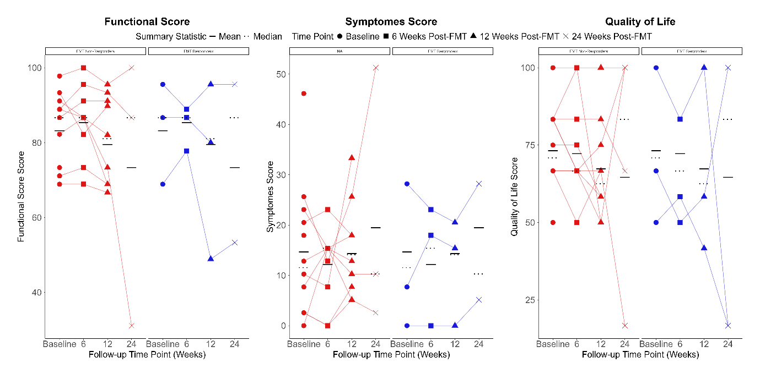
A
C
B
Supplementary Figure 3 | Quality of life (QoL) assessment Baseline, 6, 12 and 24 Weeks post-FMT QoL. The quality of life is represented by the three assessments of Functional score (A), Symptom score (B) and Overall QoL (C). For Function score and Overall QoL, a higher score means a subjective better state. For Functional score, a higher score means a subjective worst state. Each patient is represented as an individual point. Paired samples are connected by a line. The response status is color coded (FMT Responders in blue n = 3, FMT Non-Responders in red n = 11)

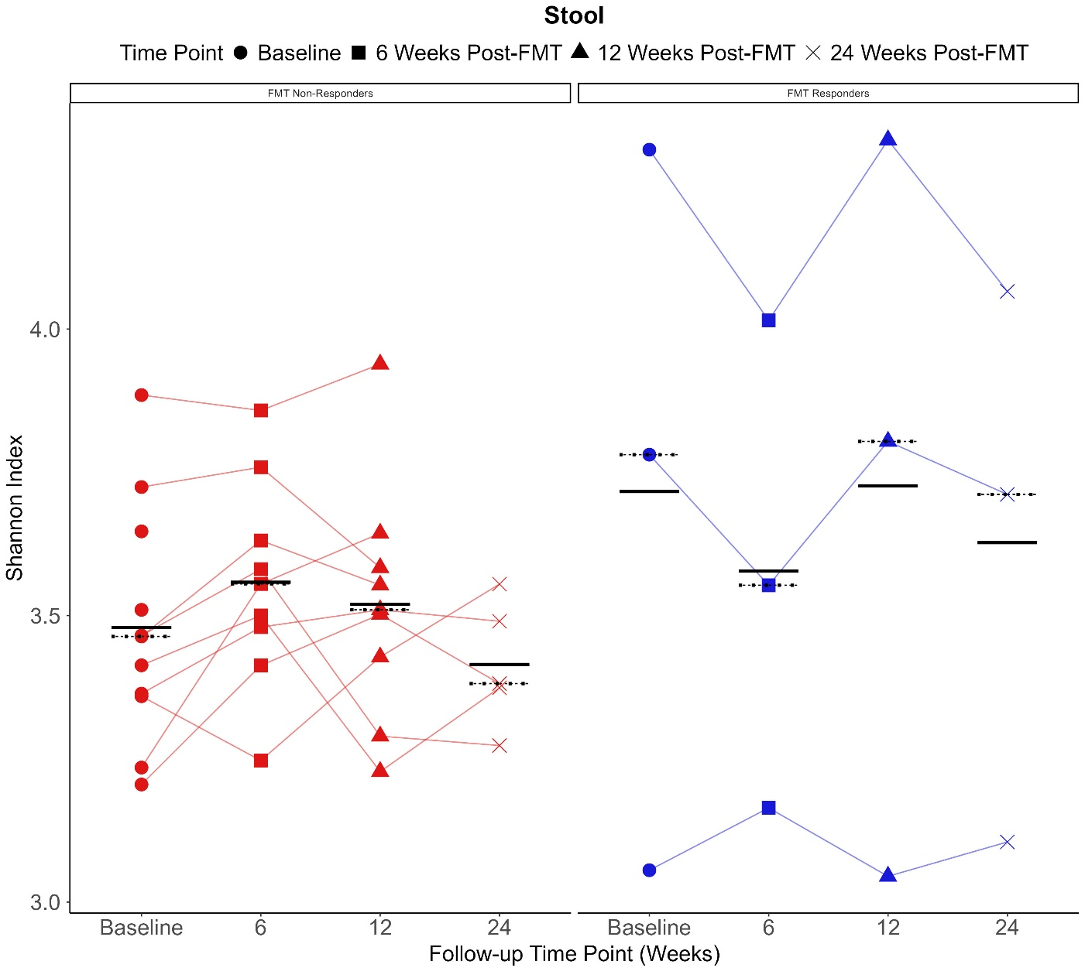
Supplementary Figure 4 | Metagenomics analysis. α-diversity measured by Shannon index in feces at baseline, 6, 12 and 24 Weeks post-FMT. The x- and y-axis represent respectively the time point and the Shannon-index. Each patient is represented as an individual point. Paired samples are connected by a line. The response status is color coded (FMT Responders in blue n = 3, FMT Non-Responders in red n = 11)
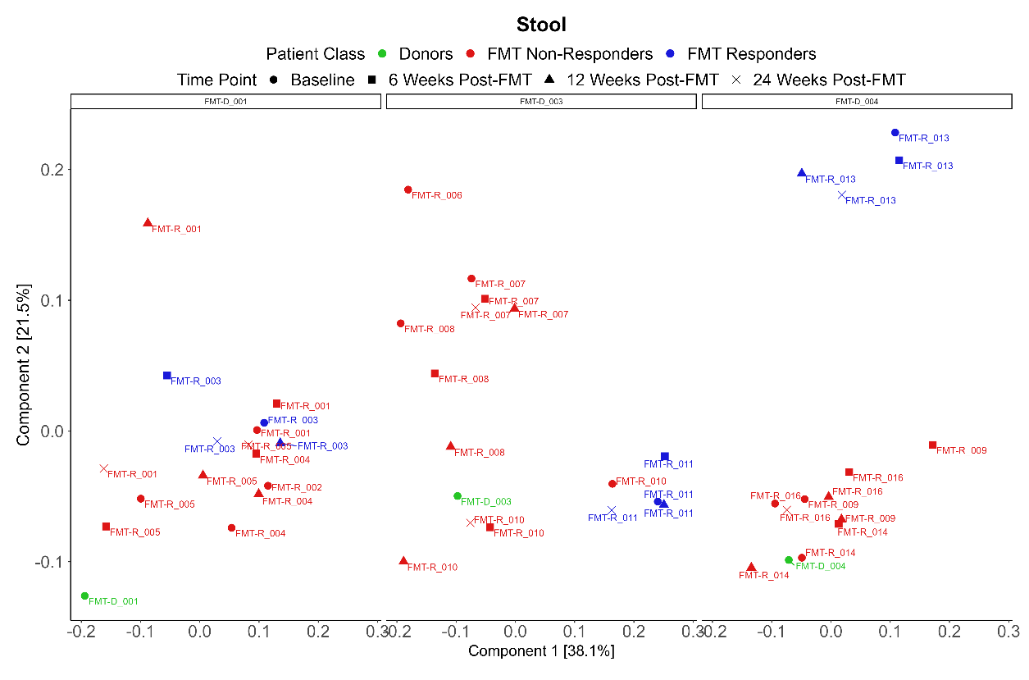
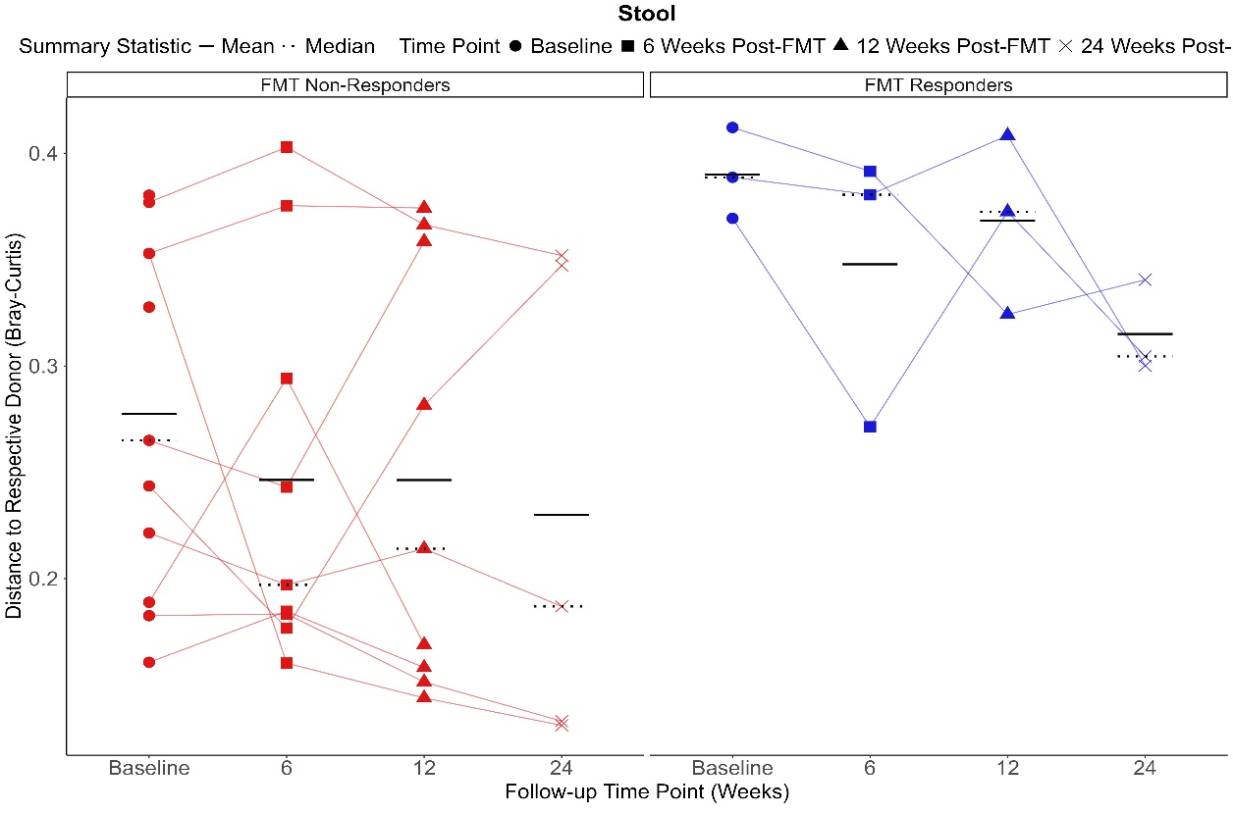
Supplementary Figure 5 | Metagenomics analysis. (A) PCoA of β-diversity measured by Bray-Curtis index at Baseline for all patients and 24 Weeks post-FMT of all patients who reached the end of the trial facetted by their respective Donor in feces. The distance between samples on the plot represents their dissimilarity – The greater the distance between two samples, the greater the dissimilarity. The percentage of variance explained by each principal coordinate from the model is reported in brackets under each axis. Response status is color coded (Donors in green n = 3, FMT Responders in blue n = 3, FMT Non-Responders in red n = 11) (B) Distance of each recipient to his respective donor represented over time. The x- and y-axis represent respectively the time point and the Bray-Curtis Dissimilarity index to respective donor. Each patient is represented as an individual point. Paired samples are connected by a line. The response status is color coded.
A
B

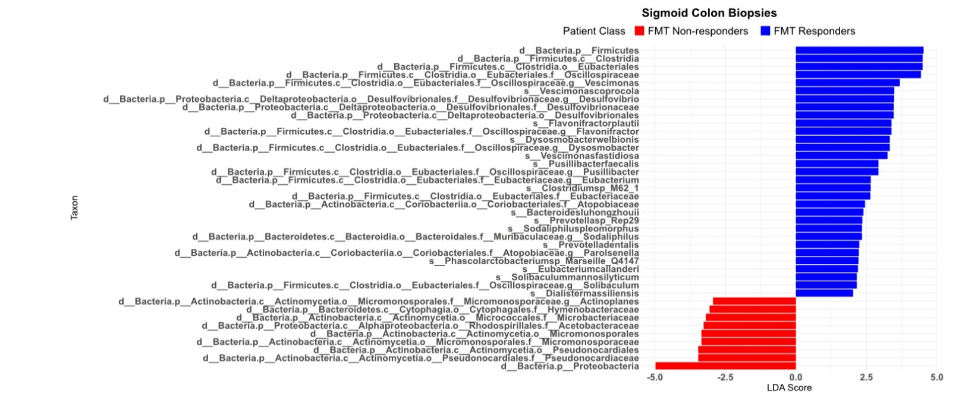
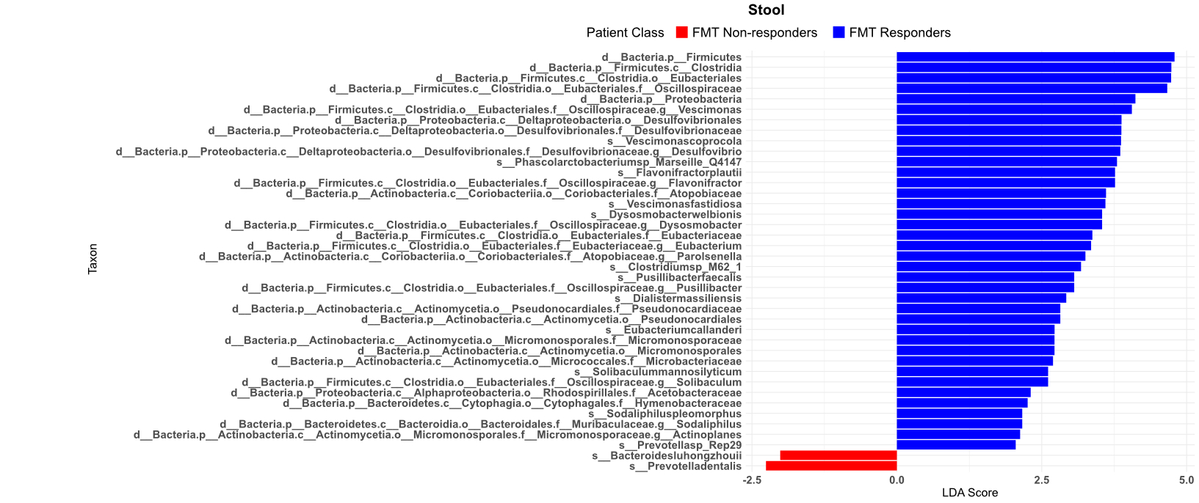
Supplementary Figure 6 | Linear discriminant analysis effect size (Lefse) analysis. Results from a 2 factor Lefse analysis with all common taxa between Feces and Biopsies identified. The X-axis represent the LDA score for each Taxa. Colors represent the response to FMT, blue for responders, red for non-responders. (A) Results in faces, (B) Results in the rectosigmoid biopsies.
A
B

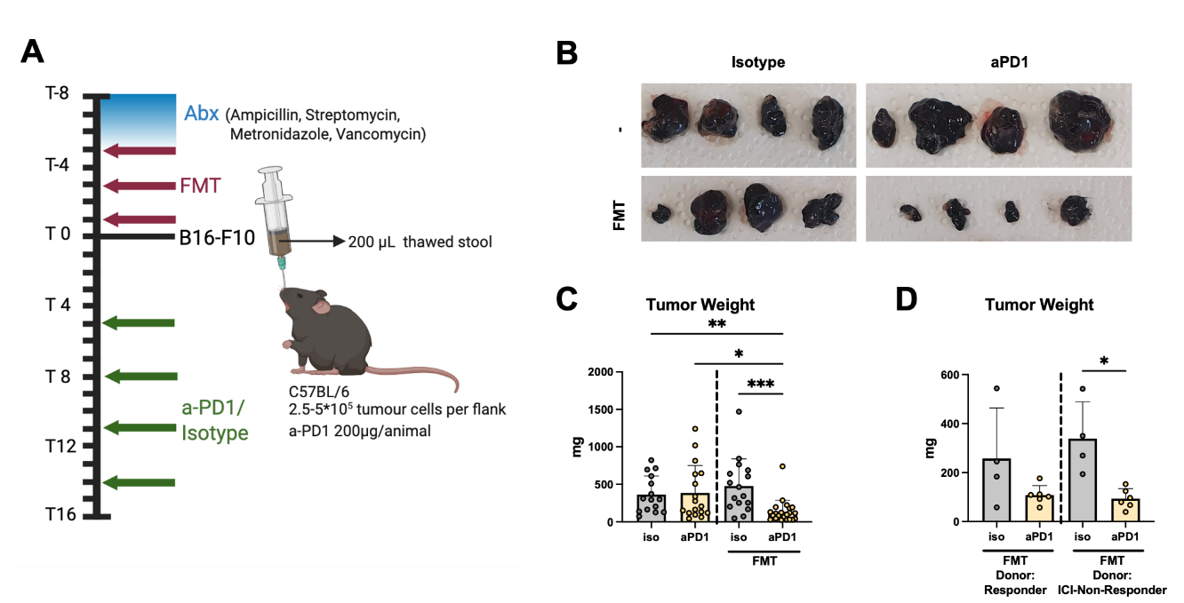
Supplementary Figure 7 | FMT synergizes with PD1 blockade in reducing the tumor burden in a B16 melanoma model. (A) Schematic overview of the study design. C57BL/6 mice were injected subcutaneously with 5x105 B16-F10 cells into both flanks. Mice received a single dose of FMT from donors as indicated and were additionally treated with either isotype control or anti-PD-1 (aPD-1) antibody. Tumors were extracted at the experimental endpoint. (B) Representative images of one study each are shown and weights (mg) were recorded (C-D). Bars indicate mean values with standard deviation (SD) as error bars. Data are pooled from two independent experiments in C. For all panels, statistical analysis was performed using the Kruskal-Wallis test with Dunn’s multiple comparison correction.

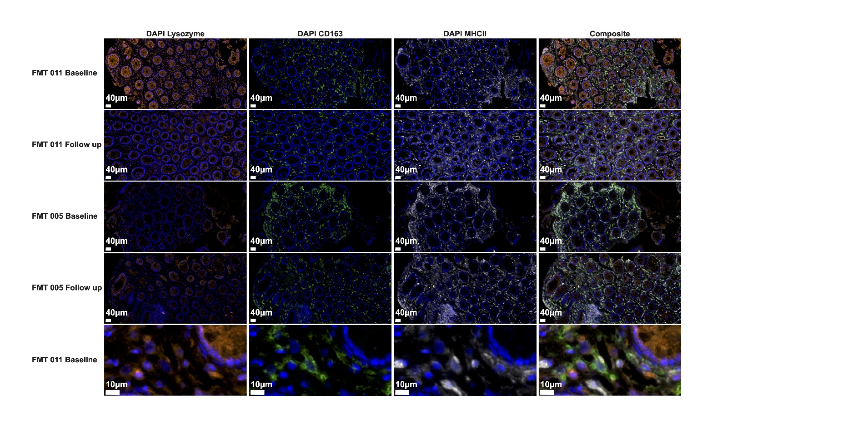
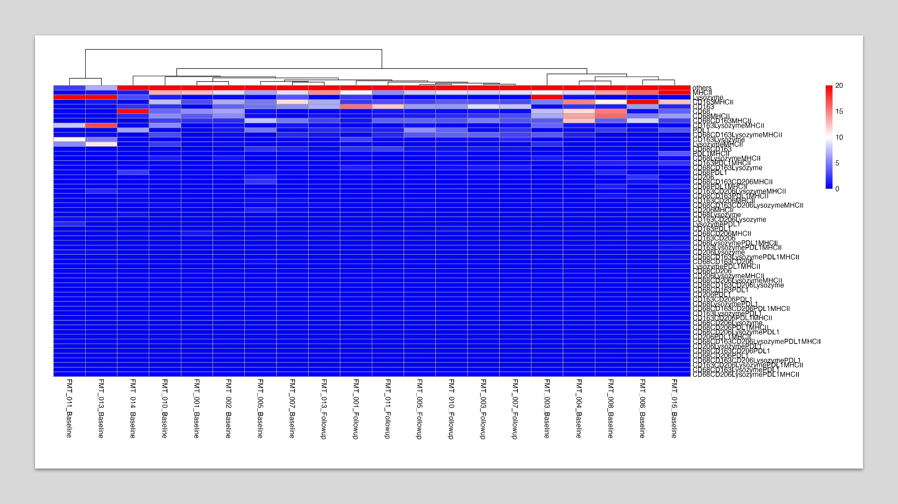
Supplementary Figure 8 | Multiplex Immunofluorescence from sigmoid colon. (A) Microscopy Pictures from FMT-R_011 and FMT-R_5 at Baseline and 24 weeks follow-up. (B) Heatmap of fluorescence intensity measured from a multiplex immunofluorescence experiment
A
B
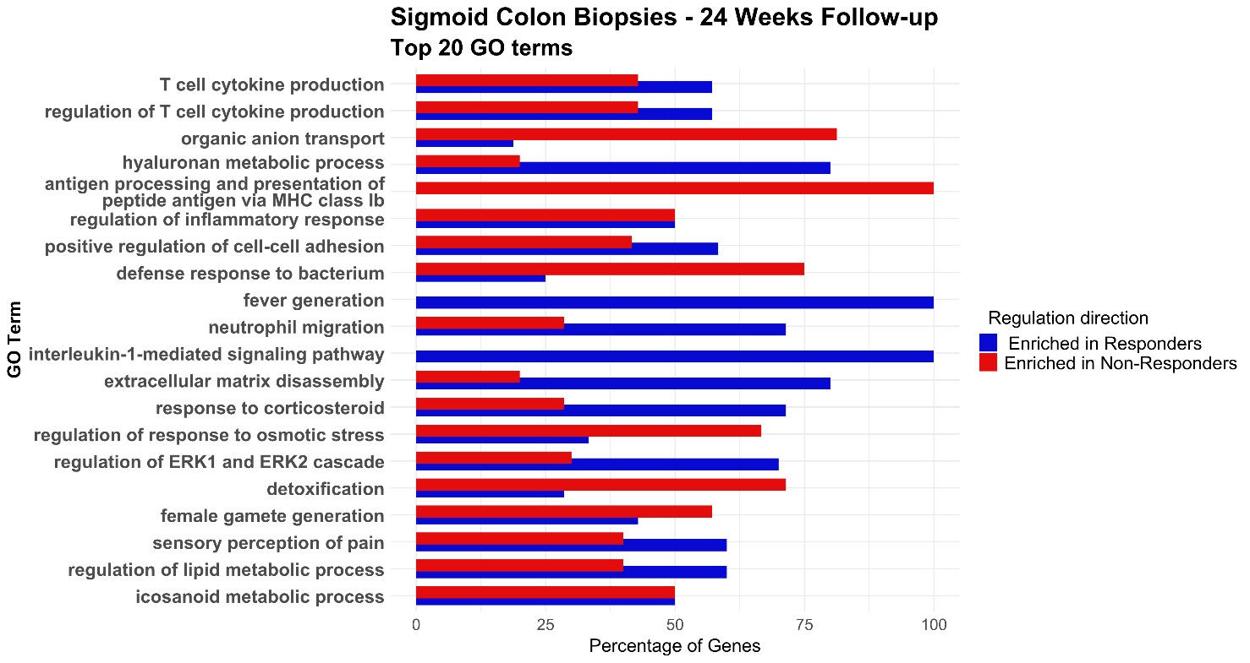
Supplementary Figure 9 | Bulk RNA sequencing from sigmoid colon biopsies. GO enrichment analysis performed on differentially expressed genes in sigmoid colon biopsies at 24 weeks post-FMT respectively in FMT Responders and FMT Non-Responders. Enriched molecular function were calculated with an over representation analysis on all differentially expressed genes between Responders and Non-Responders with adjusted p-value > 0.05 at 24 weeks upon FMT. Represented are the top 20 GO term based on the p-value. The x-axis represents the percentage of genes enriched respectively in responders and non-responders who contributes to each GO term.
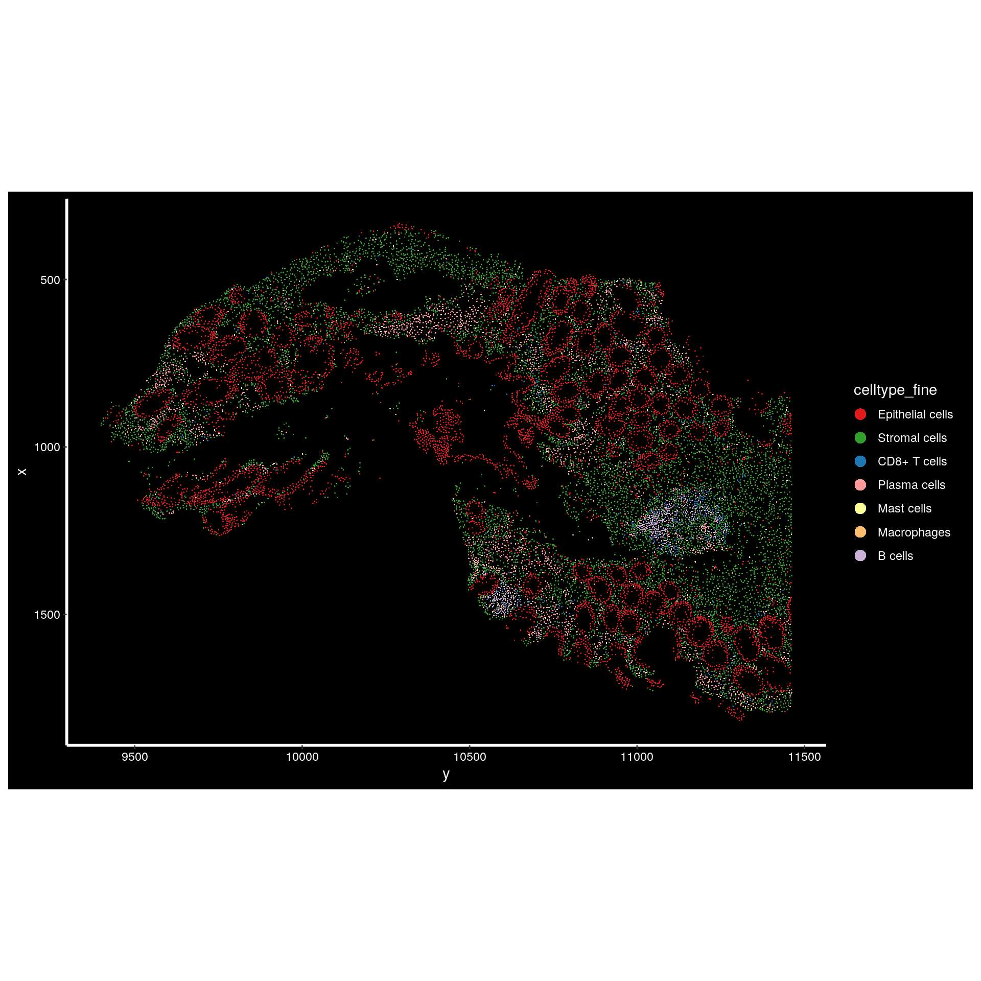
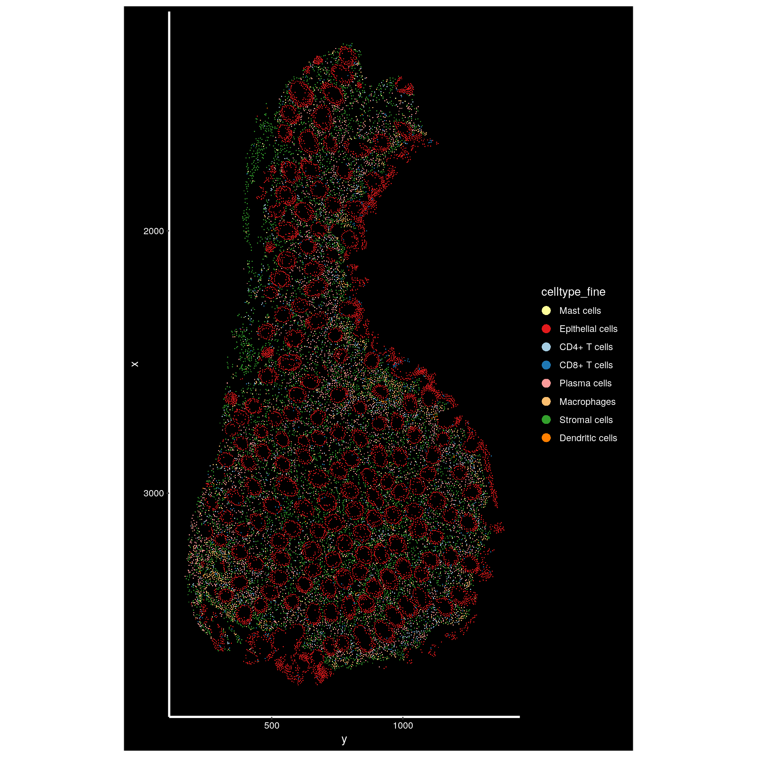
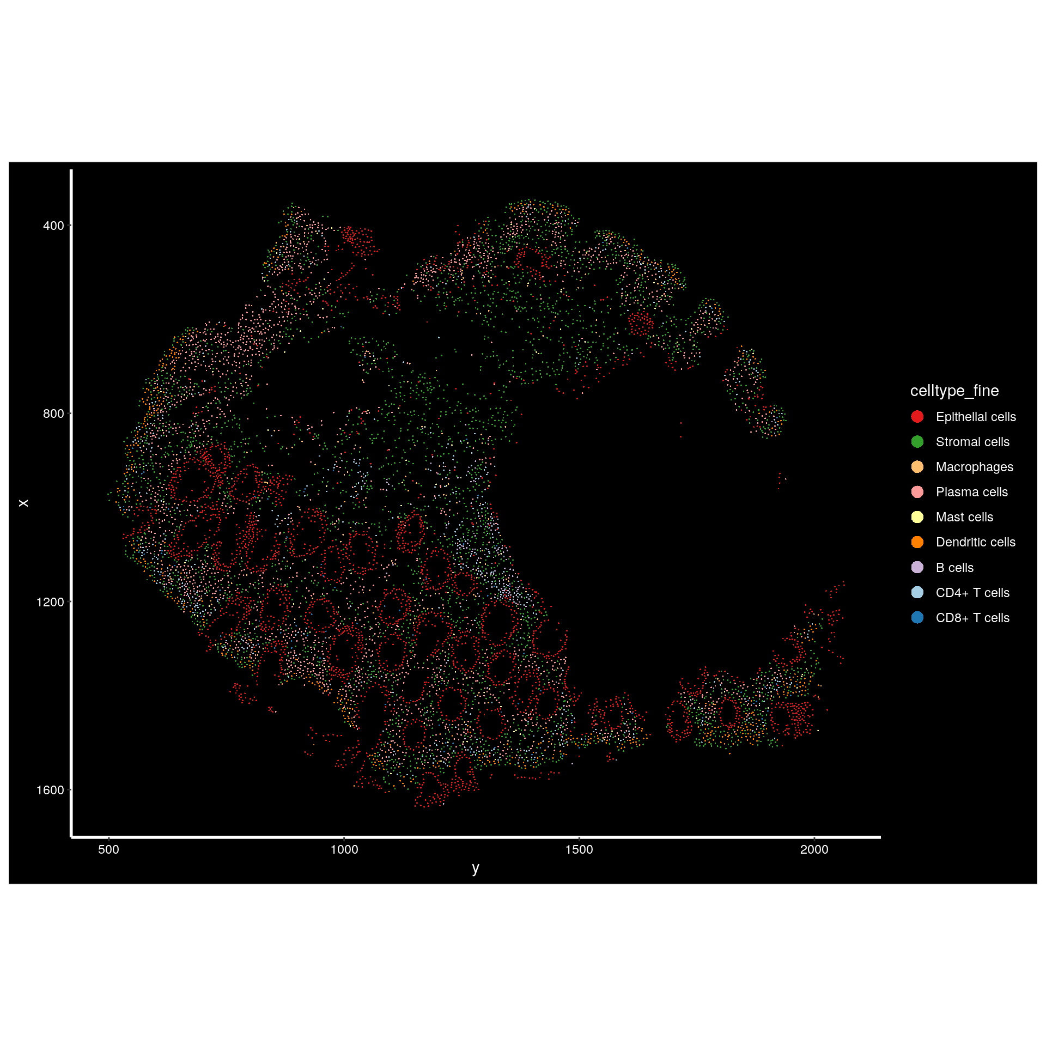
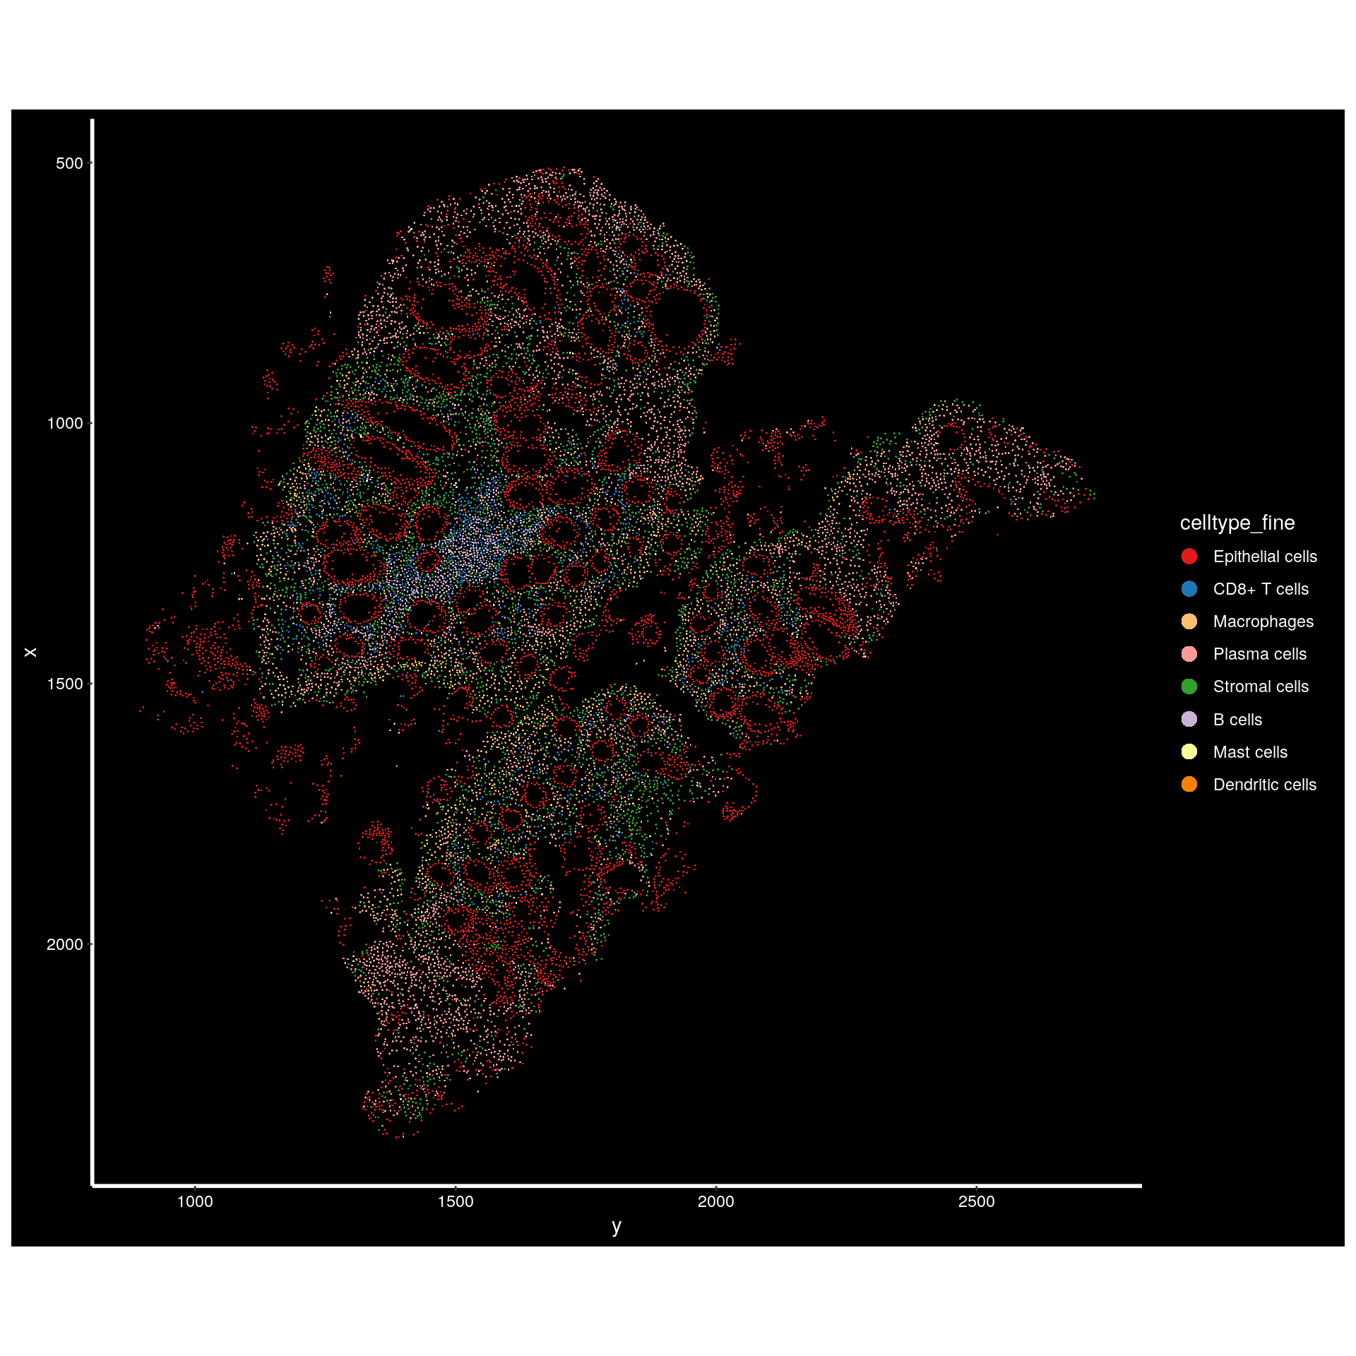
A
B
C
D
Supplementary Figure 10 | Spatial transcriptomics analysis from sigmoid colon biopsies. Xenium spatial plot in individual samples based on lineage specific marker gene expression at 24 weeks Follow-up. (A) FMT-R_003, (B) FMT-R_011, (C) FMT-R_005, (D) FMT-R_007. The x- and y- axis represent the size in µm.

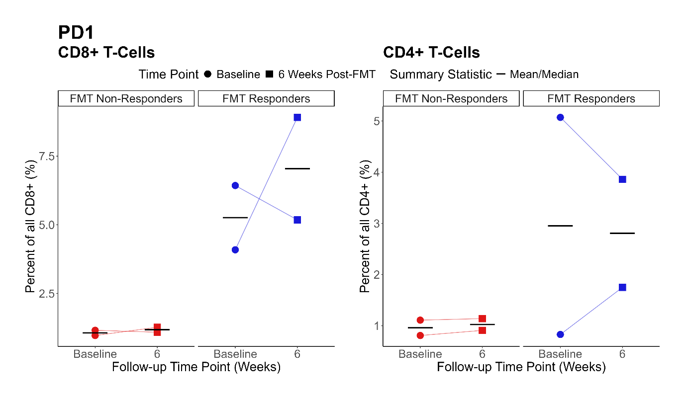
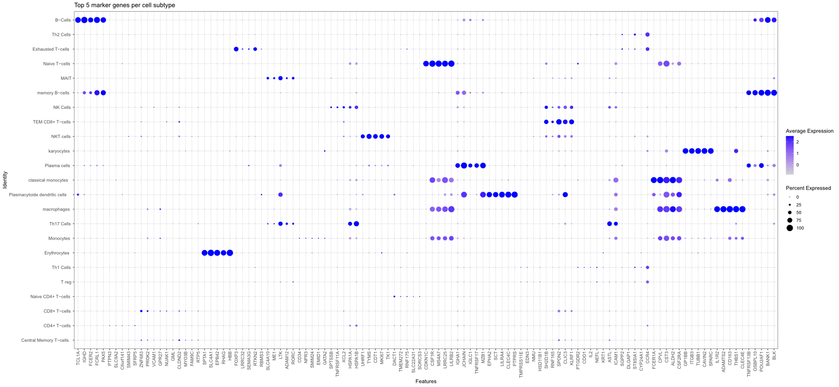
Supplementary Figure 11 | Multiplex flow cytometry from PBMC’s. The x- and y-axis represent respectively the proportions and the time point. Each patient is represented as an individual point. Paired samples are connected by a line. The line represents the median and the mean. The response status is color coded (FMT Responders in blue n = 2, FMT Non-Responders in red n = 2)
A
B
Supplementary Figure 12 | scRNA sequencing from PBMCs. Top 5 overexpressed marker genes in each cell clusters

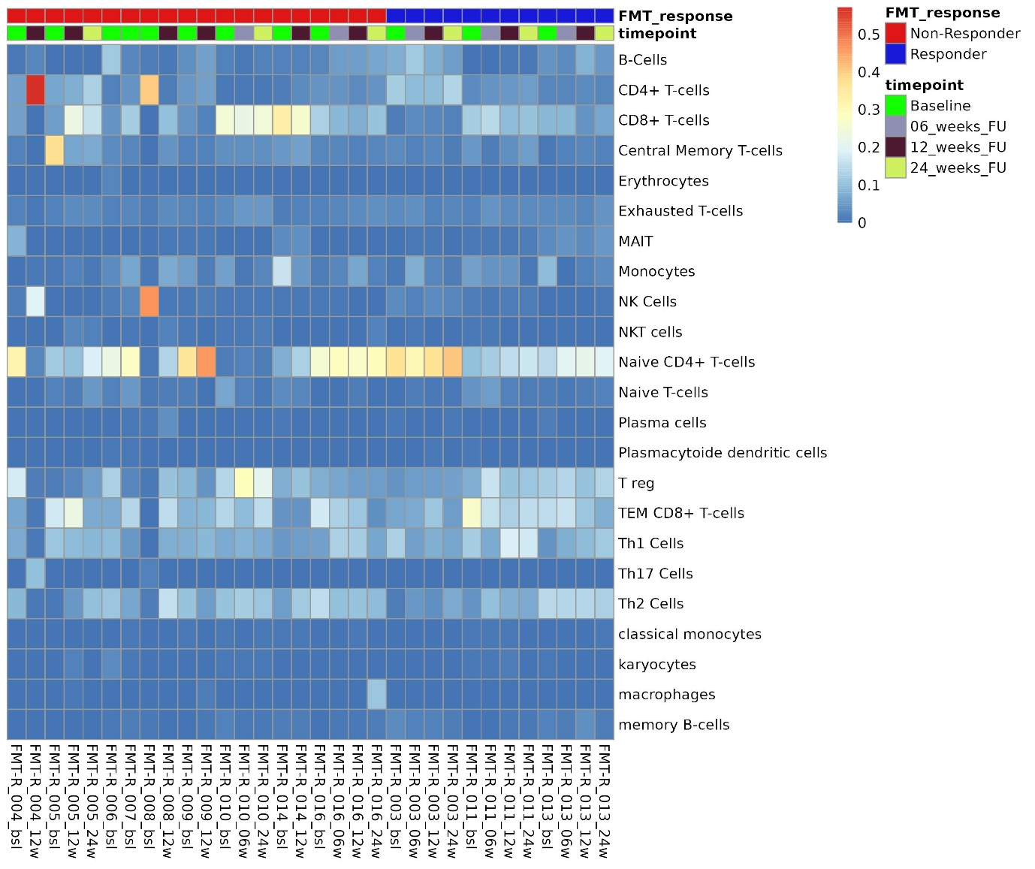
Supplementary Figure 13 | Single cell RNA sequencing from PBMCs. Heatmap of relative cell count to the total cell numbers. For each sample, the total is equal to 1. Samples are arranged by patient number and time point.

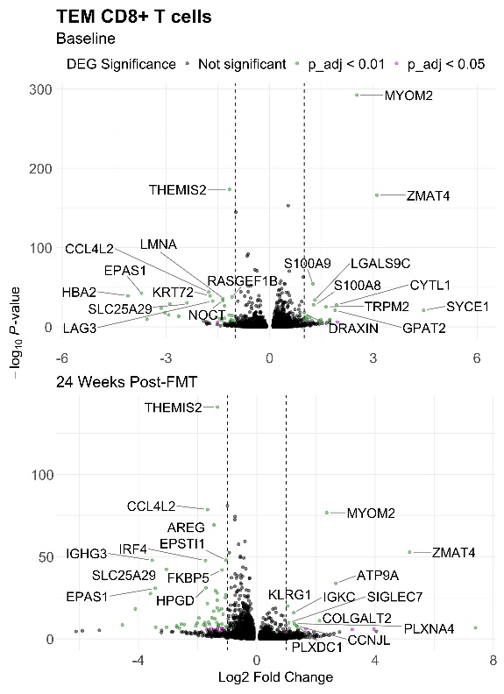
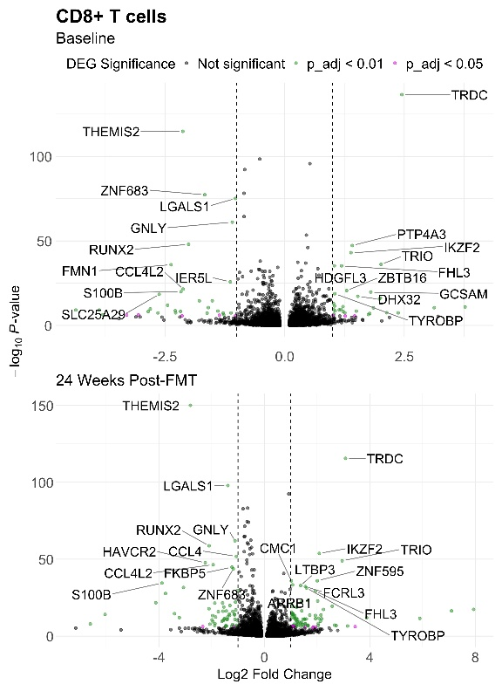
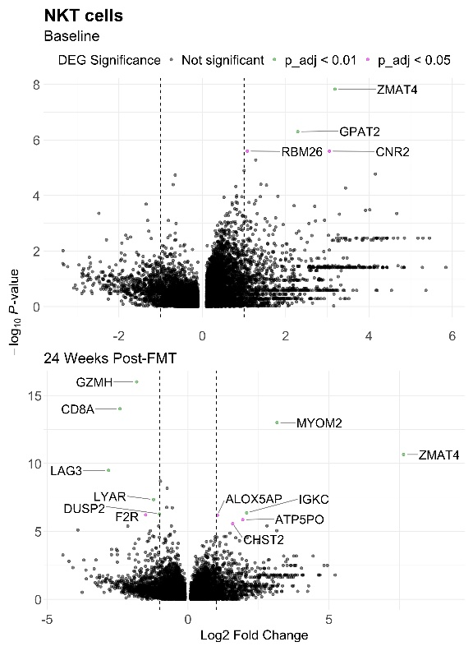
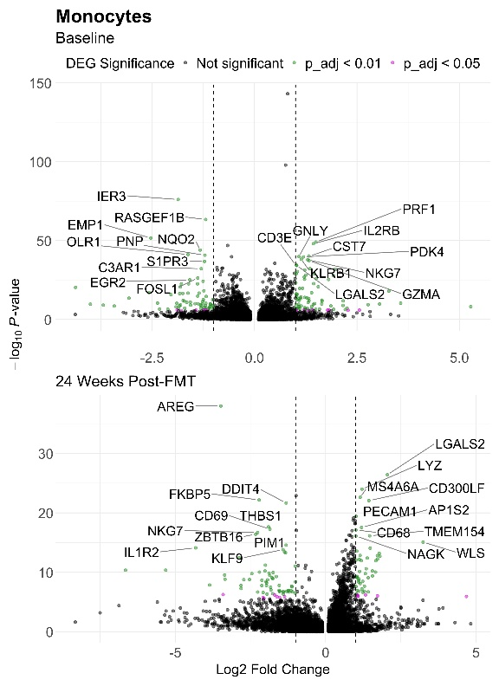
Supplementary Fig. 14 | scRNA sequencing from PBMCs
Volcano plot showing differentially expressed genes in TEM CD8+ T-cells (A), CD8+ T-cells (B), NKT cells (C) and Monocytes (D) at baseline (top panel) and 24 weeks post-FMT (lower panel) between FMT Non-Responders (left side of volcano plots) and FMT Responders (right side of volcano plots). The top 10 differentially expressed genes in each direction based on the adjusted p-value are labelled.

A
B
C
D

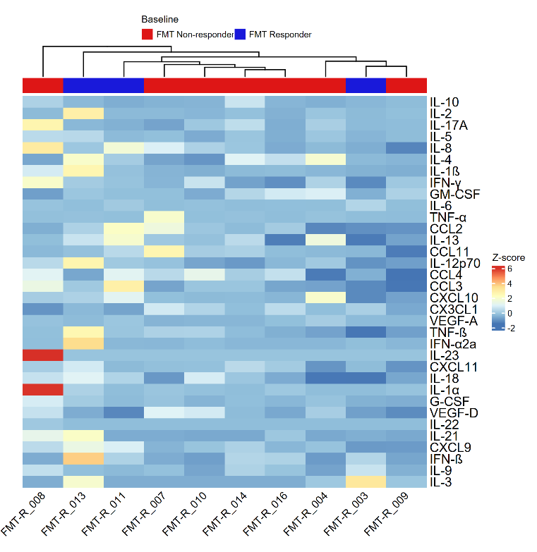
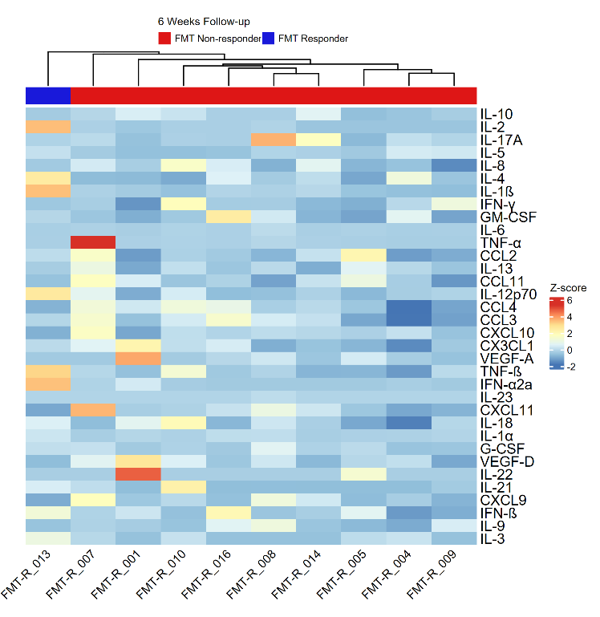
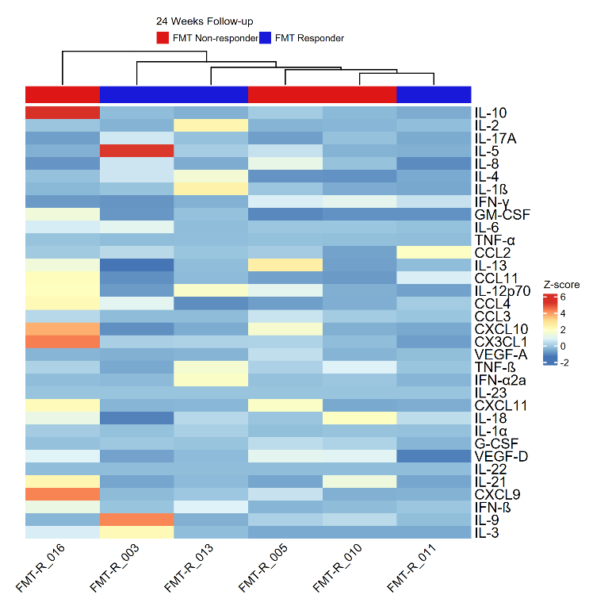
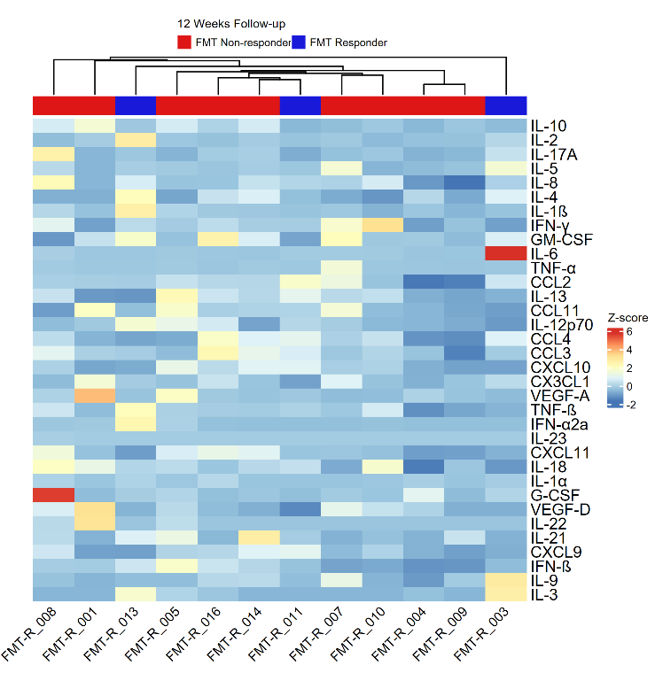
A
B
D
C
Supplementary Figure 15 | Mesoscale analysis from serum. Heatmaps showing the Z-scaled concentration of 34 cytokines detected in a Mesoscale assay respectively at Baseline (A), 6- (B), 12- (C) and 24 Weeks post-FMT (D). Red colors represent higher pic intensity and blue colors represents lower pic intensity. Response status is color coded (FMT Responders in blue, FMT Non-Responders in red). Samples are in columns and are displayed as unsupervised hierarchical clustering. Features are in rows and are not clustered.

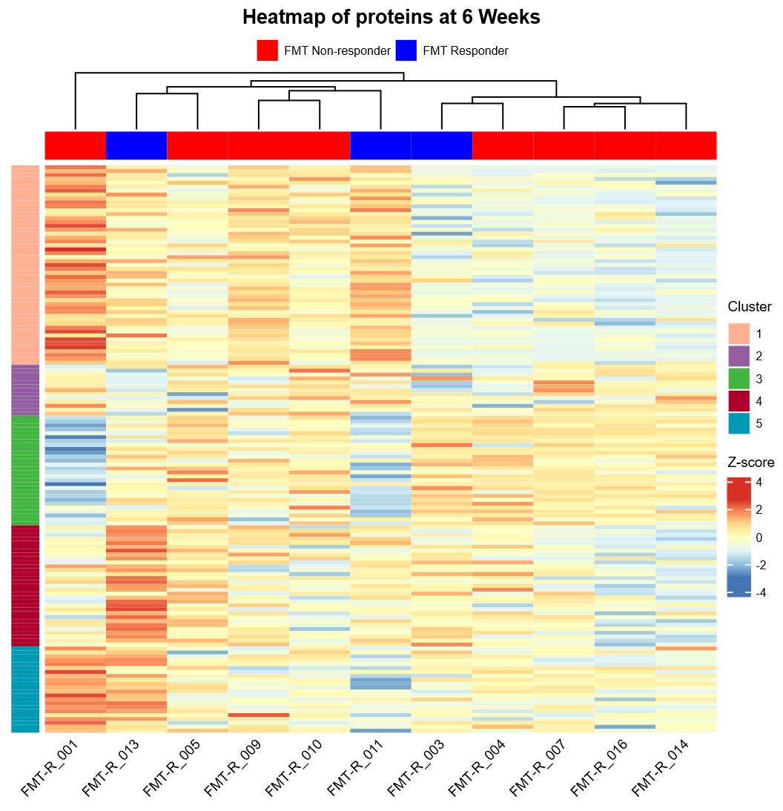
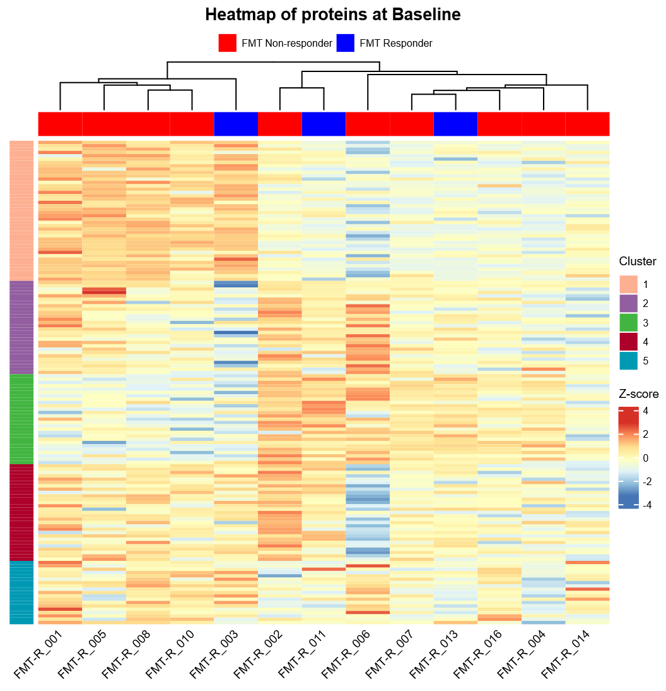
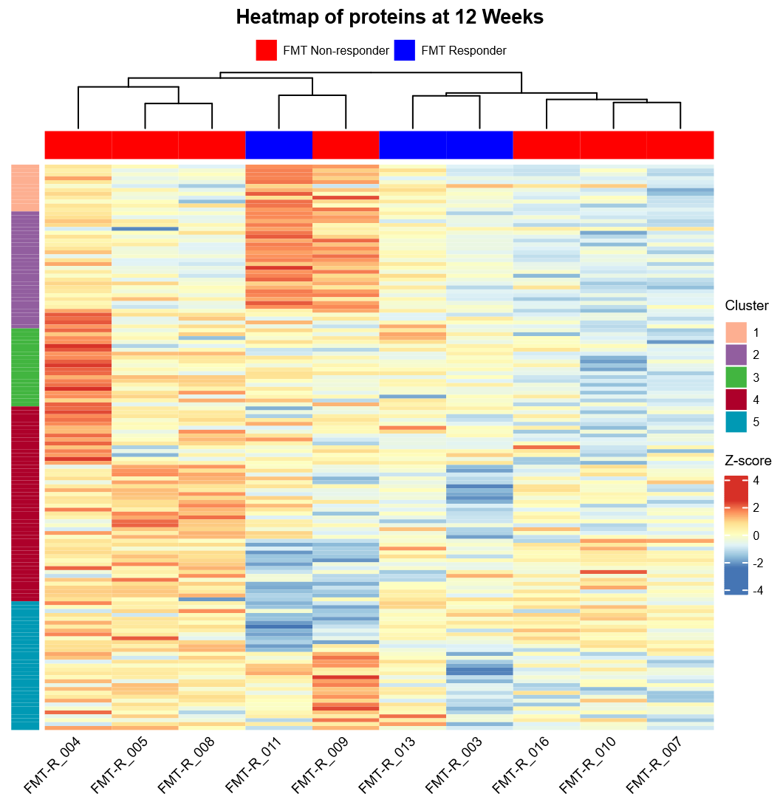
B
A
C
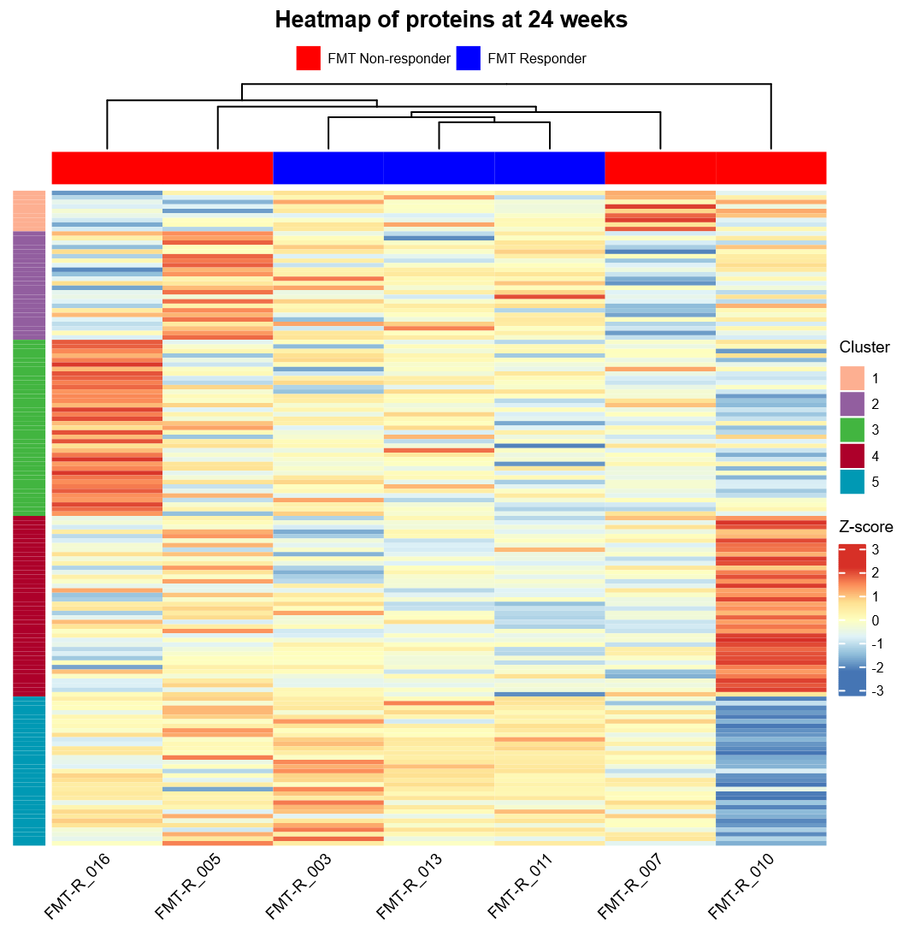
Supplementary Figure 16| Targeted LC-MS/MS proteomics analysis from serum. Heatmaps of peak intensities at Baseline(A), 6- (B), 12- (C)and 24 Weeks Post-FMT (D). Only the features who were detected in all samples are represented. The peak intensities were log2 transformed and Z-scaled for graphical representation. Red colors represent higher pic intensity and blue colors represents lower pic intensity. Response status is color coded (FMT Responders in blue, FMT Non-Responders in red). Samples are in columns and are displayed as unsupervised hierarchical clustering, features are in rows. Row clustering is the result of a k-mean clustering analysis

D

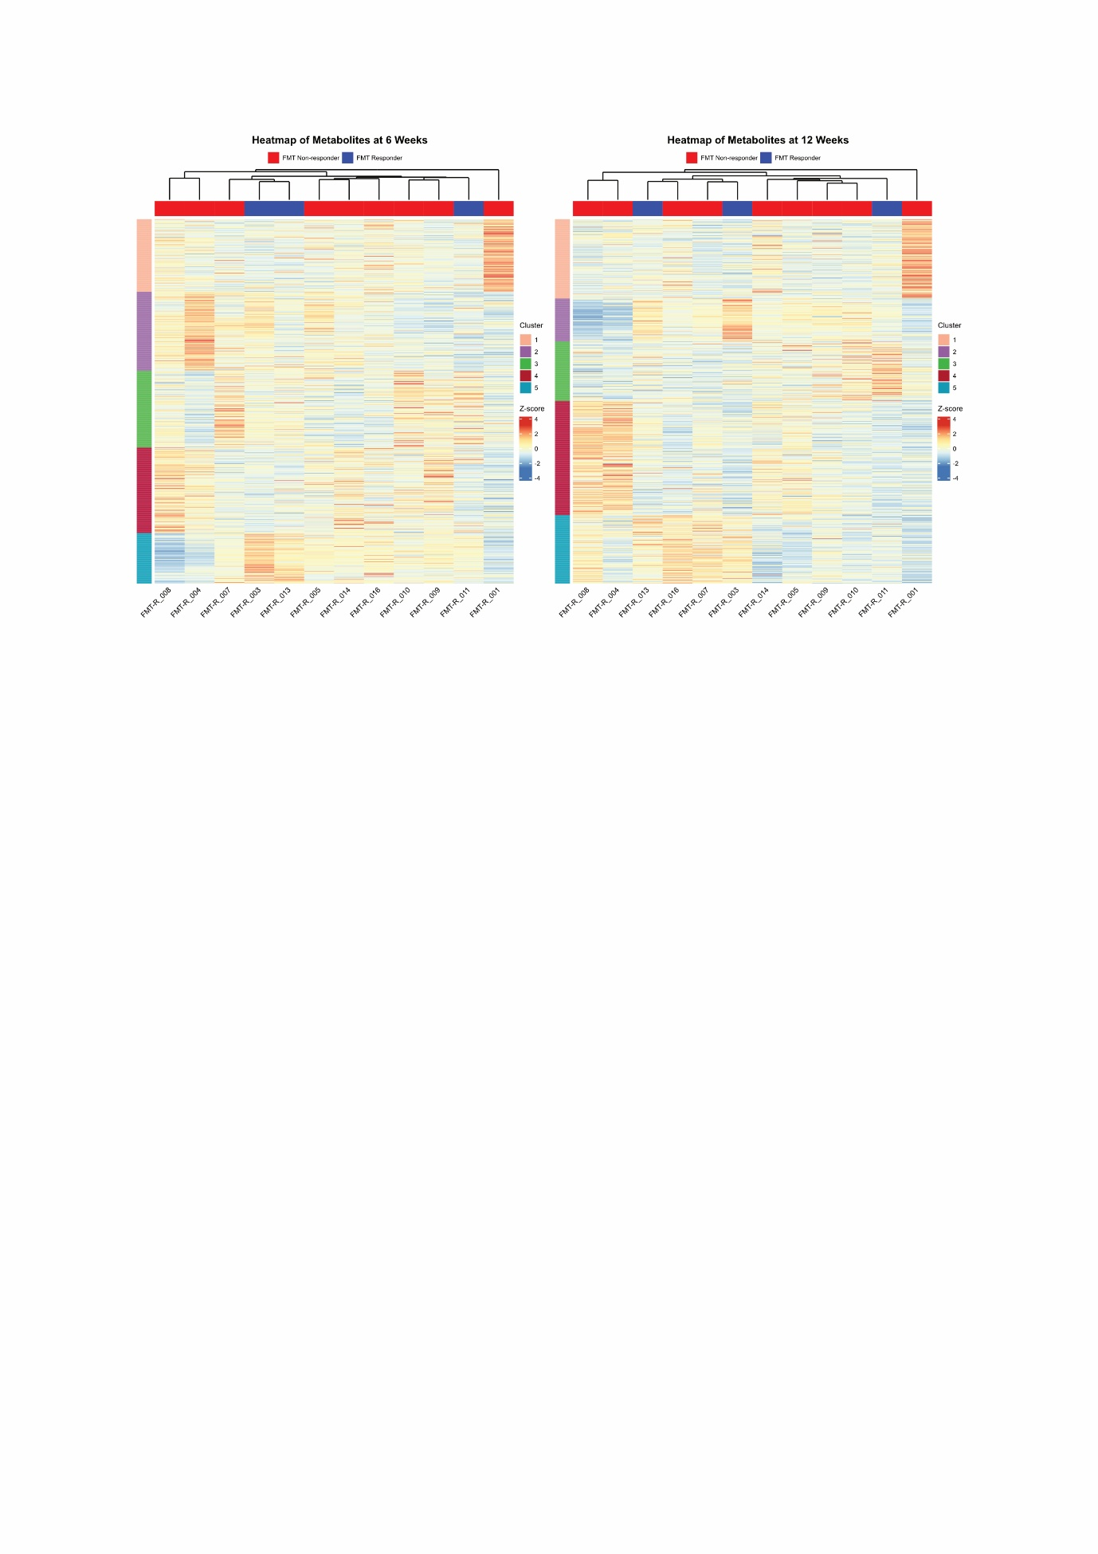
Supplementary Figure 17 |Untargeted LC-MS/MS metabolomics analysis from serum. (A-B) Heatmaps showing the peak intensities of the metabolites detected in the assay respectively at 6- (A) and 12 Weeks Post-FMT (B). The peak intensities were log2 and Z-scaled for graphical representation. Red colors represent higher pic intensity and blue colors represents lower pic intensity. Response status is color coded (FMT Responders in blue, FMT Non-Responders in red). Samples are in columns and are displayed as unsupervised hierarchical clustering. Features are in rows, row clustering is the result of a k-mean clustering analysis

A
B
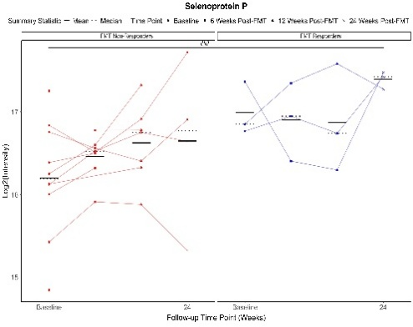
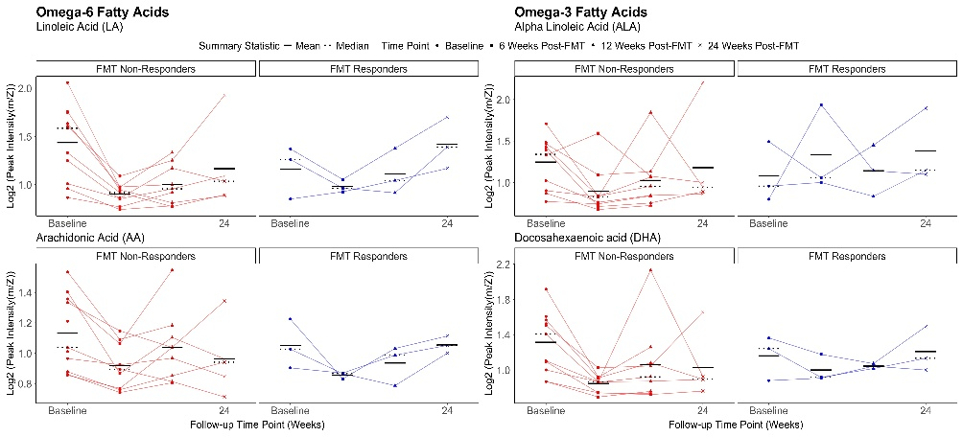
Supplementary Figure 18 |Metabolomics and Proteomics analysis from serum. (A-B) Untargeted LC-MS/MS analysis showing selected PUFAs peak intensity. (A) PUFAs from the omega-6 lineage. (B) PUFAs from the omega-3 lineage. (C) Selenoprotein P peak intensity from a targeted LC-MS/MS analysis. The peak intensities were log2 transformed for graphical representation. Response status is color coded (FMT Responders in blue, FMT Non-Responders in red)
B
A
C

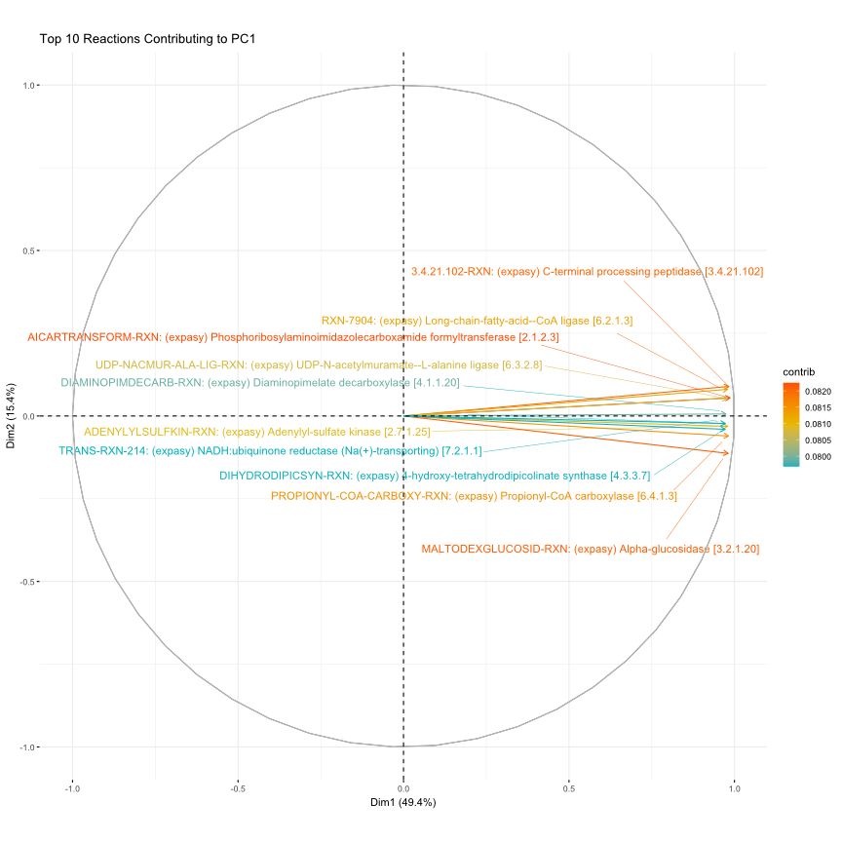
Supplementary Fig. 19 | Molecular pathway analysis from feces. Top 10 reactions contributing the most to PC1 in a PCA performed on reactions inferred from a metagenomic analysis.

Inclusion and Exclusion Criteria:
General inclusion criteria for all participants:
- Patients, at minimum 18 years of age, male or female
- Signed informed consent obtained from subject according to local regulations
- ECOG score at the time of study enrolment 0-1
The investigators will include patients/individuals fulfilling inclusion criteria for one of the following groups:
- Patients with refractory malignancy (FMT-Recipients). The investigators will recruit 25 individuals with stable or progressing disease after minimum of 1 cycle of CI.
- Patients with malignancy in remission after ICI therapy (FMT-Donors). The investigators will recruit 5 patients willing to donate stool samples for the study.
Inclusion criteria FMT-Recipients:
- Histologically or cytologically confirmed diagnosis of malignancy
- Currently treated with CI with at least 1 cycle completed. Multiple active malignancies are allowed.
- Patient with stable or progressive disease as shown at the most recent staging method and decided by the treating investigator (based on the radiologic assessment).
- Must be CI refractory/resistant as judged by the treating physician based on a recent CT or PET-CT (PET-MRI) scan not older than 8 weeks before screening visit.
- Willingness to receive FMT administered via colonoscopy and undergo necessary bowel preparation pre-procedure.
- Demonstrate adequate organ function as defined below, all screening labs should be performed within 28 days of FMT intervention.
Following laboratory parameters need to be met:
  - Platelet count ≥ 50 x 10^9 / L
  - Hemoglobin ≥ 8.5 g/dL
  - Prothrombin time (PT)-international normalized ration (INR) ≤ 1.5
- Female subject of childbearing potential should have a negative urine pregnancy within minimum 8 hours prior to receiving the study intervention (FMT). If the urine test is positive or cannot be confirmed as negative, a serum pregnancy test will be required.
- Female subjects of childbearing potential must be willing to use a clinically established method of contraception before the FMT procedure.
Inclusion criteria FMT-Donors:
- Documented history of malignancy treated with ICI therapy.
- Featuring partial or complete response of the malignancy as assessed by radiologic examination with a minimum duration of remission lasting ≥12 months measured since initiation of therapy.
- Willingness to complete donor-specific questionnaire.
- Willingness to complete donor-specific serologic and stool testing to evaluate infectious agents.
- Patient tested negatively for all infectious agents specified.
- Willingness to provide multiple stool samples, until total amount reaches 170g.
- Absence of major gastrointestinal symptoms 3 months prior to stool donation (including frequent vomiting, diarrhea, bleeding, constipation).
Exclusion criteria FMT Recipients:
- Presence of absolute contra-indications to colonoscopy and/or FMT administration:
  - Toxic megacolon
  - Inflammatory bowel disease
  - Anatomic contra-indications to colonoscopy
  - Colectomy
- Patient is currently participating and receiving other study therapy or has participated in a study of an investigational agent and received study therapy or used an investigational device within 4 weeks of this study intervention.
- Currently under any form of systemic antibiotics.
- Has a diagnosis of immunodeficiency or is receiving systemic steroid therapy (> 10 mg prednisone daily or equivalent) or any other form of immunosuppressive therapy two weeks prior to trial treatment. Patients receiving systemic steroids at physiologic doses are permitted to enrol assuming steroid dose is not above the acceptable threshold (> 10 mg prednisone daily or equivalent).
- Severe anaphylactic reaction to any food (food allergies).
- Had a severe hypersensitivity reaction to propofol.
- Has serious concomitant illnesses. The eligibility can be granted by the treating investigator on individual bases.
- Has HIV infection or AIDS-related illness.
- Has active infection of HAV, HBV or HCV. Patients with a history of Hepatitis B/C infection who have received anti-viral therapy and are disease free may be considered for enrollment after discussion with Principal Investigator.
- Patient has received a live vaccine within 4 weeks prior to the first dose of treatment. Seasonal influenza vaccines or COVID-19 vaccines for injection are generally inactivated virus vaccines and are allowed.
- Has known psychiatric or substance abuse disorders that would interfere with cooperation with the requirements of the trial.
- Females who are pregnant or breastfeeding.
- Active central nervous system (CNS) metastases and/or leptomeningeal involvement.
Exclusion criteria FMT Donors:
- History or current antibiotic treatment during the 2 month preceding donation.
- History or current intrinsic gastrointestinal illnesses, including inflammatory bowel disease, irritable bowel syndrome, chronic diarrheal disorder (e.g. celiac disease or microscopic colitis) or major gastrointestinal surgical procedures.
- History or current symptomatic autoimmune illness.
- History or current documented neurologic or neurodevelopmental disorders.
- History or current metabolic syndrome, obesity (BMI of >35), or moderate-to-severe malnutrition (as assessed clinically).
- History or current infection with HIV (or AIDS-related illness).
- Positive serological tests for Syphilis, HAV, HBV or HCV.
- Positive stool test for Escherichia coli, Vancomycin-resistant Enterococcus, Norovirus, C. difficile, Yersinia, Campylobacter, Shigella or Salmonella.
- Positive stool test for the following parasites: Flagellaten, Endolimax nana, Entamoeba coli, Entamoaeba hartmanni, Iodamoeba butschlii, Blastocystis hominis, Dientamoeba, Ascaris, Cyclospora, Cystoisospora, Entamoeba dispar, Entamoeba histolytica, Giardia, ,Hookworm, Sarcocystis, Trichuris

- Positive Sars-CoV-2 screening/testing (active infection).
- Subjects whose pregnancy test on Screening visit shows a positive result, have to be excluded from the study. All pregnancies occurring during the treatment phase of the study and within 30 days after discontinuation of study medication have to be reported to the Investigator-Sponsor within one working day of the investigational sites knowledge of the pregnancy on the Initial Pregnancy Report Form. Female Subjects should be informed in this way before signing the informed consent form. Female partners of male participants may get pregnant without any consequence to the male participant.
Supplementary Table 1 | Extensive Inclusion and Exclusion criteria for both donors and recipients.

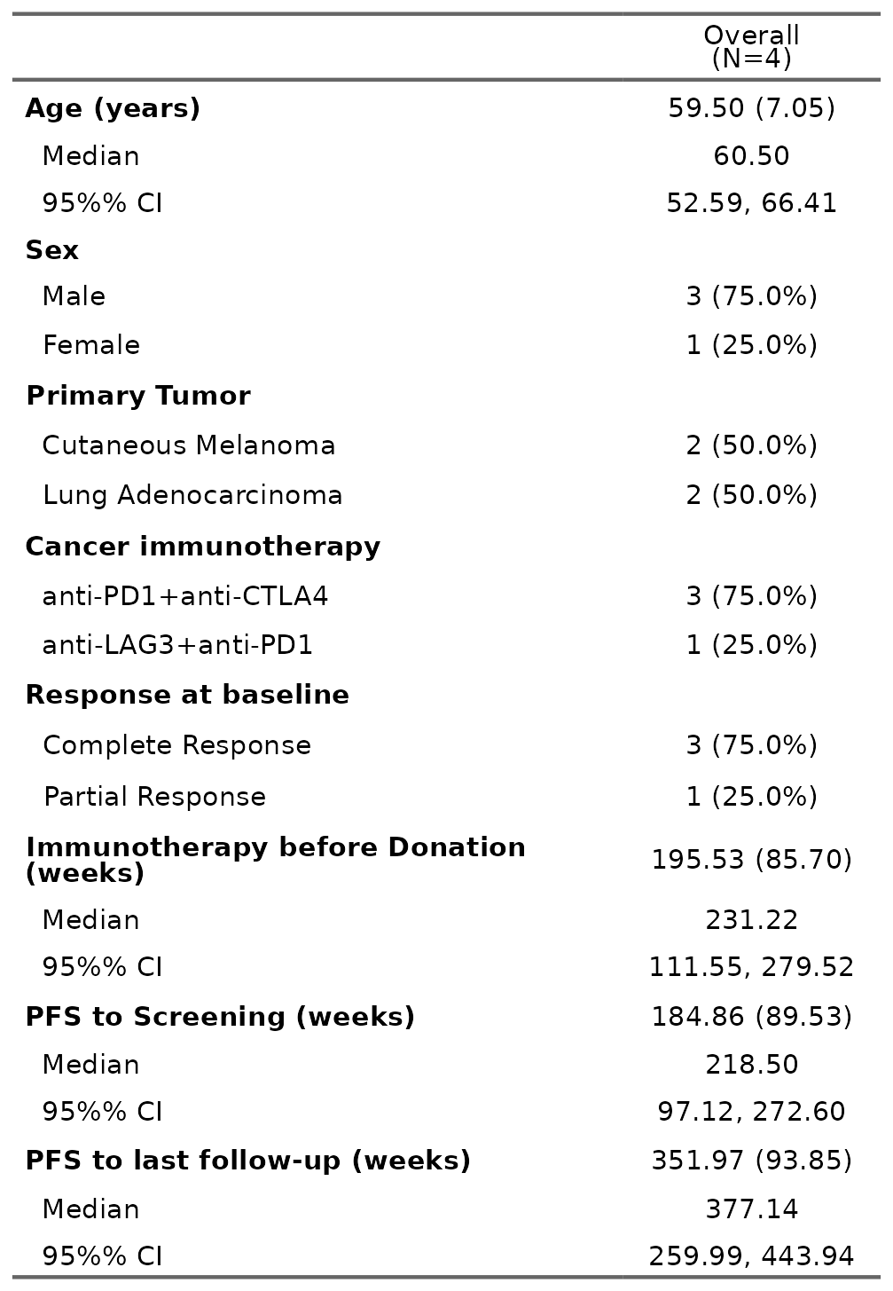
Supplementary Table 2 | Donors Baseline clinical information and Progression free survival. Last follow-up time-point was on the 30.09.2025
Supplementary Table 3 | A complete list of the adverse events that occurred during the clinical trial. The adverse events noted in red were fulfilling the criteria of serious adverse events. No adverse events related to FMT were recorded.

 | Mild | Moderate | Severe
Cardiologic
irMyocarditis |  | FMT-R_016
Constitutional
Fatigue |  | FMT-R_005  FMT-R_008
Dermatologic
Tinea lamellosa sicca | FMT-R_005
Pruritus | FMT-R_005
Erythrasma | FMT-R_005
Macular rash |  | FMT-R_016
Lentigo Maligna |  | FMT-R_008
Lichenoid Lesions | FMT-R_008
Alopecia | FMT-R_008
Seborrheic Eczema |  | FMT-R_003
Endocrinologic
irHypothyreose | FMT-R_005
Gastroenterologic
Nausea |  | FMT-R_005
Abdominal Pain | FMT-R_016 | FMT-R_005
Liver Failure |  |  | FMT-R_006
Liver Hematoma |  |  | FMT-R_007
Hematologic
Lymphopenia | FMT-R_005
Hypereosinophilia | FMT-R_003 | FMT_R-009
Anaemia | FMT-R_003
Infectious
Herpes Simplex Reactivation | FMT-R_016
COVID infection | FMT-D_005
Sepsis |  | FMT-R_001
Upper Respiratory tract infection | FMT_R-009 | FMT_R-009
Flue Like Symptoms |  | FMT-R_016
Musculoskeletal and connective tissue disorders
Undefined Muscle pain | FMT-R_013
Cramps and pain in Extremities | FMT-R_016
Osteoarticular Pain |  | FMT-R_003
Nephrologic
irNephritis |  | FMT-R_001 | FMT-R_016
Neurological
Transitioning Language impairement |  | FMT-R_004
Dysgeusia |  | FMT-R_005
Sensory Polyneuropathy |  | FMT-R_008
Opthalmologic
Keratitis |  | FMT-R_009
Vascular
Pulmonary Embolism |  |  | FMT-R_010
Supplementary Table 3 | Extensive adverse events list who occurred during our clinical trial. The adverse events noted in red were fulfilling the criteria of severe adverse events.

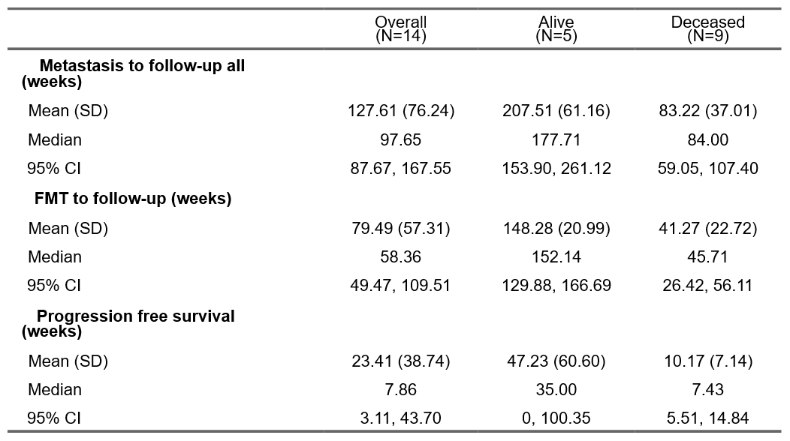
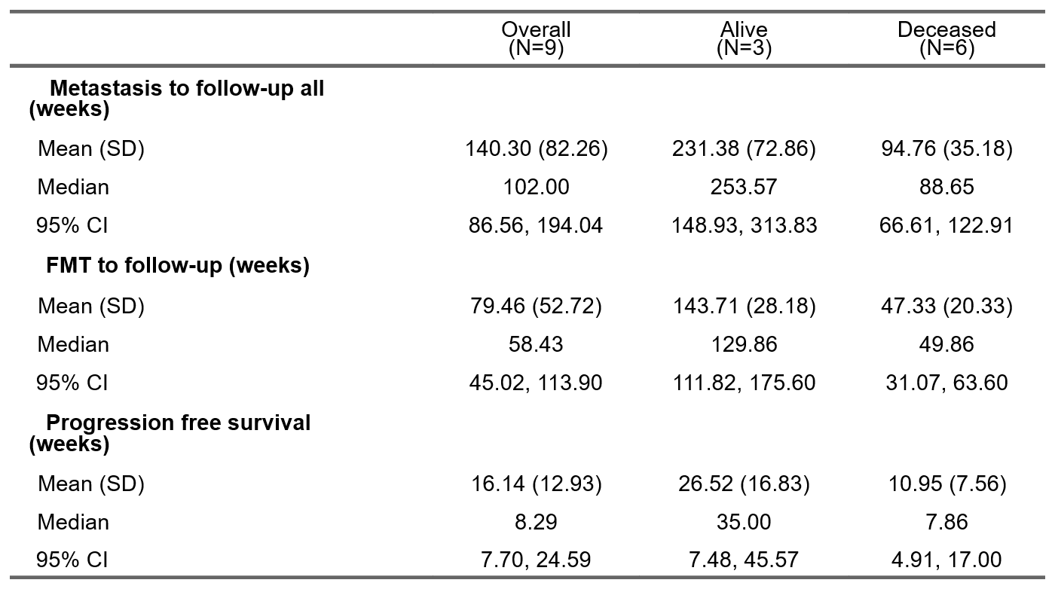
B
A
Supplementary Table 4 | Overall Survival (OS) and progression free survival (PFS). Mean and Median Survival from first metastasis to last follow-up or from FMT to last follow-up as well as from FMT to progression. Last Follow-up is either 30.09.2025 or day of death. Overall is for all patients, Alive stands for patients who were alive at the 30.09.2025, Deceased stands for patients who passed away before the 30.09.2025 (A) In all patient registered in the study, (B) Only in Uveal Melanoma. Calculated lower 95% CI PFS from alive patients in panel A was a negative value and was changed to 0

