Table S1. Physiochemical properties of different biochars used in the experiment
Parameters | Maize straw | Cow manure | Poultry manure
pH | 8.6 | 7.07 | 7.53
EC (mS cm⁻¹) | 3.78 | 5.86 | 4.72
Total N (g kg⁻¹) | 0.1441 | 0.1487 | 0.1467
Total K % | 17.3 | 34.8 | 32.9
Total P % | 0.189 | 0.697 | 0.429
Total C (g kg⁻¹) | 6.7 | 7.9 | 7.3
EC = electrical conductivity; N = nitrogen; K= potassium; P = phosphorous; C = carbon

Table S2. Experimental treatments
Factor 1 (Biochar) | Factor 2 (Microorganisms) | Factor 3 (Cadmium)
No biochar (B₀) | No inoculant (M₀) | 0 ppm (Cd₀)
Maize biochar (B₁) | Trichoderma harzianum L. (M₁) | 10 ppm (Cd₁); 49.25 mg Cd(NO₃)₂ kg⁻¹soil
Cow manure biochar (B₂) | Bacillus subtilis L. (M₂) | 30 ppm (Cd₂); 147.75 mg Cd(NO₃)₂ kg⁻¹ soil
Poultry manure biochar (B₃) | Trichoderma harzianum L. +Bacillus subtilis L. (M₃)

Table S3. Analysis of variance for the influence of co-application of biochar amendment (B) and microorganisms (M) on different soil and plant traits under cadmium (Cd) stress
Dependent variable | DF | B | Cd | M | B×Cd | B×M | Cd×M | B×Cd×M
Root length | 47 | <0.001 | <0.001 | <0.001 | <0.001 | 0.0185 | <0.001 | <0.001
Root fresh biomass | 47 | <0.001 | <0.001 | <0.001 | 0.0001 | <0.001 | <0.001 | 0.0310
Root dry biomass | 47 | <0.001 | <0.001 | <0.001 | 0.0009 | <0.001 | <0.001 | 0.0448
Shoot length | 47 | <0.001 | <0.001 | <0.001 | <0.001 | 0.0680 | <0.001 | <0.001
Shoot fresh biomass | 47 | <0.001 | <0.001 | <0.001 | <0.001 | <0.001 | <0.001 | <0.001
Shoot dry biomass | 47 | <0.001 | <0.001 | <0.001 | <0.001 | <0.001 | <0.001 | <0.001
Soil pH | 47 | <0.001 | <0.001 | <0.001 | 0.9623 | 0.0430 | 0.9361 | 0.9328
Soil electrical conductivity | 47 | <0.001 | <0.001 | <0.001 | 0.0207 | 0.1328 | 0.4927 | 0.5891
Soil organic carbon | 47 | <0.001 | <0.001 | 0.0050 | 1.0000 | 0.0050 | 1.0000 | 1.0000
Soil organic matter | 47 | <0.001 | <0.001 | 0.0047 | 1.0000 | 0.0047 | 1.0000 | 1.0000
Total nitrogen | 47 | <0.001 | <0.001 | <0.001 | <0.001 | <0.001 | 0.0008 | <0.001
Total phosphorous | 47 | <0.001 | <0.001 | <0.001 | <0.001 | <0.001 | 0.0116 | <0.001
Available phosphorous | 47 | <0.001 | <0.001 | <0.001 | <0.001 | <0.001 | 0.0116 | <0.001
Available potassium | 47 | <0.001 | 0.0003 | <0.001 | <0.001 | <0.001 | 0.0679 | 0.0005
Electrolyte leakage | 47 | <0.001 | <0.001 | 0.0004 | <0.001 | <0.001 | 0.0001 | <0.001
MDA | 47 | <0.001 | <0.001 | <0.001 | <0.001 | <0.001 | <0.001 | <0.001
H₂O₂ | 47 | <0.001 | <0.001 | <0.001 | 1.0000 | 1.0000 | <0.001 | 1.0000
SOD | 47 | <0.001 | <0.001 | <0.001 | <0.001 | <0.001 | <0.001 | <0.001
CAT | 47 | <0.001 | <0.001 | <0.001 | <0.001 | <0.001 | <0.001 | <0.001
POD | 47 | 0.0214 | <0.001 | <0.001 | <0.001 | <0.001 | <0.001 | <0.001
Chlorophyll content | 47 | <0.001 | <0.001 | <0.001 | 0.3181 | 0.4559 | 0.1368 | 0.8208
Photosynthetic rate | 47 | <0.001 | <0.001 | 0.005 | <0.001 | <0.001 | <0.001 | <0.001
Transpiration rate | 47 | <0.001 | <0.001 | <0.001 | 0.2807 | 0.7957 | 0.4742 | 0.7846
Pa/kPa | 47 | 0.001 | <0.001 | <0.001 | 0.0128 | 0.0006 | <0.001 | <0.001
Stomatal conductance | 47 | <0.001 | <0.001 | <0.001 | 0.0105 | 0.3290 | 0.0028 | 0.0024
Intercellular CO₂ | 47 | <0.001 | <0.001 | <0.001 | <0.001 | <0.001 | <0.001 | <0.001
Cd content in shoot | 47 | <0.001 | <0.001 | <0.001 | <0.001 | <0.001 | <0.001 | <0.001
Cd content in root | 47 | <0.001 | <0.001 | <0.001 | <0.001 | <0.001 | <0.001 | <0.001
Cd content in soil | 47 | <0.001 | <0.001 | <0.001 | <0.001 | <0.001 | <0.001 | <0.001
MDA = Malondialdehyde; H₂O₂ = Hydrogen peroxide; SOD = Superoxide dismutase; CAT = Catalase; POD = Peroxidase

Table 4S. Effect of integrated application of biochar and microbes on root length, root fresh biomass, and root dry biomass of maize grown under cadmium (Cd)-contaminated soil.
CD | MI | BC₀ | BC₁ |  | BC₂ | BC₃ | Mean (Cd×MI)
 |  | Root length (cm)
Cd₀ | MI₀ | 33.91±2.95 tuv | 41.59±1.75 klm |  | 54.58±2.24 b | 48.87±1.66 c-f | 44.74±8.97 B
 | MI₁ | 44.11±3.73 h-k | 37.71±1.65 n-r |  | 45.29±2.52 g-j | 47.47±1.82 d-g | 43.65±4.19 BC
 | MI₂ | 36.14±3.12 o-t | 37.05±0.99 n-t |  | 49.82±1.30 cde | 48.83±1.83 c-f | 42.96±7.37 BC
 | MI₃ | 47.04±2.38 e-h | 50.71±2.20 c |  | 61.94±2.34 a | 56.25±1.93 b | 53.99±6.52 A
Cd₁ | MI₀ | 36.30±2.31 o-t | 31.33±2.16 vw |  | 38.34±2.35 n-q | 36.80±1.58 n-t | 35.69±3.04 DE
 | MI₁ | 39.91±2.81 lmn | 35.20±2.26 q-u |  | 41.60±2.17 klm | 50.68±2.07 cd | 41.85±6.48 C
 | MI₂ | 43.81±2.70 ijk | 34.95±1.06 r-u |  | 49.47±1.96 c-f | 48.12±2.02 c-g | 44.09±6.55 BC
 | MI₃ | 42.48±2.59 jkl | 38.14±1.13 n-r |  | 48.03±1.55 c-g | 48.49±1.94 c-g | 44.29±4.92 BC
Cd₂ | MI₀ | 33.92±1.76 tuv | 25.43±2.02 x |  | 35.57±2.01 q-u | 33.95±1.90 tuv | 32.22±4.59 F
 | MI₁ | 32.56±3.21 uv | 34.40±1.59 s-v |  | 46.91±2.49 e-i | 38.84±1.90 m-p | 38.18±6.39 D
 | MI₂ | 39.30±1.90 l-o | 28.85±2.10 w |  | 35.66±1.87 p-u | 34.49±1.79 s-v | 34.57±4.33 EF
 | MI₃ | 50.30±1.63 cd | 37.59±2.42 n-s |  | 46.61±0.73 f-i | 47.78±1.47 c-g | 45.57±5.54 B
Mean (BC) |  | 39.98±5.66 B | 36.08 ±6.38 C |  | 46.15±7.71 A | 45.05±7.15 A
LSD value |  | Cd×MI= 2.71; BC= 1.22; Cd×MI×BC= 6.64
 |  | Root fresh biomass (g)
Cd₀ | MI₀ | 19.70±1.20 t-w |  | 22.80±2.03 q-t | 31.71±2.56 c-f | 29.61 ±3.09 e-j | 25.96±5.65 BCD
 | MI₁ | 21.10±1.05 s-v |  | 23.15±0.53 qrs | 28.50±2.95 f-k | 26.40 ±1.22 j-p | 24.79±3.30 DE
 | MI₂ | 19.30±0.67 u-x |  | 24.14±3.01 n-s | 28.85±2.55 f-k | 27.43 ±2.75 h-m | 24.93±4.24 CDE
 | MI₃ | 22.41±1.16 r-u |  | 27.29±1.51 h-n | 41.14±2.96 a | 32.36 ±0.69 b-e | 30.80±8.00 A
Cd₁ | MI₀ | 16.49±0.99 wxy |  | 23.87±0.92 o-s | 35.29±1.45 b | 28.27 ±1.10 g-m | 25.98±7.88 BCD
 | MI₁ | 15.18±1.87 yz |  | 23.04±0.08 qrs | 30.38±3.04 d-h | 28.33 ±2.93 g-l | 24.23±6.78 E
 | MI₂ | 17.33±0.56 wxy |  | 25.11±2.84 m-r | 33.68±1.30 bc | 31.55 ±1.88 c-f | 26.92±7.36 B
 | MI₃ | 17.37±0.34 wxy |  | 21.12±1.58 s-v | 35.40±2.07 b | 29.95 ±1.35 d-i | 25.96±8.21 BCD
Cd₂ | MI₀ | 12.16±1.79 z |  | 19.54±2.49 uvw | 31.40±2.77 c-g | 21.41 ±2.68 stu | 21.13±7.93 F
 | MI₁ | 21.24±2.67 stu |  | 21.56±2.70 stu | 29.31±2.96 e-j | 26.85 ±2.27 i-o | 24.74±3.99 DE
 | MI₂ | 17.97±2.34 v-y |  | 25.15±2.58 l-r | 33.76±3.00 bc | 28.99 ±1.56 f-k | 26.47±6.67 BC
 | MI₃ | 16.12±2.16 xy |  | 23.38±2.89 p-s | 33.15±2.03 bcd | 26.01 ±2.18 k-q | 24.67±7.04 DE
Mean (BC) |  | 18.03±2.91 D |  | 23.35±2.04 C | 32.71±3.56 A | 28.10±2.87 B
LSD value |  | Cd×MI= 1.61; BC= 0.93; Cd×MI×BC= 3.21
 |  | Dry biomass (g)
Cd₀ | MI₀ | 7.52±0.64 tuv |  | 9.21±0.79 k-q | 11.99±0.85 bcd | 11.33±0.97 def | 10.01±2.04 BCD
 | MI₁ | 8.45±0.31 p-t |  | 9.18±0.13 k-q | 10.62±1.18 e-i | 9.87±0.49 h-m | 9.53±0.93 CDE
 | MI₂ | 8.15±0.46 q-u |  | 10.37±0.69 f-j | 11.32±1.10 def | 11.34±0.72 def | 10.30±1.50 B
 | MI₃ | 8.45±0.30 p-t |  | 10.41±0.58 f-j | 14.27±1.12 a | 12.06±0.35 bcd | 11.30±2.47 A
Cd₁ | MI₀ | 6.25±0.48 w |  | 9.46±0.47 j-p | 12.68±0.68 bc | 10.43±0.28 f-j | 9.70±2.67 CDE
 | MI₁ | 6.27±0.54 w |  | 8.86±0.15 m-s | 11.33±1.12 def | 10.86±0.87 e-h | 9.33±2.31 EF
 | MI₂ | 7.28±0.06 uvw |  | 9.80±0.88 h-n | 11.65±0.18 b-e | 11.37±0.59 def | 10.03±2.00 BC
 | MI₃ | 7.14±0.13 uvw |  | 8.68±0.44 o-s | 12.74±0.48 b | 11.07±0.38 d-g | 9.91±2.49 BCD
Cd₂ | MI₀ | 4.94±0.73 x |  | 7.83±0.67 s-v | 10.74±1.00 e-h | 7.85±0.97 s-v | 7.84±2.37 H
 | MI₁ | 7.92±1.02 stu |  | 8.07±0.97 r-u | 10.28±1.16 f-k | 9.59±0.88 i-o | 8.97±1.16 FG
 | MI₂ | 6.80±0.75 vw |  | 9.36±0.84 j-p | 11.61±0.85 cde | 10.11±0.54 g-l | 9.47±2.01 DEF
 | MI₃ | 6.18±0.81 w |  | 8.69±1.10 n-s | 11.13±0.78 d-g | 9.06±0.78 l-r | 8.77±2.03 G
Mean (BC) |  | 7.11±1.07 D |  | 9.16±0.80 C | 11.70±1.11 A | 10.41±1.18 B
LSD value |  | Cd×MI= 0.55; BC= 0.32; Cd×MI×BC= 1.11

Values are representing means ±standard deviation (SD) of three replication. Means within a column followed by the same letters are not significantly different atP≤ 0.05.

Table 5S. Effect of integrated application of biochar and microbeson shoot length, shoot fresh, and dry biomass of maize grownunder cadmium (Cd)-contaminatedsoil.
CD | MI | BC₀ | BC₁ |  | BC₂ |  | BC₃ |  | Mean (Cd×MI)
 |  | Shoot length (cm)
Cd₀ | MI₀ | 33.91±2.95 s | 59.42±2.50 f |  | 77.97±3.20 b |  | 69.82±2.37 cd |  | 60.28±19.15 B
 | MI₁ | 44.11±3.73 m-q | 53.88±2.36 ghi |  | 64.71±3.60 e |  | 67.81±2.60 cde |  | 57.63±10.81 CD
 | MI₂ | 36.14±3.12 rs | 52.93±1.41 g-j |  | 71.18±1.85 cd |  | 69.76±2.61 cde |  | 57.50±16.48 CD
 | MI₃ | 47.04±2.38 k-o | 72.45±3.14 c |  | 88.49±3.35 a |  | 80.36±3.74 b |  | 72.08±17.93 A
Cd₁ | MI₀ | 36.30±2.31 rs | 44.76±3.96 l-p |  | 54.78±3.36 fgh |  | 52.57±2.26 g-j |  | 47.10±8.39 F
 | MI₁ | 39.91±2.81 pqr | 50.62±4.76 g-k |  | 59.43±3.10 f |  | 72.40±4.34 c |  | 55.59±13.76 D
 | MI₂ | 43.81±3.59 n-q | 49.92±1.52 h-k |  | 70.67±2.80 cd |  | 68.75±2.89 cde |  | 58.29±13.44 BC
 | MI₃ | 42.48±3.56 opq | 54.49±3.61 fgh |  | 68.62±3.85 cde |  | 69.27±2.78 cde |  | 58.71±12.79 BC
Cd₂ | MI₀ | 33.92±3.72 s | 36.33±3.88 rs |  | 50.81±2.88 g-k |  | 48.50±4.71 j-n |  | 42.39±8.50 G
 | MI₁ | 32.56±3.21 s | 49.15±4.27 i-m |  | 67.02±5.54 de |  | 55.49±4.71 fg |  | 51.05±14.38 E
 | MI₂ | 39.30±3.88 qr | 41.21±4.00 pqr |  | 50.94±4.67 g-k |  | 49.27±4.55 i-l |  | 45.18±5.78 F
 | MI₃ | 50.30±4.63 h-k | 53.70±4.87 ghi |  | 66.58±3.83 de |  | 68.26±3.99 cde |  | 59.71±9.04 BC
Mean (BC) |  | 39.98±5.66 D | 51.57 ±9.11 C |  | 65.93±11.01 A |  | 64.36±10.21 B
LSD value |  | Cd×MI= 2.53; BC= 1.46; Cd×MI×BC= 5.07
 |  | Fresh biomass (g)
Cd₀ | MI₀ | 23.95±1.17 wxy |  | 37.66±2.03 cd | 43.83±0.76 a |  | 38.02±1.18 cd |  | 35.87±8.43 B
 | MI₁ | 30.69±1.85 l-o |  | 34.20±0.96 fgh | 34.62±0.87 efg |  | 36.33±1.49 de |  | 33.96±2.37 C
 | MI₂ | 28.05±1.11 p-t |  | 34.52±1.08 efg | 37.46±0.93 d |  | 37.34±0.77 d |  | 34.34±4.41 C
 | MI₃ | 27.58±0.79 q-u |  | 39.70±1.48 bc | 44.01±1.18 a |  | 41.04±2.16 b |  | 38.08±7.23 A
Cd₁ | MI₀ | 22.58±0.71 yz |  | 31.27±1.49 k-n | 34.00±1.95 ghi |  | 29.63±0.80 n-q |  | 29.37±4.87 EF
 | MI₁ | 28.58±0.96 o-s |  | 28.96±1.73 o-r | 33.65±1.02 g-j |  | 38.21±2.21 cd |  | 32.35±4.54 D
 | MI₂ | 29.76±1.87 m-p |  | 32.02±0.60 i-l | 34.47±0.88 efg |  | 33.81±1.69 g-j |  | 32.51±2.11 D
 | MI₃ | 27.77±1.12 p-u |  | 30.27±1.97 l-o | 36.15±1.39 def |  | 37.29±1.61 d |  | 32.87±4.58 D
Cd₂ | MI₀ | 21.15±1.27 z |  | 22.02±1.47 yz | 25.76±1.41 uvw |  | 27.40±1.59 r-u |  | 24.08±2.98 H
 | MI₁ | 22.90±1.48 xyz |  | 26.57±1.48 s-v | 33.28±1.47 g-k |  | 32.34±1.41 h-l |  | 28.77±4.91 F
 | MI₂ | 24.79±1.79 vwx |  | 24.08±1.77 wxy | 26.63±1.79 s-v |  | 26.04±1.79 t-w |  | 25.38±1.16 G
 | MI₃ | 27.52±1.25 q-u |  | 28.01±1.86 p-t | 32.02±1.16 i-l |  | 31.81±1.39 j-m |  | 29.84±2.41 E
Mean (BC) |  | 26.28±3.08 C |  | 30.77±5.27 B | 34.66±5.52 A |  | 34.10±4.71 A
LSD value |  | Cd×MI= 1.06; BC= 0.61; Cd×MI×BC= 2.13
 |  | Dry biomass (g)
Cd₀ | MI₀ | 2.85±0.17 wxy |  | 4.81±0.29 cd | 5.69±0.11 a |  | 4.86±0.17 cd |  | 4.55±1.20 B
 | MI₁ | 3.81±0.26 l-o |  | 4.31±0.14 e-h | 4.37±0.12 efg |  | 4.62±0.21 de |  | 4.28±0.34 C
 | MI₂ | 3.44±0.16 p-t |  | 4.36±0.15 efg | 4.78±0.13 d |  | 4.76±0.11 d |  | 4.33±0.63 C
 | MI₃ | 3.37±0.11 q-u |  | 5.10±0.21 bc | 5.72±0.17 a |  | 5.29±0.31 b |  | 4.87±1.03 A
Cd₁ | MI₀ | 2.65±0.10 yz |  | 3.90±0.21 k-n | 4.29±0.28 f-i |  | 3.66±0.11 n-q |  | 3.62±0.70 E
 | MI₁ | 3.51±0.14 o-s |  | 3.57±0.25 o-r | 4.24±0.15 g-j |  | 4.89±0.32 cd |  | 4.05±0.65 D
 | MI₂ | 3.68±0.27 m-p |  | 4.00±0.09 i-l | 4.35±0.13 efg |  | 4.26±0.24 g-j |  | 4.07±0.30 D
 | MI₃ | 3.40±0.16 p-u |  | 3.75±0.28 l-o | 4.59±0.20 def |  | 4.76±0.23 d |  | 4.12±0.65 D
Cd₂ | MI₀ | 2.45±0.18 z |  | 2.57±0.21 yz | 3.11±0.20 uvw |  | 3.34±0.23 r-u |  | 2.87±0.43 G
 | MI₁ | 2.70±0.21 xyz |  | 3.22±0.21 s-v | 4.18±0.21 g-k |  | 4.05±0.20 h-l |  | 3.54±0.70 E
 | MI₂ | 2.97±0.26 vwx |  | 2.87±0.25 wxy | 3.23±0.26 s-v |  | 3.15±0.26 t-w |  | 3.05±0.17 F
 | MI₃ | 3.36±0.18 q-u |  | 3.43±0.27 p-t | 4.00±0.17 i-l |  | 3.97±0.20 j-m |  | 3.69±0.34 E
Mean (BC) |  | 3.18±0.44 C |  | 3.82±0.75 B | 4.38±0.79 A |  | 4.30±0.67 A
LSD value |  | Cd×MI= 0.15; BC= 0.09; Cd×MI×BC= 0.30
Values are representing means ±standard deviation (SD) of three replication. Means within a column followed by the same letters are not significantly different atP≤ 0.05.

Table S6. Effect of co-application of biochar and microorganisms on soil pH, electrical conductivity of soil leachates, soil organic carbon, and organic matter under cadmium (Cd) contaminated soil.
CD | MI | BC₀ | BC₁ | BC₂ |  | BC₃ |  | Mean (Cd×MI)
 |  | Soil pH
Cd₀ | MI₀ | 8.72±0.03 a | 8.51±0.03 b-f | 8.26±0.06 j-p |  | 8.45±0.11 d-h |  | 8.49±0.19 A
 | MI₁ | 8.61±0.07 abc | 8.21±0.05 l-q | 8.33±0.04 g-l |  | 8.29±0.04 i-n |  | 8.36±0.17 CD
 | MI₂ | 8.64±0.04 ab | 8.34±0.07 g-l | 8.31±0.05 h-m |  | 8.31±0.03 h-m |  | 8.40±0.16 BC
 | MI₃ | 8.59±0.06 a-d | 8.34±0.05 g-l | 8.28±0.06 j-n |  | 8.33±0.06 g-l |  | 8.39±0.14 BC
Cd₁ | MI₀ | 8.65±0.10 ab | 8.36±0.17 f-k | 8.27±0.05 j-o |  | 8.46±0.05 c-h |  | 8.44±0.16 AB
 | MI₁ | 8.54±0.09 b-e | 8.19±0.03 l-q | 8.14±0.14 n-q |  | 8.22±0.05 k-q |  | 8.27±0.18 EFG
 | MI₂ | 8.52±0.09 b-e | 8.16±0.10 m-q | 8.29±0.08 i-n |  | 8.25±0.06 j-p |  | 8.31±0.15 DEF
 | MI₃ | 8.59±0.05 a-d | 8.30±0.05 h-m | 8.21±0.09 k-q |  | 8.26±0.11 j-p |  | 8.34±0.17 CDE
Cd₂ | MI₀ | 8.59±0.11 a-d | 8.30±0.22 h-m | 8.17±0.07 m-q |  | 8.40±0.05 e-j |  | 8.37±0.18 BCD
 | MI₁ | 8.44±0.13 d-i | 8.10±0.08 q | 8.11±0.21 pq |  | 8.14±0.11 n-q |  | 8.20±0.16 G
 | MI₂ | 8.46±0.16 c-g | 8.12±0.19 opq | 8.17±0.12 m-q |  | 8.15±0.10 m-q |  | 8.23±0.16 G
 | MI₃ | 8.48±0.04 c-g | 8.14±0.15 n-q | 8.19±0.07 l-q |  | 8.19±0.16 l-q |  | 8.25±0.16 FG
Mean (BC) |  | 8.57±0.08 A | 8.26±0.12 BC | 8.23±0.07 C |  | 8.29±0.11 B
LSD value  P≤ 0.05 |  | Cd×MI= 0.08; BC= 0.04; Cd×MI×BC= 0.15
 |  | Electrical conductivity (mS cm⁻¹)
Cd₀ | MI₀ | 2.87±0.30 o-s | 3.13±0.27 m-q | 4.34±0.39 c-h |  | 4.03 ±0.46 e-i |  | 3.59±0.70 CD
 | MI₁ | 2.76±0.23 q-u | 3.66±0.27 ijk | 5.17±0.29 a |  | 4.30±0.29 c-h |  | 3.97±1.02 AB
 | MI₂ | 2.98±0.29 n-s | 3.88±0.35 g-j | 5.11±0.42 a |  | 4.03±0.14 e-i |  | 4.00±0.87 AB
 | MI₃ | 3.16±0.18 l-q | 3.62±0.25 i-l | 5.03±0.52 ab |  | 4.49±0.27 cde |  | 4.07±0.84 A
Cd₁ | MI₀ | 2.53±0.46 s-v | 3.03±0.36 m-r | 4.24±0.24 c-h |  | 3.88±0.09 g-j |  | 3.42±0.78 D
 | MI₁ | 3.15±0.32 l-q | 3.44±0.46 j-n | 4.56±0.31 cd |  | 3.98±0.20 f-i |  | 3.78±0.62 BC
 | MI₂ | 3.08±0.28 m-r | 3.87±0.04 hij | 4.43±0.31 c-f |  | 4.09±0.11 d-i |  | 3.87±0.57 AB
 | MI₃ | 3.15±0.08 l-q | 3.50±0.23 j-m | 4.63±0.32 bc |  | 4.35±0.25 c-g |  | 3.91±0.70 AB
Cd₂ | MI₀ | 1.99±0.04 w | 2.13±0.16 vw | 3.25±0.25 k-p |  | 2.75±0.41 q-u |  | 2.53±0.58 F
 | MI₁ | 1.94±0.32 w | 2.31±0.38 uvw | 3.46±0.26 j-m |  | 2.79±0.46 p-t |  | 2.63±0.66 F
 | MI₂ | 2.33±0.25 t-w | 2.61±0.41 r-u | 3.70±0.24 ijk |  | 3.26±0.30 k-p |  | 2.98±0.62 E
 | MI₃ | 2.29±0.31 uvw | 2.29±0.32 uvw | 4.02±0.13 e-i |  | 3.33±0.42 k-o |  | 2.98±0.85 E
Mean (B) |  | 2.69±0.46 D | 3.12±0.64 C | 4.33±0.63 A |  | 3.77±0.59 B
LSD value  P≤ 0.05 |  | Cd×MI= 0.24; BC= 0.14; Cd×MI×BC= 0.47
 |  | Soil organic carbon (g kg⁻¹)
Cd₀ | MI₀ | 3.83±0.05 n | 7.33±0.53 f-k | 9.01±0.66 abc |  | 8.42±0.63 bcd |  | 7.15±2.32 A
 | MI₁ | 3.67±0.36 no | 7.96±0.53 def | 9.49±0.62 a |  | 8.35±0.45 cde |  | 7.37±2.55 A
 | MI₂ | 3.68±0.23 no | 7.52±0.05 f-j | 9.10±0.21 ab |  | 8.44±0.30 bcd |  | 7.19±2.42 A
 | MI₃ | 3.66±0.20 no | 7.63±0.38 f-i | 9.50±0.49 a |  | 9.09±0.11 ab |  | 7.47±2.66 A
Cd₁ | MI₀ | 3.17±0.18 nop | 6.67±0.64 klm | 8.35±0.65 cde |  | 7.76±0.61 d-h |  | 6.49±2.32 BC
 | MI₁ | 3.01±0.48 op | 7.30±0.43 f-k | 8.83±0.72 abc |  | 7.69±0.48 e-h |  | 6.71±2.55 B
 | MI₂ | 3.02±0.38 op | 6.86±0.17 j-m | 8.44±0.26 bcd |  | 7.78±0.27 d-h |  | 6.52±2.42 BC
 | MI₃ | 3.00±0.14 op | 6.97±0.45 i-l | 8.83±0.53 abc |  | 8.43±0.21 bcd |  | 6.81±2.66 B
Cd₂ | MI₀ | 2.69±0.20 p | 6.19±0.67 m | 7.87±0.64 d-h |  | 7.28±0.60 g-k |  | 6.01±2.32 D
 | MI₁ | 2.53±0.50 p | 6.82±0.42 klm | 8.34±0.74 cde |  | 7.20±0.50 h-k |  | 6.22±2.55 CD
 | MI₂ | 2.54±0.41 p | 6.38±0.20 lm | 7.96±0.29 d-g |  | 7.30±0.26 f-k |  | 6.04±2.42 D
 | MI₃ | 2.52±0.14 p | 6.48±0.46 lm | 8.35±0.54 cde |  | 7.95±0.23 d-g |  | 6.32±2.66 CD
Mean (BC) |  | 3.11±0.49 D | 7.01±0.54 C | 8.67±0.54 A |  | 7.97±0.58 B
LSD valueP≤ 0.05 |  | Cd×MI= 0.34; BC= 0.20; Cd×MI×BC= 0.68
 |  | Soil organic matter (%)
Cd₀ | M₀ | 6.61±0.08 o | 12.64±0.91 g-l | 15.54±1.14 abc |  | 14.52±1.08 b-e |  | 12.33±4.00 A
 | MI₀ | 6.33±0.62 opq | 13.73±0.91 d-g | 16.35±1.06 a |  | 14.39±0.78 c-f |  | 12.70±4.39 A
 | MI₁ | 6.35±0.39 op | 12.96±0.08 g-k | 15.69±0.36 ab |  | 14.55±0.52 bcd |  | 12.39±4.18 A
 | MI₂ | 6.31±0.34 opq | 13.15±0.66 g-j | 16.36±0.85 a |  | 15.67±0.18 ab |  | 12.87±4.59 A
Cd₁ | MI₃ | 5.47±0.30 o-r | 11.50±1.10 lmn | 14.40±1.12 c-f |  | 13.38±1.05 e-i |  | 11.19±4.00 BC
 | MI₀ | 5.19±0.82 pqr | 12.59±0.74 g-l | 15.22±1.24 abc |  | 13.25±0.83 f-i |  | 11.56±4.39 B
 | MI₁ | 5.21±0.66 pqr | 11.82±0.29 k-n | 14.55±0.45 b-e |  | 13.41±0.46 d-i |  | 11.25±4.18 BC
 | MI₂ | 5.17±0.25 qr | 12.01±0.78 j-m | 15.22±0.91 abc |  | 14.53±0.36 b-e |  | 11.73±4.59 B
Cd₂ | MI₃ | 4.64±0.35 r | 10.67±1.15 n | 13.57±1.11 d-i |  | 12.55±1.03 h-l |  | 10.36±4.00 D
 | MI₀ | 4.36±0.86 r | 11.76±0.73 lmn | 14.39±1.27 c-f |  | 12.42±0.86 i-l |  | 10.73±4.39 CD
 | MI₁ | 4.38±0.71 r | 10.99±0.34 mn | 13.72±0.49 d-h |  | 12.58±0.45 g-l |  | 10.42±4.18 D
 | MI₂ | 4.34±0.25 r | 11.18±0.80 mn | 14.39±0.94 c-f |  | 13.70±0.40 d-h |  | 10.90±4.59 CD
Mean (BC) |  | 5.36±0.85 D | 12.08±0.94 C | 14.95±0.93 A |  | 13.75±1.00 B
LSD valueP≤ 0.05 |  | Cd×MI= 0.59; BC= 0.34; Cd×MI×BC= 1.18
Values are representing means ±standard deviation (SD) of three replication. Means within a column followed by the same letters are not significantly different at P≤ 0.05.

(c)
(b)
(a)
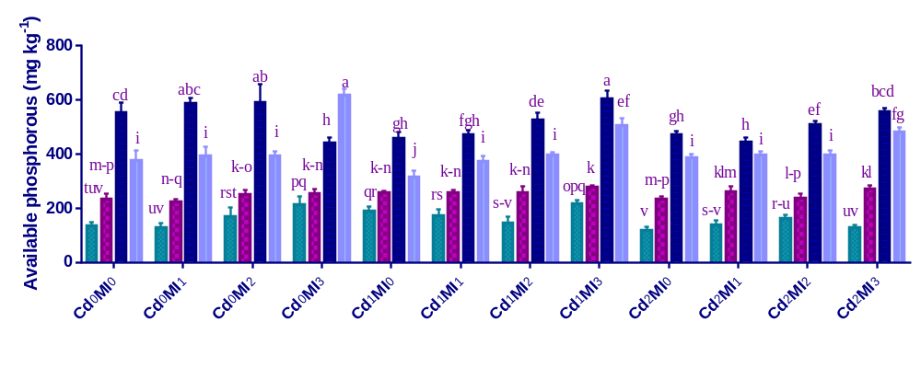
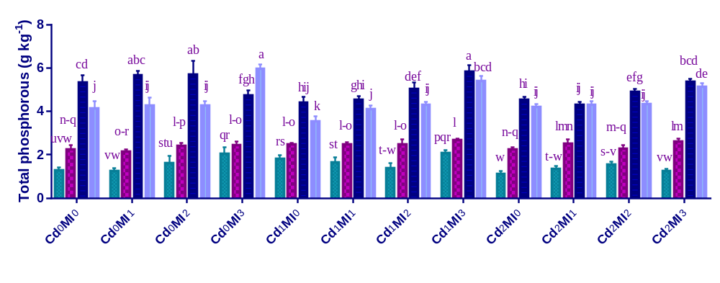
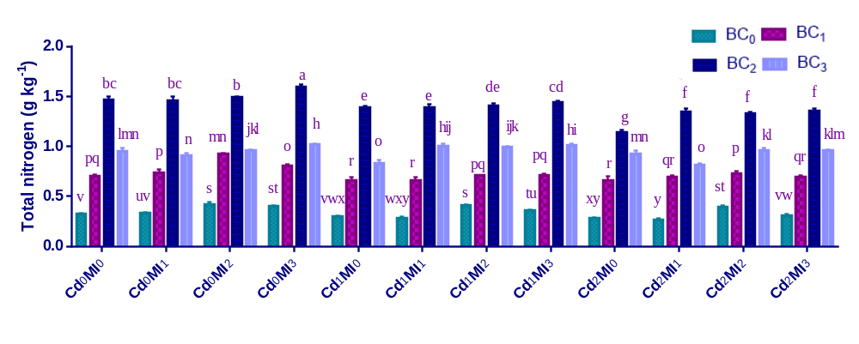
(d)

Figure S1. Effect of integrated application of biochar and microbes on (a) total nitrogen, (b) total phosphorous, (c) available phosphorous, and (d) available potassium under cadmium (Cd) stress.
Values are representing means ±standard deviation (SD) of three replication. Means within a column followed by the same letters are not significantly different at P≤ 0.05.

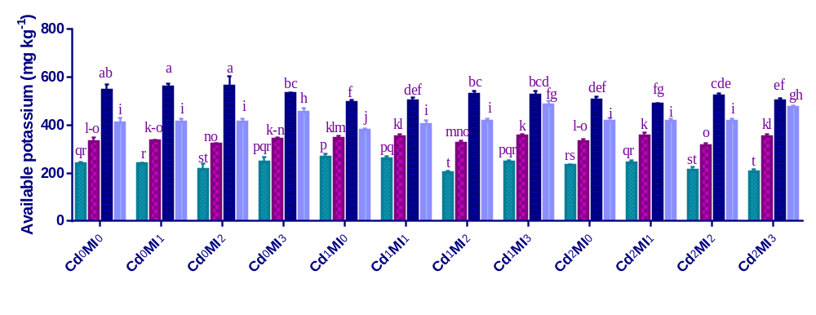
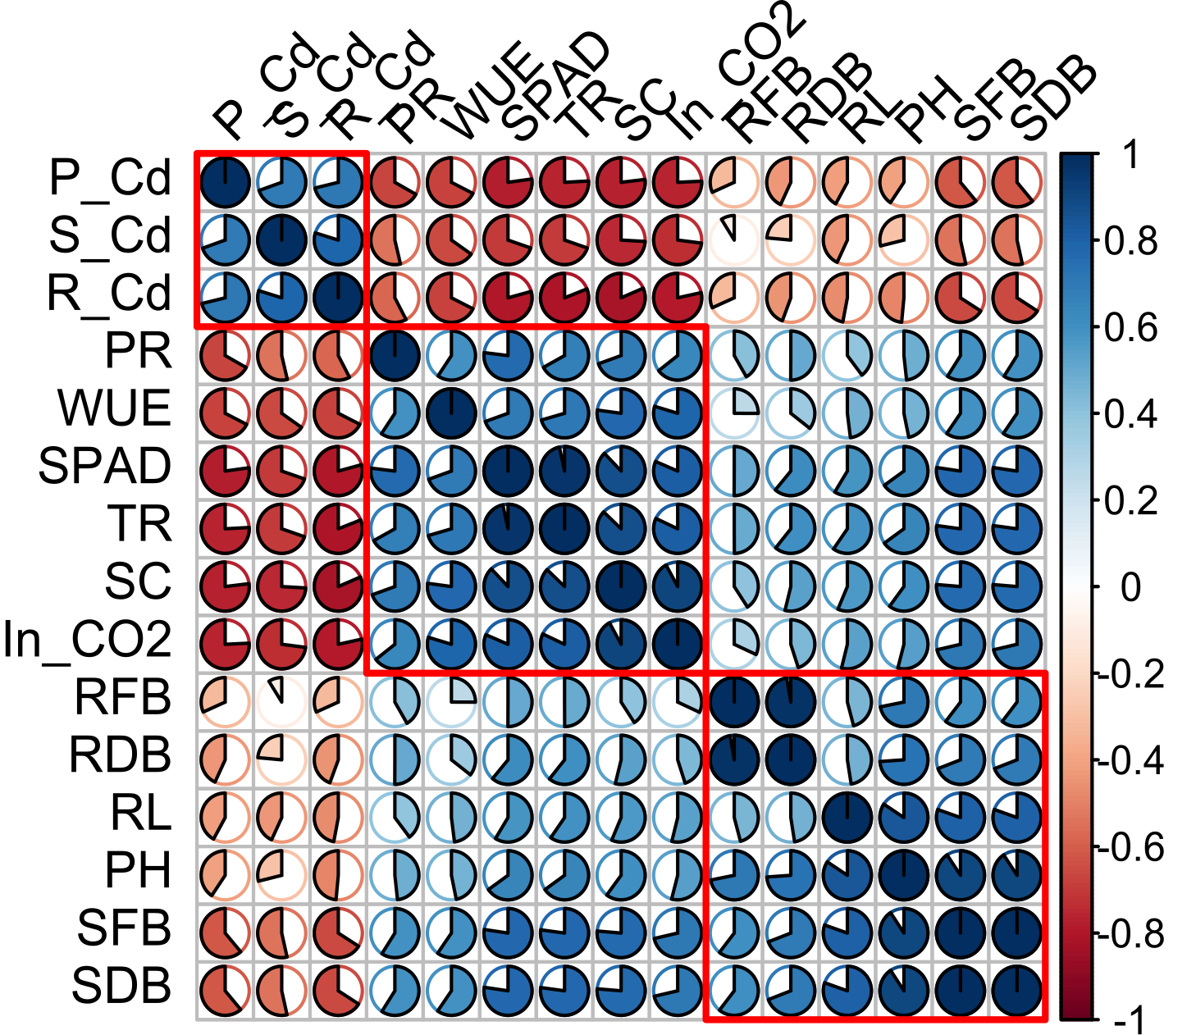
Figure S2. Pearson’s correlation among various traits under Cd stress in maize.
P_Cd= cadmium concentration in plant shoot; cadmium; S_Cd= cadmium concentration in soil; R_Cd= cadmium concentration in plant root; PR= photosynthesis rate; WUE= water use efficiency; SPAD= chlorophyll SPAD value; TR= transpiration rate; SC= stomatal conductance; In CO₂= Intercellular carbon dioxide; RFB= root fresh biomass; RDB= root dry biomass; RL= root length; PH= plant shoot height; SFB= plant shoot fresh biomass; SDB= plant shoot dry biomass.

