SUPPLIMENDARY INFORMATIONS –Growth of D614G Virus – Regression Analysis
Jaydip Datta
__________________________________________________________________________________
Figure-I (Plot of Scattered Data of freq D614G vs Number of Months )
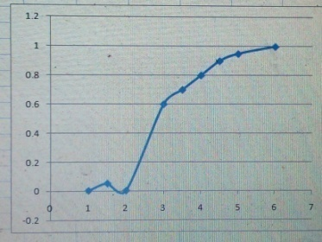
Figure – II ( Curve Finder –v.1.4 ) – Regression Analysis
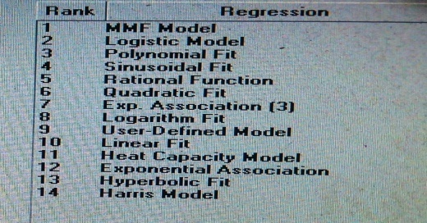
Figure –III( MMF Model Fit)
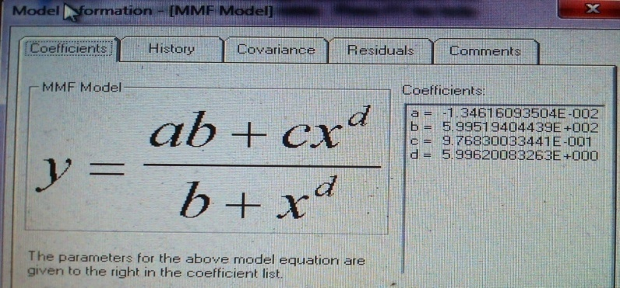
Figure – IV( 4 th Order Polynomial Fit )
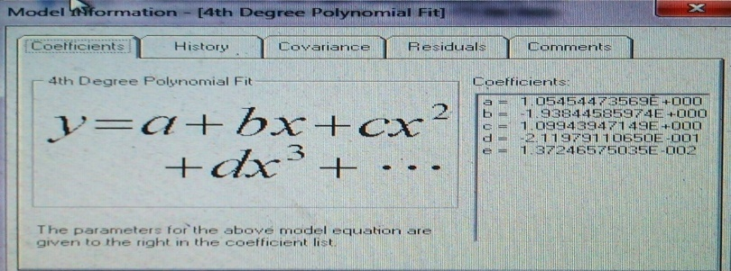
Figure – V (Covariance Matrix – 4x 4 )
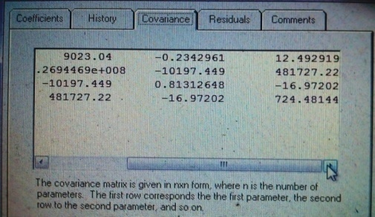

Figure – VI ( Chi-sq Hypothesis )
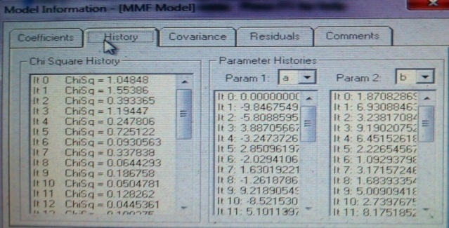
Figure – VII (Covariance Matrix – 5 x 5 )
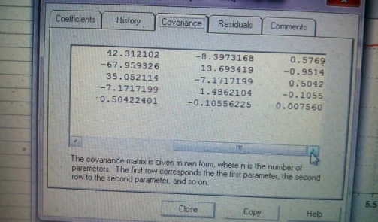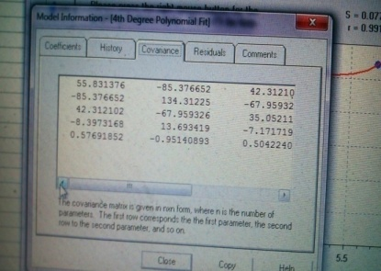
Figure –VIII( 4th Degree Polynomial Fit – r and s value )
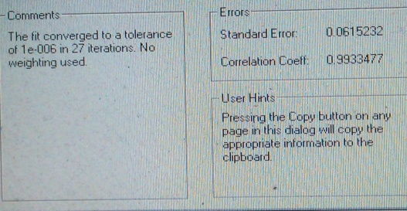
Figure – IX
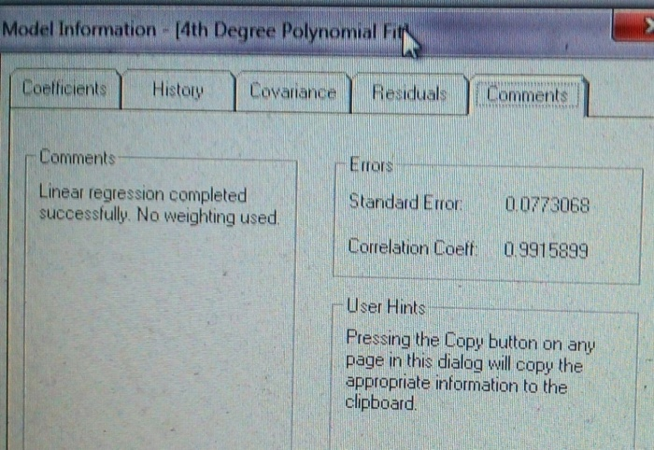

Figure – X ( 2x 2 Matrix )
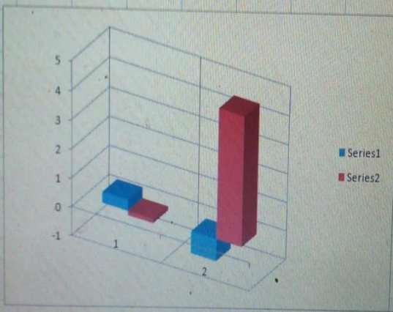
Dataset (Bioenergetics data of DEL2G in Kcal /mole) of D614G , N501Y
(https://zenodo.org/record/4514192 )
Figure – XI ( Exponential fit – r and s value )




