supplementary information
Table S1. Media and solutions used in this study with their ingredients.
Media/Solutions | Ingredients
Internal standard (IS) | 0.017 mg/mL succinic acid d₄  0.017 mg/mL glycine d₅  0.034 mg/mL malonic acid d₄  0.17 mg/mL alanine d₇  In H₂O
Retention index (RI)  RI stock solution  RI working solution | 40 µL decane  40 µL dodecane  40 µL pentadecane  30 mg nonadecane  30 mg docosane  In 10 mL hexane  1 mL RI stock solution  9 mL anhydrous pyridine

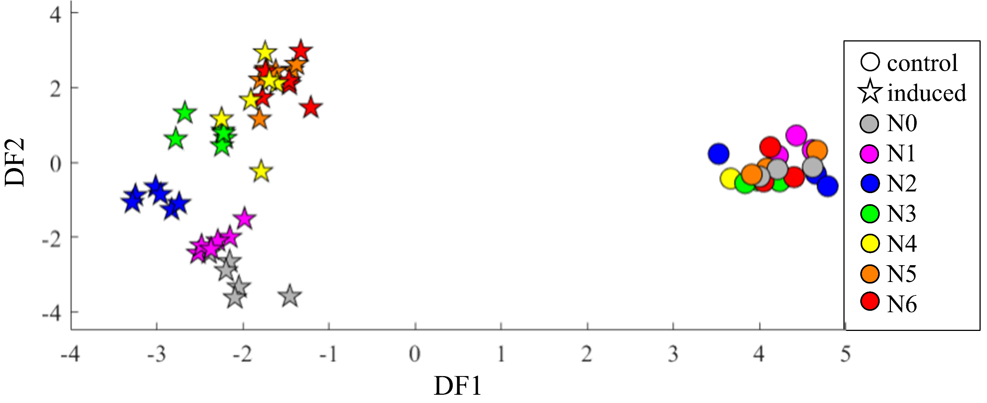
Figure S1. PC-DFA scores plot of CYT b₅-producing (stars, n = 6 biological replicates) and non-producing (circles, n = 3 biological replicates) E. coli N4830-1 strains from GC-MS metabolic profile. The number of PC used to generate this was1-20 and these PCs accounted for 92.07 % of the total explain variance. The a priori class structure was based on the biological replicates.

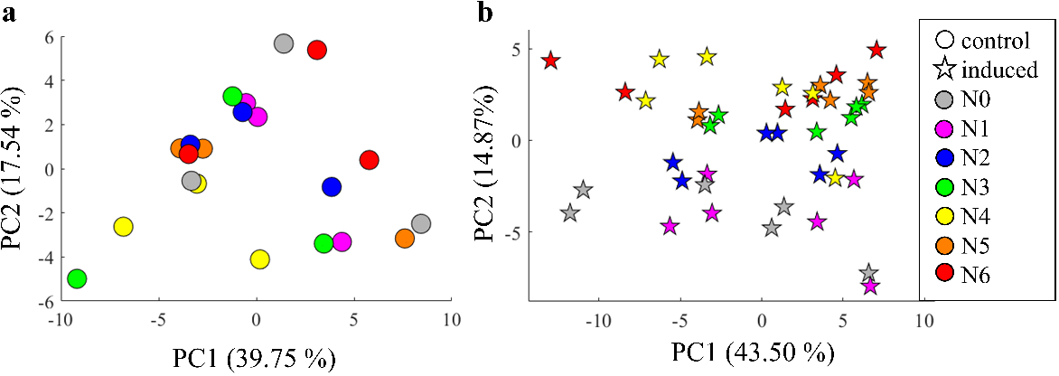
Figure S2. PCA scores plots of E. coli N4830-1 strains in (A) control or non-induced condition (circles, n = 3 biological replicates) and (B) CYT b₅-producing condition (stars, n = 6 biological replicates). The total explained variance of each PC is provided within the axes labels.

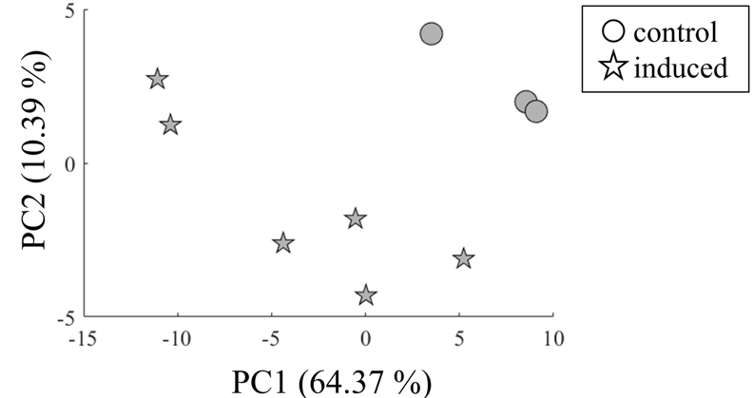
Figure S3. PCA scores plots of E. coli N4830-1 strain N0 in control (circles, n = 3 biological replicates) and induced (stars, n = 6 biological replicates) conditions. The total explained variance of each PC is provided within the axes labels.

Table S2. Lists of important annotated metabolites of all bacterial samples from t-test (control versus induced samples), PCA and PC-DFA (20 PCs, 92.07 % TEV).
Accurate mass | Retention index | Identifier | Significant test
204.1017 | 1825.17 | (-)-Shikimic acid | PC-DFA
260.1521 | 1735.46 | 2-Aminoadipic acid | PCA, t-test, PC-DFA
174.1145 | 1457.33 | 3-Aminoisobutyric acid | PC-DFA
193.1063 | 1609.21 | 3-Phenyllactic acid | PC-DFA
243.1001 | 1505.58 | 5,6-Dihydrouracil | PCA
174.1144 | 1636.68 | 5-Aminovaleric acid | PCA, t-test, PC-DFA
174.1145 | 2432.02 | 5-Methoxytryptamine | PCA
116.0902 | 1118.93 | Alanine | PC-DFA
116.0902 | 1624.63 | Alanylalanine | PC-DFA
174.1146 | 1859.96 | Cadaverine | PCA, t-test, PC-DFA
273.1002 | 1842.54 | Citric acid+Isocitric | PCA, t-test, PC-DFA
254.1163 | 1541.82 | Cytosine | PC-DFA
361.1718 | 2744.17 | D-(+)-Maltose | PCA
117.0378 | 2217.74 | Elaidic acid | PCA, t-test, PC-DFA
174.1145 | 1247.98 | Ethanolamine | PCA
245.0684 | 1359.81 | Fumaric acid | PCA, PC-DFA
159.0965 | 1977.29 | Galactosamine | PC-DFA
333.1403 | 2045.47 | Gluconic acid | PCA, t-test, PC-DFA
333.1403 | 1976.38 | Glucuronate | PCA, t-test, PC-DFA

Table S2. Lists of important annotated metabolites of all bacterial samples from t-test (control versus induced samples), PCA and PC-DFA (20 PCs, 92.07 % TEV) (cont.).
Accurate mass | Retention index | Identifier | Significant test
84.04523 | 1539.71 | Glutamate | PCA, t-test, PC-DFA
156.0856 | 1794.09 | Glutamine | PC-DFA
205.1093 | 1291.58 | Glycerol | PC-DFA
243.0657 | 1753.14 | Glycerol-3-phosphate + Glycerol-2-phosphate | PC-DFA
174.1151 | 1859.96 | Gly-Gly | PCA, t-test, PC-DFA
352.1478 | 2150.62 | Guanine | PC-DFA
187.1168 | 1174.48 | Heptanoic acid | t-test, PC-DFA
158.1373 | 1290.7 | Isoleucine | PC-DFA
117.0742 | 1076.34 | Lactic acid | t-test
218.1411 | 1463.42 | L-Homoserine | PCA
192.1557 | 1380.81 | L-Serine | PCA, PC-DFA
202.1066 | 2227.19 | L-Tryptophan | PCA, t-test
202.1154 | 2120.45 | N-Acetyl glucosamine | PCA, t-test, PC-DFA
84.0452 | 1800.33 | N-Acetyl glutamate | PCA, t-test, PC-DFA
179.0656 | 1491.25 | Nicotinamide | PC-DFA
243.1257 | 2216.73 | Oleic acid | PCA, t-test, PC-DFA
299.0741 | 1811.54 | O-Phosphoethanolamine | PC-DFA
254.0924 | 1766.5 | Orotic acid | PCA
174.0598 | 1063.88 | Oxalacetic acid+Pyruvate | PCA, t-test, PC-DFA
117.0378 | 2033.47 | Palmitoleic acid | t-test, PC-DFA
299.0741 | 1294.08 | Phosphate | PC-DFA
142.1062 | 1318.9 | Proline | PCA, PC-DFA

Table S3. Lists of important annotated metabolites of inducing samples from ANOVA (seven bacterial strains), PCA and PC-DFA (15 PCs, 90.60 % TEV).
Accurate mass | Retention index | Identifier | Significant test
260.1521 | 1735.46 | 2-Aminoadipic acid | ANOVA
193.1063 | 1609.21 | 3-Phenyllactic acid | PCA, ANOVA, PC-DFA
299.0742 | 1787.53 | 3-Phosphoglycerate | PCA
174.1145 | 2432.02 | 5-Methoxytryptamine | PCA, ANOVA
264.1123 | 1890.32 | Adenine | PC-DFA
116.0902 | 1118.93 | Alanine | PC-DFA
254.1163 | 1541.82 | Cytosine | PC-DFA
117.0378 | 2217.74 | Elaidic acid | ANOVA, PC-DFA
333.1403 | 2045.47 | Gluconic acid | PCA
333.1403 | 1976.38 | Glucuronate | PCA, ANOVA, PC-DFA
243.0657 | 1753.14 | Glycerol 3-phosphate + Glycerol-2-phosphate | PC-DFA
352.1478 | 2150.62 | Guanine | PC-DFA
187.1168 | 1174.48 | Heptanoic acid | PC-DFA
158.1373 | 1290.7 | Isoleucine | PC-DFA
192.1557 | 1380.81 | L-Serine | PCA
179.0656 | 1491.25 | Nicotinamide | PCA, ANOVA
299.0741 | 1811.54 | O-Phosphoethanolamine | PC-DFA
254.0924 | 1766.5 | Orotic acid | PCA, ANOVA
117.0378 | 2033.47 | Palmitoleic acid | ANOVA, PC-DFA
299.0741 | 1294.08 | Phosphate | PC-DFA
174.1144 | 1650.81 | Putrescine | ANOVA
230.1778 | 1521.7 | Trans-4-hydroxy-L-proline | PCA
174.1144 | 2398.5 | Tryptamine | PCA, ANOVA, PC-DFA
217.1098 | 1605.95 | Xylonolactone | PCA, ANOVA, PC-DFA

Table S4. Lists of the top most important annotated metabolites of E. coli N4830-1 strain N0 in control and induced conditions from PCA and t-test.
PCA | t-test | Summary
2-Aminoadipic acid | 2-Aminoadipic acid | 2-Aminoadipic acid
3-Aminoisobutyric acid | Elaidic acid | 3-Aminoisobutyric acid
3-Phenyllactic acid | Heptanoic acid (7:0) | 3-Phenyllactic acid
Cadaverine | Oxalacetic acid | Cadaverine
Fumaric acid | Palmitic acid (16:0) | Elaidic acid
Glutamate | Putrescine | Fumaric acid
Gly-Gly | Pyruvate | Glutamate
Histidine | Trans-4-hydroxy-L-proline | Gly-Gly
L-Serine | Tryptamine | Heptanoic acid (7:0)
O-Phosphoethanolamine |  | Histidine
Oxalacetic acid |  | L-Serine
Palmitic acid (16:0) |  | O-Phosphoethanolamine
Pyruvate |  | Oxalacetic acid
Sucrose |  | Palmitic acid (16:0)
Tryptamine |  | Putrescine
 |  | Pyruvate
 |  | Sucrose
 |  | Trans-4-hydroxy-L-proline
 |  | Tryptamine

Table S5. The bacterial pH of both before and after induction for all strains.
Bacterial strain |  | N0 | N1 | N2 | N3 | N4 | N5 | N6
pH | initial | 6.8 | 6.8 | 6.8 | 6.8 | 6.8 | 6.8 | 6.8
pH | final | 8.1 | 8.2 | 8.0 | 8.1 | 8.2 | 8.1 | 8.2

