Appendix A. L1 & L2 Normalization
Regularizations, such as the L1 and L2 regularization [116, 117] are used to decrease model complexity by penalizing significantly larger weights and reducing them to avoid overfitting. Given a loss function$L(x, y)$ with input vector$x$ and model outputs$y$, we can define the model’s predictions by a function$f:x→y$ given as,
 | $$f\left(x_{i}\right)= \sum_{i=0}^{n}{w_{i}x_{i}^{i}}= w_{0}+w_{1}x_{1}+w_{2}x_{2}^{2}+…+w_{n}x_{n}^{n}$$ | (14)

In (14), $w_{i}$ denotes the weights where $f(x_{i})$ takes $n$ input variables. Hence,$L(x, y)$ can be given as,

 | $$L\left(x,y\right)= \sum_{i=1}^{n}{{\left((y_{i}-f\left(x_{i}\right)\right)}^{2}}= \sum_{i=1}^{n}{{\left(y_{i}-\sum_{i=0}^{n}{w_{i}x_{i}^{i}}\right)}^{2}}$$ | (15)

L1 regularization (sometimes also called as Lasso regularization) introduces a regularization term to (15) with a regularization parameter$λ$ that determines the extent of penalty applied on weights as shown in (16).

 | $$L\left(x,y\right)=\sum_{i=1}^{n}{{\left(y_{i}-\sum_{i=0}^{n}{w_{i}x_{i}^{i}}\right)}^{2}}+λ\sum_{i=1}^{n}{{|w}_{i}|}$$ | (16)

On the other hand, L2 regularization (also known as Ridge regularization) is given by (17) as,

 | $$L\left(x,y\right)=\sum_{i=1}^{n}{{\left(y_{i}-\sum_{i=0}^{n}{w_{i}x_{i}^{i}}\right)}^{2}}+λ\sum_{i=1}^{n}{{w_{i}}^{2}}$$ | (17)

These regularizations have been used widely in literature and are a part of standard regularization mechanisms in place for deep neural networks [118-123].
Appendix B. Batch Normalization
Batch normalization (also termed as batch norm) proposed by Ioffe & Szegedy (2015) [124] speeds up convergence of a deep neural network by normalizing each$d$ dimensions in each layer. Having two learnable parameters$p$ and$q$, the technique takes a mini-batch $B$ of size $k$, $B←\{x_{1…k}\}$, and normalizes each input$x_{i}$ into ${\hat{x}}_{i}$ to be plugged into a linear transformation to restore the representation power of the model.
 | $${\hat{x}}_{i}=\frac{x_{i}-M_{B}}{\sqrt{{V_{B}}^{2}+c}}$$ | (18)

In (18), $M_{B}$ is the mean of the values of the batch, $V_{B}$ is the variance and $c$ is a constant added for stability. The mean and the variance are defined by (19) and (20) respectively as,

 | $$M_{B}=\frac{1}{k}\sum_{i=1}^{k}{x_{i}}$$ | (19)

 | $$V_{B}=\sqrt{\frac{1}{k}\sum_{i=1}^{k}{{(x_{i}-M_{B})}^{2}}}$$ | (20)

In final transformation step, the learnable parameters$p$ and$q$ are used as,

 | $$y_{i}=p{\hat{x}}_{i}+q$$ | (21)

Batch normalization has been used in various applications [125-128].
Appendix C. Dropout
Dropout, proposed by Srivastava et al. (2014) [24] is another technique used in deep neural networks to reduce the extent of overfitting. It does this by randomly ignoring a percentage of units (or nodes) on the layer it is applied on. By “ignoring”, it is implied that these nodes are deactivated and do not fire or propagate any values. The randomization is obtained by sampling the Bernoulli distribution. Fig. 10 shows the simplistic nature of dropout.
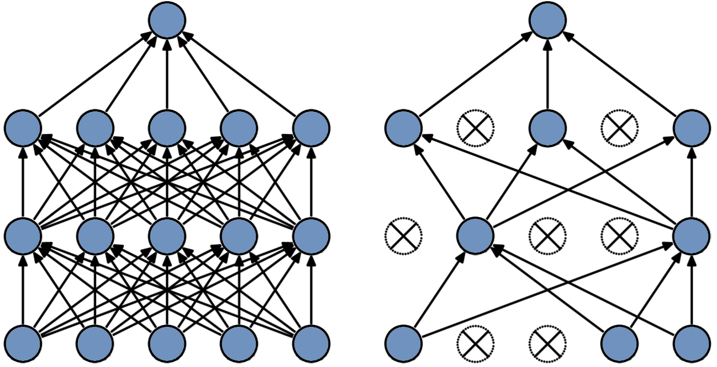
Fig. 10: (Left): A normal deep neural network. (Right): Dropout applied on each layer (except the top-most layer). Image adapted from [24].
Appendix D. Class Activation Map (CAM)
For an input image$I$, we take the activation of unit$p$ of the last convolutional layer spatially located at $(x, y)$ and denote this activation by$f_{p}(x,y)$. Let $G(x)$ be the GAP function and hence when we plug$f_{p}(x,y)$ in$G(x)$ we get,
 | $$G\left(f_{p}\left(x,y\right)\right)= \sum_{p}{f_{p}\left(x,y\right)}= G_{p}$$ | (22)

Taking weight$w_{p}^{c}$ for some class$c$ and unit$p$, the input to the softmax $S^{c}$ is given by,

 | $$S^{c}=\sum_{p}{w_{p}^{c}G_{p}}$$ | (23)
Thus, using (22) substituted in (23), we have the softmax class score,

 | $$S^{c}=\sum_{p}{w_{p}^{c}\sum_{x,y}{f_{p}(x,y)}}=\sum_{x,y}{\sum_{p}{w_{p}^{c}f_{p}(x,y)}}$$ | (24)

The prominence of activation at spatial vicinity of$(x,y)$ is characterized by a parameter$β(c;x, y)$ which decomposes (24) as,
 | $$S^{c}=\sum_{x,y}{β(c;x, y)}$$ | (25)
From (24) and (25) we infer that,
 | $$β\left(c;x, y\right)=\sum_{p}{w_{p}^{c}f_{p}(x,y)}$$ | (26)

The class prominence parameter defined in (26) allows to have a visual region-wise representation for the predicted class$c$.

