Supplementary Online Content
eMethods
eResults
eFigure 1. Schematic Diagram of the Visual Test.
eFigure 2. Diagram of a RNN neuron
eFigure 3. Diagram of an LSTM neuron
eFigure 4. 3D Data Frame of the Serial Model.
eFigure 5. ROC Curves of Auditory-Only Model, Visual-Only Model and Visual- Auditory Integrated Model based on Logistic Regression
eFigure 6. Summary Plot of the Impact of Features on the Risk of ADHD in the Integrated Model
eFigure 7. Summary Plot of the Impact of Features on the Risk of ADHD in Visual-Only Model
eFigure 8. Contribution of Stimulus Time Points to the Prediction of ADHD in Visual-Only Model
eFigure 9. The Dynamic Impact of Features on the Risk of ADHD in Visual-Only Model
eFigure 10. Summary Plot of the Impact of Features on the Risk of ADHD in Auditory-Only Model
eFigure 11. Contribution of Stimulus Time Points to the Prediction of ADHD in Auditory-Only Model
eFigure 12. The Dynamic Impact of Features on the Risk of ADHD in Auditory-Only Model
eFigure 13. Summary Plot of the Impact of Features on the Risk of ADHD in Serial Model
eFigure 14. Contribution of Stimulus Time Points to the Prediction of ADHD in Serial Model
eFigure 15. The Dynamic Impact of Features on the Risk of ADHD in Serial Model
eTable 1. Characteristics of Study Participants Undergoing the Visual Test
eTable 2. Characteristics of Study Participants Undergoing the Auditory Test
eTable 3. Prediction Performance of the Serial Model
eTable 4. Comparison of EVA Model and TOVA Scoring in Identifying ADHD
eTable 5. Model Performance based on Logistic Regression
eTable 6. Performance of the Parallel Model with Ten Splits of the Training and Test Sets

eMethods
Differences And Similarities Between EVA and TOVA
Main Differences
- Operation Method: TOVA uses an external button for operation, which provides a short travel distance and quick response but cannot be operated remotely. In contrast, EVA operates through screen taps.
- Frequency Usage: TOVA employs 324 Hz high frequency and 324 Hz low frequency for children aged six and above, with a single session duration of 21.6 minutes; EVA, however, reduces the number of trials by half.
- Session Structure: TOVA maintains continuous high and low frequencies without breaks; during frequency switches, some children may experience brief disengagement. Conversely, EVA incorporates a mandatory half-minute break during frequency changes, which cannot be interrupted prematurely.
- Visual Stimuli: The visual stimuli in TOVA consist of a single black square, whereas EVA presents a mix of black squares, triangles, circles, and other shapes. This variety in EVA not only mitigates the monotony experienced with TOVA but also increases cognitive load due to the greater diversity of stimuli, thus raising the overall difficulty level.
- Time Intervals: TOVA features a uniform time interval of 2000 ms, while EVA utilizes a pseudorandom range of 1600-2400 ms, thereby reducing anticipatory response bias.
- Stimulus Presentation: TOVA presents stimuli in a predetermined sequence, whereas EVA employs a simpler pseudorandom arrangement while ensuring that critical Go (or NoGo) trials remain unaffected.
Similarities
- Both protocols include low-frequency Go-NoGo trials in the first half and high-frequency Go-NoGo trials in the second half, maintaining a ratio of 1:3.5.
- The stimulus presentation duration for both is 100 ms (with a frame-based error of 1 ms), allowing immediate clicking upon appearance without waiting for the stimulus to disappear.
- The spatial distribution of stimuli on the screen is comparable between both systems.
- Both TOVA and EVA support the calculation of metrics such as response time, response time variability, and d'prime.

LSTM algorithm
LSTM, a deep learning model tailored for processing sequential data, is an extension of the Recurrent Neural Network (RNN). The functionality of RNN in managing time series data revolves around maintaining and propagating temporal information across hidden layers. This process can be elucidated as follows:
$$H_{t}=φ\left(W_{hh}H_{t-1}+W_{hx}X_{t}+b_{h}\right)$$
$$O_{t}=tanh(W_{ho}H_{t}+b_{o})$$
In this context, $X_{t}$ represents the variable at the current time point, while $H_{t-1}$ denotes the hidden state at the previous time point. The current hidden state $H_{t}$ is determined by both the input variable $X_{t}$ at the current time point and the hidden state $H_{t-1}$ from the previous time point. Similarly, the subsequent hidden state $H_{t+1}$ is influenced by the input variable $X_{t+1}$ at the next time point and the current hidden state $H_{t}$. As a result, each hidden state integrates information from all preceding time steps, as visualized in eFigure 2. Consequently, as time progresses, the information stored in the hidden layer will continue to accumulate.
Given that not every variable's information entering at each time point is of equal importance, and with an increase in time steps, the hidden state tends to store excessive information, making it challenging to extract information from the distant past. Therefore, RNN encounters difficulties in processing long time series data. To tackle this issue, LSTM introduces additional gating units, namely the input gate ($I_{t}$), output gate ($O_{t}$), and forget gate ($F_{t}$), which selectively regulate the information contained within the hidden state. The formula for a single LSTM unit is as follows:
$$I_{t}=σ\left(X_{t}W_{xi}+H_{t-1}W_{hi}+b_{i}\right)$$
$$F_{t}=σ\left(X_{t}W_{xf}+H_{t-1}W_{hf}+b_{f}\right)$$
$$O_{t}=σ\left(X_{t}W_{xo}+H_{t-1}W_{ho}+b_{o}\right)$$
$${\tilde{C}}_{t}=tanh⁡(X_{t}W_{xc}+H_{t-1}W_{hc}+b_{c})$$
$$C_{t}=F_{t}⊙C_{t-1}+I_{t}⊙{\tilde{C}}_{t}$$
$$H_{t}=O_{t}⊙{tanh(C}_{t})$$
The three gating units ($I_{t}$, $F_{t}$, and $O_{t}$) are computed based on the current input $X_{t}$, the previous hidden state $H_{t-1}$, learned weights $W$, and bias $b$. $F_{t}$ determines whether to retain and how much information from the past states, specifically the information from the memory cell at the previous time step ($C_{t-1}$). $I_{t}$ decides on the necessity and extent of incorporating the current state, i.e., the information from the current candidate memory cell (${\tilde{C}}_{t}$). $O_{t}$ regulates the decision of outputting and the amount of output from the current memory cell ($C_{t}$), as shown in eFigure 3.

Model Architecture
The LSTM model is designed for binary classification tasks, specifically optimized for balanced datasets. The architecture begins with an input layer that accommodates sequences shaped according to the dimensions of the training data. To facilitate the processing of padded sequences, a masking layer is incorporated, which designates a mask value of zero to ignore irrelevant timesteps. Central to this model is a Long Short-Term Memory (LSTM) layer comprising 64 units, utilizing a sigmoid activation function and a recurrent dropout rate of 0.2 to mitigate overfitting during training. The output layer consists of a single neuron, also employing a sigmoid activation function to produce a probability score indicating the likelihood of the positive class.
The model is compiled with binary cross-entropy as the loss function and utilizes the RMSprop optimizer, with the area under the curve (AUC) serving as the performance evaluation metric. During the training process, both the feature set and labels are augmented by repeating them ten times to increase the effective dataset size. The model undergoes training for 40 epochs in the auditory model and visual model, 30 epochs in the audiovisual parallel model, and 30 epochs in the serial model. A validation split of 20% is implemented to monitor performance on unseen data, while the dataset is shuffled before each epoch, and a batch size of 64 is employed to enhance training efficiency. This comprehensive architecture effectively captures temporal dependencies within the data while ensuring robust classification performance.

TOVA Variables and Scoring
Response Time Variability (RTV) is an indicator of how much variability exists in a subject's response times for accurate answers; it essentially reflects the stability of their response speed. The RTV score is determined by calculating the standard deviation of the average correct response times.
Response Time (RT) measures the mean duration required for a subject to correctly identify a target. Specifically, it represents the time from when a target is initially shown until the participant presses the microswitch. This metric is computed as the average of all correct response times, achieved by dividing the total of these response durations by the number of successful target detections, and is reported in segments of quarters, halves, and overall totals.
Errors of Commission (C or COM) arise when a subject fails to suppress an inappropriate response and mistakenly reacts to a nontarget, meaning the subject presses the button after a nontarget is displayed. The commission score is calculated by taking the total number of incorrect responses to nontargets (false positives) and dividing it by the total number of nontargets presented. These types of errors are viewed as indicators of impulsivity or insufficient inhibitory control and are expressed as a percentage of all possible errors.
Errors of Omission (O or OM) occur when a subject does not provide a response to the intended target; this means failing to activate the T.O.V.A. microswitch when a target is presented. Omission scores are derived by dividing the number of missed responses to targets (false negatives) by the total number of targets shown. Such omission errors are regarded as a reflection of inattentiveness.
The Attention Comparison Score (ACS) evaluates the performance of the subject on the T.O.V.A. against that of a recognized ADHD sample. This score indicates the degree of similarity to the ADHD profile: an ACS score below zero suggests a closer resemblance to the ADHD group, while an ACS at or above zero indicates greater alignment with the normative sample.
The formula for calculating the ACS is as follows:
ACS = Response Time Z score (Half 1) + D’ Z score (Half 2) + Variability Z score (Total) + 1.80
eResult
Characteristics of study participants undergoing visual or auditory tests
For participants who underwent visual test, the age of subjects with positive ADHD was significantly younger than that of subjects with negative ADHD (P<0.001). The proportion of male participants in the ADHD-positive group was also significantly higher than that in the ADHD-negative group (P<0.001). Participants with positive ADHD demonstrated significantly longer response time compared to those with negative ADHD, observed throughout the entire visual test as well as in both the first and second half of the test (P<0.001). Additionally, response time variability was greater in the ADHD-positive group, evident during the full test duration and in both halves (P<0.001; P=0.001; P<0.001). No statistically significant differences were found in errors of commission between the ADHD-positive and ADHD-negative groups (P>0.05). However, the ADHD-positive group exhibited higher rates of errors of omission in the second half of the test compared to the ADHD-negative group (P=0.060). See eTable 1 for details.

For participants who underwent auditory test, subjects with positive ADHD were significantly younger than those with negative ADHD (P<0.001), and the proportion of males in the ADHD-positive group was significantly higher than that in the ADHD-negative group (P<0.001). There was no statistically significant difference in response time between the ADHD-positive and ADHD-negative groups (P>0.05). In contrast, ADHD-positive subjects displayed significantly greater response time variability compared to their ADHD-negative counterparts (P<0.001). Errors of commission did not show statistically significant differences between the two groups (P>0.05). Notably, the ADHD-positive sample exhibited higher rates of errors of omission during the entire auditory test, as well as in both the first and second halves (P=0.002; P=0.011; P=0.011). See eTable 2 for details.

Performance of the serial model
The area under the curve (AUC) for the visual-auditory serial model was 0.906 (95% CI: 0.875, 0.934), which is lower than that of both the visual-only and auditory-only models. The sensitivity of the model was 0.814 (95% CI: 0.704, 0.928), and the specificity was 0.874 (95% CI: 0.757, 0.960). The Brier score recorded was 0.122 (95% CI: 0.101, 0.144). Notably, the sensitivity for data sourced from hospitals was only 0.777 (95% CI: 0.639, 0.917). Further details can be found in eTable 3.

Comparison of EVA and TOVA
The TOVA scoring formulas were used to generate the area under the curve (AUC), sensitivity, and specificity, and the results were compared with those of the deep learning-optimized EVA model (see eTable 4). The results indicated that the AUC, sensitivity, and specificity of the EVA model were significantly higher than those of the TOVA model. Additionally, the Brier score for the EVA model was significantly lower than that of the TOVA model in both visual and auditory tests, suggesting that the EVA model exhibits superior predictive performance.
Additionally, we selected a cutoff value for the TOVA scores based on the Youden index, which resulted in sensitivity and specificity values that remained lower than those derived from our model.

Model Performance based on logistic regression
The visual-auditory integrated model demonstrated an AUC of 0.861, a sensitivity of 0.800, and a specificity of 0.750 in the test set. The visual-only model exhibited an AUC of 0.796, with a sensitivity of 0.689 and a specificity of 0.774. The auditory-only model yielded an AUC of 0.670, a sensitivity of 0.622, and a specificity of 0.667 (see eTable 5). The ROC curves for all three models are presented in eFigure 5.

Model performance across multiple dataset splits
After ten iterations of dividing the dataset into training and test sets, the mean and standard deviation of model performance on the test set are presented in eTable 6. The visual-auditory integrated model achieved an AUC of 0.989 ± 0.005, sensitivity of 0.952 ± 0.027, and specificity of 0.967 ± 0.018 in the test set. For the hospital-derived data, the sensitivity was 0.947 ± 0.041, while the school-derived data achieved an AUC of 0.991 ± 0.004, sensitivity of 0.963 ± 0.016, and specificity of 0.973 ± 0.016.

Interpretability of visual-only model, auditory-only model and the serial model
In the visual-only model, longer response times are associated with a higher predicted risk of ADHD, while older age correlates with a lower predicted risk (eFigure 7). As testing progresses, the impact of stimulus timing on outcomes increases, with no distinct boundary between high-frequency and low-frequency tests (eFigure 8). Throughout the entire testing period, response time holds the highest significance; user responses are more critical during low-frequency stimuli, whereas their importance is relatively lower during the middle stages of high-frequency stimuli but increases in the latter stages. Additionally, the significance of stimulus type gradually rises (eFigure 9).
In the auditory-only model, the overall results indicate that longer response times are associated with a lower predicted risk of ADHD. Test participants who respond to stimuli have a lower probability of ADHD compared to those who do not respond. Additionally, girls exhibit a lower risk of ADHD than boys, and older age correlates with a lower predicted risk of ADHD (eFigure 10). The contribution plot of stimulus timing to outcomes shows a similar trend as observed in the parallel model (eFigure 11). Throughout the testing period, the importance of response time remains consistently significant, while the importance of other features fluctuates at different stimulus timings (eFigure 12).
In the serial model, response time remains the most significant predictor of outcomes; however, its duration does not clearly differentiate whether an individual has ADHD. Additionally, there is a trend indicating that as age increases, the risk of being predicted to have ADHD decreases. Testers who clicked show a reduced risk of outcome occurrence compared to those who did not (eFigure 13). The contribution of stimulus timing to the outcome showed that the first 324 stimuli, corresponding to the initial visual tests, contribute relatively little to the outcome, while the subsequent 324 stimuli from the auditory tests demonstrate a greater impact. Notably, the importance of the alternating low-frequency and high-frequency sections of the auditory test shows a declining trend, with the last few stimulus points providing the most significant contributions to outcome prediction (eFigure 14). Response time consistently maintains a relatively important role throughout the testing period, while age demonstrates higher significance during low-frequency stimuli, and user responses are more critical during high-frequency stimuli (eFigure 15).

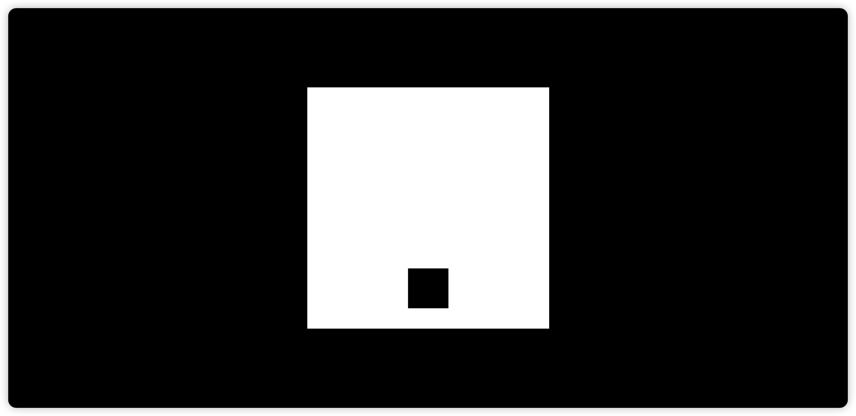
eFigure 1. Schematic Diagram of the Visual Test.
At this point, a black box appears below the white square at the center of the screen, and participants are instructed to refrain from making any clicking actions.

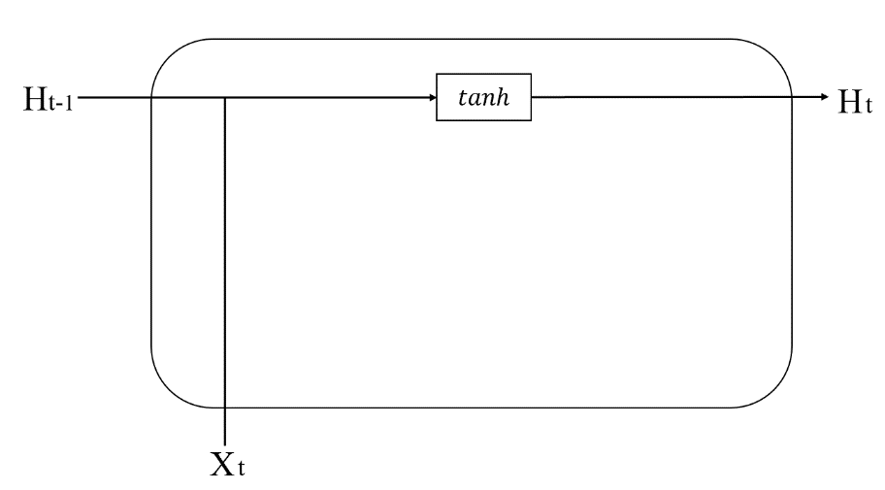
eFigure 2. Diagram of a RNN neuron

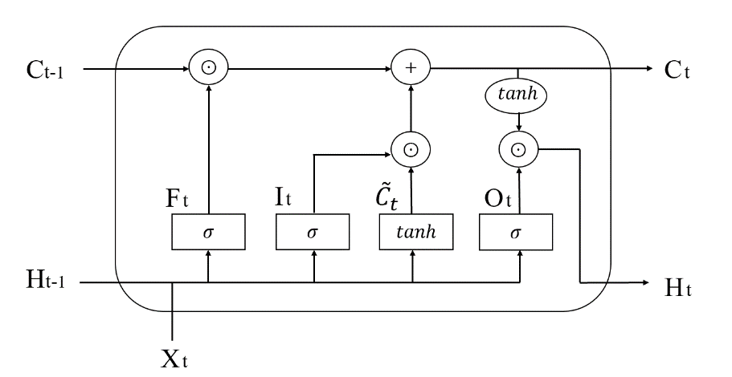
eFigure 3. Diagram of an LSTM neuron
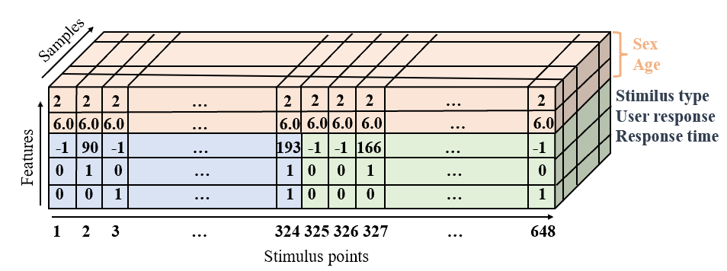
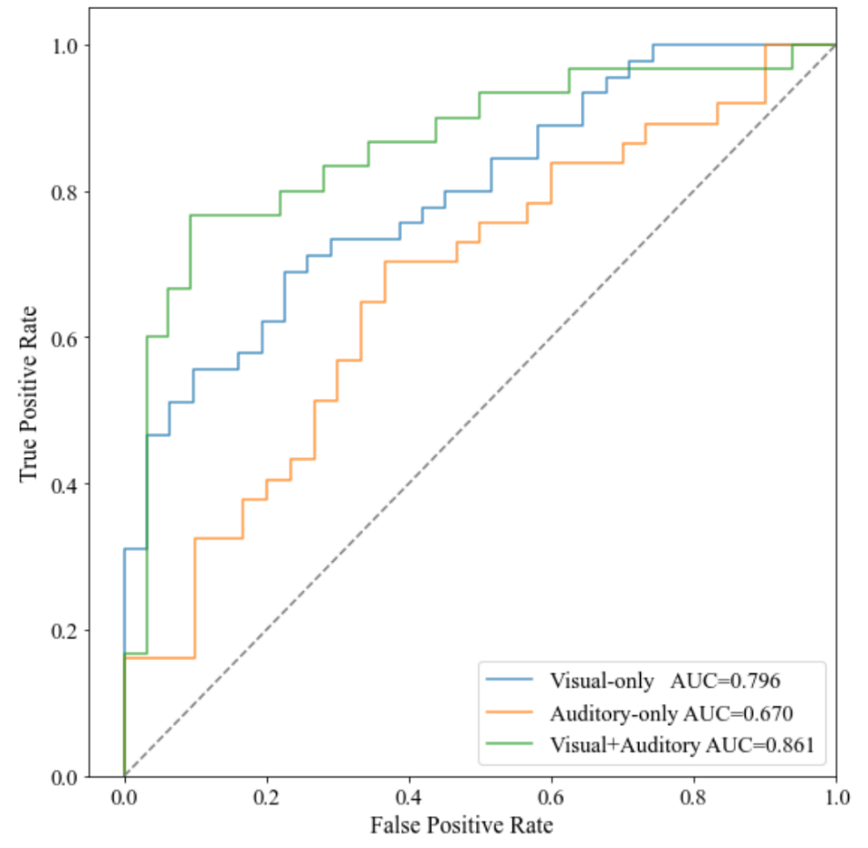
eFigure 4. 3D Data Frame of the Serial Model.
eFigure 5. ROC Curves of Auditory-Only Model, Visual-Only Model and Visual- Auditory Integrated Model based on Logistic Regression

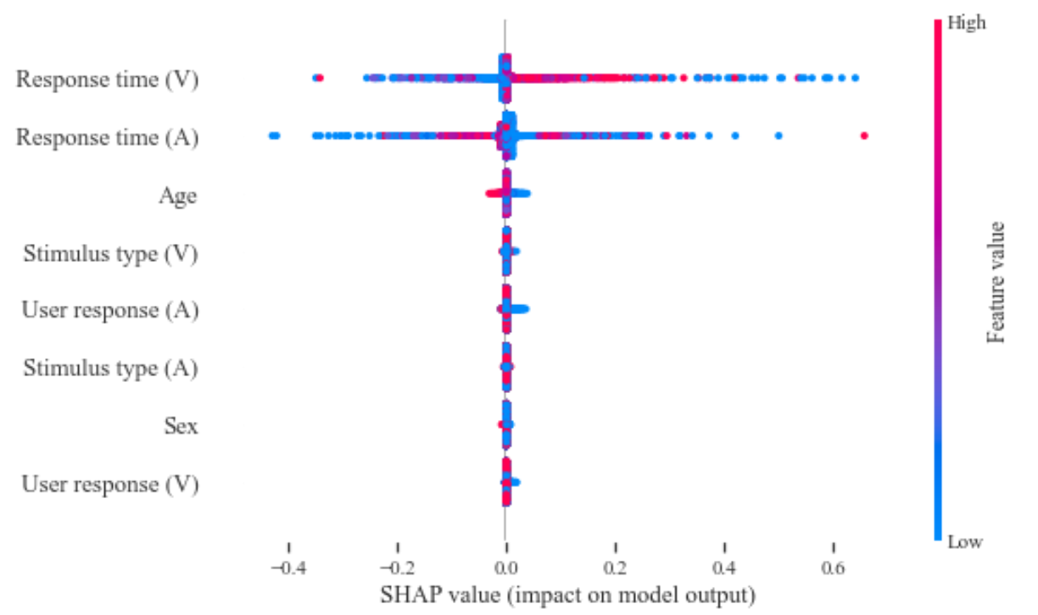
eFigure 6. Summary Plot of the Impact of Features on the Risk of ADHD in the Integrated Model
Feature significance decreased from top to bottom. Each point represents the impact of a feature on ADHD prediction for an individual participant at a specific stimulus point. Red points with positive SHAP values, akin to blue points with negative SHAP values, indicate positive associations with the outcome. Conversely, red points with negative SHAP values, similar to blue points with positive SHAP values, represent negative relationships.
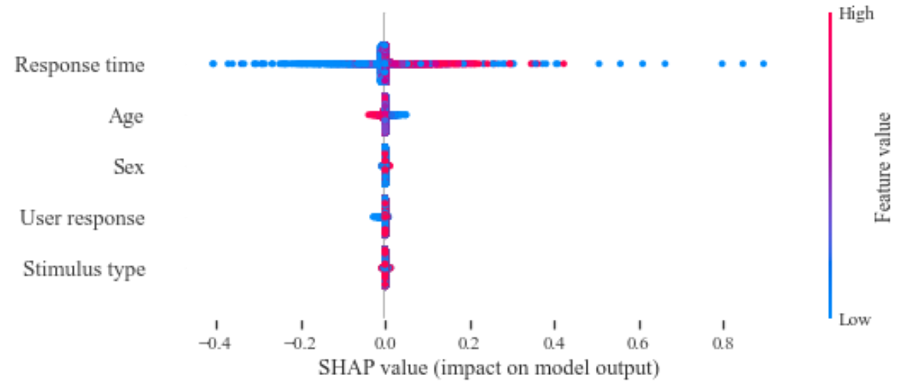
eFigure 7. Summary Plot of the Impact of Features on the Risk of ADHD in Visual-Only Model
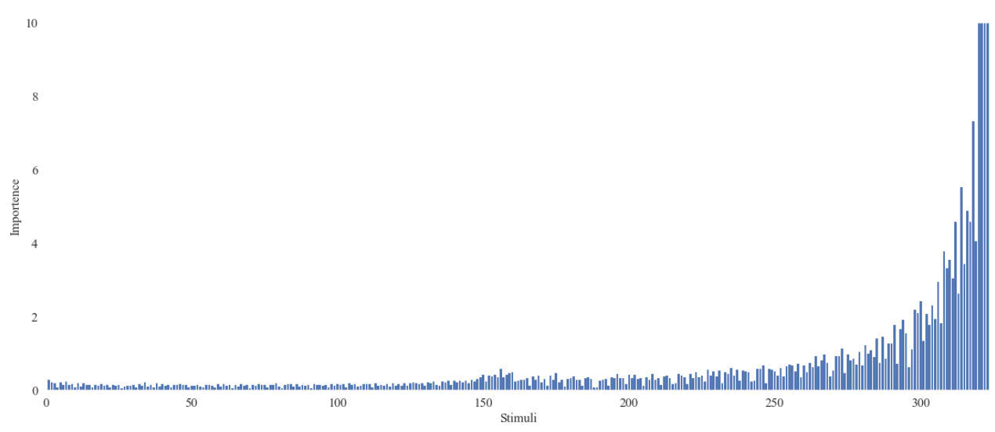
eFigure 8. Contribution of Stimulus Time Points to the Prediction of ADHD in Visual-Only Model
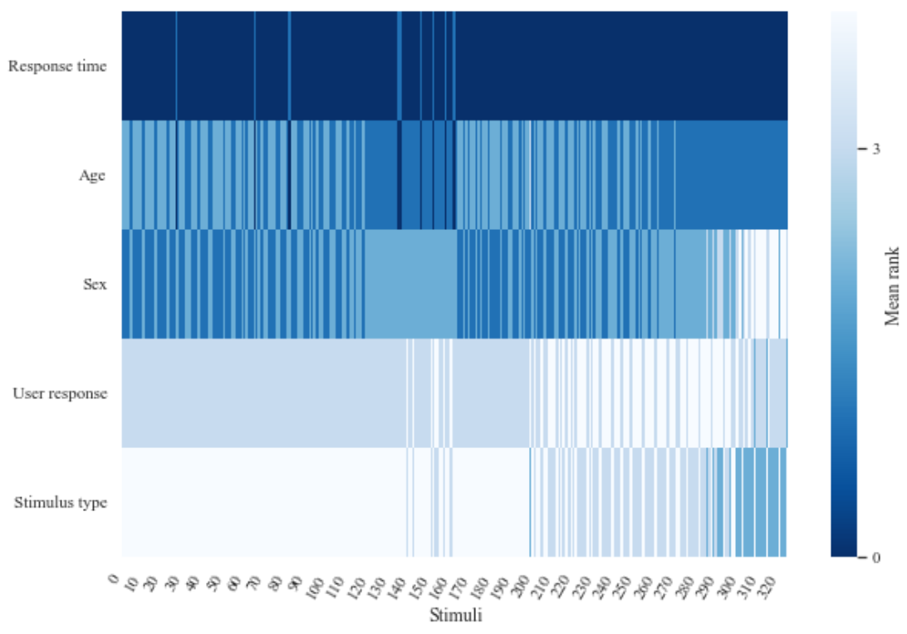
eFigure 9. The Dynamic Impact of Features on the Risk of ADHD in Visual-Only Model
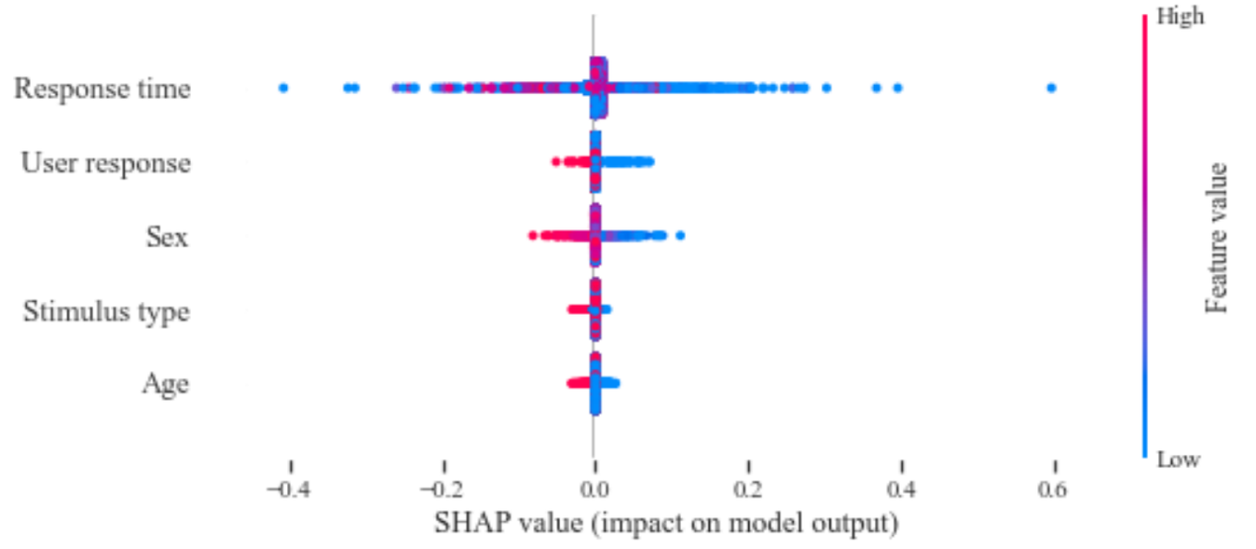
eFigure 10. Summary Plot of the Impact of Features on the Risk of ADHD in Auditory-Only Model
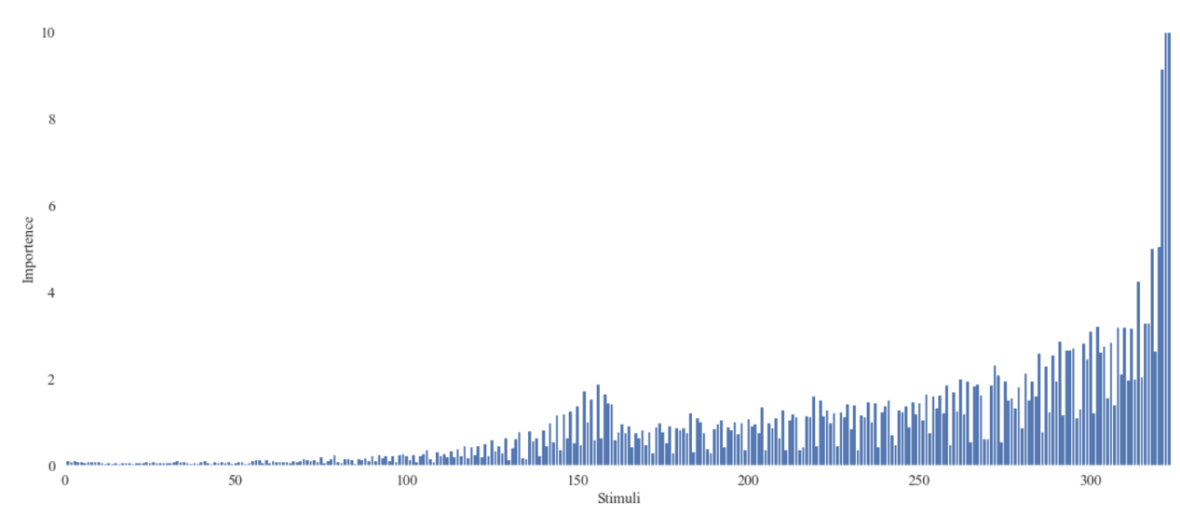
eFigure 11. Contribution of Stimulus Time Points to the Prediction of ADHD in Auditory-Only Model
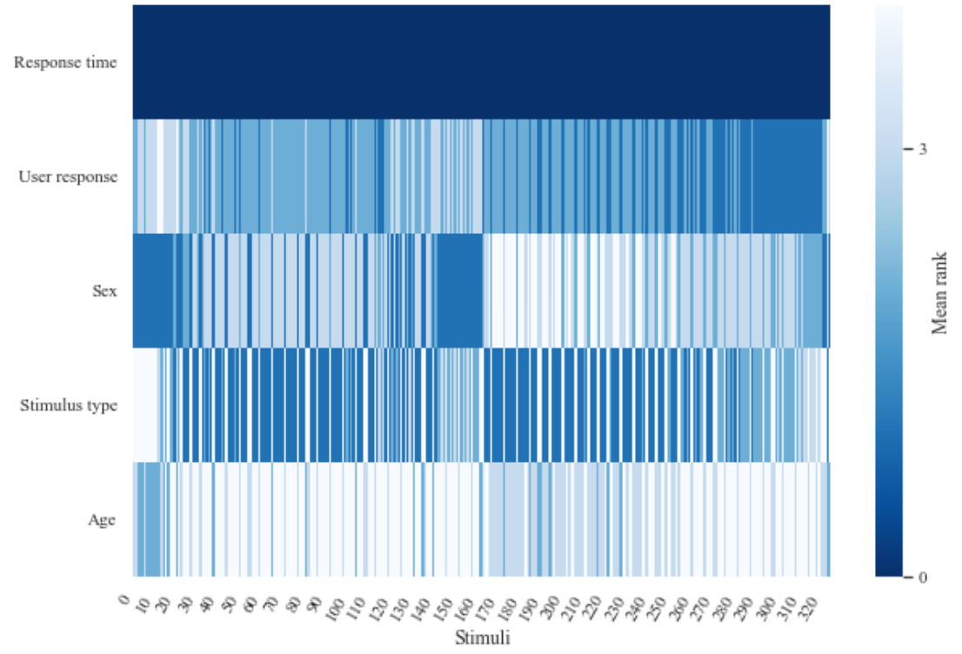
eFigure 12. The Dynamic Impact of Features on the Risk of ADHD in Auditory-Only Model
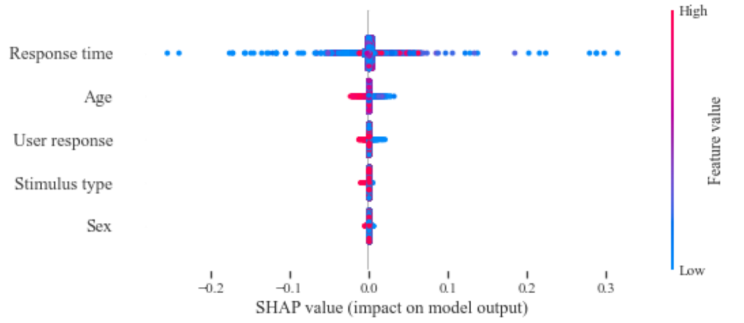
eFigure 13. Summary Plot of the Impact of Features on the Risk of ADHD in Serial Model
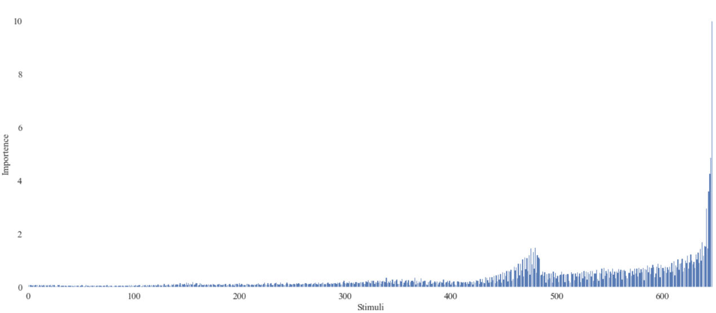
eFigure 14. Contribution of Stimulus Time Points to the Prediction of ADHD in Serial Model
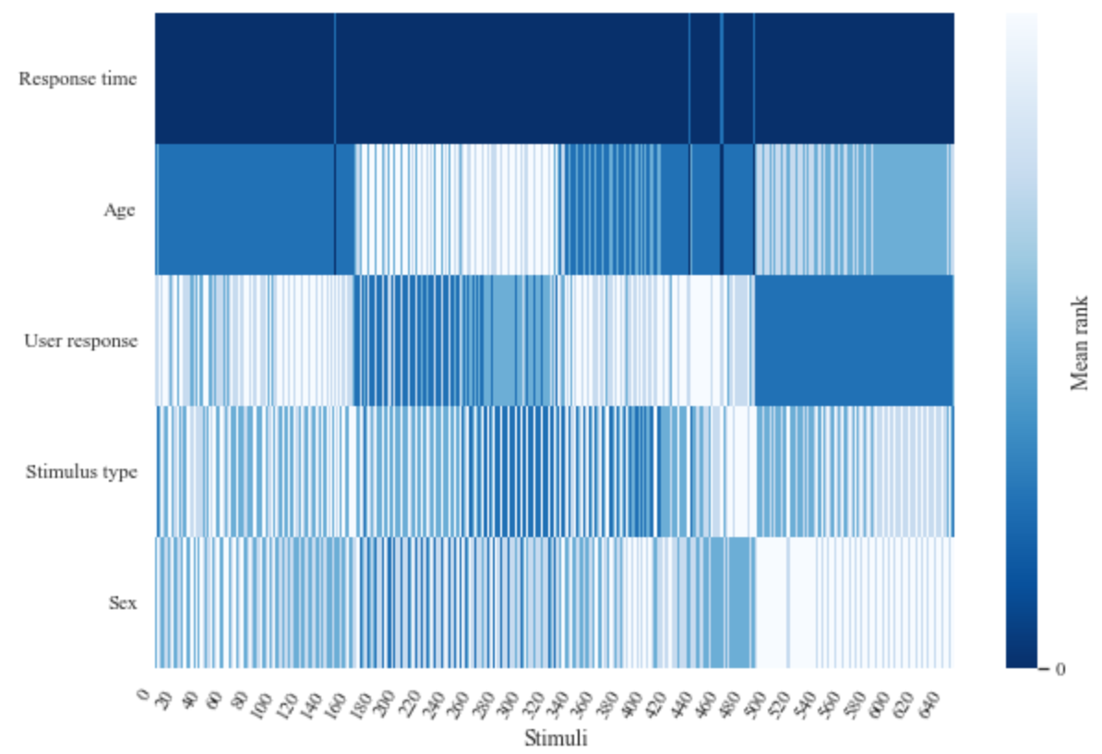
eFigure 15. The Dynamic Impact of Features on the Risk of ADHD in Serial Model

eTable 1. Characteristics of study participants undergoing the visual test
 |  | ADHD
Characteristic, n (%) | Total  (N=377) | Yes  (N=194) | No  (N=183) | P value
Age | 9.17±1.48 | 8.69±1.53 | 9.68±1.23 | <.001
Gender |  |  |  | <.001
Male | 235(62.33) | 142(73.20) | 93(50.82) | .
Female | 142(37.67) | 52(26.80) | 90(49.18) | .
Response Time
Total | 599.6±131.1 | 657.6±136.2 | 537.8±91.44 | <.001
Half 1 | 670.7±128.8 | 718.7±138.1 | 619.5±94.37 | <.001
Half 2 | 580.0±137.5 | 640.8±142.1 | 515.3±97.17 | <.001
Response Time Variability
Total | 206.7±87.48 | 231.5±91.40 | 180.3±74.73 | <.001
Half 1 | 190.1±83.93 | 203.5±88.02 | 175.9±77.06 | 0.001
Half 2 | 200.1±98.24 | 229.9±100.8 | 168.2±84.73 | <.001
Errors of Commission
Total | 0.14±0.13 | 0.14±0.13 | 0.14±0.14 | 0.778
Half 1 | 0.10±0.13 | 0.10±0.13 | 0.11±0.13 | 0.378
Half 2 | 0.28±0.21 | 0.30±0.21 | 0.27±0.22 | 0.275
Errors of Omission
Total | 0.06±0.10 | 0.07±0.10 | 0.05±0.10 | 0.113
Half 1 | 0.07±0.12 | 0.07±0.11 | 0.07±0.13 | 0.719
Half 2 | 0.06±0.10 | 0.07±0.10 | 0.05±0.10 | 0.060
eTable 2 Characteristics of study participants undergoing the auditory test
 |  | ADHD
Characteristic, n (%) | Total  (N=332) | Yes  (N=181) | No  (N=151) | P value
Age | 9.16±1.49 | 8.68±1.55 | 9.74±1.17 | <.001
Gender |  |  |  | <.001
Male | 210(63.25) | 134(74.03) | 76(50.33) | .
Female | 122(36.75) | 47(25.97) | 75(49.67) | .
Response Time
Total | 915.3±152.4 | 908.8±172.4 | 923.2±124.3 | 0.380
Half 1 | 946.8±169.4 | 946.4±194.7 | 947.3±133.5 | 0.958
Half 2 | 905.1±160.4 | 895.4±178.6 | 916.8±135.1 | 0.216
Response Time Variability
Total | 318.2±98.13 | 339.6±102.8 | 292.6±85.73 | <.001
Half 1 | 285.5±104.5 | 305.0±113.3 | 262.1±87.62 | <.001
Half 2 | 324.3±108.1 | 346.7±114.2 | 297.3±93.66 | <.001
Errors of Commission
Total | 0.15±0.15 | 0.16±0.16 | 0.13±0.14 | 0.114
Half 1 | 0.10±0.15 | 0.10±0.16 | 0.08±0.14 | 0.200
Half 2 | 0.33±0.19 | 0.35±0.20 | 0.31±0.19 | 0.057
Errors of Omission
Total | 0.12±0.14 | 0.14±0.16 | 0.09±0.11 | 0.002
Half 1 | 0.11±0.13 | 0.12±0.14 | 0.09±0.10 | 0.011
Half 2 | 0.11±0.13 | 0.12±0.14 | 0.09±0.10 | 0.011

eTable 3 Prediction performance of the serial model
Dataset | AUC | Sensitivity | Specificity | Brier score
Test set | 0.906 (0.875, 0.934) | 0.814 (0.704, 0.928) | 0.874 (0.757, 0.960) | 0.122 (0.101, 0.144)
Hospital |  | 0.777 (0.639, 0.917) |  | 0.193 (0.114, 0.280)
School | 0.942 (0.924, 0.958) | 0.872 (0.767, 0.947) | 0.872 (0.793, 0.959) | 0.086 (0.074, 0.099)

eTable 4 Comparison of EVA model¹ and TOVA scoring² in identifying ADHD
Dataset | AUC | Sensitivity | Specificity | Brier score
Visual test
TOVA | 0.659 | 0.070 | 0.873 | 0.285
TOVA  (cutoff value=2.7) | 0.659 | 0.380 | 0.791 | 0.285
EVA | 0.940 | 0.811 | 0.941 | 0.102
Auditory test
TOVA | 0.577 | 0.108 | 0.907 | 0.288
TOVA  (cutoff value=2.6) | 0.577 | 0.500 | 0.767 | 0.288
EVA | 0.941 | 0.869 | 0.912 | 0.089

¹ The EVA model refers to the ADHD prediction model optimized using the LSTM algorithm applied to the EVA test data.
² TOVA scoring refers to the scores obtained from the calculation formula of TOVA applied to the EVA test data.

eTable 5. Model performance based on Logistic Regression
Model | AUC | Sensitivity | Specificity | Brier score
Visual-Auditory Integration | 0.861 | 0.800 | 0.750 | 0.155
Visual-only | 0.796 | 0.689 | 0.774 | 0.187
Auditory-only | 0.670 | 0.622 | 0.667 | 0.241

eTable 6 Performance of the Parallel Model with Ten Splits of the Training and Test Sets
Dataset | AUC | Sensitivity | Specificity | Brier score
Test set | 0.989±0.005 | 0.952±0.027 | 0.967±0.018 | 0.040±0.010
Hospital |  | 0.947±0.041 |  | 0.045±0.023
School | 0.991±0.004 | 0.963±0.016 | 0.973±0.016 | 0.034±0.007

