Supplementary Materials for

Reactive Oxygen Pool over Ceria Enables Catalytic Oscillation

Jie Yan^{1†}, Maolin Wang^{1†}, Junzhong Xie^{1†}, Yapeng Zhao^{3†}, Xianghui Shi^{4†}, Yuxiong Hu², Shixiang Yu^{1,5}, Xingwu Liu¹, Mingyu Chu¹, Jie Zhang¹, Chaowu Xue², Shuheng Tian¹, Yaxuan Wang¹, Zijun Peng¹, Wu Zhou⁵, Hiroyuki Asakura⁶, Meng Wang¹, Zhiqiang Li^{3,4*}, Zhu-Jun Wang^{2*}, Ding Ma^{1*}.

Corresponding authors: Ding Ma (dma@pku.edu.cn), Zhu-Jun Wang (wangzhj3@ shanghaitech.edu.cn ), Zhiqiang Li (zli@math.pku.edu.cn).

The PDF file includes:

Materials and Methods
Supplementary Text
Fig. S1 to S48
Tables S1 to S2
Reference (50-55)

Materials and Methods
Catalyst Preparation
The commercial ceria powder is obtained from BASF, and its BET specific surface area is 133 m²/g.
The Pt/CeO₂ catalysts were prepared by a conventional incipient wetness impregnation method. Typically, the desired amount of H₂PtCl₆ • 6H₂O solution was added dropwise to CeO₂ powder (0.5 g) in crucible and stirred until the sample became loose particles. After the impregnation, the sample was kept at room temperature for 24 hours and then calcined and thermally aged at 400 °C for 4 hours in muffle. The catalyst precursors were then reduced in 10% H₂/Ar (30 ml/min) at 400 °C for 2 hours to get the Pt/CeO₂ catalysts. Four Pt/CeO₂ catalysts with calculated Pt loading of 0.05 wt%, 0.2 wt%, 0.5 wt%, and 1 wt% (Pt/CeO₂ weight ratio) were prepared.
Other catalysts, such as 0.2 wt% Pt/SiO₂, 0.2 wt% Pd/CeO₂, 1 wt% Ru/CeO₂, 5 wt% Cu/CeO₂, 0.2 wt% Pt/$α$-Fe₂O₃, and 0.2 wt% Pt/R-TiO₂ were prepared with the same method.
0.2 wt% Pt_{p}/CeO₂ is prepared through direct loading of Pt_{p} on CeO₂(50).
1 wt% Au/CeO₂ is prepared through the deposition-precipitation method. 0.5 g CeO₂ powder is added into 20 mL H₂O and stirred for 30 min. Then desired amount of HAuCl₄ is added to the solution and PH is controlled to 9. After stirred for 12 hours, the catalyst Au/CeO₂ was obtained by filtration.

X-ray powder diffraction (XRD)
XRD analysis was conducted using a Rigaku D/Max-PC 2500 Powder X-ray diffractometer equipped with Cu K_{α} radiation (λ = 0.1542 nm), operating at 40 kV, 100 mA and a scanning rate of 10°/min. Diffraction peaks were recorded in a 2θ range of 5 ~ 80°. Phase identification was achieved through comparison of XRD patterns of those of ‘Joint Committee on Powder Diffraction Standards (JCPDS)’.

Scanning transmission electron microscopy (STEM)
STEM images were acquired on an aberration-corrected JEOL-ARM300F2 GRAND ARM2 with a delta corrector and a cold field-emission gun operated at 200 kV. The convergence angle was set to be 32 mrad. The Z-contrast STEM-HAADF images were collected in the range of 68–280 mrad. Energy dispersive X-ray spectroscopy (EDS) spectra, line scan profiles and maps were collected using JEOL JED-2300T silicon drift detector. Electron energy-loss spectroscopy (EELS) was carried out with the same experimental setup using Gatan GIF detector.
All reduced then passivated samples for electron microscopy characterization were prepared by directly dropping the ethanol-diluted sample suspension on TEM grids coated with holey carbon film.

Operando X-ray Absorption Spectroscopy (XAS)
The experiments were conducted at the Pt L₃-edge (11564 eV) and Ce K-edge (40443 eV) on beamline BL14B2 at SPring-8, which operated at 8.0 GeV with a current of 99.5 mA. For Pt L₃-edge, Si (111) double crystal monochromator (DCM) was used. The photon flux at 11.58 keV was 8.6×10¹⁰ photon/s with a beam size of 5.0 (H) ×0.3 (V) mm² (vertically focused by Rh-coated mirror). I₀ chamber was filled with 75% N₂+25% Ar. Data were acquired in fluorescence mode using 19-element Germanium solid-state detector. For Ce K-edge, Si (311) DCM was used. The photon flux at 40.45 keV was 3.5×10⁹ photon/s with a beam size of 5.0 (H) ×0.3 (V) mm² (vertically focused by Rh-coated mirror). I₀ chamber was filled with 75% Ar+25% Kr, I₁ and I₂ chamber were filled with 100% Kr. Data were acquired in transmission mode using ionization chambers. Both quick-XANES (QXANES) mode (k_{max} = 4) and step-scan mode (for XANES and XAFS, k_{max} = 16–20) were set up. Pt foil and CeO₂ powder were set between I₁ and I₂ chamber and used for energy calibration.
The experiments were performed using a homemade Clausen cell (Fig. S21). To obtain a better signal-to-noise ratio, we used 0.5% Pt/CeO₂ rather than 0.2% Pt/CeO₂. The catalyst was pre-treated by 10% H₂/Ar at 400 °C for 2 h and stored in air. Pre-treated catalyst powder was loaded into a borosilicate capillary tube (i. d. = 0.98 mm, o. d. = 1.00 mm) without dilution and fixed with two pieces of quartz wool on both sides. The mixture of 4% CO/Ar (>99.99%), 4% O₂/Ar (>99.99%), and H₂ (>99.99%) was supplied as feed gas (CO/O₂/H₂/Ar = 1/1/50/48), under the control of mass-flow controller (MFC) with a total flow of 4 mL/min at ambient pressure. The absorption of X-ray by feed gas and capillary tube is less than 6% for photons at 11564 eV and 0.3% for photons at 40443 eV, calculated by Hephaestus. The sample was first heated to ~80°C and then cooled to ~50 °C to start the oscillation (ramping rate of 5 °C/min). The time period of oscillation (T_{oscillation}) is tuned by changing the ratio of CO and O₂. The spectra were acquired during the oscillations and under different atmospheres, which was switched by four-way valves. For QXANES spectrum, due to the time cost in spectrum acquisition and reset of monochromator, we set the period of each scan to 8 or 12 s for Ce and 12 or 20 s for Pt. For Pt L₃-edge XAFS spectrum, 10 repeated scans (~30 min for each scan) were collected and merged to improve signal-to-noise ratio. The outlet gas was analyzed by mass spectrometry (OMNI Star, Pfeiffer) using the following signals: H₂ (m/z = 2), He (m/z = 4), H₂O (m/z = 18), CO (m/z = 28), Ar (m/z = 40), and CO₂ (m/z = 44).
The XAS data were processed and analyzed using Demeter software package. For QXANES, data were used without normalization. For XANES and EXAFS data, a linear function was subtracted from the pre-edge region, then the edge jump was normalized using Athena software. The edge energy (E₀) was selected as the inflection point of absorption edge. The χ(k) data were isolated by subtracting a smooth, cubic polynomial approximating the absorption background of an isolated atom. The k³-weighted χ(k) data were Fourier transformed after applying a Hanning window (dk = 1 Å⁻¹). The global amplitude N (degeneration), R (path length), ΔE₀ (energy shift), and σ² (Debye–Waller factor) were obtained by nonlinear fitting with least-squares refinement, of the EXAFS equation to the Fourier-transformed data in R-space using Artemis software. Detailed fitting settings and parameters were listed in the tables of curve fittings.

Ex-situ X-ray Absorption Spectroscopy (XAS)
The experiment was conducted at the Pt L₃-edge on beamline 1W1B at Beijing synchrotron radiation facility (BSRF), which operated at 2.5 GeV with a current of 250 mA. A Si (111) double crystal monochromator was used. The photon flux at 11.58 keV was ~10¹⁰ photon/s. Data were acquired in transmission mode using ionization chambers detectors. The catalyst was pre-treated by 10% H₂/Ar at 400 °C for 2 h, then carefully transferred to the glove box, tableted and sealed by Kapton tape. Spectra were acquired under ambient temperature and pressure. The processing of XAS data is the same as the operando experiment.

Operando DRIFTS-MS
Operando DRIFTS-MS experiment was conducted using a Bruker INVENIO S infrared spectrometer equipped with a mercury-cadmium-telluride detector. Each spectrum was collected by averaging 16 scans at a frequency of 60 kHz and a resolution of 4 cm⁻¹ in the 4,000-900 cm⁻¹ range. The experiment was performed using a home-made DRIFTS cell with small inner volume. In operando DRIFTS–MS experiment, 50 mg 0.2% Pt/CeO₂ was placed in the DRIFTS cell and heated to 75 ℃ in 30 mL/min CO/O₂/H₂/Ar=1/1/50/48, with gas species detected by on-line MS.

Operando XRD
The experiment was conducted at the BL02U2 beamline of the Shanghai Synchrotron Radiation Facility (SSRF). The electron storage ring of the synchrotron operated at 3.5 GeV with a current of 220.75 mA. The incident X-rays energy E = 18.4003 keV (λ = 0.6715 Å), with a photon flux of 5.5×10¹² photon/s at 10.0 keV. The beam size was 200 (H) × 100 (V) μm², and the beam divergence was 200 (H) × 60 (V) μrad². Data were collected using a Pilatus 2M detector, and CeO₂ powder was used for calibration of distance between sample and detector. The integration time for all spectra was set to 1 second.
The experiments were performed using the homemade Clausen cell (Fig. S21). To obtain a better signal-to-noise ratio, we used 0.5% Pt/CeO₂ rather than 0.2% Pt/CeO₂. The catalyst was pre-treated by 10 % H₂/Ar at 400 °C for 2 h and stored in air. Pre-treated catalyst powder was loaded into a borosilicate capillary tube (i. d. = 0.98 mm, o. d. = 1.00 mm) without dilution and fixed with two pieces of quartz wool on both sides. A K-type thermal couple was placed into the catalyst bed to control the temperature. The mixture of 4% CO/Ar (>99.99 %), 4% O₂/Ar (>99.99 %), and H₂ (>99.99 %) was supplied as feed gas (feed gas ratios are marked in each experiment), under the control of mass-flow controller (MFC) with a total flow of ~4 mL/min at ambient pressure. The XRD signal of absorption of borosilicate capillary tube is a very weak and board peak at < 10°. The sample was first heated to ~80°C and then cooled to ~50 °C to start the oscillations (ramping rate of 5 °C/min). The time period of oscillations (T_{oscillation}) is tuned by changing the ratio of CO and O₂.

Temperature-Programmed (TP) reaction experiments
40 mg catalyst was loaded in a quartz reactor (i.d. = 4 mm). The catalyst was first pretreated under 10% H₂/Ar at 50 °C then switched to 20 mL/min reaction feed gas. After that, the system was heated from 50 °C to 80 °C (200 °C for CO oxidation) at the rate of 1°C/min. The reactants and products were detected by online mass spectrometry (MS, OMNI Star, Pfeiffer). CO+H₂ oxidation condition feed gas: CO/O₂/H₂/Ar = 1/1/50/48. CO oxidation condition feed gas: CO/O₂/Ar = 1/1/98. H₂ oxidation condition feed gas: O₂/H₂/Ar = 1/50/49.
For CO+H₂ oxidation reactions, another TP experiment was conducted to confirm the temperature range of oscillations on 0.2% Pt/CeO₂. After pretreated under 10% H₂/Ar at 50 °C and switched to 20 mL/min CO+H₂ oxidation condition reaction feed, the system was first heated from 50 °C to 80 °C at the rate of 1 °C/min and then kept for 10 min. After that, the system was cooled down from 80 °C to 50 °C at the rate of 1 °C/min. The reactants and products were detected by online MS.
For comparison, CO+H₂ oxidation activity of 0.2% Pt/SiO₂ was also tested through TP experiments. 40 mg 0.2% Pt/ SiO₂ was loaded in a quartz reactor (i.d. = 4 mm). The catalyst was first reduced under 10 % H₂/Ar at 400 °C then switched to 20 mL/min CO+H₂ oxidation condition feed gas at 50 °C. After that, the system was heated from 50 °C to 400 °C at the rate of 5 °C/min. The reactants and products were detected by online MS.

Stability evaluation of oscillations
40 mg 0.2% Pt/CeO₂ was loaded in a quartz reactor (i.d. = 4 mm). The catalyst was first pretreated under 10% H₂/Ar at 62 °C. Then the catalyst was exposed to 20 mL/min CO/O₂/H₂/Ar = 1/1/50/48 feed gas at 62 °C for 20 hours. The reactants and products were detected by online MS.

Activity measurement
CO oxidation reaction: The activity of 0.2% Pt/CeO₂ catalyst for CO oxidation was measured at 50 °C in TP reaction process under CO oxidation feed gas (20 ml/min CO/O₂/Ar = 1/1/98). The conversion of CO was lower than 5%.
CO+H₂ oxidation: The activity of 0.2% Pt/CeO₂ catalyst for CO oxidation in CO+H₂ oxidation condition was measured at 50 °C in temperature-programmed (TP) reaction process under CO/H₂ oxidation feed gas (20 mL/min CO/O₂/H₂/Ar = 1/1/50/48).
H₂ oxidation reaction: 5 mg 0.2% Pt/CeO₂ catalyst (diluted with 35 mg SiO₂) was pretreated under 10% H₂/Ar and then switched to H₂ oxidation reaction feed gas (100 mL/min O₂/H₂/Ar = 1/50/49) at 30°C. Due to the high conversion (~100%) of O₂, the activity of H₂ oxidation reaction was significantly underestimated.

Supplementary Text
X-ray Absorption Fine Structure (XAFS) of Pt under Different Atmosphere
As shown in Table S2, after the catalyst was reduced in H₂, the coordination number (C.N.) of Pt-Pt was 7.3 ± 0.8 and Pt-O was 0.6 ± 0.2. While oxidized in O₂, C.N. of Pt-Pt decreased to 3.5 ± 1.3 and Pt-O increased to 3.0 ± 0.5, affirming the partially oxidization of Pt nanoparticles. During oscillations, C.N. of Pt-Pt was 7.6 ± 1.0, nearly the same as that of reduced state. Though C.N. of Pt-O slightly increased from 0.6 ± 0.2 to 1.1 ± 0.5, it probably can be attributed to the increase of [O_{S}] at the interface of Pt particle and CeO₂. These results confirmed that Pt maintained nanoparticle form and reduced state during oscillations.

Simplification of H₂ oxidation reaction
H₂ oxidation process involves a sequence of elementary steps: dissociative chemisorption of H₂ on Pt sites, H₂O formation and subsequent desorption of H₂O into the gas phase.
The dissociative chemisorption of H₂ can be expressed as:
$$\begin{aligned}H_{2}+ 2* ⇄2H*,\end{aligned}$$
with the equilibrium constant defined as:
$$K_{H_{2}}=\frac{θ_{H*}^{2}}{{P_{H_{2}}θ}_{*}^{2}}.$$
This leads to the relationship:
$$θ_{H*}=mθ_{*} ,in which m=\sqrt{K_{H_{2}}P_{H_{2}}}.$$
Under this framework, H coverage ($θ_{H*}$) is governed by the fraction of available Pt sites ($θ_{*}$), and due to the rapid adsorption–desorption dynamics, this equilibrium is re-established quickly as $θ_{*}$ varies with CO coverage. Thus, even as CO coverage changes dynamically, the system maintains a quasi-equilibrium for H₂ adsorption over Pt.
The formation and desorption of H₂O can be expressed as:
$$\begin{aligned}2H*+{ O}_{S}⟶H_{2}O^{\#}+O_{V} + 2*,\end{aligned}$$
$$\begin{aligned}H_{2}O^{\#}⟶H_{2}O_{g}.\end{aligned}$$
Since the H₂ oxidation activity is very high and H₂ could deplete O₂ in the gas phase, [O_{S}] is low and the formation of H₂O# is the rate-determining step. Thus, the H₂ oxidation rate is determined by the rate of H₂O formation. The rate of H₂O formation can be expressed as:
$$r=kθ_{H*}^{2}\left[O_{S}\right]=kKP_{H_{2}}θ_{*}^{2}\left[O_{S}\right].$$
This rate expression is same as reaction R.6:
$$\begin{aligned}H_{2}+O_{S}+ 2* ⟶H_{2}O+O_{V} + 2*,\#(R.6)\#\end{aligned}$$
$$r^{'}=k^{'}P_{H_{2}}θ_{*}^{2}\left[O_{S}\right].$$
Therefore, it is reasonable to simplify the H₂ oxidation process as reaction R.6.

Calculation of the net consumption rate of O_{S}
Based on reaction R.1–7, O_{S} is consumed through H₂ oxidation (R.6) and CO oxidation (R.5 and R.7), yielding stoichiometric amount of H₂O and CO₂. Thus, the sum of the formation rate of CO₂ and H₂O can represent the consumption rate of O_{S}. Due to the re-adsorption of H₂O on catalyst and reactor tube, the signal of H₂O is delayed and unable to reveal the rapid formation rate of H₂O in stage i and stage ii. Thus, it is reasonable to choose the consumption rate of H₂ to represent the formation rate of H₂O to calculate the consumption rate of O_{S} in stage i and stage ii.
The consumption rate of O_{S} can be expressed as
$$\begin{aligned}r_{O_{S}, consumption}=r_{H_{2},consumption}+r_{{CO}_{2},formation},\#\end{aligned}$$
herein
$$r_{{CO}_{2},formation}=F_{total}C_{CO_{2}}\left(t\right),$$
in which $F_{total}$ represents the total flow rate of the feed gas (μmol/s) and $C_{CO_{2}}(t)$ represents the concentration (%) of CO₂ detected by online MS during oscillations. $r_{O_{S}, consumption}$, $r_{H_{2},consumption}$, and $r_{{CO}_{2},formation}$ represent the consumption rate of O_{S}, consumption rate of H₂, and formation rate of CO₂, respectively.
Due to the presence of H₂, D₂, and HD, the consumption rate of H₂ can be expressed as
$\begin{aligned}r_{H_{2},consumption}=F_{total}\left(C_{H_{2},feed}+C_{D_{2},feed}-C_{H_{2}}\left(t\right)-C_{D_{2}}\left(t\right)-C_{HD}\left(t\right)\right),\#\end{aligned}$in which $C_{H_{2},feed}$ represents the concentration of H₂ in feed gas and $C_{D_{2},feed}$ represents the concentration of D₂ in feed gas. $C_{H_{2}}\left(t\right)$, $C_{D_{2}}\left(t\right)$, and $C_{HD}\left(t\right)$ represent the concentration of H₂, D₂, and HD detected by online MS during oscillations, respectively.
Thus, the consumption rate of O_{S} can be expressed as
$$\begin{aligned}r_{O_{S}, consumption}=F_{total}\left(C_{H_{2},feed}+C_{D_{2},feed}-C_{H_{2}}\left(t\right)-C_{D_{2}}\left(t\right)-C_{HD}\left(t\right)+C_{CO_{2}}\left(t\right)\right).\#\end{aligned}$$
The only route to supply O_{S} is the consumption of O₂ through reaction R.3. Thus, the supplement rate of O_{S} is twice of the consumption rate of O₂:
$$\begin{aligned}r_{O_{S},supplement}=2r_{O_{2},consumption}=2F_{total}\left(C_{O_{2},feed}- C_{O_{2}}\left(t\right)\right),\#\end{aligned}$$
in which $C_{O_{2},feed}$ represents the concentration of O₂ in feed gas and $C_{O_{2}}\left(t\right)$ represents the concentration of O₂ detected by online MS during oscillations.
Taken together, we can get the net consumption rate of O_{S}:
$$r_{O_{S},consumed}^{H_{2}}=F_{total}\left(C_{H_{2},feed}+C_{D_{2},feed}-C_{H_{2}}\left(t\right)-C_{D_{2}}\left(t\right)-C_{HD}\left(t\right)+C_{CO_{2}}\left(t\right)\right) \\ \begin{aligned}-2F_{total}\left(C_{O_{2},feed}- C_{O_{2}}\left(t\right)\right).\#\end{aligned}$$
As shown in Fig. 2d, $r_{O_{S},consumed}^{H_{2}}$ is positive in stages i–ii and negative in stage iii, showing that CeO₂ is reduced in stages i–ii and oxidized in stage iii. The total oxygen consumption in stages i–ii is approximately 11.7 μmol, about thirty times the amount of Pt (0.4 μmol) in the catalyst and far exceeding the total O₂ feed (0.4 μmol, Fig. S19). This indicates that not only is all the O₂ in the feed gas fully consumed, but also a substantial amount of reactive oxygen of CeO₂ (ROP) is consumed during these stages.

Phase determination for each QXANES spectrum during oscillations
Due to the stability of the oscillations, the states of catalysts with the same phase (φ) in oscillations are identical, enabling φ to represent the state of catalysts in oscillations. The phase (φ, 0–2π) of each state in oscillations can be calculated after setting the state of phase zero. Generally, the phase of any state in oscillation can be set to be zero. According to the results of gas-phase analysis (Fig. 2d), the catalyst was rapidly reduced in stages i–ii while slowly oxidized in stage iii, making stage iii much longer than stages i–ii. Consequently, if the phase of the end of stage ii is set to be zero, O_{S} concentration would increase with φ until φ approached 2π (since region of stages i–ii is short), facilitating the analysis of QXANES data. But due to the low flow rate of feed gas in QXANES experiment, the diffusion of gas species cannot be neglected and the end point of stage ii was hard to identify. Thus, we choose the points slightly lagging behind the maximum value of CO₂ during the decline process as the end of stage ii.
Then we can obtain a series of times ($t_{n}$) of points with φ = 0. After strictly synchronizing the time of XANES data acquisition with MS (the error is about 1 s), we obtained a series of times ($t_{i}$) of these XANES spectra. If $t_{n}<t_{i}<t_{n+1}$, as shown in Fig. 3a, the phase of each XANES spectrum can be calculated:
$$\begin{aligned}φ_{i}=\frac{t_{i}-t_{n}}{t_{n+1}-t_{n}}×2π=\frac{t_{i}-t_{n}}{T_{oscillation}}×2π,\#\end{aligned}$$
$$\begin{aligned}φ_{i+1}=\frac{t_{i+1}-t_{n+1}}{t_{n+2}-t_{n+1}}×2π=\frac{t_{i+1}-t_{n+1}}{T_{oscillation}}×2π.\#\end{aligned}$$
Thus, the phase difference of two adjacent XANES spectra can be calculated through the following equation:
$$\begin{aligned}φ_{i+1}-φ_{i}= \frac{\left(t_{i+1}-t_{i}\right)-\left(t_{n+1}-t_{n}\right)}{T_{oscillation}}×2π=\frac{T_{XANES}-T_{oscillation}}{T_{oscillation}}×2π.\#\end{aligned}$$

Mathematical Analysis of the Oscillatory Model
1. Limit Cycle
In chemistry, oscillatory phenomena are mathematically modeled as dissipative dynamical systems. Among the possible attractors in such systems, the most well-known are the Lorenz attractor (a chaotic system) and limit cycles (a periodic system).
The Lorenz attractor exhibits deterministic chaos—it is non-periodic, sensitive to initial conditions (the 'butterfly effect'), and requires a minimum of three dimensions in its governing equations(51). In stark contrast, a limit cycle represents stable periodic motion, characterized by a fixed amplitude and frequency, rendering its long-term behavior predictable(52). Geometrically, a limit cycle manifests as a closed orbit in phase space. For a stable limit cycle, trajectories near the cycle are drawn toward it, and crucially, this attraction ensures that the system's final oscillatory state remains independent of initial conditions(53,54). Mathematically, the Andronov–Hopf bifurcation theorem⁴ provides the conditions sufficient for the existence of stable limit cycles.
In our observations of oscillatory behavior, we note that the periodic nature—where trajectories from different initial states converge to an identical oscillation pattern—aligns with the mathematical definition of a stable limit cycle. Therefore, we employ the Andronov–Hopf bifurcation theorem to characterize our oscillations.

2. Construction of the Limit Cycle Model
According to reactions R.1–7 (in Main Text), gas-phase species concentrations and catalyst states are determined by three processes: H₂ oxidation, CO oxidation, and O₂ consumption.
As discussed in the “Simplification of H₂ oxidation reaction” section, the H₂ oxidation process can be simplified as follows:
$$\begin{aligned}H_{2}+O_{S}+ 2* ⟶H_{2}O+O_{V} + 2*.\#(R.6)\#\end{aligned}$$
Therefore, the H₂ oxidation rate can be expressed as:
$$\begin{aligned}r_{H_{2},oxidation}=k_{1}\left[H_{2}\right]\left[O_{S}\right]θ_{*}^{2}, \#\left(eq.S1\right)\end{aligned}$$
where $k_{1}$ denotes the rate constant for the H₂ oxidation reaction, $\left[H_{2}\right]$ represents H₂ concentration in the gas phase, $θ_{*}$ signifies the coverage of the exposed Pt sites, and $\left[O_{S}\right]$ represents the concentration of active surface oxygen (O_{S}).
The CO oxidation process contains CO adsorption (R.1), standard CO* oxidation (R.5), and promoted CO* oxidation (R.7).
$$\begin{aligned}CO+ * ⟶CO*,\#\left(R.1\right)\end{aligned}$$
$$\begin{aligned}CO*+{ O}_{S}⟶{CO}_{2}+O_{V} + *,\#\left(R.5\right)\end{aligned}$$
$$\begin{aligned}CO*+{ O}_{S}+* \underset{→}{{ H}_{2}}{CO}_{2,g}+O_{V} + 2*. \#(R.7)\#\end{aligned}$$
Therefore, the CO adsorption rate can be expressed as:
$$\begin{aligned}r_{CO,adsorption}=k_{CO}{\left[CO\right]θ}_{*},\#\left(eq.S2\right)\end{aligned}$$
where $k_{CO}$ represents the rate constant for CO adsorption.
The CO oxidation rate is given by
$$\begin{aligned}r_{CO, oxidation}=l{(1+λθ_{*})θ}_{CO}\left[O_{S}\right],\#(eq.S3)\#\end{aligned}$$
where $l$ represents the rate constant of CO* oxidation, $λ$ denotes the promotional effect of $θ_{*}$ on CO oxidation, and $θ_{CO}$ represents CO coverage on Pt sites.
The O₂ consumption process can be expressed as:
$$\begin{aligned}{ O}_{2}+ {2O}_{V} ⟶{2O}_{S}.\#\left(R.3\right)\end{aligned}$$
Therefore, the O₂ consumption rate can be formulated as follows:
$$\begin{aligned}r_{O_{2}, consumption}=k_{4}\left[O_{2}\right]\left[O_{V}\right],\#\left(eq.S4\right)\end{aligned}$$
where $k_{4}$ represents the rate constant of O₂ consumption.
The relationship between $θ_{*}$ and $θ_{CO}$ is expressed as:
$$\begin{aligned}θ_{*}+θ_{CO}=1.\#\left(eq.S5\right)\end{aligned}$$
The sum of $[O_{S}]$ and $[O_{V}]$ remains constant:
$$\begin{aligned}\left[O_{S}\right]+\left[O_{V}\right]=a \left(constant\right),\#\left(eq.S6\right)\end{aligned}$$
where $a$ represents the maximum content of active surface oxygen.
According to eq. S1–S6, these reactions (R.1–7) are determined by $\left[H_{2}\right]$, $\left[CO\right]$, [O₂], $θ_{*}$, and $\left[O_{S}\right]$. It would be prohibitively complex to analyze a five-dimensional model. For the convenience of analysis, we employ a continuous stirred tank reactor (CSTR) model to describe the concentrations of gas-phase species, focusing on the variations of $θ_{*}$ and $\left[O_{S}\right]$ to construct a two-dimensional model.
The variation of $θ_{*}$ contains two components: CO adsorption and CO* oxidation. CO adsorption leads to a decrease of $θ_{*}$, while CO* oxidation results in an increase of $θ_{*}$.
When CO concentration is sufficient to sustain high $θ_{CO}$, only standard CO* oxidation (R.5) occurs, leading to a reduction in CO concentration with minimal increase in $θ_{*}$ (as the H–D exchange activity remains unchanged). Conversely, promoted CO* oxidation (R.7) leads to both a decrease of CO concentration and an increase of $θ_{*}$.
Therefore, the CO adsorption rate can be expressed as:
$$\begin{aligned}r_{CO,adsorption}=k_{CO}{\left[CO\right]θ}_{*}=k_{CO}\left(c-l{\left(1+λθ_{*}\right)(1-θ}_{*})\left[O_{S}\right]\right)θ_{*},\#\left(eq.S7\right)\end{aligned}$$
in which $c$ represents the CO feed rate in the inlet gas.
The CO* consumption rate (promoted CO* oxidation) can be formulated as follows:
$$\begin{aligned}r_{{CO}^{*},consumption}=lθ_{CO}\left[O_{S}\right]{λθ}_{*}. \#\left(eq.S8\right)\end{aligned}$$
Consequently, the temporal variation of $θ_{*}$ can be expressed as:
$$\begin{aligned}n_{Pt}\frac{dθ_{*}}{dt}=l{(1-θ}_{*})\left[O_{S}\right]{λθ}_{*}-\left(c-l{\left(1+λθ_{*}\right)(1-θ}_{*})\left[O_{S}\right]\right)k_{CO}θ_{*},\#\left(eq.S9\right)\end{aligned}$$
where $n_{Pt}$ represents the total amount of Pt sites.
The variation of $\left[O_{S}\right]$ comprises three parts: H₂ oxidation, CO* oxidation, and O₂ consumption. Given the excess concentration of H₂, the variation of $\left[H_{2}\right]$ is negligible and $\left[H_{2}\right]$ can be treated as a constant. Therefore, the H₂ oxidation rate can be simplified as:
$$\begin{aligned}r_{H_{2},oxidation}=k_{1}\left[H_{2}\right]\left[O_{S}\right]θ_{*}^{2}=k_{H_{2}}\left[O_{S}\right]θ_{*}^{2}.\#\left(eq.S10\right)\end{aligned}$$
The O₂ consumption rate can be simplified as:
$$\begin{aligned}r_{O_{2}, consumption}=k_{4}\left[O_{2}\right]\left[O_{V}\right]=k_{O_{2}}\left(a-\left[O_{S}\right]\right),\#\left(eq.S11\right)\end{aligned}$$
in which $k_{O_{2}}$ represents the rate constant for O₂ consumption.
According to eq. S3, S10, and S11, the temporal variation of $\left[O_{S}\right]$ can be expressed as:
$$\begin{aligned}\frac{d\left[O_{S}\right]}{dt}=2k_{O_{2}}\left(a-\left[O_{S}\right]\right)-k_{H_{2}}\left[O_{S}\right]{θ_{*}}^{2}-l\left[O_{S}\right]\left(1+λθ_{*}\right){(1-θ}_{*}).\#\left(eq.S12\right)\end{aligned}$$
Based on the analysis above, we have constructed a two-dimensional model to analyze the variation of $\left[O_{S}\right]$ and $θ_{*}$:
$$\begin{aligned}\left\{\begin{aligned}n_{Pt}\frac{dθ_{*}}{dt}=l{(1-θ}_{*})\left[O_{S}\right]{λθ}_{*}-\left(c-l{\left(1+λθ_{*}\right)(1-θ}_{*})\left[O_{S}\right]\right)k_{CO}θ_{*} \\ \frac{d\left[O_{S}\right]}{dt}=2k_{O_{2}}(a-[O_{S}])-k_{H_{2}}[O_{S}]{θ_{*}}^{2}-l\left[O_{S}\right]\left(1+λθ_{*}\right){(1-θ}_{*})\end{aligned}\right. \#\left(eq.S13\right)\end{aligned}$$
This model is able to exhibit oscillatory behavior upon setting appropriate parameters (Fig. S37). However, it remains too complex for straightforward mathematical analysis. Given that $θ_{*}$ is small and the variation of $θ_{CO}$ is minimal during oscillations, we approximate ($1- θ_{*}$) as 1. Therefore, the model can be simplified as follows:
$$\begin{aligned}\left\{\begin{aligned}n_{Pt}\frac{dθ_{*}}{dt}=l\left[O_{S}\right]{λθ}_{*}-\left(c-l\left[O_{S}\right]\left(1+λθ_{*}\right)\right)k_{CO}θ_{*} \\ \frac{d\left[O_{S}\right]}{dt}=2k_{O_{2}}\left(a-\left[O_{S}\right]\right)-k_{H_{2}}\left[O_{S}\right]{θ_{*}}^{2}-l\left[O_{S}\right]\left(1+λθ_{*}\right)\end{aligned}\right. \#\left(eq.S14\right)\end{aligned}$$

3. Setting of Initial Parameter Values
Having established the equations for the oscillatory model, we now assign initial values to the parameters in these equations.
CO concentration in feed gas$(c)$: Since the feed gas we used is 30 mL/min CO/O₂/H₂/Ar=1/1/50/48，CO flow-in rate calculates to 0.22 $μ$mol/s. Hence, we set
$c=0.22 μmol/s$.
Maximum content of active surface oxygen ($a$): Given that the net consumption of O_{S} during stages i–ii is 10.9 $μ$mol, we set $a$ slightly higher than 10.9:
$$a=12 μmol.$$
CO oxidation rate constant ($l$): To ensure that the gas-phase CO is sufficiently depleted at high $[O_{S}]$, $l$ must satisfy $lc>a$. Thus, we set
$$l=0.03 s^{-1}.$$
O₂ consumption rate constant ($k_{O_{2}}$): $r_{O_{2},consumption}$ should not only be large enough to deplete gas-phase O₂ but also not excess feed-in amount at high [O_{S}]. Hence, we set
$k_{O_{2}}=0.0225 s^{-1}$.
After CeO₂ is reduced, (e.g. $[O_{S}]$ < 2 $μ$mol), $r_{O,consumption}=k_{O_{2}}\left(c-\left[O_{S}\right]\right)>0.22 μ$mol/s, suggesting the depletion of gas-phase O₂. After O₂ consumption and normal CO oxidation reach equilibrium, $\left[O_{S}\right]=7 μ$mol, consistent with the fact that CeO₂ is slowly oxidized. Therefore, it is reasonable to set $k_{O_{2}}=0.022 s^{-1}$.
H₂ oxidation rate constant ($k_{H_{2}}$): $k_{H_{2}}$ should be large enough to ensure that H₂ oxidation activity is much higher than O₂ feed-in rate and can deplete $\left[O_{S}\right]$ rapidly at high $θ_{*}$ (such as $θ_{*}=0.1$). Here we set
$k_{H_{2}}=20 s^{-1}$.
As $θ_{*}$=0.1 and $\left[O_{S}\right]=7 μ$mol, $r_{H_{2},oxidation}=1.4 μmol/s$, much higher than O₂ feed-in rate (0.22 $μmol/s$).
CO adsorption rate constant ($k_{CO}$): To maintain high CO coverage, we set
$$k_{CO}=20.$$
Promotion effect of $θ_{*}$ ($λ$): $λ$ represents the promotional effect of $θ_{*}$ on CO oxidation and should be larger than 0. For simplification, we set
$λ=1$.
Amount of Pt sites ($n_{Pt}$): In our experiments, the loaded amount of Pt is 0.4 $μ$mol; therefore, we set $n_{Pt}$ to be the half of it:
$$n_{Pt}=0.2 μmol.$$
After setting these initial parameters values, we utilize MATLAB to calculate the variation of $\left[O_{S}\right]$ and $θ_{*}$ (initial condition:$\left[O_{S}\right]$ = 5 $μ$mol, $θ_{*}$= 0.01). The results demonstrate that $\left[O_{S}\right]$ and $θ_{*}$ evolve along a closed cycle (Fig. 5b), confirming the existence of a limit cycle.

4. Analysis of Limit Cycles with the Andronov–Hopf Bifurcation Theorem
From a mathematical perspective, there exist multiple rigorous methods to verify the existence of limit cycles, such as the Poincaré–Bendixson theorem and bifurcation theory. In this work, we use the Andronov–Hopf bifurcation theorem to identify the sufficient conditions for the existence of a stable limit cycle.
A two-dimensional autonomous system is defined by
$\begin{aligned}\frac{dx}{dt}=f(x,y,m) \\ \frac{dy}{dt}=g(x,y,m)\end{aligned}$,
where $m$ is a parameter, and $f(x,y,m)$ and $g(x,y,m)$ are polynomials in $x$ and $y$ for simplicity.
A steady state corresponds to an equilibrium point ($x_{0},y_{0}$) of the system that satisfies
$$\begin{aligned}f(x_{0},y_{0},m)=0 \\ g(x_{0},y_{0},m)=0\end{aligned}.$$
The application of the Andronov–Hopf bifurcation theorem(54) to analyze this model involves two main steps––assessing the stability of the steady state and identifying the conditions for the existence of a stable limit cycle.
4.1 Assessing the Stability of the Steady State
According to the Andronov–Hopf bifurcation theorem, a limit cycle might occur when a steady state loses its stability. The stability of a system’s steady state is determined by the eigenvalues of the system’s Jacobian matrix (J).
The Jacobian matrix (J) of the two-dimensional autonomous system can be expressed as:
J = $\left(\begin{matrix}f_{x}((x_{0},y_{0},m) & f_{y}((x_{0},y_{0},m) \\ g_{x}((x_{0},y_{0},m) & g_{y}((x_{0},y_{0},m)\end{matrix}\right)=\left(\begin{matrix}f_{x}(m) & f_{y}(m) \\ g_{x}(m) & g_{y}(m)\end{matrix}\right)$.
The trace (Tr(J)) and the determinant (|J|) of the Jacobian matrix are given by
$$\left\{\begin{aligned}Tr(\text{J})=f_{x}(m)+g_{y}(m) \\ |\text{J}|=f_{x}(m)g_{y}(m)-f_{y}(m)g_{x}(m)\end{aligned}.\right.$$
If they satisfy
$$∆={Tr(\text{J})}^{2}-4|\text{J}|<0,$$
then the Jacobian matrix has a pair of complex eigenvalues:
$$\left\{\begin{aligned}λ_{1}=α(m)+iβ(m) \\ λ_{2}=α(m)-iβ(m)\end{aligned} ,\right.$$
in which
$$\left\{\begin{aligned}α(m)=\frac{Tr(\text{J})}{2} \\ β(m)=\frac{\sqrt{{-Tr(\text{J})}^{2}+4|\text{J}| } }{2}>0\end{aligned}\right..$$
The real part ($α(m)$) determines the stability of the system’s steady state. If $α(m)$ < 0, the steady state is stable. Then the system remains at the steady state with no oscillations. If $α(m)$ > 0, the steady state is unstable and the system oscillates. Besides, the imaginary part of eigenvalues relates to the frequency of oscillations(53).
Since $α=\frac{Tr(\text{J})}{2}$, we also use Tr(J) to identify whether the steady state is stable.
For effective analysis, these equations must be analytically tractable, ensuring that Tr(J) is of a relatively simple form. Excessive complexity would complicate the verification of the theorem’s conditions and make computations impractical.
4.2 Identifying the Existence Conditions of a Stable Limit Cycle
While a positive $α(m)$ ensures the existence of an oscillation, it does not determine the stability. According to the Andronov–Hopf bifurcation theorem, there are three critical conditions to identify the stability of an oscillatory system––transversality condition, nondegeneracy condition, and stability condition.
4.2.1 Transversality Condition
As discussed in Section 4.1, the sign of $α(m)$ determines whether the system oscillates or remains at a steady state. Therefore, an Andronov–Hopf bifurcation might occur at the critical point of the parameter value $m_{0}$ satisfying $α\left(m_{0}\right)=0$. The transversality condition requires that the derivative of $α(m)$ with respect to $m$ be non-zero at $m=m_{0}$:
$$\frac{dα}{dm}(m=m_{0})≠0.$$
This condition ensures that the eigenvalues effectively crosse the imaginary axis at the critical point, driving the transition of the system from a stable to an unstable state.
4.2.2 Nondegeneracy Condition
The nondegeneracy condition guarantees that a limit cycle emerges from the bifurcation. For two-dimensional systems, this condition requires that the first Lyapunov coefficient ($γ$) be non-zero at the steady state and critical point:
$$γ=\frac{1}{16}\left(f_{xxx}+f_{xyy}+g_{xxy}+g_{yyy}\right)$$
$+\frac{{(-1)}^{sgn(g_{x})}}{16β}\left[f_{xy}\left(f_{xx}+f_{yy}\right)-g_{xy}\left(g_{xx}+g_{yy}\right)-f_{xx}g_{xx}+f_{yy}g_{yy}\right]≠0$.
4.2.3 Stability Condition
The stability of the resulting limit cycle is determined by the sign of the first Lyapunov coefficient ($γ$). A positive value ($γ>0$) indicates a subcritical Andronov–Hopf bifurcation, giving rise to an unstable limit cycle. In contrast, a negative value ($γ<0$) corresponds to a supercritical Andronov–Hopf bifurcation, which produces a stable limit cycle—precisely the behavior required in our model.

4.3 Summary
The application of this theorem involves two main steps. The first step is to assess the stability of the system’s steady state, which is predominantly determined by the parameters in the model. According to the theorem, parameters influence the trace of the system’s Jacobian matrix (Tr(J)) and thus determine the stability of steady states: a steady state is stable when Tr(J) < 0 and becomes unstable when Tr(J) > 0. The second step is to identify whether the system converges to a stable limit cycle (exhibiting sustained oscillations) by verifying three critical conditions. By completing these steps, we can identify the conditions for the existence of a stable limit cycle.
5. Calculation Process for Parameter Ranges of Limit Cycles
We take $k_{CO}$ as an example to illustrate how to calculate the range of parameters in which a limit cycle exists. The other parameters are fixed at the values specified in Section 3：
$$a=0.22, k_{O_{2}}=0.0225, c=12, k_{H_{2}}=20, l=0.03, λ=1,n_{Pt}=0.2.$$
With $x=[O_{S}]$ and $y=θ_{*}$, the two-dimensional autonomous system is
$$\left\{\begin{aligned}\frac{d[O_{S}]}{dt}=2k_{O_{2}}(c-[O_{S}])-k_{H_{2}}[O_{S}]{θ_{*}}^{2}-l\left[O_{S}\right]\left(1+λθ_{*}\right)=f(x,y) \\ n_{Pt}\frac{dθ_{*}}{dt}=l\left[O_{S}\right]{λθ}_{*}-(a-l\left[O_{S}\right]\left(1+λθ_{*}\right))k_{CO}θ_{*}=g(x,y)\end{aligned}\right..$$
Based on the calculations in Section 4, the trace of the Jacobian Tr(J) can be expressed as
$$Tr(\text{J})=\frac{lλ\left[O_{S}\right]}{n_{Pt}}-l(λθ_{*}+1)-\frac{k_{CO}(a-l\left[O_{S}\right]\left(λθ_{*}+1\right))}{n_{Pt}}-k_{H_{2}}{θ_{*}}^{2}-k_{O_{2}}+\frac{lk_{CO}λ[O_{S}]θ_{*}}{n_{Pt}}.$$
It is easy to verify that $∆={Tr(\text{J})}^{2}-4|\text{J}|<0$ and $β(k_{CO})=0.396>0$.
Substituting the fixed parameter values into the equation, we obtain the range of $k_{CO}$ that satisfies Tr(J)>0:
$${3.59<k}_{CO}<54.93.$$
Next, we use the value of $k_{CO}$ satisfying $Tr(\text{J})=0$ to verify the transversality and nondegeneracy conditions. As $k_{CO}$=3.59 and Tr(J)=0, through straightforward calculations, we get
$$\frac{dα}{dk_{CO}}\left|{ \atop k_{CO}=3.59}\right.=0.125 ≠0,$$
$$γ\left(k_{CO}\right)=-169 <0.$$
Calculations confirm that $γ\left(k_{CO}\right) <0$ in the range $3.59 <k_{CO}<54.93$, indicating that limit cycle exists in this range.
Using this method, we can obtain the relation between two parameters that enable the occurrence of oscillations (Fig. 5c and 5e).

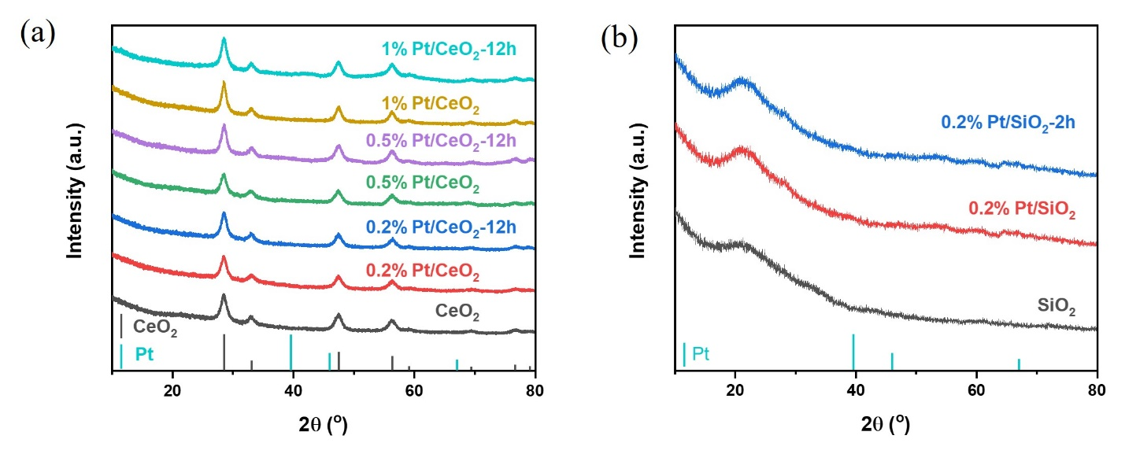
Fig. S1. XRD profiles of 0.2% Pt/SiO₂, 0.2% Pt/CeO₂, 0.5% Pt/CeO₂, and 1% Pt/CeO₂ catalysts before and after CO+H₂ oxidation reaction.

XRD patterns show no crystal Pt peaks before and after CO+H₂ oxidation reaction (Fig. S1), indicating that Pt atoms are well dispersed on CeO₂ and SiO₂. Transmission electron microscopy (TEM) images show that the size of CeO₂ is 5–10 nm and the main size of Pt clusters on CeO₂ is 1–2 nm (Fig. S2–S3 and Fig. S6–S7). This matched well with the fitting results of X-ray adsorption fine structure (XAFS) that the coordination number of Pt-Pt is 6.7 ± 0.9, suggesting that the main particle size of Pt is ~1.3 nm on CeO₂ (Fig. S4, Fig. S8–S9, and Table S1).

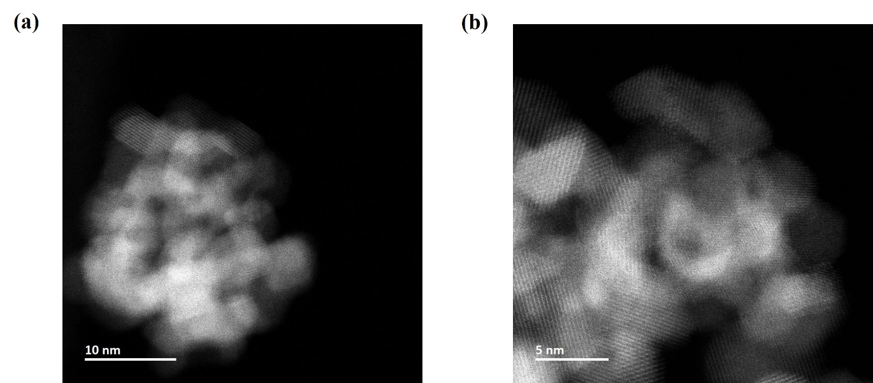
Fig. S2. HAADF–STEM images of CeO₂ with different magnification. The size of CeO₂ support is around 5–10 nm.

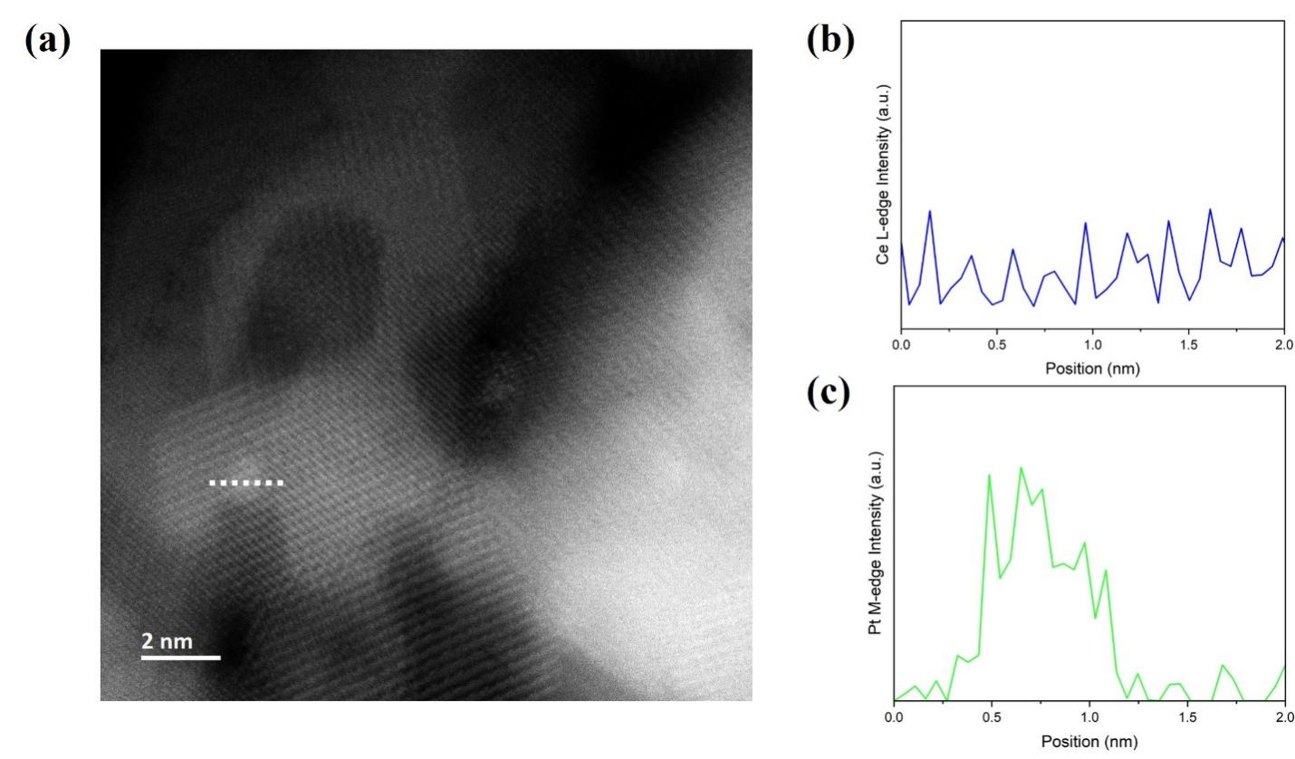
Fig. S3. HAADF–STEM image (a) of 0.2% Pt/CeO₂ catalyst and corresponding energy dispersive spectroscopy (EDS) line scan profiles of Ce L-edge (b) and Pt M-edge (c), respectively. The example position of EDS line scan is marked with white dotted line in (a).

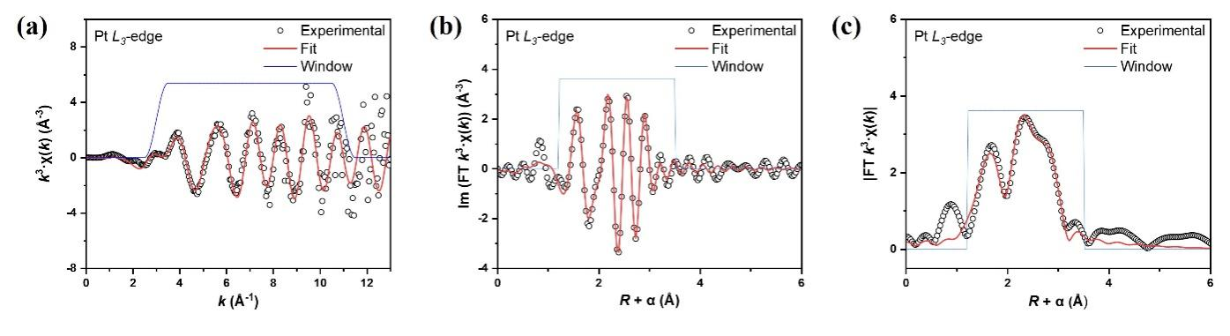
Fig. S4. Curve-fit (red line) of Pt L₃-edge EXAFS (black dot) for pristine 0.2% Pt/CeO₂ catalyst, shown in k-space (a), R-space imaginary part (b), and R-space (c); the blue line shows the fitting window. The data are k³-weighted without phase correction.

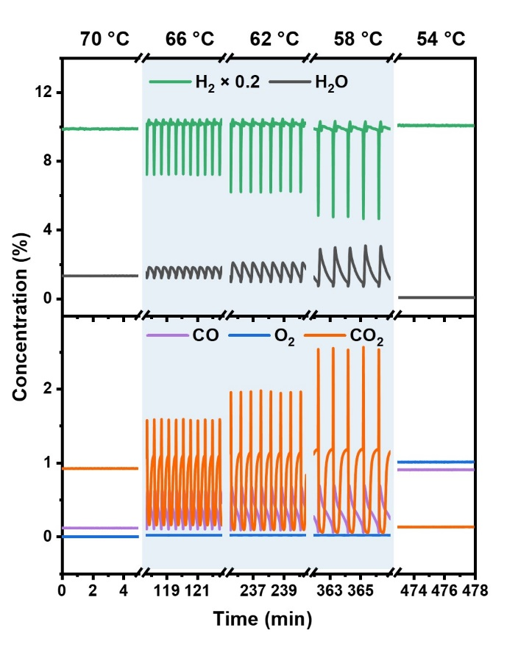
Fig. S5. Influence of temperature on oscillations catalyzed by 0.2% Pt/CeO₂ catalyst. Catalyst: 40 mg 0.2% Pt/CeO₂. Feed gas: 20 mL/min CO/O₂/H₂/Ar = 1/1/50/48. This result confirms that oscillations occur in certain temperature range.

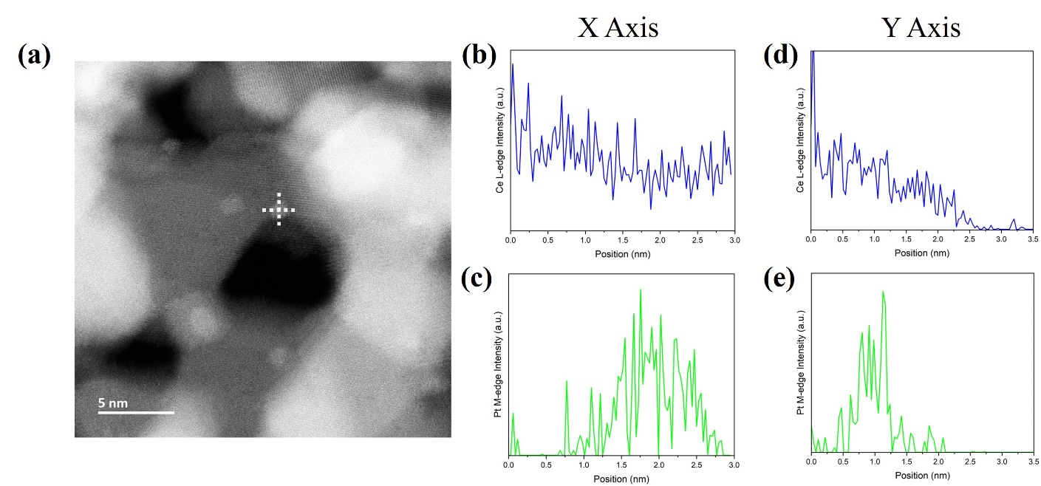
Fig. S6. HAADF–STEM image (a) of 0.5% Pt/CeO₂ catalyst and corresponding EDS line scan profiles of Ce L-edge (b and d) and Pt M-edge (c and e), respectively. (b) and (c) picture the line scan profiles of Ce-L and Pt-M edge in the X direction marked by white dotted line in (a), while (d) and (e) stand for those in the Y direction.

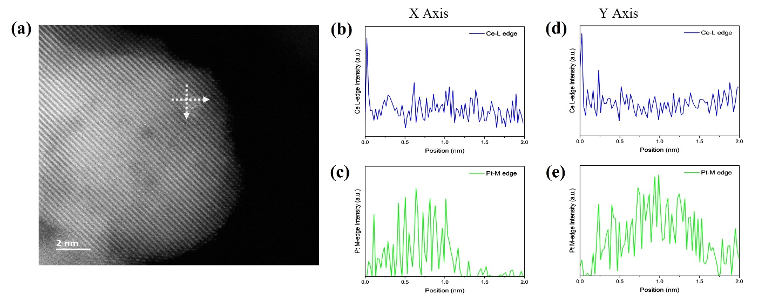
Fig. S7. HAADF–STEM image (a) of 1% Pt/CeO₂ catalyst and corresponding EDS line scan profiles of Ce L-edge (b and d) and Pt M-edge (c and e), respectively. (b) and (c) picture the line scan profiles of Ce-L and Pt-M edge in the X direction marked by white dotted line in (a), while (d) and (e) stand for those in the Y direction.

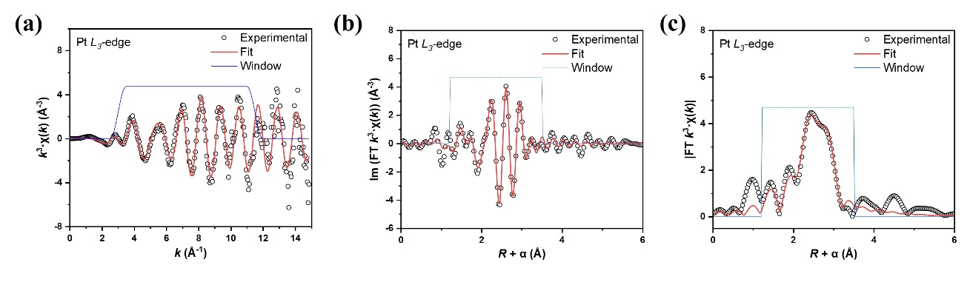
Fig. S8. Curve-fit (red line) of Pt L₃-edge EXAFS (black dot) for 0.5% Pt/CeO₂ catalyst in H₂ atmosphere at the temperature of oscillations in operando XAS experiment, shown in k-space (a), R-space imaginary part (b), and R-space (c); the blue line shows the fitting window. The data are k³-weighted without phase correction.

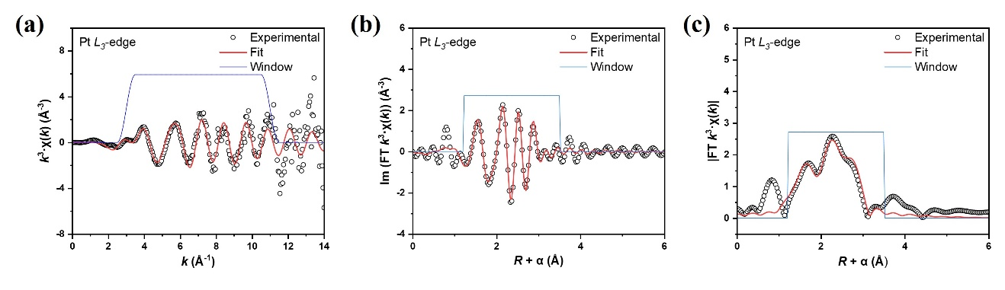
Fig. S9. Curve-fit (red line) of Pt L₃-edge EXAFS (black dot) for pristine 1% Pt/CeO₂ catalyst, shown in k-space (a), R-space imaginary part (b), and R-space (c); the blue line shows the fitting window. The data are k₃-weighted phase correction.

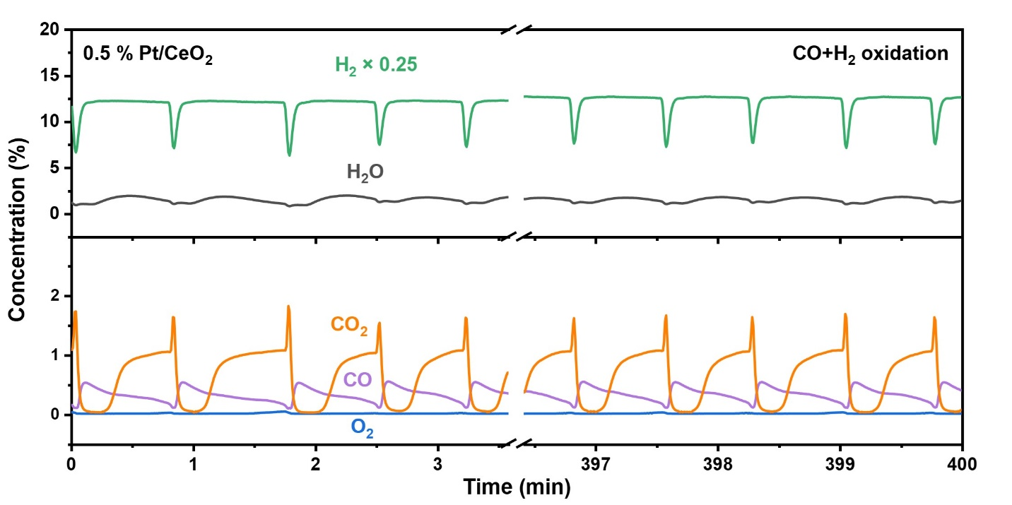
Fig. S10. CO+H₂ oxidation oscillations over 0.5% Pt/CeO₂ catalyst at 56 °C. Catalyst: 40 mg 0.5% Pt/CeO₂. Feed gas: 20 mL/min CO/O₂/H₂/Ar = 1/1/50/48.

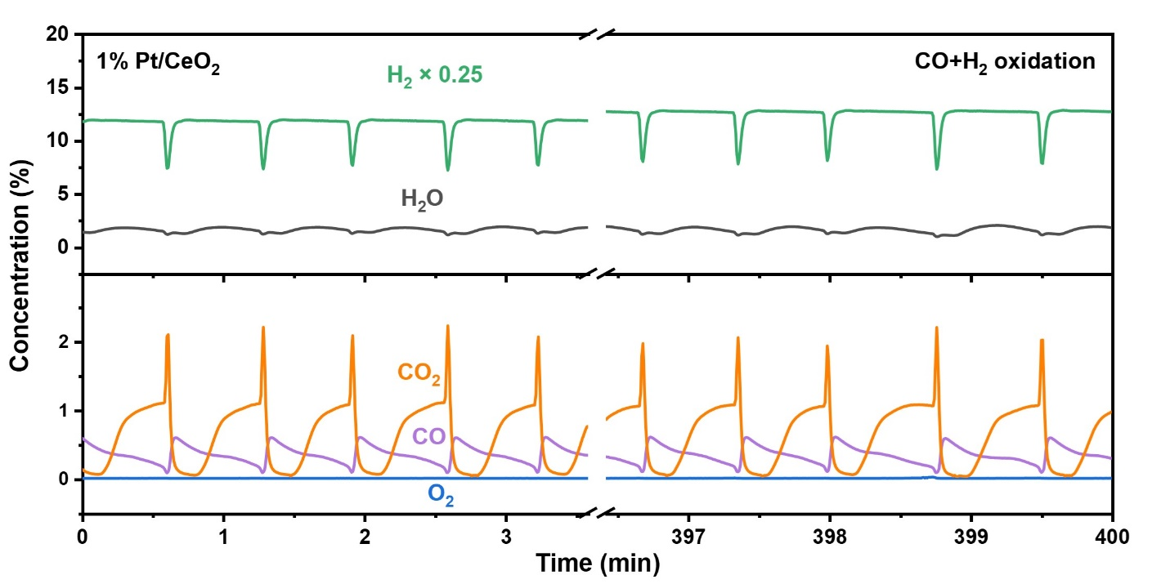
Fig. S11. CO+H₂ oxidation oscillations over 1% Pt/CeO₂ catalyst at 52 °C. Catalyst: 40 mg 1% Pt/CeO₂. Feed gas: 20 mL/min CO/O₂/H₂/Ar = 1/1/50/48.

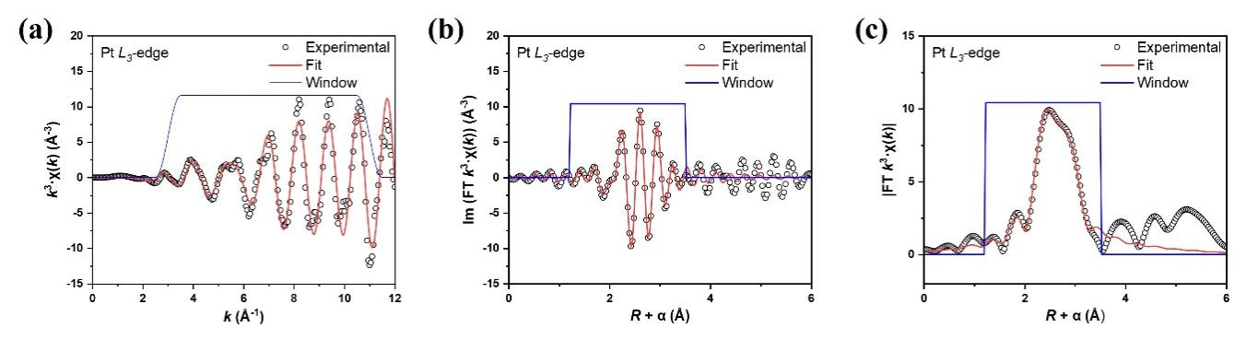
Fig. S12. Curve-fit (red line) of Pt L₃-edge EXAFS (black dot) for pristine 0.2% Pt/SiO₂, shown in k-space (a), R-space imaginary part (b), and R-space (c); the blue line shows the fitting window. The data are k³-weighted without phase correction.

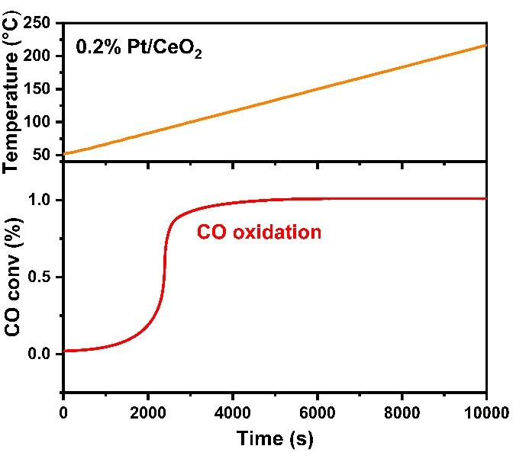
Fig. S13. Conversion of CO in pure CO oxidation reaction feed gas catalyzed by 0.2% Pt/CeO₂ catalyst as the temperature ramped up in the rate of 1 °C/min. CO oxidation reaction feed gas: 20 mL/min CO/O₂/Ar=1/1/98.

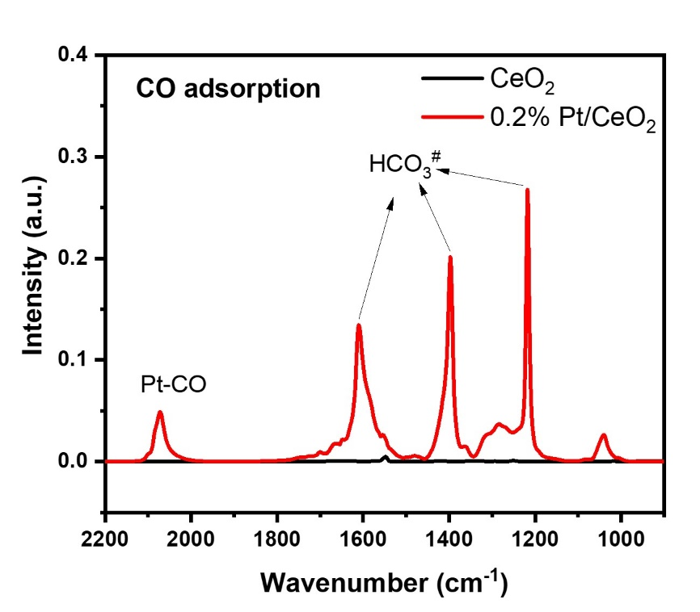
Fig. S14. CO adsorption on pure CeO₂ and Pt/CeO₂ at 60 ℃. Feed gas: 30 mL/min 1% CO/Ar.

After CO adsorption, there are a large number of carbonate-like species formed on Pt/CeO₂ while nearly no carbonate-like species formed on pure CeO₂. This suggests that CO first adsorbs on Pt sites and subsequently migrates to CeO_{2,} forming carbonate-like species at 60 ℃. Without the help of Pt, CO cannot directly adsorb on pure CeO₂ to form carbonate-like species at 60 ℃.

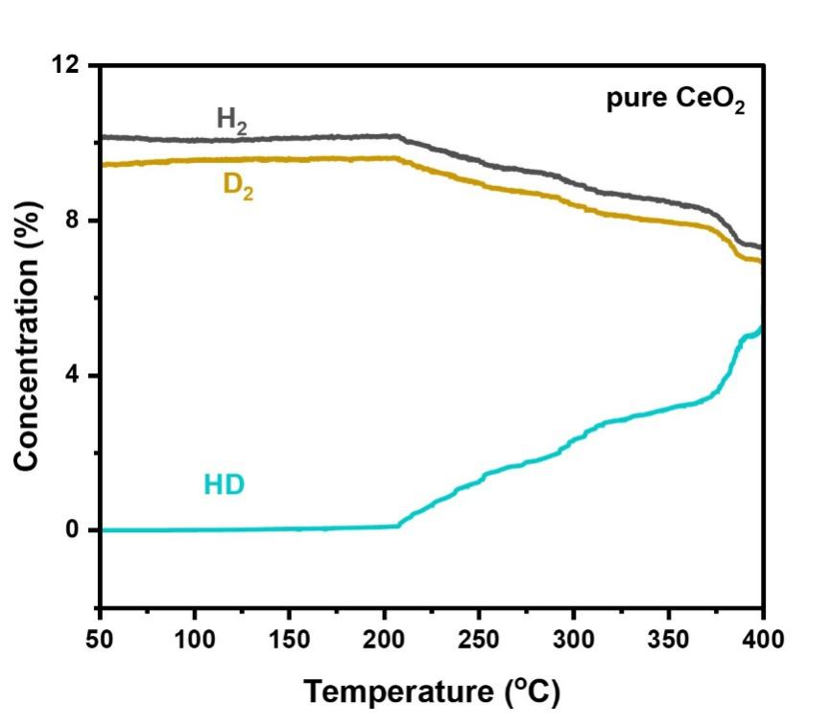
Fig. S15. Measurement of HD exchange activity on pure CeO₂. Catalyst: 40 mg CeO₂. Feed gas: 20 mL/min H₂/D₂/Ar=10/10/80. TP process: ramped from 50 °C to 400 °C in the rate of 5 °C/min.

The HD concentration is very low below 200 °C (Fig. S15), suggesting that H₂ is hard to activate on pure CeO₂ below 200 °C. However, with the presence of Pt, H–D exchange nearly reaches equilibrium at 30 °C (Fig. S16), suggesting that H₂ mainly activates on Pt sites at 60 °C.

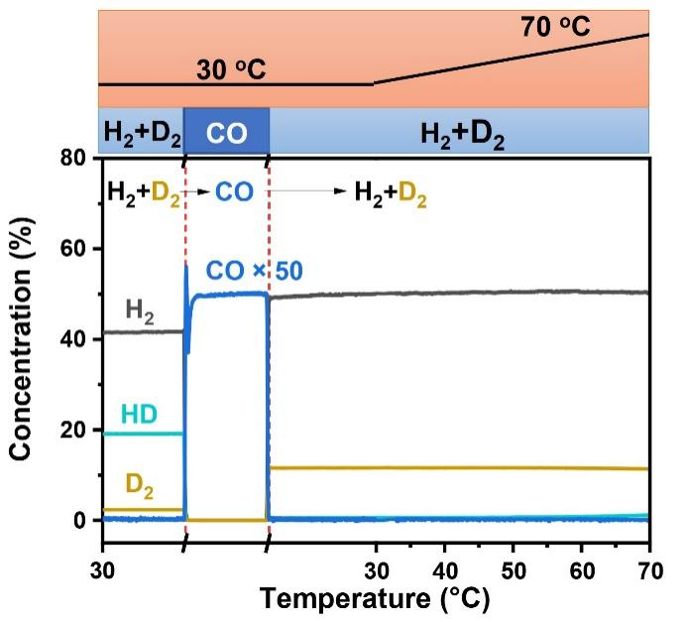
Fig. S16. The inhibition of adsorbed CO on H–D exchange over 0.2% Pt/CeO₂ catalyst. The H–D exchange activity was measured in 20 mL/min D₂/H₂/Ar = 2/10/8 at 30 °C, then the feed gas was switched to 20 mL/min 1% CO/Ar for 5 min to poison the catalyst. After that, the feed gas was switched back to 20 mL/min D₂/H₂/Ar = 2/10/8 again for 5 min. Finally, the temperature was heated to 70 °C in the rate of 2 °C/min. The result shows that the CO pre-adsorbed over 0.2% Pt/CeO₂ catalyst could have a significant impact on H–D exchange activity (inhibit the activity).

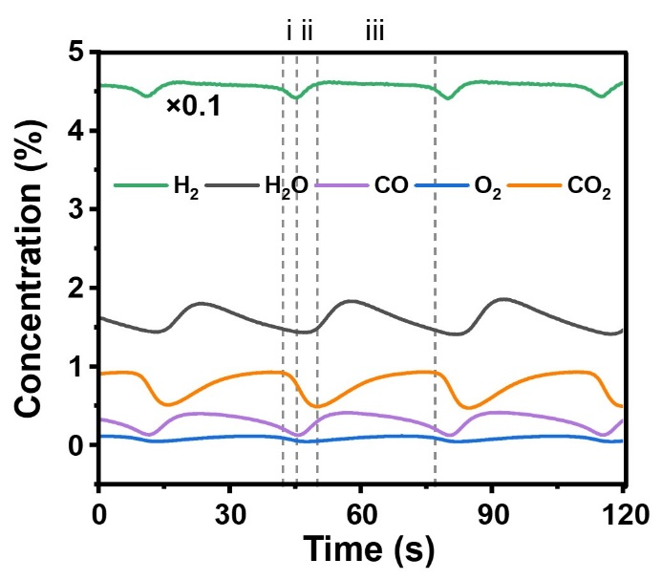
Fig. S17. Evolution of gas species detected by MS during operando DRIFTS–MS experiment. Reaction conditions: 50 mg 0.2 wt% Pt/CeO₂, 75 ℃, and 30 mL/min CO/O₂/H₂/Ar=1/1/50/48.

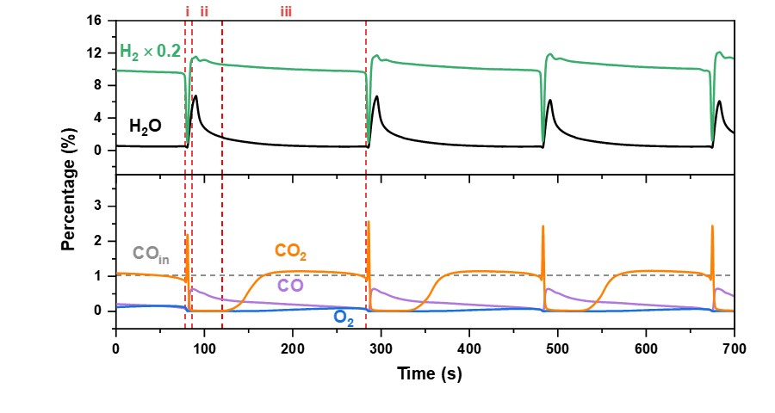
Fig. S18. Oscillations of CO+H₂ oxidation reaction monitored by MS with gas tube heated to 60 °C. Reaction conditions: 40 mg 0.2 wt% Pt/CeO₂, 56 °C, and 20 mL/min CO/O₂/H₂/Ar = 1/1/50/48.

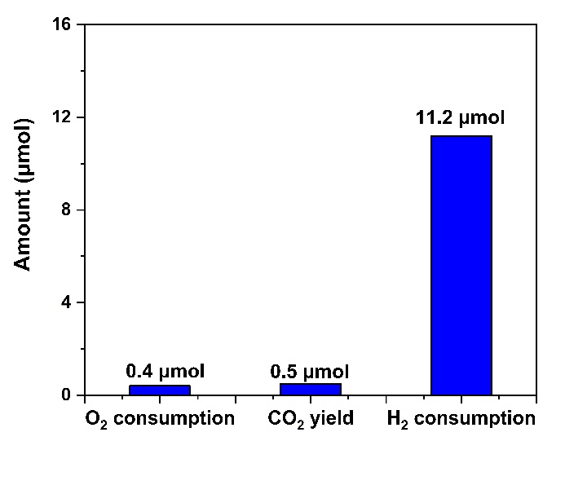
Fig. S19. Consumption of O₂, formation of CO_{2,} and consumption of H₂ in stages i–ii during one oscillation in Fig. 2d. Here, H₂ consumption refers to the sum of the consumption of H₂, HD, and D₂.

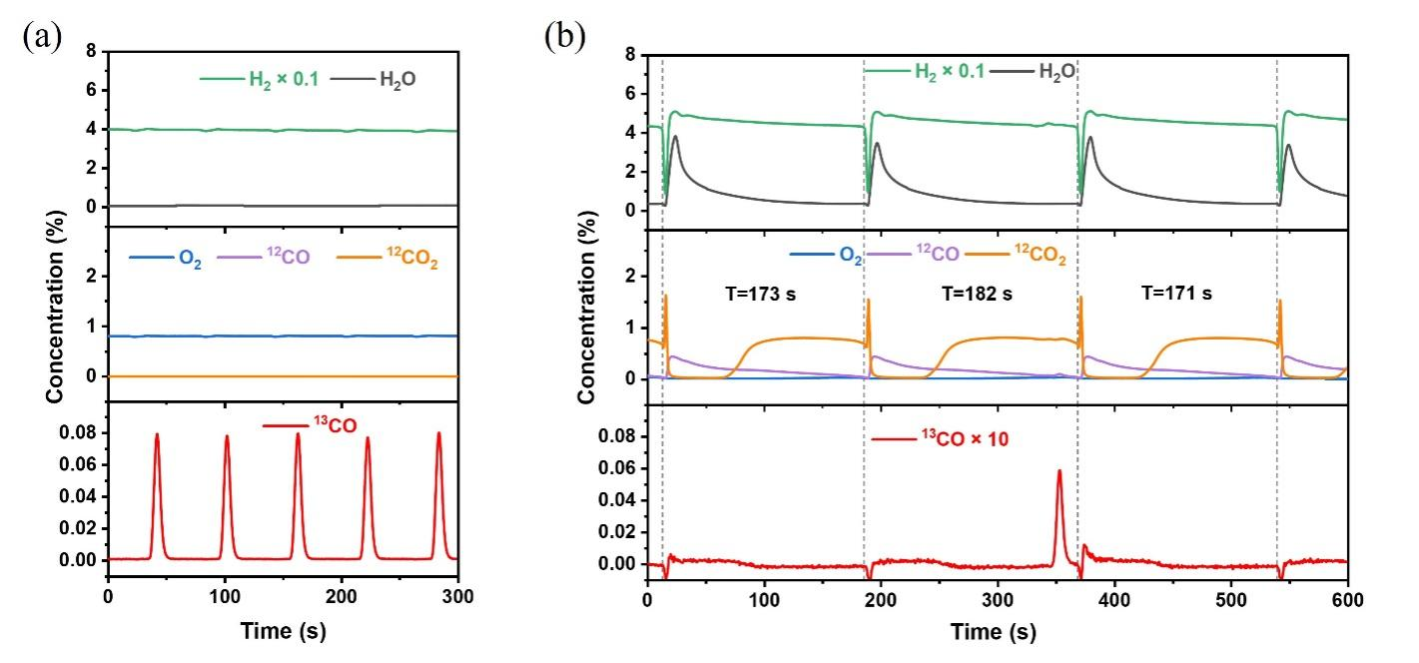
Fig. S20. ¹³CO pulse experiments during the oscillations of CO+H₂ oxidation catalyzed by 0.2% Pt/CeO₂ at 60 ℃. (a) Blank pulse of ¹³CO in feed gas with no catalyst at 60 ℃. (b) Pulse of ¹³CO in oscillations before the consumption of H₂ catalyzed by 0.2% Pt/CeO₂ at 60 ℃. CO+H₂ oxidation feed gas: 15 mL/min CO/O₂/H₂/Ar = 1/1/50/48 + 4 mL/min Ar. Pulse gas: 50 mL/min 0.4% ¹³CO/Ar.

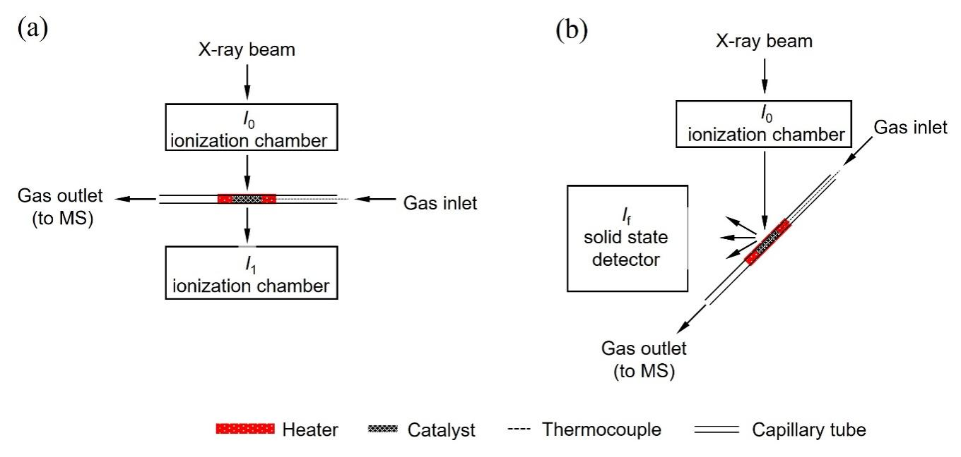
Fig. S21. The schematical setup of homemade Clausen cell (quartz capillary reactor) for operando XAS experiment for Ce K-edge in transmission mode (a) and Pt L₃-edge in fluorescence mode (b).

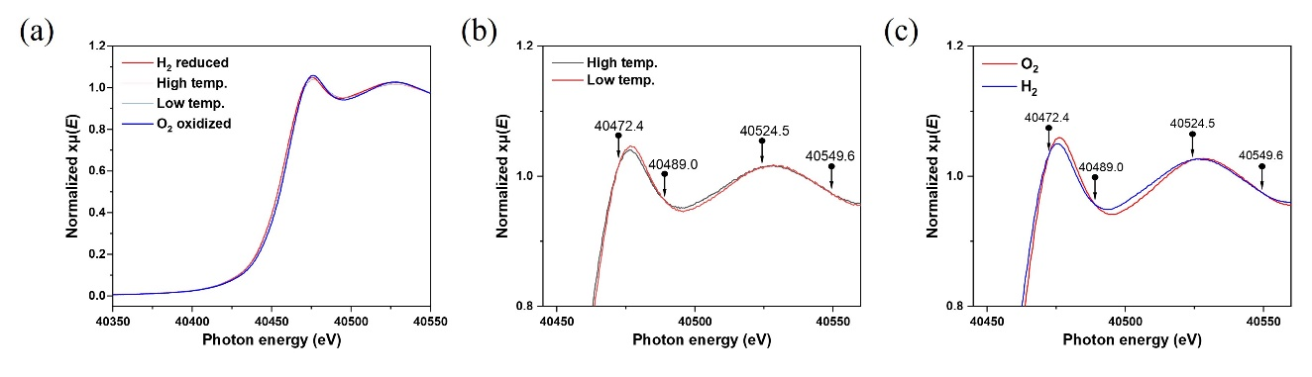
Fig. S22. Operando Ce K-edge XANES for 0.5% Pt/CeO₂ catalyst at different temperatures and atmosphere. (a) Ce K-edge XANES in H₂ atmosphere, O₂ atmosphere, high temperature, and low temperature under CO+H₂ oxidation feed gas (CO/O₂/H₂/Ar = 1:1:50:48). (b and c) Isosbestic points in zoom-in pictures. The shift of edge energy and isosbestic points at 40472.4 eV, 40489.0 eV, 40524.5 eV, and 40549.6 eV indicate the Ce species are under a transformation within a binary system, which is a transformation between Ce³⁺ and Ce⁴⁺.

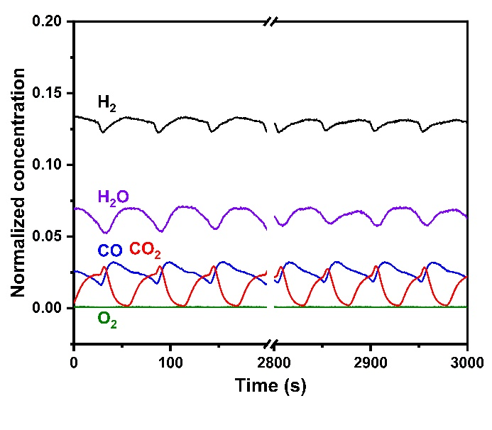
Fig. S23. The MS signals of the gas species during oscillations on 0.5% Pt/CeO₂ catalyst for operando XANES study. t_{scan} = 8 s, T_{XANES} = 60 s, and T_{oscillation} = 53 s. The MS signals of H₂ (m/z = 2), H₂O (m/z = 18), CO (m/z = 28), O₂ (m/z = 32), and CO₂ (m/z = 44) are normalized by the signal of Ar (m/z = 40).

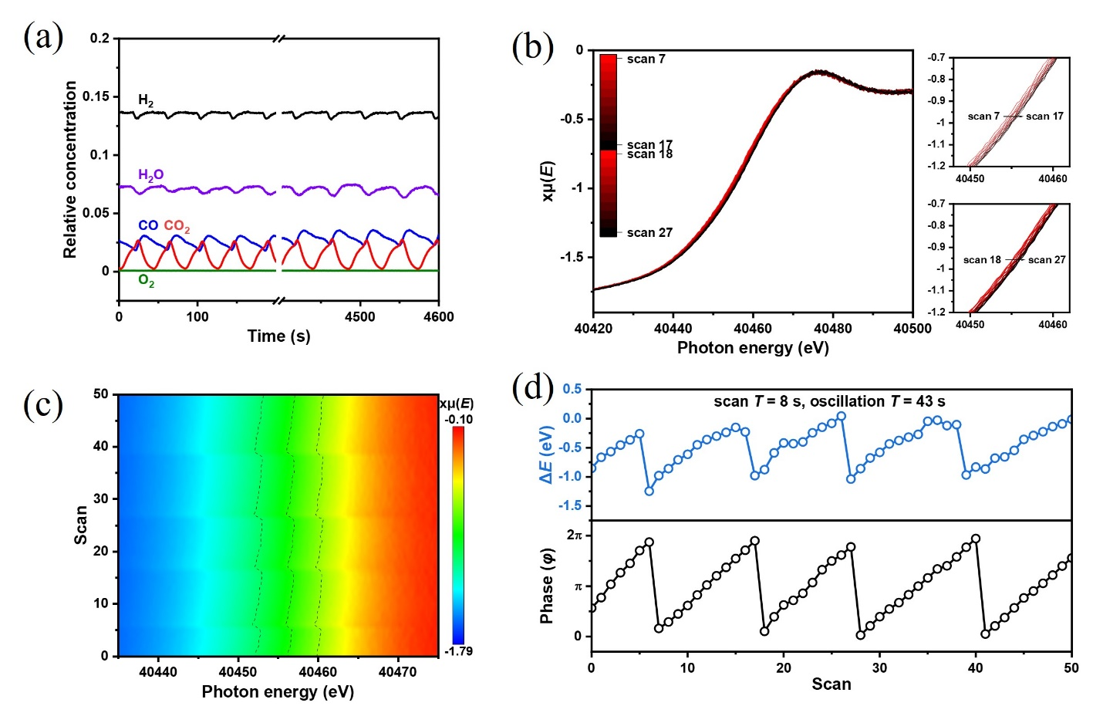 Fig. S24. Operando Ce K-edge QXANES experiment during oscillations catalyzed by 0.5% Pt/CeO₂ catalyst with t_{scan} = 8 s, T_{XANES} = 46 s, and T_{oscillation} = 43 s. (a) The MS signals of the gas species during the experiment. (b) QXANES spectra over two oscillation periods. (c) QXANES spectra for 50 scans, the dotted line represents the edge energy. (d) Phase of state (φ) in oscillations and ΔE versus scans. The MS signals of H₂ (m/z = 2), H₂O (m/z = 18), CO (m/z = 28), O₂ (m/z = 32), and CO₂ (m/z = 44) are normalized by the signal of Ar (m/z = 40).

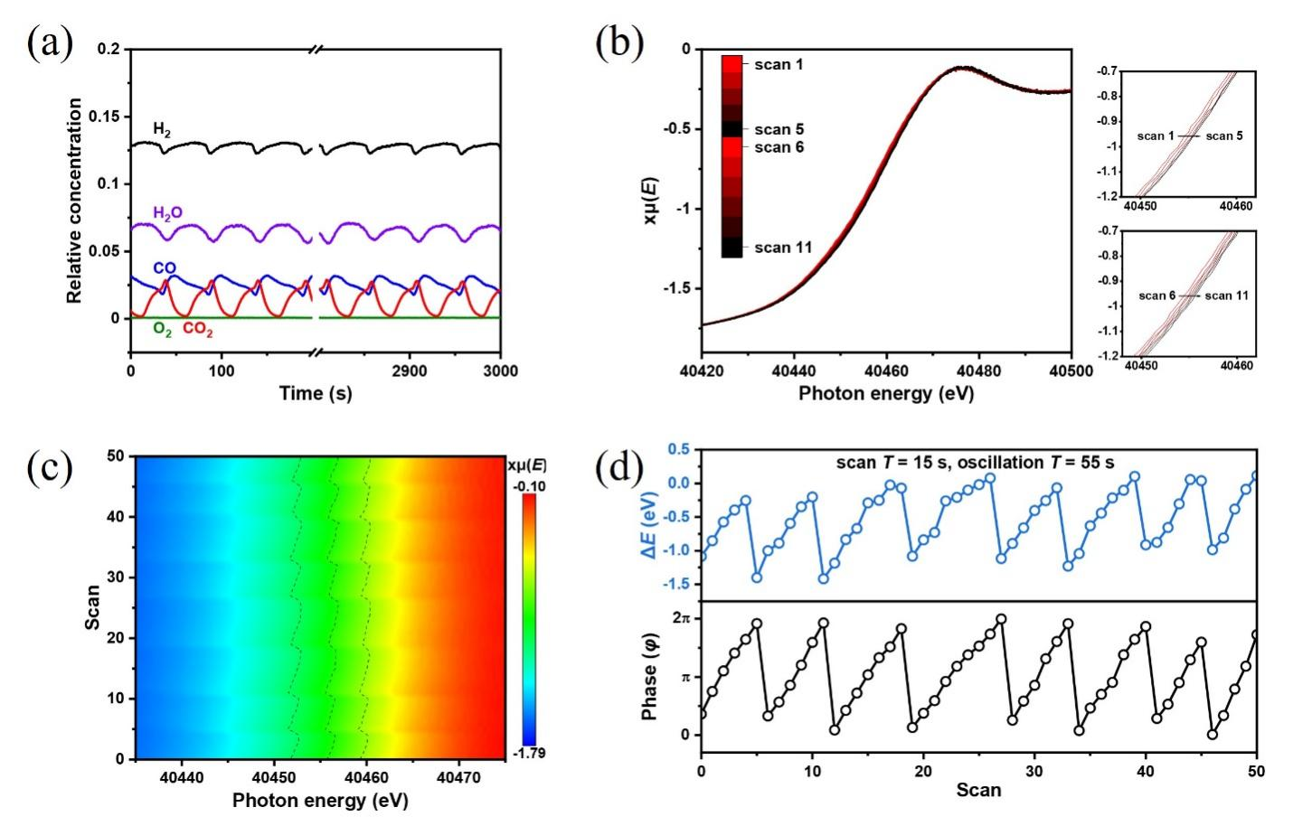
Fig. S25. Operando Ce K-edge QXANES experiment during oscillations catalyzed by 0.5% Pt/CeO₂ catalyst with t_{scan} = 15 s, T_{XANES} = 60 s, and T_{oscillation} = 55 s. (a) The MS signals of gas species during the experiment. (b) QXANES spectra over two oscillation periods. (c) QXANES spectra for 50 scans, the dotted line represents the edge energy. (d) Phase of state (φ) in oscillations and shift of edge energy (ΔE) versus scans. The MS signals of H₂ (m/z = 2), H₂O (m/z = 18), CO (m/z = 28), O₂ (m/z = 32), and CO₂ (m/z = 44) are normalized by the signal of Ar (m/z = 40).

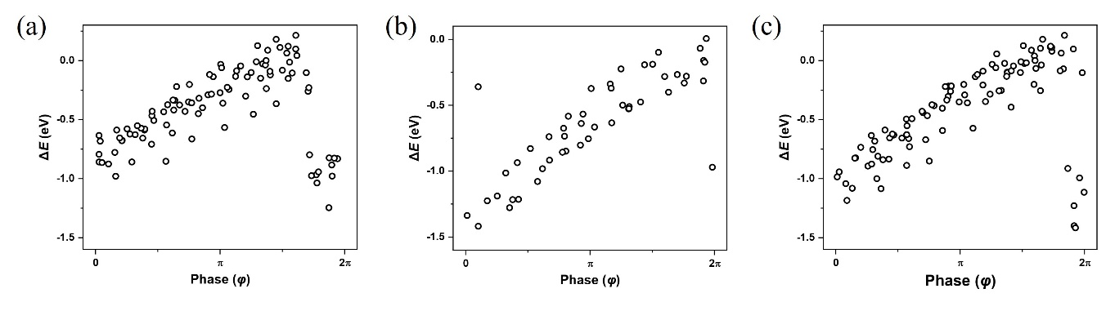
Fig. S26. Statistical plots of shift of edge energy (ΔE) in operando Ce K-edge QXANES against phase of oscillation (φ). (a) The Spearman factor is 0.886 and p-value is 4.55×10⁻³² for experiments with t_{scan} = 8 s, T_{XANES} = 46 s, and T_{oscillation} = 43 s. (b) The Spearman factor = 0.918 and p-value is 4.57×10⁻²⁰ for experiments with t_{scan} = 8 s, T_{XANES} = 60 s, and T_{oscillation} = 55 s. (c) The spearman factor = 0.894 and p-value is 3.49×10⁻³⁴ for experiments with t_{scan} = 15 s, T_{XANES} = 60 s, and T_{oscillation} = 55 s.

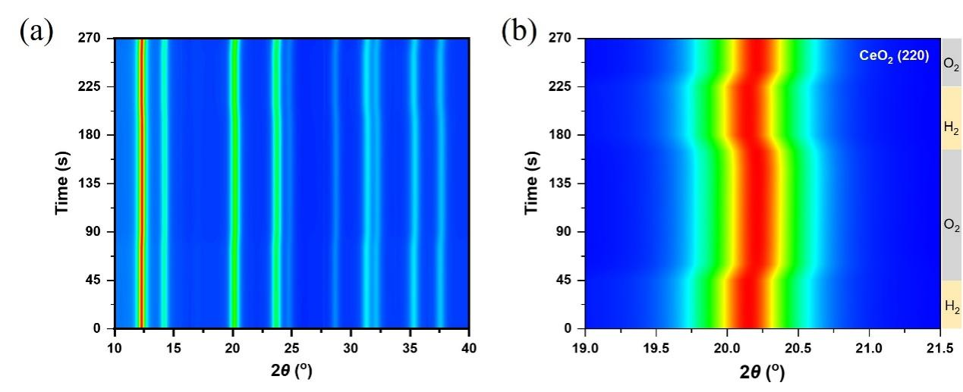
Fig. S27. Operando XRD patterns recorded during successive switching between H₂ and O₂ atmospheres. (a) Overall XRD patterns. (b) Enlarged views of CeO₂ (220) diffraction peak. The corresponding gas atmosphere is indicated by the color bar on the right side. Reaction conditions: 65 °C, alternating exposure to pure H₂ and 4% O₂/Ar, switched by a four-way valve.

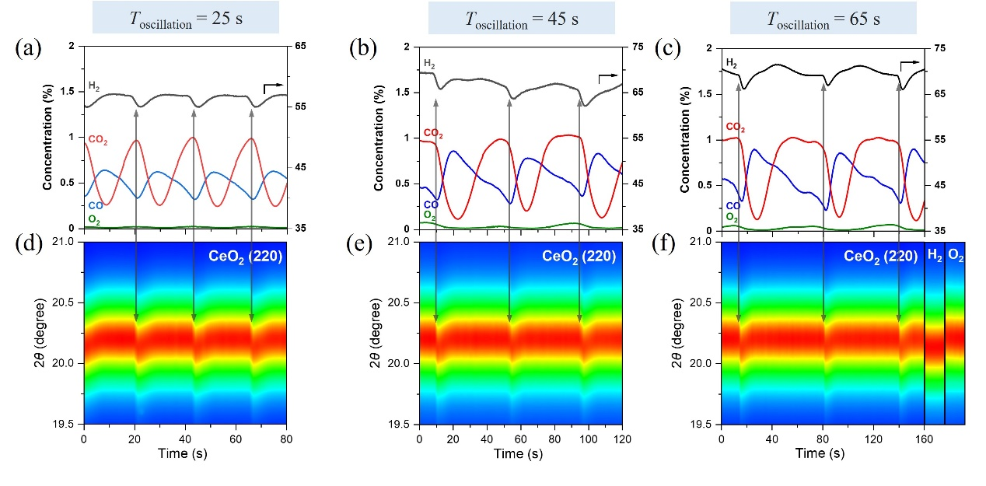
Fig. S28. Synchronized online mass spectrometry signals and corresponding evolution of the CeO₂ (220) diffraction peak, obtained from XRD of the Pt/CeO₂ catalyst under oscillatory conditions with different oscillatory periods: 25 s (a and d), 45 s (b and e), and 65 s (c and f). Reaction conditions: 65 °C; space velocity (SV) = 60,000 mL·g_{cat}⁻¹·h⁻¹; feed gas: CO/O₂/H₂/Ar = 0.7/0.9/60/38.4 for T_{oscillation} = 25 s, 0.7/0.8/70/28.5 for T_{oscillation} = 45 s, and 0.7/0.7/70/28.6 for T_{oscillation} = 65 s.

We employ operando XRD to track lattice changes in CeO₂, which can reflect redox transitions due to the differing ionic radii of Ce⁴⁺ (~0.92 Å) and Ce³⁺ (~1.03 Å)(55). As shown in Fig. S27, clear peak shifts between H₂ and 4% O₂ environments confirm lattice expansion and contraction, respectively. Fig. S28 further shows that the CeO₂ (220) peak oscillates between the two positions during oscillations, indicating that CeO₂ undergoes rapid reduction (~1 s) and slower reoxidation within each cycle. This observation confirms that redox changes extend beyond the Pt–CeO₂ interface to broader CeO₂ surface.

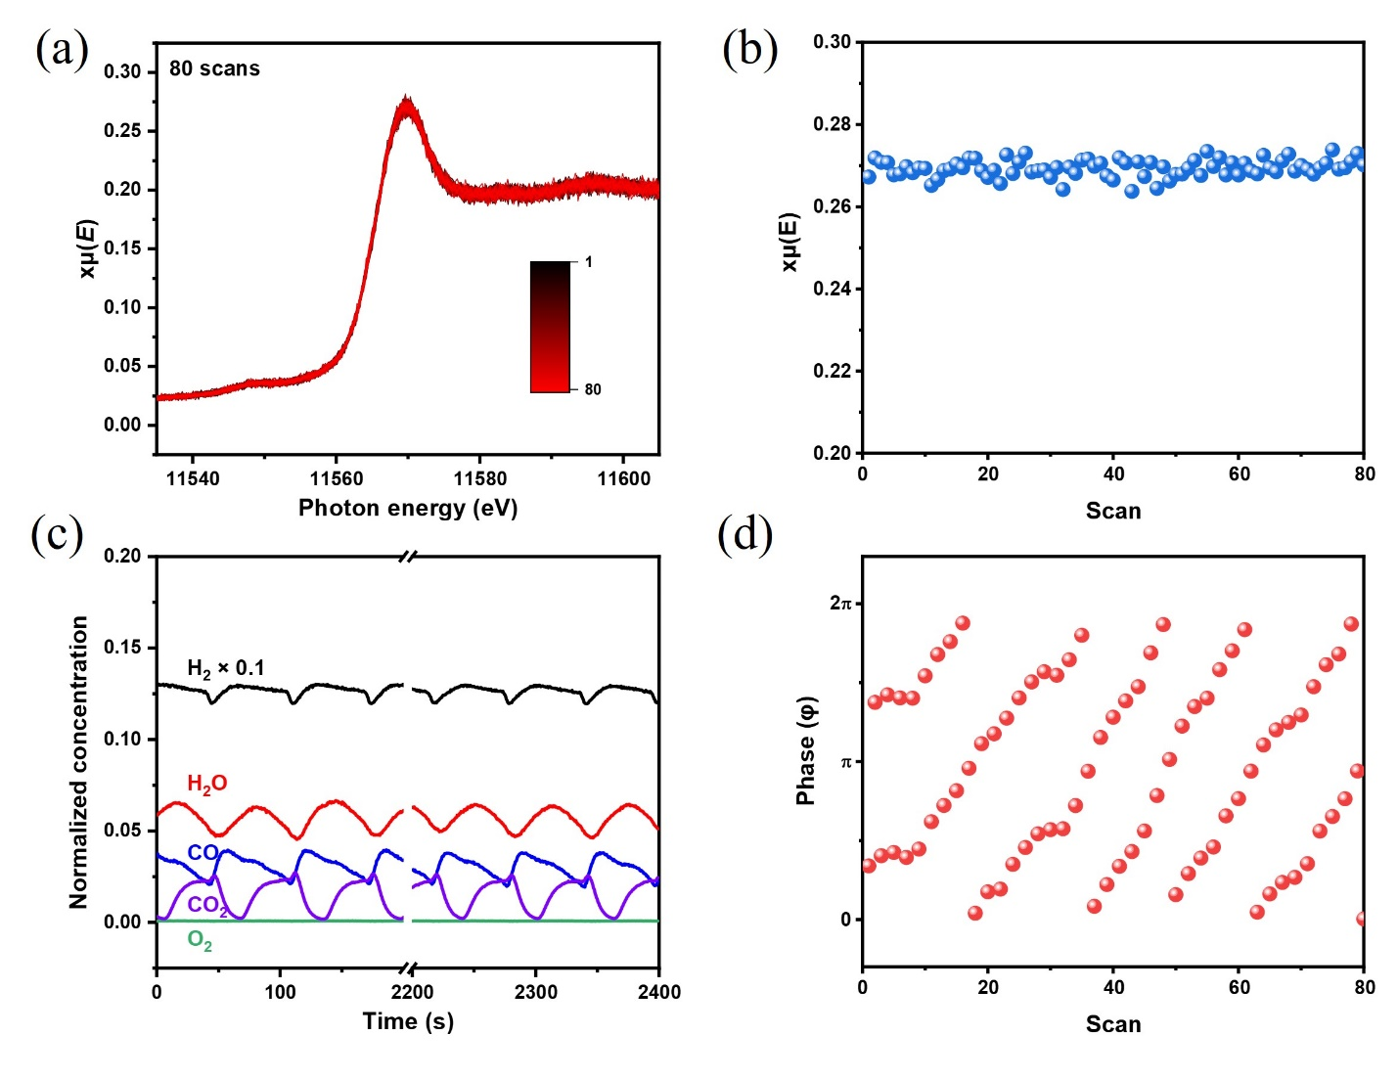
Fig. S29. Operando Pt L₃-edge QXANES experiments during oscillations for 0.5% Pt/CeO₂ catalyst with t_{scan} = 12 s, T_{XANES} = 36 s, and T_{oscillation} = 55 s. (a) QXANES spectra of 80 scans. (b) White line intensity of 80 scans. (c) The MS signals of gas species during the experiment. (d) Phase of oscillation (φ) versus scans.

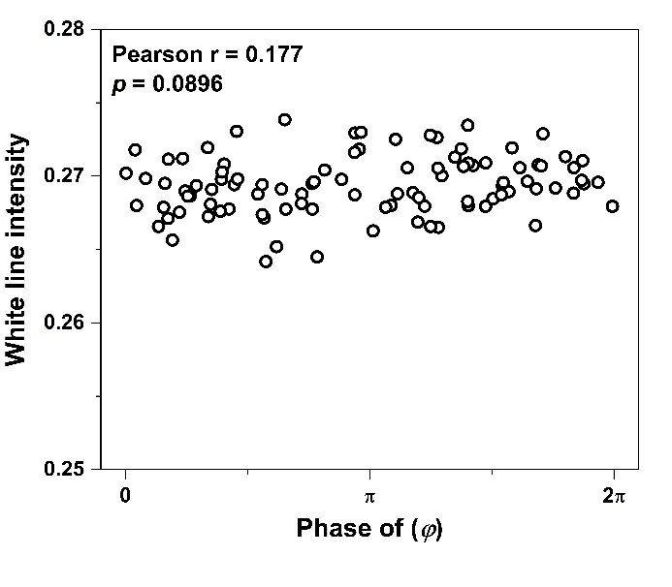
Fig. S30. Statistical plots of the white line intensity in operando Pt L₃-edge QXANES spectrum against phase of oscillation(φ) during oscillation for 0.5% Pt/CeO₂ catalyst with t_{scan} = 12 s, T_{XANES} = 36 s, and T_{oscillation} = 55 s. The Pearson correlation factor is 0.177 and p-value is 0.0896.

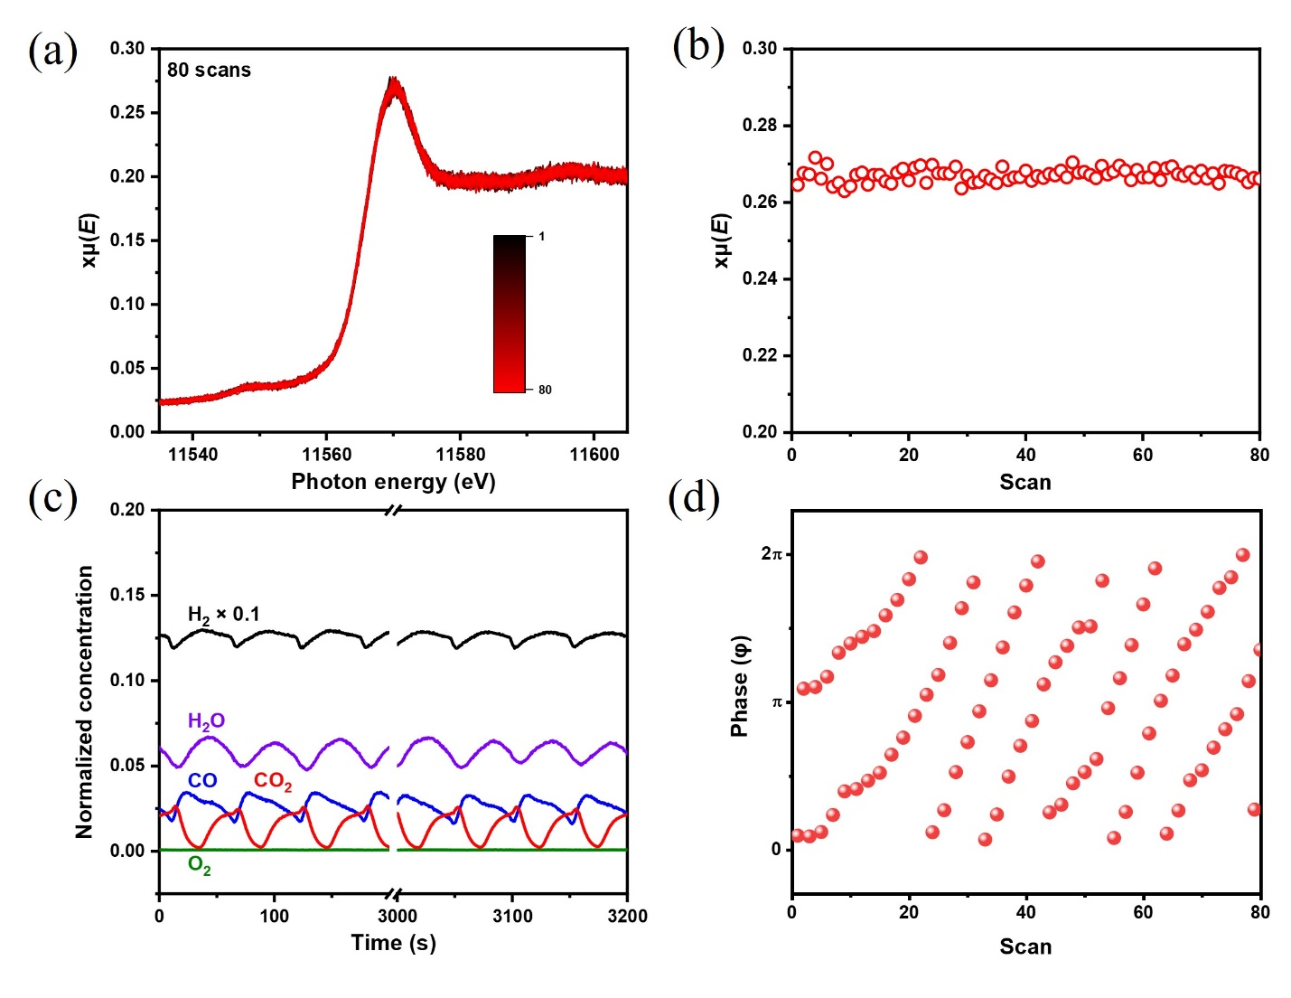
Fig. S31. Operando Pt L₃-edge QXANES experiments during oscillations for 0.5% Pt/CeO₂ catalyst t_{scan} = 20 s, T_{XANES} = 52 s, and T_{oscillation} = 55 s. (a) QXANES spectra of 80 scans. (b) White line intensity of 80 scans. (c) The MS signals of gas species during the experiment. (d) Phase of oscillation (φ) versus scans.

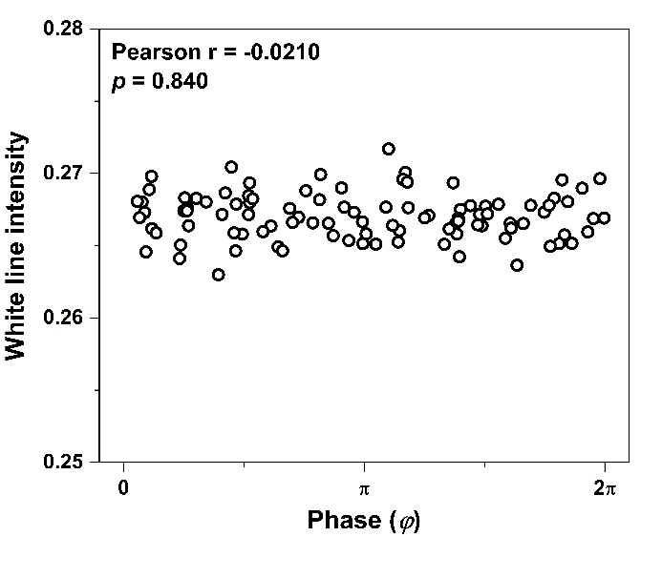
Fig. S32. Statistical plots of the white line intensity in operando Pt L₃-edge QXANES spectrum against phase (φ) during oscillations for 0.5% Pt/CeO₂ catalyst with t_{scan} = 20 s, T_{XANES} = 52 s, and T_{oscillation} = 55 s. The Pearson correlation factor is -0.0210 and p-value is 0.840.

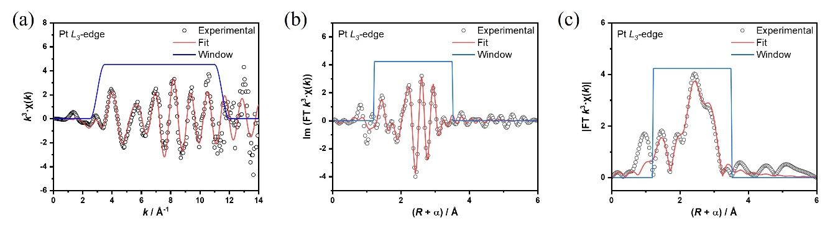
Fig. S33. Curve-fit (red line) of Pt L₃-edge EXAFS (black dot) for 0.5% Pt/CeO₂ during oscillations (in CO+H₂ oxidation feed gas and at the temperature of oscillation) in operando XAS experiment, shown in k-space (a), R-space imaginary part (b), and R-space (c); the blue line shows the fitting window. The data are k³-weighted and without phase correction.

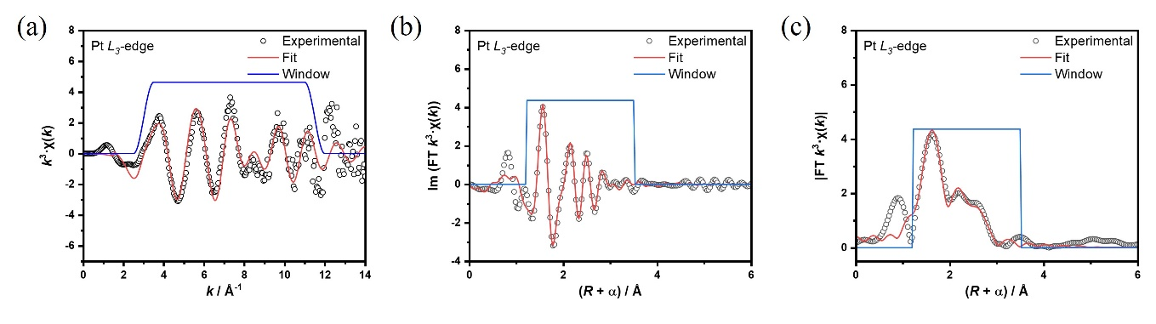
Fig. S34. Curve-fit (red line) of Pt L₃-edge EXAFS (black dot) for 0.5% Pt/CeO₂ in 4% O₂/Ar atmosphere at the temperature of oscillations in operando XAS experiment, shown in k-space (a), R-space imaginary part (b), and R-space (c); the blue line shows the fitting window. The data are k³-weighted and without phase correction.

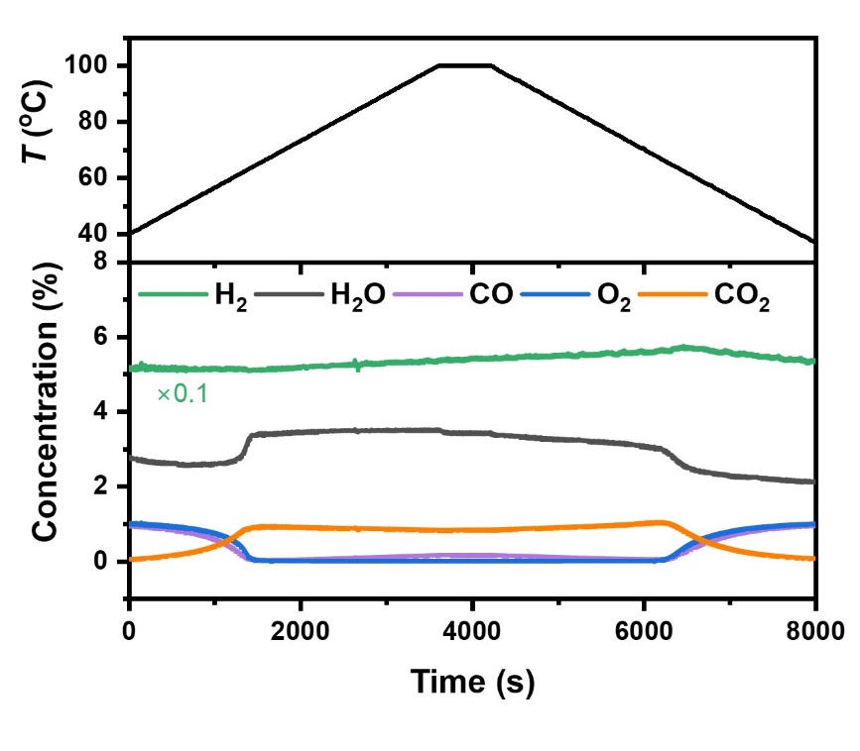
Fig. S35. H₂O co-feed TP experiment of CO+H₂ oxidation over 0.2% Pt/CeO₂. Catalyst weight: 40 mg. Feed gas: 20 mL/min CO/O₂/H₂O/H₂/Ar = 1/1/3/50/45.

Under the H₂O co-feed condition, CO oxidation activity increases steadily with temperature (0–4000 s). After the CO concentration approaches zero, H₂ oxidation increases (at about 1300 s), indicating an increase of free Pt sites. However, no abrupt increase in CO₂ is detected, suggesting that H₂ and free Pt sites (*) have little promotion effect on CO oxidation in the presence of H₂O. Furthermore, no oscillatory behavior occurs under this condition, underscoring the necessity of the promotional effect from H₂ and free Pt sites (*) on the emergence of sustained oscillations.

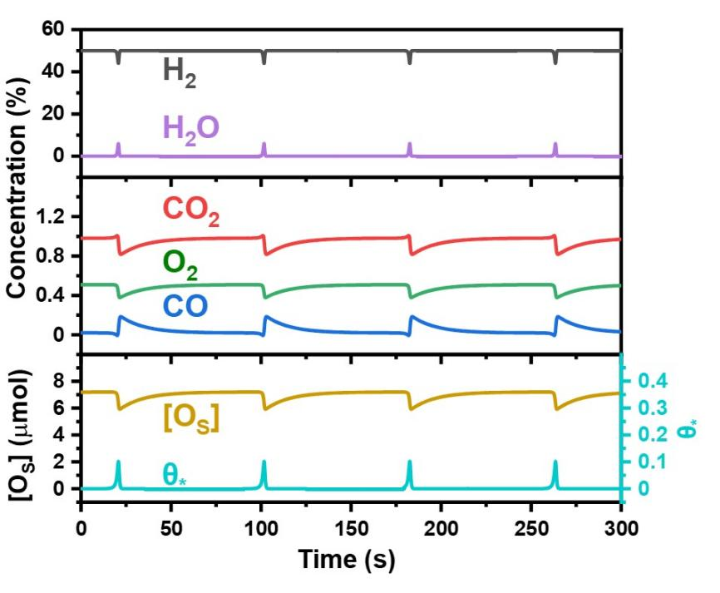
Fig. S36. Simulation results on the evolution of gas species, [O_{S}], and $θ_{*}$. Feed gas (Simulated): 30 mL/min CO/O₂/H₂/Ar = 1/1/50/48. Parameters setting: $a$ = 0.22 $μ$mol/s, c = 12 $μ$mol, $l$ = $0.03 s^{-1}$, $k_{O_{2}}=0.0225 s^{-1}$, $k_{H_{2}}=20 s^{-1}$, $k_{CO}$ =20, $λ=1$, $n_{Pt}$ = 0.2 $μ$mol.

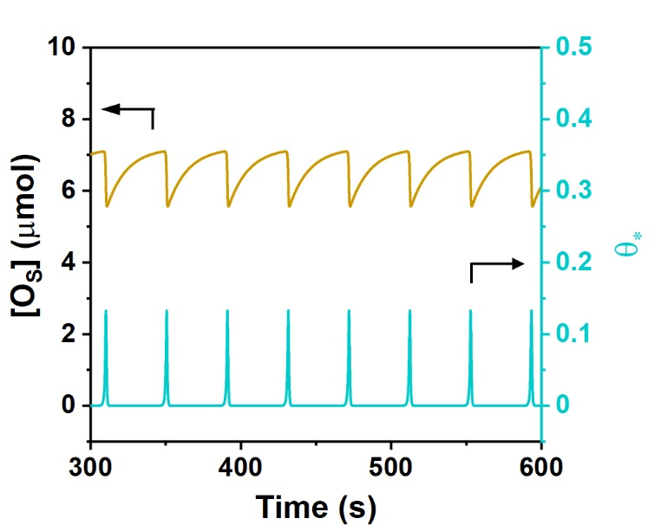
Fig. S37. Simulation result on the evolution of [O_{S}] and $θ_{*}$ based on eq. S13 in SI. Parameters setting: $a$ = 0.22 $μ$mol/s, c = 12 $μ$mol, $l$ = $0.03 s^{-1}$, $k_{O_{2}}=0.0225 s^{-1}$, $k_{H_{2}}=20 s^{-1}$, $k_{CO}$ =20, $λ=2$, $n_{Pt}$ = 0.2 $μ$mol.

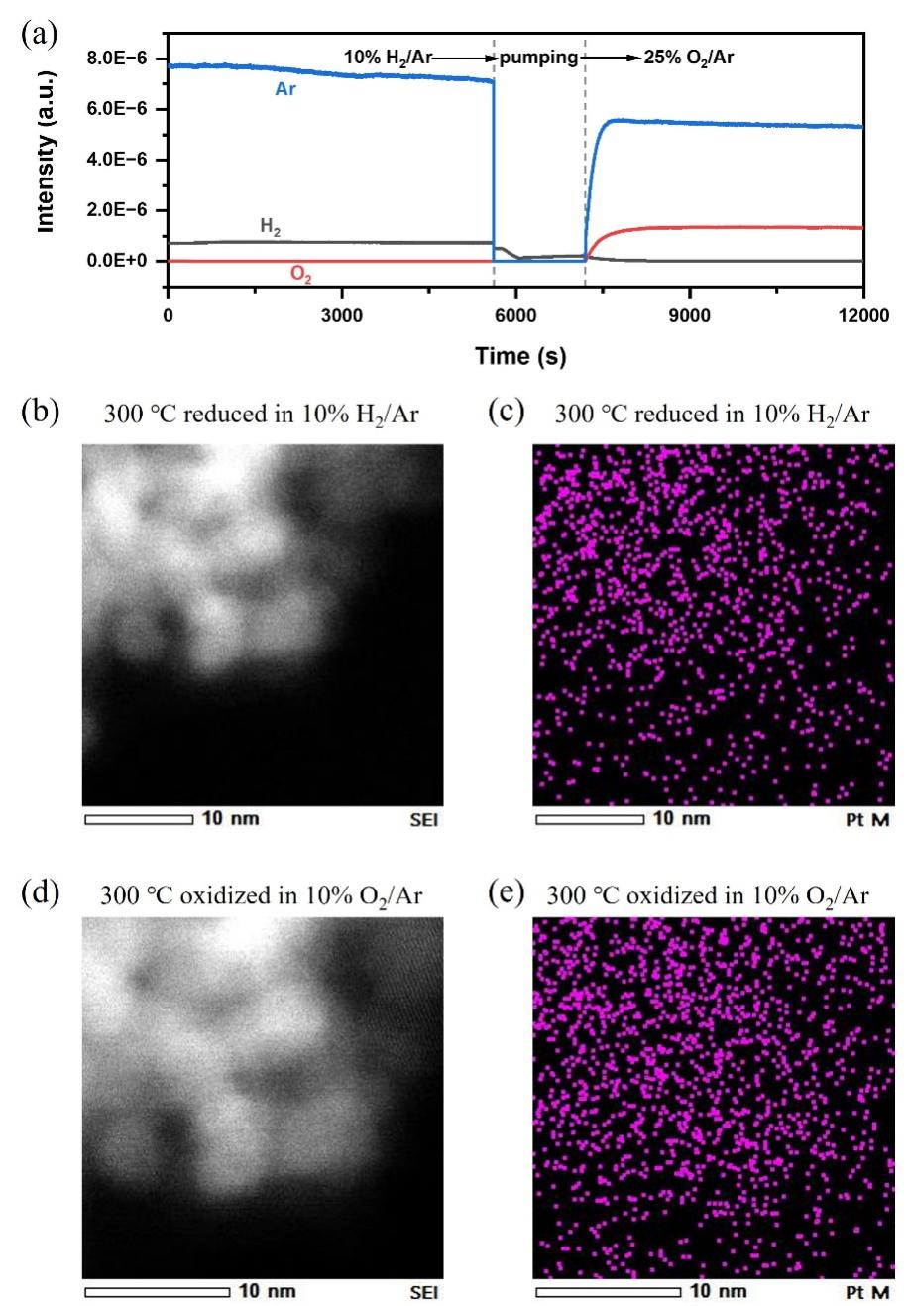
Fig. S38. Sequential HAADF–STEM measurements of 0.05% Pt/CeO₂ with EDS mapping of Pt under H₂ and O₂ atmospheres. (a) Sequential reduction and oxidation of 0.05% Pt/CeO₂ at 300 ℃. Pressure: 300 torr. (b) HAADF–STEM image of 0.05% Pt/CeO₂ in 10% H₂/Ar at 300 ℃. (c) EDS image of Pt in region of (b). (d) HAADF–STEM image of 0.05% Pt/CeO₂ in 10% O₂/Ar at 300 ℃. (e) EDS mapping of Pt in region of (d).

This experiment aimed to determine whether Pt species would re-dispersed or aggregate following reduction in H₂ or oxidation in O₂. As shown in Fig. S38a, the catalyst was first reduced in 10% H₂/Ar at 300 ℃. After the system reached a steady state, we performed HAADF–STEM imaging with EDS mapping to assess the dispersion state of Pt (Fig. S38c). The feed gas was then switched from 10% H₂/Ar to 10% O₂/Ar, and then the Pt dispersion was monitored again (Fig. S38e). Comparison of the Pt dispersion state under these conditions led to the conclusion that Pt species neither redispersed nor aggregated after reduced by H₂ or oxidized by O₂.

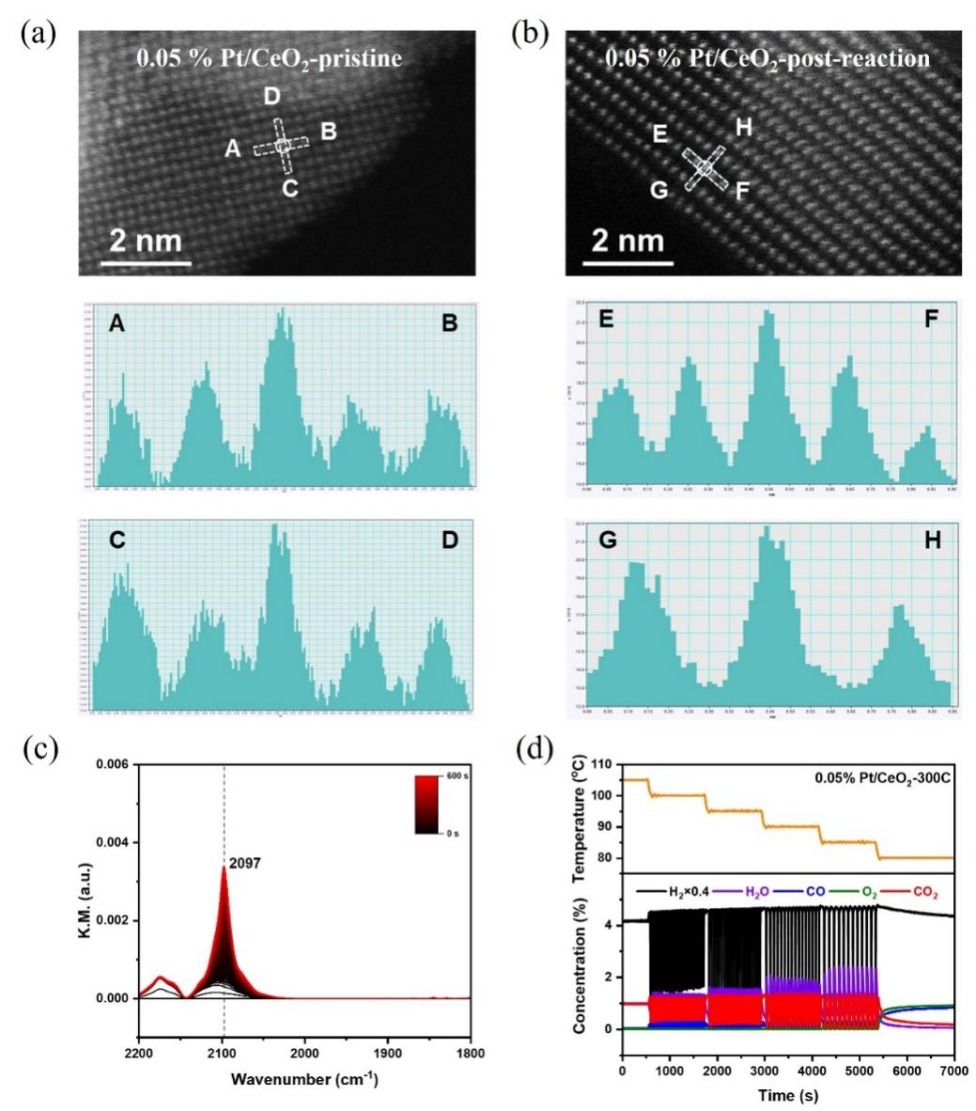
Fig. S39. Characterization and oscillation measurement of 0.05% Pt/CeO₂. (a) AC–HAADF–STEM image and line profiles of pristine 0.05% Pt/CeO₂. (b) AC–HAADF–STEM image and line profiles of post-reaction 0.05% Pt/CeO₂. (c) DRIFTS result of CO adsorption on 0.05 % Pt/CeO₂. (d) Oscillatory behavior of CO+H₂ oxidation over 0.05 % Pt/CeO₂. Reaction condition: 40 mg 0.05 % Pt/CeO₂, 20 mL/min CO/O₂/H₂/Ar=1/1/10/88.
To further confirm the existence form of Pt in the 0.05% Pt/CeO₂ catalyst, we performed Aberration-Corrected High-Angle Annular Dark-Field Scanning Transmission Electron Microscopy (AC–HAADF–STEM) imaging of pristine (Fig. S39a) and post-reaction (Fig. S39b) samples. Line profiles acquired from both catalysts show that intensity of the circled atom is significantly higher than that of adjacent atoms, suggesting the presence of Pt single atoms (Pt₁). Furthermore, DRIFTS result of CO adsorption exhibits only one Pt-CO peak (Fig. S39c), consistent with CO adsorption on Pt₁(35). These results confirm that Pt mainly exists as Pt single atoms. Oscillations were observed on this catalyst (Fig. S39d), indicating that Pt₁ is able to drive the oscillatory behavior.
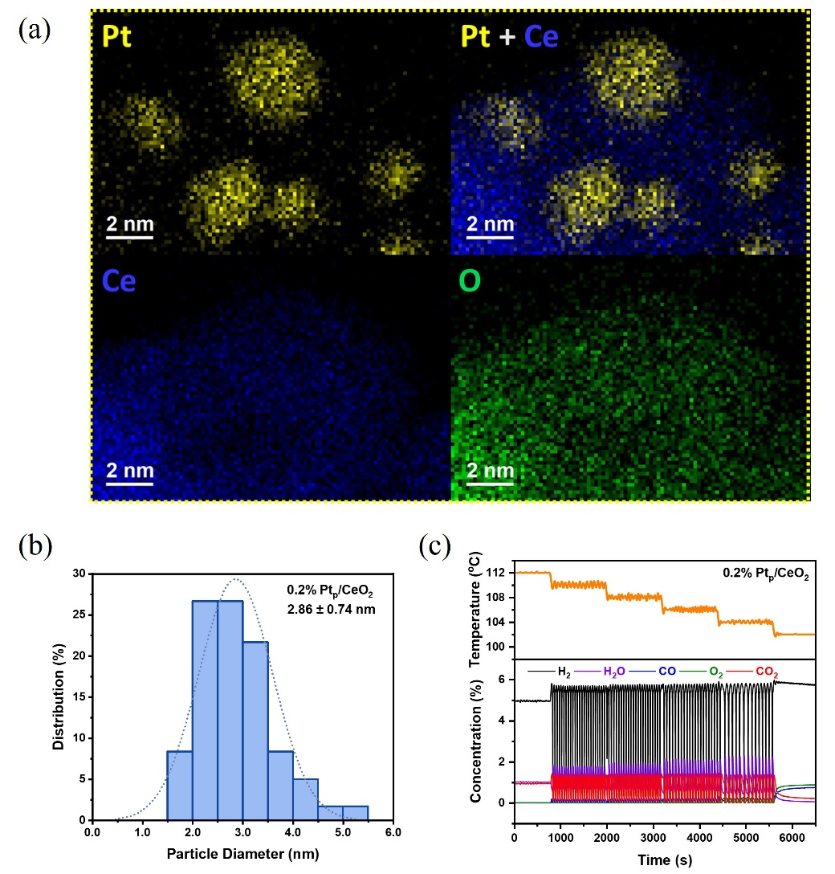
Fig. S40. Characterization and oscillation measurement of 0.2% Pt_{p}/CeO₂. (a) EDS measurement of 0.2% Pt_{p}/CeO₂. (b) Particle size distribution of Pt on 0.2% Pt_{p}/CeO₂. (c) Oscillatory behavior of CO+H₂ oxidation over 0.2% Pt_{p}/CeO₂. Reaction condition: 40 mg 0.2% Pt_{p}/CeO₂, 20 mL/min CO/O₂/H₂/Ar=1/1/5/93.

To determine the Pt particle size in the 0.2% Pt_{p}/CeO₂ catalyst, we conducted EDS mapping of Pt, Ce, and O. As shown in Fig. S40a, Pt mainly exists in the form of Pt nanoparticles (Pt_{p}). Base on analysis of 100 images, we obtain the Pt particle size distribution (Fig. S40b), which reveals the average particle size of 2.86 $±$ 0.74 nm. Similar to the Pt₁, Pt_{p} is also able to drive the oscillatory behavior.

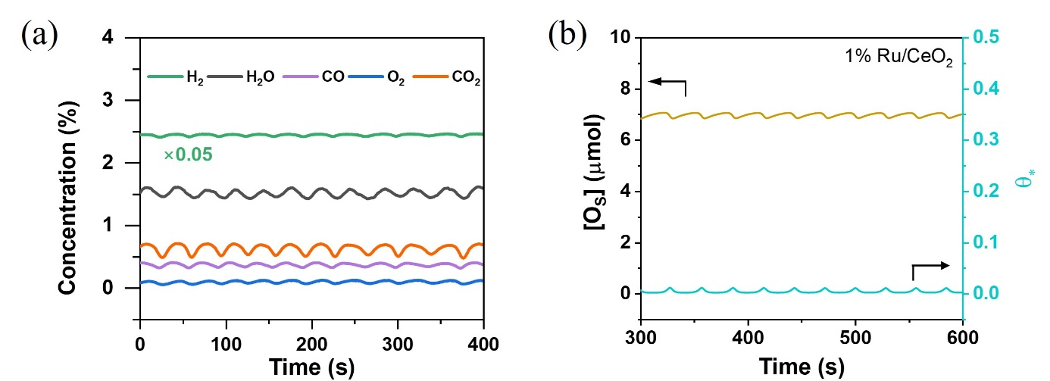
Fig. S41. Oscillations of CO+H₂ oxidation on 1% Ru/CeO₂. (a) Experimental results of CO+H₂ oxidation’s oscillations on 1% Ru/CeO₂ at 101 ℃. Feed gas: 30 ml/min CO/O₂/H₂/Ar=1/1/50/48. (b) Simulation results on the evolution of [O_{S}] and $θ_{*}$ using parameters corresponding to 1% Ru/CeO₂ labelled in Fig. 5c. Parameters setting: $a$ = 0.22 $μ$mol/s, c = 12 $μ$mol, $l$ = $0.03 s^{-1}$, $k_{O_{2}}=0.0225 s^{-1}$, $k_{H_{2}}=100 s^{-1}$, $k_{CO}$ =20, $λ=1$, $n_{Pt}$ = 0.2 $μ$mol.

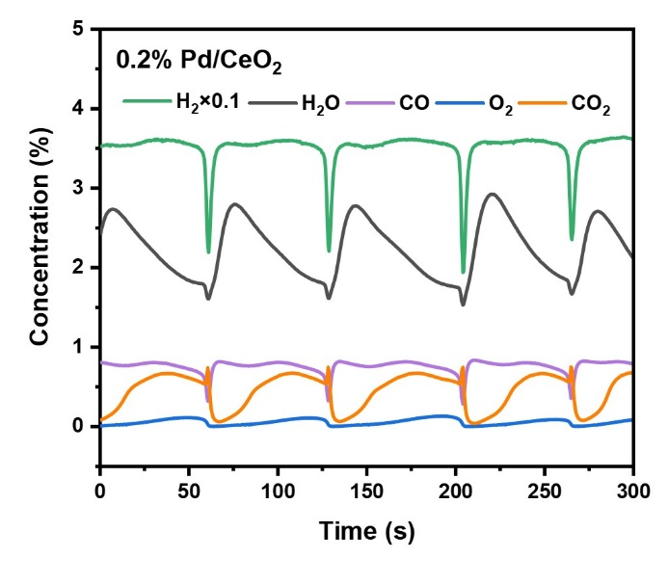
Fig. S42. Oscillations of CO+H₂ oxidation on 0.2% Pd/CeO₂. Reaction condition: 40 mg 0.2% Pd/CeO₂, 58 ℃, and 28 mL/min CO/O₂/H₂/Ar=1.3/1.3/35.7/61.7.

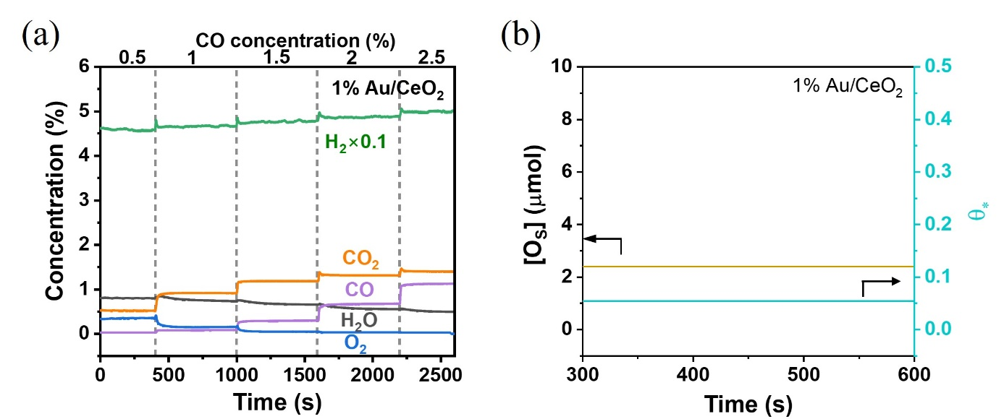
Fig. S43. (a) CO+H₂ oxidation performance on 1% Au/CeO₂. Reaction condition: 40 mg 1% Au/CeO₂, 30 ℃, and 20 mL/min CO/O₂/H₂/Ar=x/1/50/(49-x). (b) Simulation results on the evolution of [O_{S}] and $θ_{*}$ using parameters corresponding to 1% Au/CeO₂ labelled in Fig. 5c. Parameters setting: $a$ = 0.22 $μ$mol/s, c = 12 $μ$mol, $l$ = $0.03 s^{-1}$, $k_{O_{2}}=0.0225 s^{-1}$, $k_{H_{2}}=50 s^{-1}$, $k_{CO}$ =0.5, $λ=1$, $n_{Pt}$ = 0.2 $μ$mol.

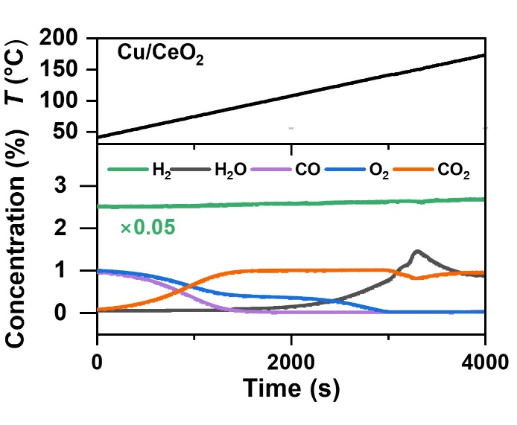
Fig. S44. TP experiment of CO+H₂ oxidation over 5% Cu/CeO₂. Catalyst weight: 40 mg. Feed gas: 20 mL/min CO/O₂/H₂/Ar = 1/1/50/48.

Due to the low H₂ activation ability, H₂ oxidation rate is very low on 5% Cu/CeO₂. After CO is nearly depleted (in the regions of 1500–3000 s), H₂ is still unable to deplete gas-phase O₂. Therefore, the competitive oxidation between CO and H₂ is weak and no oscillation is observed.

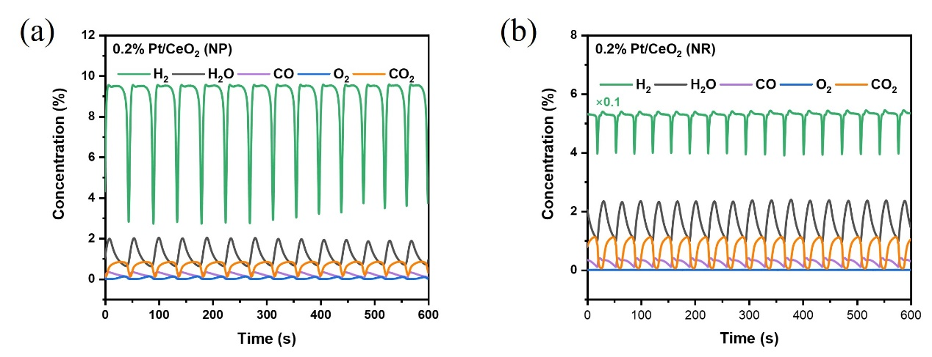
Fig. S45. Oscillations of CO+H₂ oxidation over 0.2% Pt/CeO₂ (NP, a) and 0.2% Pt/CeO₂ (NR, b). (a) Reaction condition: 40 mg 0.2% Pt/CeO₂ (NP), 52 ℃, 20 mL/min CO/O₂/H₂/Ar=1/1/10/88. (b) Reaction condition: 40 mg 0.2% Pt/CeO₂ (NR), 60 ℃, 30 mL/min CO/O₂/H₂/Ar=1/1/50/48.

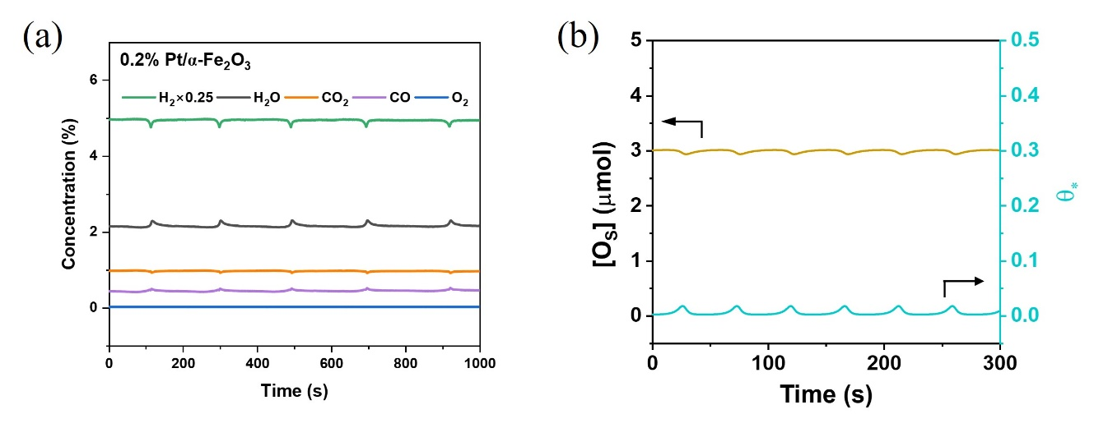
Fig. S46. Oscillations of CO+H₂ oxidation on 0.2% Pt/$α$-Fe₂O₃. (a) Experimental results of CO+H₂ oxidation’s oscillations on 0.2% Pt/$α$-Fe₂O₃. Reaction condition: 50 mg 0.2% Pt/$α$-Fe₂O₃, 67 ℃, and 50 mL/min CO/O₂/H₂/Ar=1.4/2/20/76.6. (b) Simulation results on the evolution of [O_{S}] and $θ_{*}$ using parameters corresponding to 0.2% Pt/$α$-Fe₂O₃ labelled in Fig. 5e. Parameters setting: $a$ = 0.22 $μ$mol/s, c = 7.8 $μ$mol, $l$ = $0.07 s^{-1}$, $k_{O_{2}}=0.0225 s^{-1}$, $k_{H_{2}}=20 s^{-1}$, $k_{CO}$ =20, $λ=1$, $n_{Pt}$ = 0.2 $μ$mol.

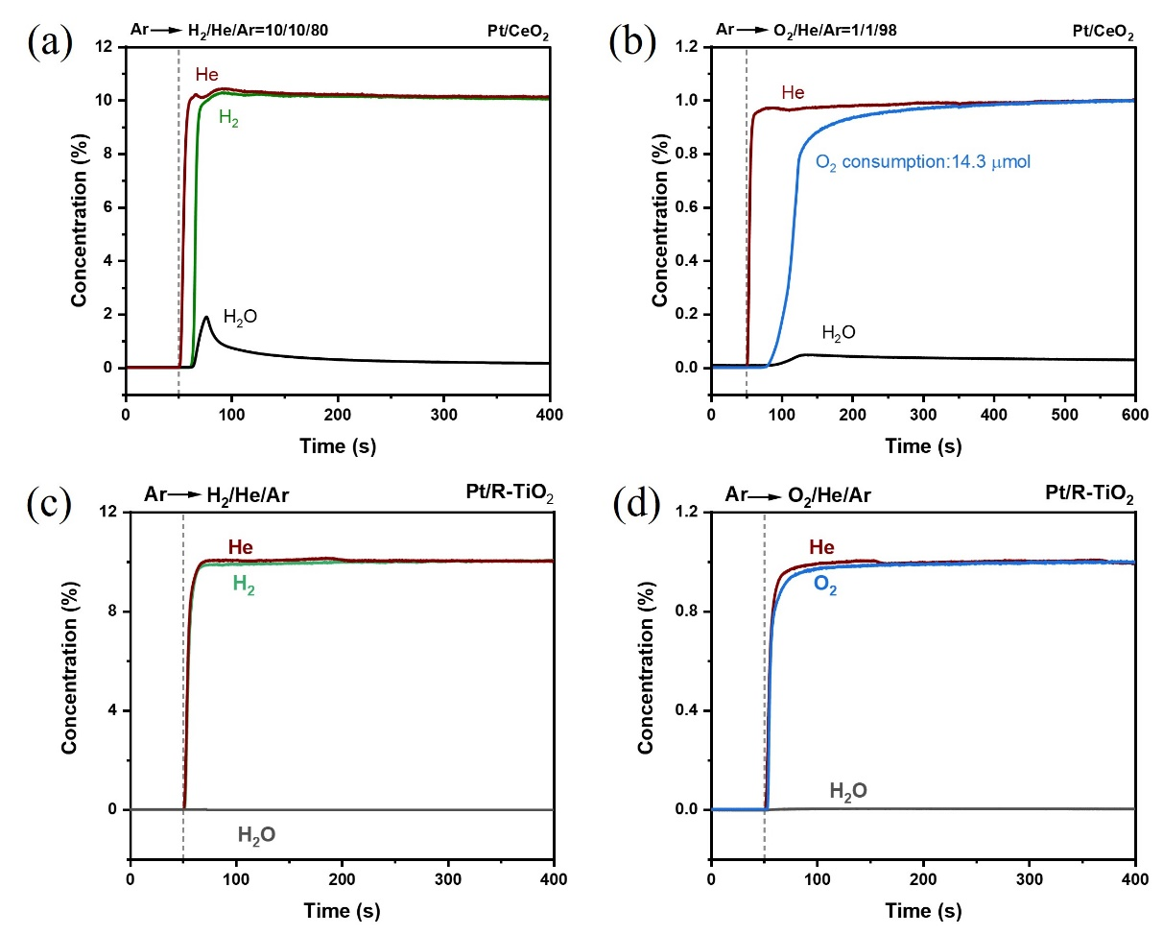
Fig. S47. Sequential reduction and oxidation of 0.2% Pt/CeO₂ (a and b) and 0.2% Pt/R-TiO₂ (c and d). (a and b) Conditions: 40 mg 0.2% Pt/CeO₂, 60 ℃. (c and d) Conditions: 40 mg 0.2% Pt/R-TiO₂, 200 ℃. Process: 30 mL/min Ar → 30 mL/min H₂/He/Ar=10/10/80 (a and c) → 30 mL/min Ar → 30 mL/min O₂/He/Ar=1/1/98 (b and d).

To compare the surface oxygen activity between 0.2% Pt/CeO₂ and 0.2% Pt/R-TiO₂, sequential reduction and oxidation experiments were conducted. As shown in Fig. S47, large amount of H₂ and O₂ were consumed during this process at 60 ℃. But for 0.2% Pt/R-TiO₂, the consumption of H₂ and O₂ were limited at even 200 ℃, with no significant production of H₂O detected. Therefore, both the activity and number of surface reactive oxygen of the 0.2% Pt/R-TiO₂ catalyst are obviously lower than that of 0.2% Pt/CeO₂.

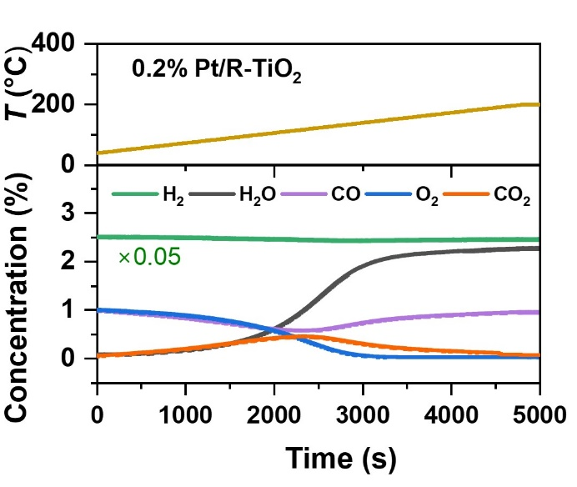
Fig. S48. TP experiment of CO+H₂ oxidation over 0.2% Pt/TiO₂. Catalyst weight: 40 mg. Feed gas: 20 mL/min CO/O₂/H₂/Ar = 1/1/50/48.

Table S1. Curve-fit Parameters ª for Pt L₃-edge EXAFS of 0.2–1% Pt/CeO₂ and 0.2% Pt/SiO₂.
Catalyst |  | Path | d (Å)^{b} | C. N.^{c} | ΔE0 (eV) | σ₂ (Å²)^{d} | R-factor
0.2% Pt/CeO₂ | Pt-O |  | 1.97 ± 0.01 | 1.5 ± 0.3 | 4 ± 1 | 0.005 ± 0.003 | 0.011
0.2% Pt/CeO₂ | Pt-Pt |  | 2.70 ± 0.01 | 6.7 ± 0.9 | 4 ± 1 | 0.009 ± 0.001 | 0.011
0.5% Pt/CeO₂e | Pt-O |  | 1.91 ± 0.03 | 0.6 ± 0.3 | 4 ± 1 | 0.008 ± 0.004 | 0.011
0.5% Pt/CeO₂e | Pt-Pt |  | 2.75 ± 0.01 | 7.3 ± 0.8 | 4 ± 1 | 0.008 ± 0.001 | 0.011
1% Pt/CeO₂ | Pt-O |  | 1.95 ± 0.01 | 1.3 ± 0.3 | 3 ± 1 | 0.009 ± 0.003 | 0.011
1% Pt/CeO₂ | Pt-Pt |  | 2.66 ± 0.01 | 5.7 ± 0.7 | 3 ± 1 | 0.010 ± 0.001 | 0.011
0.2% Pt/SiO₂ | Pt-O |  | - | - | 7 ± 1 | - | 0.009
0.2% Pt/SiO₂ | Pt-Pt |  | 2.75 ± 0.01 | 10.3 ± 0.9 | 7 ± 1 | 0.004 ± 0.001 | 0.009
a: The data ranges used in these fittings are 3.0 ≤ k ≤ 11.0 Å⁻¹ and 1.2 ≤ R ≤ 3.5 Å. S₀² is fixed at 0.728, obtained from the Pt foil measured at the same time. The number of variable parameters in each fitting is out of total independent data point.
b: The coordination distance. The distances for Pt-O and Pt-Pt are from the crystal structure of PtO₂ (P6₃mc, ICSD collection code 24923) and Pt (Fm-3m, ICSD collection code 180981).
c: Average coordination number.
d: Debye–Waller factor.
e: The data and fitting parameters of 0.5% Pt/CeO₂ are same as that in Table 2, H₂.

Table S2. Curve-fit parameters ª for Pt L₃-edge operando EXAFS of 0.5% Pt/CeO₂.
Atmosphere | Path | d (Å) ^{b} | C. N. ^{c} | ΔE₀ (eV) | σ² (Å²) ^{d} | R-factor
Oscillation | Pt-O | 1.87 ± 0.02 | 1.1 ± 0.5 | 8 ± 1 | 0.010 ± 0.007 | 0.016
Oscillation | Pt-Pt | 2.76 ± 0.01 | 7.6 ± 1.0 | 8 ± 1 | 0.009 ± 0.001 | 0.016
O₂ | Pt-O | 2.00 ± 0.02 | 3.0 ± 0.5 | 9 ± 2 | 0.007 ± 0.002 | 0.015
O₂ | Pt-Pt | 2.74 ± 0.04 | 3.5 ± 1.3 | 9 ± 2 | 0.009 ± 0.003 | 0.015
H₂ | Pt-O | 1.91 ± 0.03 | 0.6 ± 0.2 | 4 ± 1 | 0.008 ± 0.004 | 0.011
H₂ | Pt-Pt | 2.75 ± 0.01 | 7.3 ± 0.8 | 4 ± 1 | 0.008 ± 0.001 | 0.011
a: The data ranges used in these fittings are 3.0 ≤ k ≤ 13.0 Å⁻¹ and 1.2 ≤ R ≤ 3.5 Å. S₀² is fixed at 0.768, obtained from the Pt foil measured at the same time. The number of variable parameters in each fitting is out of a total of 11.2 independent data points.
b: The coordination distance. The distances for Pt-O and Pt-Pt are from the crystal structure of PtO₂ (Pnmn, ICSD collection code 4415), PtO₂ (P6₃mc, ICSD collection code 24923) and Pt (Fm-3m, ICSD collection code 180981).
c: Average coordination number.
d: Debye–Waller factor.

Strictly speaking, this limit cycle exists only in a local neighborhood of Tr(J) > 0. However, oscillations persist as long as Tr(J) > 0 according to experimental results. Thus, for the remainder of this work, including the next section, we will relax this mathematical rigor to facilitate the chemical analysis without affecting the chemical result.

