Supplementary Information
Incorporation of potent and selective Cytochrome P450 inhibitors into Ru(II) scaffolds provides unprecedented control over enzyme activity with light

Dmytro Havrylyuk, Austin Hachey, Alexander Fenton, David K. Heidary,* and Edith C. Glazer*

Department of Chemistry, University of Kentucky, 505 Rose Street, Lexington, Kentucky 40506, United States

Supplementary Methods
Synthesis

4-(2,4-dimethoxystyryl)-pyrimidine (2). To a 38 mL pressure tube, 4-methylpyrimidine (0.3 g, 3.2 mmol) and 2,4-dimethoxy-benzaldehyde (3.5 mmol) were added, with 10 mL of methanol in aqueous sodium hydroxide (1.0 g in 5 mL of water). The mixture was stirred at 110°C for 2 hours, and then allowed to cool to room temperature. The yellow precipitate was filtered off, and washed with water and hexane. The purification of the solid was performed using flash chromatography (SiO₂, CH₃CN) to give the pure compound. Yield: 463 mg (60%). ¹H NMR (400 MHz, CDCl₃): δ 9.12 (s, 1H), 8.60 (d, J = 5.4 Hz, 1H), 8.13 (d, J = 16.2 Hz, 1H), 7.56 (d, J = 8.6 Hz, 1H), 7.32 (dd, J = 5.4, 1.2 Hz, 1H), 7.05 (d, J = 16.1 Hz, 1H), 6.54 (dd, J = 8.6, 2.4 Hz, 1H), 6.48 (d, J = 2.4 Hz, 1H), 3.90 (s, 3H), 3.85 (s, 3H). 1H NMR (400 MHz, CD₃OD): δ 8.99 (s, 1H), 8.61 (d, J = 5.4 Hz, 1H), 8.16 (d, J = 16.2 Hz, 1H), 7.61 (d, J = 9.2 Hz, 1H), 7.51 (d, J = 5.4 Hz, 1H), 7.10 (d, J = 16.2 Hz, 1H), 6.59-6.60 (m, 2H), 3.93 (s, 3H), 3.86 (s, 3H); 13C NMR (DMSO-D6): δ 162.29, 161.92, 158.97, 158.37, 157.41, 131.36, 128.92, 123.14, 118.77, 116.71, 106.02, 98.37, 55.64, 55.37. HRMS calcd for C₁₄H₁₄N₂O₂ [M] 242.1055, found 243.1128 [MH]⁺.

4-(2,4-dimethoxystyryl)-pyridine (3). To a 25 mL round bottom flask 2,4-dimethoxybenzaldehyde (0.35 g, 2.2 mmol), 4-picoline (2.2 mmol), and potassium tert-butoxide (0.49 g, 4.4 mmol) were added, and dissolved in 10 mL of DMF. The reaction mixture was stirred at room temperature for 15 hours. It was then dried under vacuum and dissolved in 50 mL of water. The product was isolated by extraction into dichloromethane (100 mL) and the solvent was removed under reduced pressure. Purification of the solid was performed using flash chromatography (SiO₂, CH₃CN) to give the pure compound. Yield: 300 mg (69%). ¹H NMR (400 MHz, CDCl₃): δ 8.50 (d, J = 4.6 Hz, 2H), 7.57 (d, J = 16.2 Hz, 1H), 7.49 (d, J = 8.6 Hz, 1H), 7.32 (d, J = 4.6 Hz, 2H), 6.90 (d, J = 16.2 Hz, 1H), 6.50 (d, J = 8.8 Hz, 1H), 6.45 (s, 1H), 3.85 (s, 3H), 3.82 (s, 3H). ¹³C NMR (CDCl₃): δ 161.52, 158.63, 150.12, 145.75, 128.08, 127.98, 124.08, 120.77, 118.35, 105.23, 98.51, 55.61, 55.54. HRMS calcd for C₁₅H₁₅NO₂ [M] 241.1103, found 242.1174 [MH]⁺

[Ru(tpy)(biq)(2)]²⁺ (4). [Ru(tpy)(biq)Cl]PF₆ (50 mg, 0.065 mmol) and 5-fold excess of 2 (78 mg, 0.325 mmol) were added to 6 mL of degassed EtOH : H₂O (5:1) in a pressure tube. The mixture was then stirred at 80 °C for 2 hours, before the reaction was stopped and the mixture transferred into 50 ml of H₂O. Addition of a saturated aqueous KPF₆ solution (ca. 1 mL) produced a red precipitate that was collected by vacuum filtration and washed with ether. Purification of the solid was performed using flash chromatography (SiO₂, 0.2% saturated KNO₃, 2% water in CH₃CN, ramped to 10% H₂O) to give the pure complex. After column purification, the NO₃⁻ salt was dissolved in minimal water and converted to the PF₆⁻ salt upon the addition of a saturated solution of KPF₆. The precipitate was isolated by extraction into dichloromethane and the solvent was removed under reduced pressure. Yield: 30 mg (41%). Purity by HPLC = 92 % (this compound suffers from low thermal stability). ¹H NMR (400 MHz, (CD₃)₂CO): δ 9.28 (d, J = 8.8 Hz, 1H), 9.16 (d, J = 8.8 Hz, 1H), 9.03 (d, J = 8.8 Hz, 1H), 8.37-8.98 (m, 9H), 8.07-8.20 (m, 4H), 7.96-7.99 (m, 2H), 7.83 (t, J = 7.7 Hz, 1H), 7.74 (d, J = 8.8, 1H), 7.51-7.61 (m, 5H), 7.40 (t, J = 8.7 Hz, 1H), 7.10 (d, J = 6.4 Hz, 1H), 6.93-6.99 (m, 2H), 6.53-6.58 (m, 2H), 3.87 (s, 3H), 3.83 (s, 3H). HRMS calcd for C₄₇H₃₇N₇O₇Ru [M]²⁺ 416.6026; found 416.6023 [M]²⁺; UV/Vis (CH₃CN): λ_{max} (ε × 10-3) 535 nm (10.9).

[Ru(tpy)(bca)(2)] (5). [Ru(tpy)(bca)Cl]PF₆ (100 mg, 0.12 mmol) and a 5-fold excess of 2 (0.6 mmol) were added to 10 mL of degassed EtOH : H₂O (4:1) in a pressure tube. The mixture was stirred at 80°C for 15 hours. The reaction mixture then cooled to room temperature and solvents removed under reduced pressure. The purification of the solid was carried out by flash chromatography (SiO₂, 2% water in MeOH, ramped to 20% H₂O) to give the pure complex. The product fractions were concentrated under reduced pressure. Yield: 58 mg (40%). Purity by HPLC = 97 %. ¹H NMR (400 MHz, CD3OD): δ 9.16 (s, 1H), 8.90 (s, 1H), 8.55-8.85 (m, 5H), 8.37 (t, J = 8.0 Hz, 1H), 8.29 (d, J = 8.4 Hz, 1H), 8.01-8.15 (m, 6 H), 7.74 (t, J = 6.8 Hz, 1H), 7.65 (t, J = 6.4 Hz, 1H), 7.39-7.56 (m, 6H), 7.23 (t, J = 6.8 Hz, 1H), 7.03 (d, J = 6.2 Hz, 1H), 6.90 (d, J = 16.0 Hz, 1H), 6.76 (d, J = 8.8 Hz, 1H), 6.51-6.54 (m, 2H), 3.83 (s, 3H), 3.82 (s, 3H); ¹³C NMR (100 MHz, MeOD) δ 171.72, 170.86, 164.43, 163.57, 160.18, 160.10, 159.26, 158.72, 158.40, 156.70, 151.26, 150.37, 149.91, 149.49, 138.88, 136.89, 136.61, 130.91, 130.65, 129.84, 128.72, 128.68, 128.17, 126.80, 126.49, 125.33, 123.09, 120.28, 118.67, 118.07, 116.54, 105.87, 97.71, 54.71, 54.60. HRMS calcd for C₄₉H₃₇N₇O₆Ru [M]²⁺ 460.5925; found 460.5926 [M]²⁺; UV/Vis (H₂O): λ_{max} (ε × 10-3) 540 nm (6.3).

[Ru(tpy)(bca)(3)] (6). [Ru(tpy)(bca)Cl]PF₆ (35 mg, 0.042 mmol) and 5-fold excess of 3 (50 mg, 0.21 mmol) were added to 10 mL of degassed EtOH : H₂O (4:1) in a pressure tube. The mixture was stirred at 80°C for 15 hours. The reaction mixture then cooled to room temperature and solvents removed under reduced pressure. The purification of the solid was carried out by flash chromatography (SiO₂, 2% water in MeOH, ramped to 20% H₂O) to give the pure complex. The product fractions were concentrated under reduced pressure and precipitated in 100 mL of acetone : ether (1:9) to produce a purple precipitate that was collected by vacuum filtration and washed with ether. Yield: 21 mg (54%). Purity by HPLC = 99.5 %. ¹H NMR (400 MHz, CD₃OD): δ 9.17 (s, 1H), 8.91 (s, 1H), 8.80 (d, J = 8.6 Hz, 2H), 8.76 (d, J = 8.4 Hz, 1H), 8.62 (d, J = 8.0 Hz, 2H), 8.35 (t, J = 8.0 Hz, 1H), 8.28 (d, J = 8.4 Hz, 1H), 8.07-8.14 (m, 4 H), 7.71 (t, J = 8.0 Hz, 1H), 7.41-7.55 (m, 8H), 7.29 (t, J = 8.0 Hz, 1H), 7.21 (t, J = 8.0 Hz, 1H), 7.08 (d, J = 6.2 Hz, 2H), 6.84 (d, J = 16.4 Hz, 1H), 6.76 (d, J = 8.8 Hz, 1H), 6.45-6.50 (m, 2H), 3.82 (s, 3H), 3.80 (s, 3H); ¹³C NMR (100 MHz, CD₃OD) δ 171.78, 170.94, 162.61, 160.04, 159.26, 159.13, 158.42, 158.32, 153.11, 151.28, 150.46, 150.15, 150.08, 149.28, 148.61, 138.70, 136.59, 131.69, 130.59, 130.50, 128.68, 128.59, 128.46, 128.13, 126.73, 126.41, 125.29, 124.64, 123.84, 123.24, 121.92, 120.76, 118.09, 117.01, 105.51, 97.69, 54.64, 54.51. HRMS calcd for C₅₀H₃₈N₆O₆Ru [M]²⁺ 460.0948; found 460.0958 [M]²⁺; UV/Vis (H₂O): λ_{max} (ε × 10-3) 550 nm (6.6).

Supplementary Figures

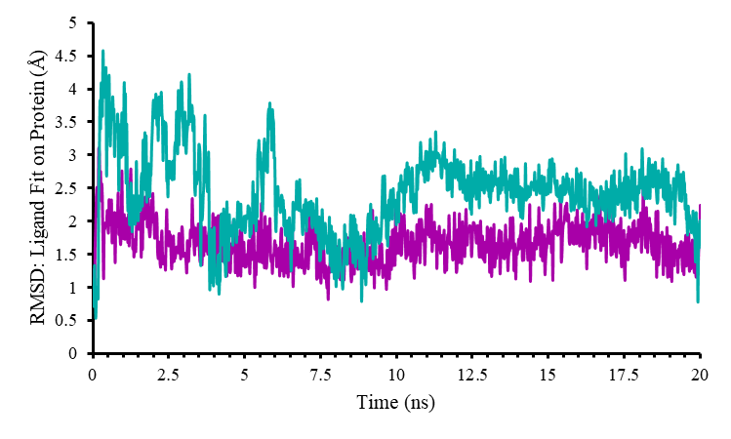

Supplementary Figure S1. RMSD of bound ligand in CYP1B1 for compound 2 (cyan) and 3 (magenta) over 20 ns molecular dynamics trajectory.

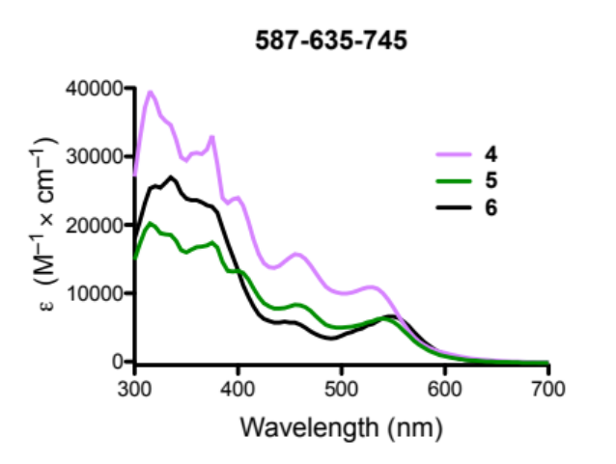
Supplementary Figure S2. Absorption spectra of 4-6 in di H₂O.
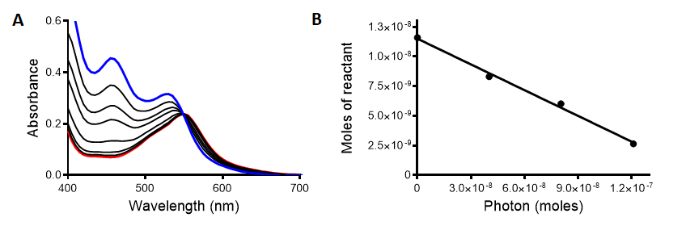
Supplementary Figure S3. Photoejection of 4 (50 µM, in di H₂O) for 0–3 min irradiation. (A) Time course from 0 (blue) to 3 (red) min, followed by UV/vis absorption. (B) Liner regression for moles of reactant vs. moles of photons absorbed for complex 4. The light source was a 470 nm LED array (Elixa).
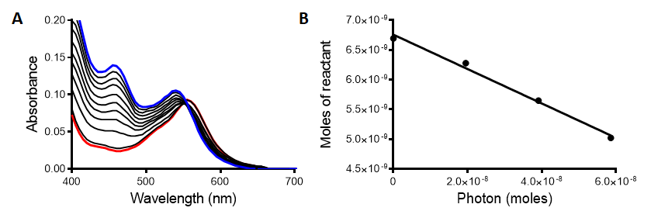
Supplementary Figure S4. Photoejection of 5 (30 µM, in di H₂O) for 0–10 min irradiation. (A) Time course from 0 (blue) to 10 (red) min, followed by UV/vis absorption. (B) Liner regression for moles of reactant vs. moles of photons absorbed for complex 5. The light source was a 470 nm LED array (Elixa).
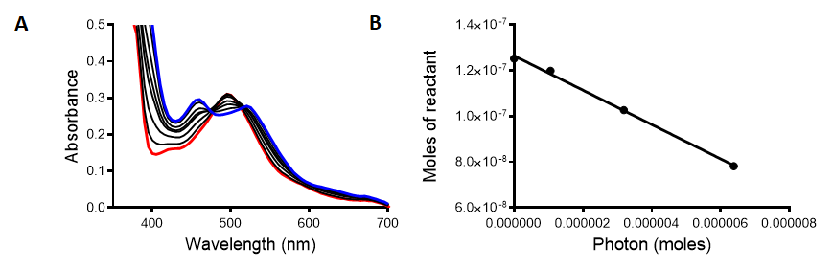
Supplementary Figure S5. Photoejection of 6 (40 µM, in MeCN) for 0–10 min irradiation. (A) Time course from 0 (blue) to 10 (red) min, followed by UV/vis absorption. (B) Liner regression for moles of reactant vs. moles of photons absorbed for complex 6. The light source was a 470 nm LED array (Elixa).
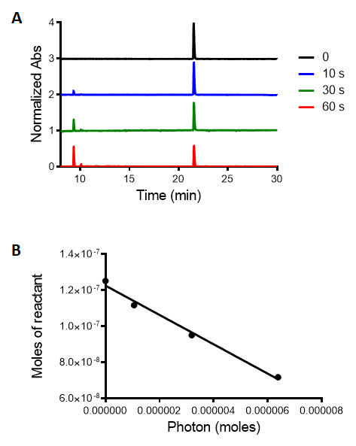
Supplementary Figure S6. Photoejection of 6 (40 µM, in MeCN) for 0–60 s irradiation. (A) HPLC chromatogram analysis of photochemistry of 6 (40 µM, in MeCN) before irradiation (black line) and after irradiation for 10–60 s. (B) Liner regression for moles of reactant vs. moles of photons absorbed for complex 6.
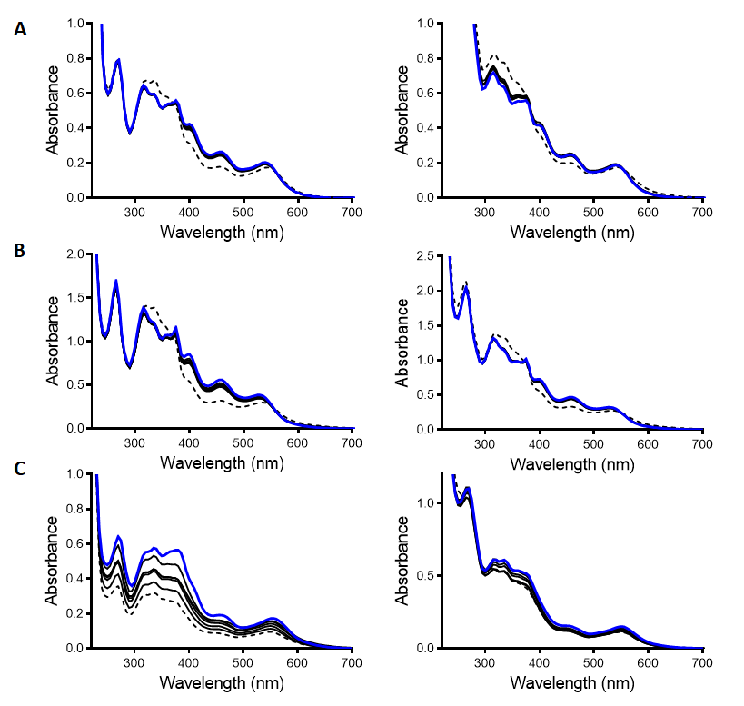
Supplementary Figure S7. Stability of complexes. (A) Complex 5, (B) 4, and (C) 6 in di H₂O (left) and Opti-MEM (right) at 37 °C in the dark over the course of 0 (blue line) to 24 h (black dashed line). The decrease in absorbance for complex 6 is explained by the slow aggregation of the compound in the 96-well plate.
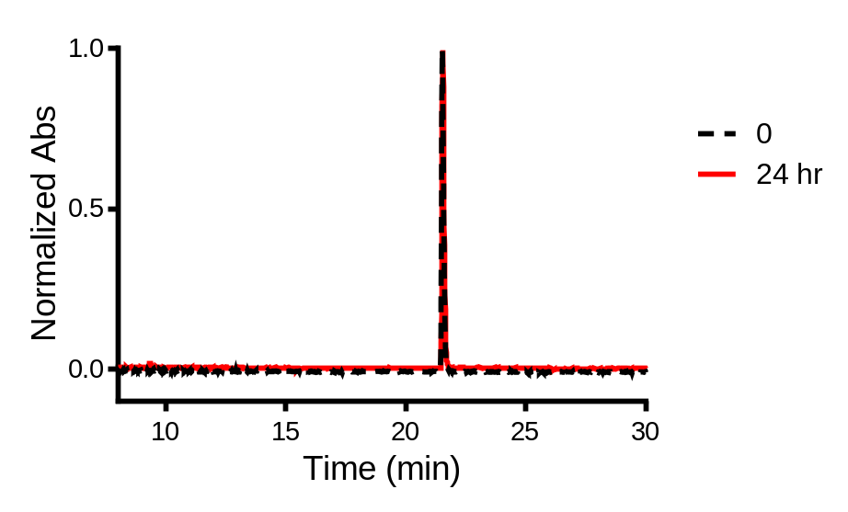
Supplementary Figure S8. HPLC chromatogram analysis of stability of 6 (40 µM in di H₂O : MeCN mixture (4:1), MeCN has been added to reduce the aggregation) before (black dashed line) and after incubation at 37 °C for 24 hours. Less than 2 % degradation was observed.

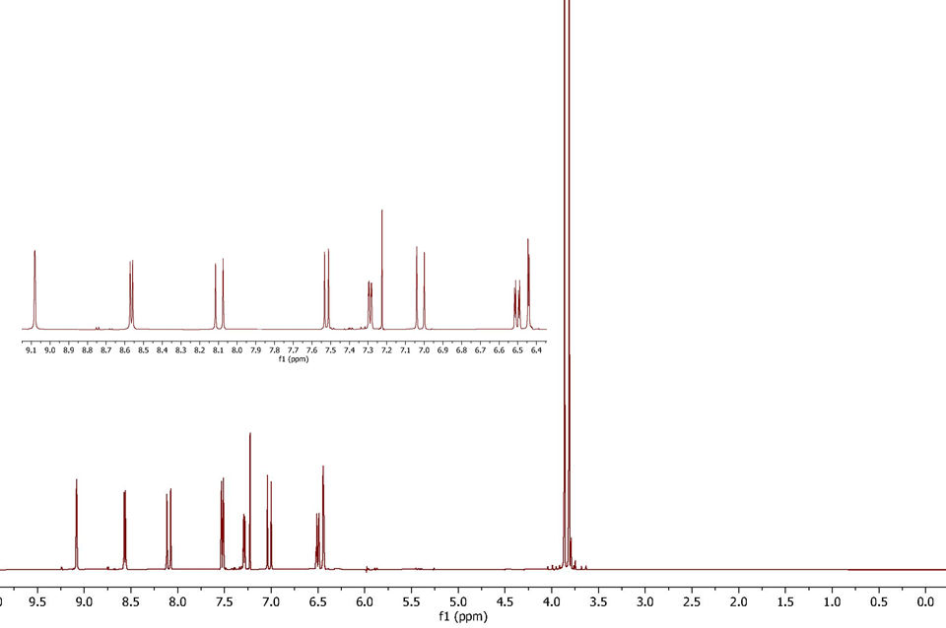
Supplementary Figure S9. ¹H NMR of 2 in CDCl₃.
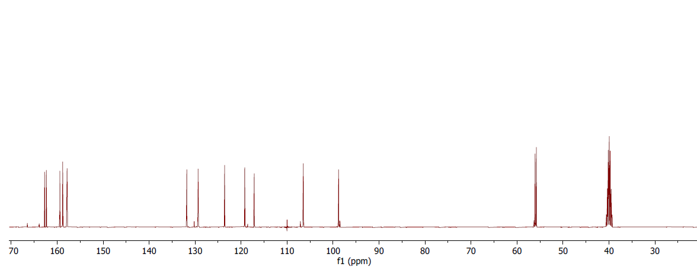
Supplementary Figure S10. ¹³C NMR of 2 in DMSO

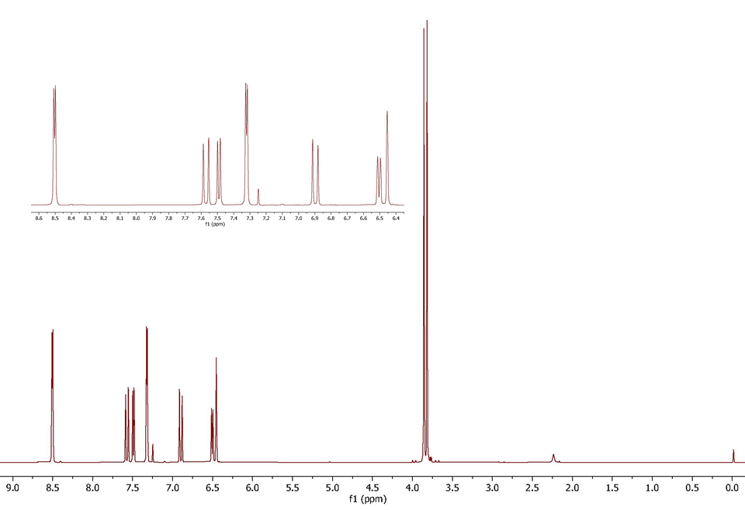
Supplementary Figure S11. ¹H NMR of 3 in CDCl₃
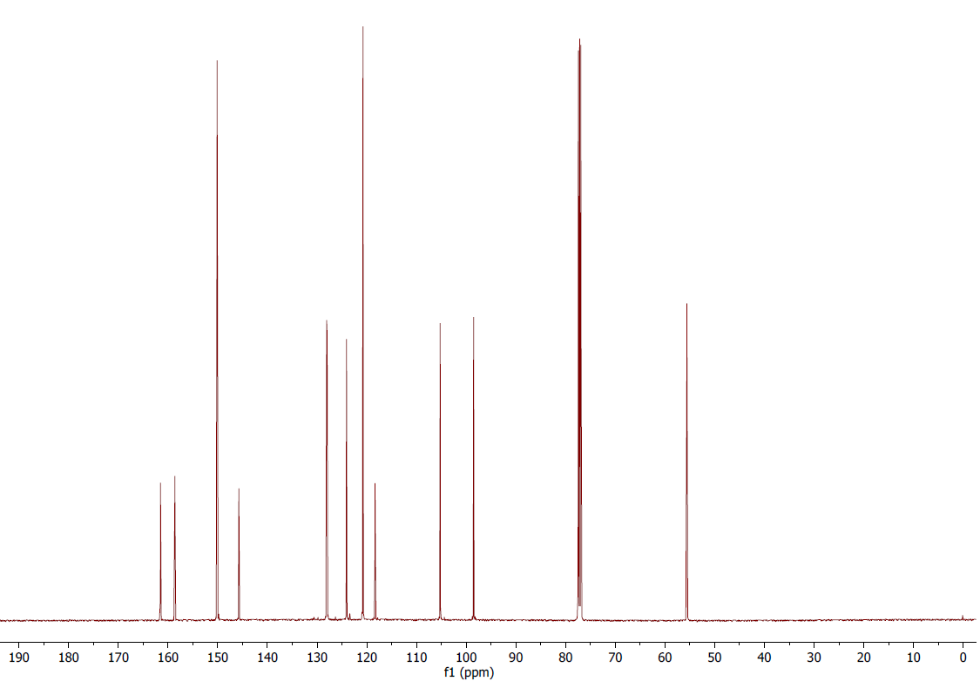
Supplementary Figure S12. ¹³C NMR of 3 in CDCl₃

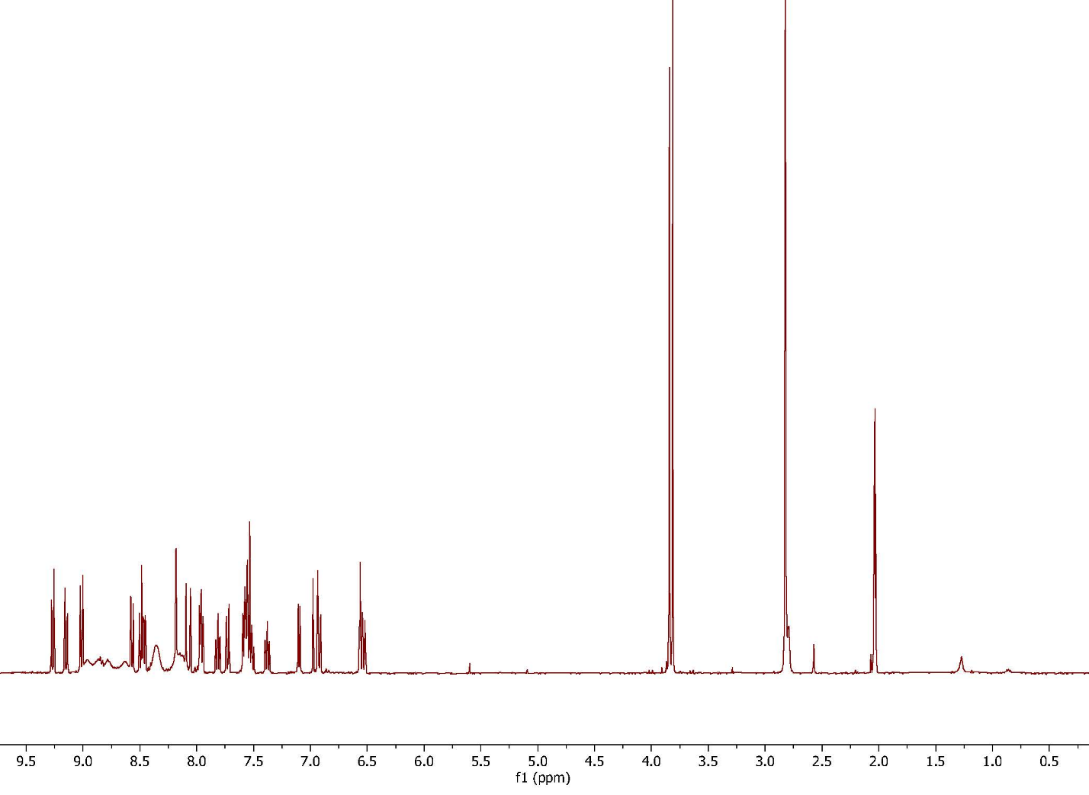
Supplementary Figure S13. ¹H NMR of 4 in CD₃CN

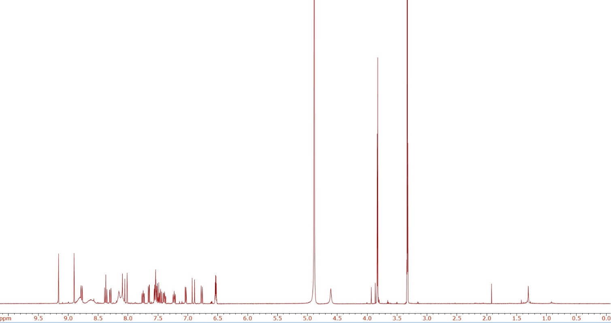
Supplementary Figure S14. ¹H NMR of 5 in CD₃OD.
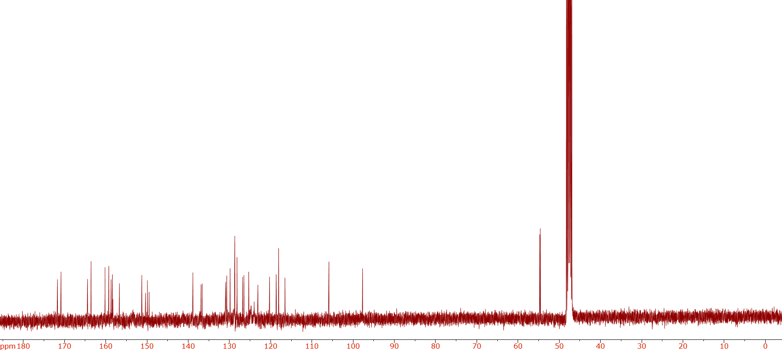
Supplementary Figure S15. ¹³C NMR of 5 in CD₃OD.

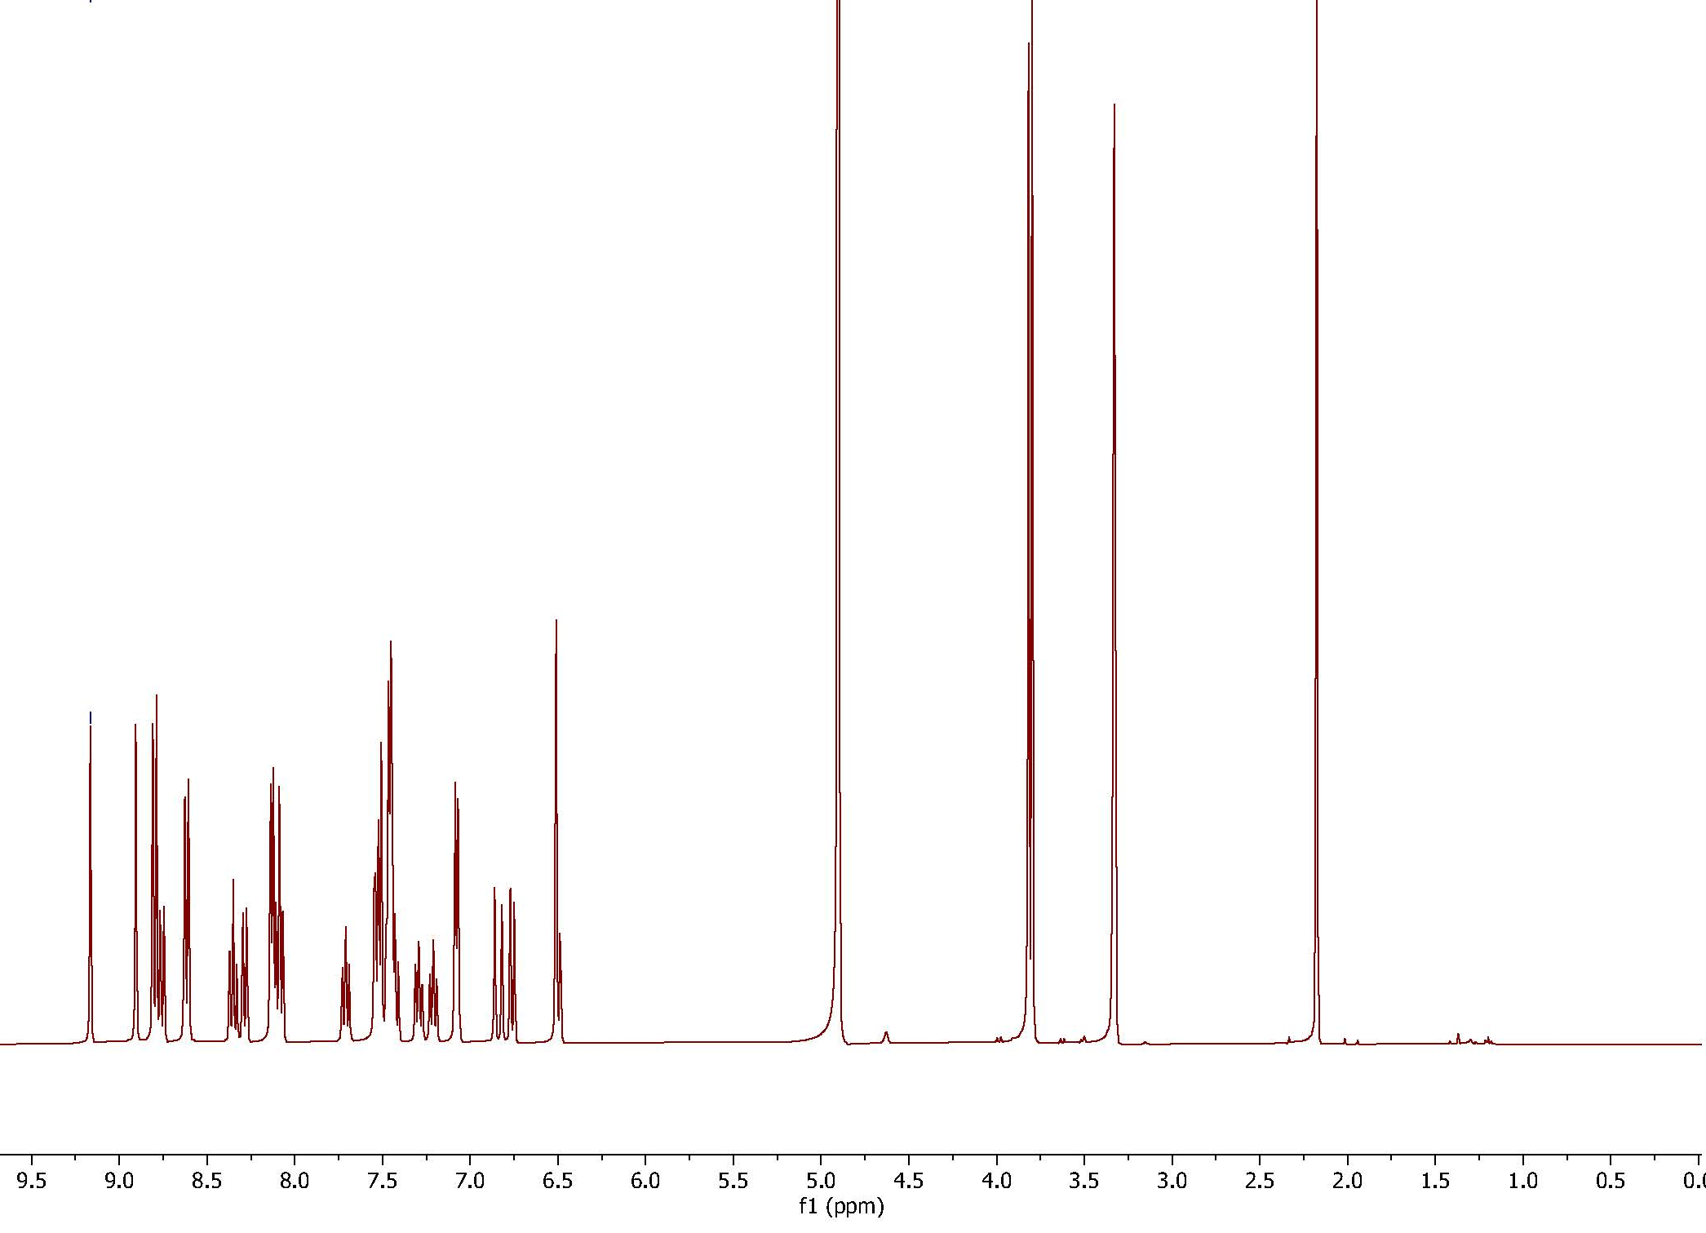
Supplementary Figure S16. ¹H NMR of 6 in MeOD.
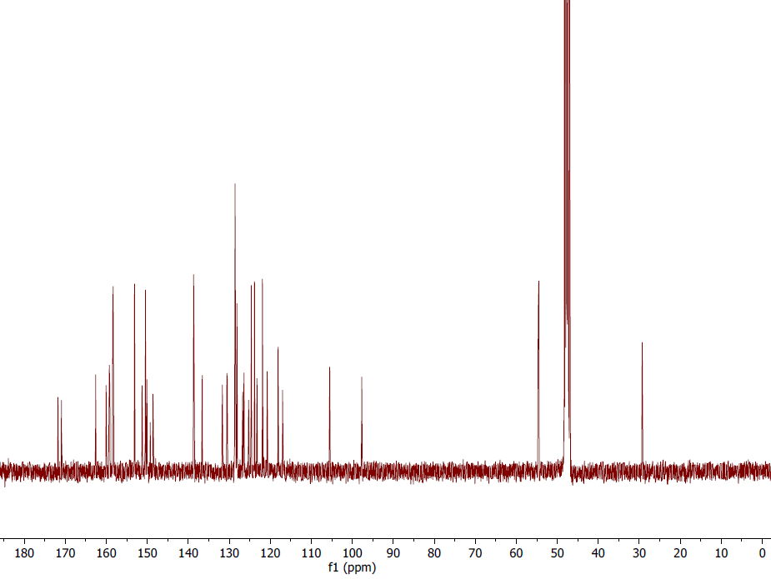
Supplementary Figure S17. ¹³C NMR of 6 in MeOD.

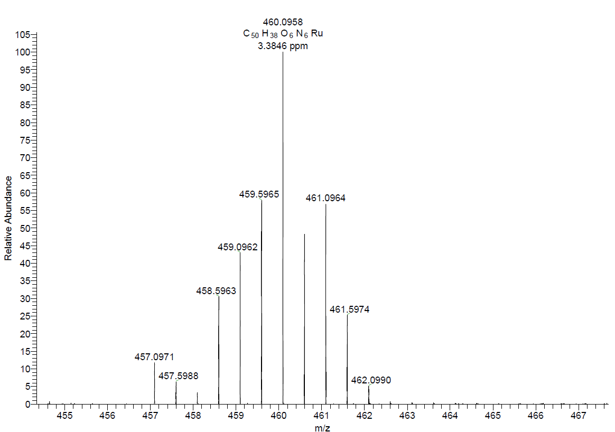
Supplementary Figure S18. ESI-MS of compound 6 calcd for C₅₀H₃₈N₆O₆Ru [M]²⁺ 460.0948; found 460.0958 [M]²⁺.

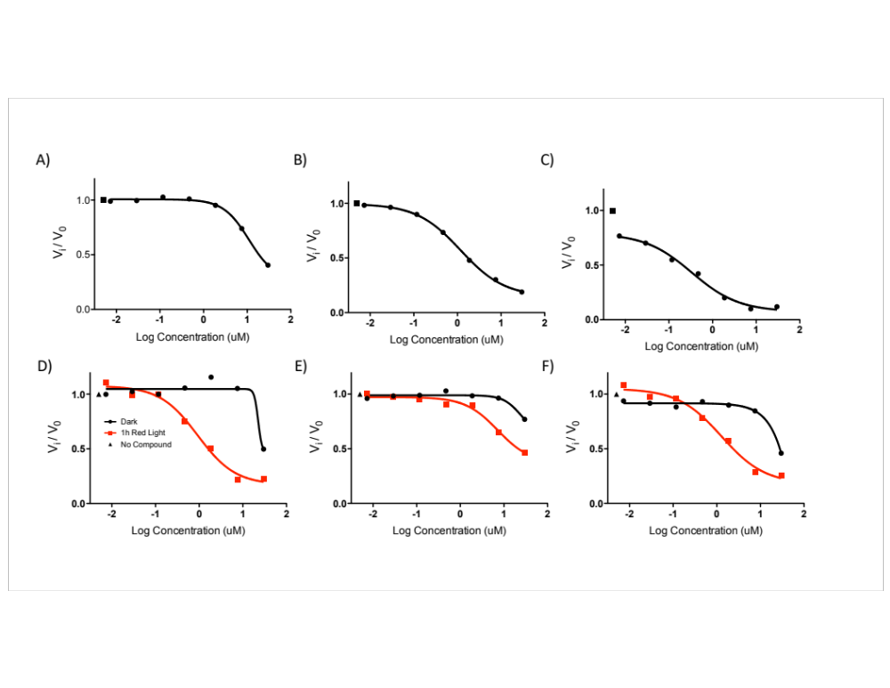
Supplementary Figure 19. Dose responses in phLMs for A) 1, B) 2, C) 3, D) 4, E) 5, and F) 6. For 4–6, data taken in the dark are shown with black circles, and data taken following irradiation with 660 nm light (1 hr = 58.7 J/cm²) is shown with red squares.

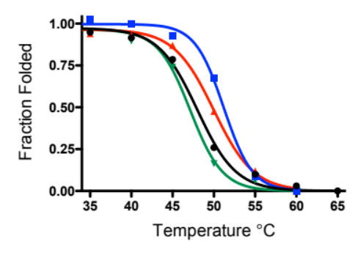
Supplementary Figure S20. Thermal melt of recombinant CYP1B1. Black circles, no compound; blue squares, 10 μM ANF; red triangles, 10 μM 3; green triangles, 20 μM 6. See Table S1 for T_{m} values from fits.

Supplementary Tables

Supplementary Table S1. Prevalence of select protein-ligand contacts.
Residue | 3 (% of frames interaction is present) | 2 (% of frames interaction is present)
Val126 | 24.4 | 0.2
Ser127 | 21.7 | 5.2
Phe134 | 27.8 | 11.0
Phe231 | 69.8 | 87.3
Asn265 | 17.3 | 12.8
Phe268 | 44.9 | 51.7
Gly329 | 5.0 | 42.6
Ala330 | 67.7 | 41.8
Thr334 | 0 | 70.3
Ile399 | 28.4 | 62.2
Leu509 | 24 | 24.3

Supplementary Table S2. IC₅₀ values for inhibitors in different CYP1B1 variants. The ratio is the IC₅₀ (mutant)/ IC₅₀ (WT).
Compound | IC₅₀ WT | S127A | Ratio | F134L | Ratio | S269A | Ratio | Q332E | Ratio | D333N | Ratio
ANF | 0.14 | 0.009 | 0.064 | 0.07 | 0.5 | 0.14 | 1 | 1.127 | 8 | 4.4 | 31
1 | 0.083 | 0.0025 | 0.030 | 0.87 | 10 | 0.18 | 2 | 0.2979 | 3.6 | 8.1 | 98
2 | 0.076 | 3.74 | 50 | 0.24 | 3 | 0.073 | 1 | 0.4024 | 5.3 | 5.0 | 66
3 | 0.0003 | .048 | 160 | 0.015 | 50 | 0.0021 | 7 | 0.0508 | 169 | 0.7 | 2333

