BiVO₄/Fe₃O₄@Polydopamine Superparticles for Tumor Multimodal Imaging and Synergistic Therapy
Ze Wang,^{a,#} Guan Wang,^{d,#} Tingting Kang,^{a,#} Shuwei Liu,ª Lu Wang,^{e} Haoyang Zou,^{b,}* Yu Chong^{c,}* and Yi Liu^{a,}*
ªState Key Laboratory of Supramolecular Structure and Materials, Jilin University, Changchun 130012, P. R. China. *Address correspondence to yiliuchem@jlu.edu.cn
^{b}Key Laboratory of Polymer Ecomaterials, Changchun Institute of Applied Chemistry, Chinese Academy of Sciences, Changchun 130012, P. R. China.
^{c}State Key Laboratory of Radiation Medicine and Protection, School for Radiological and Interdisciplinary Sciences (RAD-X), Collaborative Innovation Center of Radiation Medicine of Jiangsu Higher Education Institutions, Soochow University, Suzhou, 215123, P. R. China.
^{d}Department of Gastroenterology, China-Japan Union Hospital, Jilin University, Changchun 130033, P. R. China.
^{e}Department of Oral Pathology, School and Hospital of Stomatology, Jilin University, Changchun 130021, P. R. China.
#These authors contributed equally to this work.

Table of the Electronic Supplementary Information
1. Cancer treatment and imaging in vivo and in vitro.
2. Fig. S1 XRD patterns of BiVO₄ and Fe₃O₄ NPs.
3. Fig. S2 EDS-Mappnig images of the BiVO₄/Fe₃O₄ SPs.
4. Fig. S3 TEM images of BiVO₄/Fe₃O₄@PDA SPs with different sizes.
5. Fig. S4 TEM images of BiVO₄/Fe₃O₄@PDA SPs with different thicknesses of the PDA shell.
6. Fig. S5 UV-vis absorption spectra of BiVO₄ NPs, Fe₃O₄ NPs, BiVO₄/Fe₃O₄ SPs and BiVO₄/Fe₃O₄@PDA SPs.
7. Fig. S6 Photothermal conversion efficiency calculation of BiVO₄/Fe₃O₄@PDA SPs.
8. Fig. S7 Concentration-related cytotoxicity of BiVO₄/Fe₃O₄@PDA SPs.
9. Fig. S8 Colloidal stability of BiVO₄/Fe₃O₄@PDA SPs.
10. Fig. S9 Infrared imaging photographs of KB tumor-bearing mice with or without SPs injection.
11. Fig. S10 PA imaging of tumor oxygenation of tumors under the treatments.
12. Fig. S11 H&E stained photographs of organs after treatment.
13. Fig. S12 Blood biochemistry analyses of mice after different treatments.
14. Table. S1 BiVO₄/Fe₃O₄ SPs with different Bi/Fe element ratios.

Cell experiment:
Cytotoxicity assay:
We used CCK-8 and KB cells to test the cytotoxicity of the SPs. In the 96-well plate, we cultured 5000 cells for each well. The cells were incubated at 37 °C with 5% CO₂ for 24 h. Then the cells were treated with different concentrations of SPs and further incubated for 24 h. After that the medium was removed and the cells were washed twice with PBS. Solarbio 1640 medium is re-added with 10 μL of CCK-8 and the cells were continued to culture for 1.0 h. Finally, the microplate reader was used to measure the absorbance at 450 nm.
Clonogenic assay:
In the 6-well plate, we cultured 1000 KB cells for each well. After co-cultivation with the SPs (100 μg/mL) overnight, the cells were treated with X-rays (0, 2, 4, 6, 8 Gy) and NIR (0.33 W/cm², 10 min). The cells were then washed with PBS and continued to incubate for 10 days. Finally, the cells were stained with crystal violet staining solution. Surviving fraction (SF) was calculated by (surviving colonies)/(cells seeded × plating efficiency). The mean surviving fraction was obtained from three parallel samples. The SF and the radiation dose can be fitted using the following formula: SF = exp[-(αD+βD²)]
ROS in cells:
We use ROS assay kit to detect ROS in cells. In the 6-well plate, we cultured 50000 KB cells in each well. We used SPs (100 μg/mL) to co-cultivate with cells overnight, followed by washing the cells with PBS for three times. We added the 1000-fold diluted ROS assay kit to each well and washed the cells with PBS for three times after incubation for 20 min. Then we treated the cells with X-ray (6 Gy) or NIR (0.33W/cm², 10 min). Finally, the cells were observed using the FV1000 laser scanning confocal microscopy (excitation wavelength: 488 nm; emission wavelength: 525 nm).
DNA double-strand breaks:
In the 6-well plate, we cultured 50000 KB cells in each well. We used SPs (100 μg/mL) to co-cultivate with cells overnight, followed by treatment of cells with X-ray (6 Gy) or NIR (0.33 W/cm² 10 min). We fixed the cells with paraformaldehyde (4 %) for 10 min and washed with PBS for three times. It was then permeabilized with methanol and washed with PBS for three times. The cells were exposed in blocking buffer for 1 h and further incubated with 100-fold γ-H2AX (phospho S139) antibody [EP854(2)Y] (Alexa Fluor 568) (ab206901) at 4 °C overnight and then washed with PBS for three times (excitation wavelength: 578 nm; emission wavelength: 603 nm). The cells were stained with Hoechst 33342 (excitation wavelength: 350 nm; emission wavelength: 461 nm) and washed with PBS for three times. Finally, they were observed using FV1000 laser scanning confocal microscopy.
Animal experiment:
In vivo RT/PTT synergistic treatment:
KB cells were subcutaneously injected into the right leg of BALB/c nude mice. When the average tumor volume reached 75 mm², we divided the mice into 7 groups according to different treatment conditions: (1) PBS, (2) SPs, (3) NIR, (4) X-rays, (5) SPs+NIR, (6) SPs+X-rays, (7) SPs+NIR+X-rays. We injected 20 μL of SPs (5 mg/mL) into the tumor via intratumoral injection. Mice in the corresponding groups were then treated with NIR (0.33 W/cm², 10 min) or X-ray (6 Gy). Tumor volumes and body weights of each group of mice were recorded after this treatment. Finally, all the mice were sacrificed and the blood, heart, liver, spleen, lung, kidney and tumor were taken. The blood was centrifuged and the serum was taken for the blood analysis. The tumors and other organs were weighed and used for H&E staining.
CT imaging:
In vivo and in vitro CT imaging was used U-SPECT+/CT (MILABS). For in vitro imaging, we prepared aqueous solutions of different concentrations of SPs and iopromide and measured their HU values. For in vivo imaging, BALB/c nude mice harboring KB tumors were intratumoral injected with 50 μL, 10 mg/mL SPs solution.
MR imaging:
We used SIEMENS Avanto 1.5T clinical MRI unit to assess the MR imaging property of SPs. For in vitro imaging, we prepared aqueous solutions of different concentrations of SPs for measuring. For in vivo imaging, BALB/c nude mice with KB tumors were intratumoral injected with 20 μL, 10 mg/mL SPs solution.
PA imaging:
In vivo and in vitro PA imaging was used MSOT INVISIO-256 (iThera Medical). For in vitro imaging, we prepared aqueous solutions of different concentrations of SPs for measuring. For in vivo imaging, BALB/c nude mice with KB tumors were intratumoral injected with 20 μL, 10 mg/mL SPs solution.

Fig.S1 XRD patterns of BiVO₄ and Fe₃O₄ NPs.
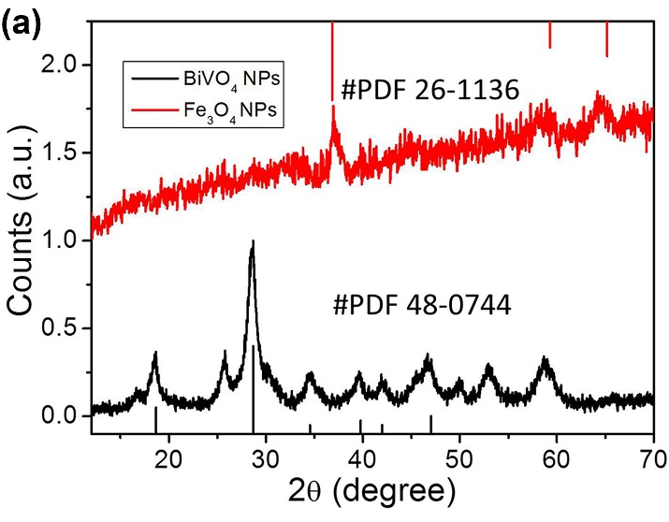

Fig. S2 EDS-Mappnig images of the BiVO₄/Fe₃O₄ SPs.
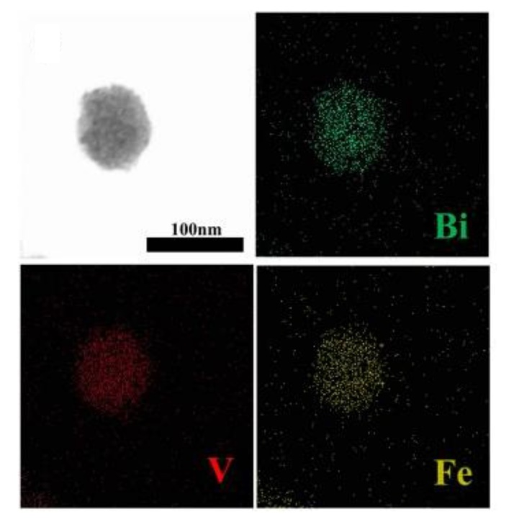

Fig.S3 TEM images of BiVO₄/Fe₃O₄@PDA SPs with the sizes of 81.20 nm (a), 120.60 nm (b), and 164.50 nm (c).

Fig. S4 TEM images of BiVO₄/Fe₃O₄@PDA SPs with the PDA shell thicknesses from 10.00 to 80.00 nm.

Fig. S5 UV-vis absorption spectra of BiVO₄ NPs, Fe₃O₄ NPs, BiVO₄/Fe₃O₄ SPs and BiVO₄/Fe₃O₄@PDA SPs.
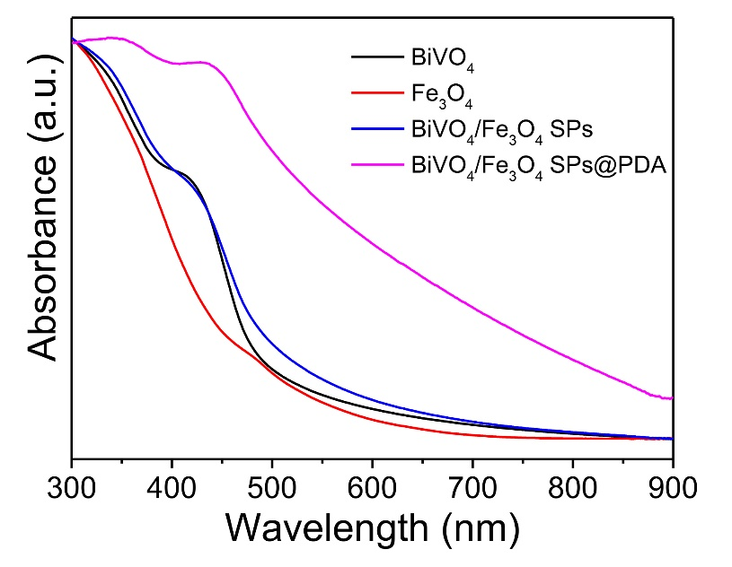

Fig. S6 (a) Temperature rises and fall curve of 100 μg/mL BiVO₄/Fe₃O₄-2@PDA SPs under 1 W/cm² 808 nm laser irradiation. (b) t=-τlnθ relationship diagram calculated by (a). The photothermal conversion efficiency was calculated to be 33.42 %.
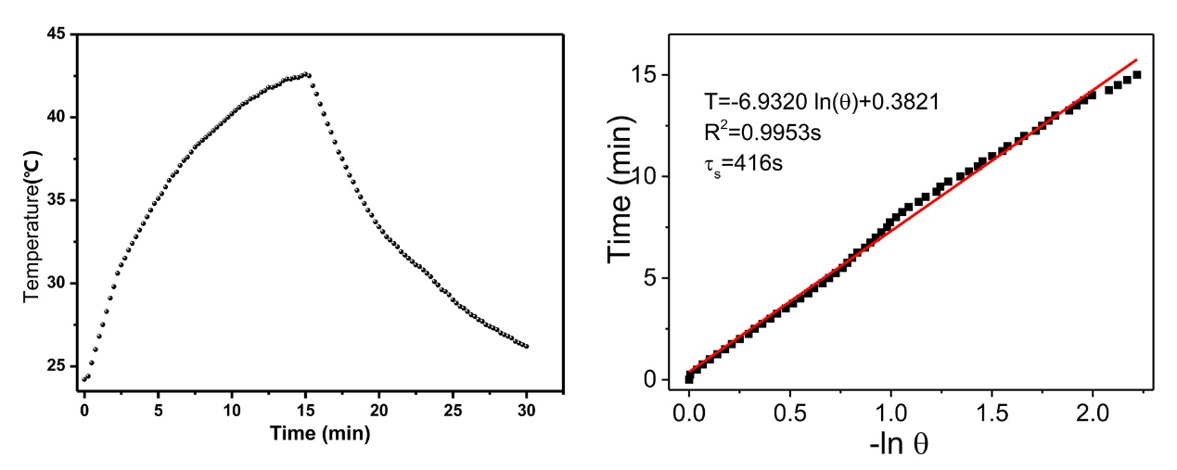

Fig. S7 Cell viability of KB cells after incubation with various concentrations of BiVO₄/Fe₃O₄@PDA SPs for 24 h.
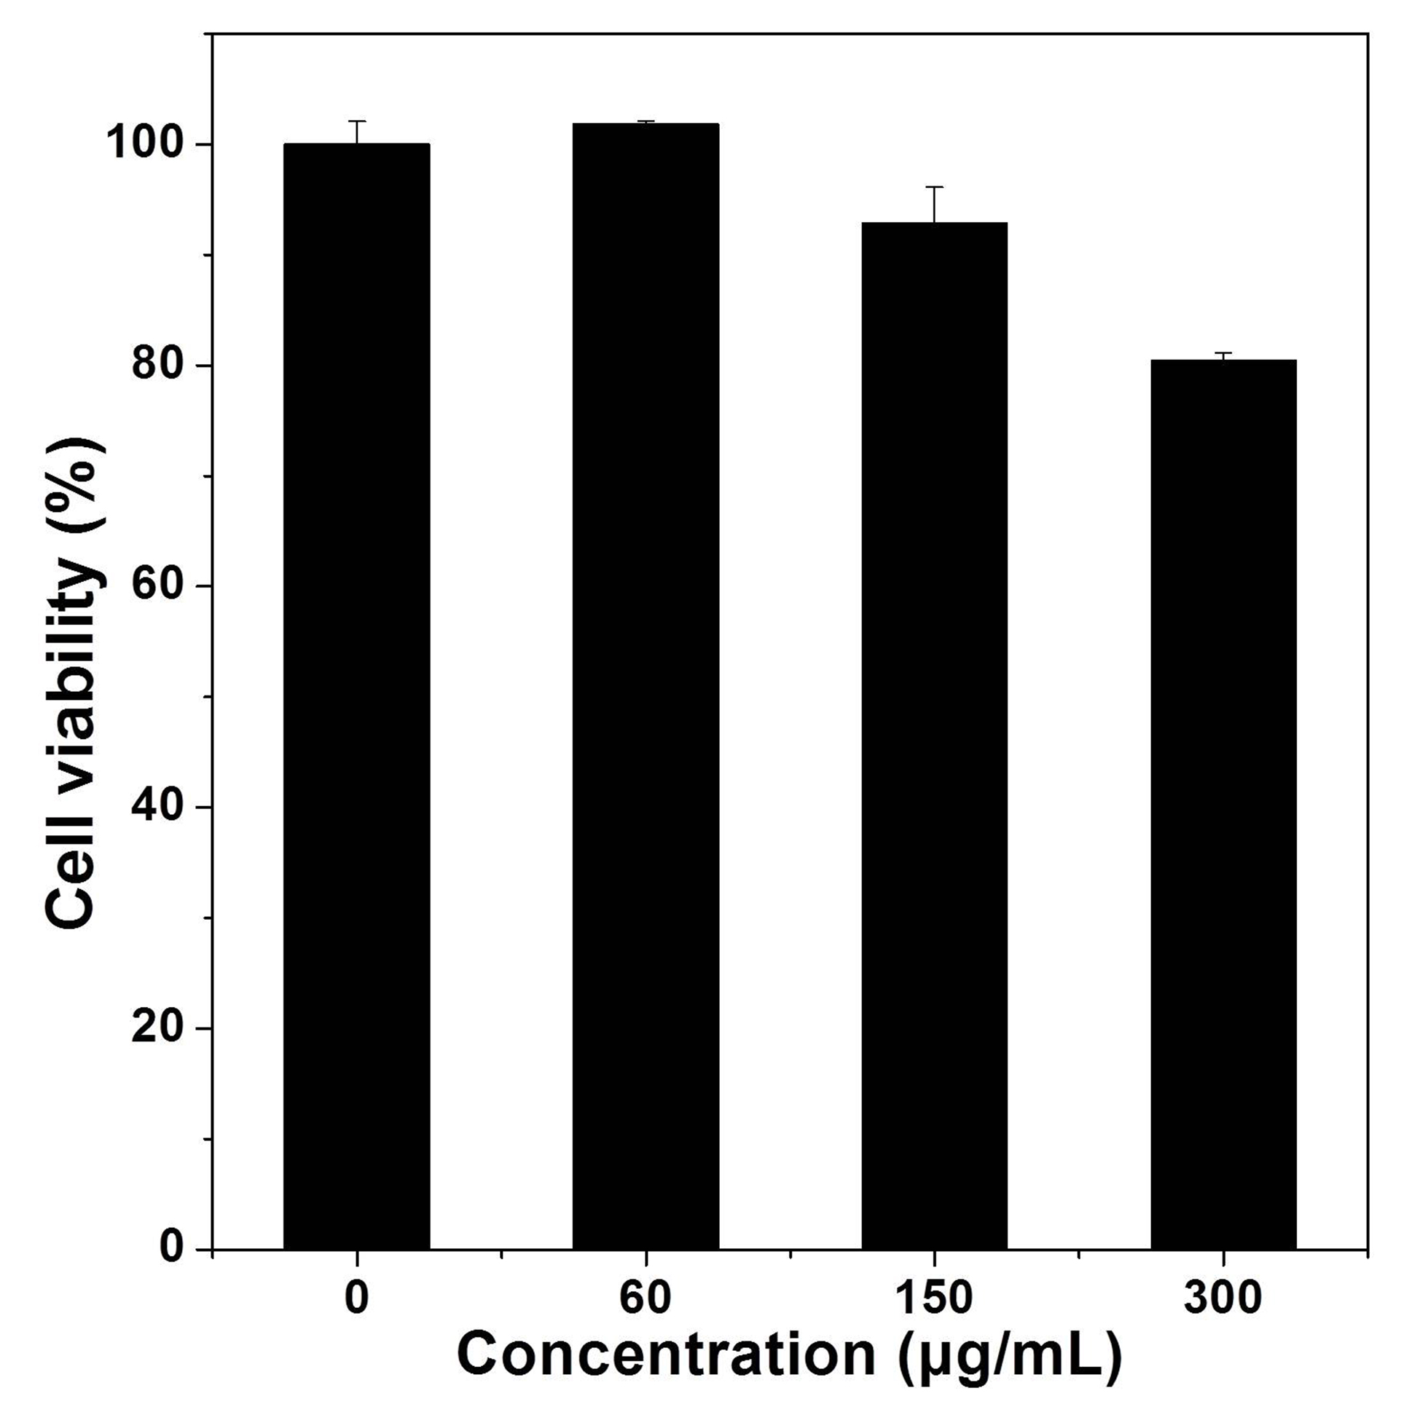

Fig. S8 Photographs of BiVO₄/Fe₃O₄@PDA SPs before and after storage in deionized water, saline, PBS, cell culture and serum-containing cell culture for 24h.
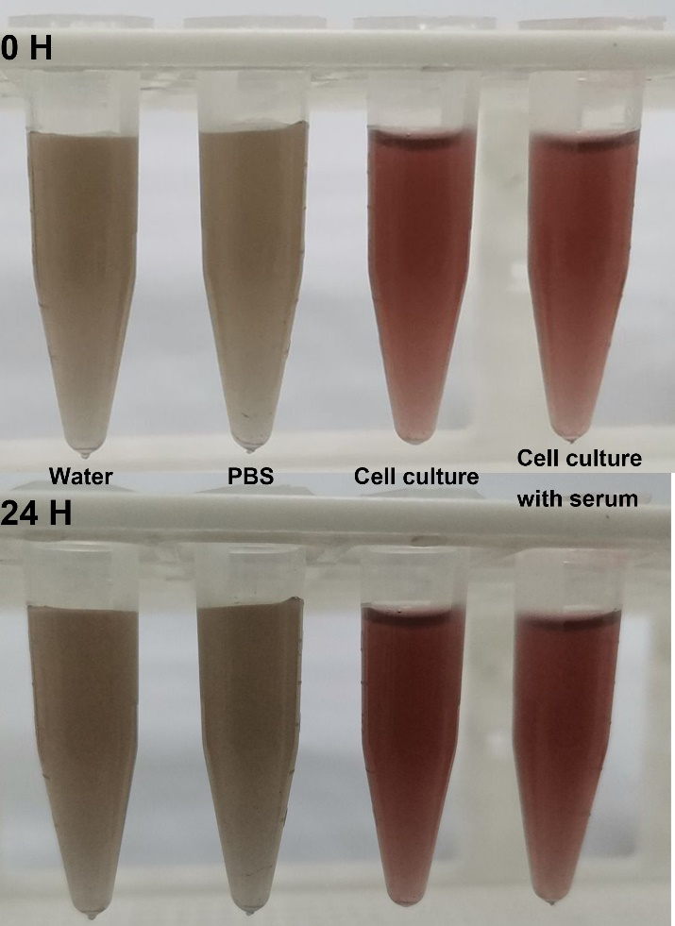

Fig. S9 Infrared imaging photographs of KB tumor-bearing mice with or without SPs injection (laser, 808 nm; 0.33 W/cm²).
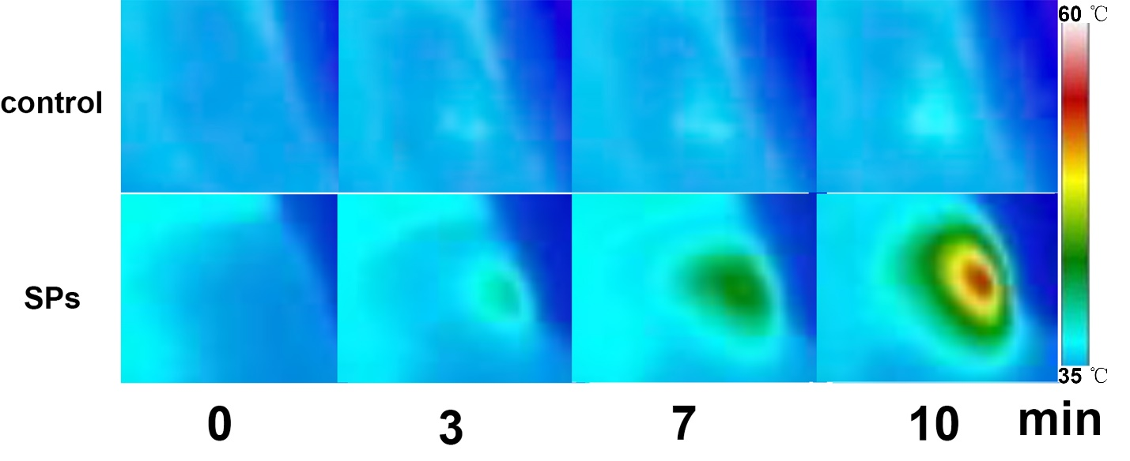

Fig. S10 PA imaging of tumor oxygenation of tumors under the treatments by PBS (a), NIR (b), SPs (c) and SPs+NIR (d). Oxygenated hemoglobin is colored red, and deoxygenated hemoglobin is colored blue.

Fig. S11 H&E stained photographs of organs (heart, liver, spleen, lung, kidney) of mice in each group after treatment (scale bar is 50 μm).
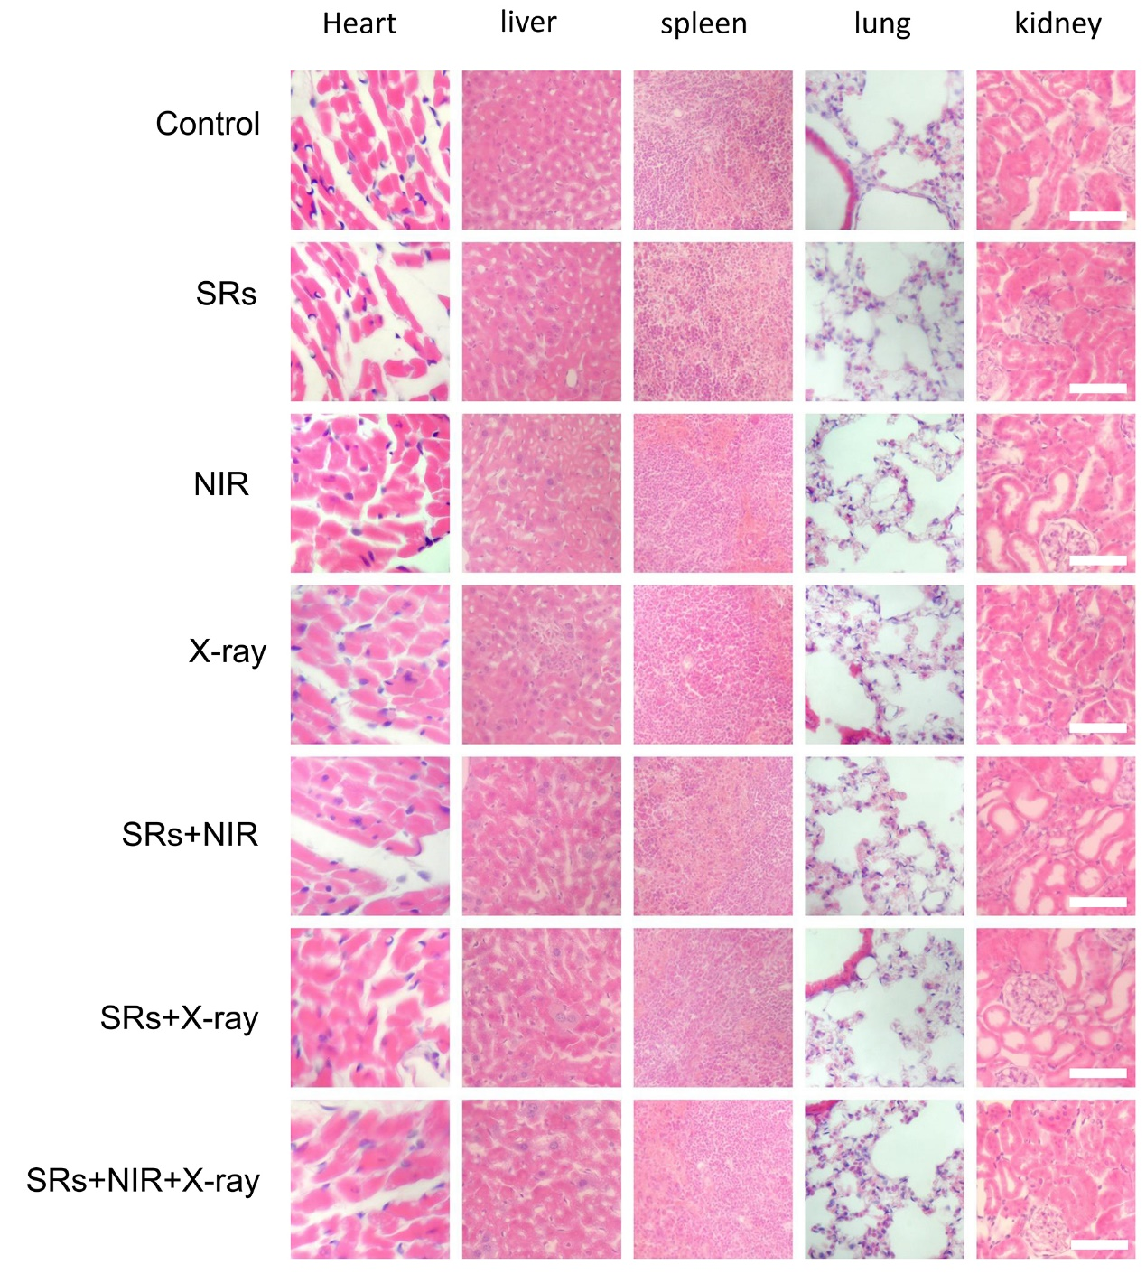

Fig. S12 Blood biochemistry analyses of mice after different treatments.
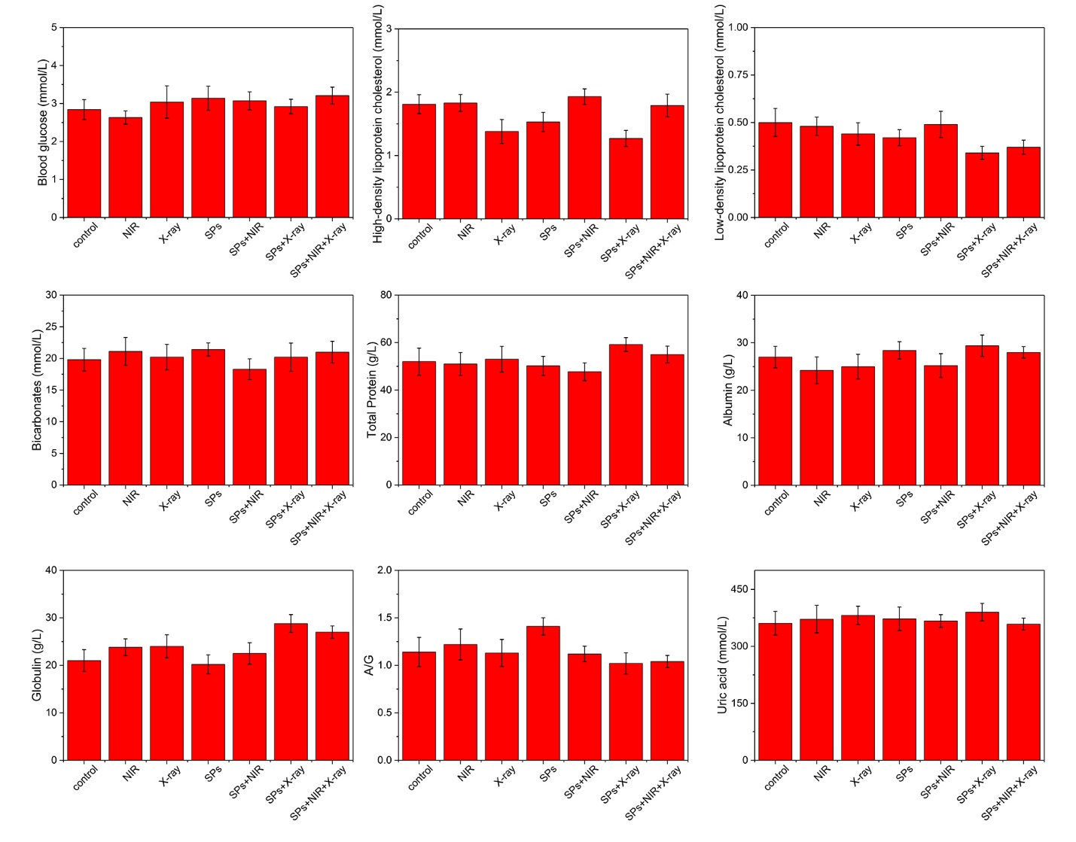
Table S1 BiVO₄/Fe₃O₄ SPs with different Bi/Fe element ratios.

Samples | BiVO₄/Fe₃O₄-1 SPs | BiVO₄/Fe₃O₄-2 SPs | BiVO₄/Fe₃O₄-3 SPs
Be:Fe | 3.5:1 | 1.8:1 | 1.2:1

