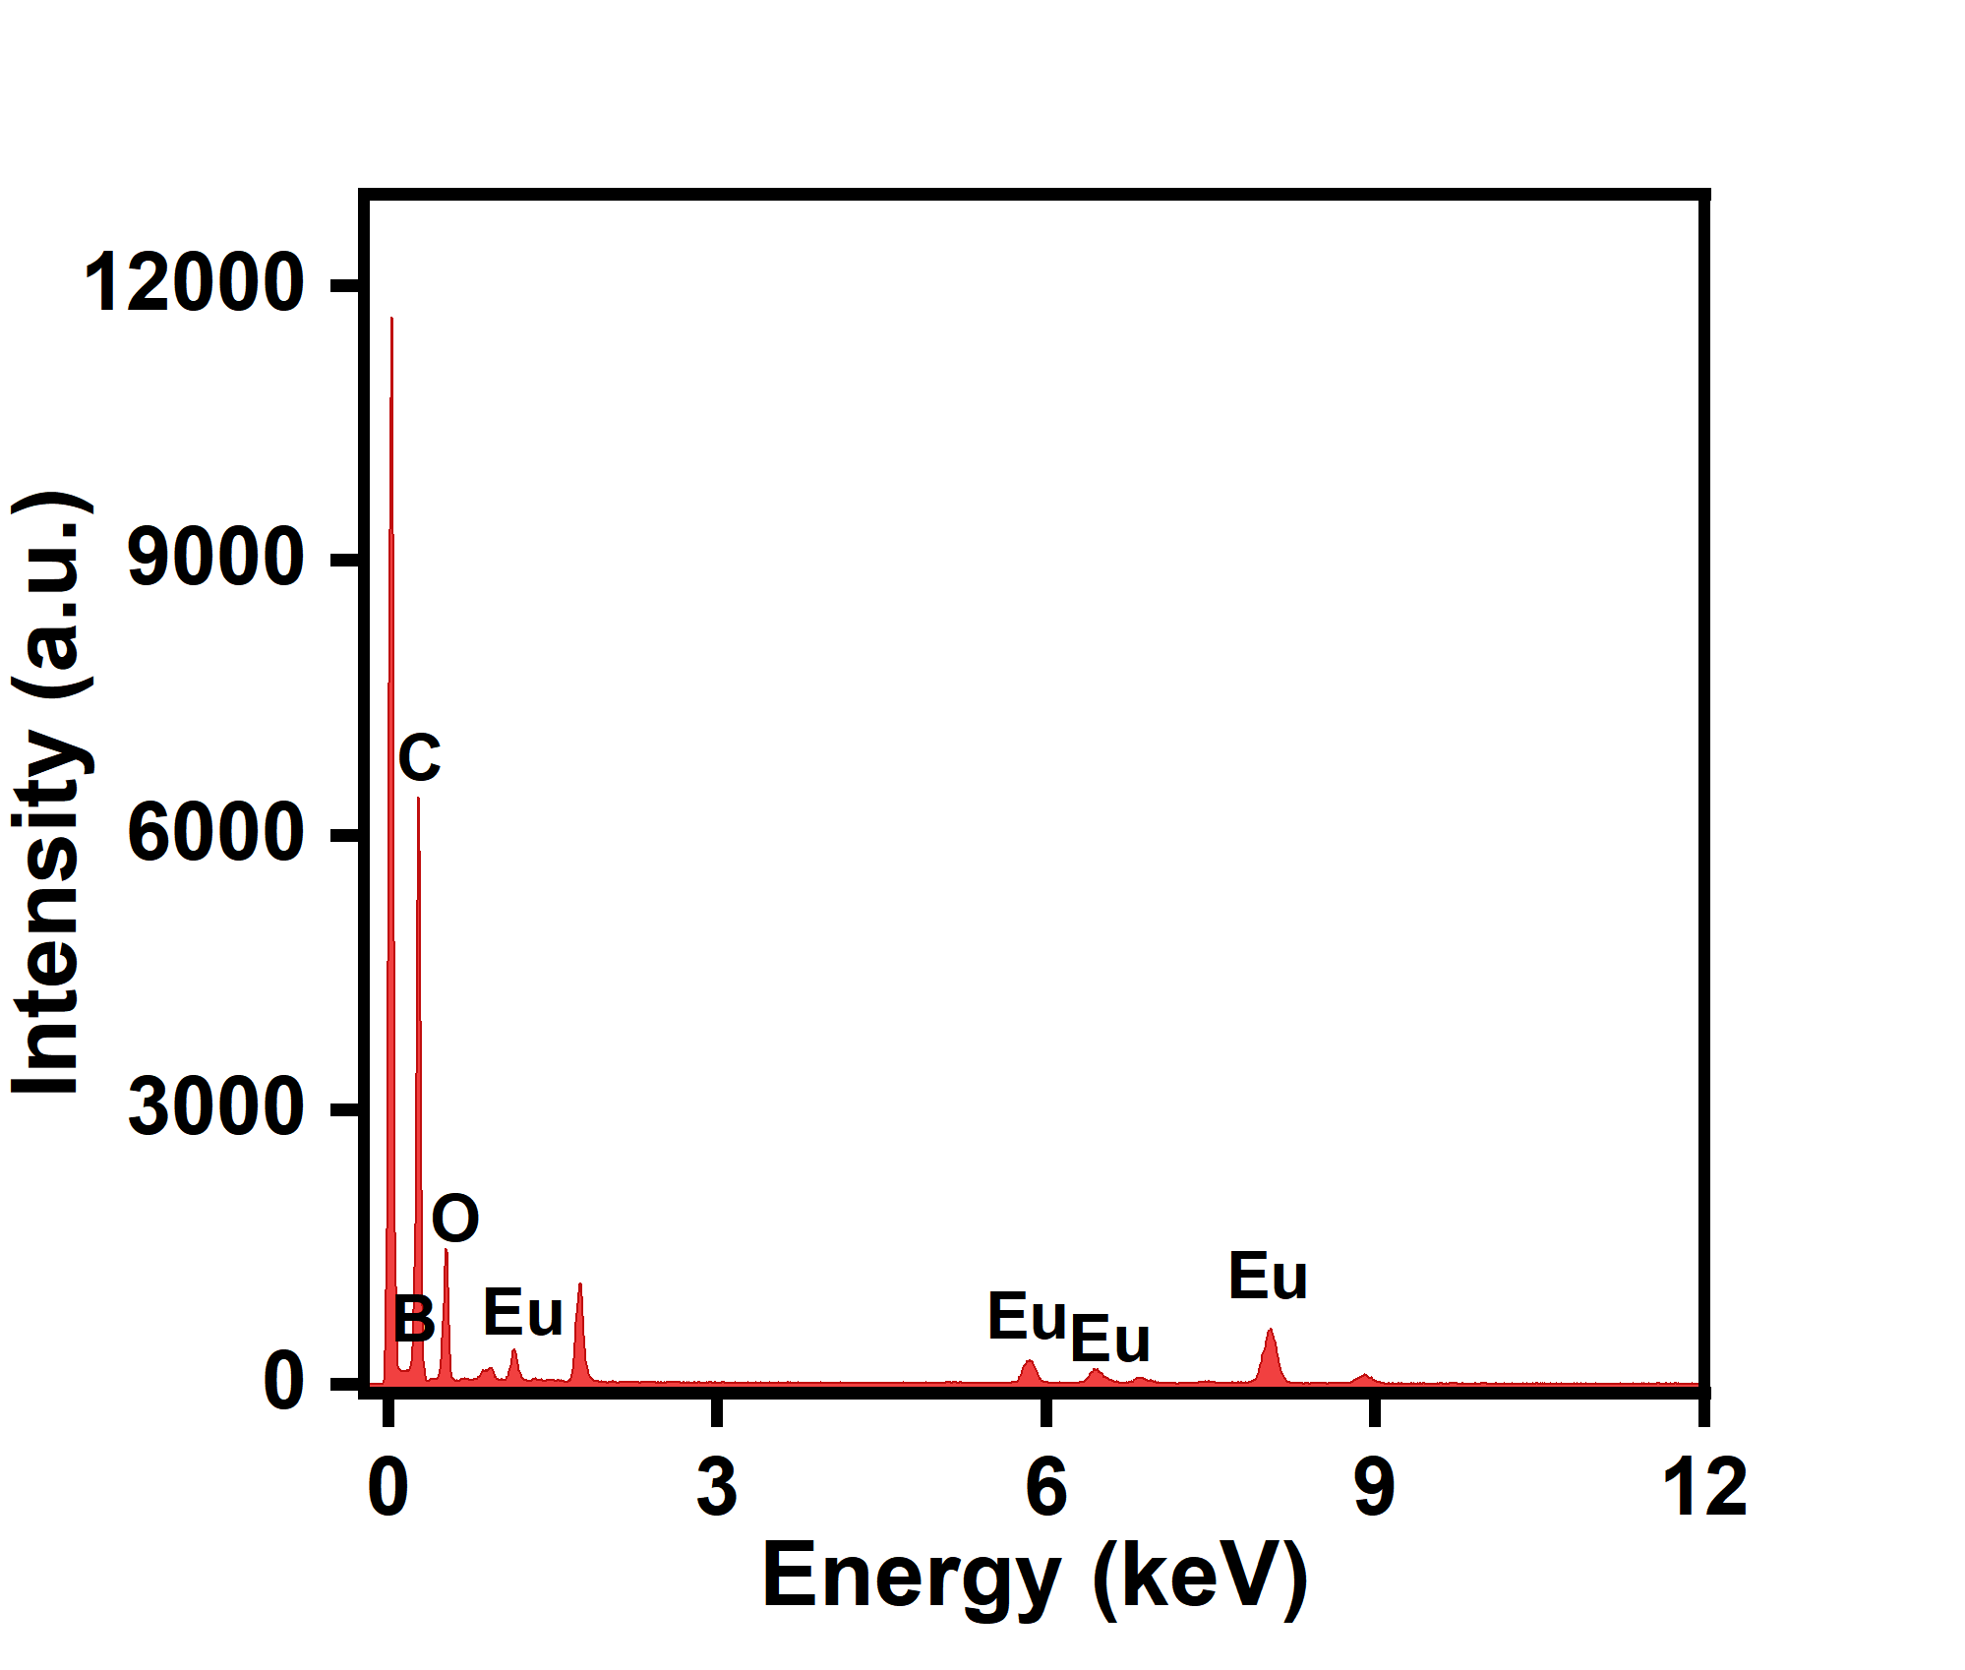
Fig. S1. EDS spectrum of Eu-BBDC/ BDC

Fig. S2. XRD spectrum of Eu-BBDC/BDC-OH

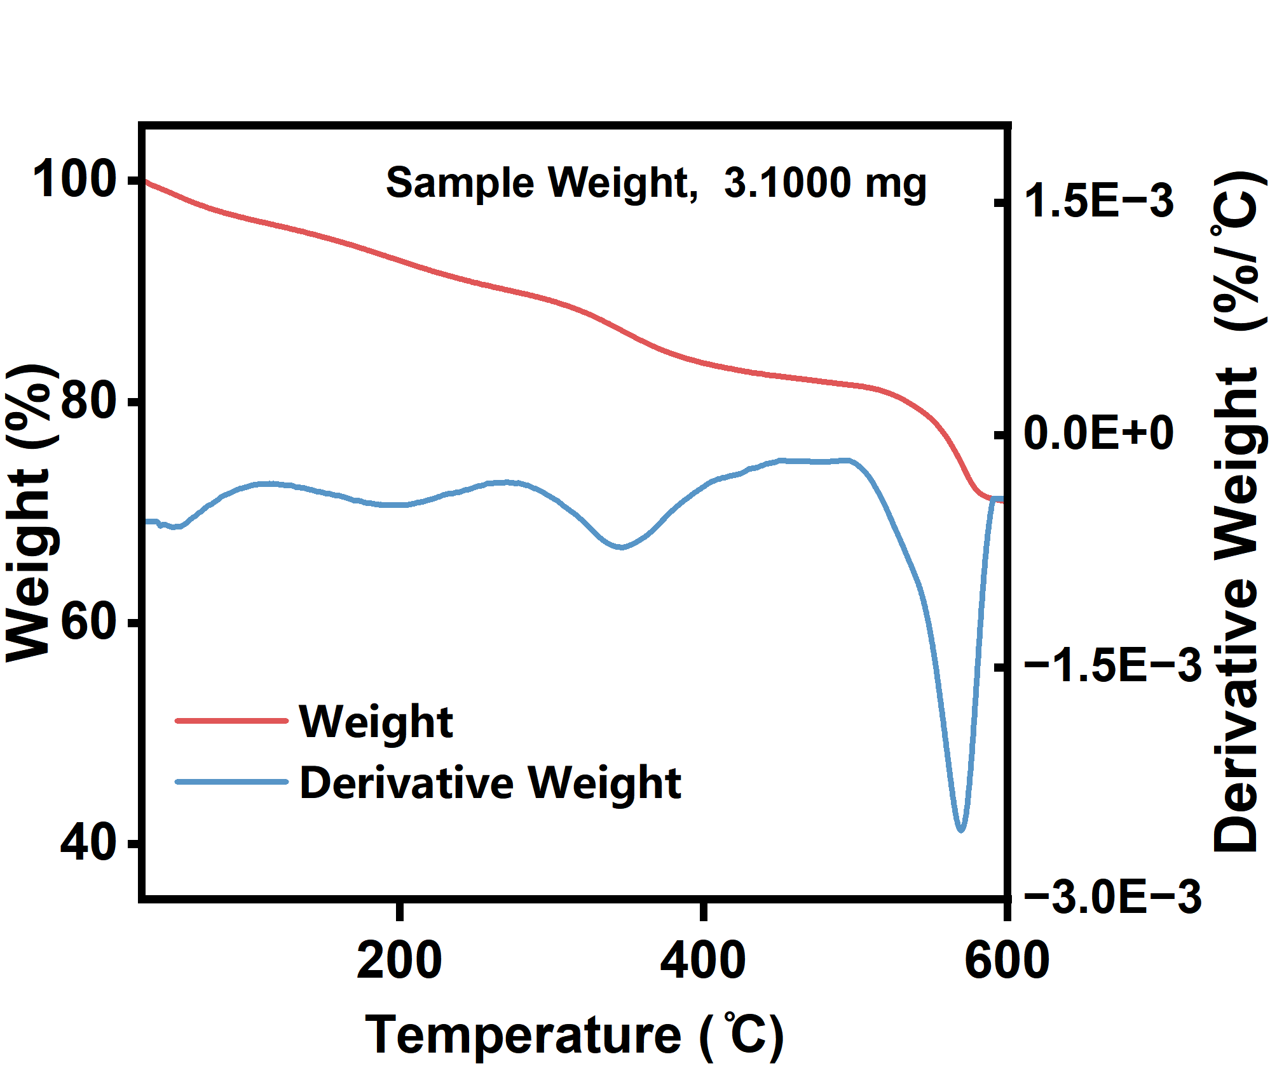
Fig. S3. TGA profile of Eu-BBDC/BDC-OH.

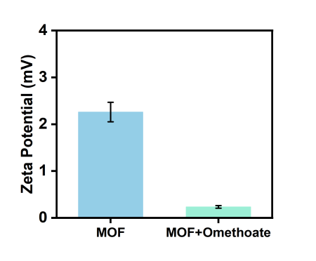
Fig. S4. Zeta potentials of Omethoate and Eu-BBDC/BDC-OH before and after the addition of Omethoate.

Fig. S5. (A) The effect of different Eu-BBDC/BDC-OH concentrations (from left to right: 10, 20, 40, 60, 80, 100, and 120 µg/mL) on the F0 and (F0-F)/F0. (B) The influence of different pH values (from left to right: 5, 6, 7, 8, and 9) on the F0 and (F0-F)/F0. (C) The effect of different temperatures (from left to right: 10, 20, 30, 40, 50, and 60 °C) on the F0 and (F0-F)/F0. (D) The influence of different incubation times (from left to right: 0, 10, 20, 30, 40, 50, and 60 min) on the F0 and (F0-F)/F0.

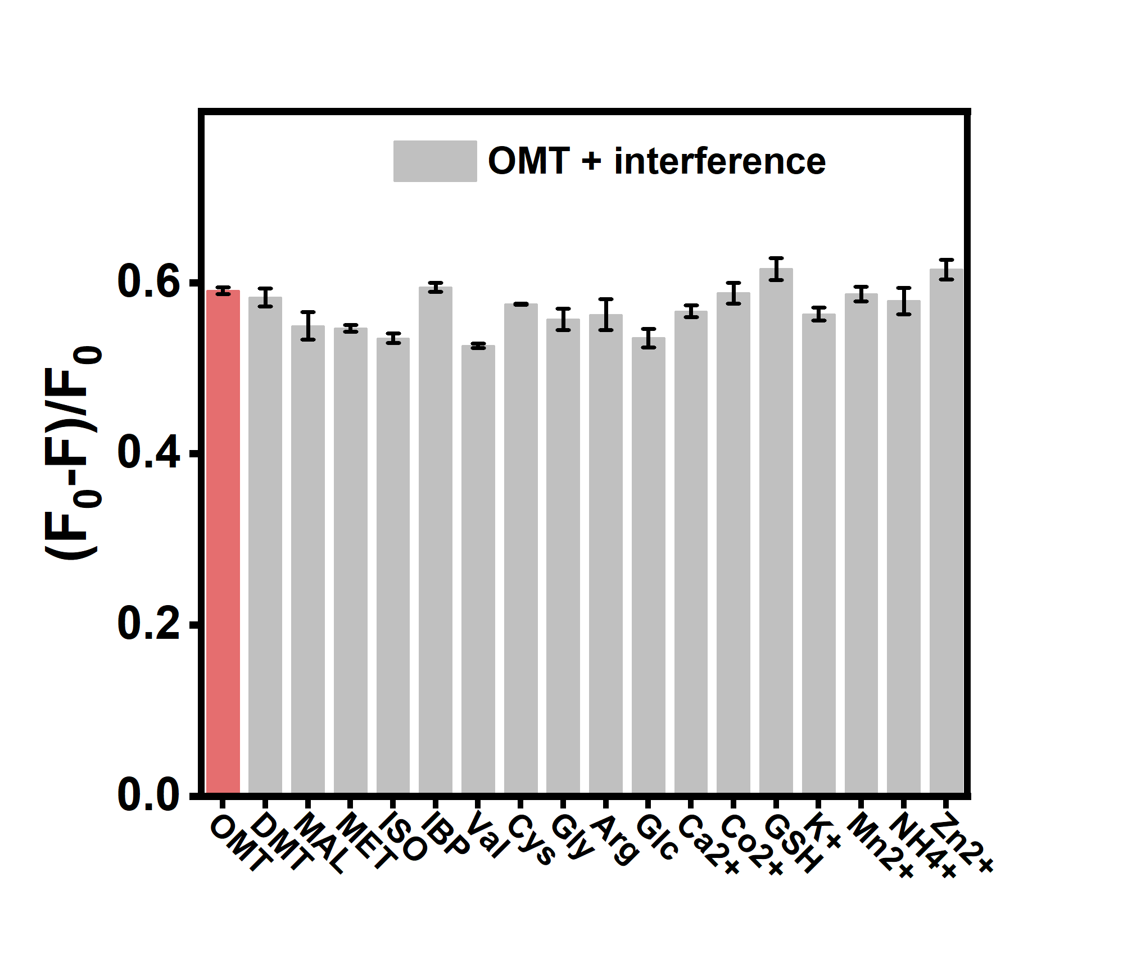
Fig. S6. (F₀-F)/F₀ of Eu-BBDC/BDC-OH in the presence of a mixed solution of OMT and other interfering substances. Error bar represents the standard deviation (n = 3).

Sensors | Linear range (μg/mL) | LOD (ng/mL) | Sample type | Ref.
de-CD–Hg²⁺ | 0.01–8 | 2.8 | Brassica chinensis | (Wu et al., 2024)
Cu-MOFs | 0-1 | 16 | cabbage | (Lin et al., 2025)
Fe3O4@RhB@ZIF90@AChE | 0.01-2 | 15 | cucumber/tomato/apple | (Zhao et al., 2025)
SACe-N-C nanozyme | 2-2.85 | 55.83 | broccoli | (Song et al., 2022)
SERS | 0.01-1000 | 10 | peach | (Yaseen et al., 2018)
Eu-BBDC/BDC-OH | 0.025-0.9 | 7.35 | Cucumbers/strawberries | This work

Table S1. Comparison of analytical characteristics of different sensors for OMT detection.

Lin, X., Zou, J., Zhu, G., Pang, L., Chen, Y., Huang, Y., 2025. Cu-MOFs nanozyme with POD-like activity for the enrichment, identification, and intelligent colorimetric detection of omethoate. Food Bioscience 72, 107533. https://doi.org/10.1016/j.fbio.2025.107533
Song, G., Zhang, J., Huang, H., Wang, X., He, X., Luo, Y., Li, J., Huang, K., Cheng, N., 2022. Single-atom Ce-N-C nanozyme bioactive paper with a 3D-printed platform for rapid detection of organophosphorus and carbamate pesticide residues. Food Chemistry 387, 132896. https://doi.org/10.1016/j.foodchem.2022.132896
Wu, H., Wang, Q., Dong, M., Liu, X., Tang, Y., 2024. pH-responsive dual-emission carbon dots for the ratiometric detection of organophosphorus pesticides in Brassica chinensis and Hg2+ in water. Food Chemistry 454, 139755. https://doi.org/10.1016/j.foodchem.2024.139755
Yaseen, T., Sun, D.-W., Pu, H., Pan, T.-T., 2018. Detection of Omethoate Residues in Peach with Surface-Enhanced Raman Spectroscopy. Food Anal. Methods 11, 2518–2527. https://doi.org/10.1007/s12161-018-1233-y
Zhao, Y., Li, R., Tang, J., Liu, M., Zhang, B., Chen, J., Ren, S., Ma, Q., Sun, Z., Weng, H., 2025. MOF-enabled magnetic-fluorescent sensors for on-site organophosphorus/carbamate pesticide detection in fruits and vegetables. Food Chemistry 493, 145935. https://doi.org/10.1016/j.foodchem.2025.145935

