Supporting Information

Self-oriented hydroxyapatite nanorods in gelatin matrix via single-directional evaporation for bone defect repair

Xiaoyang Liu ¹, Tan Chen ², Yushuai Cheng ¹, Wei He ¹, Zhengke Wang ¹*

1 MOE Key Laboratory of Macromolecular Synthesis and Functionalization, Department of Polymer Science and Engineering, Zhejiang University, Hangzhou 310058, China
2 Stomatology Hospital, School of Medicine, Zhejiang University, Hangzhou 310000, China
* E-mail: wangzk@zju.edu.cn

Materials and Methods
Materials
Gelatin, cetyl trimethyl ammonium bromide, glutaraldehyde (50% in H₂O), and PEG-4000 were supplied by Aladdin. NaH₂PO_{4,} CaCl₂ were purchased from Macklin. Ethanol (AR), hexamethylene (AR), and sodium hydroxide were provided by Sinopharm Chemical Reagent Co., Ltd. Oleic acid (AR) was purchased from Yuanye Bio-Technology Co., Ltd, and the deionized water was supplied by Zhejiang University. All reagents were used as received without purification.

Preparation of Fe-doped-HAP
Cetyltrimethylammonium bromide (CTAB, 8 g) was accurately weighed and dissolved in a mixed solution consisting of 96 mL oleic acid and 64 mL ethanol. Subsequently, 60 mL of 10 wt% NaOH solution was added to the reaction system under conditions of 70 °C and a nitrogen atmosphere, followed by continuous stirring for 30 minutes. A 30 mL mixed aqueous solution containing CaCl₂ (0.32mol/L) and FeCl₂ (0.08mol/L) was prepared and designated as Solution A; a 30 mL aqueous solution of NaH₂PO₄ (0.26mol/L) was separately prepared and labeled as Solution B. Solution A was then added dropwise to the reaction system, and after stirring was continued for another 30 minutes, Solution B was added dropwise in a similar manner. Following a complete reaction period of 30 minutes, 26 mL of 10 wt% NaOH solution was introduced to adjust the system pH to approximately 12. The resulting reaction mixture was transferred to a hydrothermal autoclave, subjected to hydrothermal treatment at 180 °C for 36 hours, and the Fe-HAP nanoparticles were collected via centrifugation. Finally, the Fe-HAP nanoparticles were repeatedly washed with hexamethylene and ethanol.

Preparation of Gel/Fe-HAP
Using the Fe-HAP aqueous dispersion solution as the solution, a solution (10 wt%) of gelatin was prepared under a water bath heating condition at 50℃, and PEG-4000 (5 wt%) was introduced as a pore-forming agent. After the gelatin was completely dissolved, it was transferred to a mold for cooling and shaping, and then cross-linked with glutaraldehyde vapor. The hydrogel was transferred to a drying oven for thermal treatment. After 4 hours of evaporation at 50℃, the central area of the semi-dry hydrogel was collected, and the PEG-4000 in the hydrogel was removed by dissolving with ethanol, thus obtaining the anisotropic gelatin/Fe-hydroxyapatite scaffold (Gel/Fe-HAP). Correspondingly, the edge portion of the semi-dry hydrogel was used as an isotropic Gel/Fe-HAP scaffold (I-Gel/Fe-HAP).

Characterization of Fe-doped-HAP
Fourier transform infrared spectroscopy (FTIR): The fully dried Fe-HAP nanoparticles were mixed uniformly with potassium bromide powder and then pressed into tablets for infrared detection. The results were compared with those of HAP nanoparticles prepared under the same conditions. The infrared signals were scanned using an infrared spectrometer (TENROS Ⅱ, BRUKER CO.) with background subtraction. Signals within the wavenumber range of 4000 to 500 cm⁻¹ were collected, and the scanning was repeated 32 times to improve the signal-to-noise ratio.
X-ray diffraction (XRD): After fully grinding the Fe-HAP nanoparticles, the XRD patterns were obtained using an X-ray diffractometer (Ultima IV, Rigaku Corporation, Japan) and compared with those of HAP nanoparticles prepared under the same conditions (working voltage: 40 kV, current: 30 mA, temperature: 25℃, step size: 0.02).
Dynamic light scattering (DLS): The size distribution of nanoparticles in the aqueous dispersions of HAP and Fe-HAP was determined by a nanoparticle size analyzer (Zetasizer Nano ZS, Malvern Instruments) at room temperature.
Transmission electron microscope (TEM): After separately preparing dilute aqueous solutions of HAP and Fe-HAP nanoparticles, they were dropped onto copper nets and allowed to dry thoroughly. The morphological characteristics of HAP and Fe-HAP nanoparticles were observed under a transmission electron microscope (HT7700).
Magnetization curve test: The magnetization curve of Fe-HAP nanoparticles was measured using an extremely low-temperature superconducting quantum interference magnetometer (MPMS-3, Quantum Design), with a measurement range of -2T to 2T and at a temperature of 25℃.
Characterization of Gel/Fe-HAP
Attenuated total reflection infrared spectroscopy (ATR): The ATR spectra were measured on an attenuated total reflection-FTIR spectroscope (Nicolet 6700, Thermo, American), and the scanned wavenumber ranged from 4000 to 675 cm⁻¹.
Thermogravimetric analysis (TGA): The thermogravimetric curves were obtained through a thermogravimetric analyzer (TA-Q500, TA Instruments, American) from room temperature to 850 ℃, using a heating rate of 10 ℃/min and air atmosphere.
Small Angle X-ray Scattering (SAXS) Analysis: The Gel/Fe-HAP samples treated for different durations were fixed on the sample tray of the Xeuss SAXs/WAXs system. A METALJET liquid target was selected as the light source. Under the test conditions of air atmosphere, a test voltage of 70 kV, a current of 3.5 mA, and a power of 250 W, the scattering signals were collected. The orientation degree of Fe-HAP nanoparticles in the Gel/Fe-HAP composite scaffold was calculated according to the following equation.
$$\begin{aligned}π=\frac{180-FWHM}{180}\end{aligned}$$
Scanning electron microscope (SEM): The Gel/Fe-HAP scaffold was fixed on the sample stage using conductive glue. After platinum plating, it was observed by scanning electron microscope (SU-3500, Hitachi, Japan).
Transmission electron microscope (TEM): For the Gel/Fe-HAP scaffold, slices were made along the narrowest edge of the cube, and the orientation behavior of Fe-HAP within the gelatin matrix was observed under a transmission electron microscope (HT7800).
Microcomputed tomography (micro-CT): The U-CT-XUHR system (Milabs, Netherlands) for live animal tomography imaging was used to scan the Gel/Fe-HAP samples. A rectangular selection area was established, and the porosity of the scaffold was analyzed.

Bone regeneration in vivo
All animal feeding and surgical procedures complied with relevant legal regulations and were authorized by the Experimental Animal Welfare and Ethics Committee of Zhejiang Provincial Laboratory Animals Center (No.: ZJCLA-IACUC-20011195). Given the anisotropy of the Gel/Fe-HAP scaffold, the rabbit femoral defect model was selected to study the effect of the orientation structure on the bone defect repair process. This study was divided into 3 groups: gelatin control group (Gel), isotropic gelatin/Fe-HAP scaffold group (I-Gel/Fe-HAP), and anisotropic gelatin/Fe-HAP scaffold group (Gel/Fe-HAP), with a total of 30 healthy male rabbits (weight 2.5 kg). Among them, 3 rabbits in each group were euthanized 6 weeks after the implantation of the scaffold, and the remaining 7 rabbits were euthanized 12 weeks after the implantation.
When the scaffold was implanted, the rabbits were first anesthetized with promethazine hydrochloride, ditanylidine hydrochloride, and zolazepam hydrochloride. The hair on the right leg was removed and disinfected. The skin was cut open, the muscles were separated, and a support was used to spread to expose the femur. A rectangular defect (8mm×5mm×1.5mm) was created in the middle section of the femur using a bone drill, and during the drilling process, physiological saline was continuously dripped to cool the drilling site and wash away the worn bone debris. After the bone defect modeling was completed, the scaffold was carefully placed in the defect area. Then, the muscle position was restored, and the skin wound was sutured. Antibiotics were continuously injected 3 days after the surgery to prevent infection. At 6 and 12 weeks after the surgery, rabbits were euthanized by intravenous air injection into the ear vein, and their femurs were collected and fixed in 4% paraformaldehyde for subsequent tests.
For the fixed femurs (after 6 weeks and 12 weeks of implantation), Micro-CT scans were conducted (resolution: 10 μm). The collected scan data were imported into the Imalytics analysis software for three-dimensional visualization and analysis of bone repair indicators (6 weeks: n = 3; 12 weeks: n = 5).
After the CT scan, the collected femoral samples were decalcified using EDTA. Then, the samples were embedded in paraffin and cut into 5 μm sections along the center of the defect site. HE and Masson staining were used to evaluate the bone repair effect of the Gel/Fe-HAP scaffold. Osteocalcin in the new bone was labeled using the osteocalcin monoclonal antibody (MA1-20788, Invitrogen™).
To assess the recovery of bone mechanical properties after 12 weeks, nanoindentation tests (G200, Agilent) were conducted on the defect area, and the results were compared with the mechanical properties of the corresponding area of the intact left leg (n = 3).

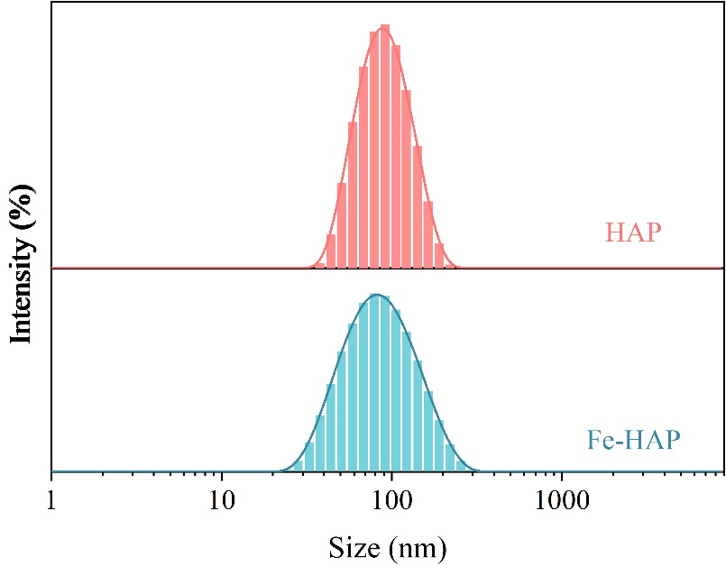
Fig.S1 The particle size distribution of HAP and Fe-HAP nanoparticles.

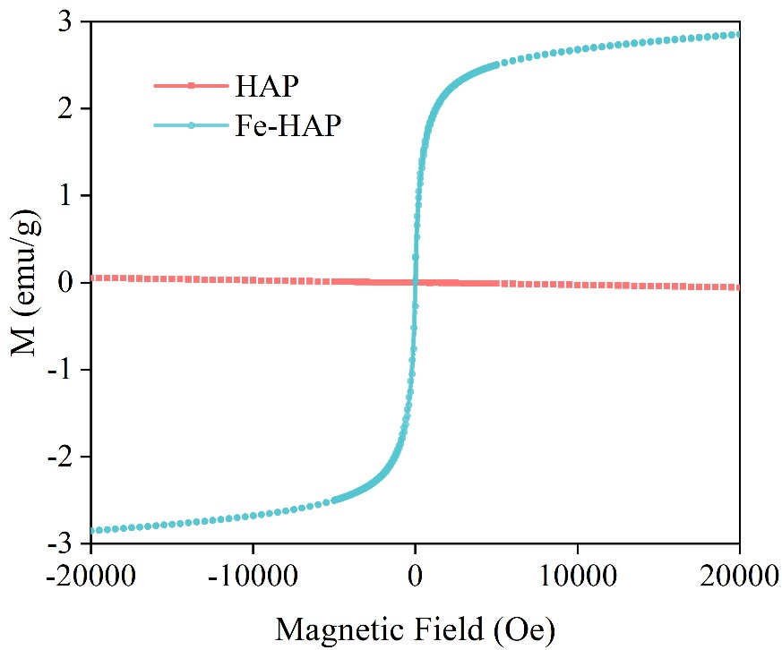
Fig.S2 The magnetization curve of Fe-HAP nanoparticles.
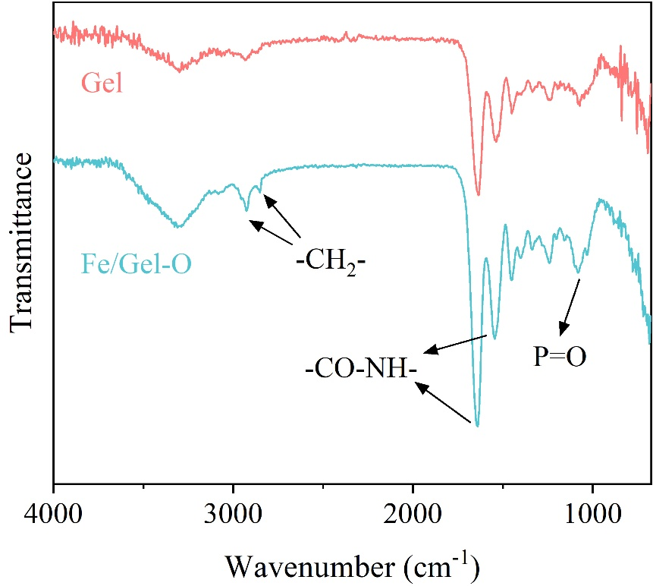
Fig.S3 ATR spectra of pure gelatin scaffolds and Gel/Fe-HAP composite scaffolds.

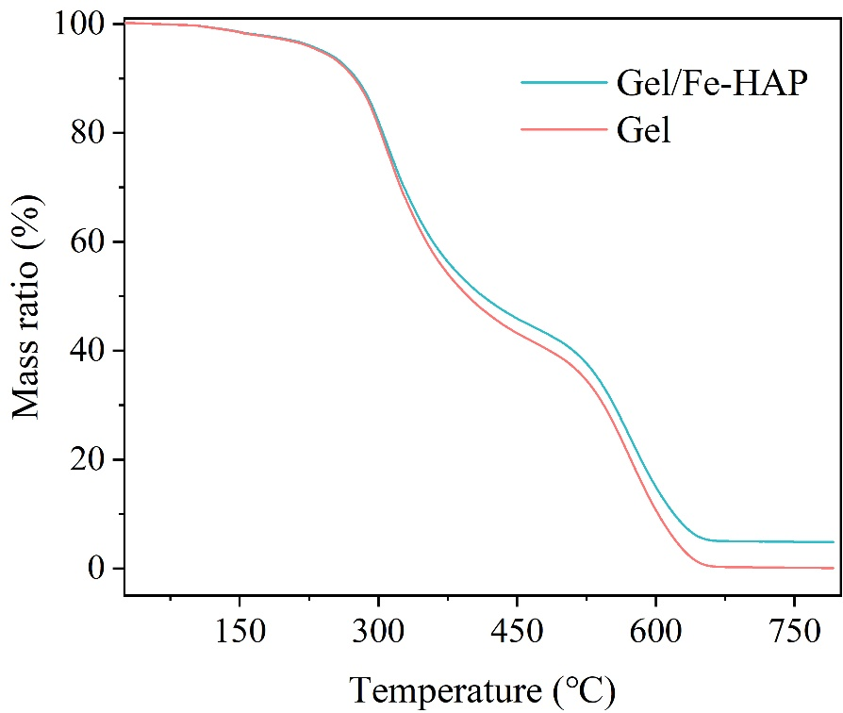
Fig.S4 Thermogravimetric curves of pure gelatin scaffolds and Gel/Fe-HAP composite scaffolds.

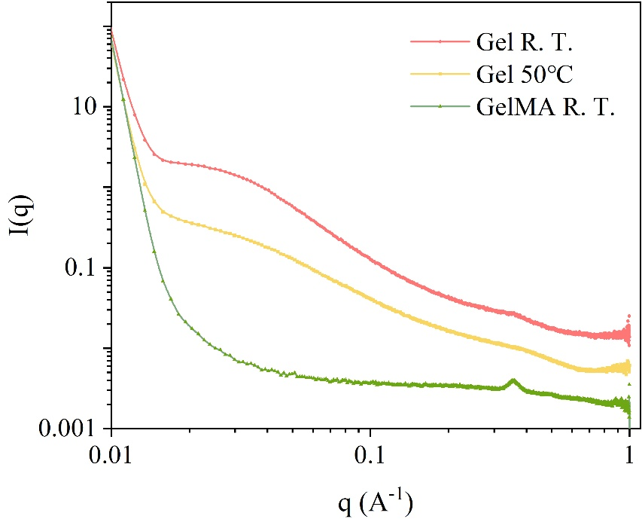
Fig.S5 One-dimensional SAXs curves of gelatin gel and GelMA gel at room temperature, and gelatin gel at 50℃.

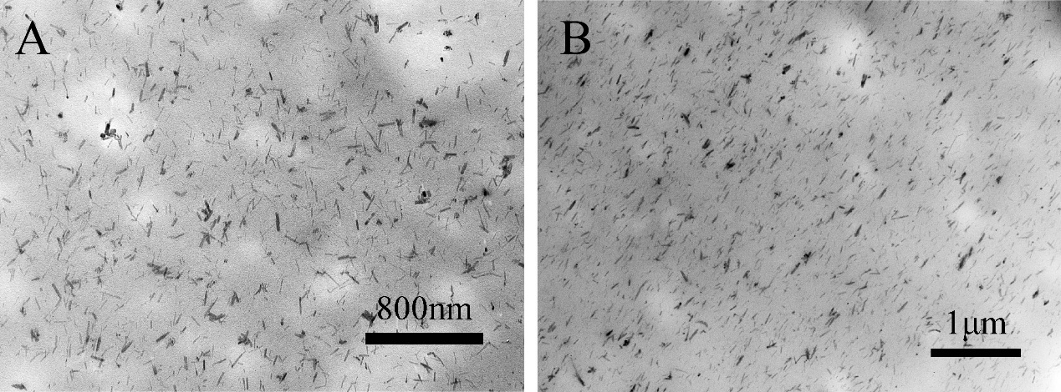
Fig.S6 TEM images of the outside (A) and interior (B) sections of the Gel/Fe-HAP composite.

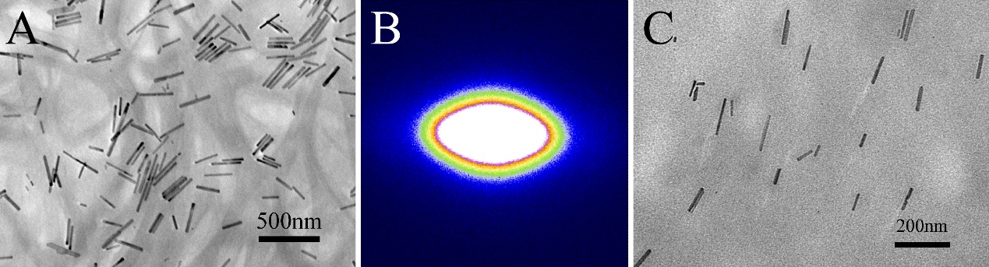
Fig.S7 TEM image of HAP nanoparticles with a relatively long aspect ratio obtained by adjusting the pH value (A); SAXs image of Gel/HAP composite scaffolds after regulating the aspect ratio of HAP (B); TEM image of Gel/HAP composite scaffold slices after regulating the aspect ratio of HAP (C).

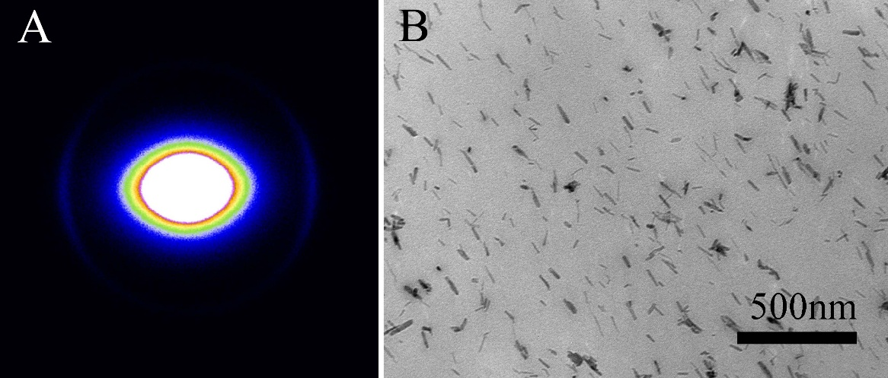
Fig.S8 SAXs image of Gel/Fe-HAP/PEG-4000 hydrogel (A); TEM image of Gel/Fe-HAP/PEG-4000 hydrogel (B).

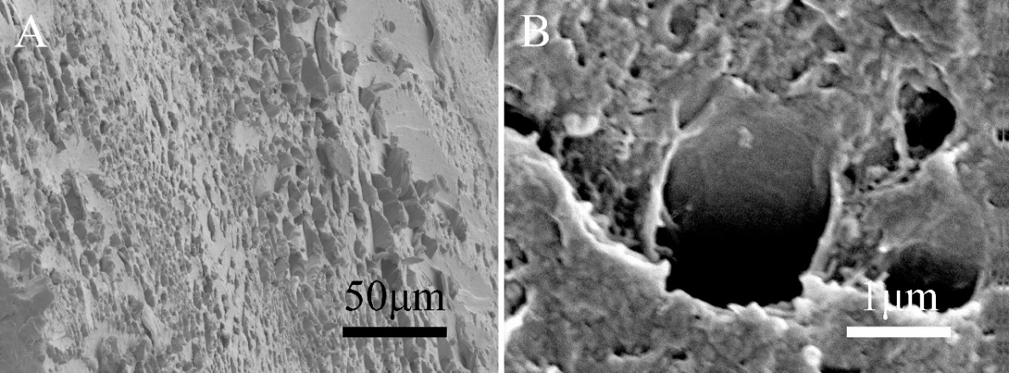
Fig.S9 SEM images of Gel/Fe-HAP composite scaffold.

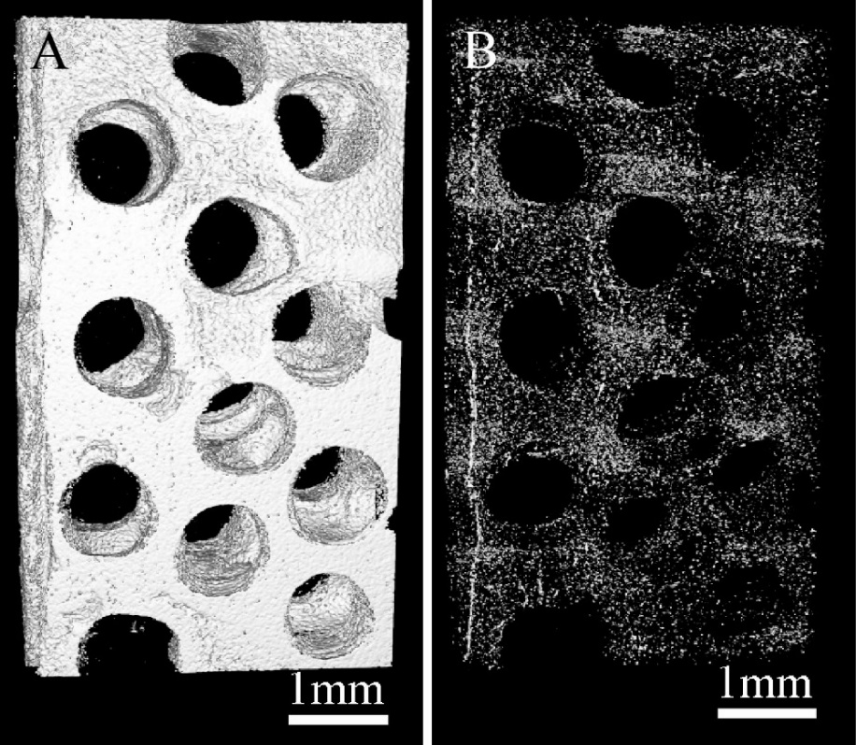
Fig.S10 CT images of the Gel/Fe-HAP composite scaffold. A: Three-dimensional morphology of the scaffold; B: Distribution of mineral phases in the scaffold.

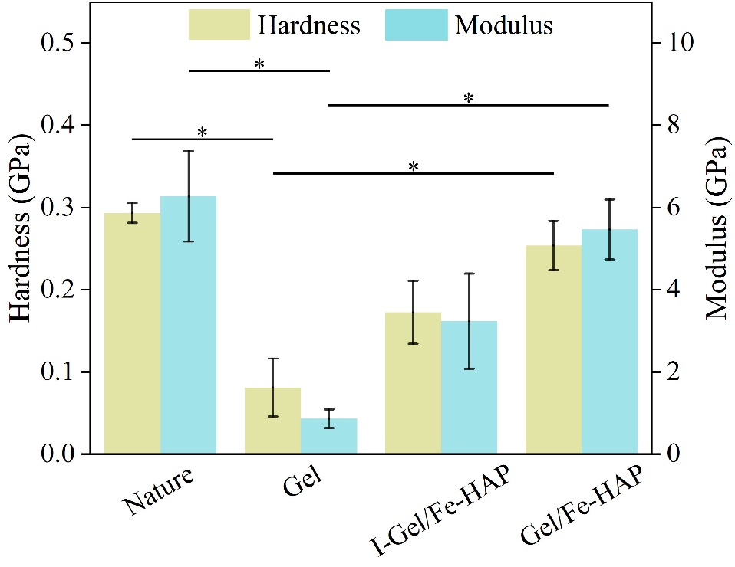
Fig.S11 Hardness and elastic modulus of the defect sites of different group after 12 weeks measured by nanoindentation (n = 3).

Table S1 Crystallographic data of HAP and Fe-HAP
Sample | a (Å) | c (Å) | c/a | Volume (Å³)
HAP | 9.420981 | 6.878114 | 0.730085 | 528.68
Fe-HAP | 9.407488 | 6.824262 | 0.725407 | 523.04

