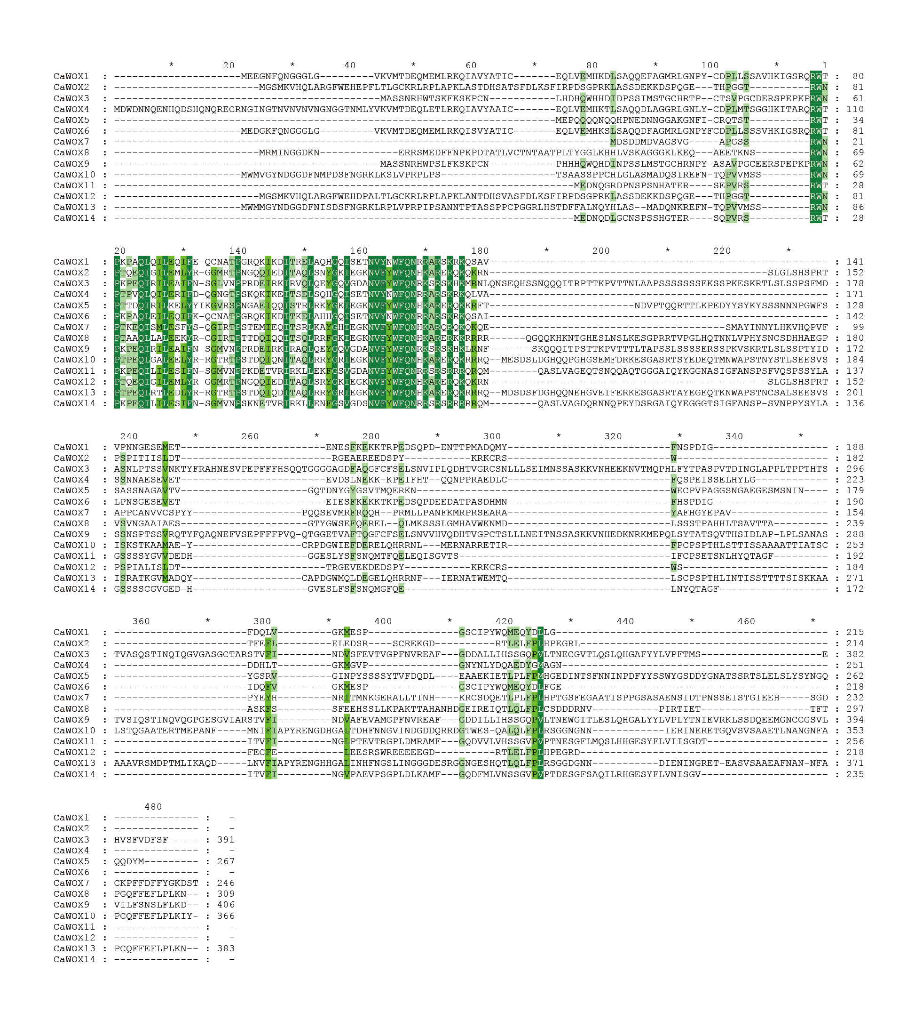
The result of sequence comparison of CaWOX gene families

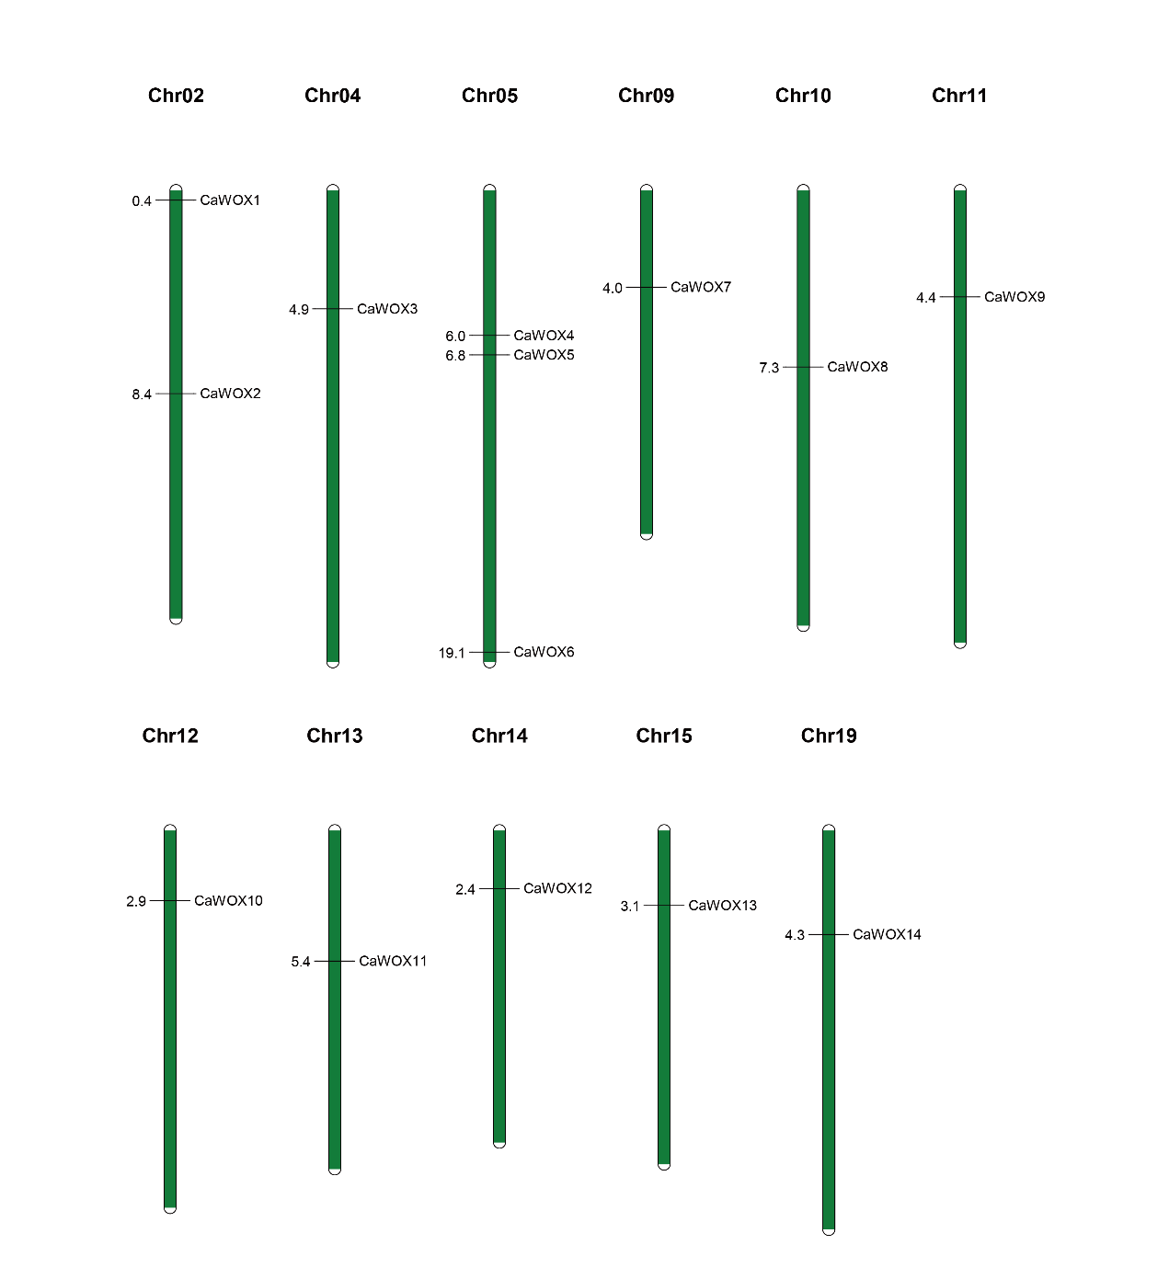
The results of chromosome localization for the CaWOX gene family

The results of Ka/Ks for CaWOX gene family
Seq_1 | Seq_2 | Ka | Ks | Ka_Ks | EffectiveLen | AverageS-sites | AverageN-sites | cN | cS | pN | pS
CaWOX1 | CaWOX4 | 0.247949 | 1.311748 | 0.189021 | 639 | 137.3333 | 501.6667 | 105.9167 | 85.08333 | 0.21113 | 0.619539
CaWOX1 | CaWOX6 | 0.059003 | 0.406183 | 0.145263 | 645 | 133.9167 | 511.0833 | 29 | 42 | 0.056742 | 0.313628
CaWOX2 | CaWOX12 | 0.038923 | 0.226551 | 0.171808 | 639 | 138.0833 | 500.9167 | 19 | 27 | 0.03793 | 0.195534
CaWOX3 | CaWOX9 | 0.144302 | 0.484628 | 0.297758 | 1143 | 265.6667 | 877.3333 | 115.1667 | 94.83333 | 0.131269 | 0.356964
CaWOX4 | CaWOX6 | 0.248161 | 1.360945 | 0.182344 | 630 | 136.5833 | 493.4167 | 104.25 | 85.75 | 0.211282 | 0.627822
CaWOX8 | CaWOX10 | 0.431422 | 1.751819 | 0.246271 | 858 | 193.25 | 664.75 | 218.0833 | 130.9167 | 0.328068 | 0.677447
CaWOX10 | CaWOX13 | 0.138441 | 0.384555 | 0.360003 | 1074 | 242.0833 | 831.9167 | 105.1667 | 72.83333 | 0.126415 | 0.300861
CaWOX11 | CaWOX14 | 0.117942 | 0.301279 | 0.391471 | 705 | 165.9167 | 539.0833 | 58.83333 | 41.16667 | 0.109136 | 0.248117

