Supplementary Appendix

Sodium-Glucose Cotransporter-2 Inhibitors and Gastrointestinal Neoplasms Risk in Type 2 Diabetes: A Systematic Review and Meta-Analysis of Randomized Controlled Trials

Yu-Fan Zhang ^{1, 2, #}, Jia-Jie Xie ^{1, 2, #}, Qi Wu ^{1, 2, 3, 5, #}, Xiao-Yu Zhou ², Chen Zeng ^{1, 2}, Yan Zeng ^{1, 2}, Yi-Meng He ^{1, 2}, Man Guo ^{1, 2, 3, 4,}*, Fang-Yuan Teng ^{1, 2, 3, 4,}*, Yong Xu ^{1, 2, 3, 4,}*

¹ Department of Endocrinology and Metabolism, the Affiliated Hospital of Southwest Medical University, Luzhou, Sichuan 646000, China
² School of Clinical Medicine, Southwest Medical University, Luzhou, Sichuan 646000, China
³ Metabolic Vascular Diseases Key Laboratory of Sichuan Province, and Metabolic Vascular Diseases Key Laboratory of Sichuan-Chongqing Cooperation, Luzhou, Sichuan 646000, China
⁴ Sichuan Clinical Research Center for Nephropathy, and Sichuan Clinical Research Center for Diabetes and Metabolic Disease, the Affiliated Hospital of Southwest Medical University, Luzhou, Sichuan 646000, China
⁵ Department of Pathology, the Affiliated Hospital of Southwest Medical University, Luzhou, Sichuan 646000, China

# These authors contributed equally: Yu-Fan Zhang, Jia-Jie Xie, and Qi Wu
* Corresponding authors: Yong Xu (xywyll@swmu.edu.cn) (ORCID: 0000-0002-9534-6252), Fang-Yuan Teng (tengfangyuan383@swmu.edu.cn) and Man Guo (guoman613@163.com)
List of Tables and Figures
Appendix 1. PRISMA checklist.
Appendix 2. Data sources and search strategies.
Appendix 3. Eligibility criteria of included studies.
Appendix 4. Classification and definition of different subgroups.
Appendix 5. Assessments of risks of bias of eligible studies.
eFigure 1. Overall risk of bias of all randomized clinical trials.
eFigure 2. Subgroup analysis by GI neoplasm subtype in adults with type 2 diabetes treated with SGLT2 inhibitors
eFigure 3. Subgroup analysis of GI neoplasm risk by SGLT2 inhibitor type in patients with diabetes
eFigure 4. Factors and risks of gastric neoplasms in RCTs of SGLT2 inhibitors use
eFigure 5. Factors and risks of esophageal neoplasms in RCTs of SGLT2 inhibitors use
eFigure 6. Factors and risks of pancreatic neoplasms in RCTs of SGLT2 inhibitors use
eFigure 7. Factors and risks of liver neoplasms in RCTs of SGLT2 inhibitors use
eFigure 8. Factors and risks of colonic neoplasms in RCTs of SGLT2 inhibitors use
eFigure 9. Factors and risks of colorectal neoplasms in RCTs of SGLT2 inhibitors use
eFigure 10. Factors and risks of rectal neoplasms in RCTs of SGLT2 inhibitors use
eFigure 11. Sensitivity analysis for overall GI neoplasms (SGLT2 inhibitors vs control)
eFigure 12. Sensitivity analysis for gastric neoplasms
eFigure 13. Sensitivity analysis for pancreatic neoplasms
eFigure 14. Sensitivity analysis for hepatic neoplasms
eFigure 15. Sensitivity analysis for colonic neoplasms
eFigure 16. Sensitivity analysis for rectal neoplasms
eFigure 17. Funnel plot for overall GI neoplasms
eFigure 18. Funnel plot for overall gastric neoplasms
eFigure 19. Funnel plot for overall pancreatic neoplasms
eFigure 20. Funnel plot for overall hepatic neoplasms
eFigure 21. Funnel plot for overall colonic neoplasms
eFigure 22. Funnel plot for overall rectal neoplasms
eFigure 23. Egger’s publication bias plot for overall GI neoplasms
eFigure 24. Egger’s publication bias plot for gastric neoplasms
eFigure 25. Egger’s publication bias plot for pancreatic neoplasms
eFigure 26. Egger’s publication bias plot for hepatic neoplasms
eFigure 27. Egger’s publication bias plot for colonic neoplasms
eFigure 28. Egger’s publication bias plot for rectal neoplasms

Appendix 1. PRISMA checklist.
Section and Topic | Item # | Checklist item | Location where item is reported
TITLE
Title | 1 | Identify the report as a systematic review. | Title page, p.1
ABSTRACT
Abstract | 2 | See the PRISMA 2020 for Abstracts checklist. | Abstract, p.3
INTRODUCTION
Rationale | 3 | Describe the rationale for the review in the context of existing knowledge. | Introduction, p.4-5
Objectives | 4 | Provide an explicit statement of the objective(s) or question(s) the review addresses. | Introduction, p.5
METHODS
Eligibility criteria | 5 | Specify the inclusion and exclusion criteria for the review and how studies were grouped for the syntheses. | Methods, p.6
Information sources | 6 | Specify all databases, registers, websites, organisations, reference lists and other sources searched or consulted to identify studies. Specify the date when each source was last searched or consulted. | Methods, p.5-6
Search strategy | 7 | Present the full search strategies for all databases, registers and websites, including any filters and limits used. | Methods, p5-6
Selection process | 8 | Specify the methods used to decide whether a study met the inclusion criteria of the review, including how many reviewers screened each record and each report retrieved, whether they worked independently, and if applicable, details of automation tools used in the process. | Methods, p.6
Data collection process | 9 | Specify the methods used to collect data from reports, including how many reviewers collected data from each report, whether they worked independently, any processes for obtaining or confirming data from study investigators, and if applicable, details of automation tools used in the process. | Methods, p.7
Data items | 10a | List and define all outcomes for which data were sought. Specify whether all results that were compatible with each outcome domain in each study were sought (e.g. for all measures, time points, analyses), and if not, the methods used to decide which results to collect. | Methods, p.7
Data items | 10b | List and define all other variables for which data were sought (e.g. participant and intervention characteristics, funding sources). Describe any assumptions made about any missing or unclear information. | Methods, p.7
Study risk of bias assessment | 11 | Specify the methods used to assess risk of bias in the included studies, including details of the tool(s) used, how many reviewers assessed each study and whether they worked independently, and if applicable, details of automation tools used in the process. | Methods, p.7
Effect measures | 12 | Specify for each outcome the effect measure(s) (e.g. risk ratio, mean difference) used in the synthesis or presentation of results. | Methods, p.7
Synthesis methods | 13a | Describe the processes used to decide which studies were eligible for each synthesis (e.g. tabulating the study intervention characteristics and comparing against the planned groups for each synthesis (item #5)). | Methods, p.7-8
Synthesis methods | 13b | Describe any methods required to prepare the data for presentation or synthesis, such as handling of missing summary statistics, or data conversions. | Methods, p.7-8
Synthesis methods | 13c | Describe any methods used to tabulate or visually display results of individual studies and syntheses. | Methods, p.7-8
Synthesis methods | 13d | Describe any methods used to synthesize results and provide a rationale for the choice(s). If meta-analysis was performed, describe the model(s), method(s) to identify the presence and extent of statistical heterogeneity, and software package(s) used. | Methods, p.7-8
Synthesis methods | 13e | Describe any methods used to explore possible causes of heterogeneity among study results (e.g. subgroup analysis, meta-regression). | Methods, p.7-8
Synthesis methods | 13f | Describe any sensitivity analyses conducted to assess robustness of the synthesized results. | Methods, p.7-8
Reporting bias assessment | 14 | Describe any methods used to assess risk of bias due to missing results in a synthesis (arising from reporting biases). | Methods, p.7
Certainty assessment | 15 | Describe any methods used to assess certainty (or confidence) in the body of evidence for an outcome. | Methods, p.7
RESULTS
Study selection | 16a | Describe the results of the search and selection process, from the number of records identified in the search to the number of studies included in the review, ideally using a flow diagram. | Results, p.9
Study selection | 16b | Cite studies that might appear to meet the inclusion criteria, but which were excluded, and explain why they were excluded. | Supplementary Appendix 3, p.20
Study characteristics | 17 | Cite each included study and present its characteristics. | Results, p.9-10
Risk of bias in studies | 18 | Present assessments of risk of bias for each included study. | Supplementary Appendix 5, p.22-23
Results of individual studies | 19 | For all outcomes, present, for each study: (a) summary statistics for each group (where appropriate) and (b) an effect estimate and its precision (e.g. confidence/credible interval), ideally using structured tables or plots. | Results, p.10-11
Results of syntheses | 20a | For each synthesis, briefly summarise the characteristics and risk of bias among contributing studies. | Results, p.9-11
Results of syntheses | 20b | Present results of all statistical syntheses conducted. If meta-analysis was done, present for each the summary estimate and its precision (e.g. confidence/credible interval) and measures of statistical heterogeneity. If comparing groups, describe the direction of the effect. | Results, p.10-11
Results of syntheses | 20c | Present results of all investigations of possible causes of heterogeneity among study results. | Results, p.10-11
Results of syntheses | 20d | Present results of all sensitivity analyses conducted to assess the robustness of the synthesized results. | Supplementary, p. 51-54
Reporting biases | 21 | Present assessments of risk of bias due to missing results (arising from reporting biases) for each synthesis assessed. | Results, p.11-12
Certainty of evidence | 22 | Present assessments of certainty (or confidence) in the body of evidence for each outcome assessed. | Not applicable
DISCUSSION
Discussion | 23a | Provide a general interpretation of the results in the context of other evidence. | Discussion, p.12-13
Discussion | 23b | Discuss any limitations of the evidence included in the review. | Discussion, p.14
Discussion | 23c | Discuss any limitations of the review processes used. | Discussion, p.14
Discussion | 23d | Discuss implications of the results for practice, policy, and future research. | Discussion, p.15
OTHER INFORMATION
Registration and protocol | 24a | Provide registration information for the review, including register name and registration number, or state that the review was not registered. | Methods, p.5
Registration and protocol | 24b | Indicate where the review protocol can be accessed, or state that a protocol was not prepared. | Methods, p.5
Registration and protocol | 24c | Describe and explain any amendments to information provided at registration or in the protocol. | Methods, p.5
Support | 25 | Describe sources of financial or non-financial support for the review, and the role of the funders or sponsors in the review. | Declarations, p.15
Competing interests | 26 | Declare any competing interests of review authors. | Declarations, p.15
Availability of data, code and other materials | 27 | Report which of the following are publicly available and where they can be found: template data collection forms; data extracted from included studies; data used for all analyses; analytic code; any other materials used in the review. | Declarations, p.15
From: Page MJ, McKenzie JE, Bossuyt PM, Boutron I, Hoffmann TC, Mulrow CD, et al. The PRISMA 2020 statement: an updated guideline for reporting systematic reviews. BMJ 2021;372:n71. doi: 10.1136/bmj.n71. For more information, visit: http://www.prisma-statement.org/

Appendix 2. Data sources and search strategies
Table S1. Search strategy of PubMed
# | Searches
1 | (Sodium-Glucose Transporter 2 Inhibitors [Mesh]) OR (Sodium Glucose Transporter 2 Inhibitors[Title/Abstract]) OR (SGLT-2 Inhibitors OR SGLT 2 Inhibitors OR SGLT-2 Inhibitor OR Inhibitor, SGLT-2 OR SGLT 2 Inhibitor OR Sodium-Glucose Transporter 2 Inhibitor OR Sodium Glucose Transporter 2 Inhibitor OR SGLT2 inhibitors OR Inhibitor, SGLT2 OR Gliflozins OR Gliflozin OR SGLT2 inhibitors [Title/Abstract]) | 13,654
2 | (Canagliflozin OR Invokana OR JNJ 28431754 OR Canagliflozin, Anhydrous OR 1-(Glucopyranosyl)-4-methyl-3-(5-(4-fluorophenyl)-2-thienylmethyl)benzene OR Canagliflozin Hemihydrate [Title/Abstract]) OR (Dapagliflozin OR Farxiga OR BMS-512148 [Title/Abstract]) OR (Ertugliflozin OR Steglatro OR PF-04971729 [Title/Abstract]) OR (Bexagliflozin OR THR-1442 OR EGT1442) OR EGT0001442 OR Bexacat[Title/Abstract]) OR (Sotagliflozin OR Inpefa OR LX-4211[Title/Abstract]) OR (velagliflozin OR Senvelgo OR LX-4211[Title/Abstract]) OR (Sergliflozin etabonate OR GW-869682 OR GW-869682X OR KGT-1251 OR GW869682X OR GW869682 OR KGT1251[Title/Abstract]) OR (Ipragliflozin OR Suglat OR ASP1941 OR Ipragliflozin L-proline[Title/Abstract]) OR (Tofogliflozin OR CSG452 OR Apleway OR CSG-452[Title/Abstract]) OR (Luseogliflozin OR Lusefi OR Luseogliflozin hydrate OR TS 071[Title/Abstract]) OR (Remogliflozin OR GSK189074 OR Remogliflozin A OR GSK-189074 OR GSK 189074 OR BHV 091009 OR BHV-091009[Title/Abstract]) OR (Licogliflozin OR LIK066[Title/Abstract]) OR (Enavogliflozin OR DWJ-16001 OR DWP-16001 OR DWP16001 drug A[Title/Abstract]) OR (Rongliflozin OR DJT1116PG OR HEC-44616 OR HEC44616[Title/Abstract]) OR (Henagliflozin OR SHR3824 OR SHR 3824 OR SHR-3824[Title/Abstract]) | 4,820
3 | #1 OR #2 | 14,591
4 | (((((((((((((((((digestive OR gastrointestinal) AND (cancer OR carcinoma OR neoplas* OR tumor OR tumour OR malignan*) )) OR (" Digestive System neoplasms"[Mesh])) OR ("Gastrointestinal neoplasms"[Mesh])) OR ((((Stomach OR Gastric ) AND (cancer OR carcinoma OR neoplas* OR tumor OR tumour OR malignan*))) OR ("gastric neoplasms"[Mesh]))) OR (((Esophageal neoplasms[MeSH Terms])) OR ((esophag* OR oesophag*) AND (cancer OR carcinoma OR neoplas* OR tumor OR tumour OR malignan*) )))) OR (((((Liver neoplasms [MeSH Terms])) OR ((liver OR Hepatic OR Hepatocellular ) AND (cancer OR carcinoma OR neoplas* OR tumor OR tumour OR malignan*) )) OR (Hepatoma*[Title/Abstract])) OR (hepatocarcinoma[Title/Abstract]))) OR (((Colorectal neoplasms[MeSH Terms])) OR ((Colorectal ) AND (cancer OR carcinoma OR neoplas* OR tumor OR tumour OR malignan*[Title/Abstract]))) OR (((((((Colonic neoplasms [MeSH Terms])) OR ((Colon*) AND (cancer OR carcinoma OR neoplas* OR tumor OR tumour OR malignan*))) OR (Colon Adenocarcinoma[Title/Abstract])) OR (Adenocarcinoma, Colon[Title/Abstract])) OR (Adenocarcinomas, Colon[Title/Abstract])) OR (Colon Adenocarcinomas[Title/Abstract]))) OR (((Rectal neoplasms [MeSH Terms])) OR ((Rectal OR Rectum) AND (cancer OR carcinoma OR neoplas* OR tumor OR tumour OR malignan*)))) OR (((Anus neoplasms [MeSH Terms])) OR ((Anus OR Anal) AND (cancer OR carcinoma OR neoplas* OR tumor OR tumour OR malignan*)))) OR (((Pancreatic neoplasms[MeSH Terms])) OR ((pancrea*) AND (cancer OR carcinoma OR neoplas* OR tumor OR tumour OR malignan*) ))) OR (((Gallbladder cancer [MeSH Terms])) OR ((Gallbladder OR Gall Bladder) AND (cancer OR carcinoma OR neoplas* OR tumor OR tumour OR malignan*)))) OR (((Cholangiocarcinoma [MeSH Terms])) OR (((Cholangiocellular) AND (cancer OR carcinoma* )) OR ((Extrahepatic OR Intrahepatic) AND (Cholangiocarcinoma*) ) OR Cholangiocarcinomas[Title/Abstract]))) OR (((Intestinal neoplasms[MeSH Terms])) OR ((Intestinal OR Intestines) AND (cancer OR carcinoma OR neoplas* OR tumor OR tumour OR malignan*)))) OR (((bile duct cancers [MeSH Terms])) OR ((Bile Duct) AND (cancer OR carcinoma OR neoplas* OR tumor OR tumour OR malignan*))) OR (((Biliary Tract neoplasms[MeSH Terms])) OR ((Biliary Tract ) AND (cancer OR carcinoma OR neoplas* OR tumor OR tumour OR malignan*)))) OR (((duodenal neoplasms[MeSH Terms])) OR ((Duodenal OR Duodenum) AND (cancer OR carcinoma OR neoplas* OR tumor OR tumour OR malignan*))) | 1,525,868
5 | #3 AND #4 | 273
6 | (((random* [Title/Abstract])) OR (Randomized Controlled Trial [Title/Abstract])) OR (RCT or RCTs [Title/Abstract]) | 1,632,713
7 | #5 AND #6 | 40

Table S2. Search strategy of Embase
# | Searches
1 | 'sodium glucose cotransporter 2 inhibitor'/exp OR 'sodium glucose cotransporter 2 inhibitor'
2 | 'gliflozin' OR 'gliflozin derivative' OR 'gliflozins' OR 'sglt2 inhibitor' OR 'SGLT2 inhibitors ' OR 'sodium dependent glucose cotransporter 2 inhibitor' OR 'sodium glucose co-transporter 2 inhibitor' OR 'sodium-glucose transporter 2 inhibitors' OR 'sodium glucose cotransporter 2 inhibitor':ab,ti
3 | 'canagliflozin'/exp OR 'canagliflozin'
4 | '1 (glucopyranosyl) 4 methyl 3 [5 (4 fluorophenyl) 2 thienylmethyl] benzene' OR '1, 5 anhydro 1 c [3 [5 (4 fluorophenyl) 2 thenyl] 4 methylphenyl] glucitol' OR '1, 5 anhydro 1 c [3 [ [5 (4 fluorophenyl) 2 thienyl] methyl] 4 methylphenyl] d glucitol' OR '1, 5 anhydro 1 c [3 [ [5 (4 fluorophenyl) thiophen 2 yl] methyl] 4 methylphenyl] d glucitol' OR '2 [3 [5 (4 fluorophenyl) 2 thiophenylmethyl] 4 methylphenyl] 6 (hydroxymethyl) tetrahydro 3, 4, 5 pyrantriol' OR '2 [3 [5 (4 fluorophenyl) thiophen 2 ylmethyl] 4 methylphenyl] 6 (hydroxymethyl) tetrahydropyran 3, 4, 5 triol' OR '2 [3 [ [5 (4 fluorophenyl) 2 thiophenyl] methyl] 4 methylphenyl] 6 (hydroxymethyl) 3, 4, 5 oxanetriol' OR '2 [3 [ [5 (4 fluorophenyl) thiophen 2 yl] methyl] 4 methylphenyl] 6 (hydroxymethyl) oxane 3, 4, 5 triol' OR 'canagliflocin' OR 'canagliflozin hemihydrate' OR 'canaglu' OR 'invokana' OR 'jnj 28431754' OR 'jnj28431754' OR 'sulisent' OR 'ta 7284' OR 'ta7284' OR 'canagliflozin':ab,ti
5 | 'dapagliflozin'/exp OR 'dapagliflozin'
6 | '1 [4 chloro 3 (4 ethoxybenzyl) phenyl] 1 deoxy beta d glucopyranose' OR '1, 5 anhydro 1 c [4 chloro 3 [ (4 ethoxyphenyl) methyl] phenyl] dextro glucitol' OR '2 (3 (4 ethoxybenzyl) 4 chlorophenyl) 6 hydroxymethyltetrahydro 2h pyran 3, 4, 5 triol' OR '2 [4 chloro 3 (4 ethoxybenzyl) phenyl] 6 (hydroxymethyl) oxane 3, 4, 5 triol' OR '2 [4 chloro 3 [ (4 ethoxyphenyl) methyl] phenyl] 6 (hydroxymethyl) oxane 3, 4, 5 triol' OR 'andatang' OR 'bms 512148' OR 'bms512148' OR 'ckd 380' OR 'ckd380' OR 'dapagliflozin acetate' OR 'dapagliflozin propanediol' OR 'dapagliflozin propanediol monohydrate' OR 'dwp 16001' OR 'dwp16001' OR 'edistride' OR 'farxiga' OR 'forxiga' OR 'hgp 1602' OR 'hgp 1812' OR 'hgp1602' OR 'hgp1812' OR 'lyn 045' OR 'lyn045' OR 'oxra' OR 'dapagliflozin':ab,ti
7 | 'ertugliflozin'/exp OR 'ertugliflozin'
8 | '1 (hydroxymethyl) 5 [3 (4 ethoxybenzyl) 4 chlorophenyl] 6, 8 dioxabicyclo [3.2.1] octane 2beta, 3alpha, 4beta triol' OR '1, 6 anhydro 1 [4 chloro 3 (4 ethoxybenzyl) phenyl] 5 hydroxymethyl beta l idopyranose' OR '1, 6 anhydro 1 c [4 chloro 3 [ (4 ethoxyphenyl) methyl] phenyl] 5 c (hydroxymethyl) beta l idopyranose' OR '5 [4 chloro 3 (4 ethoxybenzyl) phenyl] 1 hydroxymethyl 6, 8 dioxabicyclo [3.2.1] octane 2, 3, 4 triol' OR '5 [4 chloro 3 [ (4 ethoxyphenyl) methyl] phenyl] 1 (hydroxymethyl) 6, 8 dioxabicyclo [3.2.1] octane 2, 3, 4 triol' OR 'ertugliflozin pidolate' OR 'ertugliflozin pyroglutamic acid' OR 'mk 8835' OR 'mk8835' OR 'pf 04971729' OR 'pf 04971729 00' OR 'pf 04971729-00' OR 'pf 4971729' OR 'pf 4971729 00' OR 'pf 4971729-00' OR 'pf04971729' OR 'pf04971729 00' OR 'pf04971729-00' OR 'pf4971729' OR 'pf4971729 00' OR 'pf4971729-00' OR 'steglatro' OR 'ertugliflozin':ab,ti
9 | '1, 5 anhydro 1 [4 chloro 3 [4 [2 (cyclopropyloxy) ethoxy] benzyl] phenyl] glucitol' OR '1, 5 anhydro 1 [4 chloro 3 [ [4 [2 (cyclopropyloxy) ethoxy] phenyl] methyl] phenyl] glucitol' OR '1, 5 anhydro 1 c [4 chloro 3 [ [4 [2 (cyclopropyloxy) ethoxy] phenyl] methyl] phenyl] dextro glucitol' OR '2 [4 chloro 3 [4 [2 (cyclopropyloxy) ethoxy] benzyl] phenyl] 6 (hydroxymethyl) tetrahydro 2h pyran 3, 4, 5 triol' OR '2 [4 chloro 3 [ [4 [2 (cyclopropyloxy) ethoxy] phenyl] methyl] phenyl] 6 (hydroxymethyl) tetrahydro 2h pyran 3, 4, 5 triol' OR 'bexaglifozin' OR 'brenzavvy' OR 'egt 0001442' OR 'egt 1442' OR 'egt0001442' OR 'egt1442' OR 'thr 1442' OR 'thr1442' OR 'bexagliflozin' OR 'bexacat':ab,ti
10 | 'bexagliflozin'/exp OR 'bexagliflozin'
11 | '2 [4 chloro 3 (4 ethoxybenzyl) phenyl] 6 (methylthio) tetrahydro 2h pyran 3, 4, 5 triol' OR 'inpefa' OR 'lp 802034' OR 'lp802034' OR 'lx 4211' OR 'lx4211' OR 'methyl 5 [4 chloro 3 (4 ethoxybenzyl) phenyl] 1 thio beta levo xylopyranoside' OR 'methyl 5 [4 chloro 3 [ (4 ethoxyphenyl) methyl] phenyl] 1 thio beta levo xylopyranoside' OR 'sar 439954' OR 'sar439954' OR 'zynquista' OR 'sotagliflozin' OR 'inpefa':ab,ti
12 | 'sotagliflozin'/exp OR 'sotagliflozin'
13 | #1 OR #2
14 | #3 OR #4
15 | #5 OR #6
16 | #7 OR #8
17 | #9 OR #10
18 | #11 OR #12
19 | 'sergliflozin etabonate'/exp OR 'sergliflozin etabonate'
20 | '2 (4 methoxybenzyl) phenyl 6 o (ethoxycarbonyl) beta dextro glucopyranoside' OR '2 [ (4 methoxyphenyl) methyl] phenyl 6 o (ethoxycarbonyl) beta dextro glucopyranoside' OR 'gw 869682' OR 'gw 869682x' OR 'gw869682' OR 'gw869682x' OR 'kgt 1251' OR 'kgt1251' OR 'sergliflozin' OR 'sergliflozin etabonate':ab,ti
21 | 'ipragliflozin'/exp OR 'ipragliflozin'
22 | '1, 5 anhydro 1 c [3 [ (1 benzothiophen 2 yl) methyl] 4 fluorophenyl] dextro glucitol' OR 'asp 1941' OR 'asp1941' OR 'ipragliflozin' OR 'suglat':ab,ti
23 | 'tofogliflozin'/exp OR 'tofogliflozin'
24 | '6 (4 ethylbenzyl) 3`, 4`, 5`, 6` tetrahydro 6` hydroxymethylspiro [isobenzofuran 1 (3h), 2` pyran] 3`, 4`, 5` triol' OR '6 [ (4 ethylphenyl) methyl] 3`, 4`, 5`, 6` tetrahydro 6` (hydroxymethyl) spiro [isobenzofuran 1 (3h), 2` [2h] pyran] 3`, 4`, 5` triol' OR '6 [ (4 ethylphenyl) methyl] 6` (hydroxymethyl) 3`, 4`, 5`, 6` tetrahydro 3h spiro [2 benzofuran 1, 2` pyran] 3`, 4`, 5` triol' OR 'csg 452' OR 'csg452' OR 'rg 7201' OR 'rg7201' OR 'tofogliflozin':ab,ti
25 | 'luseogliflozin'/exp OR 'luseogliflozin'
26 | '1, 5 anhydro 1 [5 (4 ethoxybenzyl) 2 methoxy 4 methylphenyl] 1 thio d glucitol' OR '1, 5 anhydro 1 [5 (4 ethoxybenzyl) 2 methoxy 4 methylphenyl] 1 thio dextro glucitol' OR '1, 5 anhydro 1 [5 (4 ethoxybenzyl) 2 methoxy 4 methylphenyl] 1 thioglucitol' OR '2 [5 (4 ethoxybenzyl) 2 methoxy 4 methylphenyl] 6 (hydroxymethyl) tetrahydrothiopyran 3, 4, 5 triol' OR '2 [5 [ (4 ethoxyphenyl) methyl] 2 methoxy 4 methylphenyl] 6 (hydroxymethyl) thiane 3, 4, 5 triol' OR 'lusefi' OR 'ts 071' OR 'ts071' OR 'luseogliflozin':ab,ti
27 | 'remogliflozin etabonate'/exp OR 'remogliflozin etabonate'
28 | '4 (4 isopropoxybenzyl) 1 isopropyl 5 methyl 1h pyrazol 3 yl 6 o (ethoxycarbonyl) beta dextro glucopyranoside' OR '5 methyl 4 [4 (1 methylethoxy) benzyl] 1 (1 methylethyl) 1h pyrazol 3 yl 6 o (ethoxycarbonyl) beta dextro glucopyranoside' OR 'gsk 189075' OR 'gsk 189075a' OR 'gsk189075' OR 'gsk189075a' OR 'remogliflozin etabonate':ab,ti
29 | '4 (4 isopropoxybenzyl) 1 isopropyl 5 methyl 1h pyrazol 3 yl 6 o (ethoxycarbonyl) beta dextro glucopyranoside' OR '5 methyl 4 [4 (1 methylethoxy) benzyl] 1 (1 methylethyl) 1h pyrazol 3 yl 6 o (ethoxycarbonyl) beta dextro glucopyranoside' OR 'gsk 189075' OR 'gsk 189075a' OR 'gsk189075' OR 'gsk189075a' OR 'remogliflozin etabonate':ab,ti
30 | 'lik 066' OR 'lik 66' OR 'lik066' OR 'lik66' OR 'licogliflozin':ab,ti
31 | 'enavogliflozin'/exp OR 'enavogliflozin'
32 | '1 [7 chloro 6 (4 cyclopropylbenzyl) 2, 3 dihydro 1 benzofuran 4 yl] 1 deoxy beta dextro glucopyranose' OR '1 [7 chloro 6 [ (4 cyclopropylphenyl) methyl] 2, 3 dihydro 1 benzofuran 4 yl] 1 deoxy beta dextro glucopyranose' OR '1, 5 anhydro 1 c [7 chloro 6 (4 cyclopropylbenzyl) 2, 3 dihydro 1 benzofuran 4 yl] dextro glucitol' OR '1, 5 anhydro 1 c [7 chloro 6 [ (4 cyclopropylphenyl) methyl] 2, 3 dihydro 1 benzofuran 4 yl] dextro glucitol' OR '2 (7 chloro 6 (4 cyclopropylbenzyl) 2, 3 dihydrobenzofuran 4 yl) 6 (hydroxymethyl) tetrahydro 2h pyran 3, 4, 5 triol' OR 'enavogliflozin' OR 'dwp-1600' OR 'dwj-16001':ab,ti
33 | 'henagliflozin'/exp OR henagliflozin
34 | 'shr3824' OR 'shr-3824' OR 'shr 3824':ab,ti
35 | rongliflozin
36 | #13 OR #14 OR #15 OR #16 OR #17 OR #18 OR #19 OR #20 OR #21 OR #22 OR #23 OR #24 OR #25 OR #26 OR #27 OR #28 OR #29 OR #30 OR #31 OR #32 OR #33 OR #34 OR #35
37 | 'gastrointestinal tumor'/exp OR 'gastrointestinal tumor'
38 | 'gastro intestinal tumor' OR 'gastro intestinal tumour' OR 'gastroenteric tumor' OR 'gastrointestinal neoplasia' OR 'gastrointestinal neoplasms' OR 'gastrointestinal tract neoplasia' OR 'gastrointestinal tract neoplasms' OR 'gastrointestinal tract tumor' OR 'gastrointestinal tract tumorigenesis' OR 'gastrointestinal tract tumour' OR 'gastrointestinal tumorigenesis' OR 'gastrointestinal tumour' OR 'gastrointestine tract tumor' OR 'gastrointestine tract tumour' OR 'gastrointestine tumor' OR 'gastrointestine tumour' OR 'gi neoplasia' OR 'gi neoplasms' OR 'gi tract tumor' OR 'gi tumor' OR 'neoplasia of the gastrointestinal tract' OR 'neoplasms of gastrointestinal tract' OR 'neoplastic gastro-intestinal' OR 'neoplastic gastrointestinal' OR 'neoplastic gastrointestinal tract' OR 'tumors of gastrointestinal tract' OR 'tumors of the gastro-intestinal tract' OR 'tumors of the gastrointestinal system' OR 'gastrointestinal tumor':ab,ti
39 | 'stomach tumor'/exp OR 'stomach tumor'
40 | 'gastric mass (tumor)' OR 'gastric masses (tumor)' OR 'gastric neoplasia' OR 'gastric neoplasms' OR 'gastric subepithelial tumor' OR 'gastric tumor' OR 'gastric tumorigenesis' OR 'gastric tumour' OR 'mucosa tumor, stomach' OR 'mucosa tumour, stomach' OR 'neoplasia of the stomach' OR 'neoplasms of the stomach' OR 'neoplasms of the stomach' OR 'neoplastic gastric' OR 'neoplastic stomach' OR 'stomach mucosa tumor' OR 'stomach mucosa tumour' OR 'stomach neoplasia' OR 'gastric neoplasms' OR 'gastric neoplasms' OR 'stomach tumorigenesis' OR 'stomach tumour' OR 'stomach ulcerated tumor' OR 'stomach ulcerated tumour' OR 'stomach ulcerating tumor' OR 'stomach ulcerating tumour' OR 'tumor of the gastric' OR 'tumor of the stomach' OR 'tumor, stomach mucosa' OR 'tumour of the gastric' OR 'tumour of the stomach' OR 'tumour, stomach mucosa' OR 'stomach tumor':ab,ti
41 | 'digestive system tumor'/exp
42 | 'alimentary canal tumor' OR 'alimentary canal tumour' OR 'alimentary neoplasia' OR 'alimentary tract tumor' OR 'alimentary tract tumour' OR 'digestive canal tumor' OR 'digestive canal tumour' OR 'digestive neoplasia' OR 'digestive neoplasms' OR 'digestive system neoplasms' OR 'digestive system neoplasms' OR 'digestive system tumour' OR 'digestive tract neoplasia' OR 'digestive tract neoplasms' OR 'digestive tract tumor' OR 'digestive tract tumour' OR 'digestive tumor' OR 'digestive tumour' OR 'tumor of digestive tract' OR 'tumor of the alimentary tract' OR 'tumor of the digestive system' OR 'digestive system tumor':ab,ti
43 | 'esophagus tumor'/exp
44 | 'esophageal mass (tumor)' OR 'esophageal masses (tumor)' OR 'esophageal neoplasms' OR 'esophageal tumor' OR 'esophageal tumorigenesis' OR 'esophagus neoplasms' OR 'esophagus tumour' OR 'neoplasia of the esophagus' OR 'neoplasia of the oesophagus' OR 'neoplasms of the esophagus' OR 'neoplastic esophageal' OR 'neoplastic esophagus' OR 'neoplastic oesophageal' OR 'oesophageal neoplasms' OR 'oesophageal tumor' OR 'oesophageal tumour' OR 'oesophagus tumor' OR 'oesophagus tumour' OR 'tumor of the esophagus' OR 'tumor, esophagus' OR 'tumors of the esophagus' OR 'tumour of the oesophagus' OR 'tumour, esophagus' OR 'tumours of the oesophagus' OR 'esophagus tumor':ab,ti
45 | 'liver tumor'/exp
46 | 'hepatic tumor' OR 'hepatic tumour' OR 'hepatocellular neoplasia' OR 'hepatocellular neoplasms' OR 'hepatocellular tumor' OR 'hepatocellular tumorigenesis' OR 'hepatocellular tumour' OR 'hepatocyte tumorigenesis' OR 'liver cell tumor' OR 'liver cell tumour' OR 'liver neoplasia' OR 'liver neoplasms' OR 'liver neoplasmsa' OR 'liver neoplasms' OR 'liver tumorigenesis' OR 'liver tumour' OR 'neoplasia of the liver' OR 'neoplasms of the liver' OR 'neoplastic hepatocellular' OR 'neoplastic liver' OR 'tumor of the liver' OR 'tumor, liver' OR 'tumour, liver' OR 'liver tumor':ab,ti
47 | 'liver cell carcinoma'/exp
48 | 'carcinoma in the liver' OR 'carcinoma of the liver' OR 'carcinoma, hepatic cell' OR 'carcinoma, hepatocellular' OR 'carcinoma, liver' OR 'carcinoma, liver cell' OR 'hepatic carcinoma' OR 'hepatic cell carcinoma' OR 'hepato-carcinoma' OR 'hepato-cellular carcinoma' OR 'hepatocarcinoma' OR 'hepatocellular carcinoma' OR 'hepatocellular carcinomata' OR 'hepatocyte carcinoma' OR 'hepatocytic carcinoma' OR 'hepatoma' OR 'hepatomata' OR 'hepatomatous' OR 'liver carcinoma' OR 'liver carcinoma rupture' OR 'malignant hepatoma' OR 'primary liver carcinoma' OR 'liver cell carcinoma':ab,ti
49 | 'colorectal tumor'/exp
50 | 'colorectal neoplasia' OR 'colorectal neoplasms' OR 'colorectal neoplasms' OR 'colorectal tumorigenesis' OR 'colorectal tumour' OR 'neoplastic colorectal' OR 'tumor, colorectal' OR 'tumour, colorectal' OR 'colorectal tumor':ab,ti
51 | 'colon tumor'/exp
52 | 'colon mass (tumor)' OR 'colon neoplasia' OR 'colon neoplasms' OR 'colon tumorigenesis' OR 'colon tumour' OR 'colon villous tumor' OR 'colon villous tumour' OR 'colonic mass (tumor)' OR 'colonic masses (tumor)' OR 'colonic neoplasia' OR 'colonic neoplasms' OR 'colonic neoplasms' OR 'colonic tumor' OR 'colonic tumorigenesis' OR 'colonic tumour' OR 'mesocolon tumor' OR 'mesocolon tumour' OR 'neoplasia in the colon' OR 'neoplasia of the colon' OR 'neoplastic colon' OR 'neoplastic colonic' OR 'tumor in the colon' OR 'tumor of the colon' OR 'tumorigenesis in colon' OR 'colon tumor':ab,ti
53 | 'rectum tumor'/exp
54 | 'mass, rectum (tumor)' OR 'neoplasms of the rectum' OR 'neoplasmsa recti' OR 'pararectal tumor' OR 'pararectal tumour' OR 'rectal mass (tumor)' OR 'rectal neoplasia' OR 'rectal neoplasms' OR 'rectal neoplasms' OR 'rectal tumor' OR 'rectal tumour' OR 'rectum mass (tumor)' OR 'rectum neoplasia' OR 'rectum neoplasms' OR 'rectum tumour' OR 'retrorectal tumor' OR 'retrorectal tumour' OR 'tumor of the rectum' OR 'tumor recti' OR 'tumour of the rectum' OR 'tumour recti' OR 'rectum tumor':ab,ti
55 | 'anus tumor'/exp
56 | 'anal canal neoplasia' OR 'anal canal tumor' OR 'anal canal tumour' OR 'anal gland neoplasms' OR 'anal neoplasia' OR 'anal neoplasms' OR 'anal tumor' OR 'anal tumour' OR 'anus neoplasms' OR 'anus neoplasms' OR 'anus tumour' OR 'neoplasia of the anal canal' OR 'neoplasms of the anus' OR 'neoplastic anal' OR 'perianal gland tumor' OR 'tumor of the anal canal' OR 'tumor of the anus' OR 'tumors of the anus' OR 'tumour of the anal canal' OR 'tumours of the anus' OR 'anus tumor':ab,ti
57 | 'pancreas tumor'/exp
58 | 'neoplasia of the pancreas' OR 'neoplasms of the pancreas' OR 'neoplastic pancreas' OR 'neoplastic pancreatic' OR 'pancreas neoplasia' OR 'pancreas neoplasms' OR 'pancreas tumorigenesis' OR 'pancreas tumour' OR 'pancreatic neoplasms' OR 'pancreatic neoplasms' OR 'pancreatic tumor' OR 'pancreatic tumorigenesis' OR 'pancreatic tumour' OR 'tumor of the pancreas' OR 'tumour of the pancreas' OR 'pancreas tumor':ab,ti
59 | 'gallbladder cancer'/exp
60 | 'cancer of the gall bladder' OR 'cancer of the gallbladder' OR 'gall bladder cancer' OR 'gall bladder carcinogenesis' OR 'gall bladder malignancies' OR 'gall bladder malignancy' OR 'gallbladder carcinogenesis' OR 'gallbladder malignancies' OR 'gallbladder malignancy' OR 'malignant neoplasms of the gallbladder' OR 'malignant tumor of the gallbladder' OR 'malignant tumour of the gallbladder' OR 'gallbladder cancer':ab,ti
61 | 'bile duct carcinoma'/exp
62 | 'bile tract carcinoma' OR 'biliary carcinoma' OR 'biliary duct carcinoma' OR 'biliary tract carcinoma' OR 'carcinoma of bile duct' OR 'carcinoma of the biliary tract' OR 'cholangiocarcinoma' OR 'cholangiocellular carcinoma' OR 'cholangiolar carcinoma' OR 'gall duct carcinoma' OR 'malignant cholangioma' OR 'bile duct carcinoma':ab,ti
63 | 'bile tract carcinoma' OR 'biliary carcinoma' OR 'biliary duct carcinoma' OR 'biliary tract carcinoma' OR 'carcinoma of bile duct' OR 'carcinoma of the biliary tract' OR 'cholangiocarcinoma' OR 'cholangiocellular carcinoma' OR 'cholangiolar carcinoma' OR 'gall duct carcinoma' OR 'malignant cholangioma' OR 'bile duct carcinoma':ab,ti
64 | 'bile duct carcinoma cell line' OR 'biliary carcinoma cell line' OR 'biliary tract carcinoma cell line' OR 'ccc cell line (cholangiocarcinoma)' OR 'cholangio-carcinoma cell line' OR 'cholangio-cellular carcinoma cell line' OR 'cholangiocarcinoma-derived cell line' OR 'cholangiocellular carcinoma (ccc) cell line' OR 'cholangiocellular carcinoma cell line' OR 'cholangiocarcinoma cell line':ab,ti
65 | 'biliary neoplasia' OR 'biliary neoplasms' OR 'biliary tract neoplasms' OR 'biliary tract neoplasms' OR 'biliary tract tumour' OR 'biliary tumor' OR 'biliary tumorigenesis' OR 'biliary tumour' OR 'neoplasms of the biliary tract' OR 'neoplasms of the biliary tract' OR 'neoplastic biliary' OR 'tumor of the biliary tract' OR 'tumors of the biliary tract' OR 'biliary tract tumor':ab,ti
66 | 'intestine tumor'/exp
67 | 'bowel tumor' OR 'bowel tumour' OR 'gut neoplasia' OR 'gut tumor' OR 'gut tumorigenesis' OR 'gut tumour' OR 'intestinal canal tumor' OR 'intestinal canal tumour' OR 'intestinal neoplasia' OR 'intestinal neoplasms' OR 'intestinal neoplasms' OR 'intestinal tract tumor' OR 'intestinal tract tumour' OR 'intestinal tumor' OR 'intestinal tumorigenesis' OR 'intestinal tumour' OR 'intestine neoplasia' OR 'intestine tumour' OR 'neoplasms of the gut' OR 'neoplasms of the intestine' OR 'neoplastic intestinal' OR 'tumor of the bowel' OR 'tumor of the intestine' OR 'tumor, intestine' OR 'tumorigenesis in the intestine' OR 'tumors of the bowel' OR 'tumors of the intestine' OR 'tumors of the intestines' OR 'tumour of the intestine' OR 'tumour, intestine' OR 'tumours of the bowel' OR 'tumours of the intestine' OR 'tumours of the intestines' OR 'intestine tumor':ab,ti
68 | 'duodenum tumor'/exp
69 | 'duodenal mass' OR 'duodenal masses' OR 'duodenal neoplasia' OR 'duodenal neoplasms' OR 'duodenal neoplasms' OR 'duodenal tumor' OR 'duodenal tumorigenesis' OR 'duodenal tumour' OR 'duodenum tumour' OR 'neoplasms of the duodenum' OR 'neoplasms of the duodenum' OR 'neoplastic duodenal' OR 'tumor of the duodenum' OR 'tumors of the duodenum' OR 'tumour of the duodenum' OR 'tumours of the duodenum' OR 'duodenum tumor':ab,ti
70 | #37 OR #38 OR #39 OR #40 OR #41 OR #42 OR #43 OR #44 OR #45 OR #46 OR #47 OR #48 OR #49 OR #50 OR #51 OR #52 OR #53 OR #54 OR #55 OR #56 OR #57 OR #58 OR #59 OR #60 OR #61 OR #62 OR #63 OR #64 OR #65 OR #66 OR #67 OR #68 OR #69
71 | rct* OR random*:ab,ti,de
72 | #36 AND #70 AND #71

Table S3. Search strategy of Scopus
# | Searches
1 | ((TITLE-ABS-KEY (glp1 OR "GLP 1" OR glp-1)) OR ((TITLE-ABS-KEY ("Glucagon like peptide-1 receptor agonist" OR "GLP-1 receptor agonist")) OR ((TITLE-ABS-KEY ("Glucagon like peptide-1"))
2 | ((TITLE-ABS-KEY (semaglutide OR taspoglutide)) OR (TITLE-ABS-KEY ( lixisenatide OR lyxumia)) OR (TITLE-ABS-KEY (liraglutide OR nn 2211 OR victoza OR saxenda)) OR (TITLE-ABS-KEY (exenatide OR bydureon OR byetta OR ac 2993 OR ly 2148568)) OR (TITLE-ABS-KEY (dulaglutide OR ly 2189265 OR trulicity)) OR (TITLE-ABS-KEY (albiglutide OR syncria OR gsk716155 OR naliglutide OR tanzeum))
3 | #1 OR #2
4 | ((TITLE-ABS-KEY (cancer OR carcinoma OR neoplas* OR tumor OR tumour OR malignan*)) AND (TITLE-ABS-KEY (digestive OR gastrointestinal))) OR (TITLE-ABS-KEY ("gastrointestinal neoplasms" OR "digestive system neoplasms"))
5 | (TITLE-ABS-KEY ("esophageal neoplasms")) OR ((TITLE-ABS-KEY (esophag* OR oesophag*)) AND (TITLE-ABS-KEY (cancer OR carcinoma OR neoplas* OR tumor OR tumour OR malignan*)))
6 | #4 OR #5
7 | #3 AND #6
8 | #7 AND (LIMIT-TO (DOCTYPE, "ar") OR LIMIT-TO (DOCTYPE, "re")) AND (LIMIT-TO (EXACTKEYWORD, "Human")) AND (LIMIT-TO (SRCTYPE, "j"))

Table S4. Search strategy of Web of Science:
# | Searches
1 | TS=(Sodium-Glucose Transporter 2 Inhibitors OR Sodium Glucose Transporter 2 Inhibitors OR SGLT-2 Inhibitors OR SGLT 2 Inhibitors OR SGLT-2 Inhibitor OR SGLT 2 Inhibitor OR Sodium-Glucose Transporter 2 Inhibitor OR Sodium Glucose Transporter 2 Inhibitor OR SGLT2 inhibitors OR Inhibitor, SGLT2 OR Gliflozins OR Gliflozin OR SGLT2 inhibitors OR Canagliflozin OR Invokana OR JNJ 28431754 OR Canagliflozin Hemihydrate OR Dapagliflozin OR Farxiga OR BMS-512148 OR Ertugliflozin OR Steglatro OR PF-04971729 OR Ertugliflozin OR Steglatro OR PF-04971729 OR Bexagliflozin OR THR-1442 OR EGT1442 OR EGT0001442 OR Bexacat OR Sotagliflozin OR Inpefa OR LX-4211 OR velagliflozin OR Senvelgo OR LX-4211 OR Sergliflozin etabonate OR GW-869682 OR GW-869682X OR KGT-1251 OR GW869682X OR GW869682 OR KGT1251 OR Ipragliflozin OR Suglat OR ASP1941 OR Ipragliflozin L-proline OR Tofogliflozin OR CSG452 OR Apleway OR CSG-452 OR Luseogliflozin OR Lusefi OR Luseogliflozin OR Luseogliflozin hydrate OR TS 071 OR Remogliflozin OR GSK189074 OR Remogliflozin A OR GSK-189074 OR GSK 189074 OR BHV 091009 OR BHV-091009 OR Licogliflozin OR LIK066 OR Enavogliflozin OR DWJ-16001 OR DWP-16001 OR DWP16001 drug A OR Rongliflozin OR DJT1116PG OR HEC-44616 OR HEC44616 OR Henagliflozin OR SHR3824 OR SHR 3824 OR SHR-3824) and Preprint Citation Index (Exclude – Database)
2 | TS =(gastrointestinal tumor OR gastro intestinal tumor OR gastro intestinal tumour OR gastroenteric tumor OR gastrointestinal neoplasia OR gastrointestinal neoplasms OR gastrointestinal tract neoplasia OR gastrointestinal tract neoplasms OR gastrointestinal tract tumor OR gastrointestinal tract tumorigenesis OR gastrointestinal tract tumour OR gastrointestinal tumorigenesis OR gastrointestinal tumour OR gastrointestine tract tumor OR gastrointestine tract tumour OR gastrointestine tumor OR gastrointestine tumour OR gi neoplasia OR gi neoplasms OR gi tract tumor OR gi tumor OR neoplasia of the gastrointestinal tract OR neoplasms of gastrointestinal tract OR neoplastic gastrointestinal OR neoplastic gastrointestinal OR neoplastic gastrointestinal tract OR tumors of gastrointestinal tract OR tumors of the gastrointestinal tract OR tumors of the gastrointestinal system OR gastrointestinal tumor) and Preprint Citation Index (Exclude – Database)
3 | TS =( stomach tumor OR gastric mass (tumor) OR gastric masses (tumor) OR gastric neoplasia OR gastric neoplasms OR gastric subepithelial tumor OR gastric tumor OR gastric tumorigenesis OR gastric tumour OR mucosa tumor, stomach OR mucosa tumour, stomach OR neoplasia of the stomach OR neoplasms of the stomach OR neoplasms of the stomach OR neoplastic gastric OR neoplastic stomach OR stomach mucosa tumor OR stomach mucosa tumour OR stomach neoplasia OR gastric neoplasms OR gastric neoplasms OR stomach tumorigenesis OR stomach tumour OR stomach ulcerated tumor OR stomach ulcerated tumour OR stomach ulcerating tumor OR stomach ulcerating tumour OR tumor of the gastric OR tumor of the stomach OR tumor, stomach mucosa OR tumour of the gastric OR tumour of the stomach OR tumour, stomach mucosa OR stomach tumor) and Preprint Citation Index (Exclude – Database)
4 | TS =(digestive system OR tumoralimentary canal tumor OR alimentary canal tumour OR alimentary neoplasia OR alimentary tract tumor OR alimentary tract tumour OR digestive canal tumor OR digestive canal tumour OR digestive neoplasia OR digestive neoplasms OR digestive system neoplasms OR digestive system neoplasms OR digestive system tumour OR digestive tract neoplasia OR digestive tract neoplasms OR digestive tract tumor OR digestive tract tumour OR digestive tumor OR digestive tumour OR tumor of digestive tract OR tumor of the alimentary tract OR tumor of the digestive system OR digestive system tumor) and Preprint Citation Index (Exclude – Database)
5 | TS =( esophagus tumor OR esophageal mass (tumor) OR esophageal masses (tumor) OR esophageal neoplasms OR esophageal tumor OR esophageal tumorigenesis OR esophagus neoplasms OR esophagus tumour OR neoplasia of the esophagus OR neoplasia of the oesophagus OR neoplasms of the esophagus OR neoplastic esophageal OR neoplastic esophagus OR neoplastic oesophageal OR oesophageal neoplasms OR oesophageal tumor OR oesophageal tumour OR oesophagus tumor OR oesophagus tumour OR tumor of the esophagus OR tumor, esophagus OR tumors of the esophagus OR tumour of the oesophagus OR tumour, esophagus OR tumours of the oesophagus OR esophagus tumor) and Preprint Citation Index (Exclude – Database)
6 | TS =( hepatic tumor OR hepatic tumour OR hepatocellular neoplasia OR hepatocellular neoplasms OR hepatocellular tumor OR hepatocellular tumorigenesis OR hepatocellular tumour OR hepatocyte tumorigenesis OR liver cell tumor OR liver cell tumour OR liver neoplasia OR liver neoplasms OR liver neoplasmsa OR liver neoplasms OR liver tumorigenesis OR liver tumour OR neoplasia of the liver OR neoplasms of the liver OR neoplastic hepatocellular OR neoplastic liver OR tumor of the liver OR tumor, liver OR tumour, liver OR liver tumor) and Preprint Citation Index (Exclude – Database) Timespan: All years (Publication Date)
7 | TS=(carcinoma in the liver OR carcinoma of the liver OR carcinoma, hepatic cell OR carcinoma, hepatocellular OR carcinoma, liver OR carcinoma, liver cell OR hepatic carcinoma OR hepatic cell carcinoma OR hepato-carcinoma OR hepato-cellular carcinoma OR hepatocarcinoma OR hepatocellular carcinoma OR hepatocellular carcinomata OR hepatocyte carcinoma OR hepatocytic carcinoma OR hepatoma OR hepatomata OR hepatomatous OR liver carcinoma OR liver carcinoma rupture OR malignant hepatoma OR primary liver carcinoma OR liver cell carcinoma) and Preprint Citation Index (Exclude – Database)
8 | TS =( colorectal neoplasia OR colorectal neoplasms OR colorectal neoplasms OR colorectal tumorigenesis OR colorectal tumour OR neoplastic colorectal OR tumor, colorectal OR tumour, colorectal OR colorectal tumor) and Preprint Citation Index (Exclude – Database)
9 | TS =( colon mass (tumor) OR colon neoplasia OR colon neoplasms OR colon tumorigenesis OR colon tumour OR colon villous tumor OR colon villous tumour OR colonic mass (tumor) OR colonic masses (tumor) OR colonic neoplasia OR colonic neoplasms OR colonic neoplasms OR colonic tumor OR colonic tumorigenesis OR colonic tumour OR mesocolon tumor OR mesocolon tumour OR neoplasia in the colon OR neoplasia of the colon OR neoplastic colon OR neoplastic colonic OR tumor in the colon OR tumor of the colon OR tumorigenesis in colon OR colon tumor) and Preprint Citation Index (Exclude – Database)
10 | TS =( mass, rectum (tumor) OR neoplasms of the rectum OR neoplasmsa recti OR pararectal tumor OR pararectal tumour OR rectal mass (tumor) OR rectal neoplasia OR rectal neoplasms OR rectal neoplasms OR rectal tumor OR rectal tumour OR rectum mass (tumor) OR rectum neoplasia OR rectum neoplasms OR rectum tumour OR retrorectal tumor OR retrorectal tumour OR tumor of the rectum OR tumor recti OR tumour of the rectum OR tumour recti OR rectum tumor) and Preprint Citation Index (Exclude – Database)
11 | TS =( anal canal neoplasia OR anal canal tumor OR anal canal tumour OR anal gland neoplasms OR anal neoplasia OR anal neoplasms OR anal tumor OR anal tumour OR anus neoplasms OR anus neoplasms OR anus tumour OR neoplasia of the anal canal OR neoplasms of the anus OR neoplastic anal OR perianal gland tumor OR tumor of the anal canal OR tumor of the anus OR tumors of the anus OR tumour of the anal canal OR tumours of the anus OR anus tumor) and Preprint Citation Index (Exclude – Database)
12 | TS =(gastrointestinal tumor OR gastro intestinal tumor OR gastro intestinal tumour OR gastroenteric tumor OR gastrointestinal neoplasia OR gastrointestinal neoplasms OR gastrointestinal tract neoplasia OR gastrointestinal tract neoplasms OR gastrointestinal tract tumor OR gastrointestinal tract tumorigenesis OR gastrointestinal tract tumour OR gastrointestinal tumorigenesis OR gastrointestinal tumour OR gastrointestine tract tumor OR gastrointestine tract tumour OR gastrointestine tumor OR gastrointestine tumour OR gi neoplasia OR gi neoplasms OR gi tract tumor OR gi tumor OR neoplasia of the gastrointestinal tract OR neoplasms of gastrointestinal tract OR neoplastic gastrointestinal OR neoplastic gastrointestinal OR neoplastic gastrointestinal tract OR tumors of gastrointestinal tract OR tumors of the gastrointestinal tract OR tumors of the gastrointestinal system OR gastrointestinal tumor) and Preprint Citation Index (Exclude – Database)
13 | TS =( cancer of the gall bladder OR cancer of the gallbladder OR gall bladder cancer OR gall bladder carcinogenesis OR gall bladder malignancies OR gall bladder malignancy OR gallbladder carcinogenesis OR gallbladder malignancies OR gallbladder malignancy OR malignant neoplasms of the gallbladder OR malignant tumor of the gallbladder OR malignant tumour of the gallbladder OR gallbladder cancer) and Preprint Citation Index (Exclude – Database)
14 | TS =( bile tract carcinoma OR biliary carcinoma OR biliary duct carcinoma OR biliary tract carcinoma OR carcinoma of bile duct OR carcinoma of the biliary tract OR cholangiocarcinoma OR cholangiocellular carcinoma OR cholangiolar carcinoma OR gall duct carcinoma OR malignant cholangioma OR bile duct carcinoma) and Preprint Citation Index (Exclude – Database)
15 | TS =( bile duct carcinoma cell line OR biliary carcinoma cell line OR biliary tract carcinoma cell line OR ccc cell line (cholangiocarcinoma) OR cholangio-carcinoma cell line OR cholangio-cellular carcinoma cell line OR cholangiocarcinoma-derived cell line OR cholangiocellular carcinoma (ccc) cell line OR cholangiocellular carcinoma cell line OR cholangiocarcinoma cell line) and Preprint Citation Index (Exclude – Database)
16 | TS =( biliary neoplasia OR biliary neoplasms OR biliary tract neoplasms OR biliary tract neoplasms OR biliary tract tumour OR biliary tumor OR biliary tumorigenesis OR biliary tumour OR neoplasms of the biliary tract OR neoplasms of the biliary tract OR neoplastic biliary OR tumor of the biliary tract OR tumors of the biliary tract OR biliary tract tumor) and Preprint Citation Index (Exclude – Database)
17 | TS =( bowel tumor OR bowel tumour OR gut neoplasia OR gut tumor OR gut tumorigenesis OR gut tumour OR intestinal canal tumor OR intestinal canal tumour OR intestinal neoplasia OR intestinal neoplasms OR intestinal neoplasms OR intestinal tract tumor OR intestinal tract tumour OR intestinal tumor OR intestinal tumorigenesis OR intestinal tumour OR intestine neoplasia OR intestine tumour OR neoplasms of the gut OR neoplasms of the intestine OR neoplastic intestinal OR tumor of the bowel OR tumor of the intestine OR tumor, intestine OR tumorigenesis in the intestine OR tumors of the bowel OR tumors of the intestine OR tumors of the intestines OR tumour of the intestine OR tumour, intestine OR tumours of the bowel OR tumours of the intestine OR tumours of the intestines OR intestine tumor) and Preprint Citation Index (Exclude – Database)
18 | TS =( carcinoma in the liver OR carcinoma of the liver OR carcinoma, hepatic cell OR carcinoma, hepatocellular OR carcinoma, liver OR carcinoma, liver cell OR hepatic carcinoma OR hepatic cell carcinoma OR hepato-carcinoma OR hepato-cellular carcinoma OR hepatocarcinoma OR hepatocellular carcinoma OR hepatocellular carcinomata OR hepatocyte carcinoma OR hepatocytic carcinoma OR hepatoma OR hepatomata OR hepatomatous OR liver carcinoma OR liver carcinoma rupture OR malignant hepatoma OR primary liver carcinoma OR liver cell carcinoma) and Preprint Citation Index (Exclude – Database)
19 | #18 OR #17 OR #16 OR #15 OR #14 OR #13 OR #12 OR #11 OR #10 OR #9 OR #8 OR #7 OR #6 OR #5 OR #4 OR #3 OR #2 and Preprint Citation Index (Exclude – Database)
20 | #19 AND #1 and Preprint Citation Index (Exclude – Database)

Table S5. Search strategy of Cochrane Central Register of Controlled Trials (CENTRAL)
# | Searches
1 | MeSH descriptor: [Sodium-Glucose Transporter 2 Inhibitors] explode all trees
2 | (Sodium Glucose Transporter 2 Inhibitors):ti,ab,kw OR ( SGLT-2 Inhibitors):ti,ab,kw OR ( SGLT 2 Inhibitors):ti,ab,kw OR ( SGLT-2 Inhibitor):ti,ab,kw OR ( Inhibitor, SGLT-2):ti,ab,kw OR ( SGLT 2 Inhibitor):ti,ab,kw OR ( Sodium-Glucose Transporter 2 Inhibitor):ti,ab,kw OR (Sodium Glucose Transporter 2 Inhibitor):ti,ab,kw OR (SGLT2 Inhibitor):ti,ab,kw OR (Inhibitor, SGLT2):ti,ab,kw OR ( Gliflozins):ti,ab,kw OR ( Gliflozin):ti,ab,kw OR ( SGLT2 inhibitors ):ti,ab,kw OR ( Canagliflozin):ti,ab,kw OR ( Invokana):ti,ab,kw OR ( JNJ 28431754):ti,ab,kw OR ( Canagliflozin, Anhydrous):ti,ab,kw OR ( Canagliflozin Hemihydrate):ti,ab,kw OR ( Dapagliflozin):ti,ab,kw OR ( Farxiga):ti,ab,kw OR ( BMS-512148):ti,ab,kw OR ( Ertugliflozin):ti,ab,kw OR ( Steglatro):ti,ab,kw OR ( PF-04971729):ti,ab,kw OR ( Ertugliflozin):ti,ab,kw OR ( Steglatro):ti,ab,kw OR ( PF-04971729):ti,ab,kw OR ( Bexagliflozin):ti,ab,kw OR ( THR-1442):ti,ab,kw OR ( EGT1442):ti,ab,kw OR ( EGT0001442):ti,ab,kw OR ( Bexacat):ti,ab,kw OR ( Sotagliflozin):ti,ab,kw OR ( Inpefa):ti,ab,kw OR ( LX-4211):ti,ab,kw OR (velagliflozin):ti,ab,kw OR (Senvelgo):ti,ab,kw OR ( LX-4211):ti,ab,kw OR ( Sergliflozin etabonate):ti,ab,kw OR ( GW-869682):ti,ab,kw OR ( GW-869682X):ti,ab,kw OR (KGT-1251):ti,ab,kw OR (GW869682X):ti,ab,kw OR ( GW869682):ti,ab,kw OR ( KGT1251):ti,ab,kw OR ( Ipragliflozin):ti,ab,kw OR ( Suglat):ti,ab,kw OR ( ASP1941):ti,ab,kw OR ( Ipragliflozin L-proline):ti,ab,kw OR ( Tofogliflozin):ti,ab,kw OR ( CSG452):ti,ab,kw OR ( Apleway):ti,ab,kw OR ( CSG-452):ti,ab,kw OR ( Luseogliflozin):ti,ab,kw OR ( Lusefi):ti,ab,kw OR ( Luseogliflozin):ti,ab,kw OR ( Luseogliflozin hydrate):ti,ab,kw OR ( TS 071):ti,ab,kw OR ( Remogliflozin):ti,ab,kw OR ( GSK189074):ti,ab,kw OR ( Remogliflozin A):ti,ab,kw OR ( GSK-189074):ti,ab,kw OR ( GSK 189074):ti,ab,kw OR ( BHV 091009):ti,ab,kw OR ( BHV-091009):ti,ab,kw OR ( Licogliflozin ):ti,ab,kw OR ( LIK066):ti,ab,kw OR ( Enavogliflozin):ti,ab,kw OR ( DWJ-16001):ti,ab,kw OR ( DWP-16001):ti,ab,kw OR ( DWP16001 drug A):ti,ab,kw OR ( Rongliflozin):ti,ab,kw OR ( DJT1116PG ):ti,ab,kw OR ( HEC-44616):ti,ab,kw OR ( HEC44616):ti,ab,kw OR ( Henagliflozin):ti,ab,kw OR ( SHR3824):ti,ab,kw OR ( SHR 3824):ti,ab,kw OR ( SHR-3824):ti,ab,kw
3 | #1 OR #2
4 | MeSH descriptor: [Gastrointestinal neoplasms] explode all trees
5 | ((digestive OR gastrointestinal) AND (cancer OR carcinoma OR neoplas* OR tumor OR tumour OR malignan*)):ti,ab,kw
6 | MeSH descriptor: [gastric neoplasms] explode all trees
7 | ((Stomach OR Gastric ) AND (cancer OR carcinoma OR neoplas* OR tumor OR tumour OR malignan*)):ti,ab,kw
8 | #6 OR #7
9 | MeSH descriptor: [Digestive System neoplasms] explode all trees
10 | #4 OR #5 OR #9
11 | MeSH descriptor: [Esophageal neoplasms] explode all trees
12 | ((esophag* OR oesophag*) AND (cancer OR carcinoma OR neoplas* OR tumor OR tumour OR malignan*)):ti,ab,kw
13 | #11 OR #12
14 | MeSH descriptor: [Liver neoplasms] explode all trees
15 | ((liver OR Hepatic OR Hepatocellular ) AND (cancer OR carcinoma OR neoplas* OR tumor OR tumour OR malignan*)):ti,ab,kw OR (Hepatoma*):ti,ab,kw OR (hepatocarcinoma):ti,ab,kw
16 | #14 OR #15
17 | MeSH descriptor: [Colorectal neoplasms] explode all trees
18 | ((Colorectal ) AND (cancer OR carcinoma OR neoplas* OR tumor OR tumour OR malignan*)):ti,ab,kw
19 | #17 OR #18
20 | MeSH descriptor: [Colonic neoplasms] explode all trees
21 | ((Colon*) AND (cancer OR carcinoma OR neoplas* OR tumor OR tumour OR malignan*)):ti,ab,kw OR (Colon Adenocarcinoma):ti,ab,kw OR (Adenocarcinoma, Colon):ti,ab,kw OR (Adenocarcinomas, Colon):ti,ab,kw OR (Colon Adenocarcinomas):ti,ab,kw
22 | #20 OR #21
23 | MeSH descriptor: [Rectal neoplasms] explode all trees
24 | ((Rectal OR Rectum) AND (cancer OR carcinoma OR neoplas* OR tumor OR tumour OR malignan*)):ti,ab,kw
25 | #23 OR #24
26 | MeSH descriptor: [Anus neoplasms] explode all trees
27 | ((Anus OR Anal) AND (cancer OR carcinoma OR neoplas* OR tumor OR tumour OR malignan*)):ti,ab,kw
28 | #26 OR #27
29 | MeSH descriptor: [Pancreatic neoplasms] explode all trees
30 | ((pancrea*) AND (cancer OR carcinoma OR neoplas* OR tumor OR tumour OR malignan*)):ti,ab,kw
31 | #29 OR #30
32 | MeSH descriptor: [Gallbladder neoplasms] explode all trees
33 | ((Gallbladder OR Gall Bladder) AND (cancer OR carcinoma OR neoplas* OR tumor OR tumour OR malignan*)):ti,ab,kw
34 | #32 OR #33
35 | MeSH descriptor: [Cholangiocarcinoma] explode all trees
36 | ((Cholangiocellular) AND (cancer OR carcinoma* )):ti,ab,kw
37 | ((Extrahepatic OR Intrahepatic) AND (Cholangiocarcinoma*)):ti,ab,kw OR (Cholangiocarcinomas):ti,ab,kw
38 | #35 OR #36 OR #37
39 | MeSH descriptor: [Intestinal neoplasms] explode all trees
40 | ((Intestinal OR Intestines) AND (cancer OR carcinoma OR neoplas* OR tumor OR tumour OR malignan*)):ti,ab,kw
41 | #39 OR #40
42 | MeSH descriptor: [Bile Duct neoplasms] explode all trees
43 | ((Bile Duct) AND (cancer OR carcinoma OR neoplas* OR tumor OR tumour OR malignan*)):ti,ab,kw
44 | #42 OR #43
45 | MeSH descriptor: [Bile Duct neoplasms] explode all trees
46 | ((Biliary Tract ) AND (cancer OR carcinoma OR neoplas* OR tumor OR tumour OR malignan*)):ti,ab,kw
47 | #45 OR #46
48 | MeSH descriptor: [Duodenal neoplasms] explode all trees
49 | ((Duodenal OR Duodenum) AND (cancer OR carcinoma OR neoplas* OR tumor OR tumour OR malignan*)):ti,ab,kw
50 | #48 OR #49
51 | #8 OR #10 OR #13 OR #16 OR #19 OR #22 OR #25 OR #28 OR #31 OR #34 OR #38 OR #41 OR #44 OR #47 OR #50
52 | #3 AND #51

Table S6. Search strategy of Clinical.gov
# | Searches
1 | sodium glucose cotransporter 2 inhibitor OR canagliflozin OR dapagliflozin OR ertugliflozin OR bexagliflozin OR sotagliflozin OR sergliflozin etabonate OR ipragliflozin OR tofogliflozin OR luseogliflozin OR remogliflozin etabonate OR licogliflozin OR enavogliflozin OR henagliflozin

Appendix 3. Eligibility criteria of included studies.
 | Inclusion criteria | Exclusion criteria
Participants | Adults (≥ 18 or 20 years old); with type 2 diabetes. | Participants < 18 years old or receiving SGLT2 inhibitor treatments before the trials.
Intervention | Any type, dose, or frequency of SGLT2 inhibitor was eligible, including use as monotherapy or as add-on therapy to other interventions or hypoglycemic agents, provided that the minimum intervention duration was ≥24 weeks. | Co-formulation of fixed-dose combinations of SGLT2 inhibitors and other antidiabetic drugs (e.g., Synjardy is a fixed-ratio combination of Metformin and Empagliflozin).
Comparators | Placebo, non-SGLT2 inhibitor therapies or other interventions (e.g., dietary management, physical exercise). | Analyses lacking direct head-to-head comparisons between SGLT2 subtypes, doses, or administration schedules.
Outcomes | Reporting the outcomes in one or more of: gastrointestinal neoplasms. | No primary or secondary outcome data available.
Study design | Randomized controlled clinical trials (RCTs). | Reviews or case reports, conference abstracts, and expert opinion; uncompleted or withdrawn studies

Appendix 4. Classification and definition of different subgroups.

  - Baseline mean age: ≤60 or >60 years.
  - Baseline mean BMI: (1) Overweight: 25 ≤ BMI < 30 kg/m²; (2) Obesity: BMI ≥ 30 kg/m².
  - Treatment durations: (1) ≤52 weeks; (2) 52-104 weeks; (3) >104 weeks.
  - Type of control: placebo or another oral antidiabetic drug (Active comparator);
  - Indication for treatment: type 2 diabetes.
  - The different doses of each SGLT2 inhibitor :
- High doses of SGLT2 inhibitor were defined as equal to or greater than: Canagliflozin, 300mg qd; Empagliflozin, 25mg qd; Ertugliflozin, 15 mg qd; Sotagliflozin 400mg qd; Luseogliflozin, 5mg qd.
- Low doses were defined as: Canagliflozin, 100mg qd; Empagliflozin, 10mg qd; Ertugliflozin, 5 mg qd; Sotagliflozin, 200mg qd; Luseogliflozin, 2.5mg qd.

Appendix 5. Assessments of risks of bias of eligible studies.
Version 2 of the Cochrane risk-of-bias tool for assessing risk of bias of randomized clinical trials.

Study | NCT | Randomization | Deviations from intended interventions | Missing outcome data | Measurement of the outcome | Selection of the reported result | Overall risk of bias
Strojek K 2011 | NCT00680745 | Low | Low | Low | Low | Low | Low risk
NCT01095653 2012 | NCT01095653 | Low | Low | Low | Low | Low | Low risk
Lavalle-González FJ 2013 | NCT01106677 | Low | Low | Low | Low | Low | Low risk
Barnett AH 2014 | NCT01164501 | Low | Low | Some | Low | Low | Moderate risk
Kaku K 2014 | Japic CTI-101349 | Low | Low | Low | Low | Low | Low risk
Leiter LA 2014 | NCT01042977 | Low | Low | Low | Low | Low | Low risk
Ji L 2014 | NCT01095653 | Low | Low | Some | Low | Low | Moderate risk
Rosenstock J 2014 | NCT01306214 | Low | Low | Some | Low | Low | Moderate risk
Nauck MA 2014 | NCT00660907 | Low | Low | Some | Low | Low | Moderate risk
Ridderstråle M 2014 | NCT01167881 | Low | Low | Some | Low | Low | Moderate risk
Inagaki N 2014 | NCT01413204 | Low | Low | Low | Low | Low | Low risk
Wilding JP 2014 | NCT00673231 | Low | Low | Low | Low | Low | Low risk
Bailey CJ 2015 | NCT01106651 | Low | Some | High | Low | Low | High risk
J Rosenstock 2015 | NCT01011868 | Low | Low | Some | Low | Low | Moderate risk
Roden M 2015 | NCT01289990 | Low | Some | High | Low | Low | High risk
Rosenstock Julio 2015 | NCT01606007 | Low | Low | Low | Low | Low | Low risk
Rosenstock J 2016 | NCT01809327 | Low | Low | Low | Low | Low | Low risk
Haneda M 2016 | JapicCTI-111543 | Low | Low | some | Low | Low | Moderate risk
Kadowaki T 2017 | NCT02354235 | Low | Low | Low | Low | Low | Low risk
Pratley RE 2017 | NCT02099110 | Low | Low | Low | Low | Low | Low risk
Terra SG 2017 | NCT01958671 | Low | Low | Low | Low | Low | Low risk
CANVAS | NCT01989754 | Low | Low | Low | Low | Low | Low risk
CANVAS-R | NCT01032629 | Low | Low | Low | Low | Low | Low risk
CREDENCE,2018 | NCT02065791 | Low | Low | Low | Low | Low | Low risk
Rosenstock J 2018 | NCT02033889 | Low | Low | Low | Low | Low | Low risk
Scott R 2018 | NCT02532855 | Low | Low | Low | Low | Low | Low risk
Yang W 2018 | NCT02096705 | Low | Low | Low | Low | Low | Low risk
Hollander P 2019 | NCT01999218 | Low | Some | Low | Low | Low | Moderate risk
Rodbard HW 2019 | NCT02863328 | Low | Low | Low | Low | Low | Low risk
Ji L 2019 | NCT02630706 | Low | Low | Low | Low | Low | Low risk
Halvorsen YD 2019 | NCT03115112 | Low | Low | Low | Low | Low | Low risk
Fuchigami A 2020 | UMIN000028014 | Low | Some | Low | Low | Low | Moderate risk
Katakami N 2020 | UMIN000017607 | Low | Low | Low | Low | Low | Low risk
Jabbour SA 2020 | NCT02229396 | Low | Some | High | Low | Low | High risk
Allegretti AS 2021 | NCT02836873 | Low | Low | Low | Low | Low | Low risk
BEST,2021 | NCT02558296 | Low | Low | Low | Low | Low | Low risk
SOTA-BONE 2021 | NCT03386344 | Some | Low | Low | Low | Low | Moderate risk
NCT02769481 2021 | NCT02769481 | Low | Low | Low | Low | Low | Low risk
NCT02926950 2021 | NCT02926950 | Some | Low | Low | Low | Low | Moderate risk
NCT03066830 2021 | NCT03066830 | Low | Low | Low | Low | Low | Low risk
SOTA-GLIM 2021 | NCT03332771 | Low | Low | Low | Low | Low | Low risk
SOTA-EMPA 2021 | NCT03351478 | Low | Low | Low | Low | Low | Low risk
SOTA-INS 2021 | NCT03285594 | Low | Low | Low | Low | Low | Low risk
Cherney DZI 2021 | NCT03242018 | Some | Low | Low | Low | Low | Moderate risk
Wada T 2022 | NCT03436693 | Low | Low | Low | Low | Low | Low risk
Takeshita Y 2022 | NCT02649465 | Low | Low | Low | Low | Low | Low risk
Cherney DZI 2023 | NCT03242252 | Low | Low | some | Low | Low | Moderate risk
Herrington WG 2023 | NCT03594110 | Low | Low | some | Low | Low | Moderate risk
Shimoda M 2024 | jRCTs061190008 | Low | Low | Low | Low | Low | Low risk

Note: Each domain of risk was assigned “Low” for low risk, “Moderate” for moderate risk, and “Some concerns” for certain risks or issues present that are not sufficient to fully impact the study's conclusions.

eFigure 1. Overall risk of bias of all randomized clinical trials.
Overall risk of bias is presented as a percentage of each risk of bias item across all included studies.

eFigure 2. Subgroup analysis by GI neoplasm subtype in adults with type 2 diabetes treated with SGLT2 inhibitors
(A) Esophageal and gastric neoplasms; pancreatic and hepatic neoplasms.
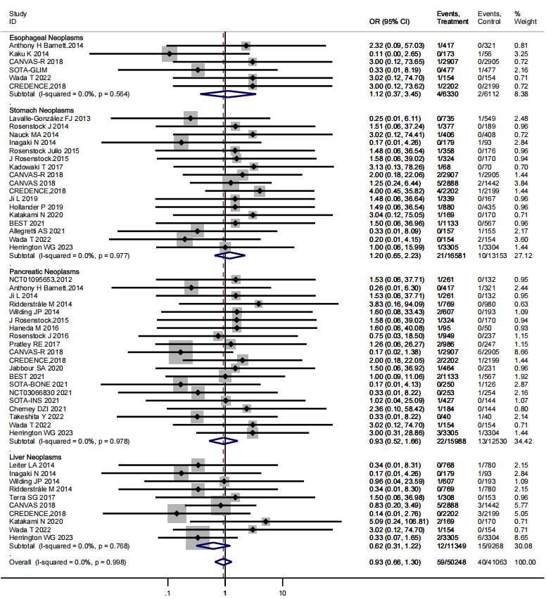
(B) Colonic, colorectal, and rectal neoplasms; biliary tract neoplasms.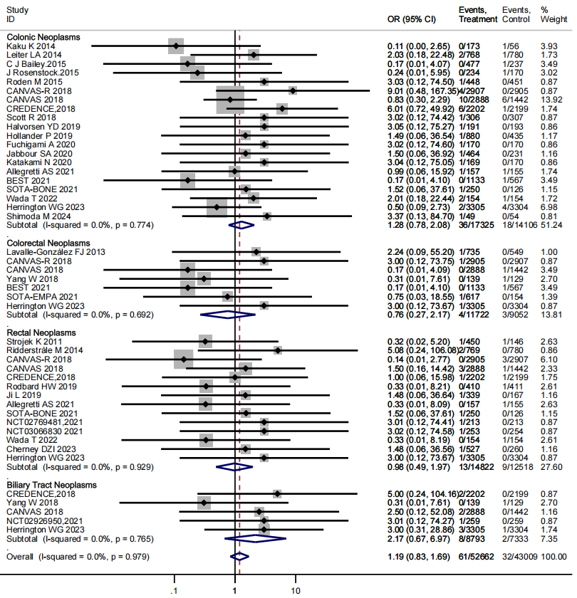

eFigure 3. Subgroup analysis of GI neoplasm risk by SGLT2 inhibitors type in patients with diabetes
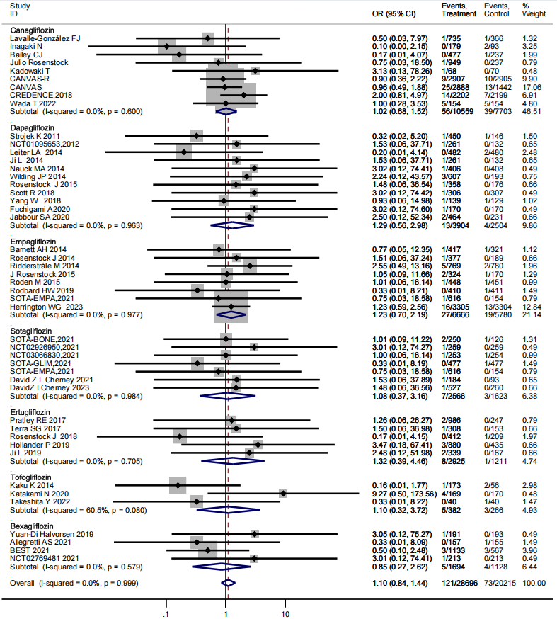

eFigure 4 Factors and risks of gastric neoplasms in RCTs of SGLT2 inhibitors use
[A] Association between Use and gastric neoplasms risk stratified by treatment duration

[B] Association between Use and gastric neoplasms risk stratified by body mass index (BMI)
[C] Association between SGLT2 inhibitor use and gastric neoplasms risk stratified by dosage

[D] Association between SGLT2 inhibitors use and gastric neoplasms risk stratified by age
[E] Association between SGLT2 inhibitors use and gastric neoplasms risk stratified by drug class
[F] Association between SGLT2 inhibitors use and gastric neoplasms risk stratified by hemoglobin A1c

eFigure 5. Factors and risks of esophageal neoplasms in RCTs of SGLT2 inhibitors use
[A] Association between SGLT2 inhibitosr use and esophageal neoplasms risk stratified by age
[B] Association between SGLT2 inhibitors use and esophageal neoplasms risk stratified by treatment duration
[C] Association between SGLT2 inhibitors use and esophageal neoplasms risk stratified by dosage
[D] Association between SGLT2 inhibitors use and esophageal neoplasms risk stratified by drug class
eFigure 6. Factors and risks of pancreatic neoplasms in RCTs of SGLT2 inhibitors use
[A] Association between SGLT2 inhibitor use and pancreatic neoplasms risk stratified by age
[B] Association between SGLT2 inhibitors use and pancreatic neoplasms risk stratified by BMI
[C] Association between SGLT2 inhibitors use and pancreatic neoplasms risk stratified by treatment duration
[D] Association between SGLT2 inhibitors use and pancreatic neoplasms risk stratified by hemoglobin A1c
[E] Association between SGLT2 inhibitors use and pancreatic neoplasms risk stratified by dosage

[F] Association between SGLT2 inhibitors use and pancreatic neoplasms risk stratified by drug class

eFigure 7. Factors and risks of Liver neoplasms in RCTs of SGLT2 inhibitors use
[A] Association between SGLT2 inhibitors use and liver neoplasms risk stratified by BMI
[B] Association between SGLT2 inhibitors use and liver neoplasms risk stratified by treatment duration

[C] Association between SGLT2 inhibitors use and liver neoplasms risk stratified by age
[D] Association between SGLT2 inhibitors use and liver neoplasms risk stratified by hemoglobin A1c

[E] Association between SGLT2 inhibitors use and liver neoplasms risk stratified by dosage
[F] Association between SGLT2 inhibitors use and liver neoplasms risk stratified by drug class

eFigure 8. Factors and risks of Colonic neoplasms in RCTs of SGLT2 inhibitors use
[A] Association between SGLT2 inhibitors use and colonic neoplasms risk stratified by BMI
[B] Association between SGLT2 inhibitors use and colonic neoplasms risk stratified by treatment duration
[C] Association between SGLT2 inhibitors use and colonic neoplasms risk stratified by age
[D] Association between SGLT2 inhibitors use and colonic neoplasms risk stratified by hemoglobin A1c
[E] Association between SGLT2 inhibitors use and colonic neoplasms risk stratified by dosage

[F] Association between SGLT2 inhibitors use and colonic neoplasms risk stratified by drug class

eFigure 10. Factors and risks of colorectal neoplasms in RCTs of SGLT2 inhibitors use
[A] Association between SGLT2 inhibitors use and colorectal neoplasms risk stratified by age
[B] Association between SGLT2 inhibitors use and colorectal neoplasms risk stratified by treatment duration
[C] Association between SGLT2 inhibitors use and colorectal neoplasms risk stratified by dosage
[D] Association between SGLT2 inhibitors use and colorectal neoplasms risk stratified by drug class
eFigure 9. Factors and risks of rectal neoplasms in RCTs of SGLT2 inhibitors use
[A] Association between SGLT2 inhibitors use and rectal neoplasms risk stratified by BMI
[B] Association between SGLT2 inhibitors use and rectal neoplasms risk stratified by treatment duration
[C] Association between SGLT2 inhibitors use and rectal neoplasms risk stratified by age
[D] Association between SGLT2 inhibitors use and rectal neoplasms risk stratified by hemoglobin A1c
[E] Association between SGLT2 inhibitors use and rectal neoplasms risk stratified by dosage
[F] Association between SGLT2 inhibitors use and rectal neoplasms risk stratified by drug class

eFigure 11. Sensitivity analysis for overall GI neoplasms (SGLT2 inhibitors vs control)

eFigure 12. Sensitivity analysis for gastric neoplasms
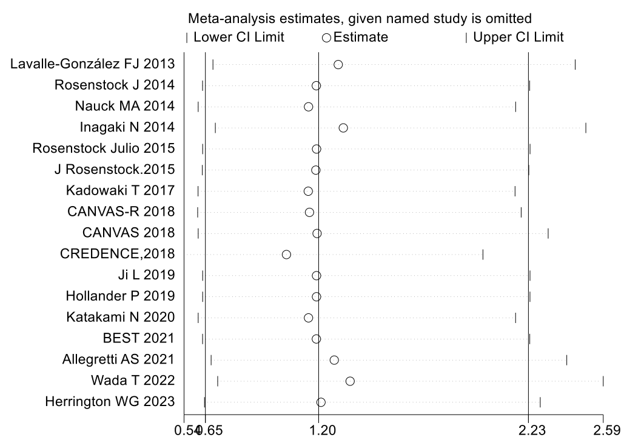
eFigure 13. Sensitivity analysis for pancreatic neoplasms
eFigure 14. Sensitivity analysis for hepatic neoplasms
eFigure 15. Sensitivity analysis for colonic neoplasms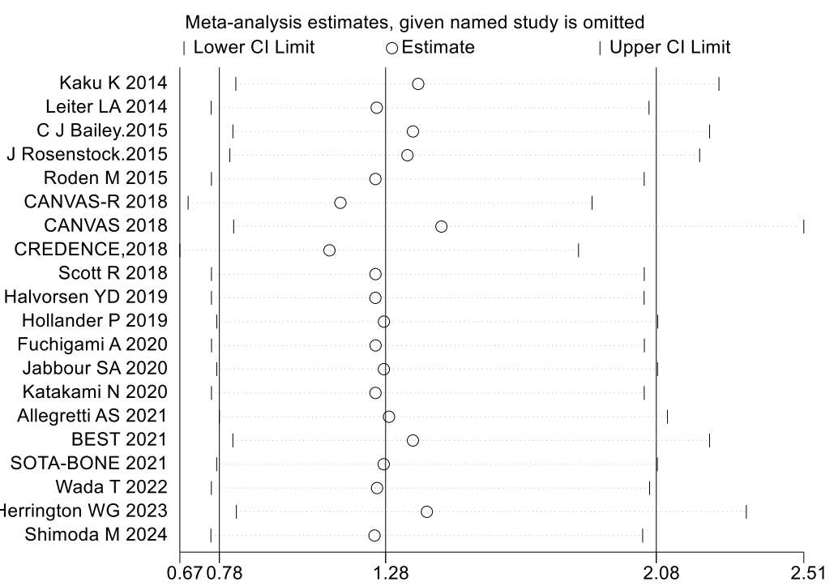

eFigure 16. Sensitivity analysis for rectal neoplasms

eFigure 17. Funnel plot for overall GI neoplasms

eFigure 18. Funnel plot for overall gastric neoplasms
eFigure 19. Funnel plot for overall pancreatic neoplasms

eFigure 20. Funnel plot for overall hepatic neoplasms

eFigure 21. Funnel plot for overall colonic neoplasms

eFigure 22. Funnel plot for overall rectal neoplasms
eFigure 23. Egger’s publication bias plot for overall GI neoplasms

eFigure 24. Egger’s publication bias plot for overall gastric neoplasmseFigure 25. Egger’s publication bias plot for overall pancreatic neoplasms
eFigure 26. Egger’s publication bias plot for overall hepatic neoplasms
eFigure 27. Egger’s publication bias plot for colonic neoplasms

eFigure 28. Egger’s publication bias plot for rectal neoplasms

