Neurovascular and Inflammatory Effects of Biperiden in the Acute Phase of Moderate Traumatic Brain Injury: Evidence from a Non-Human Primate Model
Viviam Sanabria ^{1, *}, Christiane Gimenes ¹, Simone Romariz ¹, Amarildo Souza Gois ², Matheus B. Braga¹, Michele Longoni Calió ^{2,3}, Juliana Lima Willers ², Maira L. Foresti ^{2,3}, Luiz Eugênio Mello ^{2,3}, and Beatriz M. Longo ^{1, *}
1. Laboratory of Neurophysiology, Department of Physiology, Universidade Federal
de São Paulo, São Paulo, Brazil.
2. Laboratory of Neurobiology, Department of Physiology, Universidade Federal de
São Paulo, São Paulo, Brazil.
3. Instituto D’Or de Pesquisa e Ensino, São Paulo, São Paulo, Brazil.
* Correspondence: Beatriz Monteiro Longo, biamonteironeuro@gmail.com and Viviam Sanabria, calvo.sofia10@unifesp.br

NEOCORTICAL REGIONS ANALYSIS
1.1. FLUORO-JADE B FOR NEOCORTICAL REGIONS

Neoortical regions were analyzed independently, and significant differences were detected only in the parietal (KW(3) = 11.35, p = 0.0014) and temporal cortices (KW(3) = 11.18, p = 0.0016). In the parietal cortex, both TBI groups—TBI-SAL (226.8 ± 69.55; p = 0.025) and TBI-BIP (215.7 ± 78.42; p = 0.047)—showed markedly greater neuronal degeneration compared with the naïve group (27.08 ± 19.01). A similar pattern was observed in the temporal cortex, where TBI-SAL (156.8 ± 45.28; p = 0.025) and TBI-BIP (161.9 ± 50.45; p = 0.0197) exhibited higher levels of neuronal degeneration than the naïve group (29.25 ± 23.26). See, figure S1

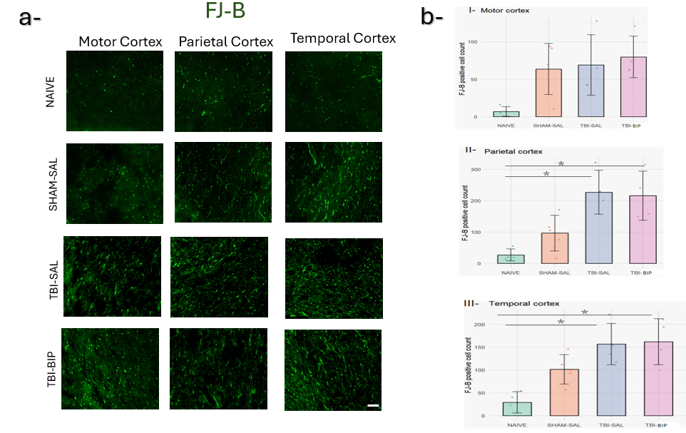
Figure S1-Fluorojade B (FJ-B) positive cells in the different neocortical regions (motor , parietal, and temporal cortex). a- Photomicrographs of FJ-B (yellow arrows) in each group: NAIVE, SHAM-SAL, TBI-SAL, and TBI-BIP. b- Graphic representation of the number of FJ-B positive cells in I- Motor cortex, II- Parietal cortex, III-Temporal cortex. Statistical significance: *p < 0.05; **, p< 0.01; ***, p < 0.001; ****, p < 0.0001. Data are shown as the mean ± standard deviation of the mean. Scale bars = 40 μm.
1.2 NEOCORTICAL REGIONS VESSELS ANALYSIS
The number and density of vessels in the different neocortical regions (motor, parietal, and temporal cortex) were analysed, see figure S2
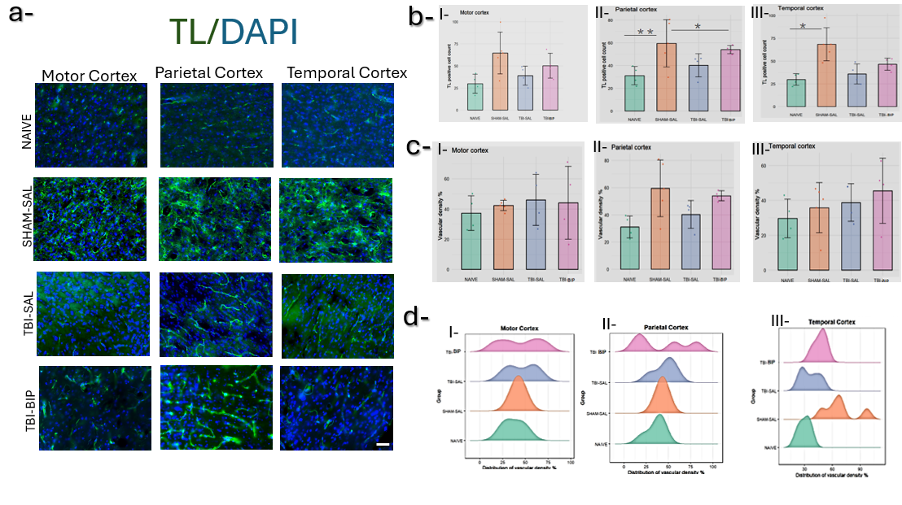
Figure S2. Tomato Lectine (TL) results. a- Photomicrographs of TL immunofluorescence of all groups; neocortical regions (Motor, Parietal, and Temporal cortex). TL (green), DAPI (blue). b- TL positive cells count in the: I-Motor Cortex, II-Parietal Cortex, III-Temporal Cortex. c- Percentage of vascular density I-Motor Cortex, II-Parietal Cortex, III-Temporal Cortex. d- Vascular density distribution I-Motor Cortex, II-Parietal Cortex, III-Temporal Cortex. Statistical significance: *p < 0.05; **, p< 0.01; ***, p < 0.001; ****, p < 0.0001. Data are shown as the mean ± standard deviation of the mean. Scale bars = 40 μm.

1.3 GFAP ANALYSE FOR NEOCORTICAL REGIONS
The number of astrocyte branches, the average length, the quantity of triple points, and the hierarchical analysis of the number of branches and average length in the different neocortical regions (motor, parietal, and temporal cortex) were analysed, see figure S3.

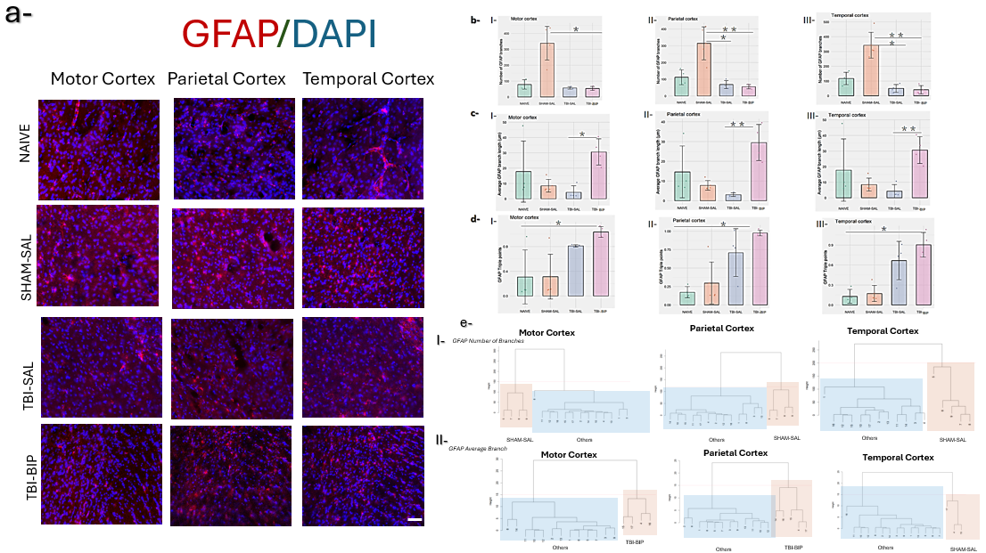

Figure S3. Astrocytes (GFAP) results. a-Photomicrographs of GFAP immunofluorescence in the different neocortical regions (Motor Cortex, Parietal Cortex, and Temporal Cortex). GFAP (red), and DAPI (blue). b-Number of GFAP branches I-Motor Cortex, II-Parietal Cortex, III-Temporal Cortex. c-Average GFAP branch length (µm). I-Motor Cortex, II-Parietal Cortex, III-Temporal Cortex. d-GFAP triple points I-Motor Cortex, II-Parietal Cortex, III-Temporal Cortex. e-Hierarchical cluster analysis. Naive groups are represented by numbers from 1-4, SHAM-SAL from 5-8, TBI-SAL from 9-12, and TBI-BIP from 13-16. I- GFAP number branches. Orange boxes represent the SHAM-SAL cluster, and blue boxes represent OTHER (NAIVE, TBI-SAL, and TBI-BIP) cluster. II- GFAP Average branch. Orange boxes represent the TBI-BIP or NAIVE and TBI-BIP clusters, and blue boxes represent OTHER (NAIVE, SHAM-SAL, and TBI-SAL) clusters. Statistical significance: *p < 0.05; **, p< 0.01; ***, p < 0.001; ****, p < 0.0001. Data are shown as the mean ± standard deviation of the mean. Scale bars = 40 μm.

1.4 Iba-1 ANALYSE FOR NEOCORTICAL REGIONS
The number of microglial branches, the average length and triple points across the different neocortical regions (motor, parietal, and temporal cortex) were analysed; see figure S4.
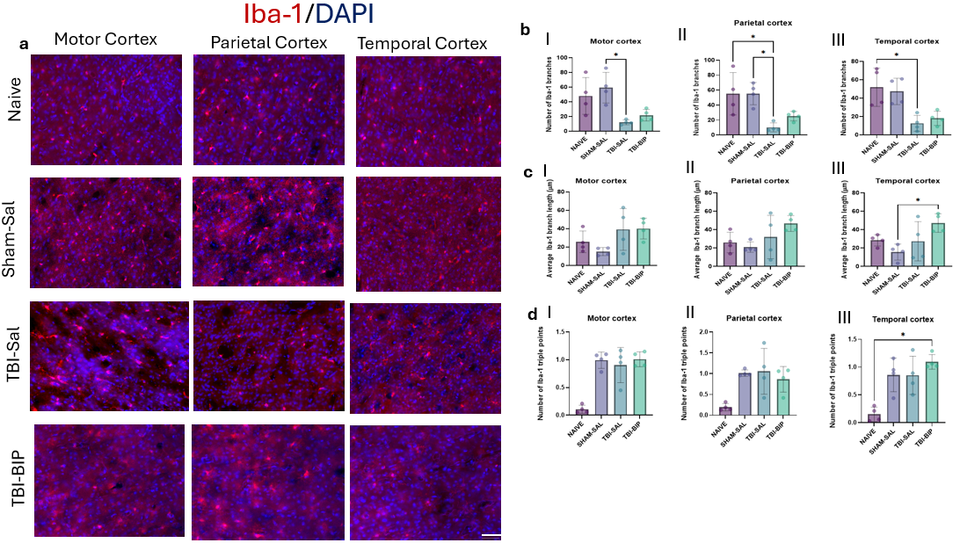

Figure S4. Microglia (Iba-1) results. a-Photomicrographs of Iba-1 immunofluorescence in the different neocortical regions (Motor Cortex, Parietal Cortex, and Temporal Cortex). Iba-1 (red), and DAPI (blue). b-Number of Iba-1 branches I-Motor Cortex, II-Parietal Cortex, III-Temporal Cortex. c-Average Iba-1 branch length (µm). I-Motor Cortex, II-Parietal Cortex, III-Temporal Cortex. d-Iba-1 triple points I-Motor Cortex, II-Parietal Cortex, III-Temporal Cortex. Statistical significance: *p < 0.05; **, p< 0.01; ***, p < 0.001; ****, p < 0.0001. Data are shown as the mean ± standard deviation of the mean. Scale bars = 40 μm.

2.Correlation Matrix
p-values of the correlation matrix for each variable analysis .
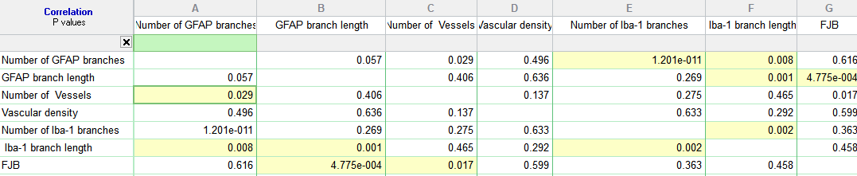
2.PCA

We selected two dimensions based on the following screen plot, which together explain 49.2% of the variance in the explained variable, as shown in the followings graphs.

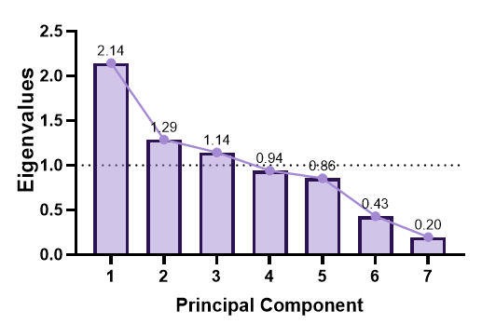  a- | 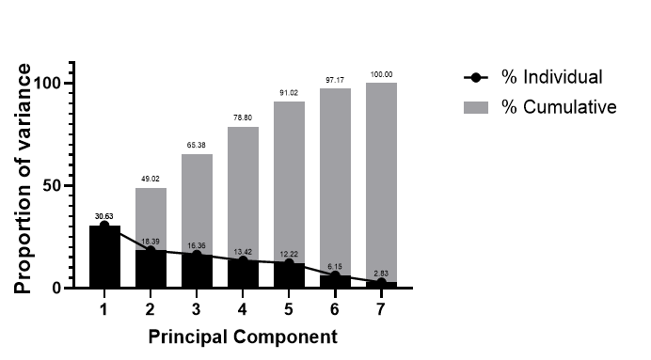  b-

Figure S4. Eigenvalues and proportion of the variance. a-A screen plot that shows the eigenvalues according to the dimension. The number of dimensions was selected using the Kaiser-Guttman rule, which states that only components with eigenvalues greater than 1 should be retained, and the elbow method. The sharp elbow on the curve determined the optimal number of components. b- A screen plot that determined the percentage of explained variances (individual and cumulative) and the number of dimensions.

