Table 1. Paired T-Test Results for Knowledge Scores
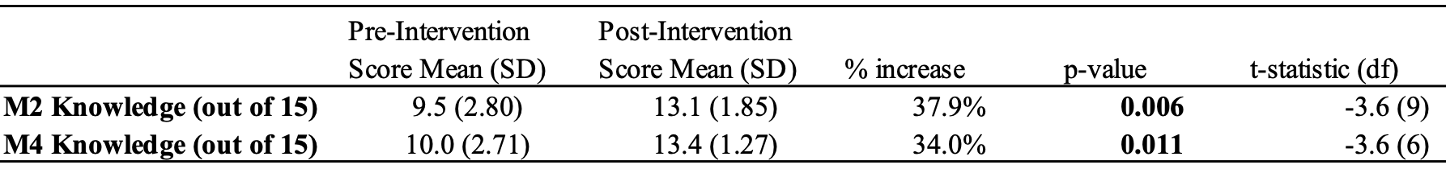

Table 2. Paired T-Test Results for Confidence Scores
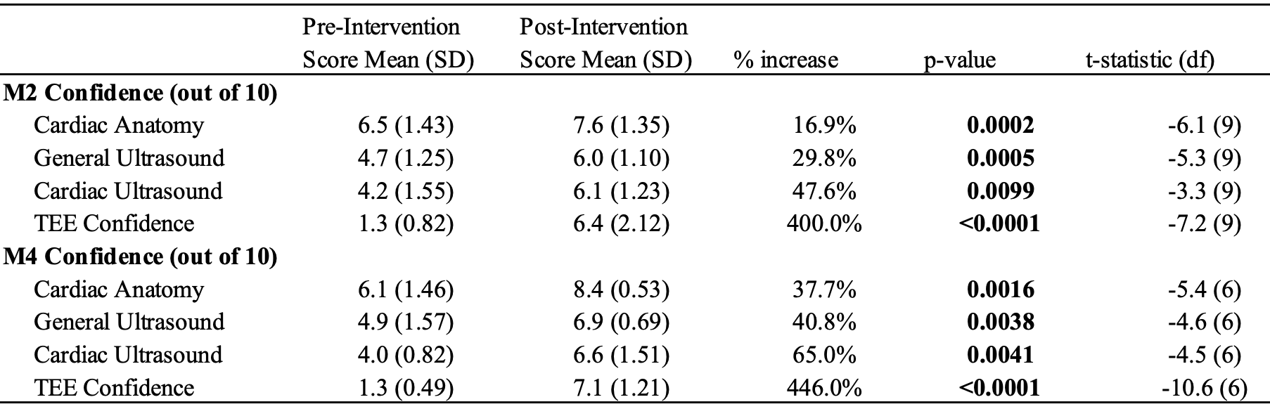
Table 3. Paired T-Test Results for Confidence Scores in M1s
