Psychological and emotional impact of COVID-19 pandemic on people living with chronic disease: HIV and cancer.
Figure 2: The figure showed the main results of the study.

Authors: Emanuele Focà^{1§}, Chiara Fornari^{1§}, Stefania Arsuffi¹, Maria Chiara Vetrano¹, Stefano Calza², Stefano Renzetti², Silvia Copeta³, Alfredo Berruti³, Francesco Castelli¹, Silvia Compostella^{4#}, Eugenia Quiros-Roldan^{1#}

Affiliations:
1: University Department of Infectious and Tropical Diseases, University of Brescia and ASST Spedali Civili Hospital, Brescia, Italy
2: Unit of Biostatistics and Bioinformatics, Department of Molecular and Translational Medicine, University of Brescia, Brescia, Italy
3: Department of Medical and Surgical Specialties, Radiological Sciences, and Public Health, Medical Oncology, University of Brescia at ASST Spedali Civili, Brescia, Italy.
4: Unit of Infectious Diseases of ASST Spedali Civili Hospital, Brescia, Italy

Corresponding to:
Emanuele Focà MD, PhD
Unit of Infectious and Tropical Diseases, Department of Clinical and Experimental Sciences, University of Brescia and ASST Spedali Civili, Brescia, Italy
Emanuele.foca@unibs.it

Supplementary Materials
TABLE S1. Pathological history
Characteristics | Observed |  | Total (N=324) | p- value
 | PLWH (N=167) | PLWOD (N=157)
History of psychological problems: n (%) |  |  |  | .268
Yes | 45 (26.9%) | 34 (21.7%) | 79 (24.4%)
No | 122 (73.1%) | 123 (78.3%) | 245 (75.6%)
If positive history of psychological problems. Psychological disorders: n (%)ª |  |  |  | .543
Anxiety | 20 (29.4%) | 26 (37.7%) | 46 (33.6%)
Depression | 41 (60.3%) | 38 (55.1%) | 79 (57.7%)
Others | 7 (10.3%) | 5 (7.2%) | 12 (8.7%)
Adherence to the therapy during the pandemic: n (%) |  |  |  | .842
N-Miss | 1 | 42 | 43
Yes | 161 (97.0%) | 112 (97.4%) | 273 (97.2%)
No | 5 (3.0%) | 3 (2.6%) | 8 (2.8%)
Care regime: n (%) |  |  |  | .001*
N-Miss | 20 | 9 | 29
Hospitalization | 3 (2.0%) | 17 (11.5%) | 20 (6.8%)
Day Hospital | 144 (98.0%) | 131 (88.5%) | 275 (93.2%)
Ask to stop the therapy: n (%) |  |  |  | .692
N-Miss | 2 | 24 | 26
Yes | 2 (1.2%) | 1 (0.8%) | 3 (1.0%)
No | 163 (98.8%) | 132 (99.2%) | 295 (99.0%)
Cancel an appointment: n (%) |  |  |  | .204
N-Miss | 1 | 9 | 10
Yes | 6 (3.61%) | 2 (1.35%) | 8 (2.5%)
No | 160 (96.4%) | 146 (98.6%) | 306 (97.5%)
Thought to be infected and concern about the infection: n (%) |  |  |  | .003*
No | 116 (69.5%) | 135 (86.0%) | 251 (77.5%)
Not at all | 21 (12.6%) | 6 (3.8%) | 27 (8.3%)
A little | 15 (9.0%) | 8 (5.1%) | 21 (7.1%)
A lot | 15 (9.0%) | 8 (5.1%) | 21 (7.1%)
Note: ª more than one answer option was allowed (N=137; total PLWH: 68; total PLWOD: 69).
* Significant values.

TABLE S2. Information about COVID-19
Characteristics | Observed |  | Total (N=324) | p- value
 | PLWH (N=167) | PLWOD (N=157)
Source of information: n (%)ª |  |  |  | .325
Television | 147 (35.0%) | 144 (43.4%) | 291 (38.7%)
Internet | 121 (28.8%) | 91 (27.4%) | 212 (28.2%)
Social media | 71 (16.9%) | 47 (14.2%) | 118 (15.7%)
Messaging app | 5 (1.2%) | 3 (0.9%) | 8 (1.1%)
Family | 26 (6.2%) | 16 (4.8%) | 42 (5.6%)
Healthcare providers | 30 (7.1%) | 22 (6.6%) | 52 (6.9%)
Friends | 18 (4.3%) | 9 (2.7%) | 27 (3.6%)
Others | 2 (0.5%) | 0 (0.0%) | 2 (0.3%)
Frequency of the access to the information: n (%) |  |  |  | .013*
No | 8 (4.8%) | 1 (0.6%) | 9 (2.8%)
Each hour | 11 (6.6%) | 14 (9.0%) | 25 (7.7%)
Every 3-5 hours | 71 (42.5%) | 90 (57.3%) | 161 (49.7%)
Once a day | 64 (38.3%) | 44 (28.0%) | 108 (33.3%)
Less than once a day | 13 (7.8%) | 8 (5.1%) | 21 (6.5%)
Information from medical staff: n (%) |  |  |  | .273
N-Miss | 36 | 25 | 61
Not at all | 14 (10.7%) | 14 (10.6%) | 28 (10.6%)
A little | 18 (13.7%) | 28 (21.2%) | 46 (17.5%)
A lot | 99 (75.6%) | 90 (68.2%) | 189 (71.9%)
Information from politicians: n (%) |  |  |  | .635
N-Miss | 2 | 1 | 3
Not at all | 39 (23.6%) | 41 (26.3%) | 80 (24.9%)
A little | 66 (40.0%) | 66 (42.3%) | 132 (41.1%)
A lot | 60 (36.4%) | 49 (31.4%) | 109 (34.0%)
Elements that influenced the Covid-19 pandemic: n (%)
Environmental pollution |  |  |  | .747
Yes | 92 (55.1%) | 80 (51.0%) | 172 (53.1%)
No | 36 (21.6%) | 38 (24.2%) | 74 (22.8%)
I do not know | 39 (23.4%) | 39 (24.8%) | 78 (24.1%)
Global overcrowding |  |  |  | .432
N-Miss | 1 | 0 | 1
Yes | 120 (72.3%) | 122 (77.7%) | 242 (74.9%)
No | 27 (16.3%) | 18 (11.5%) | 45 (13.9%)
I do not know | 19 (11.4%) | 17 (10.8%) | 36 (11.1%)
Immigration |  |  |  | .241
Yes | 95 (56.9%) | 97 (61.9%) | 192 (59.3%)
No | 65 (38.9%) | 49 (31.2%) | 114 (35.2%)
I do not know | 7 (4.2%) | 11 (7.0%) | 18 (5.6%)
Source of Covid-19 pandemic: n (%) |  |  |  | .335
Natural element | 35 (21.0%) | 39 (24.8%) | 74 (22.8%)
Manipulation | 91 (54.5%) | 73 (46.5%) | 164 (50.6%)
I do not know | 41 (24.6%) | 45 (28.7%) | 86 (26.5%)
Note: ª more than one answer option was allowed (N=752; total PLWH: 420; total PLWOD: 332).
* Significant values.

TABLE S3. Social support and coping strategies
Characteristics | Observed |  | Total (N=324) | p- value
 | PLWH (N=167) | PLWOD (N=157)
Family support in everyday life: n (%) |  |  |  | .992
N-Miss | 40 | 18 | 58
Not at all | 7 (5.3%) | 8 (5.7%) | 15 (5.6%)
A little | 17 (13.5%) | 18 (13.0%) | 35 (13.2%)
A lot | 103 (81.2%) | 113 (81.3%) | 216 (81.2%)
Loneliness during the quarantine: n (%) |  |  |  | .130
Not at all | 101 (60.5%) | 100 (63.7%) | 201 (62.0%)
A little | 29 (17.4%) | 35 (22.3%) | 64 (19.8%)
A lot | 37 (22.2%) | 22 (14.0%) | 59 (18.2%)
Maintenance of good relationship with others: n (%) |  |  |  | .069
Not at all | 4 (2.4%) | 3 (1.9%) | 7 (2.2%)
A little | 22 (13.2%) | 9 (5.7%) | 31 (9.6%)
A lot | 141 (84.4%) | 145 (92.4%) | 286 (88.3%)
Express thoughts and concerns to the family: n (%) |  |  |  | .814
N-Miss | 2 | 4 | 6
Not at all | 13 (7.9%) | 15 (9.8%) | 28 (8.8%)
A little | 20 (12.1%) | 17 (11.1%) | 37 (11.6%)
A lot | 132 (80.0%) | 121 (79.1%) | 253 (79.6%)
Telephone contact with other patients: n (%) |  |  |  | .016*
N-Miss | 0 | 6 | 6
Not at all | 118 (70.7%) | 116 (76.8%) | 234 (73.6%)
A little | 20 (12.0%) | 5 (3.3%) | 25 (7.9%)
A lot | 29 (17.4%) | 30 (19.9%) | 59 (18.6%)
Support given by faith: n (%) |  |  |  | < .001
N-Miss | 1 | 4 | 5
Not at all | 102 (61.4%) | 62 (40.5%) | 164 (51.4%)
A little | 32 (19.3%) | 29 (19.0%) | 61 (19.1%)
A lot | 32 (19.3%) | 62 (40.5%) | 94 (29.5%)
Use of meditation techniques: n (%) |  |  |  | .189
N-Miss | 0 | 1 | 1
Not at all | 128 (76.6%) | 132 (84.6%) | 260 (80.5%)
A little | 16 (9.6%) | 9 (5.8%) | 25 (7.7%)
A lot | 23 (13.8%) | 15 (9.6%) | 38 (11.8%)
Take pleasure to the activities: n (%) |  |  |  | .511
Not at all | 16 (9.58%) | 15 (9.55%) | 31 (9.6%)
A little | 36 (21.6%) | 26 (16.6%) | 62 (19.1%)
A lot | 115 (68.9%) | 116 (73.9%) | 231 (71.3%)
Note: * Significant values.

TABLE S4. Experience in the hospital ward
Characteristics | Observed |  | Total (N=324) | p- value
 | PLWH (N=167) | PLWOD (N=157)
Time of use, yr: mean (sd) | 15.8 (9.5) | 9.65 (4.5) | 9.9 (9.5) | < .001*
Hygiene measures were adequate: n (%) |  |  |  | .813
N-Miss | 6 | 0 | 6
Yes | 154 (95.7%) | 151 (96.2%) | 305 (95.9%)
No | 7 (4.3%) | 6 (3.8%) | 13 (4.1%)
Feeling protect during the previous visits: n (%) |  |  |  | .689
N-Miss | 10 | 16 | 26
Yes | 150 (95.5%) | 136 (96.5%) | 286 (96.0%)
No | 7 (4.5%) | 5 (3.5%) | 12 (4.0%)
Feeling protect during the current visit: n (%) |  |  |  | .672
N-Miss | 1 | 0 | 1
Yes | 162 (97.6%) | 152 (96.8%) | 314 (97.2%)
No | 4 (2.4%) | 5 (3.2%) | 9 (2.8%)
Healthcare provider as a point: n (%) |  |  |  | .653
N-Miss | 4 | 2 | 6
Not at all | 130 (79.8%) | 117 (75.5%) | 247 (77.7%)
A little | 16 (9.8%) | 19 (12.3%) | 35 (11.0%)
A lot | 17 (10.4%) | 19 (12.3%) | 36 (11.3%)
Concern of being infected by the medical staff: n (%) |  |  |  | .976
N-Miss | 1 | 1 | 2
Not at all | 143 (86.2%) | 134 (85.9%) | 277 (86.0%)
A little | 15 (9.0%) | 15 (9.6%) | 30 (9.3%)
A lot | 8 (4.8%) | 7 (4.5%) | 15 (4.7%)
To be informed about the sanitary situation: n (%) |  |  |  | .547
Yes | 24 (14.4%) | 19 (12.1%) | 43 (13.3%)
No | 143 (85.6%) | 138 (87.9%) | 281 (86.7%)
Emotional support: n (%) |  |  |  | .026*
N-Miss | 38 | 10 | 48
Not at all | 21 (16.3%) | 11 (7.5%) | 32 (11.6%)
A little | 16 (12.4%) | 12 (8.2%) | 28 (10.1%)
A lot | 92 (71.3%) | 124 (84.3%) | 216 (78.3%)
Opportunity of improvement: n (%) |  |  |  | .498
N-Miss | 3 | 1 | 4
Not at all | 9 (5.5%) | 13 (8.3%) | 22 (6.8%)
A little | 22 (13.4%) | 24 (15.4%) | 46 (14.4%)
A lot | 133 (81.1%) | 119 (76.3%) | 252 (78.8%)
Decrease the attention towards the chronic disease: n (%) |  |  |  | .464
Not at all | 96 (57.5%) | 88 (56.1%) | 184 (56.8%)
A little | 35 (21.0%) | 27 (17.2%) | 62 (19.1%)
A lot | 36 (21.5%) | 42 (26.7%) | 78 (24.1%)
To feel neglected: n (%) |  |  |  | .428
N-Miss | 2 | 1 | 3
Not at all | 147 (89.1%) | 143 (91.7%) | 290 (90.3%)
A little | 13 (7.9%) | 7 (4.5%) | 20 (6.2%)
A lot | 5 (3.0%) | 6 (3.8%) | 11 (3.4%)
To feel assisted as usual: n (%) |  |  |  | .273
N-Miss | 4 | 4 | 8
Not at all | 3 (1.8%) | 3 (2.0%) | 6 (1.9%)
A little | 12 (7.4%) | 5 (3.2%) | 17 (5.4%)
A lot | 148 (90.8%) | 145 (94.8%) | 293 (92.7%)
Note: * Significant values.

TABLE S5. Resilience Scale
Characteristics | Observed |  | Total (N=324) | p-value
 | PLWH (N=167) | PLWOD (N=157)
N-Miss | 1 | 2 | 3
Resilience: mean (sd) | 59.7 (6.89) | 59.6 (7.0) | 59.7 (6.92) | .989
Median (Q1, Q3) | 61.0 (55.2, 64.0) | 61.0 (56.0, 64.0) | 61.0 (56.0, 64.0)
Minimum | 24.0 | 25.0
Maximum | 70.0 | 70.0
Items of the RS
RS1 |  |  |  | 0.451
N-Miss | 1 | 2 | 3
Mean (sd) | 5.9 (1.1) | 6.0 (1.0) | 6.0 (1.1)
RS2 |  |  |  | 0.147
N-Miss | 1 | 2 | 3
Mean (sd) | 6.3 (1.1) | 6.5 (0.9) | 6.4 (1.0)
RS3 |  |  |  | 0.523
N-Miss | 1 | 2 | 3
Mean (sd) | 5.5 (1.4) | 5.6 (1.5) | 5.5 (1.4)
RS4 |  |  |  | 0.574
N-Miss | 1 | 2 | 3
Mean (sd) | 5.6 (1.6) | 5.8 (1.5) | 5.7 (1.5)
RS5 |  |  |  | 0.820
N-Miss | 1 | 2 | 3
Mean (sd) | 6.0 (1.2) | 6.0 (1.2) | 6.0 (1.2)
RS6 |  |  |  | 0.324
N-Miss | 1 | 2 | 3
Mean (sd) | 6.1 (1.0) | 6.2 (1.0) | 6.2 (1.0)
RS7 |  |  |  | 0.404
N-Miss | 1 | 2 | 3
Mean (sd) | 6.2 (1.0) | 6.1 (1.1) | 6.1 (1.0)
RS8 |  |  |  | 0.599
N-Miss | 1 | 2 | 3
Mean (sd) | 6.2 (1.3) | 6.3 (1.2) | 6.2 (1.3)
RS9 |  |  |  | 0.473
N-Miss | 1 | 2 | 3
Mean (sd) | 6.0 (1.0) | 6.0 (1.0) | 6.0 (1.0)
RS10 |  |  |  | 0.002*
N-Miss | 1 | 2 | 3
Mean (sd) | 5.8 (1.4) | 5.3 (1.6) | 5.5 (1.5)
Note: * Significant values.

Fig. S1 Heatmap of the loadings estimated by the factor analysis.
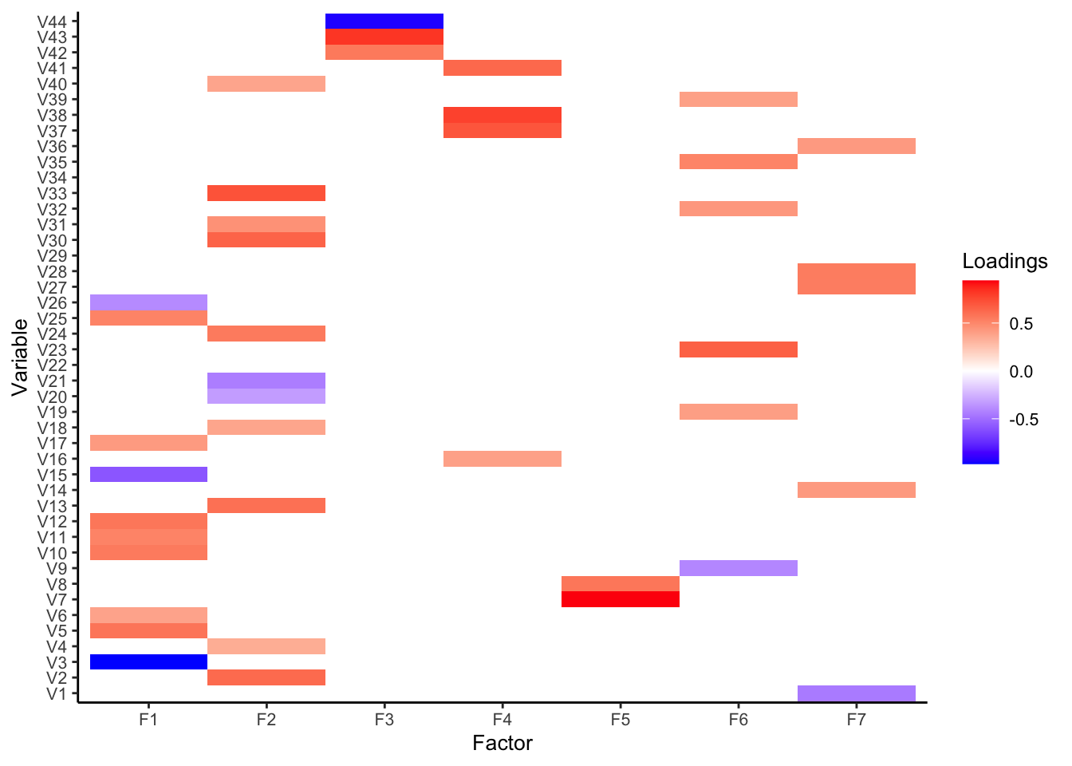Values below 0.31 were set to 0. The factors represented on the x-axis are: F1=anxiety/concern; F2=psychological problems; F3=concern of the infection; F4=need of attention; F5=feelings of anger; F6=coping; F7=lockdown conditions. The variables displayed on the y-axis are: V1=number of rooms in the house; V2=psychological problems; V3=feeling calm; V4=feeling indifferent; V5=feeling sad; V6=feeling helpless; V7=feeling angry; V8=feeling nervous; V9=feeling restless; V10=feeling worried; V11=feeling anxious; V12=feeling scared; V13=feeling panicked; V14=feeling isolated; V15=manage the situation serenely; V16=signs of being unwell; V17=worried for economic problems; V18=feeling lonely; V19=apply meditative techniques; V20=take pleasure from activities; V21=keeping good relationships; V22=talk with family; V23=talk with other patients; V24=sleep quality; V25=feeling pessimist; V26=feeling confident; V27=eating more; V28=smoking; V29=alcohol consumption; V30=taking more drugs; V31=thinking about suicide; V32=helped by faith; V33=need to talk with a psychologist; V34=others more scared; V35=personal growth opportunity; V36=weight change; V37=feeling more at risk; V38=risk to worsen the disease; V39=worried to get COVID; V40= emotionally supported by doctors; V41=worried about doctors getting COVID; V42=worried about decreased attention by doctors; V43= feeling neglected; V44=feeling assisted

TABLE S6. Linear regression analysis
Resilience Score
Predictors | Estimates | 95% CI | p-values
PLWOD vs PLWH | -1.00 | -3.37 – 1.38 | .410
Male vs Female | 0.15 | -1.61 – 1.90 | .870
Age | -0.03 | -0.12 – 0.06 | .508
Foreigner vs Italian | 1.35 | -2.56 – 5.26 | .497
Middle school vs primary school diploma | -1.04 | -3.6 – 1.51 | .421
High school vs primary school diploma | -1.57 | -4.30 – 1.15 | .257
Degree vs primary school diploma | -0.36 | -3.70 – 2.98 | .833
Unemployed vs employed | -3.52 | -6.68 – -0.35 | .029*
Housewife vs employed | -0.39 | -3.45 – 2.67 | .801
Pensioners vs employed | 0.13 | -2.19 – 2.45 | .913
Other occupation vs employed | 0.75 | -3.92 – 5.41 | .753
With companionship vs single | 1.26 | -0.91 – 3.43 | .255
Diagnosis > 5 years vs < 5 years | -0.33 | -2.42 – 1.76 | .759
Feelings of anger | -1.76 | -2.67 – -0.85 | < .001*
Need of attention | 0.00 | -0.88 – 0.89 | .996
Concern of the infection | -0.32 | -0.83 – 0.19 | .213
Psychological problems | -2.18 | -3.17 – -1.18 | < .001*
Anxiety/concern | -1.56 | -2.30 – -0.82 | < .001*
Coping | 0.48 | -0.47 – 1.44 | .322
Lockdown conditions | 0.22 | -0.86 – 1.30 | .686
Note: * Significant values.

