Supplementary Materials
Table S1. Water Sampling Sites, Fish sampling sites, Physicochemical Parameters, and Isolate Identifications
State | Water ID | Date/Time | Location | pH | Temperature (C) | Salinity (ppt) | TDS (ppm) | Conductivity (uS) | Isolates ID
Michigan | C1 | 10/3/23 13:25 | Cadillac Lake, Cadillac, MI  44°14'01.9"N 85°26'58.1"W | 8.44 | 20.7 | 0.09 | 92.9 | 185.9 | C1-1
Michigan | C2 | 10/3/23 13:25 | Cadillac Lake, Cadillac, MI  44°14'04.2"N 85°26'58.1"W | 8.07 | 20.7 | 0.08 | 93 | 185.3 | C2-1  C2-2
Michigan | HB1 | 10/3/23 18:00 | Harvey Iron Pony Truss Bridge, Buckley, MI  44°26'20.8"N 85°38'31.5"W | 8.63 | 16.2 | 0.17 | 167 | 337 | HB1-2
Michigan | HB2 | 10/3/23 18:10 | Harvey Iron Pony Truss Bridge, Buckley, MI  44°26'20.8"N 85°38'31.5"W | 8.52 | 16.1 | 0.16 | 169 | 338 | HB2-2
Michigan | B1 | 10/4/23 15:20 | Boardman River (Boardman Weir), Traverse City, MI  44°45'52.8"N 85°37'36.9"W | -7.2 | 18.1 | 0.21 | 207 | 424 | B1-2
Michigan | B2 | 10/4/23 15:30 | Boardman River (Boardman Weir), Traverse City, MI  44°45'53.0"N 85°37'37.1"W | 7.56 | 17.8 | 0.21 | 212 | 425 | B2-1
Michigan | B3 | 10/4/23 15:40 | Boardman River (Boardman Weir), Traverse City, MI  44°45'52.8"N 85°37'37.1"W | -7.3 | 18 | 0.21 | 211 | 423 | B3-2  B3-3
Michigan | B5 | 10/4/23 16:00 | Boardman River, Traverse City, MI  44°45'51.9"N 85°37'36.4"W | 6.27 | 17.6 | 0.21 | 205 | 420 | B5-1  B5-2  B5-3
Michigan | B6 | 10/4/23 16:10 | Boardman River, Traverse City, MI  44°45'53.9"N 85°37'37.4"W | - | 17.6 | 0.21 | 213 | 435 | B6-1
Michigan | TB1 | 10/4/23 18:00 | Lake Michigan (near West Arm Grand Traverse Bay), Traverse City, MI  44°46'11.6"N 85°38'03.7"W | - | 16.9 | 0.14 | 149 | 300 | TB1-1
Michigan | LP1 | 10/5/23 8:30 | Lake Michigan (near Lions Pavilion), Manistee, MI 44°14'53.4"N 86°20'27.2"W | - | 17.9 | 0.17 | 176 | 354 | LP1-1  LP1-2
Michigan | LP2 | 10/5/23 8:40 | Lake Michigan (near Lions Pavilion), Manistee, MI 44°14'51.4"N 86°20'25.9"W | - | 18.1 | 0.18 | 180 | 361 | LP2-1  LP2-2
Michigan | WC2 | 10/5/23 13:50 | Lake White Cloud (after dam), White Cloud, MI  43°32'46.5"N 85°46'02.4"W | - | 17.7 | 0.2 | 193 | 383 | WC2-1  WC2-2
Michigan | WC3 | 10/5/23 14:00 | Lake White Cloud (after dam/raceway), White Cloud, MI  43°32'49.3"N 85°46'06.0"W | - | 16.9 | 0.19 | 195 | 391 | WC3-1
Michigan | MR1 | 10/5/23 15:42 | Muskegon River, Newaygo, MI  43°25'09.9"N 85°47'27.2"W | - | 18.8 | 0.21 | 206 | 412 | MR1-1
Michigan | MR2 | 10/5/23 15:50 | Muskegon River, Newaygo, MI  43°25'07.9"N 85°47'23.5"W | - | 18.3 | 0.21 | 206 | 415 | MR2-1  MR2-2
Michigan | MR3 | 10/5/23 16:10 | Muskegon River, Newaygo, MI (fish stocking release site) 43°25'24.4"N 85°40'30.9"W | - | 18.8 | 0.21 | 208 | 346 | MR3-2
Ohio | GY/YPS | 8/17/23 12:30 | Bowling Green State University Greenhouse, Bowling Green, OH 41°22'56.7"N 83°38'23.2"W | 6.5 | 19.2 | - | - | - | GY1, GY2-1, GY2-2, GY4, YPS1, YPS3, YPS4
Ohio | SFP | 11/7/23 | Bowling Green Pond, Bowling Green, OH  41°21'13.4"N 83°37'08.8"W | - | - | - | - | - | SPF1
Indiana | W4 | 1/30/24 | Richard Clay Bodine State Fish Hatchery (fish tanks), Mishawaka, IN  41°40'15.1"N 86°07'29.6"W | 6.35 | 12.4 | 0.36 | 342 | 705 | W4-3
Michigan | LakC | 4/14/24 | Lake Chemung, Brighton, MI  42°34'41.2"N 83°50'18.1"W | 7 | 14 | - | - | - | LakC1  LakC3  LakC4
Ohio | GR1 | 4/17/24 8:17 | Grand River, Fairport Harbor, OH  41°44'25.1"N 81°15'46.3"W | 6.5 | 13.8 | 0.09 | 92.4 | 187.5 | GR1-1  GR1-2
Ohio | GR2 | 4/17/24 8:25 | Grand River, Fairport Harbor, OH 41°44'24.7"N 81°15'46.5"W | 6.5 | 13.8 | 0.08 | 95.5 | 191.5 | GR2-3
Ohio | FH2 | 4/17/24 13:25 | Lake Erie, Fairport Harbor, OH 41°45'32.5"N 81°16'43.2"W | 6.5 | 13.8 | 0.11 | 115 | 239 | FH2-1
Ohio | D1 | 4/17/24 15:42 | Cloverdale Lake, Concord Township, OH  41°41'19.2"N 81°14'20.9"W | 6.5 | 18.4 | 0.19 | 188 | 383 | D1-1
Ohio | D2 | 4/17/24 15:44 | Cloverdale Lake, Concord Township, OH  41°41'19.2"N 81°14'20.9"W | 6.5 | 19.1 | 0.25 | 230 | 480 | D2-3  D2-4
Ohio | D3 | 4/17/24 15:47 | Cloverdale Lake, Concord Township, OH  41°41'19.2"N 81°14'20.9"W | 6.5 | 17.7 | 0.21 | 201 | 430 | D3-1
Ohio | TIR44  (fish sample) | 4/17/24 | Fairport Harbor Fisheries Research Station, Fairport Harbor, OH  41°44'30.3"N 81°16'18.6"W | - | - | - | - | - | TIR44-1
Ohio | Tag49  (fish sample) | 4/17/24 | Fairport Harbor Fisheries Research Station, Fairport Harbor, OH 41°44'30.3"N 81°16'18.6"W | - | - | - | - | - | Tag49-1

Table S2. Species identification of 47 isolates using ITS and COX1 markers, with concordance analysis.
Isolates ID | Species based on ITS | ITS Accession Number | ID by COX1 | COX1 Accession Number
GY1 | Saprolegnia ferax | PX612137 | Saprolegnia ferax | PX757084
GY2-1 | Saprolegnia ferax | PX612138 | Saprolegnia ferax | PX757085
GY2-2 | Saprolegnia ferax | PX612139 | Saprolegnia ferax | PX757086
GY04 | Saprolegnia ferax | PX612140 | Saprolegnia ferax | PX757087
YPS1 | Saprolegnia ferax | PX612141 | Saprolegnia ferax | PX757110
YPS3 | Saprolegnia ferax | PX612142 | Saprolegnia ferax | PX757111
YPS04 | Saprolegnia ferax | PX612143 | Saprolegnia ferax | PX757112
C1-1 | Scoliolegnia asterophora | PX612097 | Scoliolegnia asterophora | PX757072
C2-1 | Scoliolegnia asterophora | PX612098 | Scoliolegnia asterophora | PX757073
C2-2 | Scoliolegnia asterophora | PX612099 | Scoliolegnia asterophora | PX757074
HB1-2 | Saprolegnia delica | PX612124 | Saprolegnia delica | PX757088
HB2-2 | Saprolegnia australis | PX612103 | Saprolegnia ferax | PX757089
B1-2 | Saprolegnia ferax | PX612130 | Saprolegnia ferax | PX757064
B2-1 | Saprolegnia australis | PX612100 | Saprolegnia ferax | PX757065
B3-2 | Saprolegnia ferax | PX612134 | Saprolegnia ferax | PX757066
B3-3 | Scoliolegnia asterophora | PX612095 | Scoliolegnia asterophora | PX757067
B5-1 | Saprolegnia parasitica | PX612045 | Saprolegnia delica | PX757068
B5-2 | Saprolegnia salmonis | PX612076 | Saprolegnia delica | PX757069
B5-3 | Scoliolegnia asterophora | PX612096 | Scoliolegnia asterophora | PX757070
B6-1 | Saprolegnia australis | PX612101 | Saprolegnia ferax | PX757071
TB1-1 | Saprolegnia australis | PX612104 | Saprolegnia ferax | PX757104
LP1-1 | Saprolegnia delica | PX612125 | Saprolegnia ferax | PX757093
LP1-2 | Saprolegnia australis | PX612106 | Saprolegnia ferax | PX757094
LP2-1 | Saprolegniaceae sp. | PX612168 | Saprolegniaceae sp. | PX757095
LP2-2 | Saprolegnia australis | PX612107 | Saprolegnia ferax | PX757096
WC2-1 | Saprolegnia longicaulis | PX612084 | Saprolegnia ferax | PX757107
WC2-2 | Saprolegnia ferax | PX612135 | Saprolegnia ferax | PX757108
WC3-1 | Saprolegnia parasitica | PX612046 | Saprolegnia hypogyna | PX757109
MR1-1 | Saprolegnia delica | PX612126 | Saprolegnia ferax | PX757097
MR2-1 | Saprolegnia parasitica | PX612047 | Saprolegnia delica | PX757098
MR2-2 | Saprolegnia ferax | PX612136 | Saprolegnia ferax | PX757099
MR3-2 | Saprolegnia australis | PX612110 | Saprolegnia ferax | PX757100
SFP1 | Saprolegnia ferax | PX612160 | Saprolegnia ferax | PX757102
W4-3 | Saprolegnia australis | PX612109 | Saprolegnia ferax | PX757106
LakC1 | Scoliolegnia asterophora | PX612170 | Scoliolegnia asterophora | PX757090
LakC3 | Saprolegnia australis | PX612111 | Saprolegnia delica | PX757091
LakC4 | Saprolegnia hypogyna | PX612079 | Saprolegnia hypogena | PX757092
FH2-1 | Saprolegnia parasitica | PX612054 | Saprolegnia delica | PX757079
GR1-1 | Saprolegnia ferax | PX612145 | Saprolegnia ferax | PX757080
GR1-2 | Saprolegnia terrestris | PX612169 | Saprolegnia terrestris | PX757081
GR2-3 | Saprolegnia ferax | PX612146 | Saprolegnia ferax | PX757083
TIR44-1 | Saprolegnia parasitica | PX612055 | Saprolegnia delica | PX757105
Tag49-1 | Saprolegnia diclina | PX612132 | Saprolegnia diclina | PX757103
D1-1 | Saprolegnia ferax | PX612147 | Saprolegnia ferax | PX757075
D2-3 | Saprolegnia sp. | PX612162 | Scoliolegnia asterophora | PX757076
D2-4 | Saprolegnia hypogyna | PX612081 | Saprolegnia hypogyna | PX757077
D3-1 | Saprolegnia sp. | PX612163 | Achlya sp. | PX757078

Table S3. Oomycete isolates recovered from each site (Identification based on ITS region)
Location | S. parasitica | S. ferax | S. australis | S. hypogena | S. delica | S. diclina | S. salmonis | S. longicaulis | Scoliolegnia asterophora | S. sp | Saprolegniaceae sp. | S. terrestris
Cadillac Lake, Cadillac, MI | 0 | 0 | 0 | 0 | 0 | 0 | 0 | 0 | 3 | 0 | 0 | 0
Harvey Iron Pony Truss Bridge, Buckley, MI | 0 | 0 | 1 | 0 | 1 | 0 | 0 | 0 | 0 | 0 | 0 | 0
Boardman River (Boardman Weir), Traverse City, MI | 1 | 2 | 2 | 0 | 0 | 0 | 1 | 0 | 2 | 0 | 0 | 0
Lake Michigan (near West Arm Grand Traverse Bay), Traverse City, MI | 0 | 0 | 1 | 0 | 0 | 0 | 0 | 0 | 0 | 0 | 0 | 0
Lake Michigan (near Lions Pavilion), Manistee, MI | 0 | 0 | 2 | 0 | 1 | 0 | 0 | 0 | 0 | 0 | 1 | 0
Lake White Cloud (after dam/raceway), White Cloud, MI | 1 | 1 | 0 | 0 | 0 | 0 | 0 | 1 | 0 | 0 | 0 | 0
Muskegon River, Newaygo, MI | 1 | 1 | 1 | 0 | 1 | 0 | 0 | 0 | 0 | 0 | 0 | 0
Bowling Green Pond, Bowling Green, OH | 0 | 1 | 0 | 0 | 0 | 0 | 0 | 0 | 0 | 0 | 0 | 0
Lake Chemung, Brighton, MI | 0 | 0 | 1 | 1 | 0 | 0 | 0 | 0 | 1 | 0 | 0 | 0
Bowling Green State University Greenhouse, Bowling Green, OH | 0 | 7 | 0 | 0 | 0 | 0 | 0 | 0 | 0 | 0 | 0 | 0
Lake Erie, Fairport Harbor, OH | 1 | 0 | 0 | 0 | 0 | 0 | 0 | 0 | 0 | 0 | 0 | 0
Grand River, Fairport Harbor, OH | 0 | 2 | 0 | 0 | 0 | 0 | 0 | 0 | 0 | 0 | 0 | 1
Fish fin wound from TIR44, OH | 1 | 0 | 0 | 0 | 0 | 0 | 0 | 0 | 0 | 0 | 0 | 0
Fish fin wound from Tag49, OH | 0 | 0 | 0 | 0 | 0 | 1 | 0 | 0 | 0 | 0 | 0 | 0
Cloverdale Lake, Concord Township, OH | 0 | 1 | 0 | 1 | 0 | 0 | 0 | 0 | 0 | 2 | 0 | 0
Richard Clay Bodine State Fish Hatchery (fish tanks), Mishawaka, IN | 0 | 0 | 1 | 0 | 0 | 0 | 0 | 0 | 0 | 0 | 0 | 0
Total | 5 | 15 | 9 | 2 | 3 | 1 | 1 | 1 | 6 | 2 | 1 | 1

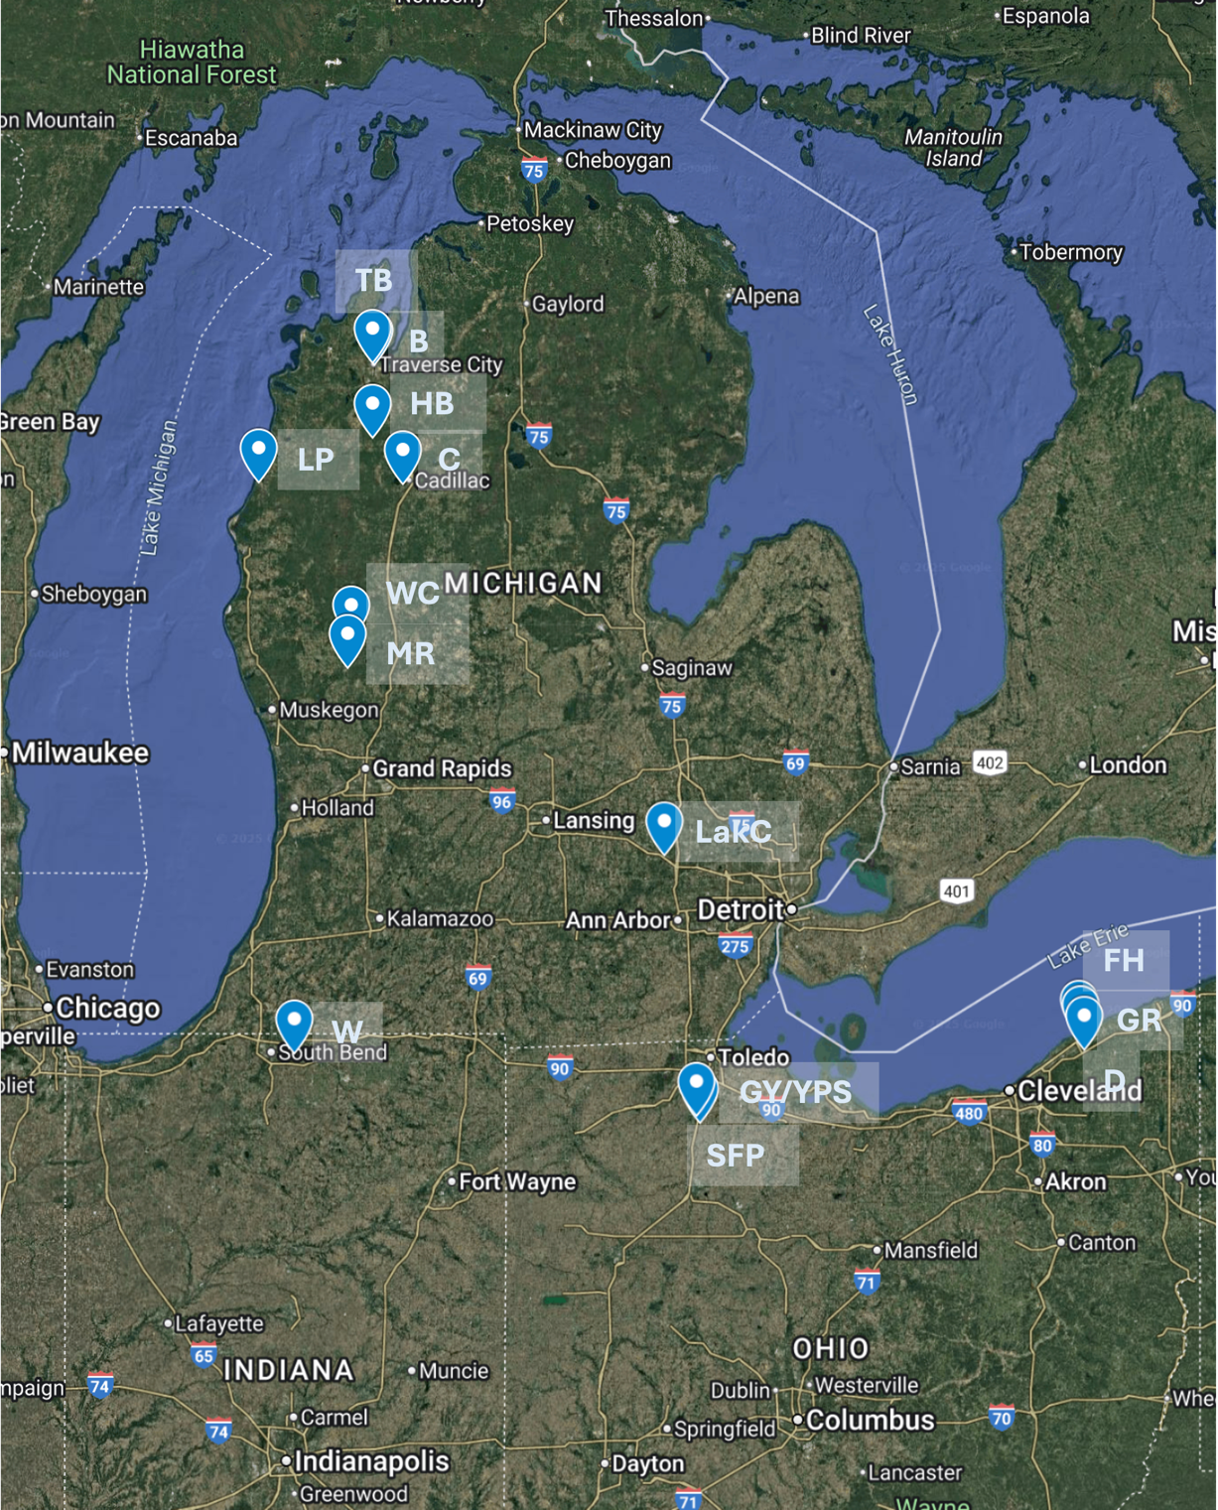
Fig. S1 Sampling locations for Saprolegnia across Michigan, Ohio, and Indiana. Twenty-seven water samples and 2 fish tissue samples were collected from 14 sites. TB: Lake Michigan, Traverse City, MI; B: Boardman River, Traverse City, MI; HB: Harvey Iron Pony Truss Bridge, Buckley, MI; C: Cadillac Lake, Cadillac, MI; LP: Lake Michigan, Manistee, MI; WC: Lake White Cloud, White Cloud, MI; MR: Muskegon River, Newaygo, MI; LakC: Lake Chemung, Brighton, MI; W: Richard Clay Bodine State Fish Hatchery (fish tanks), Mishawaka, IN; GY/YPS: Bowling Green State University Greenhouse, Bowling Green, OH; SFP: Bowling Green Pond, Bowling Green, OH; FH: Lake Erie, Fairport Harbor, OH; GR: Grand River, Fairport Harbor, OH; D: Cloverdale Lake, Concord Township, OH. Precise geographical coordinates and landmarks for all sites are provided in Table S1.

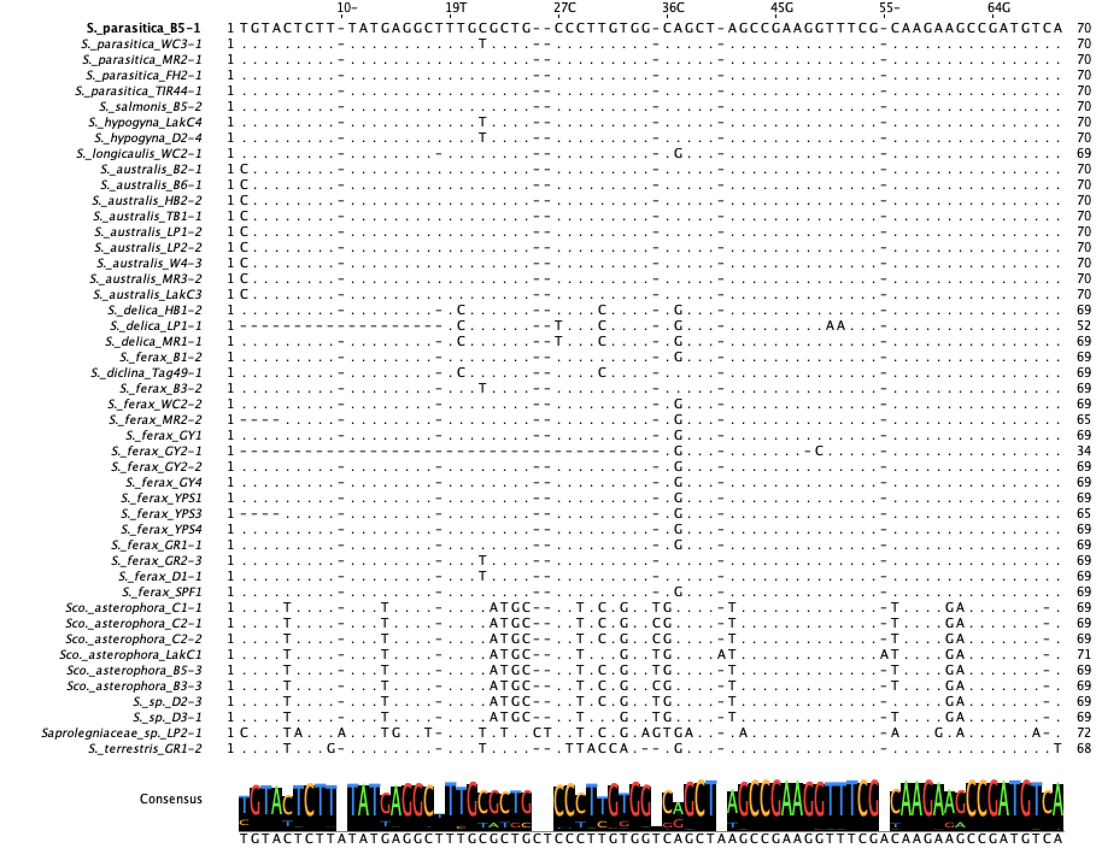
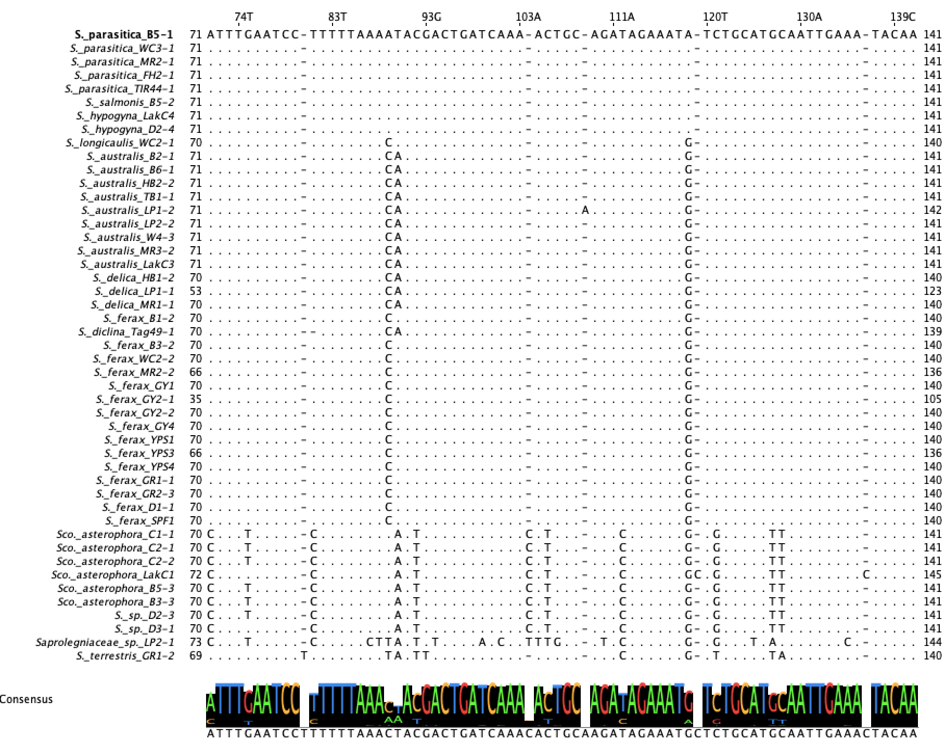
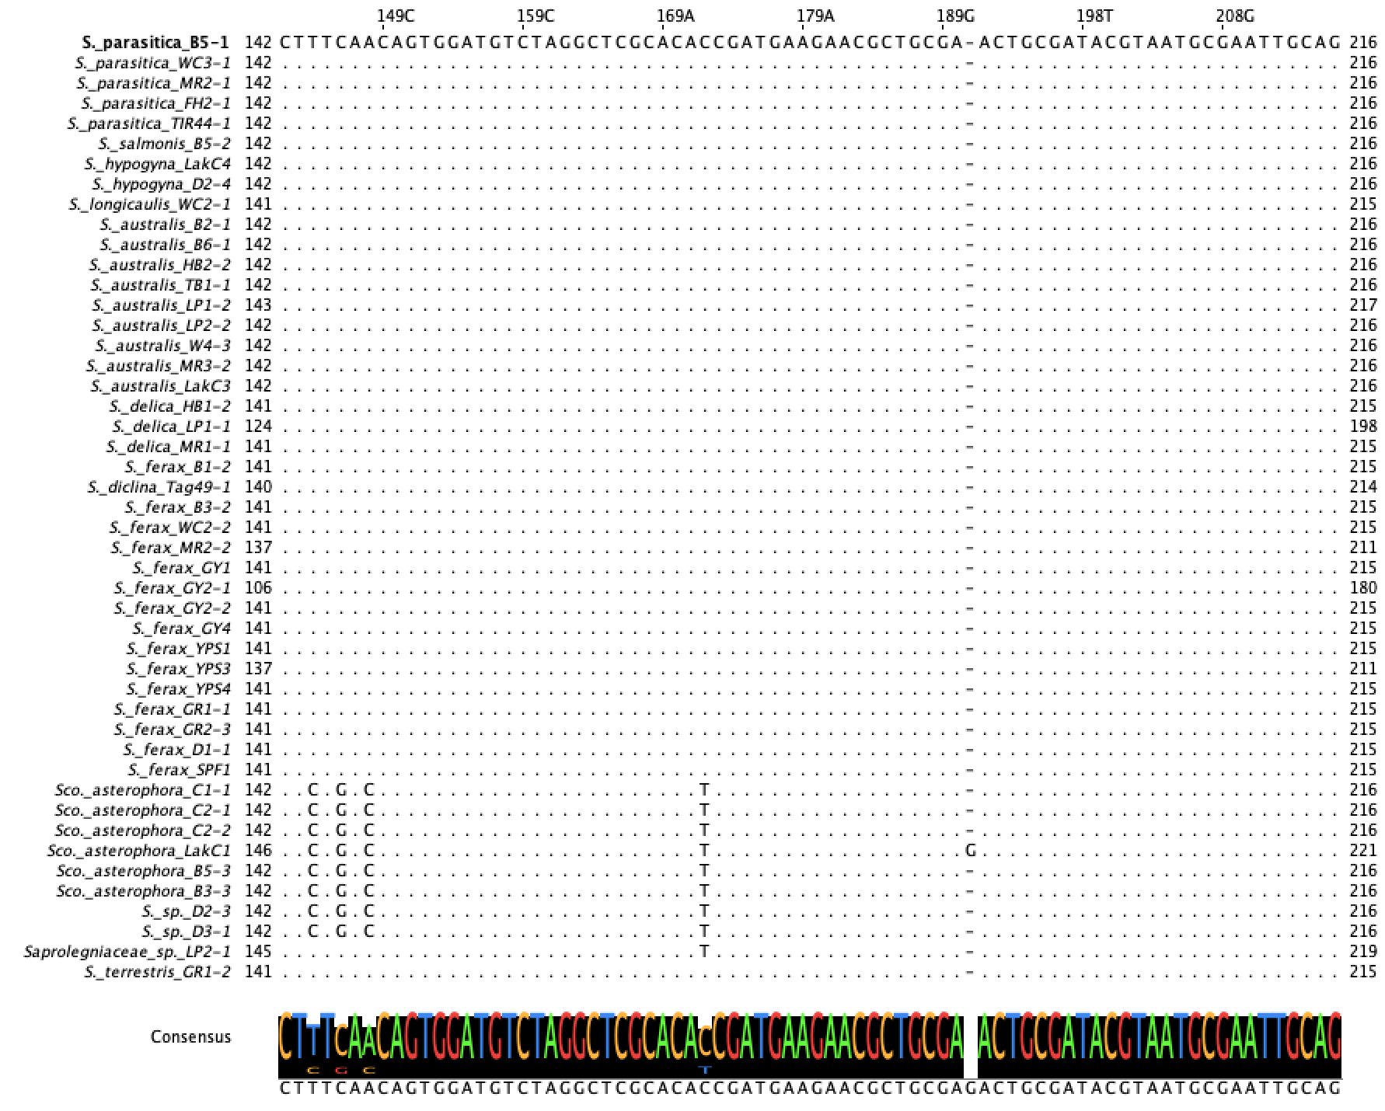
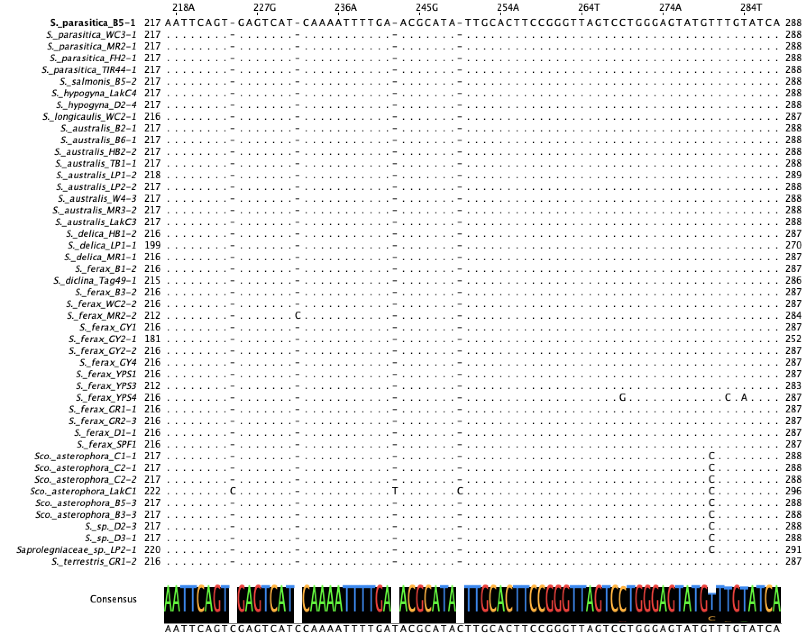
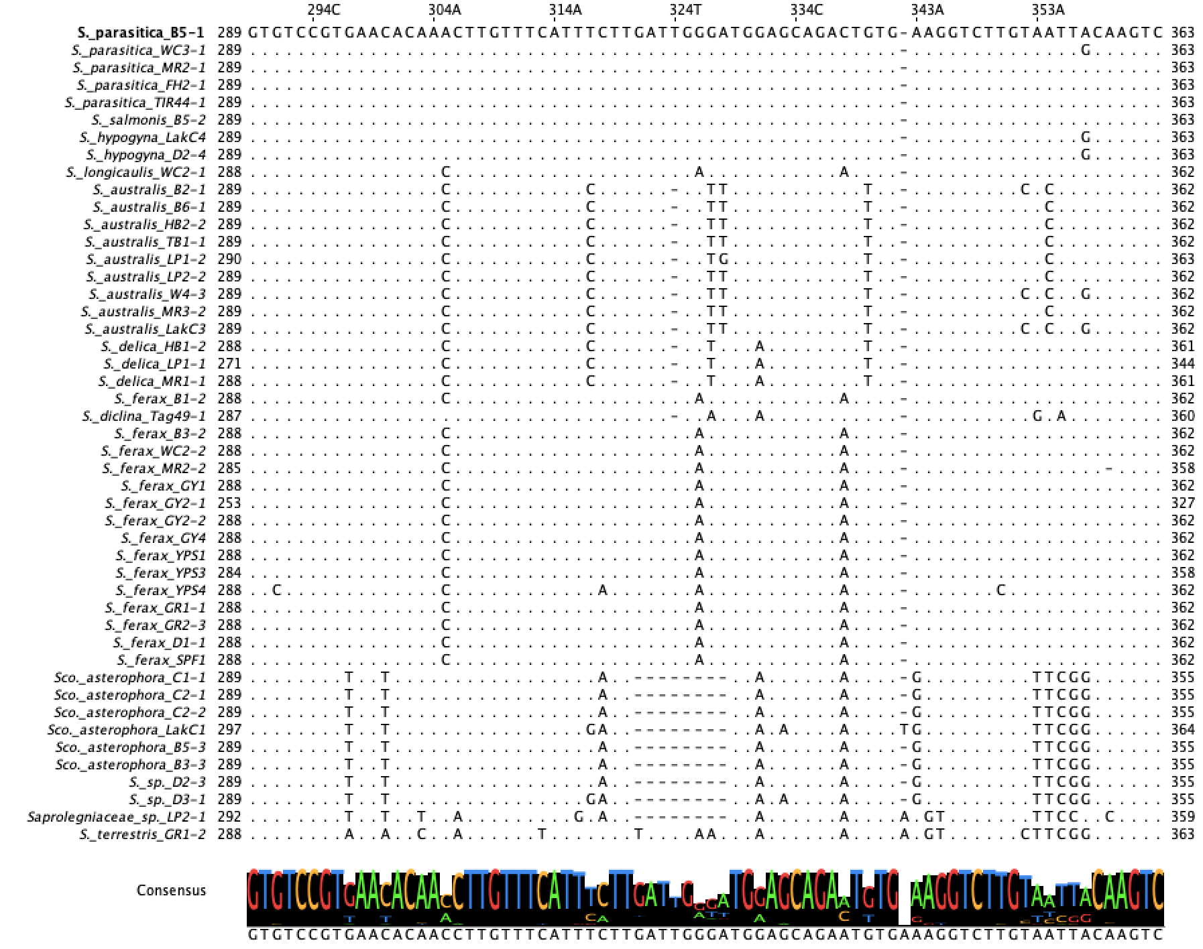
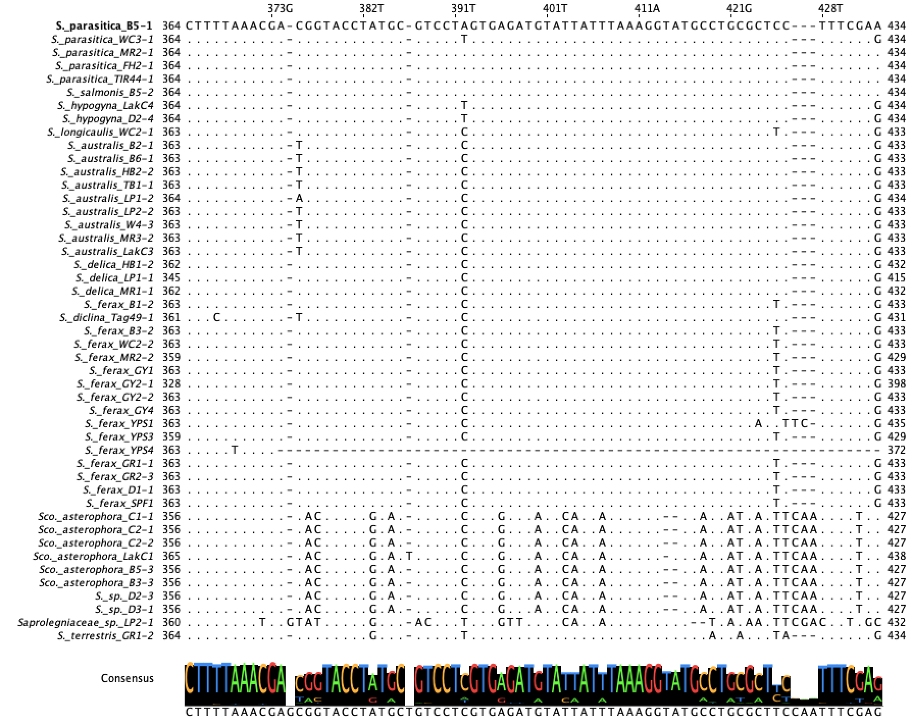
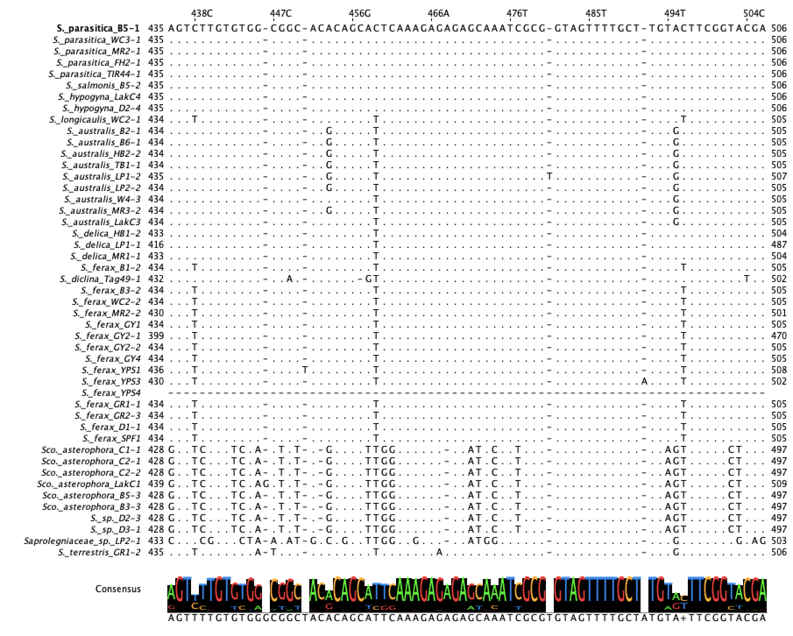
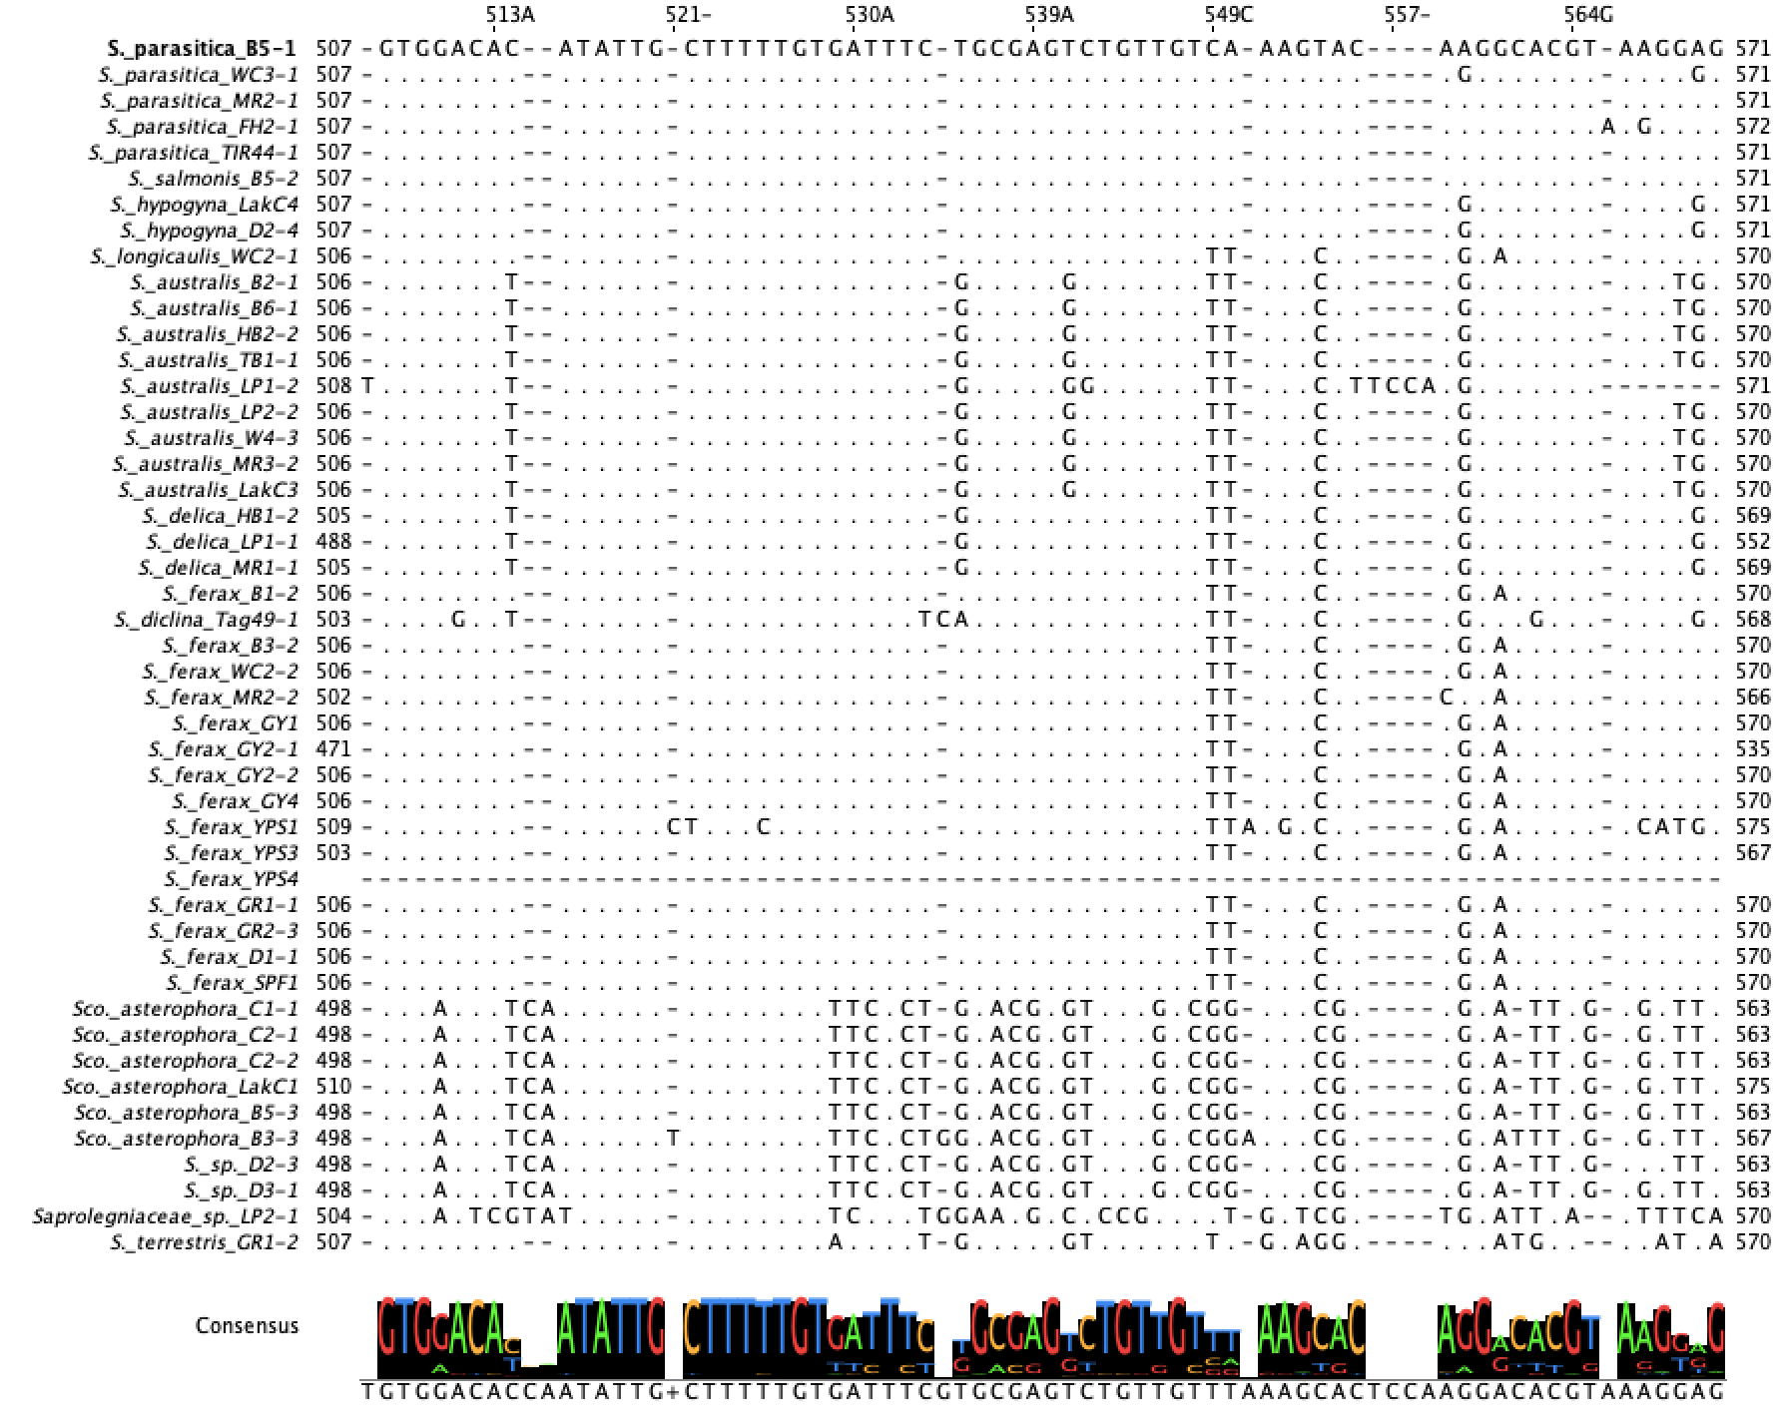
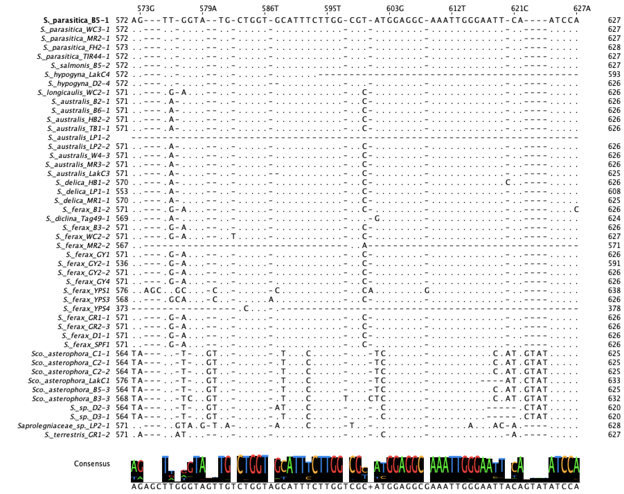
Fig. S2 Multiple sequence alignment of the ITS sequences from 47 Saprolegnia isolates. The alignment includes sequences from Saprolegnia and Scolegnia spanning the ITS1, 5.8S rRNA, and ITS2 sub-regions. Sequences were aligned using the MUSCLE alignment within Jalview. Dots (.) indicate nucleotides identical to the top reference sequence, and dashes (-) represent alignment gaps introduced to accommodate insertions or deletions. Species and isolates identifiers are listed on the left.

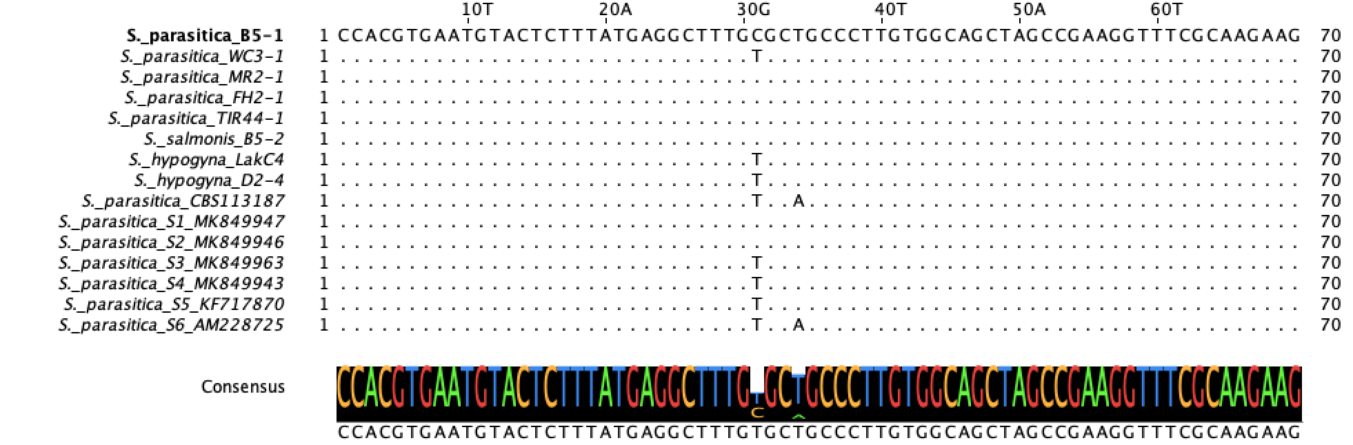

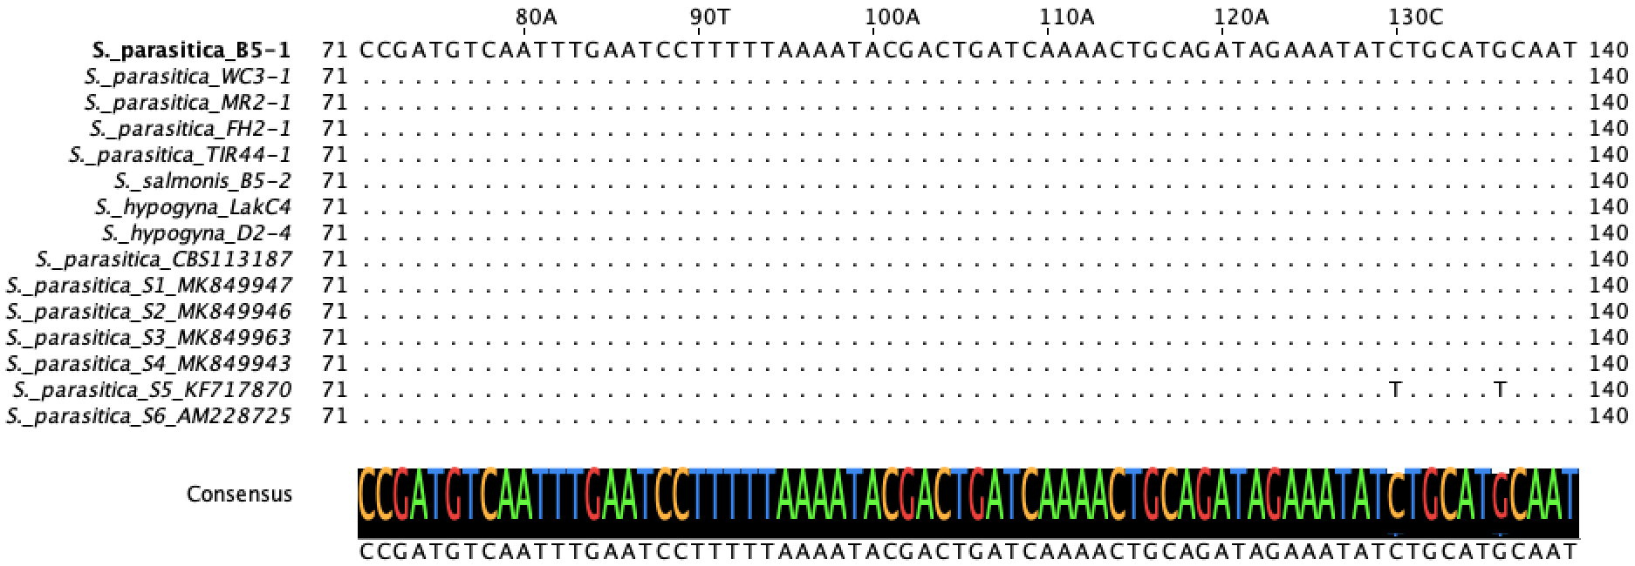

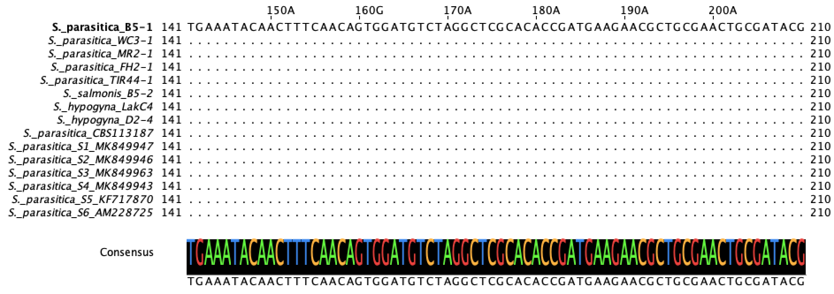

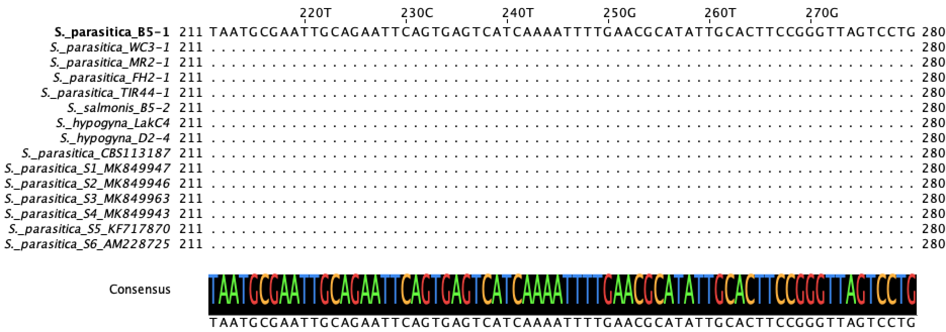

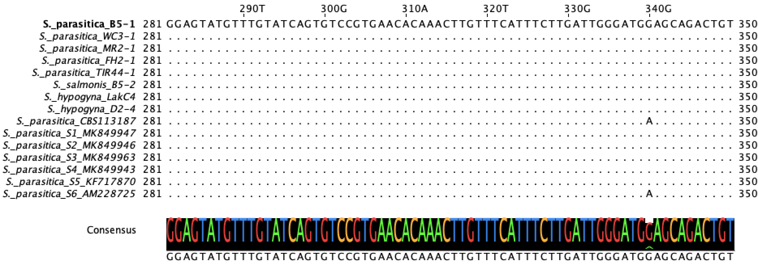

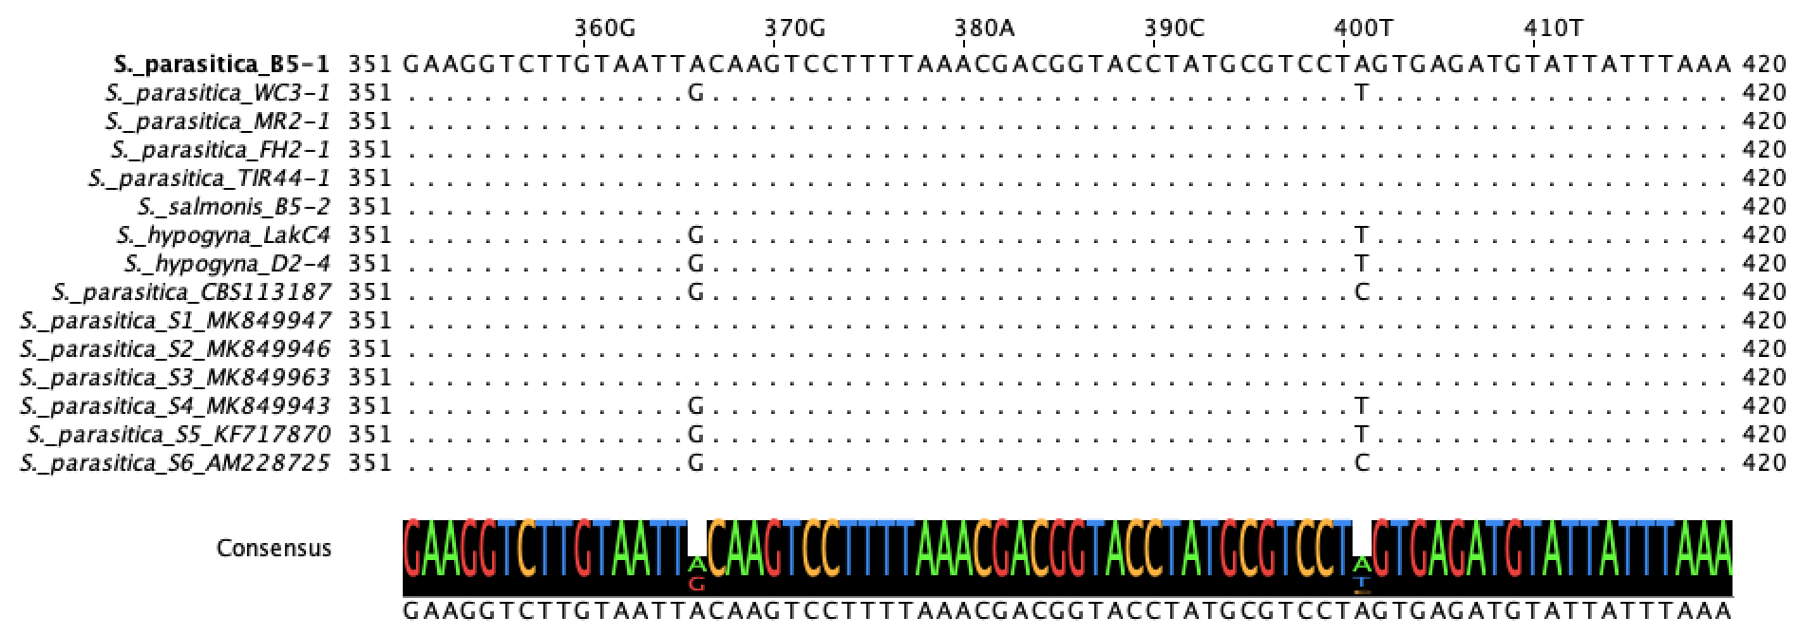

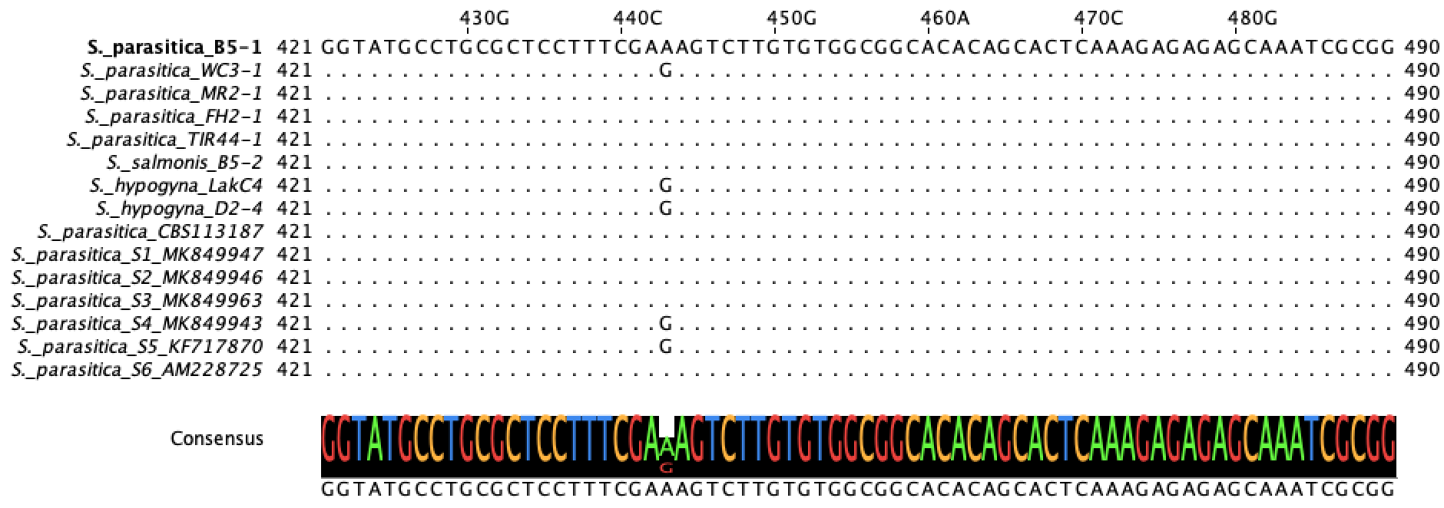

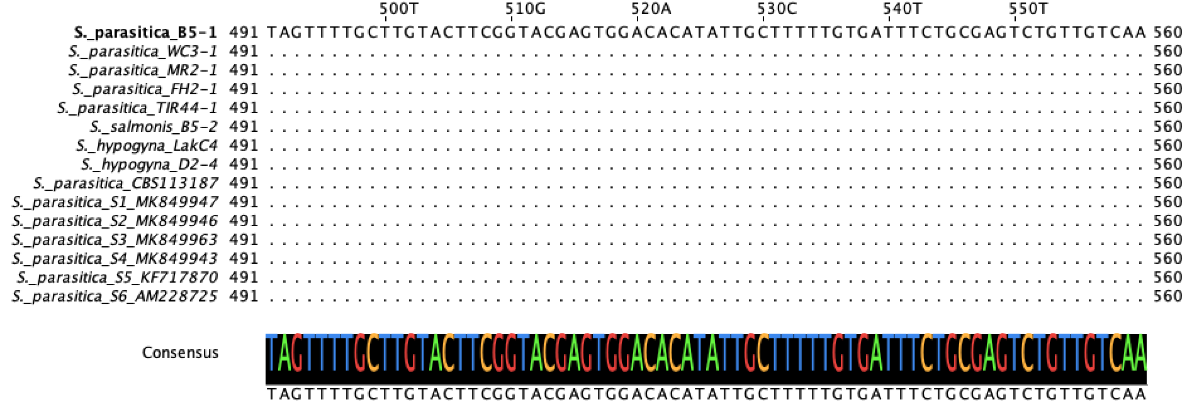

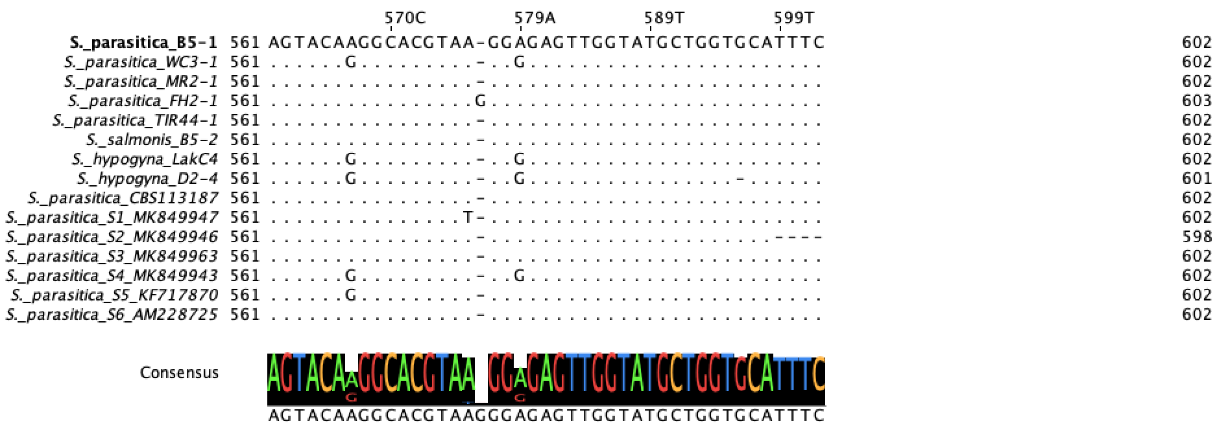

Fig. S3 Alignment of variable nucleotide sites among Saprolegnia parasitica isolates and reference phylotypes. The isolates from this study were compared with S2 and S4 reference phylotypes at 16 variable nucleotide positions (128, 146, 346, 372, 375, 393, 471, 499, 524, 560, 574, 575, 576, 577, 578, and 605 bp. Dots (.) indicate identity to the first sequence, and dashes (-) represent alignment gaps.

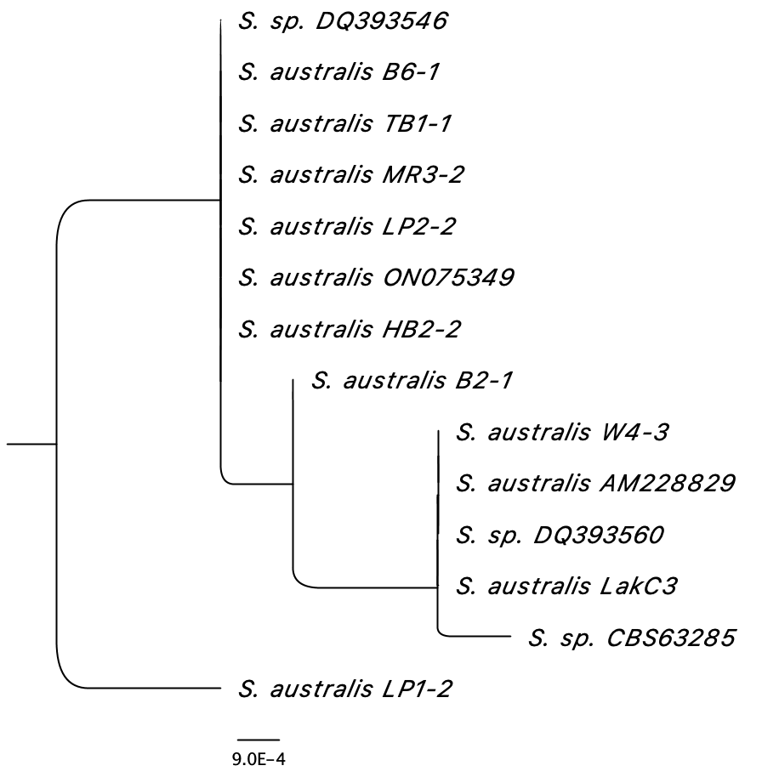
Fig. S4 Maximum-likelihood phylogeny of Saprolegnia australis ITS sequences. Nine isolated from this study (B6-1, TB1-1, MR3-2, LP2-2, HB2-2, B2-1, W4-3, LakC3, and LP1-2) were analyzed with five reference sequences (DQ393546, ON075349, AM228829, DQ393560, and CBS63285) to assess intraspecific relationship with S. australis.

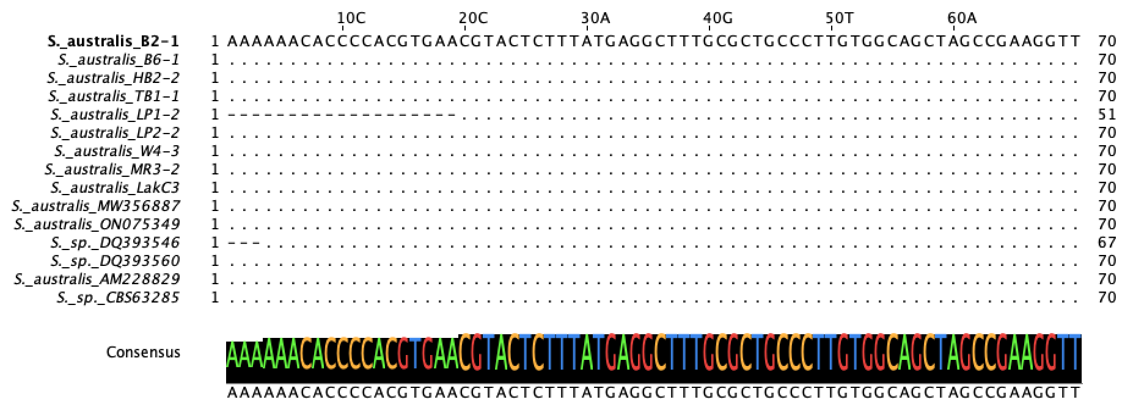

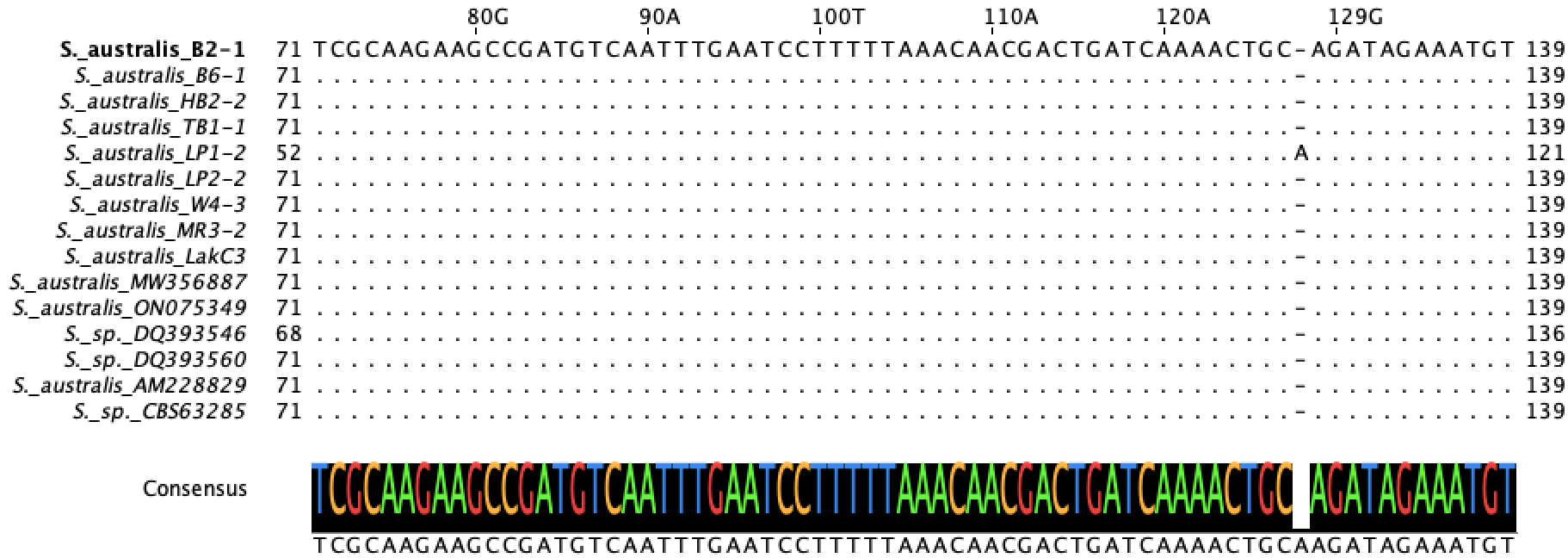

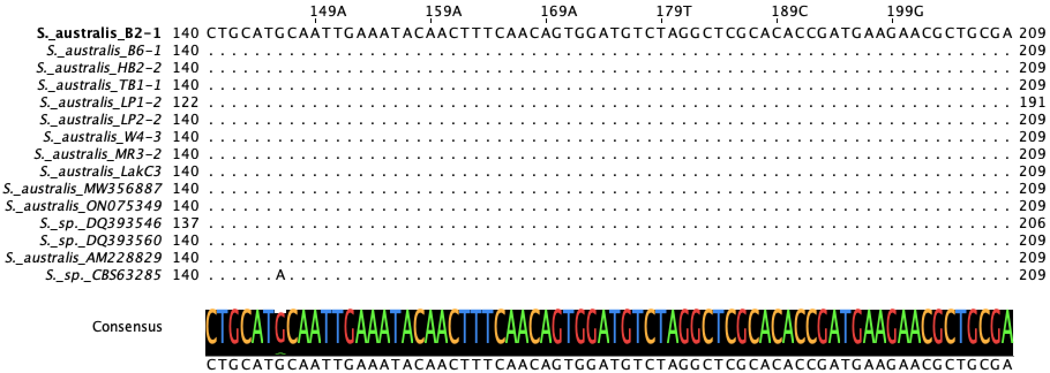

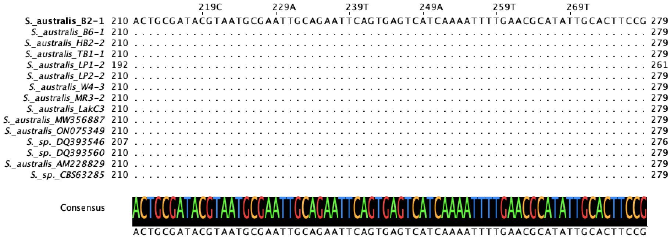

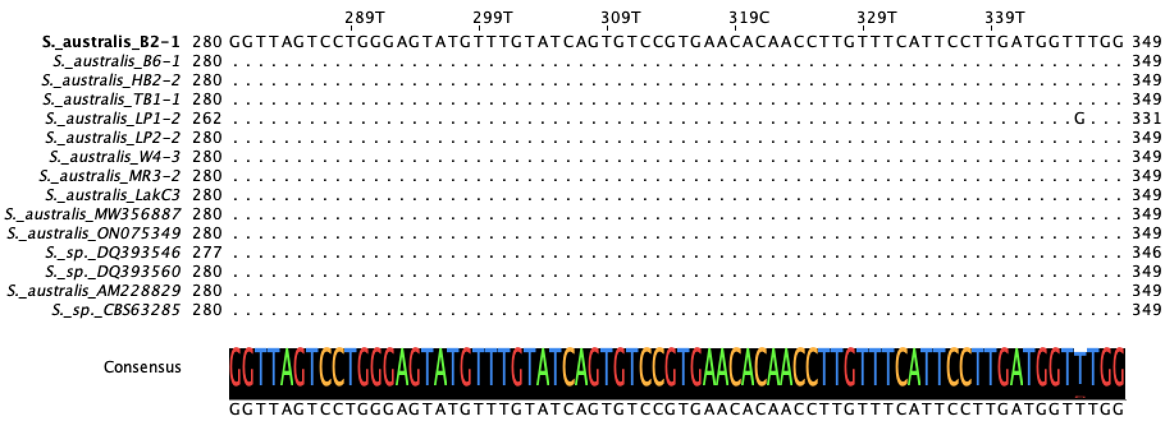

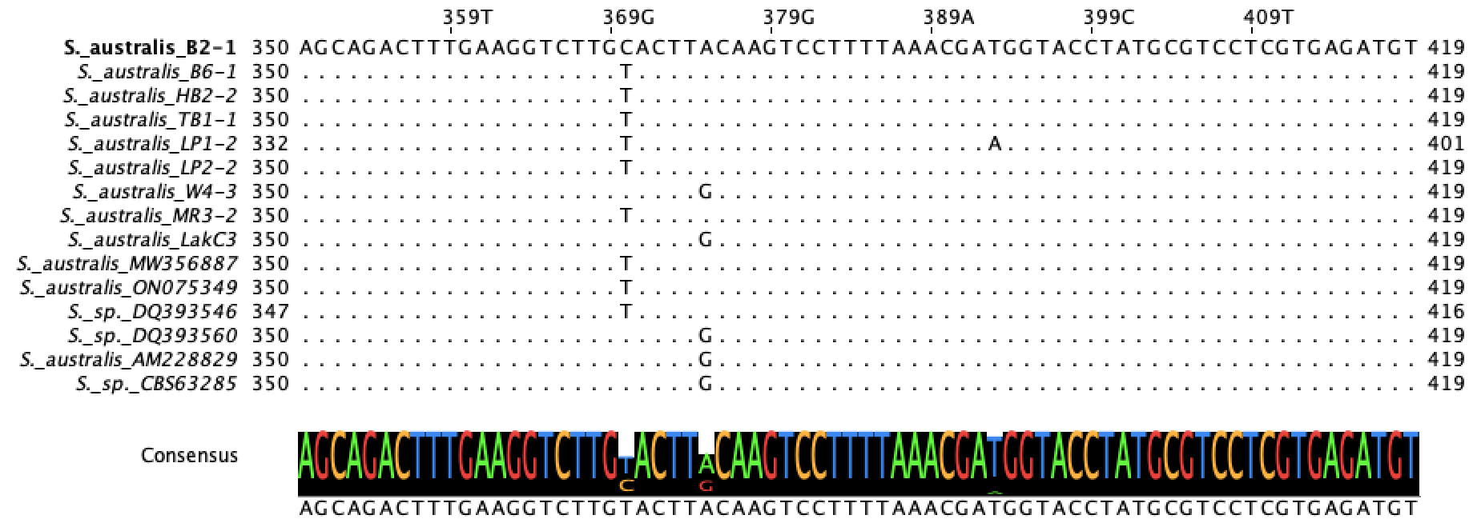

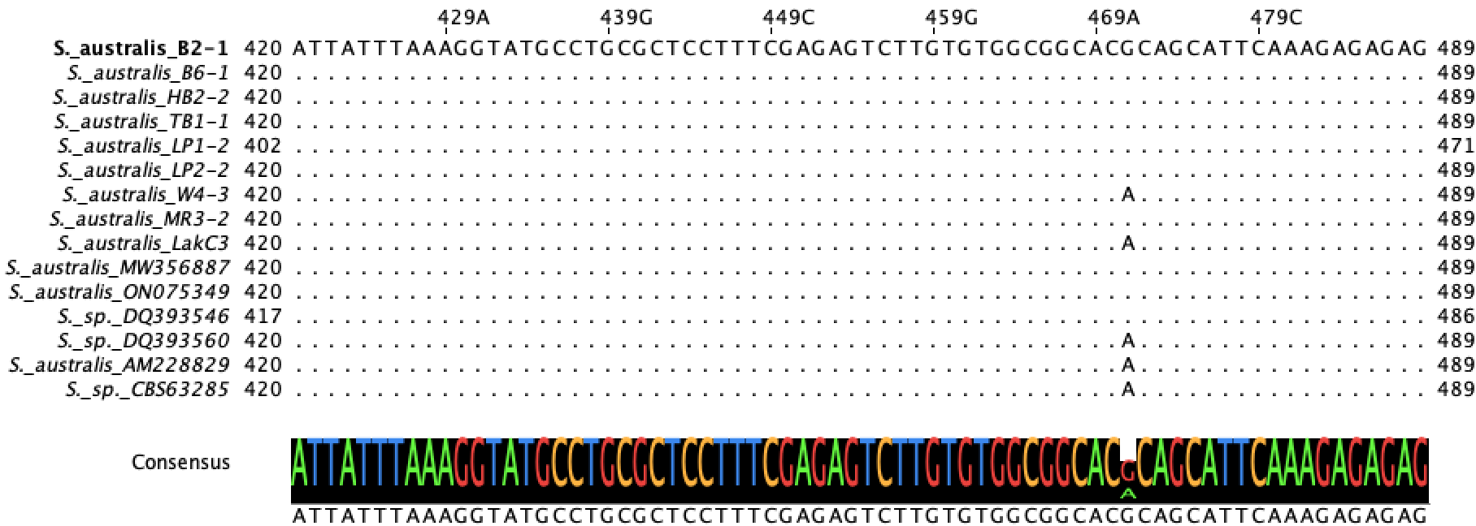

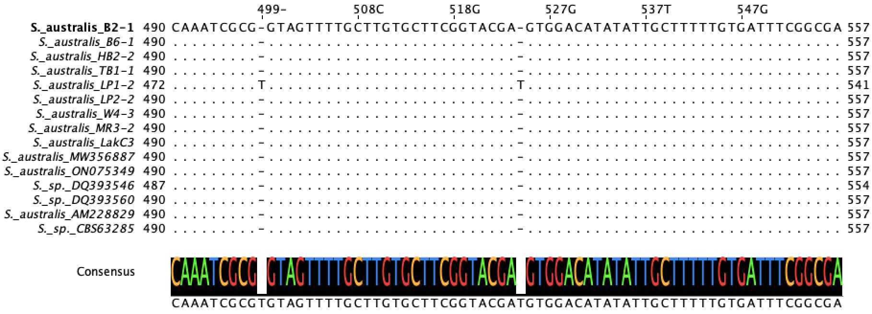

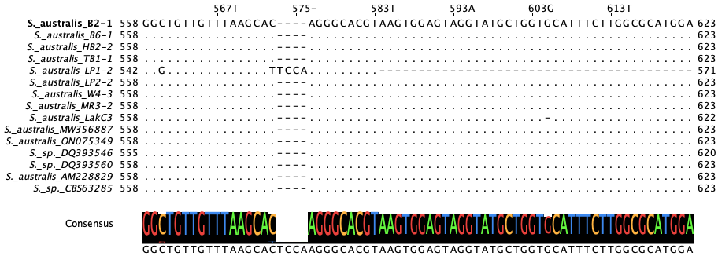

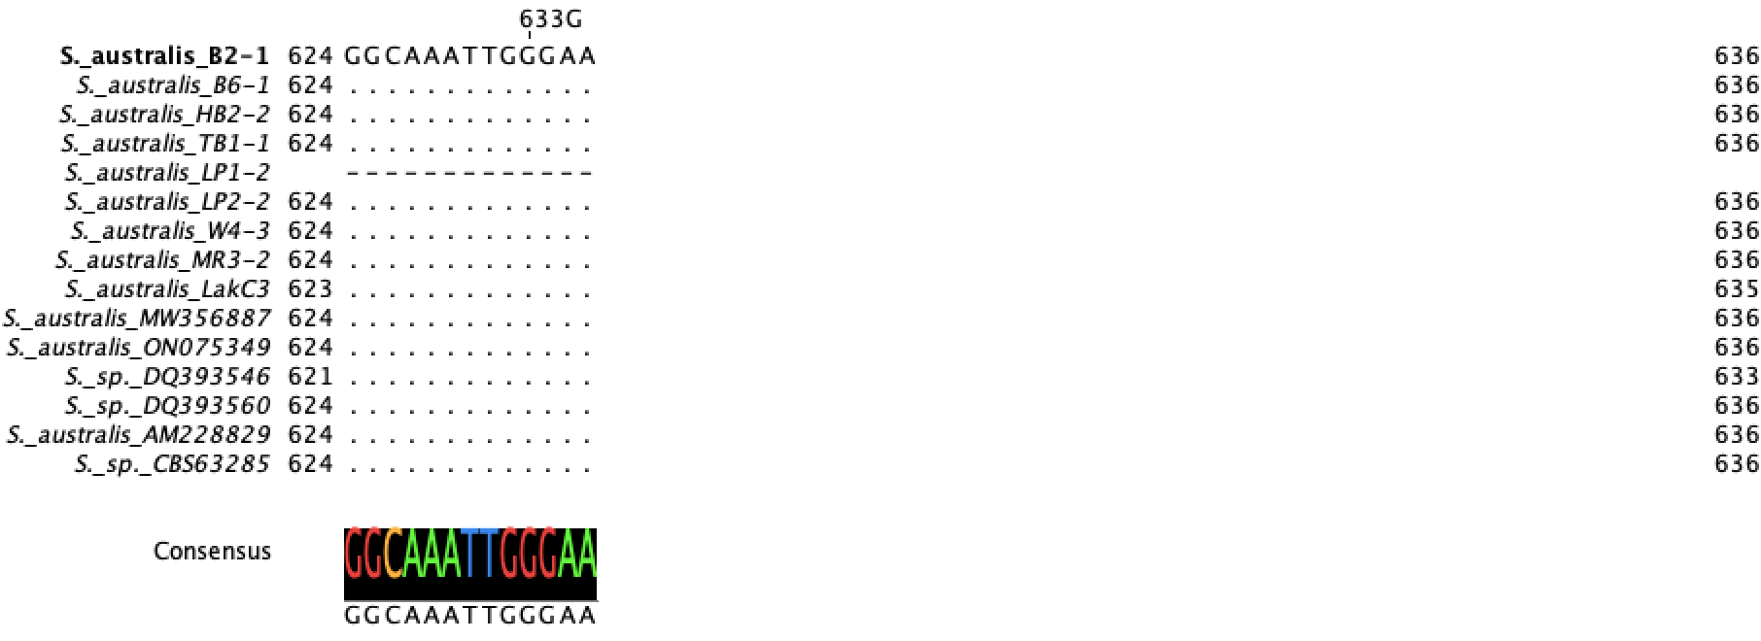

Fig. S5 Multiple sequence alignment of the ITS region for S. australis isolates. The alignment includes sequences from nine isolates and five reference sequence (DQ393546, ON075349, AM228829, DQ393560, and CBS63285). Dots (.) indicate nucleotides identical to the top reference sequence, while dashes (-) represent alignment gaps. Strain identifiers are listed on the left.

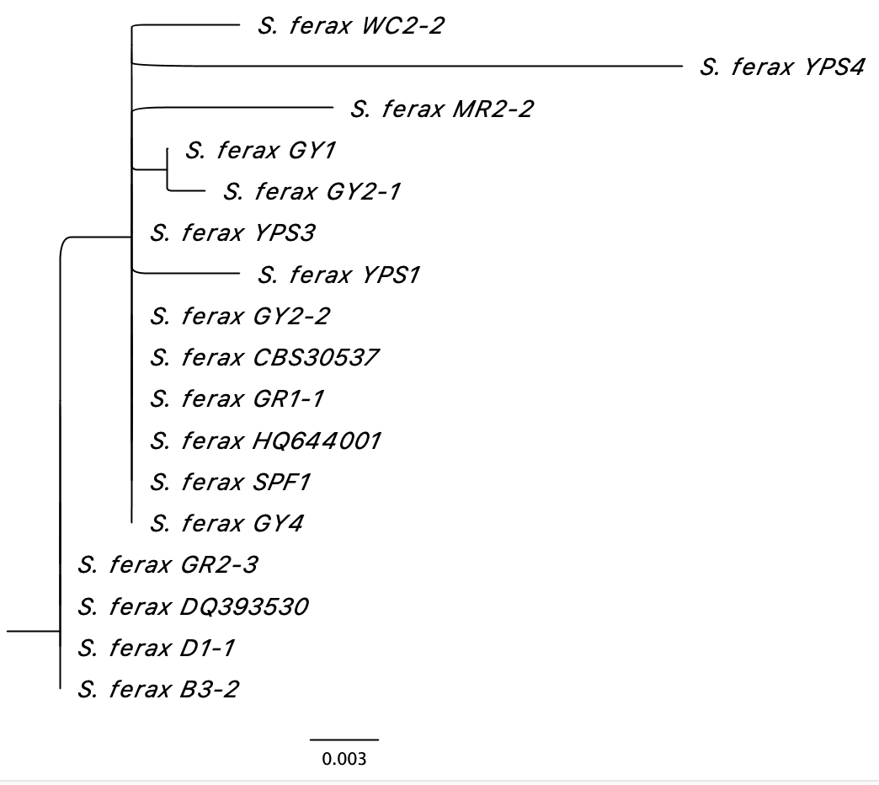
Fig. S6 Maximum-likelihood phylogeny of Saprolegnia ferax ITS sequences. Fourteen isolates from this study (WC2-2, YPS4, MR2-2, GY1, GY2-1, YPS3, YPS1, GY2-2, GR1-1, SPF1, GY4, GR2-3, D1-1, and B3-2) were analyzed with three reference sequences (CBS30537, HQ644001, and DQ393530) to assess intraspecific relationships with S. ferax.

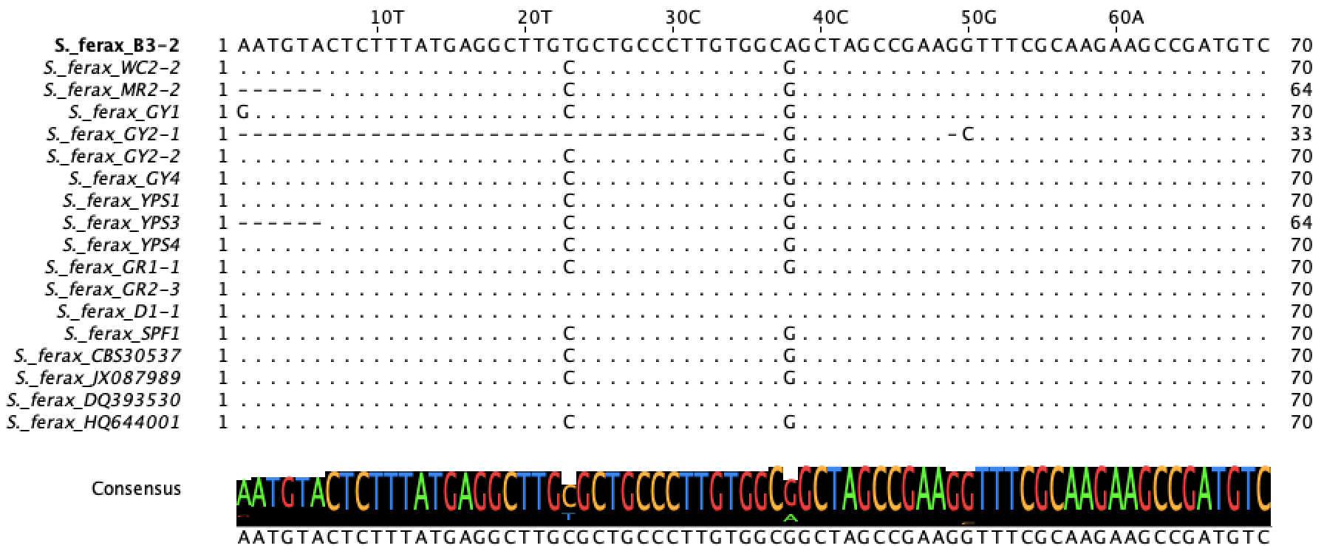

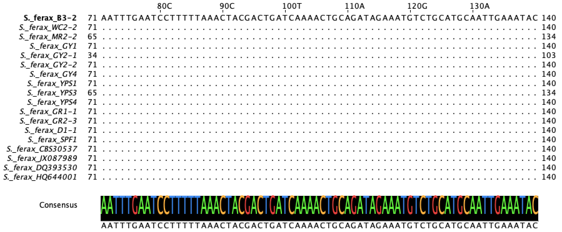

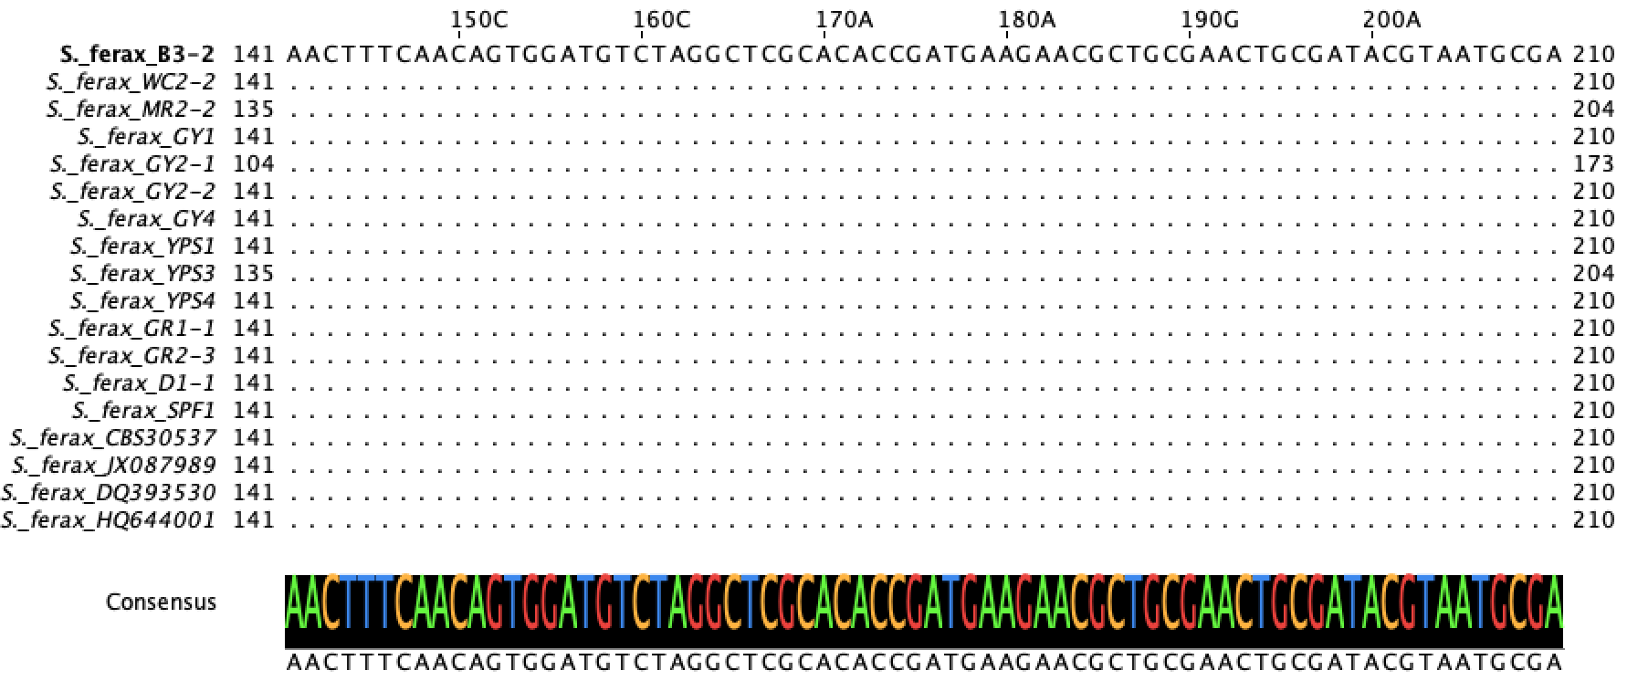

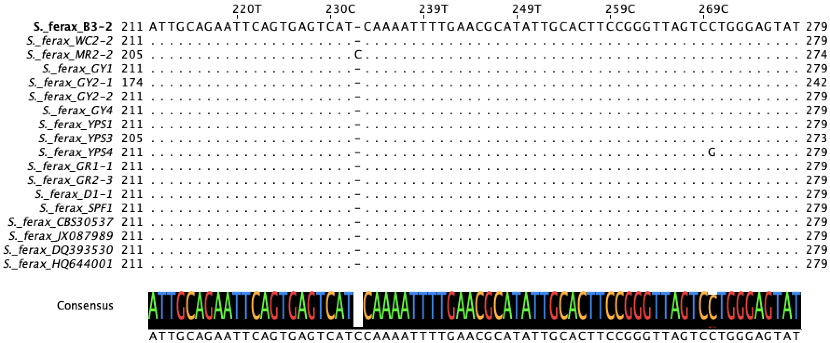

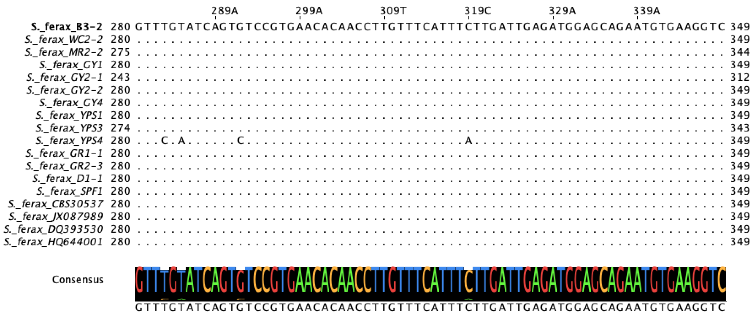

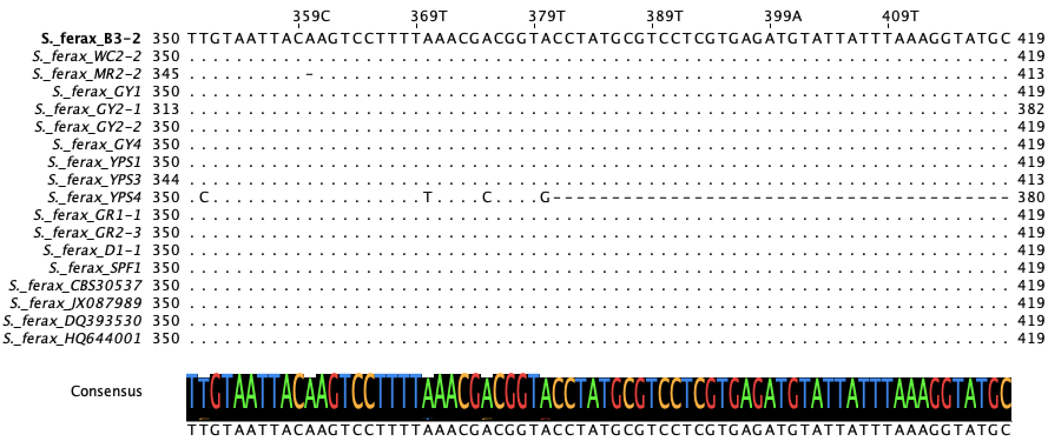

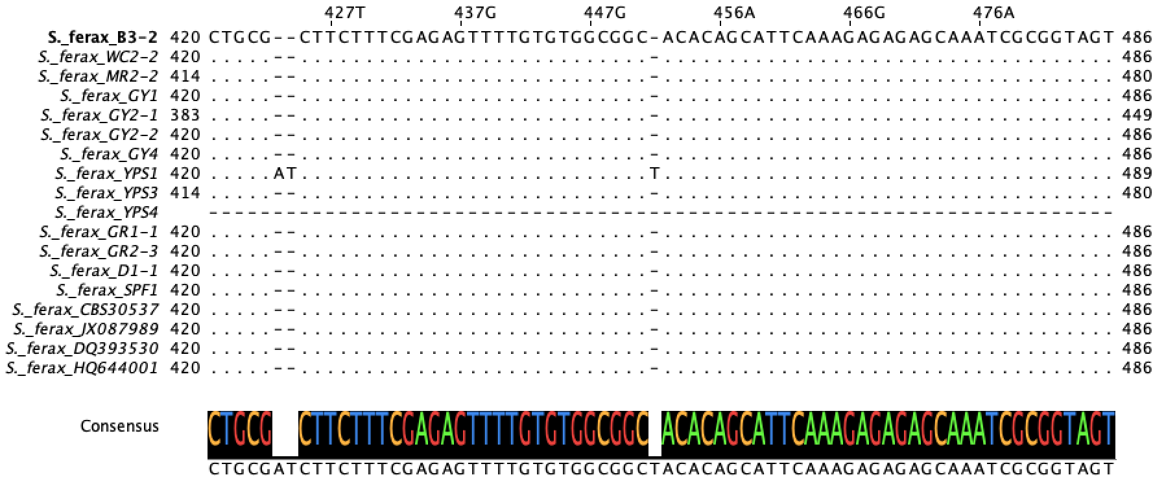

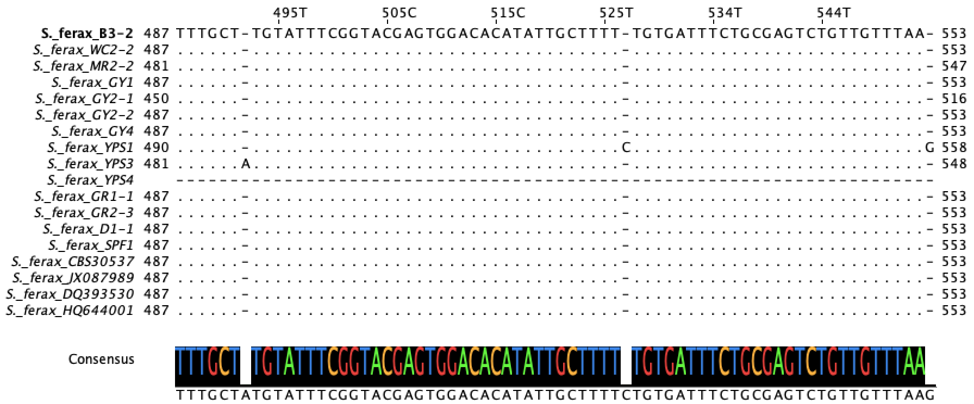

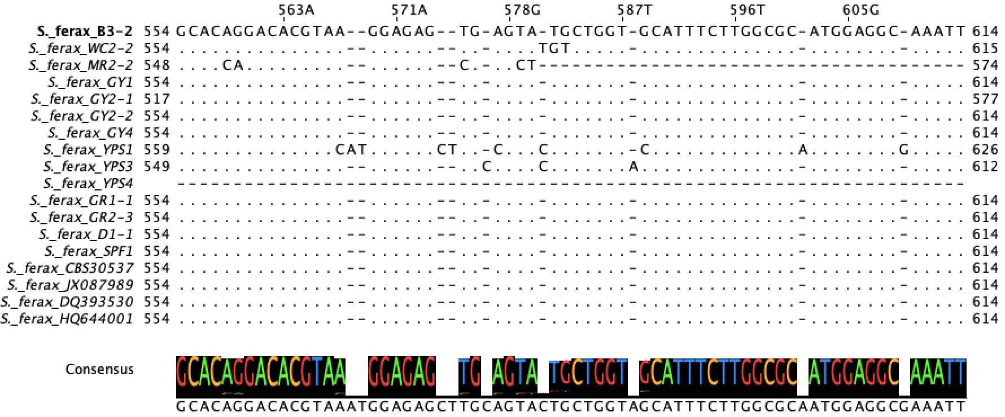

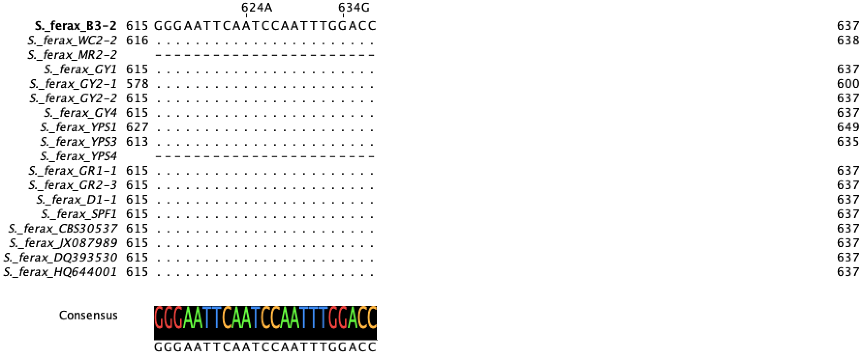

Fig. S7 Multiple sequence alignment of the ITS region for S. ferax. The alignment includes sequences from fourteen isolates and three reference sequences (CBS30537, HQ644001, and DQ393530). Dots (.) indicate nucleotides identical to the top reference sequence, while dashes (-) represent alignment gaps.

