Supplementary Appendix
Figure 5: Emed® platform (Left) 5m walkway with time gates at start and end (Right)
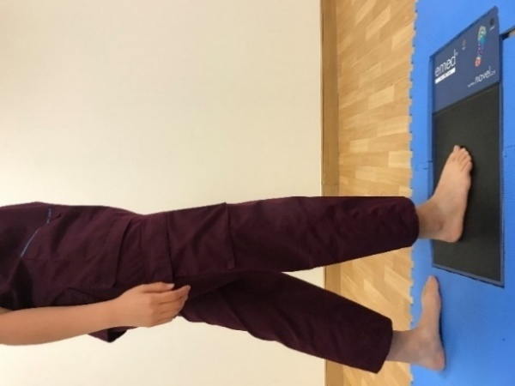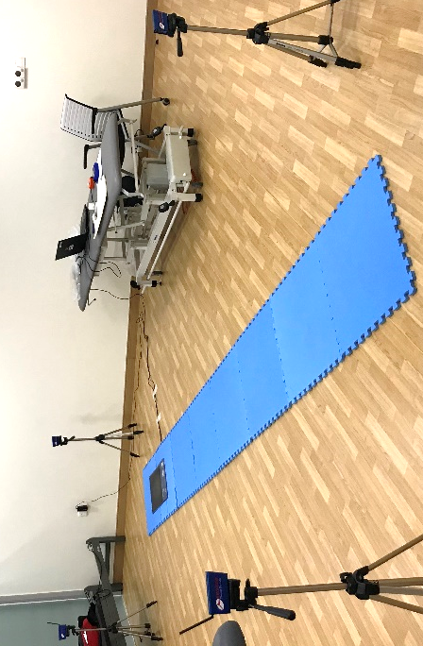

.
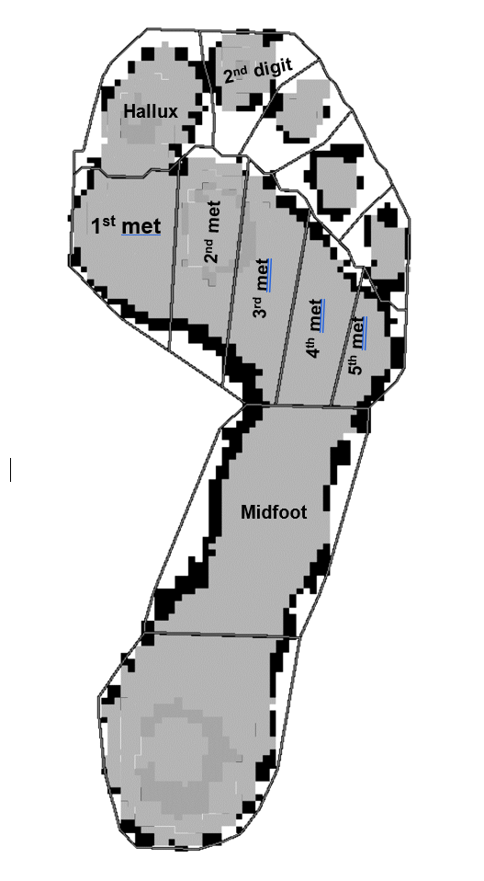
Figure 6: Automated mask with 8 regions of interest selected for analysis

Table 3: Participant’s demographics
Age, years | 39 ±12 (24 - 67)
Gender (male:female) | 14:16
Weight, kg | 64.8 ± 10.1 (47.3 - 91.9)
Height, cm | 164.9 ± 7.67 (148.0 - 184.0)
Foot length, cm | 24.9 (23.0 - 28.6)
Dominant on right foot (%) | 96.7
FPI (dominant foot) | 4.3 ± 2.7

