Appendix 1
Ⅰ. The Physical Fitness and Breathing Training team struture:
Group leader: 1 person
Liaison: head nurse of each ward
Coordinator: 2 person
Ⅱ. Responsibilities:
All team members should work under the leadership of the team leader, and the medical department of the hospital should be responsible for overall coordination.
Each group developed the rehabilitation treatment plan for COVID-19 patients according to their own professional characteristics, and achieved full evaluation, individual treatment and comprehensive treatment. Formulate the technical plan, group work plan, quality evaluation standard and schedule of rehabilitation treatment. Detailed division of labor, strengthened cooperation, held regular communication and coordination meetings to ensure smooth operation of work.
Ⅲ.Work plan
To determine the Physical fitness and Breathing Training prescription.
The patients' physical fitness training prescription is according to Borg Scale's Measurement of Dyspnea (Table 1), clinical presentation score (Table 2), and lung function which measure the degree of lung function damage. The detailed are shown in Table 3.
    - Borg Scale's Measurement of Dyspnea is shown in table 1
Table 1 Borg classification of dyspnea
No asthma at all | 0
Very,very slight (just noticeable) | 1
Very slight | 2
General | 3
A little bit serious | 4
Serious | 5
 | 6
Very serious | 7
 | 8
Very, very serious (almost the worst) | 9
The most serious | 10
* Note: the score may not be an integer

2.1.2 Clinical evaluation of the patient
Table 2 The patient's clinical performance score
Consciousness | Sober | 0
Consciousness | Lethargy or coma | 1
SaO2 | >90% | 0
SaO2 | <90% | 1
Heart rate | 50-120 times/min | 0
Heart rate | <50 or >120 times/min | 1
The use of vasoactive drugs | No | 0
The use of vasoactive drugs | Yes | 1
Discomfort such as pain or dizziness | No | 0
Discomfort such as pain or dizziness | Yes | 1
Oxygen therapy (nasal catheter, high flow humidification, non-invasive, invasive ventilator) | No | 0
 | Yes | 1

Table 3 evaluation of patients with COVID-19 before therapy rehabilitation implementation
Records of rehabilitation evaluation of patients with physical fitness therapy
Valuation date：Year month day
The patient name： Gender： Age： Admission No(AD)：
Bed number：
breathing：
R： times/min
SaO2： %
Oxygen inhalation： L/min
Abnormal breathing pattern：□Shallow and fast breathing
□Breathe deep slow
Abnormal breath sounds： □Rhonchus □Mosit crackles
Cough： □Yes exacerbation： d
Expectoration： □White phlegm □Serum foam sputum □Sputum
□ Increased sputum volume： d
Shortness of breath：□When resting □During activity：□Eat □Bath
□defecation □Exert oneself
□Consciously panting □pant

Borg dyspnea rating： ； Clinical performance score： ；
FEV real/pre： %
Note: American Thoracic Society(ATS) and the European Respiratory Society (ERS) proposed joint guidelines suggest: no matter obstructive, restrictive or mixed ventilation dysfunction, the degree of lung function damage can be judged according to the percentage of FEV1 in the measured value / expected value: (1) mild FEV1 real/ pre > 70%, but less than normal expected value lower limit or FEV1 / FVC < normal value is expected to lower limit; (2) moderate FEV1 real/pre 60% -69%; (3) moderate to severe FEV1 real/pre 50%-59%; (4) heavy FEV1 real/forecast 35%-49%; Extremely heavy FEV1 real/forecast <35%.
2.2 Rehabilitation prescription of physical fitness training
Physical fitness training prescription is shown in Table 4. The specific training methods are as follows:

Table 4. Specific content of physical fitness prescription (please "√" on the appropriate item)
Name: Gender: □ male □ female Age: Admission No. :
date:
Borg score:≤3 and clinical presentation score:0 (mild risk);Mild impairment of lung function | 1、Breathing training  □Effective cough sputum removal techniques： times /d  □Position management： times /d  □Controlled breathing techniques（pursed-lip breathing： times /d， min/times；abdominal breathing： times /d， min/time  □Chest dilation training： times /d， min/time  □Breathing muscle training（Use a motivational breathing trainer）： times /d， min/time  □Active cyclic breathing control training： times /d，  min/time  2、Sports training  □Active body movement ： times /d， min/time  □Resistance training； times /d， min/time
Borg dyspnea score:≤3 and clinical presentation score:≥1； Moderate impairment of lung function (moderate risk of disease) | 1、Breathing training  □Effective cough sputum removal techniques： times /d  □Position: supine or half-seated  □Controlled breathing techniques（pursed-lip breathing： times /d， min/times；abdominal breathing： times /d， min/times  □Chest dilation training： times /d， min/times  □Breathing muscle training（Use a motivational breathing trainer）： times /d， min/times  □Active cyclic breathing control training： times /d，  min/times  2、Sports training  □Active body movement in bed ： times /d， min/times
Borg dyspnea grade score: >3 and clinical presentation score:≥1 or severe impairment of ventilator assisted ventilation or lung function (severe risk of disease) | 1、Breathing training  □Chest wall high frequency vibration sputum extractor or sputum aspiration: times /d， min/times  □Prone position ventilation: times /d， min/times  2、Sports training  □Passive physical activity: times /d， min/times
* Note: update the physical fitness prescription every three days, and see Annex 1 for tips and notes on breathing and physical fitness training

Table 5 Records of training
Name： Bed number： Admission No：
 | Date | AM(Record the actual completed quantity and special situation) | PM(Record the actual completed quantity and special situation)
Effective cough sputum removal techniques
Postural management/prone ventilation
Pursed-lip breathing
Abdominal breathing
Thoracic expansion training
Breathing muscle training using a motivational breathing trainer
Active cyclic breathing control training
Active body movement
Resistance training
Passive limb movement
Note: Record every day whether the patients are compliance with the physical fitness prescription and the changes during the physical fitness
2.3. Evaluation of rehabilitation effectiveness of physical fitness therapy
2.3.1 Pulmonary function examination was used to evaluate the rehabilitation effect of physical fitness therapy, as shown in Table 6.
2.3.2 Evaluation of the rehabilitation effect of physical fitness training based on Borg scale and clinical manifestations.
2.3.3 Evaluation frequency: once every three days, timely adjust the rehabilitation prescription of physical fitness training according to the evaluation results, and timely adjust according to the changes of patients' conditions during the implementation of rehabilitation training.

Table 6 Evaluation of rehabilitation efficacy of physical fitness training
Patient status evaluation record sheet
Date of evaluation: year, month, date
The patient name： Gender： Age： Admission No(AD)：
Bed number：
breathing：
R： times/min
SaO2： %
Oxygen inhalation： L/min
Abnormal breathing pattern：□Shallow and fast breathing
□Breathe deep slow
Abnormal breath sounds： □Rhonchus □Mosit crackles
Cough： □Yes exacerbation： d
Expectoration： □White phlegm □Serum foam sputum □Sputum
□ Increased sputum volume： d
Shortness of breath：□When resting □During activity：□Eat □Bath
□defecation □Exert oneself
□Consciously panting □pant

Borg dyspnea rating： ； Clinical performance score： ；
FEV real/pre： %
Tips: The rehabilitation training should be carried out step by step without causing discomfort, such as chest tightness, shortness of breath, dyspnea, dizziness, headache, blurred vision, palpitations, sweating, and inability to maintain balance, etc., during the training, please immediately terminate the training and rest in bed, while seeking help from health care worker.
Physical fitness and breathing training for mild impairment of lung function in COVID-19 patient
The following training methods are mainly applicable to patients with mild impairment of lung function COVID-19.
Section 1, abdominal breathing
Position: sitting or standing
Method: relax the muscles of the whole body, put both hands in the abdomen, try your best to breathe in to make the abdomen bulge, stay for 3 ~ 5 seconds after the gas slowly exhaled, at the same time abdominal depression.
Beat: inhalation, 1,2,3,4; Exhalation, 1,2,3,4,5,6,7,8. A total of eight times

Section 2,
Pursed-lip breathing
Position: sitting or standing
Method: Inhale through the nose, exhale slowly like a whistle, inhalation: exhalation ratio is 1: 2 ~ 5.
Beat: inhalation, 1,2,3,4; Exhalation, 1,2,3,4,5,6,7,8. A total of eight times

Section 3, Standing position breathing training (a total of 6 sets of movements, the training inhalation: the exhalation ratio is 1:2 ~ 5)
Position: Standing
Action 1: Neck back-stretch and front-flex exercise
Method: Inhale backward, exhale forward
Beat: inhalation, 1,2,3,4; Exhalation, 1,2,3,4,5,6,7,8. A total of eight times

Action 2: Shrugging exercise
Method: raise your shoulder to inhale and lower your shoulder to exhale
Beat: inhalation, 1,2,3,4; Exhalation, 1,2,3,4,5,6,7,8. A total of eight times

Action 3: Chest expansion exercise
Methods: Shoulder forward flexion, arm abduction inhalation; shoulder adduction, elbow flexion and exhalation
Beat: inhalation, 1,2,3,4; Exhalation, 1,2,3,4,5,6,7,8. A total of eight times

Action 4: Arm lifts exercise
Method: double upper limbs draw a circle to inhale, return to exhale
Beat: inhalation, 1,2,3,4; Exhalation, 1,2,3,4,5,6,7,8. A total of eight times

Action 5: Body rotation exercise
Method: Keep your feet as wide as your shoulders, naturally sag your hands, inhale in the standing position, and rotate your torso to exhale
Beat: inhalation, 1,2,3,4; Exhalation, 1,2,3,4,5,6,7,8. A total of eight times
Action 6: Stepping exercise
Method: raise your head and chest, step on the spot, hold the railing if necessary
Beat: inhalation, 1,2,3,4; Exhalation, 1,2,3,4,5,6,7,8. A total of eight times
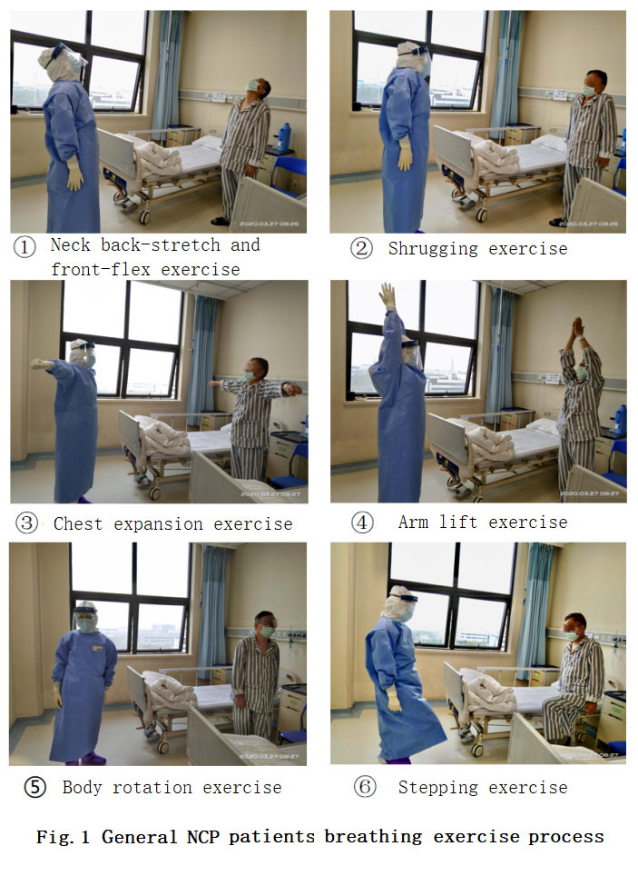
Figure 1 Physical fitness and breathing training for mild impairment of lung function in COVID-19 patients

Physical fitness and breathing training for moderate impairment of lung function in COVID-19 patient
Section 1: abdominal breathing
Position: supine, semi-recumbent or sitting
Method: relax the muscles of the whole body, put both hands in the abdomen, try your best to breathe in to make the abdomen bulge, stay for 3 ~ 5 seconds after the gas slowly exhaled, at the same time abdominal depression.
Beat: inhalation, 1,2,3,4; Exhalation, 1,2,3,4,5,6,7,8. A total of six times
Section 2: pursed-lip breathing
Position: supine, semi-recumbent or sitting
Method: Inhale through the nose, exhale slowly like a whistle, inhalation: exhalation ratio is 1: 2 ~ 5.
Beat: inhalation, 1,2,3,4; Exhalation, 1,2,3,4,5,6,7,8. A total of six times
Section 3: Application of breathing training apparatus
Position: sitting or standing
Method: Hold a breathing training apparatus, breathe through the mouth with a straw, and slowly inhale to make a ball slowly rise to the top. Continue to inhale as deeply as possible to make all three balls rise to the target scale. Hold the inhalation state for 5-10s, release the straw, and exhale calmly.
Beat: inhalation, 1,2,3,4; Exhalation, 1,2,3,4,5,6,7,8. A total of six times
Section 4: bed physical fitness (a total of 5 sets of movements)
Posture: lying or semi-sitting position.
Action 1: Chest expansion exercise (inhalation &expiratory ratio is 1: 2 ~ 5)
Methods: Shoulder forward flexion, arm abduction inhalation; shoulder adduction, elbow flexion and exhalation.
Beat: inhalation, 1,2,3,4; Exhalation, 1,2,3,4,5,6,7,8. A total of six times
Action 2: Ankle pump exercise
Method: Try to lift the toes, hold for 5 to 10 seconds, and press the toes to the maximum, hold for 5 ~10s, then relax.
Beat: inhalation, 1,2,3,4; Exhalation, 1,2,3,4,5,6,7,8. A total of six times
Action 3: Ankle joint surround movement
Method: Take the ankle joint as the center, and rotate it clockwise and counterclockwise 360 ° respectively.
Beat: inhalation, 1,2,3,4; Exhalation, 1,2,3,4,5,6,7,8. A total of six times
Action 4: Equal length contraction movement of the quadriceps
Method: Tighten the muscles in front of the thigh for 5 ~ 10s, then relax.
Beat: inhalation, 1,2,3,4; Exhalation, 1,2,3,4,5,6,7,8. A total of six times
Action 5: Leg raising and knee flexion
Method: Raise one straight leg by 30° ~ 40°, hold it for 5 seconds, restore by bending the knee and the hip; the legs are crossed.
Beat: inhalation, 1,2,3,4; Exhalation, 1,2,3,4,5,6,7,8. A total of six times

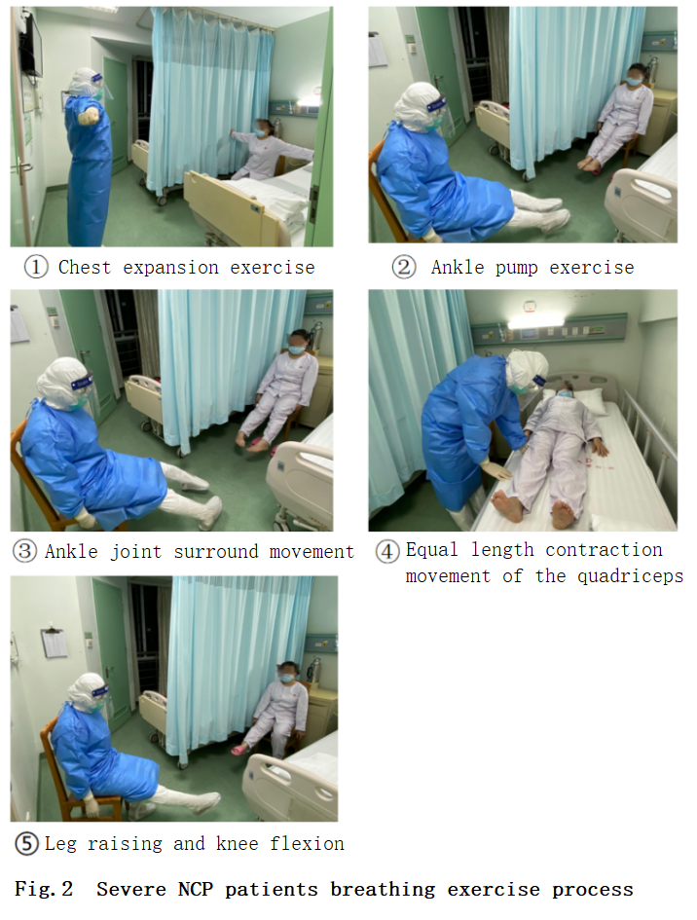

Figure 2 Physical fitness and breathing training for moderate impairment of lung function in COVID-19 patients

Physical fitness and breathing training for critically ill COVID-19 patients
1. Chest wall high-frequency vibration sputum extractor
The patient can be placed in the lateral position. The vibration frequency of the instrument is selected from 20 to 35 Hz. The therapist places the tapping head at the place where the patient's sputum is accumulated for about 30 seconds, lifts the tapping head and puts it in another part, from bottom to top, from the outside to the inside, it can promote the excretion of sputum, and can improve the blood circulation of the lungs, prevent venous stasis, relax the respiratory muscles, improve the muscle tone of the whole body, enhance the respiratory muscles and produce a cough reflex. For patients with weak cough and frailty, use a sputum suction device for suction.
2. Active physical activity
(1) Bed limb physical fitness is suitable for severe patients with bed rest. Early bed limb physical fitness training can be carried out on the premise that the patient's vital signs, blood oxygenation are stable and can cooperate actively. Objective to increase limb muscle strength, promote respiratory function and improve physical activity through training when patients are tolerant to physical fitness
(2) Bedside limb movement is suitable for severe patients with stable pneumonia control but reduced cardiopulmonary function and physical activity. Objective to increase limb muscle strength and limb activity function and improve cardiopulmonary function through training when patients are tolerant to physical fitness. Choose joint activity physical fitness s, step training, etc.
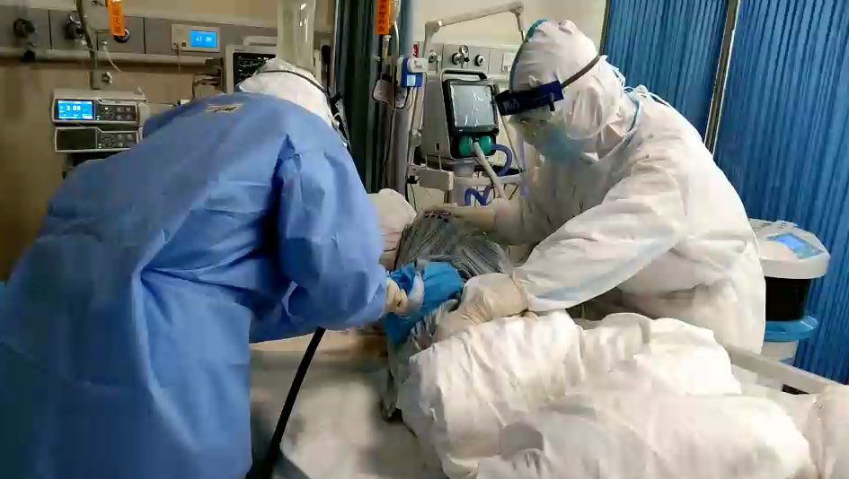
Figure 3 Chest wall high-frequency vibration sputum extractor 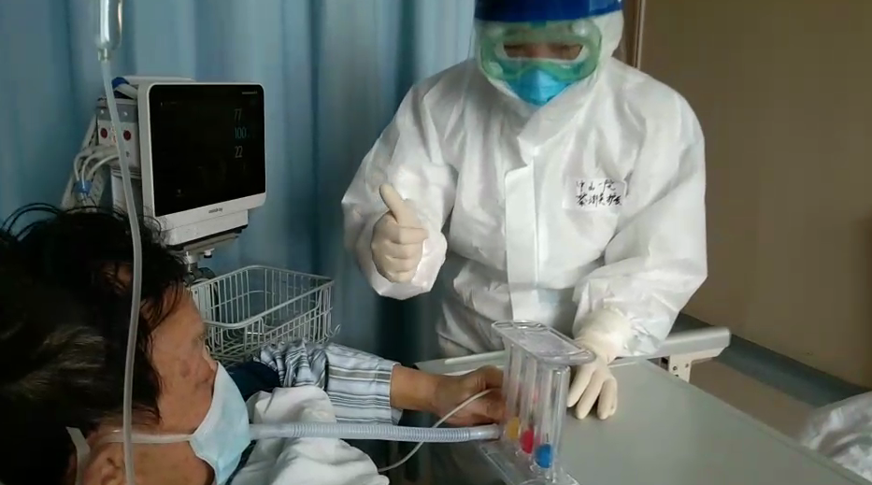
Figure 4 Application of breathing training apparatus

