Table S1. Binding affinity and predicted binding sites of acarbose, and some fatty acid in the bee products docked with α-amylase residues.
Ligands | Affinity (Kcal/mol | Conventional hydrogen bond | Van der Waals bond | Pi-alkyl | Carbon hydrogen bond | Pi-sigma
Acarbose | -8.2 | Gln63, Glu233,  Thr163, | Ala106, Ala198, Arg195, Asn105, Asp197, Gly104, His101, His299, Ile235, Ile51, Leu162, Leu165, Trp58, Trp59, Tyr62, Val107 | - | -
6,9,12-Octadecatrienoic acid | -5.8 | Asp300 | Ala198, Arg195, Asp197, Gln63, Glu233, His201, His299, Ile235, Leu162, Leu165, Thr163, Trp58, Trp59, Tyr62
3-Hydroxy-decanoic acid | -5.6 | Arg421, Gly334 | Arg10, Arg252, Gly403, Thr1 | Phe335, Pro4 | Asp402, Pro332 | -
Decanedioic acid | -5.5 | Asp300, Glu233  Thr163 | Arg195, Asn298, Asp197, Gln63, His299, Leu162, Leu165, Trp58, Trp59, Tyr62 | - | --
2-Dodecenedioic acid | -5.4 | Gln63, His201, Thr163, | Leu165, Trp59, Trp58, His101, Leu162, Tyr151, Ile235, Tyr62, Ala198, Asp197, Glu233 | - | - | -
9,12-Octadecadienoic acid | -5.3 | Thr163, | Asp197, Asp300, Gln63, His101, His299, Leu162, Trp58, Trp59, Tyr62 | Leu165 | - | -
9-Octadecenoic acid | -5.3 | Asp197, Asp300 | Glu233, Gln63, His299, Leu162, Leu165, Thr163, Trp58, Trp59, Tyr62 | - | - | -
10-Hydroxydecanoic acid | -5.2 | Asp300 | Arg195, Asp197, Gln63, Glu233, His299, Leu163, Leu165, Thr163, Trp58, Trp59, Tyr62 | - | - | -
9,12,15-Octadecatrienoic acid | -5.2 | - | Ala106, Asn105, Asp197, Gln63, Glu233, Gly104, Gly164, His101, Ile235, Leu165, Thr163, Trp59, Trp59, Tyr62, | Ala195  His201,  Leu162 | - | -
10-Hydroxy-2-decenoic acid | -5.1 | Arg421, Asp402, | Arg10, Arg398, Gln7, Gln8, Gly403, Gly9, Phe335, Pro332, Pro4, Thr11, Thr6 | - | - | -
Hexadecanoic acid | -5.1 | Trp59 | Arg303, Asp197, Asp300, Asp356, Gln63, His299, His305, Leu165, Trp357, Trp58, Tyr62
9-Hexadecenoic acid | -4.9 | Gln63 | Leu162, Leu165, Thr163, Trp58, Tyr62 | Trp59 | - | Trp59
Docosanoic Acid | -4.9 | His201 | Ala198, Asp300, Gln63, Glu233, His299, Ile235, Leu162, Leu165, Lys200, Thr163, Trp58, Tyr151, Tyr62 | Trp59 |  | Trp59
11-Hydroxy-dodecanoic acid | -4.8 | Asp300 | Trp59, Gln63, His299, Trp58, Leu165 | Tyr62 |  | Tyr62
Tetradecanoic acid | -4.8 | Asp356, Trp59 | Asp300, Gln63, Leu162, Leu165, Thr163, Trp357, Trp58, Tyr62
Molecular docking revealed that fatty acids interact with amino acid residues near the allosteric sites of amylase through Van der Waals and hydrogen bonds interactions.

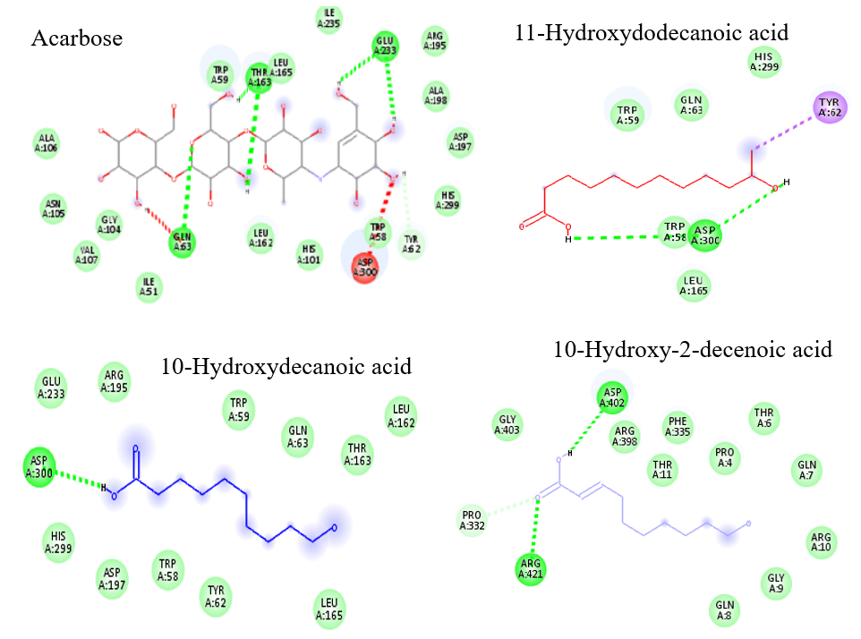

Figure S1. Predicted binding sites of acarbose, and fatty acid docked with α-amylase and 2D interactions of acarbose, and fatty acid in the binding pocket of α-amylase.

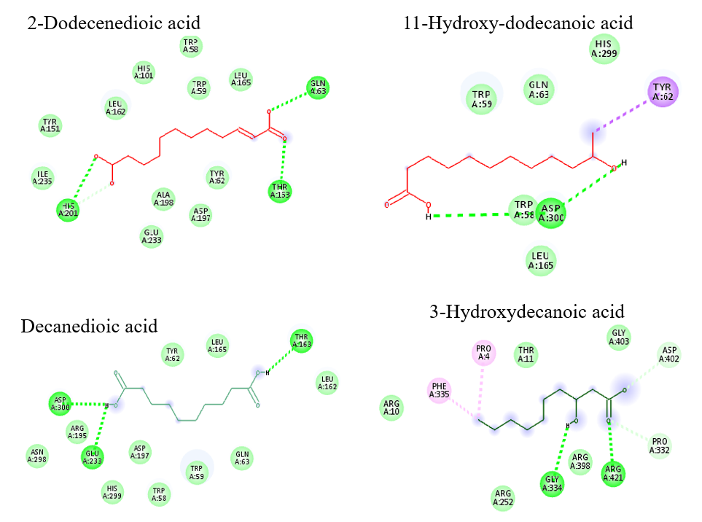

Figure S2. Predicted binding sites of and fatty acid docked with α-amylase and 2D interactions of fatty acid in the binding pocket of α-amylase.

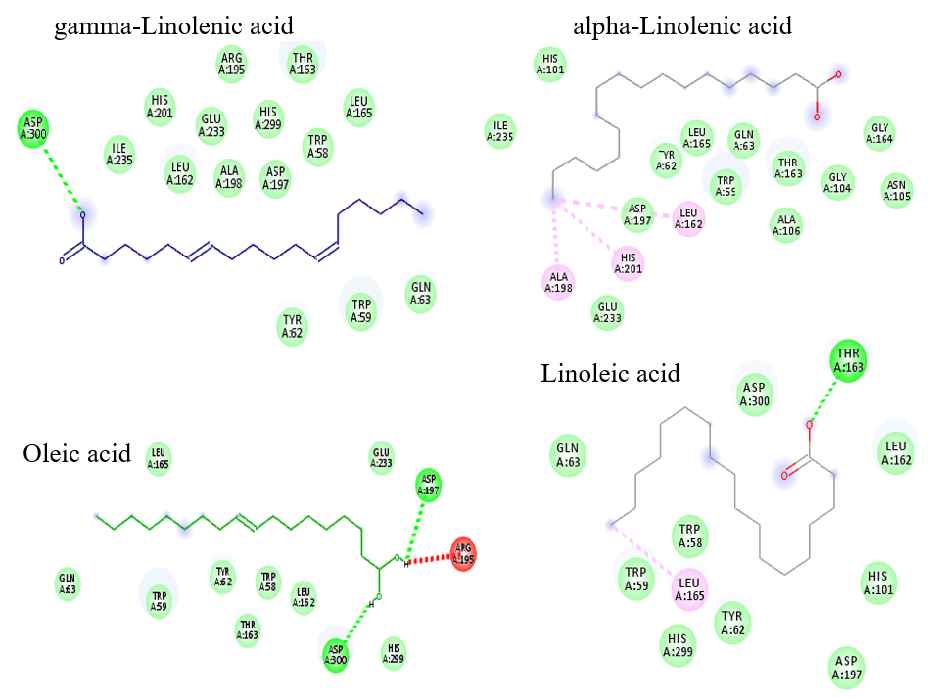

Figure S3. Predicted binding sites of and fatty acid docked with α-amylase and 2D interactions of fatty acid in the binding pocket of α-amylase.

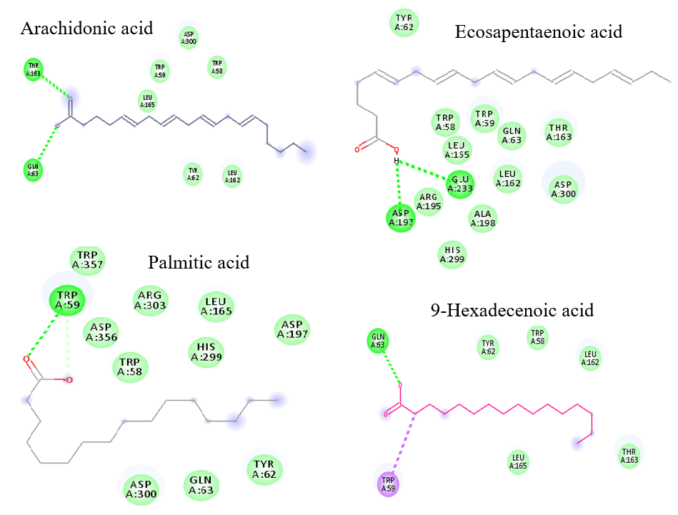

Figure S4. Predicted binding sites of and fatty acid docked with α-amylase and 2D interactions of fatty acid in the binding pocket of α-amylase.

