Additional Information
Author Contribution statement
Li Su conceived, and designed the study, performed data analysis and wrote the manuscript. Zhao Yue performed experiments, whereas Sun Qingyang and Zhu Yifan participated in data analysis.
Conflicts of Interest: The authors declare no conflict of interest.

Appendix A
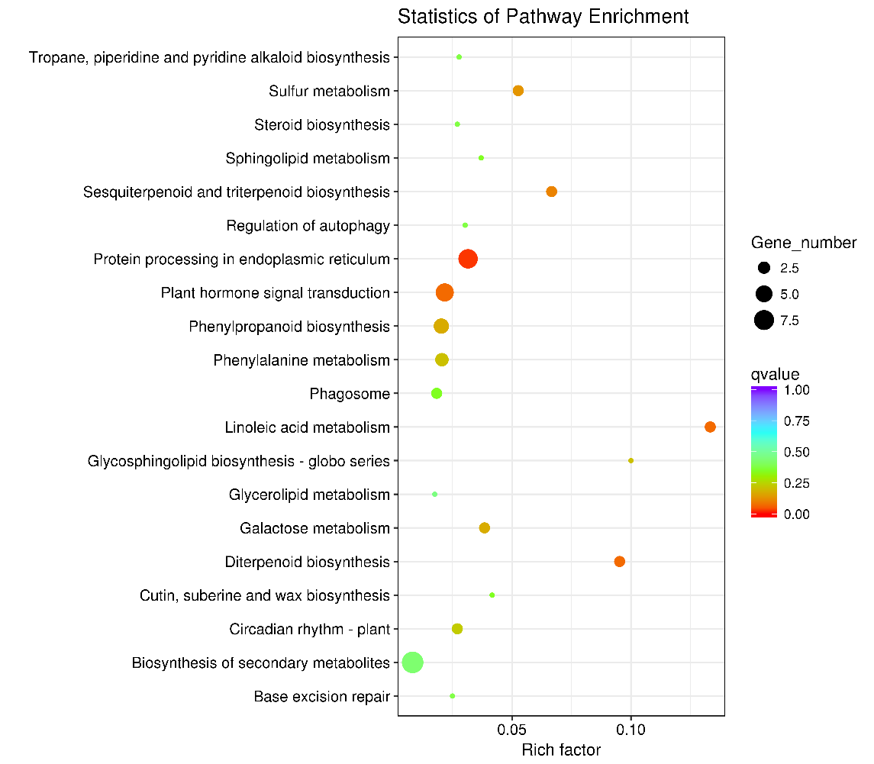
A1
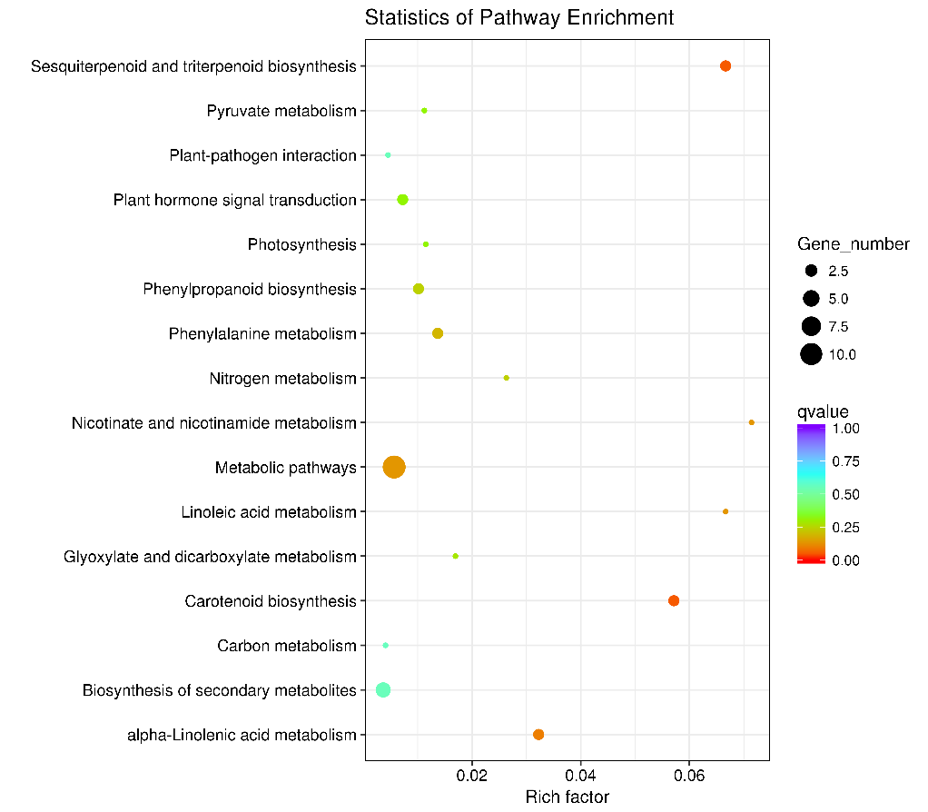
A2

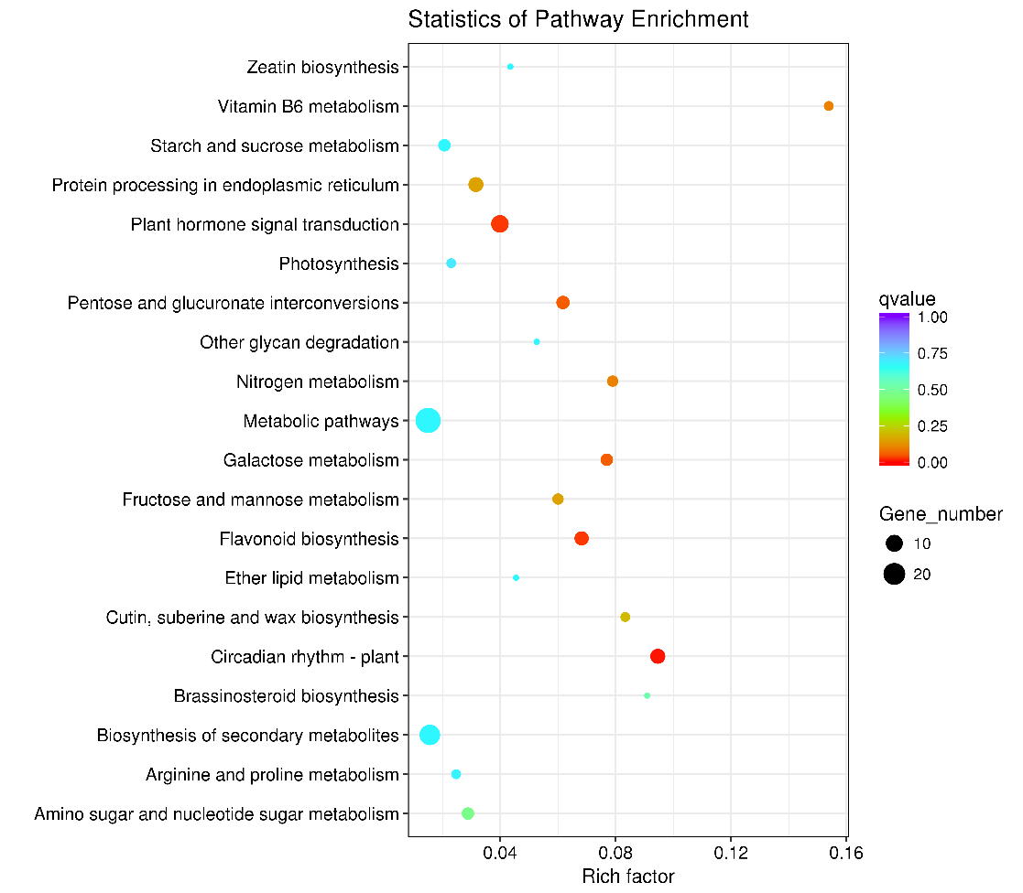
A3
Figure A. Scatter diagram of differential gene analyzed via KEGG
A1.3-day vs 0-day; A2. 7-day vs 0-day; A3. 3-day vs 7-day

Appendix B
Relative fluorescence quantitative PCR verification
Table B1 Results of RNA detection
Number | Sample name | Purity A260/A280 | Concentration
1 | CK1 | 1.92 | 600.93
2 | CK2 | 2.06 | 279.73
3 | CK3 | 1.97 | 257.46
4 | 3-day-1 | 2.07 | 771.1
5 | 3-day-2 | 2.09 | 530.91
6 | 3-day-33 | 1.89 | 217.58
7 | 7-day-1 | 2.02 | 773.99
8 | 7-day-2 | 2.14 | 358.46
9 | 7-day-3 | 1.95 | 539.29

Table B2 Primer synthesis information
Gene Number | Name of primer | Sequence | Annealing temperature
1 | GAPDH-F | TCACGGACAGTGGAAGCATCAT | 60
 | GAPDH-R | ACCCTTCAAATGAGCAGCAGC
2 | 100263588-F | GGATGGAGAGGTCCTATGGCAAGT | 60
 | 100263588-R | CAGACGACAAGTTGGGCAAAGACA
3 | 100256457-F | TGGGCTACAAGAGGTGGACTCGTA | 60
 | 100256457-R | GGACTGTTGCTGGAGGATGGAGAC
4 | 100263317-F | TCTGCTGGTAACGATGGAC | 60
 | 100263317-R | GCACCTCGGTCAAGAACT
5 | 100255553-F | ACCTACAGCAGTGCCAGTTCCA | 60
 | 100255553-R | CCAGCGTGTACTCATCTTCGTCCT
6 | 100267551-F | TCAAGGACGAGGAAGGCAACT | 60
 | 100267551-R | GAAGGTGGGCAGTGGTGAAAG
7 | 100242946-F | TGGAGATAGAGATGCTGAATTGC | 60
 | 100242946-R | GGGAGATGGCTTATCGTATTGG
8 | 100232948-F | CCTCCTAATGTGTCTGCTGCTGTT | 60
 | 100232948-R | TCATGCCATAGACCCGCTTCC
9 | 104879576-F | GTGTGAACAACCACCATACCATCC | 60
 | 104879576-R | TTCTTGCCACCATCGCCATC
10 | 100266562-F | TGGCTCCATCGCTCAACATACG | 60
 | 100266562-R | GAGTGATCTTGGACTTAGGCTGGC
11 | 100253885-F | GCAGGAGGAAGAGAAGAGA | 60
 | 100253885-R | ACGAGTGGAGTCATCAGG

G
Figure B1. Results of RT-PCR and Sequence results of 7 target genes

