SUPPLEMENT PART 1
MATERIALS AND METHODS
1. Study Setting, Period, and Ethics
This study was approved by the Karadeniz Technical University Scientific Research Ethics Committee (Protocol No: 2018/142) and was conducted retrospectively in patients diagnosed with ventilator-associated pneumonia (VAP) who were followed in the intensive care unit (ICU) of Karadeniz Technical University between January 1, 2015, and June 30, 2018.
2. Study Design and Data Collection
The ICU of Karadeniz Technical University is monitored through daily rounds conducted by a faculty member from the Department of Infectious Diseases and Clinical Microbiology, a research assistant, and an infection control nurse. During these rounds, patient follow-up charts and infection control forms are completed by the research assistant and infection control nurse.
Patient enrollment was performed based on patient follow-up charts recorded during daily consultation services to ICUs and infection control committee data. Demographic characteristics, vital signs, medication records, mechanical ventilation (MV) settings, progress notes, consultation records, chest radiographs, and laboratory results were retrospectively reviewed and transferred to study-specific patient data forms (Appendix 1). Post-treatment clinical follow-up data were obtained from consultation notes, discharge summaries, and outpatient clinic records.
3. Inclusion and Exclusion Criteria
Inclusion criteria were determined according to Centers for Disease Control and Prevention (CDC) criteria using patient medical records as follows:
a) Patients aged ≥18 years
b) Patients without pneumonia at the time of intubation who developed pneumonia ≥48 hours after initiation of invasive mechanical ventilation
c) Presence of at least two of the following criteria:
- Fever or hypothermia (oral or rectal temperature >38°C or <36°C)
- Leukocytosis (>12,000 cells/mm³) or leukopenia (<4,000 cells/mm³)
- Presence of purulent respiratory secretions
d) Presence of at least one of the following clinical or laboratory findings:
- Hypoxemia defined as arterial partial pressure of oxygen (PaO₂) <60 mmHg, oxygen saturation <90% on room air measured by pulse oximetry, worsening PaO₂/FiO₂ ratio, or documented respiratory failure requiring mechanical ventilation
- Documented physical examination findings consistent with consolidation (e.g., rales, pleural friction rub)
- Respiratory sample findings including Gram staining showing ≥25 leukocytes and ≤10 squamous epithelial cells per low-power field (×10), reported presence of Gram-positive or Gram-negative microorganisms, positive respiratory culture obtained within the previous 24 hours, or positive urinary antigen test for Legionella spp.
- New or progressive infiltrates or pneumonic findings such as parapneumonic effusion consistent with acute bacterial pneumonia on chest radiography or computed tomography performed within 24 hours prior to diagnosis
Exclusion criteria were as follows:
a) Diagnosis of community-acquired pneumonia
b) Known or suspected active tuberculosis, cystic fibrosis, human immunodeficiency virus infection with CD4 count <200 cells/mm³, invasive pulmonary fungal infection, suspected or confirmed empyema, or lung abscess
c) Presence of pneumonia at the time of intubation
d) Presence of concomitant infection at another focus during treatment or within the first 7 days, except bacteremia secondary to pneumonia
e) Patients lacking laboratory data on days 3, 5, and 7 or who died within the first 7 days were excluded from the study
4. Study Protocol
Data obtained through retrospective review were recorded on study-specific patient data forms (Appendix 1) according to the following parameters:
- Age was recorded in years based on date of birth.
- Primary diagnoses leading to ICU admission were recorded and categorized into four groups: trauma or postoperative conditions, neurological diseases (e.g., cerebrovascular events, Guillain-Barré syndrome), respiratory failure due to underlying pulmonary or cardiac diseases, and other medical conditions.
- Medical history including chronic obstructive pulmonary disease, asthma, bronchiectasis, prior lung surgery, thoracic trauma, cardiac disease, diabetes mellitus, hypertension, malignancy, and use of immunosuppressive therapy was recorded.
- Length of hospital and ICU stay was calculated based on calendar days from admission.
- Catheter and MV days were counted beginning from the day following the procedure.
- Steroid and proton pump inhibitor use was considered present if documented in nursing observation forms at the time of VAP diagnosis, regardless of dose or duration.
- Radiological findings from chest radiographs obtained within the preceding 24 hours were evaluated, supplemented by computed tomography images when available. Findings were categorized as newly developed or progressive localized/lobar infiltration, newly developed or progressive diffuse infiltration, or absence of findings suggestive of VAP.
- Method of respiratory sample collection (endotracheal aspirate or bronchoalveolar lavage), culture technique (quantitative or semiquantitative), isolated microorganisms (monomicrobial or polymicrobial), and quantitative growth levels were recorded.
- Non-respiratory cultures (blood, urine, wound) were evaluated for microbial growth, causative relevance, and related treatment.
- Laboratory parameters including C-reactive protein (mg/dL), leukocyte count (/µL), erythrocyte sedimentation rate (mm/h), procalcitonin (µg/L), and creatinine (mg/dL) were recorded on the day of diagnosis and on treatment days 3, 5, and 7.
- Glomerular filtration rate (GFR) was calculated using the CKD-EPI formula on days 0, 3, 5, and 7 of treatment.
- Clinical Pulmonary Infection Score (CPIS) was calculated at diagnosis and on days 3, 5, and 7.
- Body temperature was recorded as the highest or lowest value within 48 hours prior to diagnosis.
- Glasgow Coma Scale scores recorded on days 0, 3, 5, and 7 were analyzed, with the lowest daily value used if multiple measurements were available.
- PaO₂/FiO₂ ratio was calculated using arterial blood gas values and FiO₂ data from MV records or estimated using the formula FiO₂ = 20 + (4 × oxygen flow rate in L/min). The lowest daily value was recorded.
- Initial antimicrobial therapy was evaluated under four categories, including main antibiotic regimen, colistin use, Gram-positive coverage, and use of fluoroquinolones or aminoglycosides.
- Addition or modification of antibiotics within 24 hours was defined as treatment modification.
- Treatment duration was calculated from the first infusion, accounting for dose adjustments based on GFR and creatinine clearance.
- Antibiotic-free days were calculated as days without antimicrobial therapy for VAP or other infections.
- Time without VAP and post-treatment hospital stay were calculated based on calendar days.
- Microbiological eradication was defined as absence of growth of the initial causative microorganism in control respiratory cultures obtained before treatment completion.
- Mortality was assessed at end of treatment and at 28 days, and survival until hospital discharge was recorded.
- Empirical therapy was considered appropriate if isolated microorganisms were susceptible and clinical/laboratory improvement was observed.

5. Study Population
A total of 286 VAP episodes in 184 patients were evaluated. Episodes not meeting inclusion criteria (n=34), those with multiple infection foci at diagnosis (n=22), early mortality within 7 days (n=40), presence of empyema (n=10), or development of another infection focus within the first 7 days of VAP treatment (n=33) were excluded. Ultimately, 147 episodes in 111 patients were included. Patients were categorized into two groups: short-course treatment group (7–10 days) and long-course treatment group (>10 days).

6. Statistical Analysis
All data were recorded in Microsoft Excel 2015 and analyzed using SPSS for Windows version 22.0. Continuous variables were expressed as mean ± standard deviation or median (interquartile range), and categorical variables as number and percentage. Distribution of variables was assessed using the Kolmogorov–Smirnov test. Parametric data were analyzed using Student’s t-test, while nonparametric data were analyzed using the Mann–Whitney U test. Categorical variables were compared using chi-square or Fisher’s exact test. Results were presented as p values, odds ratios, and 95% confidence intervals. Statistical significance was defined as p<0.05. Spearman correlation analysis was used for non-normally distributed variables. Receiver operating characteristic (ROC) curve analysis was performed to calculate area under the curve (AUC), cut-off values, sensitivity, specificity, positive predictive value, and negative predictive value.

SUPPLEMENT PART 2
SUPPLEMENTARY RESULTS
Detailed Statistical Results of Short-Term and Long-Term Treatment Groups
A total of 147 VAP episodes were evaluated in this study. These included 35 episodes in 30 patients receiving short-term treatment (STTG) and 112 episodes in 81 patients receiving long-term treatment (LTTG).
The demographic characteristics of the patients, including age and sex, were similar between the two groups (p>0.05). In addition, there were no significant differences in primary diagnoses or underlying comorbidities between the groups at the time of VAP diagnosis (p>0.05).
At the time of diagnosis, the mean duration of hospitalization was 35.2±65.4 days in the STTG and 40.9±65.5 days in the LTTG, while the duration of ICU stay was 30.7±63.4 days and 36.2±62.6 days, respectively. Although the differences between the groups were 5.7 days for total hospital stay and 5.5 days for ICU stay, these differences were not statistically significant (p>0.05).

Baseline Clinical and Laboratory Findings
At the time of diagnosis, there were no statistically significant differences between the groups regarding:
- presence of increased respiratory secretions
- presence and duration of invasive devices (central venous catheter, Foley urinary catheter, thoracic tube)
- clinical parameters
- leukocyte count
- C-reactive protein (CRP)
- erythrocyte sedimentation rate
- PaO₂/FiO₂ ratio
- procalcitonin (PCT) level
- creatinine level
- Clinical Pulmonary Infection Score (CPIS)
- glomerular filtration rate (GFR)
(all p>0.05).
However, radiographic findings suggestive of VAP were detected in 65.7% of patients in the STTG and 84.8% of patients in the LTTG, which was 2.92-fold higher in the LTTG (p=0.025; OR=2.92; 95% CI=1.12–7.57).

Clinical Course and Inflammatory Markers During Treatment
There were no differences between the groups in the presence of fever at 48 hours before diagnosis, 24 hours before diagnosis, or at the time of diagnosis (p>0.05).
However, during treatment:
- On day 3, febrile patients were 4 times more frequent in the LTTG (p=0.020; OR=4.0; 95% CI=1.66–9.89).
- On day 5, fever was 5.26 times more frequent in the LTTG (p=0.004).
The resolution of fever occurred significantly earlier in the STTG (3.2±1.6 days) compared with the LTTG (5.3±2.9 days) (p=0.004).
The mean leukocyte count and erythrocyte sedimentation rate on days 3, 5, and 7 were similar between the groups.
CRP levels were also similar on the day of diagnosis and day 3, but on day 5 CRP was significantly lower in the STTG (10.7±8.5 vs 14.2±8.5; p=0.030).
Similarly, mean PCT levels on day 5 were significantly lower in the STTG (2.0±3.6) compared with the LTTG (6.5±12.5) (p=0.009). The proportion of episodes with PCT >0.5 µg/L on day 5 was 41.9% in the STTG and 67.6% in the LTTG (p=0.010; OR=0.35; 95% CI=0.14–0.85).
Since PCT levels may be influenced by renal function, creatinine levels and GFR calculated using the CKD-EPI formula were also evaluated. These parameters were similar between the groups, and there were no differences in the number of patients whose GFR decreased below 60, 30, or 15 during treatment (p>0.05).

Oxygenation and Clinical Severity Scores
While PaO₂/FiO₂ ratios were similar on the day of diagnosis and on day 3, the day-5 PaO₂/FiO₂ ratio was significantly higher in the STTG (p<0.001).
The Glasgow Coma Scale (GCS) values measured at diagnosis and on days 3, 5, and 7 differed between the groups by 1–1.7 points, with statistically significant differences (p<0.05).
Although CPIS values were similar at diagnosis, the decrease in CPIS during treatment was significantly greater in the STTG starting from day 3, reflecting better clinical improvement. The largest difference between the groups occurred on day 5 (p=0.003).

Microbiological Findings
When respiratory cultures were evaluated, the distribution of causative pathogens was similar between the groups.
- Monomicrobial growth:
  - STTG: 20% (n=7)
  - LTTG: 31.3% (n=35)
- Polymicrobial growth:
  - STTG: 77.1% (n=27)
  - LTTG: 59.8% (n=67)
(p=0.154)
Episodes involving non-fermenting Gram-negative bacteria (NF-GNB) were also similar between the groups (p=0.852). Among patients without NF-GNB growth, the distribution of other Gram-negative microorganisms did not differ significantly (p=0.121).

Treatment Regimens and Modifications
The initial antibiotic regimens were similar between the groups (p>0.05).
There were no differences regarding:
- presence of Gram-positive active antibiotics
- quinolone or aminoglycoside antibiotics in the initial regimen
However, colistin was included significantly less frequently in the STTG regimen (25.7% vs 47.3%) (p=0.039; OR=0.39; 95% CI=0.15–0.96).
During clinical follow-up:
- Treatment modification occurred in 22.9% of STTG episodes and 56.3% of LTTG episodes (p<0.001; OR=0.23; 95% CI=0.09–0.59).
The mean day of treatment modification was 2.3±1.3 days in the STTG and 5.7±3.9 days in the LTTG (p=0.007).
Appropriate empirical therapy was significantly more frequent in the STTG (91.4% vs 71.4%) (p=0.021; OR=4.27; 95% CI=1.14–18.85).
Among patients with positive respiratory cultures, antibiotic susceptibility of the isolated pathogens was also significantly higher in the STTG (91.2% vs 71.6%) (p=0.035; OR=4.11; 95% CI=1.08–18.31).

Colistin Use and Additional Therapies
Colistin addition due to treatment modification occurred in 2.9% of STTG episodes and 15.2% of LTTG episodes, although this difference was not statistically significant (p=0.073).
However, during the overall treatment course, colistin therapy was administered significantly more frequently in the LTTG (62.5% vs 28.6%) (p<0.001; OR=0.24; 95% CI=0.10–0.59).
The addition of Gram-positive active agents or inhaled colistin therapy during treatment did not differ significantly between the groups (p>0.05).

Complications and Clinical Outcomes
Secondary bacteremia related to VAP occurred significantly more frequently in the LTTG (33.9% vs 8.6%) (p=0.003; OR=0.18; 95% CI=0.04–0.68).
Although post-treatment ICU and hospital stay durations were shorter in the STTG, these differences were not statistically significant.
The development of a second VAP episode after completion of treatment was significantly more frequent in the LTTG (38.3% vs 16.7%) (p=0.043; OR=0.41; 95% CI=0.17–0.97).
The interval between episodes was 31.7±37.8 days in the STTG and 25.1±42.2 days in the LTTG (p=0.207).
Patients in the STTG had significantly more VAP-free days (17.6±10.3 vs 12.1±10.7; p=0.004).
The rate of microbiological eradication in respiratory cultures after treatment was similar between the groups (p=0.583).

Treatment Duration
The mean treatment duration was 8.7±1.5 days in the STTG and 14.5±4.2 days in the LTTG (p<0.001).
Similar differences were observed in subgroups:
- NF-GNB infections: 8.8±1.4 vs 14.3±4.2 days (p<0.001)
- S. aureus infections: 8.4±1.5 vs 14.1±4.8 days (p<0.001)
Treatment modification did not significantly prolong treatment in the STTG, whereas it significantly increased treatment duration in the LTTG (p=0.002).
Patients in the STTG also experienced significantly more antibiotic-free days after treatment (15.9±22.7 vs 8.2±10.6; p=0.004).

Mortality
At the end of treatment, no deaths occurred in the STTG, whereas mortality was 20.5% in the LTTG (p=0.008).
During 28-day follow-up, mortality was 5.7% in the STTG and 25.9% in the LTTG (p=0.020; OR=0.17; 95% CI=0.03–0.81).
The hospital survival rate was 62.9% in the STTG and 35.7% in the LTTG (p=0.008), indicating that survival was 3.05 times higher in the STTG.

Analysis of Short-Term Treatment Criteria
After statistical evaluation, seven criteria were identified to predict eligibility for short-term treatment:
- Absence of fever on day 5
- PCT ≤0.5 µg/L on day 5
- CRP <15 mg/dL on day 5
- PaO₂/FiO₂ >300 mmHg on day 5
- CPIS ≤4 on day 5
- Absence of bacteremia
- Appropriate empirical treatment
The odds ratios of these criteria ranged from 2.89 to 10.8, with the strongest predictor being PaO₂/FiO₂ >300 mmHg on day 5 (OR=10.8).
Sensitivity, specificity, PPV, NPV and AUC values were calculated for each criterion.
Among these criteria:
- The most sensitive predictors were absence of fever (C1) and appropriate empirical therapy (C7).
- The most specific predictors were PCT ≤0.5 µg/L (C2) and PaO₂/FiO₂ >300 mmHg (C4).
The negative predictive values of the criteria ranged between 84.5% and 93.5%.

Combined Criteria Analysis
When criteria were evaluated collectively for each patient:
- ≥4 criteria provided 91.4% sensitivity and 50.9% specificity (AUC=0.712).
- ≥5 criteria reduced sensitivity to 82.9% but increased specificity to 74.1% (AUC=0.839).
If three criteria were present, provided that PaO₂/FiO₂ >300 mmHg (C4) was also present, sensitivity and specificity were 85.7% and 65.2%, respectively.
The proportion of episodes fulfilling ≥5 criteria was 82.9% in the STTG and 25.9% in the LTTG (p<0.001), indicating that patients meeting ≥5 criteria were 13.8 times more likely to receive short-term treatment.
When ≥4 criteria were used as the threshold, episodes fulfilling this condition were 11.1 times more frequent in the STTG (95% CI=2.99–48.21).
If PaO₂/FiO₂ >300 mmHg on day 5 was mandatory:
- presence of four criteria increased the likelihood of short-term treatment by 18-fold
- presence of three criteria increased it by 11.2-fold.
TABLES
Table 1. Demographic Characteristics and Medical History of the Patients
Patient Characteristics | STTG  (n=30) | LTTG  (n=81) | p value
Age (years) | 61.7±17.0 | 61.0±19.5 | 0.808
Sex, n (%)  Male  Female | 19 (63.3%)  11 (37.7%) | 54 (66.7%)  27 (33.3%) | 0.918
Primary diagnosis, n (%)  Trauma and postoperative conditions  Neurological diseases  Respiratory failure  Other non-surgical conditions | 7 (23.3%)  10 (33.3%)  8 (26.7%)  5 (16.7%) | 23 (28.4%)  32 (39.5%)  13 (16%)  13 (16%) | 0.629
History of lung disease, n (%) | 7 (23.3%) | 29 (35.8%) | 0.309
History of heart disease, n (%) | 15 (50%) | 28 (34.6%) | 0.207
History of hypertension, n (%) | 19 (63.3%) | 41 (50.7%) | 0.327
History of diabetes mellitus, n (%) | 7 (23.3%) | 19 (23.5%) | 1.000
Abbreviations: STTG, short-term treatment group; LTTG, long-term treatment group

Table 2. Clinical Characteristics and Laboratory Parameters at the Time of Diagnosis
Characteristics at Diagnosis | STTG (n=35) | LTTG (n=112) | p value
Increased amount of secretions, n (%) | 28 (80.0%) | 82 (73.2%) | 0.559
Secretion characteristics, n (%)  Hemorrhagic appearance  Non-purulent appearance  Purulent appearance | 0  8 (22.9%)  27 (77.1%) | 7 (6,2%)  28 (25%)  77 (68.8%) | 0.286
Episodes with fever or hypothermia within 48 h before diagnosis, n (%) | 15 (42.9%) | 66 (58.9%) | 0.095
Body temperature 48 h before diagnosis (°C) | 37.4 ± 0.9 | 37.4 ± 1.1 | 0.531
Episodes with fever or hypothermia within 24 h before diagnosis, n (%) | 22 (62.9%) | 79 (70.5%) | 0.392
Body temperature 24 h before diagnosis (°C) | 37.5 ± 0.9 | 37.7 ± 1.2 | 0.248
Fever or hypothermia on day of diagnosis, n (%) | 21 (60.0%) | 87 (77.7%) | 0.065
Body temperature on day of diagnosis (°C) | 37.8 ± 1.2 | 38.1 ± 1.2 | 0.092
Hospital stay at diagnosis (days) | 35.2 ± 65.4 | 40.9 ± 65.5 | 0.083
ICU stay at diagnosis (days) | 30.7 ± 63.4 | 36.2 ± 62.6 | 0.118
Duration of mechanical ventilation at diagnosis (days) | 29.7 ± 51.4 | 27.3 ± 56.6 | 0.959
Presence of central venous catheter (CVC), n (%) | 19 (54.3%) | 65 (58.0%) | 0.696
Duration of CVC use (days) | 7.3 ± 4.3 | 10.2 ± 9.5 | 0.570
Presence of thoracic catheter, n (%) | 3 (8.6%) | 10 (8.9%) | 1.000
Presence of urinary catheter, n (%) | 32 (97.0%) | 106 (94.6%) | 0.445
New or progressive infiltrates on PA chest radiograph, n (%) | 23 (65.7%) | 95 (84.8%) | 0.025
PA chest radiograph findings, n (%)  None  Diffuse infiltration  Lobar infiltration | 12 (34.3%)  12 (34.3%)  11 (31.4%) | 17 (15.2%)  52 (46.4%)  43 (38.4%) | 0.045
PaO₂/FiO₂ ratio (mmHg) | 212.5 ± 62.0 | 224.0 ± 88.6 | 0.691
Leukocyte count (/mm³) | 12103 ± 4175 | 13140 ± 7251 | 0.865
Erythrocyte sedimentation rate (mm/h) | 56.3 ± 30.2 | 48.8 ± 32.9 | 0.213
C-reactive protein (mg/dL) | 17.1 ± 10.3 | 18.0 ± 9.7 | 0.514
Procalcitonin (µg/L) | 5.2 ± 12.9 | 5.7 ± 13.3 | 0.245
Creatinine (mg/dL) | 1.30 ± 1.0 | 1.2 ± 1.1 | 0.294
Glomerular filtration rate (mL/min/1.73 m²) | 74.8 ± 40.7 | 75.3 ± 40.6 | 0.806
Clinical Pulmonary Infection Score (CPIS) | 7.7 ± 1.3 | 7.9 ± 1.5 | 0.517
Abbreviations: PA, posterior–anterior; PaO₂, arterial partial pressure of oxygen; FiO₂, fraction of inspired oxygen; ICU, intensive care unit.

Table 3. Body Temperature Measurements According to Treatment Days
Treatment Day and Body Temperature | STTG  (n=35) | LTTG  (n=112) | p value | OR | 95% CI
Episodes with fever/hypothermia at diagnosis, n (%) | 21 (60.0%) | 87 (77.7%) | 0.065 | – | –
Body temperature at diagnosis (°C) | 37.8 ± 1.2 | 38.1 ± 1.2 | 0.097 | – | –
Episodes with fever/hypothermia on day 3, n (%) | 9 (25.7%) | 56 (50.0%) | 0.020 | 0.35 | 0.14–0.86
Body temperature on day 3 (°C) | 37.5 ± 0.8 | 37.5 ± 1.1 | 0.556 | – | –
Episodes with fever/hypothermia on day 5, n (%) | 3 (8.6%) | 37 (33.0%) | 0.004 | 0.19 | 0.04–0.71
Body temperature on day 5 (°C) | 37.1 ± 0.7 | 37.4 ± 1.0 | 0.052 | – | –
Episodes with fever/hypothermia on day 7, n (%) | 3 (8.6%) | 35 (31.3%) | 0.014 | 0.21 | 0.05–0.77
Body temperature on day 7 (°C) | 36.9 ± 0.6 | 37.3 ± 1.1 | 0.060 | – | –
Time to defervescence (days) | 3.2 ± 1.6 | 5.3 ± 2.9 | 0.004 | – | –

Figure 1. Temporal Changes in Body Temperature During Treatment

Table 4. Leukocyte Count and Acute Phase Reactant Levels According to Treatment Days

Parameter by Treatment Day | STTG (n=35) | LTTG (n=112) | p value | OR | 95% CI
Leukocyte count (/mm³) Day 1 | 12103 ± 4175 | 13140 ± 7251 | 0.865 | – | –
Leukocyte count (/mm³) Day 3 | 10652 ± 4342 | 11680 ± 6474 | 0.623 | – | –
Leukocyte count (/mm³) Day 5 | 11974 ± 7277 | 11334 ± 5559 | 0.739 | – | –
Leukocyte count (/mm³) Day 7 | 11220 ± 5336 | 11729 ± 7136 | 0.849 | – | –
ESR (mm/h) Day 1 | 56.3 ± 30.2 | 48.8 ± 32.9 | 0.213 | – | –
ESR (mm/h) Day 3 | 50.6 ± 28.9 | 50.7 ± 31.1 | 0.993 | – | –
ESR (mm/h) Day 5 | 57.7 ± 33.2 | 48.1 ± 31.7 | 0.163 | – | –
ESR (mm/h) Day 7 | 57.7 ± 30.2 | 45.2 ± 27.2 | 0.059 | – | –
CRP (mg/dL) Day 1 | 17.1 ± 10.3 | 18.0 ± 9.7 | 0.514 | – | –
CRP (mg/dL) Day 3 | 13.1 ± 8.1 | 16.9 ± 11.0 | 0.112 | – | –
CRP (mg/dL) Day 5 | 10.7 ± 8.5 | 14.2 ± 8.5 | 0.030 | – | –
CRP (mg/dL) Day 7 | 9.5 ± 6.4 | 12.8 ± 8.3 | 0.029 | – | –
Procalcitonin (PCT) Mean value, Day 1 (µg/L) | 5.2 ± 12.9 | 5.7 ± 13.3 | 0.245 | – | –
PCT >0.5 µg/L, Day 1, n (%) | 13 (48.0%) (n=27) | 74 (66.1%) (n=104) | 0.042 | 0.38 | 0.15–0.97
PCT, Mean value, Day 3 (µg/L) | 6.7 ± 13.6 | 8.4 ± 20.3 | 0.978 | – | –
PCT >0.5 µg/L, Day 3, n (%) | 17 (70.8%) (n=24) | 71 (76.3%)  (n=93) | 0.770 | – | –
PCT, Mean value, Day 5 (µg/L) | 2.0 ± 3.6 | 6.5 ± 12.5 | 0.009 | – | –
PCT >0.5 µg/L, Day 5, n (%) | 13 (41.9%) (n=31) | 71 (67.6%) (n=105) | 0.010 | 0.35 | 0.14–0.85
PCT, Mean value, Day 7 (µg/L) | 1.6 ± 2.0 | 9.0 ± 21.8 | 0.128 | – | –
PCT >0.5 µg/L, Day 7, n (%) | 12 (52.2%) (n=23) | 51 (65.4%)  (n=78) | 0.366 | – | –
PCT: Prokalsitonin, OR: Odds ratio, GA: Güven aralığı, CRP: C reaktif protein, AFR: Akut faz reaktanları, ESH: Eritrosit sedimentasyon hızı

Table 5. Changes in Renal Function Parameters During Treatment
Parameters by Treatment Day | STTG  (n=35) | LTTG  (n=112) | p value
Serum creatinine (mg/dL) Day 1 | 1.3 ± 1.0 | 1.2 ± 1.1 | 0.294
Serum creatinine (mg/dL) Day 3 | 1.1 ± 0.8 | 1.2 ± 0.9 | 0.837
Serum creatinine (mg/dL) Day 5 | 1.2 ± 0.9 | 1.2 ± 1.1 | 0.996
Serum creatinine (mg/dL) Day 7 | 1.1 ± 0.7 | 1.2 ± 1.1 | 0.854
GFR (mL/min/1.73 m²) Day 1 | 74,8 ± 40,7 | 75,3 ± 40,6 | 0,806
GFR (mL/min/1.73 m²) Day 3 | 79,1 ± 40,9 | 72,1 ± 38,6 | 0,375
GFR (mL/min/1.73 m²) Day 5 | 78,8 ± 41,8 | 72,4 ± 40,9 | 0,437
GFR (mL/min/1.73 m²) Day 7 | 81,3 ± 42,7 | 71,9 ± 42,8 | 0,219
GFR <60 mL/min/1.73 m² during treatment, n (%) | 15 (42.9%) | 63 (56.3%) | 0.233
GFR <30 mL/min/1.73 m² during treatment, n (%) | 10 (28.6%) | 37 (33.0%) | 0.774
GFR <15 mL/min/1.73 m² during treatment, n (%) | 3 (8.6%) | 12 (10.7%) | 0.963
Abbreviations: GFR, glomerular filtration rate.
Formula: Glomerular filtration rate (GFR) = 186 × (serum creatinine)^−1.154 × (age)^−0.203 × sex × race

Table 6. Changes in PaO₂/FiO₂ Ratio, Glasgow Coma Scale (GCS), and Clinical Pulmonary Infection Score (CPIS) During Treatment

Treatment Day / Parameter | STTG (n=35) | LTTG (n=112) | p value
PaO₂/FiO₂ ratio (mmHg) Day 1
  212.5 ± 62.0
  224.0 ± 88.6
  0.691
PaO₂/FiO₂ ratio (mmHg) Day 3
  287.5 ± 63.2
  265.5±79.3
  0.138
PaO₂/FiO₂ ratio (mmHg) Day 5 |  |  | <0.001
  335.6 ± 63.0
  274.9± 95.4
PaO₂/FiO₂ ratio (mmHg) Day 7
  349.7 ± 77.6
  280.1± 99.5
  <0.001
Glasgow Coma Scale (GCS) Day 1
  7.7 ± 2.4
  6.7 ± 2.2
  0.025
Glasgow Coma Scale (GCS) Day 3
  8.2 ± 2.7
  6.9 ± 2.1
  0.010
Glasgow Coma Scale (GCS) Day 5
  8.8 ± 3.2
  7.2 ± 2.4
  0.010
Glasgow Coma Scale (GCS) Day 7
  8.9 ± 3.3
  7.2 ± 2.7
  0.012
Clinical Pulmonary Infection Score (CPIS) Day 1
  7.7 ± 1.3
  7.9 ± 1.5
  0.517
Clinical Pulmonary Infection Score (CPIS) Day 3
  4.9 ± 1.7
  5.7 ± 1.9
  0.036
Clinical Pulmonary Infection Score (CPIS) Day 5 |  |  | 0.003
  3.8 ± 1.2
  5.0 ± 2.1
Clinical Pulmonary Infection Score (CPIS) Day 7 |  |  | 0.005
  3.4 ± 1.2
  4.5 ± 2.1
PaO₂, arterial partial pressure of oxygen; FiO₂, fraction of inspired oxygen

Table 7. Causative Microorganism Groups
Parameter | STTG (n=35) | LTTG (n=112) | p value
VAP pathogen pattern, n (%)  None  Monomicrobial  Polymicrobial | 1 (2.9%)  7 (20.0%)  27 (77.1%) | 10 (8.9%)  35 (31.3%)  67 (59.8%) | 0.154
Episodes with non-fermenter Gram-negative bacilli (NF-GNB), n (%) | 26 (74.3%) | 87 (77.7%) | 0.852
Episodes with Gram-negative microorganisms other than NF-GNB, n (%) | 8 (22.9%) | 12 (10.7%) | 0.121
Episodes involving Gram-positive pathogens, n (%) | 8 (22.9%) | 24 (21.4%) | 0.601
Abbreviations: NF-GNB, non-fermenter Gram-negative bacilli; VAP, ventilator-associated pneumonia.

Table 8. Treatment Regimens
Parameter | STTG  (n=35) | LTTG (n=112) | p value | OR | 95% CI
Initial primary antibiotic regimen, n (%)  Meropenem / Imipenem  Ceftazidime / Cefoperazone  Piperacillin–tazobactam  Other antibiotics | 4 (11.4%)  7 (20%)  16 (45.7%)  8 (22.9%) | 32 (28.6%)  26 (23.2%)  29 (25.9%)  25 (22.3%) | 0,080
Colistin included in initial regimen, n (%) | 9 (25.7%) | 53 (47.3%) | 0.039 | 0.39 | 0.15–0.96
Gram-positive coverage in initial regimen, n (%) | 7 (20.0%) | 26 (23.2%) | 0.868 | – | –
Aminoglycoside or quinolone in initial regimen, n (%) | 4 (11.4%) | 8 (7.1%) | 0.480 | – | –
Episodes requiring treatment modification during follow-up, n (%) | 8 (22.9%) | 63 (56.3%) | 0.001 | 0.23 | 0.09–0.59
Day of treatment modification (mean ± SD) | 2.3 ± 1.3  (n=8) | 5.7 ± 3.9 (n=63) | 0.007 | – | –
Appropriate empirical therapy, n (%) | 32 (91.4%) | 80 (71.4%) | 0.021 | 4.27 | 1.14–18.85
Appropriateness of initial therapy according to identified pathogen* | 31 (91.2%) (n=34) | 73 (71.6%) (n=102) | 0.035 | 4.11 | 1.08–18.31
Colistin added after treatment modification, n (%) | 1 (2.9%) | 17 (15.2%) | 0.073 | – | –
Colistin use at any time during treatment, n (%) | 10 (28.6%) | 70 (62.5%) | <0.001 | 0.24 | 0.10–0.59
Gram-positive agent added after modification, n (%) | 4 (11.4%) | 17 (15.2%) | 0.782 | – | –
Gram-positive therapy at any time during treatment, n (%) | 10 (28.6%) | 42 (37.5%) | 0.446 | – | –
Inhaled colistin added, n (%) | 1 (2.9%) | 16 (14.3%) | 0.074 | – | –
Abbreviations: OR, odds ratio; CI, confidence interval.
*Analysis limited to patients with an identified VAP pathogen.

Table 9. Clinical Outcomes

Parameters | STTG (n=35) | LTTG (n=112) | p value | OR | 95% CI
Bacteremia secondary to VAP, n (%) | 3 (8.6%) | 38 (33.9%) | 0.003 | 0.18 | 0.04–0.68
Hospital length of stay after treatment (days) | 51.0 ± 52.9 | 59.6 ± 87.7 | 0.749 | – | –
ICU length of stay after treatment (days) | 47.3 ± 51.5 | 56.3 ± 85.2 | 0.550 | – | –
Recurrent VAP episode, n (%) | 5 (16.7%)  (n=30) | 31 (38.3%) (n=81) | 0.167 | – | –
Time from completion of VAP treatment to recurrence (days) | 31.7 ± 37.8 | 25.1 ± 42.2 | 0.207 | – | –
VAP-free days | 17.6 ± 10.3 | 12.1 ± 10.7 | 0.004 | – | –
Microbiological eradication, n (%) | 7 (38.9%)  (n=18) | 21 (28.8%) (n=73) | 0.583 | – | –
Treatment duration (days) | 8.7 ± 1.5 | 14.5 ± 4.2 | <0.001 | – | –
Treatment duration in NF-GNB infections (days) | 8.8 ± 1.4 (n=26) | 14.3 ± 4.2 (n=87) | <0.001 | – | –
Treatment duration in S. aureus infections (days) | 8.4 ± 1.5 (n=7) | 14.1 ± 4.8 (n=24) | 0.001 | – | –
Antibiotic-free days after treatment | 15.9 ± 22.7 | 8.2 ± 10.6 | 0.004 | – | –
Mortality at end of treatment, n (%) | 0 | 23 (20.5%) | 0.008 | – | –
28-day mortality, n (%) | 2 (5.7%) | 29 (25.9%) | 0.020 | 0.17 | 0.03–0.81
In-hospital mortality, n (%) | 13 (37.1%) | 72 (64.3%) | 0.008 | 0.33 | 0.14–0.77
In-hospital survival, n (%) | 22 (62.9%) | 40 (35.7%) | 0.008 | 3.05 | 1.30–7.22
Abbreviations: NF-GNB, non-fermenter Gram-negative bacilli; OR, odds ratio; CI, confidence interval; STTG, short-term treatment group; LTTG, long-term treatment group; VAP, ventilator-associated pneumonia; ICU, intensive care unit.

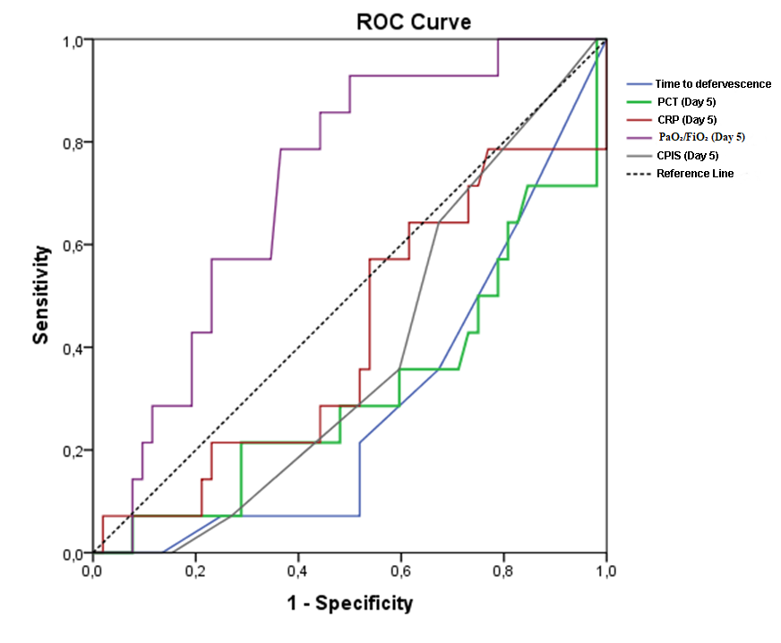
Figure 2: ROC Analysis of Parameters with Statistically Significant Discriminatory Performance
*In ROC analysis, the day 5 PaO₂/FiO₂ ratio emerged as the most powerful discriminator, demonstrating the largest area under the curve (AUC) and thus the strongest predictive performance among the evaluated parameters. Early defervescence, together with lower day 5 levels of PCT, CRP, and CPIS, also showed substantial AUC values, reinforcing their role as dynamic response markers rather than static severity indicators. Collectively, these findings support the concept that early physiological and biomarker improvement—particularly oxygenation recovery—provides objective and quantifiable guidance for treatment individualization.

Table 10. Cut-off Values, AUC, 95% CI, Sensitivity, Specificity, PPV, and NPV Derived from ROC Analysis
Parameter | Cut-off Value | AUC | 95% CI | Sensitivity (%) | Specificity (%) | PPV (%) | NPV (%)
Infiltration on PA chest radiograph | 0 | 0.596 | 0.512–0.676 | 34.3 | 84.8 | 41.4 | 80.5
Time to defervescence (days) | ≤5 | 0.622 | 0.539–0.701 | 91.4 | 33.0 | 29.9 | 92.5
CRP (Day 5) (mg/dL) | <15 | 0.632 | 0.548–0.710 | 80.0 | 46.4 | 32.2 | 87.9
CRP (Day 7) (mg/dL) | ≤12.7 | 0.615 | 0.524–0.700 | 79.3 | 46.9 | 30.7 | 88.5
PCT (Day 5) (µg/L) | ≤0.5 | 0.628 | 0.541–0.710 | 58.1 | 67.6 | 34.6 | 84.5
PaO₂/FiO₂ (Day 5) | >300 | 0.750 | 0.672–0.818 | 85.7 | 64.3 | 42.9 | 93.5
PaO₂/FiO₂ (Day 7) | >300 | 0.700 | 0.619–0.773 | 80.0 | 63.4 | 40.6 | 91.0
Glasgow Coma Scale (Day 5) | >8 | 0.644 | 0.561–0.721 | 54.3 | 71.4 | 37.3 | 83.3
CPIS (Day 3) | ≤5 | 0.616 | 0.532–0.695 | 68.6 | 50.9 | 30.4 | 83.8
CPIS (Day 5) | ≤4 | 0.671 | 0.588–0.746 | 74.3 | 59.8 | 36.6 | 88.2
Colistin use during treatment | 0 | 0.670 | 0.587–0.745 | 71.4 | 62.5 | 37.3 | 87.5
Antibiotic-free days | >4 | 0.665 | 0.574–0.747 | 82.9 | 45.0 | 37.2 | 87.0
Abbreviations: AUC, area under the curve; PPV, positive predictive value; NPV, negative predictive value; CI, confidence interval; PA, posterior–anterior; PCT, procalcitonin; CRP, C-reactive protein; PaO₂, arterial partial pressure of oxygen; FiO₂, fraction of inspired oxygen; CPIS, Clinical Pulmonary Infection Score; GCS, Glasgow Coma Scale.

Table 11. Correlation Matrix of the Study Criteria
 |  | C1 | C2 | C3 | C4 | C5 | C6 | C7
C1 | r | 1.000
C1 | p | -
C1 | n | 147
C2 | r | 0.095 | 1.000
C2 | p | 0.272 | -
C2 | n | 136 | 136
C3 | r | 0.076 | 0.247** | 1.000
C3 | p | 0.362 | 0.004 | -
C3 | n | 145 | 134 | 145
C4 | r | 0.185* | 0.144 | 0.141 | 1.000
C4 | p | 0.025 | 0.094 | 0.091 | -
C4 | n | 147 | 136 | 145 | 147
C5 | r | 0.316** | 0.307** | 0.141 | 0.441** | 1.000
C5 | p | <0.001 | <0.001 | 0.091 | <0.001 | -
C5 | n | 147 | 136 | 145 | 147 | 147
C6 | r | 0.164* | 0.254** | 0.030 | 0.180* | 0.161 | 1.000
C6 | p | 0.046 | 0.003 | 0.724 | 0.029 | 0.051 | -
C6 | n | 147 | 136 | 145 | 147 | 147 | 147
C7 | r | -0.091 | -0.099 | 0.080 | 0.085 | 0.093 | -0.105 | 1.000
C7 | p | 0.275 | 0.253 | 0.340 | 0.304 | 0.263 | 0.204 | -
C7 | n | 147 | 136 | 145 | 147 | 147 | 147 | 147
Number of criteria ≥4 | r | 0.394** | 0.505** | 0.327** | 0.459** | 0.609** | 0.500** | 0.153
Number of criteria ≥4 | p | <0.001 | <0.001 | <0.001 | <0.001 | <0.001 | <0.001 | 0.064
Number of criteria ≥4 | n | 147 | 136 | 145 | 147 | 147 | 147 | 147
Number of criteria ≥5 | r | 0.368** | 0.382** | 0.437** | 0.652** | 0.612** | 0.384** | 0.157
Number of criteria ≥5 | p | <0.001 | <0.001 | <0.001 | <0.001 | <0.001 | <0.001 | 0.057
Number of criteria ≥5 | n | 147 | 136 | 145 | 147 | 147 | 147 | 147

Table 12. Compliance of STTG and LTTG with the Predefined Short-Term Treatment Criteria
Day 5 Parameters | STTG | LTTG | p value | OR | 95% CI
Absence of fever | 32 (91.4%) (n=35) | 75 (67.0%) (n=112) | 0.004 | 5.26 | 1.41–23.12
PCT ≤0.5 µg/L | 18 (58.1%) (n=31) | 34 (32.4%) (n=105) | 0.010 | 2.89 | 1.18–7.14
CRP <15 mg/dL | 28 (80.0%) (n=35) | 59 (53.6%) (n=110) | 0.010 | 3.46 | 1.30–9.55
PaO₂/FiO₂ >300 mmHg | 30 (85.7%) (n=35) | 40 (35.7%) (n=112) | <0.001 | 10.8 | 3.61–34.62
CPIS ≤4 | 26 (74.3%) (n=35) | 45 (40.2%) (n=112) | 0.001 | 4.30 | 1.72–10.99
Absence of bacteremia | 32 (91.4%) (n=35) | 74 (66.1%) (n=112) | 0.003 | 5.48 | 1.47–24.04
Appropriate empirical therapy | 32 (91.4%) (n=35) | 80 (71.4%) (n=112) | 0.021 | 4.27 | 1.14–18.85
Abbreviations: PCT, procalcitonin; CRP, C-reactive protein; PaO₂, arterial partial pressure of oxygen; FiO₂, fraction of inspired oxygen; CPIS, Clinical Pulmonary Infection Score; OR, odds ratio; CI, confidence interval; STTG, short-term treatment group; LTTG, long-term treatment group.

Table 13. Discriminatory Performance of Grouped Criteria Between STTG and LTTG
Criteria | STTG (n=35) | LTTG (n=112) | p value | OR | 95% CI
≥5 criteria | 29 (82.9%) | 29 (25.9%) | <0.001 | 13.8 | 4.83–41.66
≥4 criteria | 32 (91.4%) | 55 (49.1%) | <0.001 | 11.1 | 2.99–48.21
≥4 criteria including C1 | 30 (85.7%) | 46 (41.1%) | <0.001 | 8.6 | 2.89–27.46
≥4 criteria including C2 | 18 (51.4%) | 30 (26.8%) | 0.005 | 3.5 | 1.40–8.63
≥4 criteria including C3 | 27 (77.1%) | 36 (32.1%) | <0.001 | 6.9 | 2.67–18.57
≥4 criteria including C4 | 30 (85.7%) | 28 (25.0%) | <0.001 | 18.0 | 5.89–58.94
≥4 criteria including C5 | 26 (74.3%) | 38 (33.9%) | <0.001 | 5.6 | 2.24–14.49
≥4 criteria including C6 | 28 (80.0%) | 46 (41.1%) | <0.001 | 5.7 | 2.15–15.87
≥4 criteria including C7 | 29 (82.9%) | 42 (37.5%) | <0.001 | 8.1 | 2.87–23.73
≥3 criteria including C4 | 30 (85.7%) | 39 (34.8%) | <0.001 | 11.2 | 3.75–36.04
STTG, short-term treatment group; LTTG, long-term treatment group; K, criterion; OR, odds ratio; CI, confidence interval.

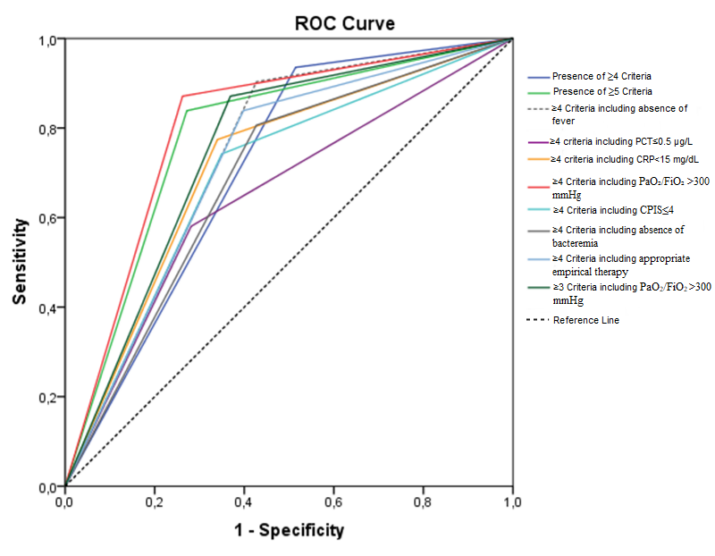
Figure 3. ROC Analysis of the Grouped Criteria
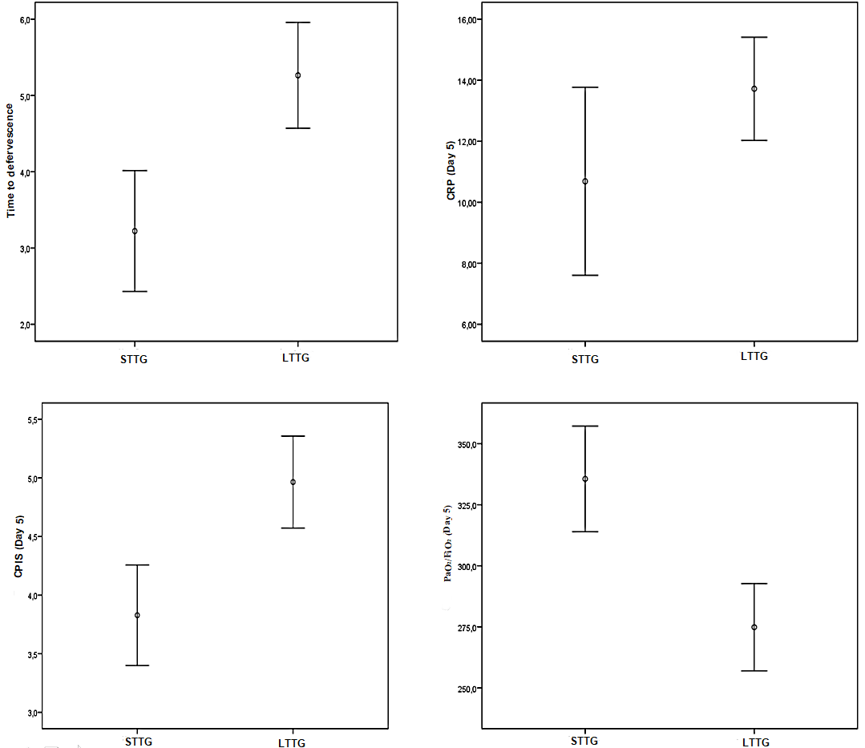
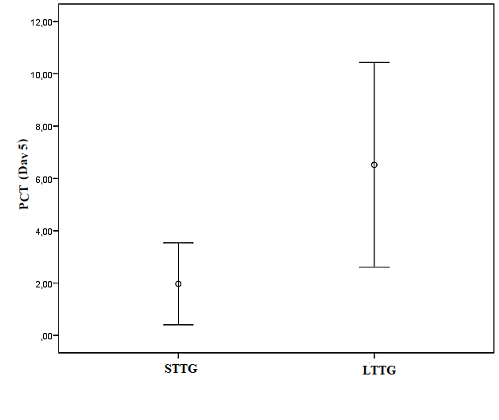
Figure 4. Error Bar Plots of Quantitative Criteria in the Study Groups

