Supplementary Information

A Systematic Investigation into the Influence of Zeolite Framework Differences on the Catalytic Performance of Copper Sites in Ammonia Oxidation

Sisi Deng ª, Fuming Liu ª, Shuqing Dengª, Ruifeng Miao ª, Changqiu Chen ª, Dingding Liu ^{a*}.
a. Department of Environmental Science & Engineering, College of Chemical Engineering, Huaqiao University, Xiamen, Fujian 361021, China.

Section 1

Table S1. Physicochemical properties of proton and copper containing catalysts prepared in this study.
Sample | IZA code | Pore topology | Pore size (A) | ICP elemental analysis  Si/Al Cu(wt%)
H-BETA | BEA | 3D,12-ring | 6.5×6.7，5.6×5.6 | 20
H-ZSM-5 | MFI | 3D,10-ring | 5.1×5.5，5.3×5.6 | 25
H-SSZ-13 | CHA | 3D,8-ring | 3.8×3.8 | 20
Cu/BETA |  |  |  | 20 | 1.90
Cu-ZSM-5 |  |  |  | 25 | 1.74
Cu-SSZ-13 |  |  |  | 20 | 1.94

Section 2

Table S2. The results of integrating the peak areas of Cu/SSZ-13, Cu/ZSM-5 and Cu/BETA catalysts by H₂-TPR.

Sample | Peak I | Peak II | Peak III
Cu/SSZ-13 | 0.044 | 0.037 | 0.047
Cu/ZSM-5 | 0.036 | 0.047 | 0.030
Cu/BETA | 0.030 | 0.035 | 0.023

Section 3

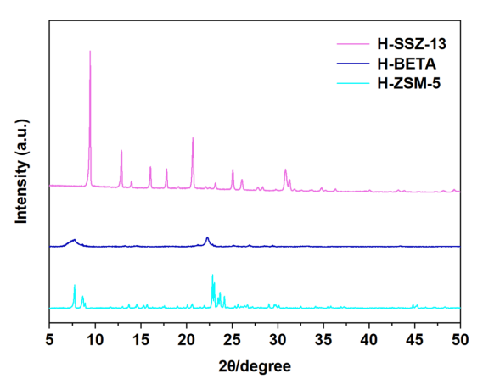
Fig. S1. XRD patterns of H-SSZ-13,H-BETA and H-ZSM-5.

Section 4

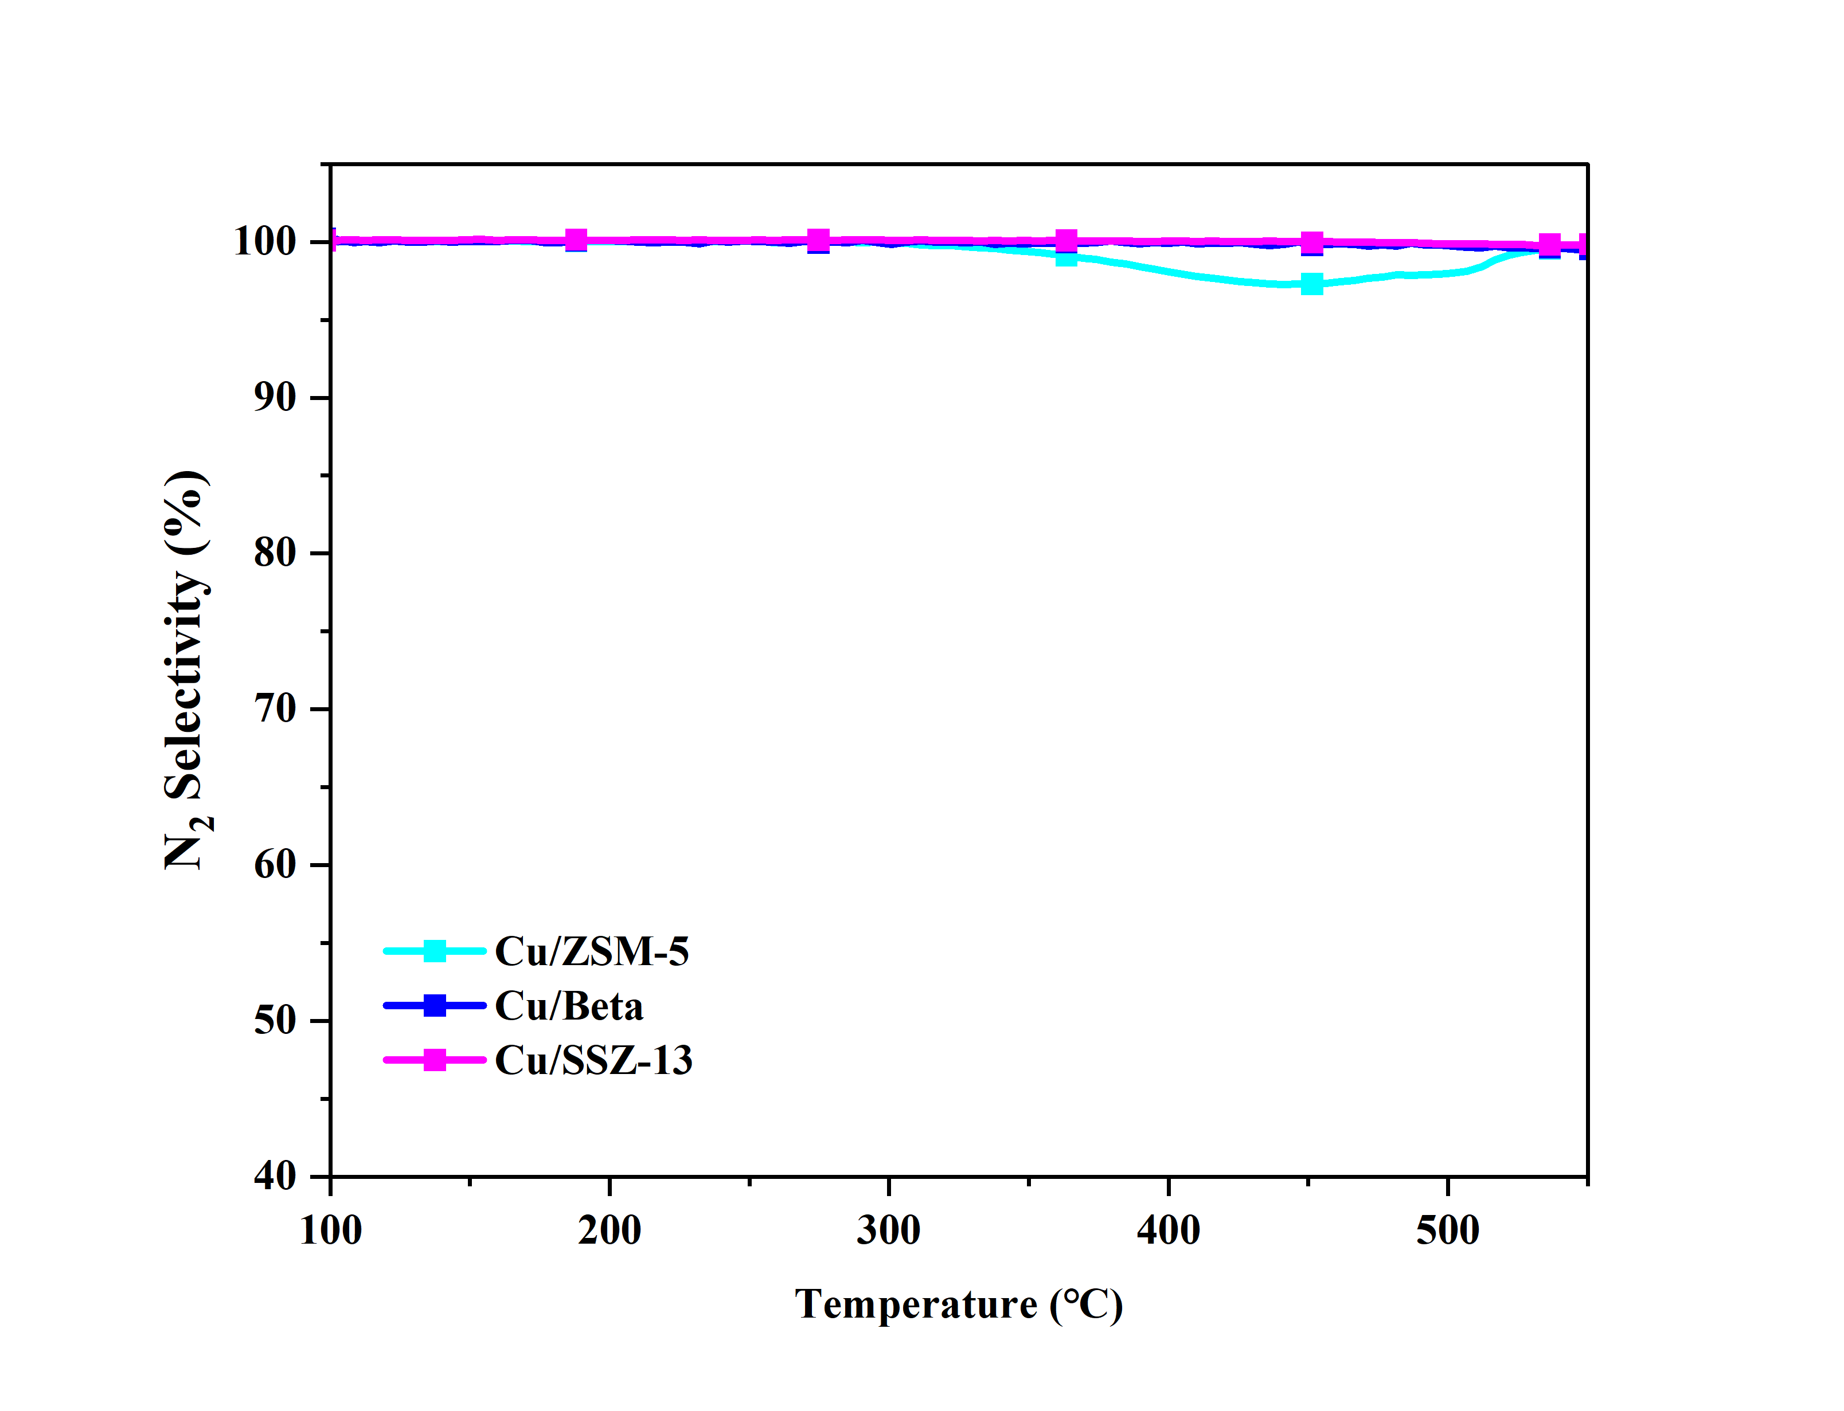

Fig. S2. The N₂ selectivity of Cu-SSZ-13, Cu-ZSM-5, and Cu-BETA.

Section 5

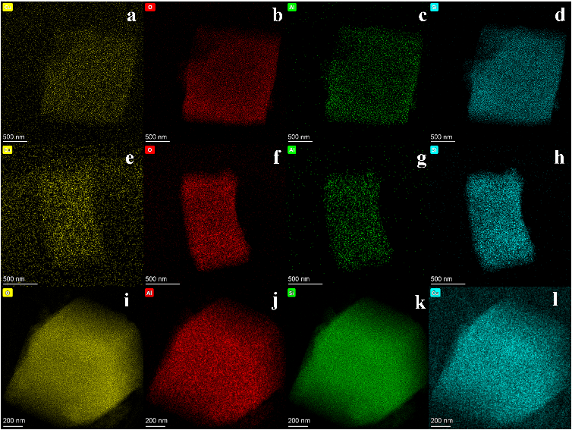

Fig. S3. EDS results of the Cu/SSZ-13 (a-d), Cu/ZSM-5 (e-h), and Cu/BETA (i-l) catalysts.

Section 6
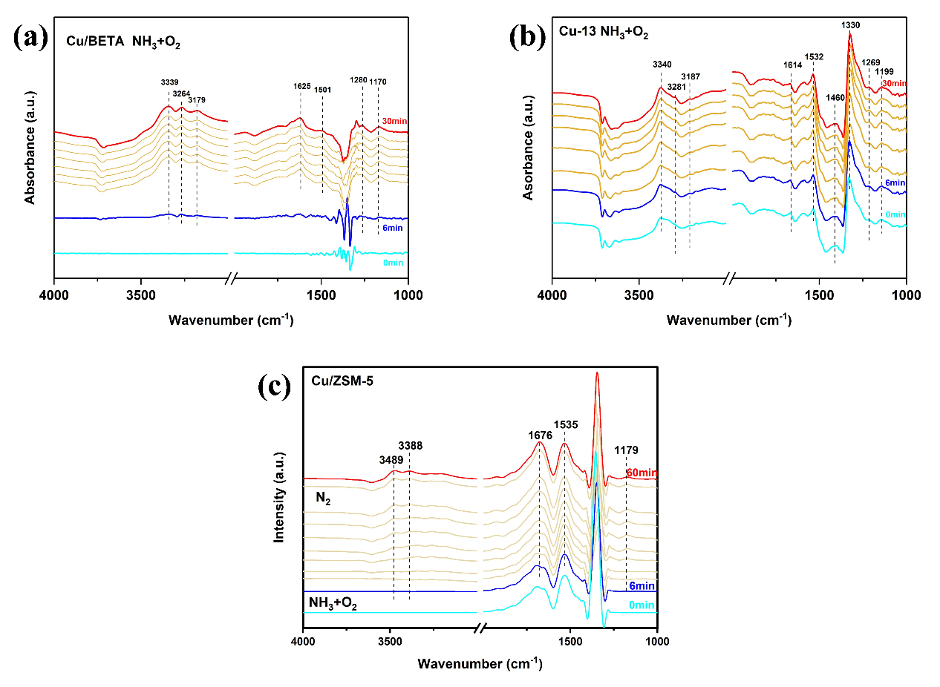
Fig. S4. In-situ infrared spectra of Cu/ZSM-5, Cu/BETA and Cu/SSZ-13 molecular sieves

