Data analytics accelerates the experimental discovery of new thermoelectric materials with extremely high figure of merit

Yaqiong Zhong^{1#}, Xiaojuan Hu^{2#}, Debalaya Sarker^{3#}, Qingrui Xia^{1,5}, Liangliang Xu⁴, Chao Yang^{1,5}, Zhong-Kang Han³*, Jiaolin Cui¹* and Sergey V. Levchenko³*
¹ School of Materials and Chemical Engineering, Ningbo University of Technology, Ningbo 315211, China.
² Fritz-Haber-Institute of the Max Planck Society, Berlin 14195, Germany.
³ Center for Energy Science and Technology, Skolkovo Institute of Science and Technology, Moscow 413026, Russia.
⁴ Multidisciplinary Computational Laboratory, Department of Electrical and Biomedical Engineering, Hanyang University, Seoul 04763, Korea.
⁵ School of Materials Science and Engineering, China University of Mining and Technology, Xuzhou 221116, China
# These authors contributed equally.
Correspondence Email: S.Levchenko@skoltech.ru; H.Zhongkang@skoltech.ru; cuijl@nbut.edu.cn

Supplementary Methods
For constructing the Φ₁ and Φ₂ feature spaces we made use of the set of algebraic/functional operators given in eq. 1.
Ĥ^{(m)} ≡{+, −, ·, /, log, exp, exp−, ⁻¹, ², ³, √, ³√, |−|}, (1)
The superscript m indicates that when applying Ĥ^{(m)} to primary features φ₁ and φ₂ a dimensional analysis is performed, which ensures that only physically meaningful combinations are retained (e.g. only primary features with the same unit are added or subtracted). All primary features included in this study were obtained from the literature.¹ The values of the primary features for the training data sets at each iteration can be found in the file “Supplementary Data”.

The sparsifying ℓ₀ constraint is applied to a smaller feature subspace selected by a screening procedure (sure independence screening (SIS)), where the size of the subspace is equal to a user-deﬁned SIS value times the dimension of the descriptor. The SIS value is not an ordinary hyperparameter and its optimization through a validation data set is not straightforward. Ideally, one would want to search the entire feature space for the optimal descriptor. However, this is not computationally tractable since the computational cost of the sparsifying ℓ₀ constraint grows exponentially with the size of the searched feature space. Instead, the SIS value should be chosen as large as computationally possible. The reasonable SIS values were chosen based on the convergence of the training error.

The high-throughput (HT) screening of the huge compositional space of ternary based chalcogenide materials A_{1−x}A*_{x}B_{1−y}B*_{y}C_{2−z}C*_{z} (where A = Cu or Ag; B = Bi, In, Sb, or Ga; C = Se or Te; A* = Cu, Ag, Zn, or Na; B* = Ga, In, Bi, Sb, Zn, or Sn; C* = Te or Cl) was performed at the final iteration. The values of x, y, and z were limited to smaller than 0.1, 0.1, and 0.2, respectively, which corresponding to 10% of dopant concentration. The mixtures of CuInTe₂, CuGaTe₂, AgInTe₂, and AgGaTe₂ are stable in a large temperature range according to the literature.² Thus, their mixtures are also included in our high-throughput screening. The best ternary, quaternary, and quintenary A-B-C₂ type based chalcogenide materials were systematically screened at the first, second, and third iteration, respectively. The newly found best systems at each iteration are collected in the Supplementary Data.

Table S1. Values for all primary features.
Element | HF (eV) | HV (eV) | EN | IE (eV) | AW (amu) | AR (Å)
Cu | 0.14 | 3.11 | 1.90 | 7.73 | 63.55 | 1.28
Ag | 0.12 | 2.63 | 1.93 | 7.58 | 107.87 | 1.44
Ga | 0.06 | 2.65 | 1.81 | 6.00 | 69.72 | 1.35
In | 0.03 | 2.40 | 1.78 | 5.79 | 114.82 | 1.67
Bi | 0.12 | 1.86 | 2.02 | 7.29 | 208.98 | 1.56
Sb | 0.21 | 2.00 | 2.05 | 8.64 | 121.76 | 1.40
Te | 0.18 | 1.18 | 2.10 | 9.01 | 127.60 | 1.40
Se | 0.07 | 0.99 | 2.55 | 9.75 | 78.97 | 1.20
Sn | 0.07 | 3.07 | 1.96 | 7.34 | 118.71 | 1.40
Cl | 0.07 | 0.21 | 3.16 | 12.97 | 35.45 | 0.99
Na | 0.03 | 1.01 | 0.93 | 5.14 | 22.99 | 1.86
Zn | 0.08 | 1.19 | 1.65 | 9.39 | 65.38 | 1.34

Table S2. Top subgroups obtained by maximization of zT, α² (10⁻¹²V²K⁻²), σ (Ω⁻¹ m⁻¹), 1/κ (W⁻¹Km), and 1/κ_{L} (W⁻¹Km) with a range of the quality function parameter constraining the minimum value of a target property within the subgroups.
Property | Parameter | Selector | Frequency
zT | 0.6 | ARB*<1.4 & CA*>0.05 & T>696.21 | 0.057
zT | 0.9 | ARB*<1.4 & CA*>0.05 & T>696.21 | 0.057
zT | 1.2 | ARB*<1.4 & CA*>0.05 & T>696.21 | 0.057
zT | 1.5 | ARB*<1.4 & CA*>0.05 & T>696.21 | 0.057
α² | 1E+5 | HVA<3.1134 & T<=617.76 | 0.201
α² | 1.5E+5 | ARA*>1.34 & CA*<0.005 & 343.764<=T<=617.76 | 0.123
α² | 2E+5 | ARA*>1.34 & ARB*>=1.35 & CA*<0.005 & 488.915<=T<=617.76 | 0.059
σ | 1E+4 | CA*<=0.05 & HVA*<2.633 & T<=750.79 | 0.154
σ | 2E+4 | CA*<=0.05 & HVA*<1.9125 & T<=715.105 | 0.140
σ | 3E+4 | CA*<=0.05 & CB*<=0.025 & HVA*<1.9125 & T<537.989 | 0.059
1/κ | 2 | HVA<3.1134 & T>715.105 | 0.184
1/κ | 4 | ARA>1.28 & ARB*>=1.345 & CA*<=0.2375 & T>750.79 | 0.128
1/κ | 6 | ARA*>=1.34 & ARB*>=1.35 & HVA<2.8732 & T>823.07 | 0.017
1/κ | 8 | 0.05<=CB*<=0.075 & T>789.97 | 0.010
1/κ_{L} | 2 | AWA>=85.7071 & AWB*>=67.5515 & T>750.79 | 0.137
1/κ_{L} | 4 | ARA>=1.36 & AWB*>=67.5515 & T>750.79 | 0.137
1/κ_{L} | 6 | ARA>1.28 & AWB<92.2705 & AWB*>=69.723 & T>750.79 | 0.088
1/κ_{L} | 8 | 0.01<CA*<=0.2375 & HVA<3.1134 & T>715.105 | 0.042

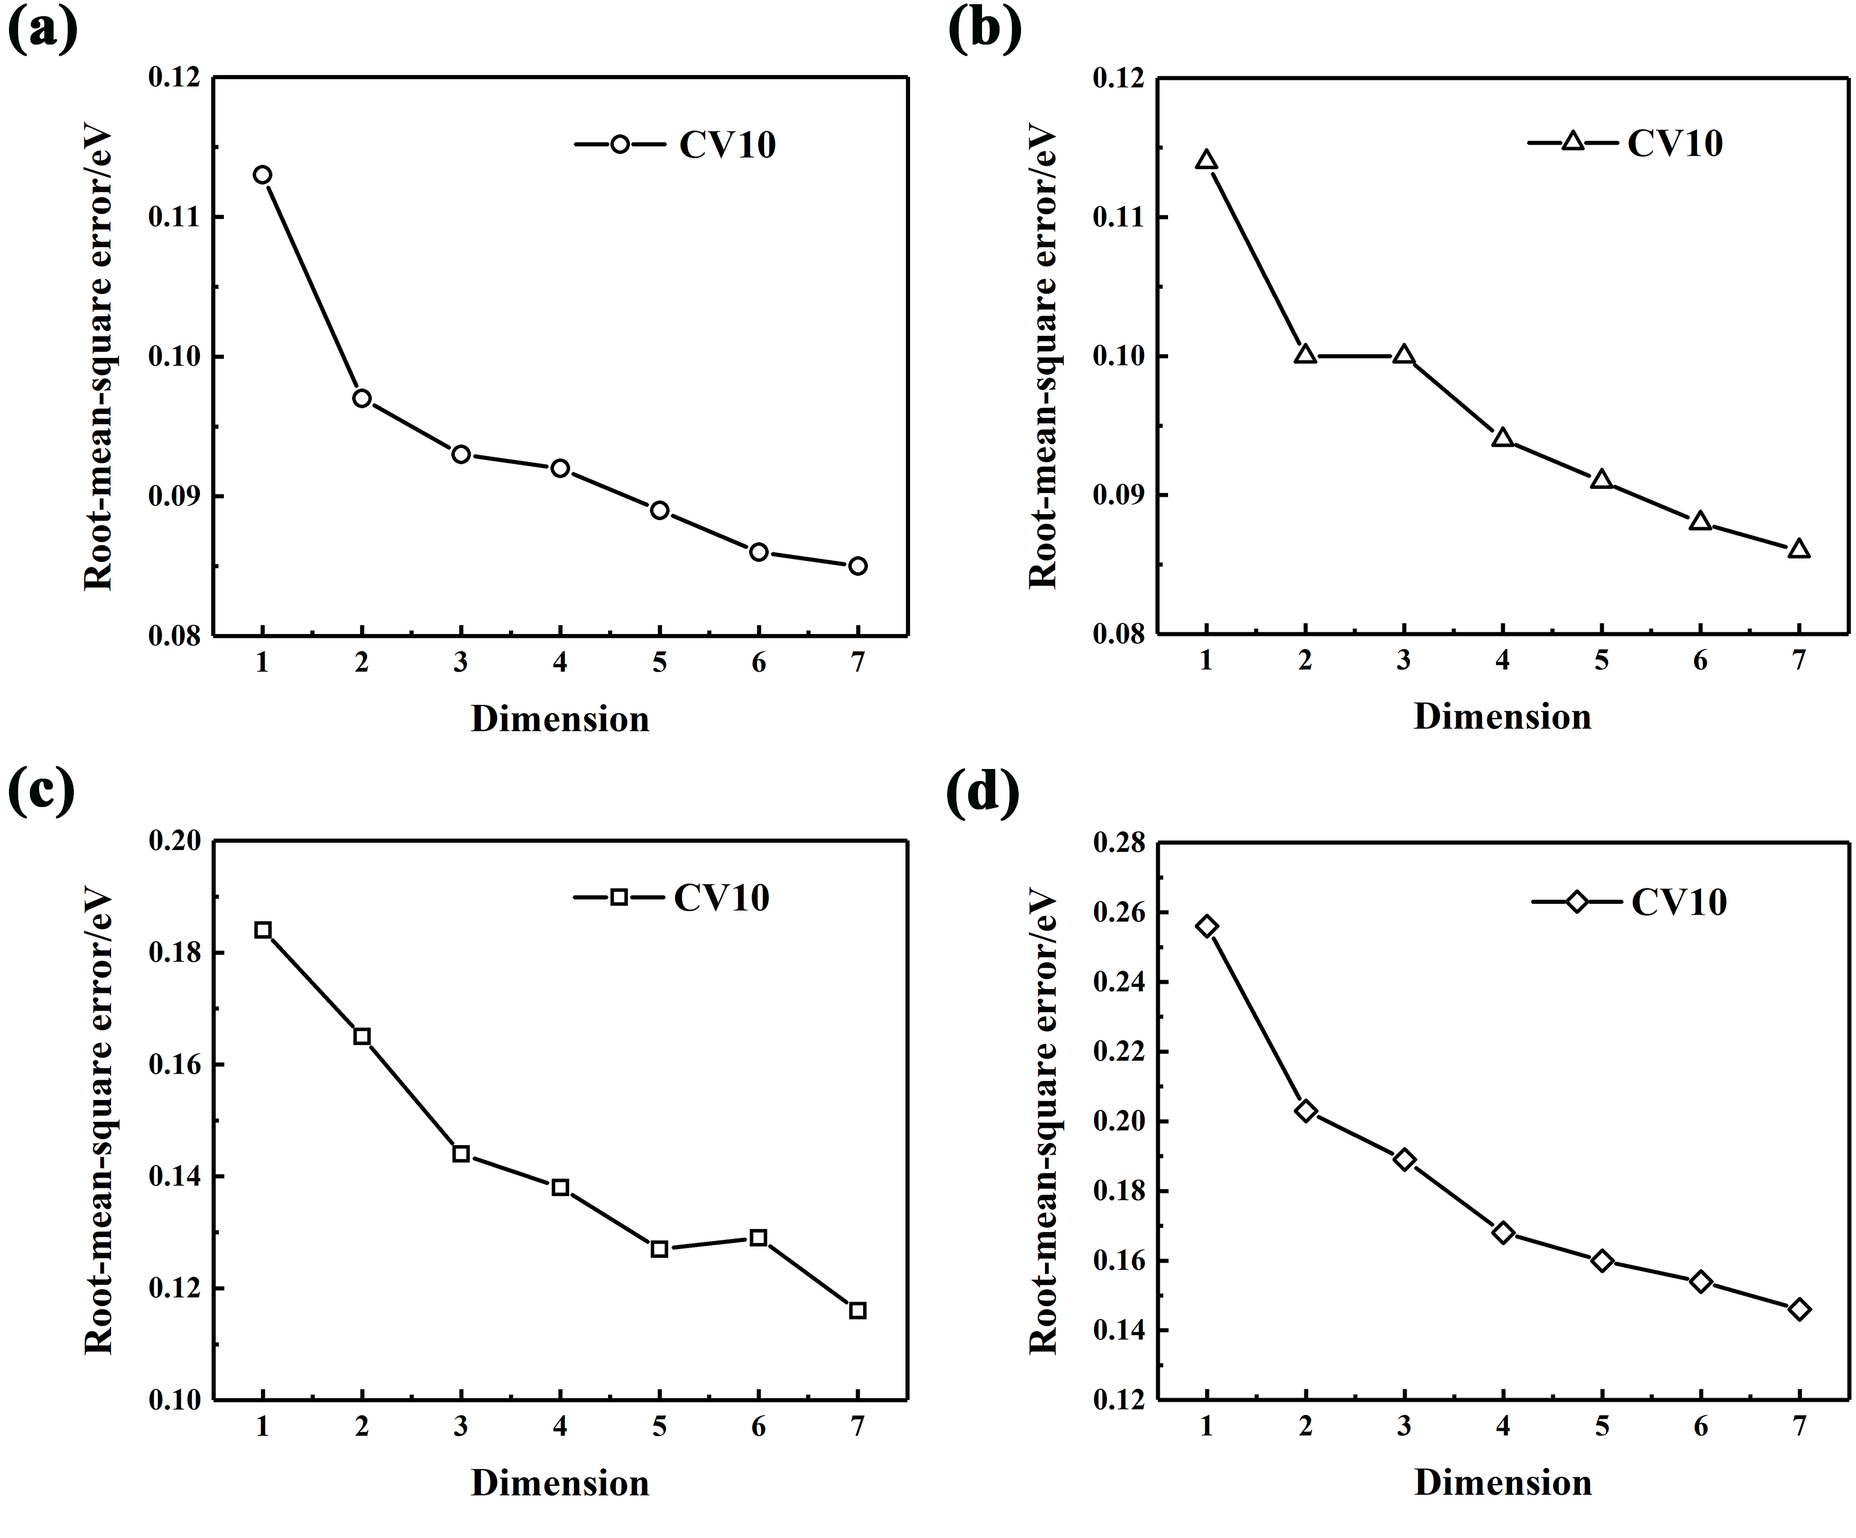
Figure S1. CV10 error at each iteration.

Table S3. zT values from previous reports on chalcogenide materials from other groups alongside with the SISSO-predicted values.
systems | temperature (K) | SISSO-predicted | previous reported
CuGaTe₂ | 950 | 1.48 | 1.40³
Cu_{0.7}Ag_{0.3}In_{0.6}Ga_{0.4}Te₂ | 873 | 1.30 | 1.64²
AgSb_{0.98}Bi_{0.02}Se₂ | 680 | 0.66 | 1.15⁴
AgSbTe₂ | 533 | 0.81 | 1.55⁵
AgBiSe₂ | 700 | 0.46 | 1.50⁶
AgSb_{0.96}Zn_{0.04}Te₂ | 585 | 1.16 | 1.90⁷
AgSbTe_{1.98}Se_{0.02} | 565 | 0.83 | 1.37⁸
AgSbTe_{1.85}Se_{0.15} | 575 | 0.84 | 2.10⁹
AgSb_{0.93}In_{0.07}Te₂ | 650 | 0.88 | 1.35¹⁰

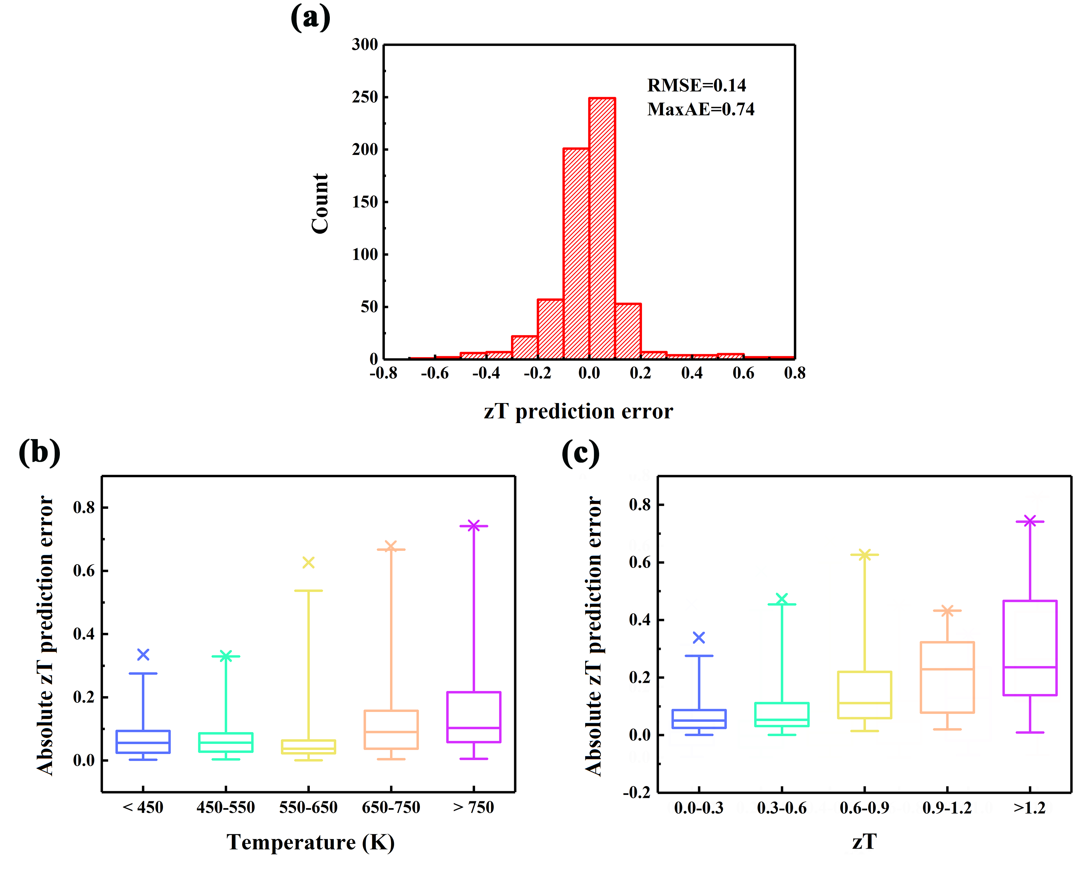
Figure S2. (a) Distribution of zT prediction errors for the best SISSO model at the final iteration; (b) and (c) Box plots for error distribution as a function of temperature range and zT range, respectively. The upper and lower limits of the rectangles show the 75th and 25th percentiles of the distributions, the internal horizontal lines mark the median (50th percentile), and the upper and lower limits of the error bars indicate the 99th and 1st percentiles of the distributions. The crosses represent the maximum errors.

Table S4. The top five largest deviations between SISSO model predicted zT values and the experimentally measured zT values.
system | temperature (K) | predicted zT | measured zT | deviation
Ag_{0.55}Cu_{0.45}GaTe₂ | 730.3 | 1.62 | 2.38 | 0.76
Ag_{0.55}Cu_{0.45}GaTe₂ | 769.4 | 1.95 | 2.69 | 0.74
Ag_{0.6}Cu_{0.4}GaTe₂ | 769.3 | 1.83 | 2.52 | 0.68
Ag_{0.6}Cu_{0.4}GaTe₂ | 730.2 | 1.53 | 2.21 | 0.68
Ag_{0.525}Cu_{0.475}GaTe₂ | 730.2 | 1.67 | 2.29 | 0.62

Table S5. The descriptor components $d_{i}$, the coefficients $c_{i}$, and the occurrence number of each component during the 10CV processes for the best SISSO model at the first iteration.
 | descriptor component | coefficient | occurrence number
$$d_{1}^{}$$ | T³/(AW_{B}∙AW_{C*}) | 0.93247E-05 | 10
$$d_{2}^{}$$ | (1−C_{A*})/(EN_{C*}∙|EN_{A}−EN_{B}|) | 0.17046E+00 | 1
$$d_{3}^{}$$ | (T/AW_{B})³ | 0.21914E-03 | 7
$$d_{4}^{}$$ | (T∙C_{B*})/(IE_{B*}−IE_{C}) | -0.16632E-02 | 0
$$d_{5}^{}$$ | T∙C_{B*}∙(AR_{A*}−AR_{B}) | -0.11212E-01 | 0
$$d_{6}^{}$$ | AW_{A*}/(HF_{A*}∙HV_{B}∙HV_{B*}) | 0.82582E-03 | 0
$$d_{7}^{}$$ | C_{B*}²/HV_{A*}³ | -0.15125E+03 | 0

Table S6. The descriptor components $d_{i}$, the coefficients $c_{i}$, and the occurrence number of each component during the 10CV processes for the best SISSO model at the second iteration.
 | descriptor component | coefficient | occurrence number
$$d_{1}^{}$$ | T³/(AW_{B}∙AW_{C*}) | 0.28180E-04 | 10
$$d_{2}^{}$$ | T/(AR_{B}∙|EN_{A}−EN_{B}|) | 0.93246E-04 | 1
$$d_{3}^{}$$ | T²/(AW_{B}∙AW_{C*}) | -0.16963E-01 | 3
$$d_{4}^{}$$ | C_{B*}³∙(AW_{A*}−AW_{B}) | -0.91257E+00 | 6
$$d_{5}^{}$$ | T²∙(C_{A*}+C_{C*}) | -0.30352E-05 | 3
$$d_{6}^{}$$ | (HF_{A}∙IE_{B*})/(T∙HV_{A*}) | 0.67027E+02 | 0
$$d_{7}^{}$$ | (AW_{B*}−AW_{C*})/(AW_{A*}−AW_{B}) | -0.15383E-01 | 0

Table S7. The descriptor components $d_{i}$, the coefficients $c_{i}$, and the occurrence number of each component during the 10CV processes for the best SISSO model at the third iteration.
 | descriptor component | coefficient | occurrence number
$$d_{1}^{}$$ | T²/((1−C_{A*})∙AW_{B}) | 0.65004E-04 | 10
$$d_{2}^{}$$ | T∙(HV_{B}−HV_{C*})/(1−C_{A*}) | 0.12435E-03 | 1
$$d_{3}^{}$$ | (C_{A*}/HV_{A})∙(HF_{A}−HF_{A*}) | 0.12824E+03 | 0
$$d_{4}^{}$$ | (1−C_{A*})³∙AW_{B}∙HV_{A} | 0.15328E-01 | 1
$$d_{5}^{}$$ | (C_{A*}−C_{B*})/(AR_{A}−AR_{C}) | 0.61174E-01 | 0
$$d_{6}^{}$$ | (AW_{A*}∙AW_{C*})/T² | 0.46100E+01 | 0
$$d_{7}^{}$$ | AW_{B}∙C_{B*}∙(IE_{A}−IE_{B*}) | 0.39042E-02 | 0

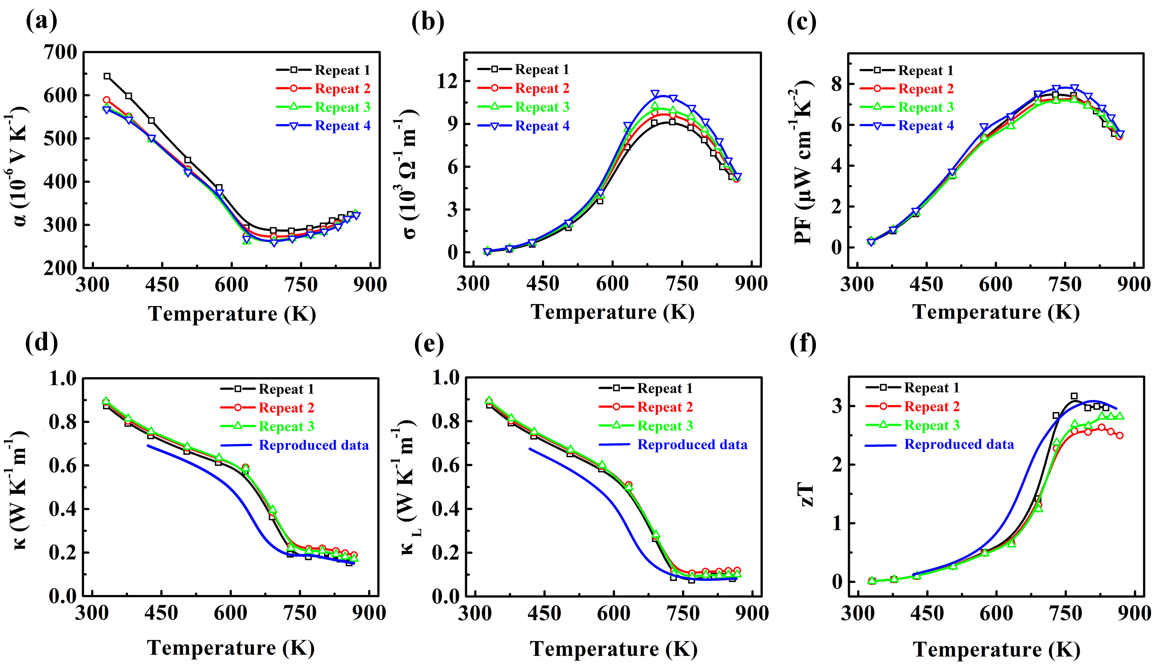
Figure S3. The repeated measurements of thermoelectric properties as a function of temperature for Ag_{0.55}Cu_{0.45}GaTe₂. (a) Seebeck coefficients (α); (b) Electrical conductivities (σ); (c) Power factors (PF); (d) Total thermal conductivities (κ); (e) Lattice thermal conductivities (κ_{L}); (f) Figure of merit (zT).

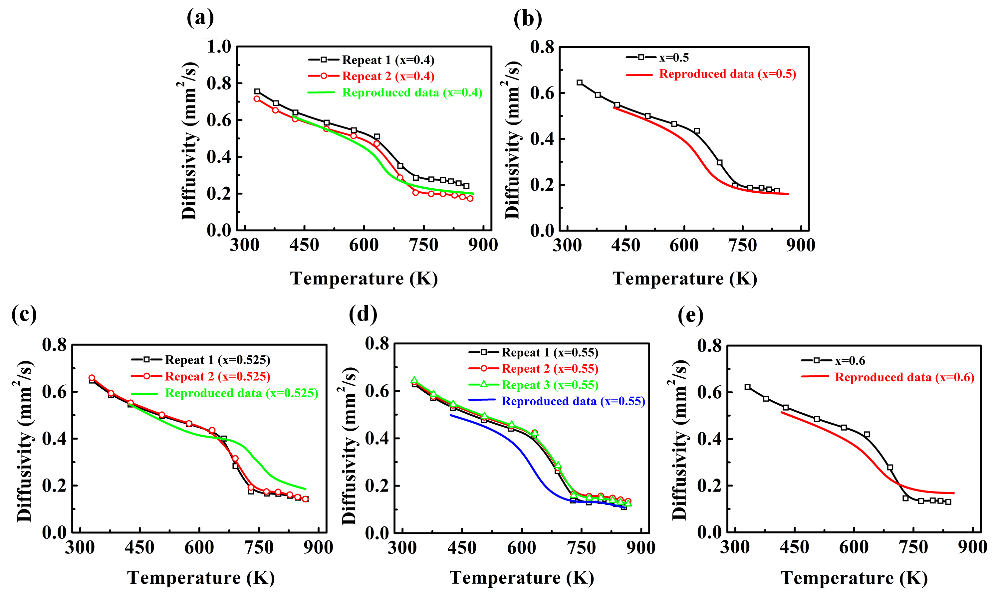
Figure S4. Thermal diffusivity as a function of temperature for Cu_{1−x}Ag_{x}GaTe₂ (x=0.4-0.6). (a) x=0.4; (b) x=0.5; (c) x=0.525; (d) x=0.55; (e) x=0.6.

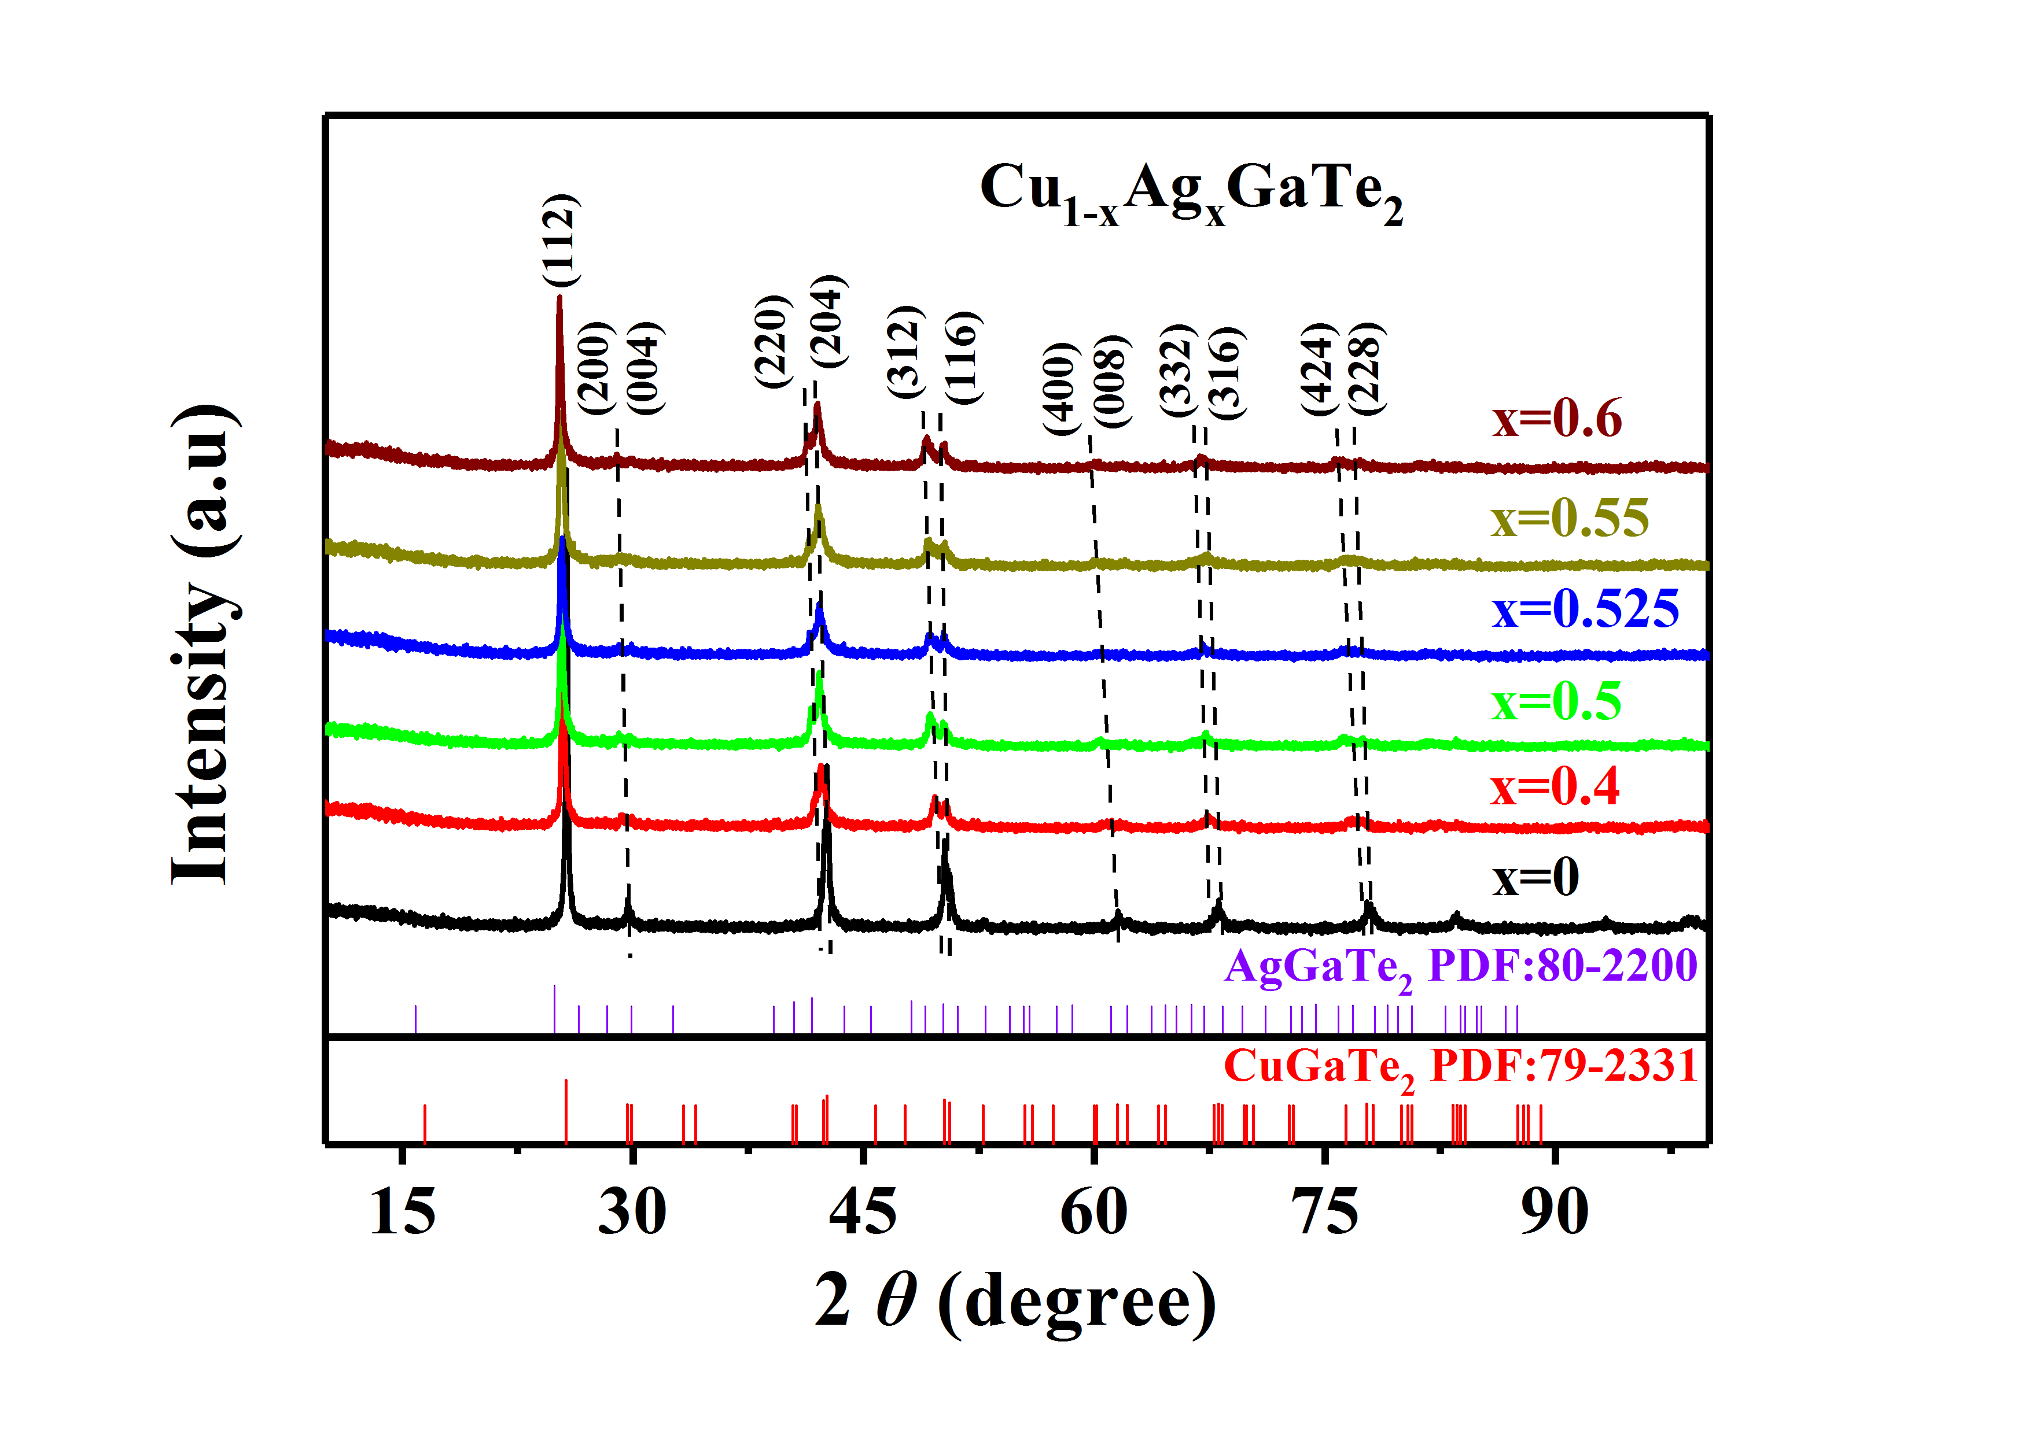
Figure S5. Powder XRD patterns for Cu_{1−x}Ag_{x}GaTe₂ (x=0-0.6). The XRD peaks show a shifting trend with increasing x.

Supplementary References

1. Speight, J.G. Lange's handbook of chemistry. (McGraw-Hill Education, 2017).
2. Zhang, J. et al. Design of domain structure and realization of ultralow thermal conductivity for record-high thermoelectric performance in chalcopyrite. Advanced Materials 31, 1905210 (2019).
3. Plirdpring, T. et al. Chalcopyrite CuGaTe₂: a high-efficiency bulk thermoelectric material. Advanced Materials 24, 3622-3626 (2012).
4. Guin, S.N., Chatterjee, A., Negi, D.S., Datta, R. & Biswas, K. High thermoelectric performance in tellurium free p-type AgSbSe₂. Energy & Environmental Science 6, 2603-2608 (2013).
5. Xu, J. et al. High thermoelectric figure of merit and nanostructuring in bulk AgSbTe₂. Journal of Materials Chemistry 20, 6138-6143 (2010).
6. Xiao, C. et al. High thermoelectric and reversible pnp conduction type switching integrated in dimetal chalcogenide. Journal of the American Chemical Society 134, 18460-18466 (2012).
7. Roychowdhury, S., Panigrahi, R., Perumal, S. & Biswas, K. Ultrahigh thermoelectric figure of merit and enhanced mechanical stability of p-type AgSb_{1–x}Zn_{x}Te₂. ACS Energy Letters 2, 349-356 (2017).
8. Du, B., Li, H., Xu, J., Tang, X. & Uher, C. Enhanced figure-of-merit in Se-doped p-type AgSbTe₂ thermoelectric compound. Chemistry of Materials 22, 5521-5527 (2010).
9. Hong, M. et al. Achieving zT > 2 in p-type AgSbTe_{2−x}Se_{x} alloys via exploring the extra light valence band and introducing dense stacking faults. Advanced Energy Materials 8, 1702333 (2018).
10. Mohanraman, R. et al. Influence of In doping on the thermoelectric properties of an AgSbTe₂ compound with enhanced figure of merit. Journal of Materials Chemistry A 2, 2839-2844 (2014).

Supplementary Appendix
Testing report for thermal diffusivity from The Center for Materials Research and Analysis in Wuhan University of Technology.
