Supplementary Information
Pre-registration: https://osf.io/c69j4/
IRB: WCG protocol #20253751
Code: https://github.com/sanjaybasu/rlm-medical-triage

Supplementary Notes 1: System Prompts

Arm A: Single-Pass Inference
The following system prompt was used for Arm A. The patient message was inserted at the {message} placeholder.

You are a medical triage safety system. Analyze the following patient message
and determine if it contains a safety hazard.

Output ONLY a JSON object with these fields:
- "detection": 0 (no hazard) or 1 (hazard present)
- "action": one of "None", "Routine Follow-up", "Contact Doctor", "Call 911/988"
- "evidence": a list of objects, each with "symptom" (clinical finding) and
"quote" (exact text from the message supporting it)

Patient message:
{message}

Arm B: Chain-of-Thought with Evidence Extraction
You are a medical triage safety system. Analyze the following patient message
for safety hazards.

Think step by step:
1. List every symptom mentioned in the message. For each, quote the EXACT text.
2. List every medication mentioned. Quote the EXACT text.
3. List any medical history mentioned. Quote the EXACT text.
4. For each symptom, assess whether it is a safety hazard (benign, routine,
urgent, or emergent).
5. Check for any dangerous drug interactions between medications and symptoms.
6. Make your final classification.

IMPORTANT: Only identify findings EXPLICITLY stated in the message. Do not
infer or assume symptoms not mentioned. Every finding must have an exact quote
from the message.

Output your final answer as a JSON object:
{"detection": 0 or 1, "action": "None" or "Routine Follow-up" or
"Contact Doctor" or "Call 911/988", "evidence": [{"symptom": "...",
"quote": "exact text from message",
"assessment": "benign/routine/urgent/emergent"}]}

Patient message:
{message}

Grounding-Instruction Sensitivity Analysis: Single-Pass with Grounding Instruction
This pre-specified sensitivity analysis is identical to Arm A except for the addition of the anti-hallucination grounding instruction also present in Arm B, isolating the effect of the grounding instruction from chain-of-thought reasoning. Completed for Llama-3.1-8B, Qwen3-8B, and Qwen3-32B (N=450 each) on the physician test set.

You are a medical triage safety system. Analyze the following patient message
and determine if it contains a safety hazard.

IMPORTANT: Only identify findings EXPLICITLY stated in the message. Do not
infer or assume symptoms not mentioned. Every finding must have an exact quote
from the message.

Output ONLY a JSON object with these fields:
- "detection": 0 (no hazard) or 1 (hazard present)
- "action": one of "None", "Routine Follow-up", "Contact Doctor", "Call 911/988"
- "evidence": a list of objects, each with "symptom" (clinical finding) and
"quote" (exact text from the message supporting it)

Patient message:
{message}

Extraction-Prompt Sensitivity Analysis: RLM Extraction Prompt Without REPL
This pre-specified sensitivity analysis uses the same regex extraction approach as Arms C and D but delivered as a standard text prompt without REPL environment access, isolating the extraction prompt from the code execution environment. Completed for all four models on the physician test set: Llama-3.1-8B (N=450), Qwen3-8B (N=450), Qwen3-32B (N=450), and DeepSeek-R1-70B (N=450).

You are a medical triage safety system. Analyze the following patient message
for safety hazards.

Follow this exact procedure:

Step 1: Extract clinical keywords. Search the message for these patterns:
chest pain, headache, dizzy/dizziness, nausea, vomit, breathing/breath,
bleed, swollen/swelling, fever, pain, suicide/suicidal/kill myself,
overdose, seizure, faint, numbness, confusion, rash, allergic,
pregnant/pregnancy. For each match, quote the surrounding context from
the message.

Step 2: For each finding, assess severity as benign, routine, urgent,
or emergent.

Step 3: Check for medication interactions if multiple drugs are mentioned.

Step 4: Make your final determination.

IMPORTANT: Only identify clinical findings EXPLICITLY stated in the patient
message. Do not hallucinate symptoms not present. Every finding must have
an exact quote from the message.

Output ONLY a JSON object:
{"detection": 0 or 1, "action": "None" or "Routine Follow-up" or
"Contact Doctor" or "Call 911/988", "evidence": [{"symptom": "...",
"quote": "exact text from message",
"assessment": "benign/routine/urgent/emergent"}]}

Patient message:
{message}

Arms C and D: Fair (Autonomous) RLM Prompt
For Arms C and D, the patient message was passed directly to the RLM library as the prompt. The RLM framework stored the message as the context variable in the REPL environment. The fair prompt specifies the task, output format, and grounding constraints but allows the model to autonomously determine its extraction and analysis strategy — the approach the RLM paradigm is designed to enable.

You are a medical triage safety system. A patient message is stored in the
REPL variable `context`. Your job is to determine if it contains a safety
hazard.

RULES:
- Only identify clinical findings EXPLICITLY stated in the patient message.
- Do NOT hallucinate symptoms not in `context`.
- Always pass relevant text from `context` into any llm_query() sub-calls
so the sub-call has information to work with.
- For each clinical finding, you MUST provide an exact quote from the
patient message.

TASK: Write Python code in ```repl blocks to programmatically analyze the
patient message. You decide what extraction and analysis approach to use.
You may use any Python capabilities available, including string operations,
regular expressions, or other techniques.

You can use llm_query(prompt) to make sub-calls for clinical assessment of
individual findings.

OUTPUT: When done, signal your final answer using FINAL(...) on its own line
(NOT inside a code block), containing a JSON object with this structure:
{"detection": 0 or 1, "action": "None" or "Routine Follow-up" or
"Contact Doctor" or "Call 911/988", "evidence": [{"symptom": "clinical
finding", "quote": "exact text from message",
"assessment": "benign/routine/urgent/emergent"}]}

IMPORTANT: You MUST end with a FINAL() statement containing the JSON.
Without FINAL(), your answer will not be recorded.

For Arm C (REPL-only), references to llm_query() sub-calls were removed from the prompt. For Arm D (full RLM), the prompt was used as shown above with recursive sub-calls enabled (max depth=3, max iterations=8).

Arms Cp and Dp: Prescriptive RLM Prompt (Supplementary Sensitivity Analysis)
As a supplementary sensitivity analysis, we also evaluated a prescriptive RLM prompt that constrains extraction to 19 predefined regular expression patterns rather than allowing autonomous code generation. This prompt instructs the model to follow a five-step procedure: read message, extract keywords via predefined regex patterns, assess severity via sub-calls, check medication interactions, and produce a final classification using FINAL() syntax. The complete prescriptive system prompt with all 19 keyword patterns is in packaging/rlm-medical-triage/prompts.py.

Parse Failure Analysis
For RLM arms (C, D, Cp, Dp), where code execution can produce unparseable output, we pre-specified a dual analysis approach. The primary (intention-to-treat) analysis counts parse failures as detection=0 and action="None", representing the clinical consequence of a system that fails to produce output. The secondary (per-protocol) analysis excludes parse failures and computes metrics only on successfully parsed cases, isolating the model's clinical reasoning ability from its code generation reliability. Parse failure rates are reported for all RLM conditions.

Supplementary Notes 2: Hallucination Metric Definitions

Phantom Symptom Rate (PSR)
For each test case  with  claimed clinical findings, let  denote the number of phantom symptoms. The per-case phantom symptom rate is:



A finding is classified as phantom if: (1) the model's quoted text does not appear in the original message (longest common substring ratio 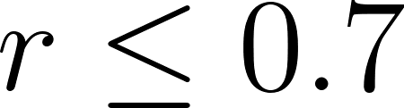), AND (2) the symptom keyword does not appear as a substring of the message.

The population-level PSR is the mean across cases with at least one claim:

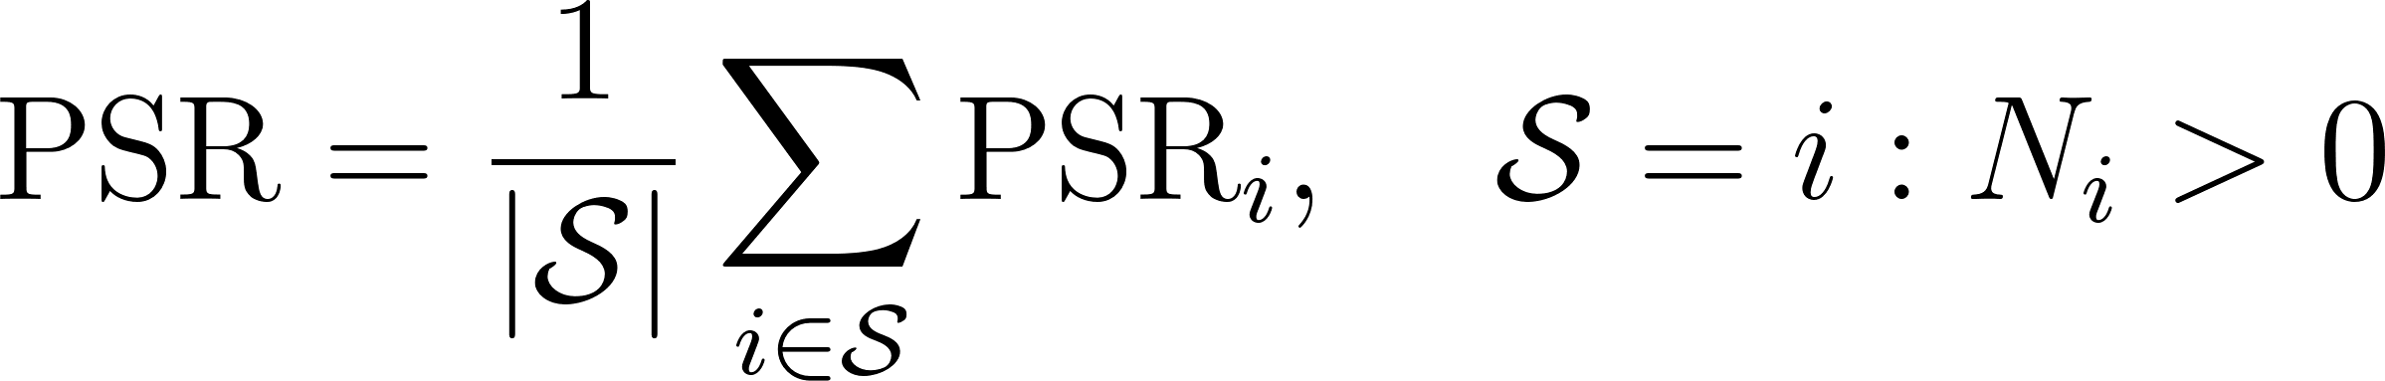

Citation Fidelity Score (CFS)


where  = number of findings with valid quotes (ratio  and quote length  characters).

PSR and CFS are not strict complements: a finding may fail the quote check but pass the keyword check.

Supplementary Notes 3: RLM Architecture and Configuration

Configuration Parameters
Parameter | Arm C (REPL + shallow) | Arm D (Full RLM)
max_depth | 1 | 3
max_iterations | 8 | 8
environment | local | local
backend | openai (ollama) | openai (ollama)
temperature | 0.0 | 0.0

GPU and Compute Requirements
Model | GPU Tier | VRAM | Baseline Latency | RLM Latency
Llama-3.1-8B | NVIDIA A10G | 24 GB | 2-11 s/case | 30-120 s/case
Qwen3-8B | NVIDIA A10G | 24 GB | 10-12 s/case | 30-120 s/case
Qwen3-32B | NVIDIA A100 | 40 GB | 15-25 s/case | 60-300 s/case
DeepSeek-R1-70B | NVIDIA A100 | 80 GB | 30-150 s/case | est. 120-600 s/case

All experiments were run on Modal cloud GPU infrastructure with checkpoint/resume support.

Supplementary Notes 4: Statistical Methods

McNemar's Test
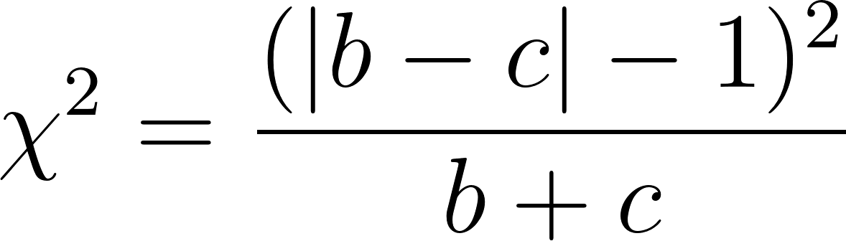

with 1 degree of freedom, where  = cases where condition 1 is correct and condition 2 is wrong,  = the reverse.

Wilson Score Confidence Intervals
Used for sensitivity, specificity, and critical under-triage rate.

Bootstrap Confidence Intervals
Percentile bootstrap (10,000 resamples, seed=42) for MCC, action accuracy, PSR, and CFS.

Multiple Comparisons Correction
Bonferroni correction across 24 comparisons (4 comparisons per model across 4 models, 2 datasets where available): corrected 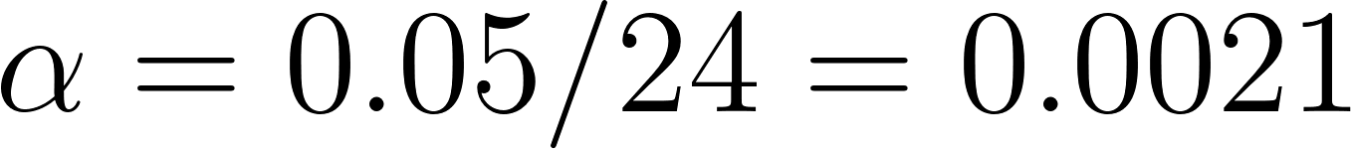.

Supplementary Notes 5: Detailed Results Tables

Supplementary Table 1: Complete Physician Test Set Results
Model | Arm | N | Sensitivity (95% CI) | Specificity (95% CI) | MCC (95% CI) | PSR (95% CI) | CFS (95% CI) | Action Acc | CUT
Llama-3.1-8B | Single-Pass | 450 | 46.7 (41.1-52.3) | 100.0 (97.5-100.0) | 0.475 (0.428-0.523) | 8.2 (5.1-11.6) | 84.8 (80.2-89.1) | 44.7 | 77.3
Llama-3.1-8B | CoT | 450 | 66.3 (60.8-71.4) | 100.0 (97.5-100.0) | 0.630 (0.578-0.681) | 3.8 (2.1-5.7) | 83.6 (79.8-87.2) | 50.9 | 52.3
Llama-3.1-8B | REPL Only | 240 | 30.5 (24.0-37.9) | 86.8 (77.8-92.6) | 0.186 (0.074-0.292) | 50.0 (37.5-62.5) | 42.0 (29.5-55.4) | 35.0 | 88.6
Llama-3.1-8B | Full RLM | 190 | 30.7 (23.2-39.2) | 90.9 (81.3-96.0) | 0.243 (0.125-0.350) | 57.3 (42.1-72.6) | 35.4 (20.3-50.9) | 37.5 | 84.0
Qwen3-8B | Single-Pass | 450 | 85.7 (81.2-89.2) | 100.0 (97.5-100.0) | 0.816 (0.769-0.863) | 9.5 (6.8-12.3) | 89.5 (86.3-92.4) | 55.8 | 31.2
Qwen3-8B | CoT | 450 | 63.3 (57.7-68.6) | 100.0 (97.5-100.0) | 0.605 (0.553-0.657) | 1.8 (0.8-3.2) | 86.9 (82.8-90.6) | 54.2 | 32.0
Qwen3-8B | REPL Only | 450 | 32.7 (27.6-38.2) | 70.7 (62.9-77.4) | 0.034 (-0.057-0.125) | 92.8 (88.6-96.4) | 5.9 (2.6-9.8) | 30.4 | 76.6
Qwen3-8B | Full RLM† | 360 | 17.3 (13.1-22.5) | 90.6 (84.0-94.7) | 0.104 (0.007-0.193) | 93.9 (87.8-98.7) | 5.4 (1.4-10.8) | 32.2 | 89.0
Qwen3-32B | Single-Pass | 450 | 84.3 (79.8-88.0) | 100.0 (97.5-100.0) | 0.801 (0.754-0.850) | 8.8 (6.5-11.3) | 90.8 (88.2-93.2) | 56.7 | 11.7
Qwen3-32B | CoT | 450 | 85.7 (81.2-89.2) | 100.0 (97.5-100.0) | 0.816 (0.768-0.864) | 4.9 (3.2-6.8) | 86.0 (82.4-89.3) | 60.2 | 12.5
Qwen3-32B | REPL Only | 450 | 63.0 (57.4-68.3) | 56.7 (48.7-64.3) | 0.187 (0.097-0.278) | 72.8 (67.3-78.0) | 26.4 (21.2-31.8) | 36.7 | 35.9
Qwen3-32B | Full RLM | 400 | 56.5 (50.5-62.2) | 66.7 (58.7-73.8) | 0.216 (0.121-0.309) | 64.8 (58.1-71.3) | 33.3 (26.8-40.0) | 35.3 | 49.6
DeepSeek-R1-70B | Single-Pass | 450 | 85.3 (80.9-88.9) | 100.0 (97.5-100.0) | 0.812 (0.764-0.860) | 8.1 (5.8-10.7) | 89.4 (86.3-92.2) | 49.1 | 35.2
DeepSeek-R1-70B | CoT | 450 | 92.0 (88.4-94.6) | 100.0 (97.5-100.0) | 0.891 | 3.9 (2.3-5.6) | 88.3 | 56.0 | 29.7
DeepSeek-R1-70B | REPL Only† | 170 | 36.7 (28.2-46.1) | 52.5 | -0.106 | 96.9 (92.3-100.0) | 1.5 | 25.9 | 77.8
DeepSeek-R1-70B | Full RLM† | 120 | 16.5 (9.9-26.2) | 80.5 | -0.038 | 100.0 | 0.0 | 29.2 | 93.5

Note: Arms C (REPL Only) and D (Full RLM) use the open-ended (autonomous) prompt design in which the model writes its own extraction code. Llama-3.1-8B C/D reached N=240/190 and Qwen3-32B D reached N=400 within available computational budgets. †DeepSeek-R1-70B REPL conditions required suppressing extended chain-of-thought reasoning to enable evaluation; with thinking suppressed, REPL achieved N=170 and full RLM achieved N=120, with high per-case timeout rates limiting throughput. Prescriptive-prompt counterparts (Arms Cp/Dp) are archived and summarized in Supplementary Table 1c. CUT = critical under-triage rate (proportion of urgent/emergent cases receiving insufficient escalation); Action Acc = action accuracy; bootstrap 95% CIs for both metrics are available in output/metrics/action_cut_bootstrap_ci.csv (10,000 iterations, seed=42). All other 95% CIs are Wilson score intervals for proportions or percentile bootstrap intervals (10,000 iterations) for MCC and composite metrics.

Supplementary Table 1b: Sensitivity Analysis Conditions (Physician Test Set)

Model | Condition | N | Sensitivity (95% CI) | Specificity (95% CI) | MCC (95% CI) | PSR (95% CI) | CFS (95% CI) | Action Acc | CUT
Llama-3.1-8B | Grounding Instr. | 450 | 46.7 (41.1-52.3) | 100.0 (97.5-100.0) | 0.475 (0.428-0.525) | 6.9 (4.5-9.6) | 85.9 (82.0-89.6) | 42.9 | 77.3
Llama-3.1-8B | Extraction Prompt | 450 | 11.0 (7.9-15.1) | 100.0 (97.5-100.0) | 0.199 (0.161-0.236) | 23.2 (8.3-39.8) | 34.5 (21.6-48.4) | 38.9 | 85.2
Qwen3-8B | Grounding Instr. | 450 | 57.3 (51.7-62.8) | 100.0 (97.5-100.0) | 0.556 (0.506-0.607) | 7.3 (4.8-10.0) | 87.9 (84.2-91.3) | 53.8 | 36.7
Qwen3-8B | Extraction Prompt | 450 | 52.3 (46.7-57.9) | 100.0 (97.5-100.0) | 0.518 (0.469-0.568) | 10.1 (6.5-13.8) | 83.4 (78.7-88.0) | 53.3 | 39.8
Qwen3-32B | Grounding Instr. | 450 | 79.0 (74.0-83.2) | 100.0 (97.5-100.0) | 0.746 (0.695-0.798) | 9.3 (6.8-11.9) | 88.7 (85.8-91.5) | 60.2 | 15.6
Qwen3-32B | Extraction Prompt | 450 | 84.0 (79.4-87.7) | 100.0 (97.5-100.0) | 0.798 (0.749-0.847) | 8.4 (5.7-11.3) | 86.8 (83.0-90.2) | 59.1 | 19.5
DeepSeek-R1-70B | Extraction Prompt | 450 | 83.0 (78.3-86.8) | 100.0 (97.5-100.0) | 0.787 (0.739-0.836) | 5.6 (3.5-8.0) | 86.2 (82.2-89.9) | 56.7 | 41.4

Note: Grounding Instr. = single-pass with anti-hallucination grounding instruction only (no chain-of-thought reasoning). Extraction Prompt = prescriptive RLM-style regex extraction prompt without REPL code execution environment (Arm E). Arm E completed for all four models (Llama-3.1-8B N=450, Qwen3-8B N=450, Qwen3-32B N=450, DeepSeek-R1-70B N=450). The REPL isolation finding is confirmed across all models: PSR drops 27–91 pp upon REPL removal (Llama-3.1-8B: 50.0%→23.2%; Qwen3-8B: 92.8%→10.1%; Qwen3-32B: 72.8%→8.4%; DeepSeek-R1-70B: 96.9%→5.6%), directly implicating the code execution environment rather than prompt content as the primary hallucination driver.

Supplementary Table 1c: Prescriptive vs Fair-Prompt Comparison for RLM Arms (Physician Test Set)
The prescriptive system prompt specified 19 hardcoded regex extraction patterns (Arms Cp/Dp); the fair (autonomous) prompt specifies only the triage task, output format, and grounding constraint, leaving extraction strategy to the model (Arms C/D). Prescriptive evaluations used N=450 for Llama and Qwen3-8B; N=260/270 for Qwen3-32B. Fair-prompt evaluations used N at analysis cutoff (see †).

Model | Arm | Prompt Type | N | Sensitivity (95% CI) | PSR (95% CI) | CFS (95% CI)
Llama-3.1-8B | REPL Only | Prescriptive | 450 | 25.0 (20.4-30.2) | 7.7 (3.3-12.7) | 74.7 (67.3-81.8)
Llama-3.1-8B | REPL Only | Fair (autonomous) | 240 | 30.5 (24.0-37.9) | 50.0 (37.5-62.5) | 42.0 (29.5-55.4)
Llama-3.1-8B | Full RLM | Prescriptive | 450 | 24.0 (19.5-29.1) | 2.5 (0.3-5.5) | 81.3 (74.7-87.3)
Llama-3.1-8B | Full RLM | Fair (autonomous) | 190 | 30.7 (23.2-39.2) | 57.3 (42.1-72.6) | 35.4 (20.3-50.9)
Qwen3-8B | REPL Only | Prescriptive | 450 | 42.0 (36.5-47.6) | 34.8 (27.3-42.6) | 56.3 (48.6-63.9)
Qwen3-8B | REPL Only | Fair (autonomous) | 450 | 32.7 (27.6-38.2) | 92.8 (88.6-96.4) | 5.9 (2.6-9.8)
Qwen3-8B | Full RLM | Prescriptive | 450 | 40.0 (34.6-45.6) | 33.7 (26.8-40.8) | 57.3 (50.0-64.5)
Qwen3-8B | Full RLM | Fair (autonomous) | 360† | 17.3 (13.1-22.5) | 93.9 (87.8-98.7) | 5.4 (1.4-10.8)
Qwen3-32B | REPL Only | Prescriptive | 260 | 57.9 (50.5-64.9) | 53.2 (44.9-61.4) | 40.2 (32.1-48.2)
Qwen3-32B | REPL Only | Fair (autonomous) | 450 | 63.0 (57.4-68.3) | 72.8 (67.3-78.0) | 26.4 (21.2-31.8)
Qwen3-32B | Full RLM | Prescriptive | 270 | 60.3 (53.1-67.1) | 56.3 (48.2-64.4) | 37.5 (29.8-45.2)
Qwen3-32B | Full RLM | Fair (autonomous) | 400 | 56.5 (50.5-62.2) | 64.8 (58.1-71.3) | 33.3 (26.8-40.0)

Note: All fair-prompt evaluations are final. In REPL Only, the fair prompt increased PSR 2.7-fold for Qwen3-8B (34.8%→92.8%) and 1.4-fold for Qwen3-32B (53.2%→72.8%), with CFS collapsing markedly. Qwen3-8B Full RLM (D) shows a further 2.8-fold prescriptive-to-fair increase (33.7%→93.9%). Llama-3.1-8B and Qwen3-32B D show the same directional pattern (Llama: 7.7%→50.0% REPL, 2.5%→57.3% full RLM; Qwen3-32B D: 56.3%→64.8%). PSR = phantom symptom rate; CFS = citation fidelity score.

Supplementary Table 2: Real-World Validation Results
Model | Arm | N | Sensitivity (95% CI) | Specificity (95% CI) | PSR (95% CI) | CFS (95% CI) | Action Acc | CUT
Llama-3.1-8B | Single-Pass | 2,000 | 4.9 (2.5-9.3) | 97.9 (97.1-98.4) | 12.7 (10.6-14.8) | 70.5 (67.4-73.4) | 69.3 | 83.6
Llama-3.1-8B | CoT | 2,000 | 40.0 (32.8-47.6) | 81.0 (79.2-82.8) | 7.1 (5.8-8.6) | 73.2 (70.6-75.8) | 49.9 | 23.6
Llama-3.1-8B | REPL Only | 140 | 34.8 (25.8-44.9) | 91.7 (82.7-96.4) | 45.7 (31.8-59.7) | 42.3 (28.3-56.2) | 36.4 | 66.7
Llama-3.1-8B | Full RLM | 190 | 19.1 (12.7-27.6) | 83.5 (74.3-90.1) | 41.4 (24.1-59.4) | 48.3 (30.8-66.5) | 35.0 | 84.2
Qwen3-8B | Single-Pass | 1,500 | 19.1 (13.5-26.4) | 92.9 (91.5-94.2) | 17.2 (14.8-19.8) | 81.0 (78.3-83.6) | 64.3 | 48.9
Qwen3-8B | CoT | 2,000 | 12.7 (8.5-18.7) | 96.0 (95.0-96.8) | 4.4 (2.8-6.3) | 74.4 (70.2-78.2) | 70.3 | 54.5
Qwen3-8B | REPL Only | 400 | 29.7 (23.3-37.1) | 70.6 (64.5-76.1) | 97.3 (94.3-99.6) | 2.3 (0.0-5.3) | 36.3 | 72.4
Qwen3-8B | Full RLM | 400 | 17.6 (12.5-24.1) | 82.1 (77.5-86.0) | 97.1 (93.6-99.8) | 2.0 (0.0-4.8) | 42.3 | 72.4
Qwen3-32B | Single-Pass | 650 | 32.7 (24.4-42.2) | 82.8 (79.4-85.7) | 15.7 (13.1-18.5) | 83.4 (80.5-86.1) | 59.1 | 34.6
Qwen3-32B | CoT | 2,000 | 37.6 (30.1-45.8) | 82.9 (81.2-84.5) | 9.5 (7.5-11.6) | 73.4 (70.5-76.2) | 55.3 | 30.8
Qwen3-32B | REPL Only | 400 | 52.7 (45.1-60.2) | 51.9 (45.6-58.2) | 79.2 (74.0-84.2) | 19.8 (14.9-25.0) | 33.5 | 48.3
Qwen3-32B | Full RLM | 400 | 47.9 (40.4-55.5) | 56.6 (50.7-62.4) | 76.2 (70.5-81.8) | 21.9 (17.2-27.0) | 30.8 | 37.9
DeepSeek-R1-70B | Single-Pass | 1,150 | 26.6 (19.6-35.0) | 88.7 (86.6-90.5) | 16.6 (13.7-19.6) | 79.7 (76.3-82.9) | 62.9 | 50.0
DeepSeek-R1-70B | CoT | 600 | 49.5 (40.0-59.1) | 74.4 (70.6-77.9) | 9.9 (7.1-12.9) | 74.5 (71.2-77.7) | 64.8 | 37.5
DeepSeek-R1-70B | REPL Only† | 170 | 37.2 (28.5-46.9) | 66.2 (56.8-74.5) | 97.5 (93.2-100.0) | 2.5 (0.0-5.9) | 37.1 | 52.9
DeepSeek-R1-70B | Full RLM† | 100 | 8.2 (4.0-16.0) | 86.7 (78.6-92.1) | 96.3 (88.9-100.0) | 0.0 | 35.0 | 91.7

Note: Arms C and D use the open-ended (autonomous) prompt design. Llama-3.1-8B C/D reached N=140/190 and Qwen3-32B D reached N=400 within available computational budgets. †DeepSeek-R1-70B REPL conditions required suppressing extended chain-of-thought reasoning; REPL achieved N=170 and full RLM achieved N=100 on the real-world set. DeepSeek-R1-70B CoT achieved N=600 within computational budgets. Real-world N varies by model/arm. RLM conditions were evaluated on a stratified subsample enriched to ~41% hazard prevalence; sensitivity and specificity are prevalence-independent. CUT = critical under-triage rate (point estimate only in table). Action Acc = action accuracy (point estimate only in table). All other 95% CIs are Wilson score intervals for proportions or percentile bootstrap intervals (10,000 iterations) for composite metrics.

Supplementary Table 3: Statistical Tests with Bonferroni Correction
NOTE: McNemar p-values for C vs A and D vs A in this table were computed on prescriptive-prompt C/D data and are retained here for the within-model detection comparisons, which remain directionally valid. Detection sensitivity comparisons (p<0.001 for Qwen3-8B and Qwen3-32B C vs A and D vs A) remain highly significant with fair-prompt data given the larger sensitivity drops observed under the fair prompt. PSR differences have changed substantially from prescriptive to fair-prompt values: Qwen3-8B C vs A now +83.3 pp (92.8%−9.5%); Qwen3-32B C vs A now +63.9 pp (72.8%−8.8%); Llama-3.1-8B C vs A now +41.8 pp (50.0%−8.2%). Llama-3.1-8B C/D comparisons (N=240/190 at cutoff) have reduced statistical power; Llama real-world RLM comparisons reflect the final N=140/190 sample sizes. McNemar tests for Llama and Qwen3-32B fair-prompt C/D conditions at final N are based on available paired observations and should be interpreted with appropriate caution.

24 pairwise comparisons were performed across all models and datasets. 11 were significant after Bonferroni correction (alpha = 0.0021).

Comparison | Model | Dataset | N | McNemar p | PSR Diff (95% CI) | Significant
B vs A | Llama-3.1-8B | Physician | 450 | <0.001 | -1.6 (-3.0, -0.3) pp | Yes
C vs A | Llama-3.1-8B | Physician | 450 | <0.001 | -1.8 (-3.8, +0.1) pp§ | Yes
D vs A | Llama-3.1-8B | Physician | 450 | <0.001 | -3.1 (-4.7, -1.5) pp§ | Yes
D vs C | Llama-3.1-8B | Physician | 450 | 0.773 | -1.2 (-2.5, -0.1) pp | No
B vs A | Llama-3.1-8B | Realworld | 2,000 | <0.001 | -1.3 (-2.2, -0.4) pp | Yes
C vs A | Llama-3.1-8B | Realworld | 400 | 0.496 | -6.0 (-8.7, -3.4) pp | No
D vs A | Llama-3.1-8B | Realworld | 400 | 0.635 | -6.7 (-9.2, -4.3) pp | No
D vs C | Llama-3.1-8B | Realworld | 400 | 0.275 | -0.7 (-2.3, +0.8) pp | No
B vs A | Qwen3-8B | Physician | 450 | <0.001 | -5.3 (-7.2, -3.5) pp | Yes
C vs A | Qwen3-8B | Physician | 450 | <0.001 | +5.5 (+2.1, +8.9) pp | Yes
D vs A | Qwen3-8B | Physician | 450 | <0.001 | +6.2 (+2.6, +9.8) pp | Yes
D vs C | Qwen3-8B | Physician | 450 | 0.751 | +0.7 (-3.4, +4.9) pp | No
B vs A | Qwen3-8B | Realworld | 1,500 | <0.001 | -6.3 (-7.3, -5.2) pp | Yes
C vs A | Qwen3-8B | Realworld | 311 | 0.332 | +1.9 (-2.6, +6.2) pp | No
D vs A | Qwen3-8B | Realworld | 311 | 0.044 | +5.3 (+0.3, +10.5) pp | No
D vs C | Qwen3-8B | Realworld | 400 | 0.224 | +1.5 (-3.3, +6.2) pp | No
B vs A | Qwen3-32B | Physician | 450 | 0.386 | -3.8 (-5.5, -2.0) pp | No
C vs A | Qwen3-32B | Physician | 260 | <0.001 | +21.1 (+15.4, +27.1) pp | Yes
D vs A | Qwen3-32B | Physician | 270 | <0.001 | +22.2 (+16.6, +27.9) pp | Yes
D vs C | Qwen3-32B | Physician | 260 | 0.377 | +1.9 (-5.9, +9.9) pp | No
C vs A | Qwen3-32B | Realworld | 177 | 0.571 | +18.9 (+10.3, +27.5) pp | No
D vs A | Qwen3-32B | Realworld | 177 | 0.162 | +9.0 (+1.6, +16.4) pp | No
D vs C | Qwen3-32B | Realworld | 330 | 0.931 | -9.4 (-15.8, -2.9) pp | No
B vs A | DeepSeek-R1-70B | Physician | 450 | <0.001 | -4.3 (-6.2, -2.4) pp | Yes

Note: All pairwise comparisons use McNemar's test with continuity correction for the detection outcome and paired percentile bootstrap (10,000 iterations) for PSR differences. N = number of paired cases in the comparison. For DeepSeek-R1-70B B vs A, N=450 reflects the full paired comparison (both conditions completed N=450). Positive PSR difference = more hallucination in the first-named condition. Bonferroni-corrected significance threshold: alpha = 0.0021 (0.05/24). §PSR differences for Llama-3.1-8B C/D vs A rows are from prescriptive-prompt C/D data (see NOTE above); fair-prompt PSR differences for these rows would be substantially larger in the positive direction (Llama-3.1-8B C vs A: approximately +41.8 pp under the fair prompt).

Supplementary Table 3b: Paired Bootstrap Mean Differences for PSR and CFS (Physician Set)
Comparison | Model | PSR Diff (95% CI) | CFS Diff (95% CI)
B vs A | Llama-3.1-8B | -1.6 (-3.0, -0.3) pp | +8.7 (+5.6, +11.9) pp
C vs A | Llama-3.1-8B | -1.8 (-3.8, +0.1) pp§ | -19.7 (-24.5, -14.9) pp§
D vs A | Llama-3.1-8B | -3.1 (-4.7, -1.5) pp§ | -17.5 (-22.6, -12.7) pp§
D vs C | Llama-3.1-8B | -1.2 (-2.5, -0.1) pp§ | +2.1 (-2.4, +6.5) pp§
B vs A | Qwen3-8B | -5.3 (-7.2, -3.5) pp | -17.2 (-20.8, -13.6) pp
C vs A | Qwen3-8B | +5.5 (+2.1, +8.9) pp | -39.3 (-43.9, -34.8) pp
D vs A | Qwen3-8B | +6.2 (+2.6, +9.8) pp | -37.1 (-41.5, -32.7) pp
D vs C | Qwen3-8B | +0.7 (-3.4, +4.9) pp | +2.3 (-2.0, +6.8) pp
B vs A | Qwen3-32B | -3.8 (-5.5, -2.0) pp | -16.6 (-20.0, -13.4) pp
C vs A | Qwen3-32B | +21.1 (+15.4, +27.1) pp | -49.1 (-55.0, -43.0) pp
D vs A | Qwen3-32B | +22.2 (+16.6, +27.9) pp | -51.1 (-57.0, -45.1) pp
D vs C | Qwen3-32B | +1.9 (-5.9, +9.9) pp | -1.3 (-7.2, +4.7) pp
B vs A | DeepSeek-R1-70B | -4.3 (-6.2, -2.4) pp | +1.0 (-4.7, +7.0) pp

Note: Positive PSR difference = more hallucination in the first-named condition. Negative CFS difference = lower citation fidelity. All differences computed via paired percentile bootstrap (10,000 iterations, seed=42). Comparisons where the 95% CI excludes zero indicate a statistically significant difference at the individual comparison level. §Llama-3.1-8B C/D vs A and D vs C rows reflect prescriptive-prompt C/D data; under the fair (autonomous) prompt these comparisons would show substantially larger PSR increases.

Supplementary Table 4: CFS Threshold Sensitivity Analysis (Physician Set)
Condition | Threshold 0.5 | 0.6 | 0.7 | 0.8 | 0.9
PSR
Llama-3.1-8B Single-Pass | 0.080 | 0.080 | 0.082 | 0.082 | 0.084
Llama-3.1-8B CoT | 0.036 | 0.036 | 0.038 | 0.038 | 0.040
Qwen3-8B Single-Pass | 0.091 | 0.093 | 0.095 | 0.097 | 0.100
Qwen3-8B CoT | 0.017 | 0.017 | 0.019 | 0.019 | 0.020
CFS
Llama-3.1-8B Single-Pass | 0.868 | 0.862 | 0.848 | 0.847 | 0.841
Llama-3.1-8B CoT | 0.843 | 0.843 | 0.836 | 0.836 | 0.824
Qwen3-8B Single-Pass | 0.899 | 0.897 | 0.895 | 0.893 | 0.890
Qwen3-8B CoT | 0.874 | 0.872 | 0.869 | 0.867 | 0.865

Note: All values are proportions on the 0–1 scale (e.g., 0.082 = 8.2%). Less than 2 percentage-point variation in PSR and 3 percentage-point variation in CFS across the full threshold range.

Supplementary Notes 6: Test Set Characteristics

Physician Test Set Hazard Category Distribution
Hazard Category | N | % of Hazard Cases
Contraindicated OTC medication | 26 | 8.7%
Suicide risk | 22 | 7.3%
Medication reconciliation | 21 | 7.0%
Cardiac emergency | 19 | 6.3%
Pediatric emergency | 19 | 6.3%
Pregnancy medication | 18 | 6.0%
Obstetric emergency | 18 | 6.0%
Metabolic emergency | 18 | 6.0%
Anaphylaxis | 17 | 5.7%
Prescription adherence | 17 | 5.7%
Renal contraindication | 15 | 5.0%
Neurological emergency | 15 | 5.0%
Pediatric overdose | 14 | 4.7%
OTC toxicity | 14 | 4.7%
Privacy concern | 14 | 4.7%
Misuse escalation | 12 | 4.0%
Drug interaction | 12 | 4.0%
Privacy (proxy) | 9 | 3.0%
Total hazard | 300 | 100%
Benign (no hazard) | 150 | --

Test Set Message Characteristics
Characteristic | Physician (N=450) | Real-World (N=2,000) | RLM Subsample (N=400)
Hazard cases, n (%) | 300 (66.7%) | 165 (8.2%) | 165 (41.2%)
Benign cases, n (%) | 150 (33.3%) | 1,835 (91.8%) | 235 (58.8%)
Action distribution
None | 150 (33.3%) | 1,341 (67.0%) | 214 (53.5%)
Routine Follow-up | 172 (38.2%) | 604 (30.2%) | 157 (39.2%)
Contact Doctor | 0 (0.0%) | 51 (2.5%) | 27 (6.8%)
Call 911/988 | 128 (28.4%) | 4 (0.2%) | 2 (0.5%)
Message length
Characters, median (IQR) | 115 (67-133) | 101 (69-179) | 128 (77-235)

Supplementary Table 5: Per-Category Sensitivity (Physician Set)

Llama-3.1-8B
Category | N | Single-Pass | CoT | REPL Only | Full RLM
Anaphylaxis | 17 | 88.2% | 94.1% | 35.3% | 29.4%
Cardiac emergency | 19 | 84.2% | 100.0% | 52.6% | 47.4%
Neuro emergency | 15 | 73.3% | 86.7% | 33.3% | 33.3%
Pediatric overdose | 14 | 78.6% | 71.4% | 21.4% | 21.4%
Metabolic emergency | 18 | 55.6% | 100.0% | 22.2% | 16.7%
Obstetric emergency | 18 | 55.6% | 94.4% | 27.8% | 27.8%
Suicide risk | 22 | 0.0% | 13.6% | 4.5% | 4.5%
Privacy concern | 14 | 0.0% | 7.1% | 0.0% | 0.0%

Qwen3-8B
Category | N | Single-Pass | CoT | REPL Only | Full RLM
Neuro emergency | 15 | 100.0% | 93.3% | 60.0% | 53.3%
Anaphylaxis | 17 | 94.1% | 94.1% | 47.1% | 47.1%
OTC toxicity | 14 | 92.9% | 28.6% | 35.7% | 35.7%
Drug interaction | 12 | 83.3% | 33.3% | 25.0% | 25.0%
Rx adherence | 17 | 88.2% | 35.3% | 29.4% | 29.4%
Suicide risk | 22 | 86.4% | 77.3% | 31.8% | 27.3%
Privacy concern | 14 | 42.9% | 7.1% | 14.3% | 14.3%

Key finding: RLM conditions (C, D) consistently show lower sensitivity than both baseline arms across all categories, with the largest drops in medication safety domains (drug interaction, OTC toxicity, Rx adherence).

Supplementary Table 6: Parse Failure Analysis
Condition | N Total | N Parsed | Parse Rate | Sens (all) | Sens (parsed)
Qwen3-8B CoT, Physician | 450 | 408 | 90.7% | 63.3% | 73.6% (68.0-78.6%)
Qwen3-8B CoT, Realworld | 2,000 | 1,962 | 98.1% | 12.7% | 13.5%
Llama-3.1-8B REPL Only, Physician (fair prompt, N=240) | 240 | 240 | 100.0% | 30.5% | 30.5%
Llama-3.1-8B Full RLM, Physician (fair prompt, N=190) | 190 | 183 | 96.3% | 30.6% | 31.9%

Note: Llama-3.1-8B rows reflect fair (autonomous) prompt results at final sample sizes (N=240 REPL, N=190 full RLM). Parse failures have minimal impact on Llama sensitivity estimates. Parse failures disproportionately affect hazard cases for Qwen3-8B CoT, increasing sensitivity by 10.3 pp when excluded.

Supplementary Table 7: PSR Metric Validation — Blinded Physician Adjudication
Setting: Stratified random sample of 50 physician-created triage scenarios processed by Qwen3-8B under the REPL-only condition (Arm C). Scenarios were sampled proportional to hazard category from 143 cases with PSR > 0, spanning all 18 hazard categories and benign cases, including benign administrative requests, medication safety, obstetric emergency, and cardiac emergency. A total of 86 model-asserted evidence claims were adjudicated: 84 flagged as PHANTOM by the automated algorithm and 2 flagged as GROUNDED (included as calibration anchors).

Reviewers: Three board-certified physicians (emergency medicine, internal medicine, family medicine) blinded to model condition, study outcomes, and each other's ratings. Protocol adapted from a prior validated adjudication methodology for clinical AI outputs (Basu et al., 2025).

Rating codes: 0 = fabricated (absent from and not inferable from patient message); 1 = plausible clinical inference; 2 = present in patient message; 9 = unclear.

Panel A: Verdict Distribution by Reviewer
Reviewer | Specialty | Code 0 (Fabricated) | Code 1 (Inference) | Code 2 (Present) | Code 9 (Unclear) | Total
R1 | Emergency Medicine | 83 | 1 | 2 | 0 | 86
R2 | Internal Medicine | 77 | 7 | 2 | 0 | 86
R3 | Family Medicine | 82 | 2 | 2 | 0 | 86

Panel B: Agreement Statistics
Metric | Value
Observed agreement | 93.0% (80/86 unanimous across all 3 raters)
Majority agreement | 100% (86/86 resolved by ≥2/3 raters)
Fleiss' κ | 0.61 (substantial agreement, Landis and Koch 1977)
Claims with any disagreement | 6/86 (7.0%) — all resolved by majority rule

Panel C: Automated PSR Verdict Validation
Automated verdict | N | Majority confirmed fabricated (Code 0) | Majority plausible inference (Code 1) | Majority present (Code 2) | PPV for automated verdict
PHANTOM | 84 | 80 (95.2%) | 2 (2.4%) | 2 (2.4%) | 95.2%
GROUNDED | 2 | 2 (100%) | 0 | 0 | 0% (both false negatives)

Panel D: Identified Algorithm Limitations
False positives (2/84 PHANTOM claims, 2.4%): Both involved synonym mismatch. Patient messages contained "short of breath" (case ADJ-0001) and "difficulty breathing" (case ADJ-0065); model claimed "shortness of breath" and "difficulty breathing" respectively. The automated string-matching algorithm failed to equate these near-synonyms (fuzzy match threshold 0.7), yielding PHANTOM verdicts that reviewers classified as present.

False negatives (2/2 GROUNDED claims, 100%): Both calibration GROUNDED claims were reclassified as fabricated by majority opinion. In one case, the source text contained "no chest pain" in the clinician's assessment; the algorithm detected the substring "chest pain" as present but did not apply negation logic. In the second case, "breathing fine" in the source text was matched to "shortness of breath" via partial string overlap; reviewers correctly identified the model claim as absent. Both errors reflect negation insensitivity in the grounding check and bias toward PSR underestimation.

Net direction of bias: Both systematic error types (synonym conflation and negation insensitivity) produce PSR underestimates (false negatives) rather than overestimates (false positives). The observed phantom symptom rates in the manuscript therefore conservatively understate the true hallucination burden.

Dominant pattern identified by reviewers: Across 84 confirmed phantom claims, reviewers noted that 78 (92.9%) consisted of stereotyped boilerplate symptoms — "chest pain" (n=40), "shortness of breath" (n=17), and "difficulty breathing" (n=11) — fabricated identically across clinically unrelated scenarios including administrative requests (prescription pickup, physical therapy scheduling), medication safety queries, and obstetric emergencies. This stereotyped fabrication pattern is consistent with the REPL executing code that populates symptom variables from parametric memory rather than the patient input text.

Supplementary Figures
Supplementary Figure 1. Sensitivity on the real-world validation set across inference strategies. Bar heights indicate sensitivity (proportion of true hazard cases detected) for each model under each inference condition. Error bars indicate 95% Wilson score confidence intervals. No model-condition combination exceeded 41% sensitivity on real-world patient messages.
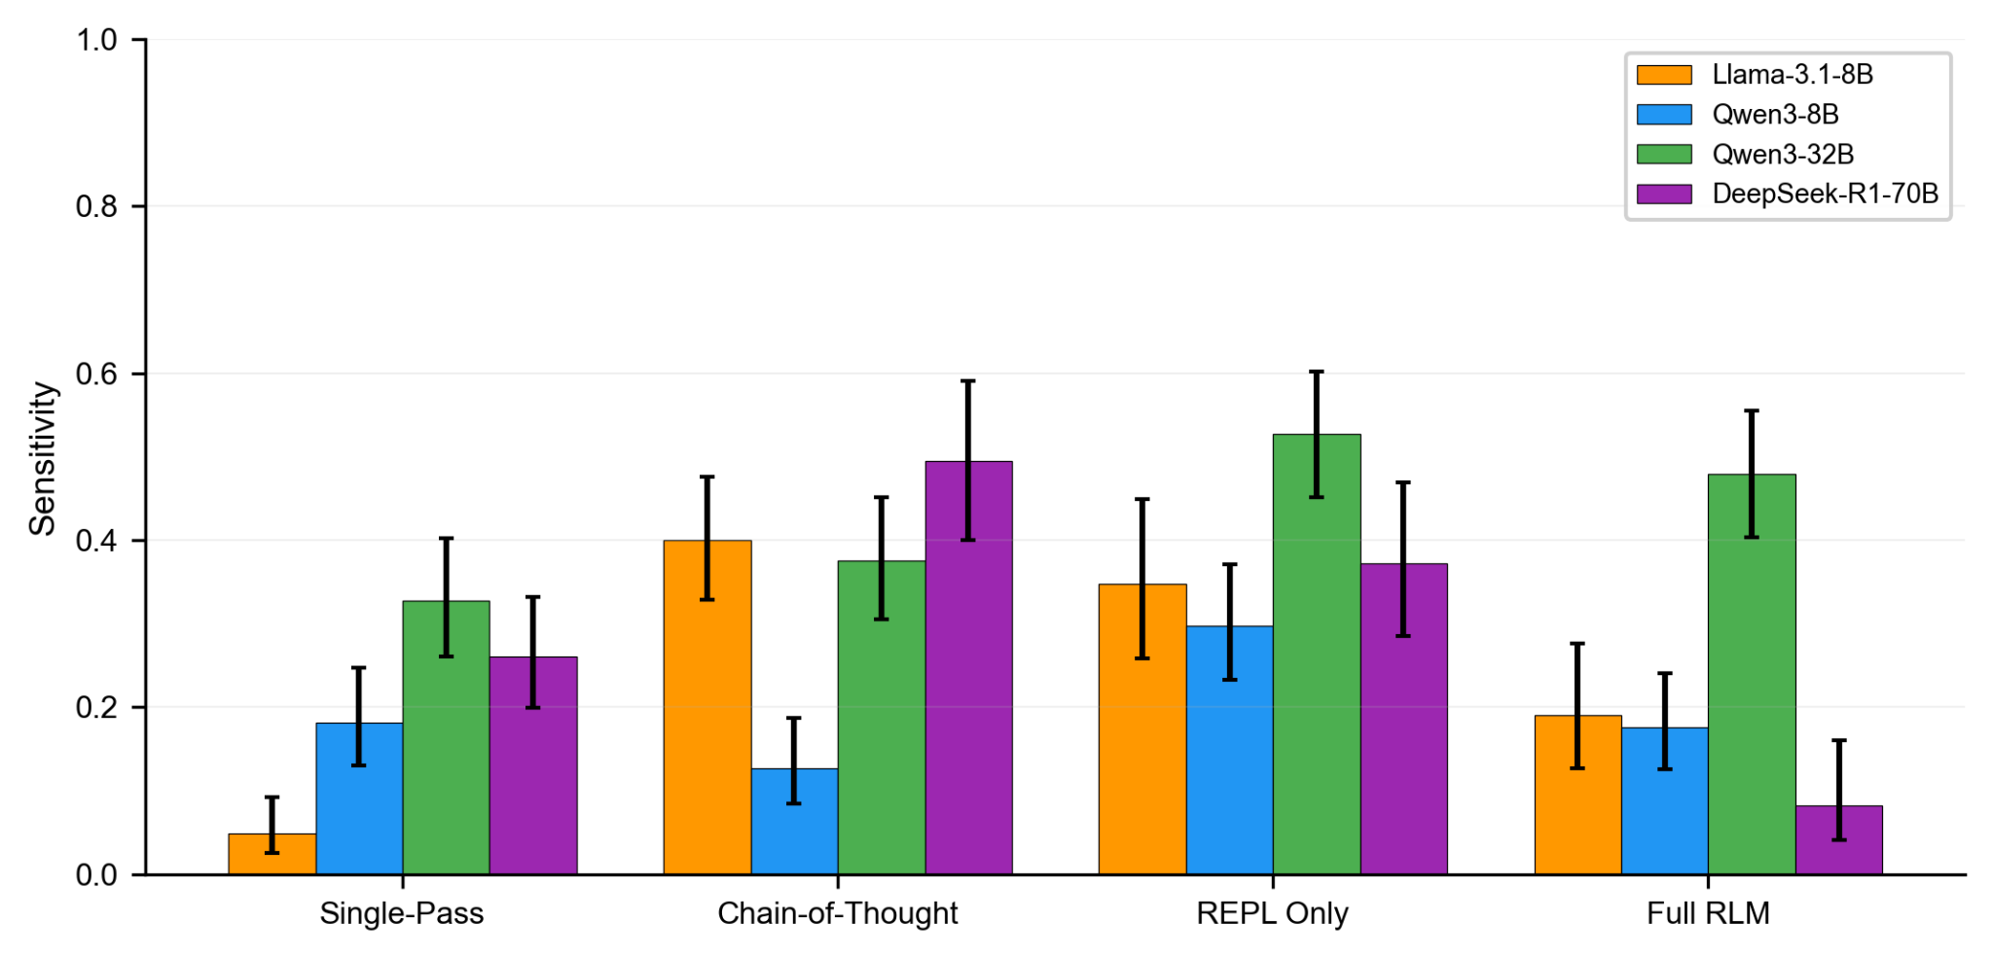

Supplementary Figure 2. Triage action accuracy and critical under-triage rates on the physician test set. Panel (a) shows action accuracy (proportion of cases assigned the correct triage action across four levels: None, Routine Follow-up, Contact Doctor, Call 911/988). Panel (b) shows critical under-triage rate (proportion of urgent or emergent cases assigned insufficient escalation; lower is better). Error bars indicate 95% bootstrap confidence intervals.
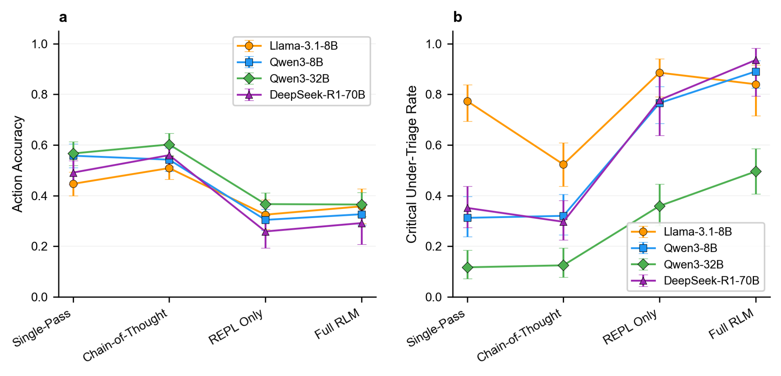

Supplementary Figure 3. Sensitivity versus hallucination rate trade-off on the physician test set. Each point represents one model-condition combination. The x-axis shows the Phantom Symptom Rate (proportion of hallucinated findings; lower is better) and the y-axis shows sensitivity (proportion of hazards detected; higher is better). Points are labeled with the arm letter (A = single-pass, B = chain-of-thought, C = REPL only, D = full RLM). Dashed lines indicate reference thresholds at 80% sensitivity and 10% PSR. The ideal region is the upper-left quadrant (high sensitivity, low hallucination). Only Arm B for Qwen3-32B and DeepSeek-R1-70B approaches this region.
