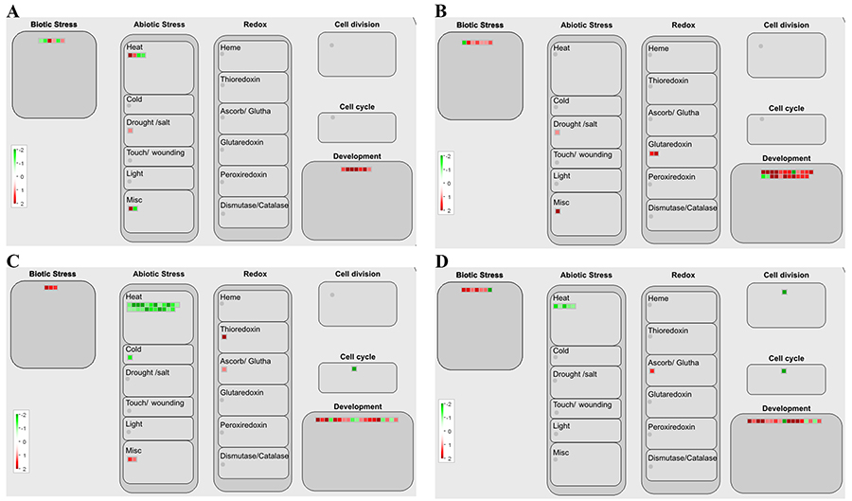
Additional file 10: Fig. S6. Cellular response overview in each comparison. Cellular response overview maps were designed by MapMan based on the transcript levels of differentially expressed genes (DEGs) in (a) LD7-vs.-SD7, (b) LD10-vs.-SD10, (c) LD13-vs.-SD13, and (d) LD19-vs.-SD19. The color indicates log₂ value of fold changes, with green and red colors representing down- and up-regulated transcripts, respectively.

