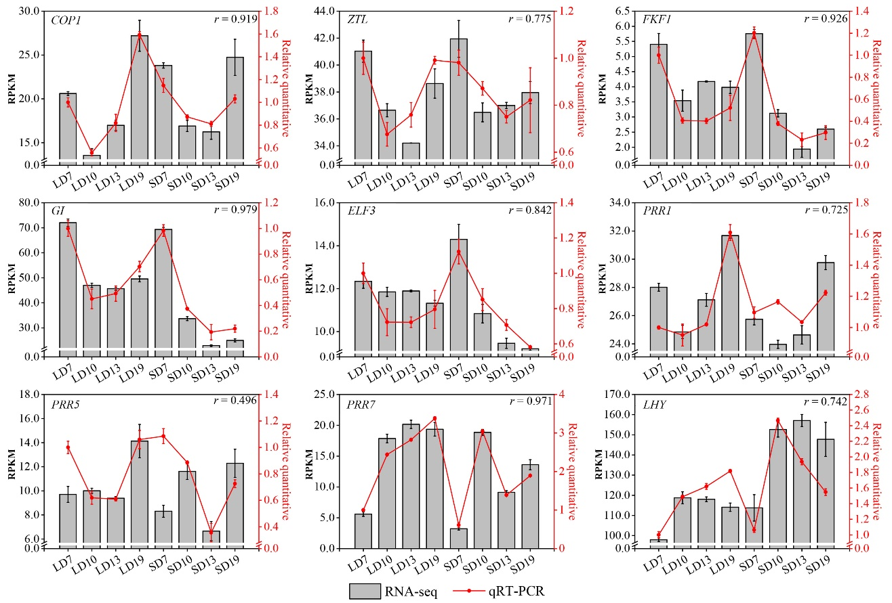
Additional file 4: Fig. S2. Relative expression of flowering-related genes at four time points under short-day and long-day treatments. The relative gene expression as detected by RNA sequencing (RNA-seq) and confirmed by quantitative real-time PCR (qRT-PCR).

