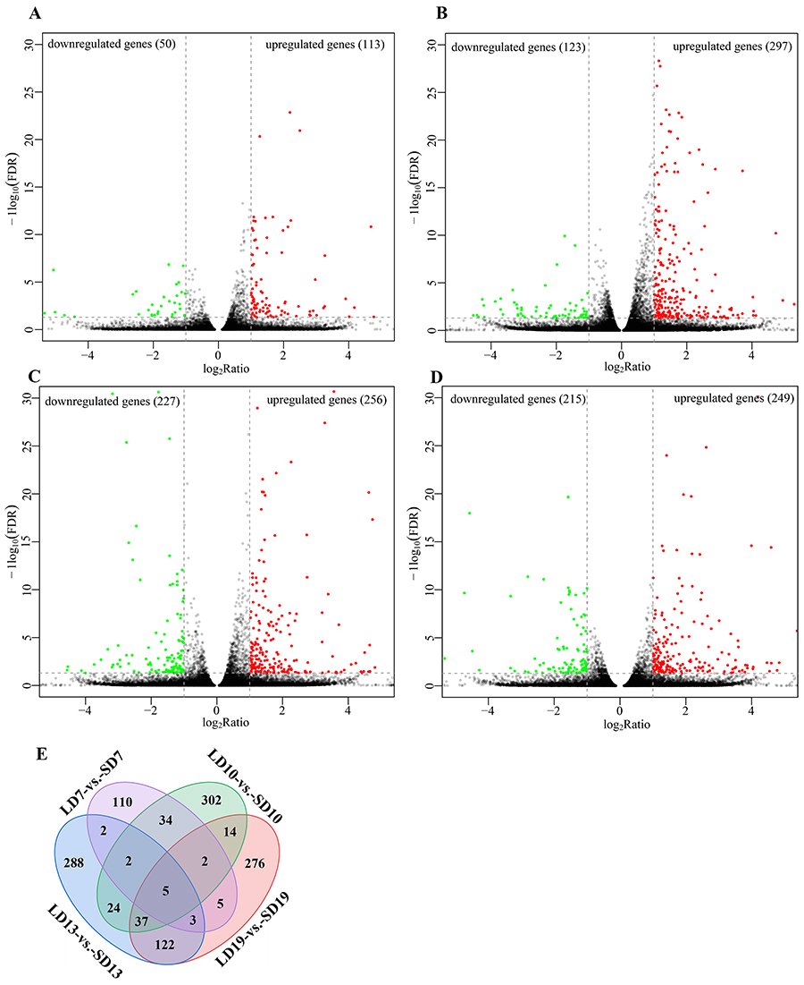
Additional file 5: Fig. S3. Differentially expressed genes (DEGs) in each comparison. Numbers of DGEs in comparisons (a) LD7-vs.-SD7, (b) LD10-vs.-SD10, (c) LD13-vs.-SD13, and (d) LD19-vs.-SD19. e Venn diagram showing differentially and stage-specific gene profile per comparison.

