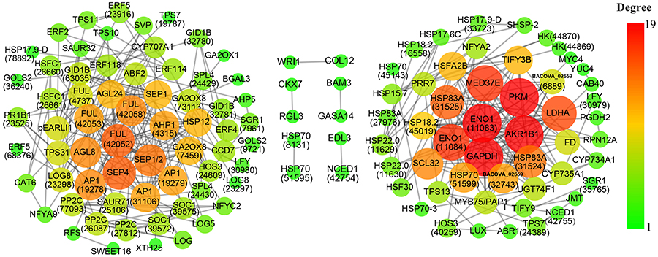
Additional file 15: Fig. S7. Co-expression network of differentially expressed genes (DEGs) associated with floral transition in Luculia gratissima. A total of 126 floral transition-related DEGs with edge weight > 0.1 were mapped by Cytoscape. The larger and redder the circles, the higher is the connectivity. When more than two unigenes are the same gene, the unigene ID is marked in parentheses after the gene name.

